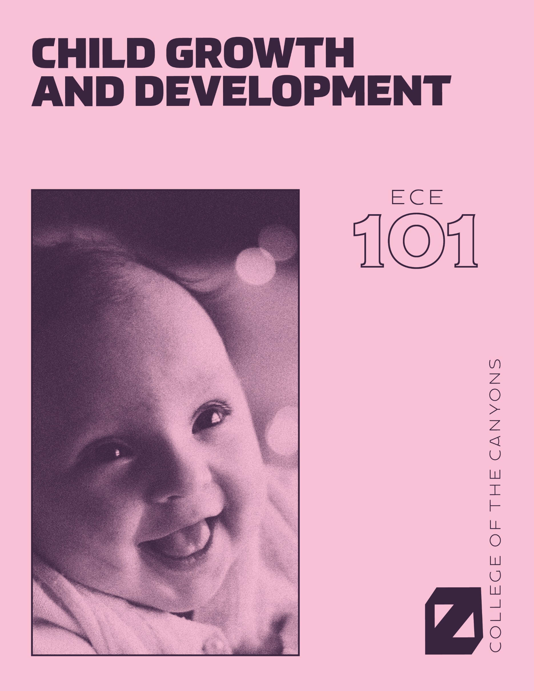

Child growth and Development

An Open Educational Resources Publication by College of the Canyons

Authored and compiled by Jennifer Paris, Antoinette Ricardo, & Dawn Rymond

Editor: Alexa Johnson
Cover & Graphics: Ian Joslin

Version 1.2

2019

Acknowledgements

College of the Canyons would like to extend appreciation to the following people and organizations for allowing this textbook to be created:

California Community Colleges Chancellor’s Office
Chancellor Dianne G. Van Hook
Santa Clarita Community College District
College of the Canyons Distance Learning Office

Have Feedback or Resources to Share?

Catch a typo? Want to suggest a change to improve the book? Please send us your feedback in this survey.

Did you use this book and make changes? Did you create supplementary resources (PowerPoints, activities, test/quiz banks, etc.)? Please put a creative commons license on those and share them back with us by joining and uploading them to the Google Group. If you are having issues, please contact Jennifer.Paris@canyons.edu.

Looking for resources? See what has been compiled in the Google Group.

© 2018, California Community Colleges, Chancellor’s Office.
This work is licensed under a Creative Commons Attribution 4.0 International License.

Further Acknowledgements

I would like to thank:

My department including my full-time faculty colleagues, Cindy Stephens and Wendy Ruiz, who supported me pursuing the grant that funded this book and believe in the purpose of our OER work.

James Glapa-Grossklag for taking a chance on working with me for this grant before he really knew me and for all the opportunities I have been afforded since then.

Brian Weston for his leadership, guidance, and just being there to help facilitate the amazing project that this book is part of.

Alexa Johnson for her painstaking work on the book and taking words on pages and turning them into this beautiful book.

Chloe McGinley, Joy Shoemate, Trudi Radtke, and any other OER and Online Education staff that helped me maintain my sanity in this project.

My co-authors, Antoinette Ricardo and Dawn Rymond, for their tireless efforts and collaboration.

The peer reviewers, Michelle Hancock, Gina Peterson, and Ashlei Snead for widening the collaboration and their work to make the book better.

The ECE 101 students of Spring 2019 at College of the Canyons for piloting the textbook, chapter by chapter with us and providing feedback and content that may be used to create supplementary resources.

My family, especially my children Ashlynn and Aidan, for being understanding of the time and energy commitments that this book, the larger project it is part of, and my advocacy for OER has taken.

Amanda Taintor, my colleague, ally, and co-conspirator in the effort to engage the field of Early Childhood Education in OER efforts.

The larger OER community that keeps me thinking and pushing my understanding of what open is, what it should be, and what role I can play in that.

Jennifer Paris

First and foremost, I would like to thank God for blessing me with an amazing job that allows me to teach and grow each and every day. Thank you to College of the Canyons and our whole OER team for making this vision a reality. Special thanks to Jennifer Paris who has not only mentored me and been a great friend, but has also lead us in this whole OER journey. I’m grateful to work for a such a wonderful department that sets the foundation for positive growth in children.

Thank you to my parents and my brother whose love and support has gotten me to where I am today. To my husband, Andres, thank you for always believing in me and pushing me to be the best I can be, I love you.

To my children, Manolo and Paloma; this book is for you. Every day, you are my inspiration. Mamita te ama!

Antoinette Ricardo

Writing and contributing to this textbook has been a labor of love. My hope is that after students gain knowledge, they will continue to be inspired to learn and will be a positive role in the lives of children.

I would like to say a special thank you to College of the Canyons, ECE department. I’ve been very fortunate to be a part of this outstanding Open Educational Resources (OER) team, which has been a supportive and collaborative experience. I’d like to thank Jennifer Paris, the faculty lead for the grant that funded the creation of this and other OER books for our department.

I am continually grateful to my family. Thank you, Nick, Jake, and Jordan, for your contually love and support.

“Education is not the preparation for life; education is life itself.”
-John Dewey

Dawn Rymond

Table of Contents

Chapter 1: Introduction to Child Development 8
Chapter 2: Conception, Heredity, & Prenatal Development 39
Chapter 3: Birth and the Newborn 71
Chapter 4: Physical Development in Infancy & Toddlerhood 89
Chapter 5: Cognitive Development in Infancy and Toddlerhood 126
Chapter 6: Social and Emotional Development in Infancy and Toddlerhood 146
Chapter 7: Physical Development in Early Childhood 165
Chapter 8: Cognitive Development in Early Childhood 184
Chapter 9: Social Emotional Development in Early Childhood 210
Chapter 10: Middle Childhood - Physical Development 238
Chapter 11: Middle Childhood – Cognitive Development 268
Chapter 12: Middle Childhood - Social Emotional Development 302
Chapter 13: Adolescence – Physical Development 327
Chapter 14: Adolescence – Cognitive Development 362
Chapter 15: Adolescence – Social Emotional Development 384

Chapter 1: Introduction to Child Development

Chapter Objectives
After this chapter, you should be able to:
- Describe the principles that underlie development.
- Differentiate periods of human development.
- Evaluate issues in development.
- Distinguish the different methods of research.
- Explain what a theory is.
- Compare and contrast different theories of child development.

Introduction
Welcome to Child Growth and Development. This text is a presentation of how and why children grow, develop, and learn.

We will look at how we change physically over time from conception through adolescence. We examine cognitive change, or how our ability to think and remember changes over the first 20 years or so of life. And we will look at how our emotions, psychological state, and social relationships change throughout childhood and adolescence.

Principles of Development
There are several underlying principles of development to keep in mind:
- Development is lifelong and change is apparent across the lifespan (although this text ends with adolescence). And early experiences affect later development.
- Development is multidirectional. We show gains in some areas of development, while showing loss in other areas.
- Development is multidimensional. We change across three general domains/dimensions; physical, cognitive, and social and emotional.
  - The physical domain includes changes in height and weight, changes in gross and fine motor skills, sensory capabilities, the nervous system, as well as the propensity for disease and illness.
  - The cognitive domain encompasses the changes in intelligence, wisdom, perception, problem-solving, memory, and language.
  - The social and emotional domain (also referred to as psychosocial) focuses on changes in emotion, self-perception, and interpersonal relationships with families, peers, and friends.

All three domains influence each other. It is also important to note that a change in one domain may cascade and prompt changes in the other domains.
- Development is characterized by plasticity, which is our ability to change and that many of our characteristics are malleable. Early experiences are important, but children are remarkably resilient (able to overcome adversity).
- Development is multicontextual. We are influenced by both nature (genetics) and nurture (the environment) - when and where we live and our actions, beliefs, and values are a response to circumstances surrounding us. The key here is to understand that behaviors, motivations, emotions, and choices are all part of a bigger picture.

Now let’s look at a framework for examining development.

Periods of Development
Think about what periods of development that you think a course on Child Development would address. How many stages are on your list? Perhaps you have three: infancy, childhood, and teenagers. Developmentalists (those that study development) break this part of the life span into these five stages as follows:
- Prenatal Development (conception through birth)
- Infancy and Toddlerhood (birth through two years)
- Early Childhood (3 to 5 years)
- Middle Childhood (6 to 11 years)
- Adolescence (12 years to adulthood)

This list reflects unique aspects of the various stages of childhood and adolescence that will be explored in this book. So while both an 8 month old and an 8 year old are considered children, they have very different motor abilities, social relationships, and cognitive skills. Their nutritional needs are different and their primary psychological concerns are also distinctive.

Prenatal Development
Conception occurs and development begins. All of the major structures of the body are forming and the health of the mother is of primary concern. Understanding nutrition, teratogens (or environmental factors that can lead to birth defects), and labor and delivery are primary concerns.
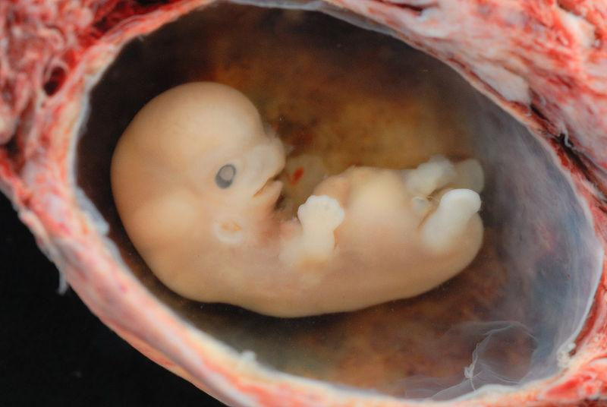
Figure 1.1 - A tiny embryo depicting some development of arms and legs, as well as facial features that are starting to show.

Infancy and Toddlerhood
The two years of life are ones of dramatic growth and change. A newborn, with a keen sense of hearing but very poor vision is transformed into a walking, talking toddler within a relatively short period of time. Caregivers are also transformed from someone who manages feeding and sleep schedules to a constantly moving guide and safety inspector for a mobile, energetic child.

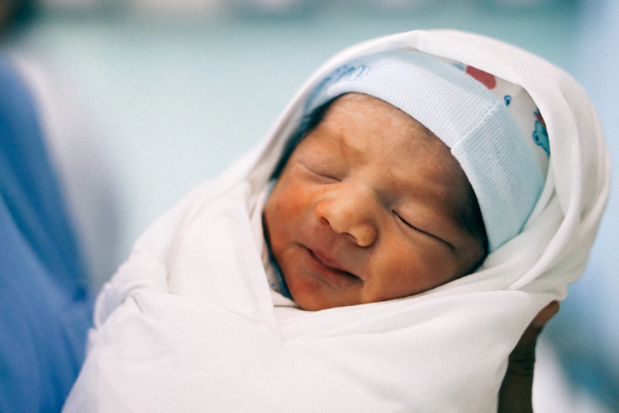
Figure 1.2 - A swaddled newborn.

Early Childhood
Early childhood is also referred to as the preschool years and consists of the years which follow toddlerhood and precede formal schooling. As a three to five-year-old, the child is busy learning language, is gaining a sense of self and greater independence, and is beginning to learn the workings of the physical world. This knowledge does not come quickly, however, and preschoolers may initially have interesting conceptions of size, time, space and distance such as fearing that they may go down the drain if they sit at the front of the bathtub or by demonstrating how long something will take by holding out their two index fingers several inches apart. A toddler’s fierce determination to do something may give way to a four-year-old’s sense of guilt for action that brings the disapproval of others.

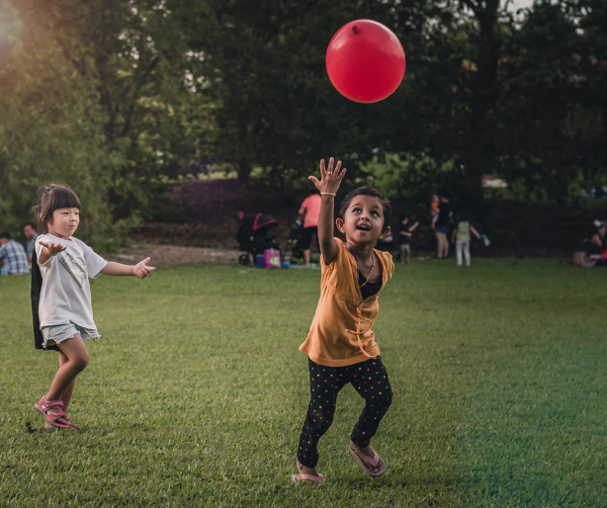
Figure 1.3 - Two young children playing in the Singapore Botanic Gardens

Middle Childhood
The ages of six through eleven comprise middle childhood and much of what children experience at this age is connected to their involvement in the early grades of school. Now the world becomes one of learning and testing new academic skills and by assessing one’s abilities and accomplishments by making comparisons between self and others. Schools compare students and make these comparisons public through team sports, test scores, and other forms of recognition. Growth rates slow down and children are able to refine their motor skills at this point in life. And children begin to learn about social relationships beyond the family through interaction with friends and fellow students.

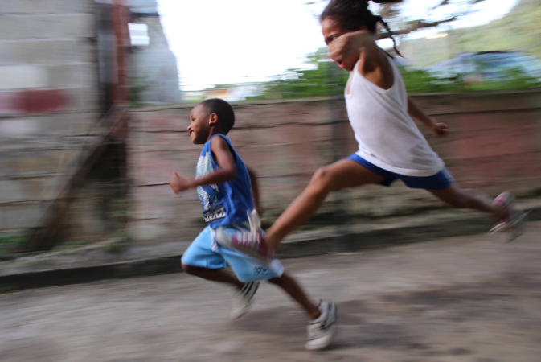
Figure 1.4 - Two children running down the street in Carenage, Trinidad and Tobago

Adolescence
Adolescence is a period of dramatic physical change marked by an overall physical growth spurt and sexual maturation, known as puberty. It is also a time of cognitive change as the adolescent begins to think of new possibilities and to consider abstract concepts such as love, fear, and freedom. Ironically, adolescents have a sense of invincibility that puts them at greater risk of dying from accidents or contracting sexually transmitted infections that can have lifelong consequences.

Figure 1.5 - Two smiling teenage women.

There are some aspects of development that have been hotly debated. Let’s explore these.

Issues in Development

Nature and Nurture
Why are people the way they are? Are features such as height, weight, personality, being diabetic, etc. the result of heredity or environmental factors-or both? For decades, scholars have carried on the "nature/nurture" debate. For any particular feature, those on the side of Nature would argue that heredity plays the most important role in bringing about that feature. Those on the side of Nurture would argue that one's environment is most significant in shaping the way we are. This debate continues in all aspects of human development, and most scholars agree that there is a constant interplay between the two forces. It is difficult to isolate the root of any single behavior as a result solely of nature or nurture.

Continuity versus Discontinuity
Is human development best characterized as a slow, gradual process, or is it best viewed as one of more abrupt change? The answer to that question often depends on which developmental theorist you ask and what topic is being studied. The theories of Freud, Erikson, Piaget, and Kohlberg are called stage theories. Stage theories or discontinuous development assume that developmental change often occurs in distinct stages that are qualitatively different from each other, and in a set, universal sequence. At each stage of development, children and adults have different qualities and characteristics. Thus, stage theorists assume development is more discontinuous. Others, such as the behaviorists, Vygotsky, and information processing theorists, assume development is a more slow and gradual process known as continuous development. For instance, they would see the adult as not possessing new skills, but more advanced skills that were already present in some form in the child. Brain development and environmental experiences contribute to the acquisition of more developed skills.

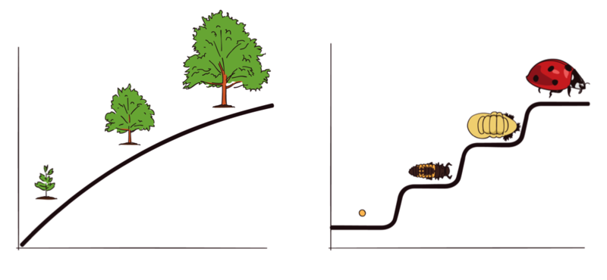
Figure 1.6 – The graph to the left shows three stages in the continuous growth of a tree. The graph to the right shows four distinct stages of development in the life cycle of a ladybug.

Active versus Passive
How much do you play a role in your own developmental path? Are you at the whim of your genetic inheritance or the environment that surrounds you? Some theorists see humans as playing a much more active role in their own development. Piaget, for instance believed that children actively explore their world and construct new ways of thinking to explain the things they experience. In contrast, many behaviorists view humans as being more passive in the developmental process.

How do we know so much about how we grow, develop, and learn? Let’s look at how that data is gathered through research

Research Methods
An important part of learning any science is having a basic knowledge of the techniques used in gathering information. The hallmark of scientific investigation is that of following a set of procedures designed to keep questioning or skepticism alive while describing, explaining, or testing any phenomenon. Some people are hesitant to trust academicians or researchers because they always seem to change their story. That, however, is exactly what science is all about; it involves continuously renewing our understanding of the subjects in question and an ongoing investigation of how and why events occur. Science is a vehicle for going on a never-ending journey. In the area of development, we have seen changes in recommendations for nutrition, in explanations of psychological states as people age, and in parenting advice. So think of learning about human development as a lifelong endeavor.

Take a moment to write down two things that you know about childhood. Now, how do you know? Chances are you know these things based on your own history (experiential reality) or based on what others have told you or cultural ideas (agreement reality) (Seccombe and Warner, 2004). There are several problems with personal inquiry. Read the following sentence aloud:
Paris in the
the spring

Are you sure that is what it said? Read it again:

Paris in the
the spring

If you read it differently the second time (adding the second “the”) you just experienced one of the problems with personal inquiry; that is, the tendency to see what we believe. Our assumptions very often guide our perceptions, consequently, when we believe something, we tend to see it even if it is not there. This problem may just be a result of cognitive ‘blinders’ or it may be part of a more conscious attempt to support our own views. Confirmation bias is the tendency to look for evidence that we are right and in so doing, we ignore contradictory evidence. Popper suggests that the distinction between that which is scientific and that which is unscientific is that science is falsifiable; scientific inquiry involves attempts to reject or refute a theory or set of assumptions (Thornton, 2005). Theory that cannot be falsified is not scientific. And much of what we do in personal inquiry involves drawing conclusions based on what we have personally experienced or validating our own experience by discussing what we think is true with others who share the same views.

Science offers a more systematic way to make comparisons guard against bias.

Scientific Methods
One method of scientific investigation involves the following steps:
- Determining a research question
- Reviewing previous studies addressing the topic in question (known as a literature review)
- Determining a method of gathering information
- Conducting the study
- Interpreting results
- Drawing conclusions; stating limitations of the study and suggestions for future research
- Making your findings available to others (both to share information and to have your work scrutinized by others)

Your findings can then be used by others as they explore the area of interest and through this process a literature or knowledge base is established. This model of scientific investigation presents research as a linear process guided by a specific research question. And it typically involves quantifying or using statistics to understand and report what has been studied. Many academic journals publish reports on studies conducted in this manner.

Another model of research referred to as qualitative research may involve steps such as these:
- Begin with a broad area of interest
- Gain entrance into a group to be researched
- Gather field notes about the setting, the people, the structure, the activities or other areas of interest
- Ask open ended, broad “grand tour” types of questions when interviewing subjects
- Modify research questions as study continues
- Note patterns or consistencies
- Explore new areas deemed important by the people being observed
- Report findings

In this type of research, theoretical ideas are “grounded” in the experiences of the participants. The researcher is the student and the people in the setting are the teachers as they inform the researcher of their world (Glazer & Strauss, 1967). Researchers are to be aware of their own biases and assumptions, acknowledge them and bracket them in efforts to keep them from limiting accuracy in reporting. Sometimes qualitative studies are used initially to explore a topic and more quantitative studies are used to test or explain what was first described.

Research Methods
Let’s look more closely at some techniques, or research methods, used to describe, explain, or evaluate. Each of these designs has strengths and weaknesses and is sometimes used in combination with other designs within a single study.

Observational Studies
Observational studies involve watching and recording the actions of participants. This may take place in the natural setting, such as observing children at play at a park, or behind a one-way glass while children are at play in a laboratory playroom. The researcher may follow a checklist and record the frequency and duration of events (perhaps how many conflicts occur among 2-year-olds) or may observe and record as much as possible about an event (such as observing children in a classroom and capturing the details about the room design and what the children and teachers are doing and saying). In general, observational studies have the strength of allowing the researcher to see how people behave rather than relying on self-report. What people do and what they say they do are often very different. A major weakness of observational studies is that they do not allow the researcher to explain causal relationships. Yet, observational studies are useful and widely used when studying children. Children tend to change their behavior when they know they are being watched (known as the Hawthorne effect) and may not survey well.

Experiments
Experiments are designed to test hypotheses (or specific statements about the relationship between variables) in a controlled setting in efforts to explain how certain factors or events produce outcomes. A variable is anything that changes in value. Concepts are operationalized or transformed into variables in research, which means that the researcher must specify exactly what is going to be measured in the study.

Three conditions must be met in order to establish cause and effect. Experimental designs are useful in meeting these conditions.
- The independent and dependent variables must be related. In other words, when one is altered, the other changes in response. (The independent variable is something altered or introduced by the researcher. The dependent variable is the outcome or the factor affected by the introduction of the independent variable. For example, if we are looking at the impact of exercise on stress levels, the independent variable would be exercise; the dependent variable would be stress.)
- The cause must come before the effect. Experiments involve measuring subjects on the dependent variable before exposing them to the independent variable (establishing a baseline). So we would measure the subjects’ level of stress before introducing exercise and then again after the exercise to see if there has been a change in stress levels. (Observational and survey research does not always allow us to look at the timing of these events, which makes understanding causality problematic with these designs.)
- The cause must be isolated. The researcher must ensure that no outside, perhaps unknown variables are actually causing the effect we see. The experimental design helps make this possible. In an experiment, we would make sure that our subjects’ diets were held constant throughout the exercise program. Otherwise, diet might really be creating the change in stress level rather than exercise.

A basic experimental design involves beginning with a sample (or subset of a population) and randomly assigning subjects to one of two groups: the experimental group or the control group. The experimental group is the group that is going to be exposed to an independent variable or condition the researcher is introducing as a potential cause of an event. The control group is going to be used for comparison and is going to have the same experience as the experimental group but will not be exposed to the independent variable. After exposing the experimental group to the independent variable, the two groups are measured again to see if a change has occurred. If so, we are in a better position to suggest that the independent variable caused the change in the dependent variable.
The major advantage of the experimental design is that of helping to establish cause and effect relationships. A disadvantage of this design is the difficulty of translating much of what happens in a laboratory setting into real life.

Case Studies
Case studies involve exploring a single case or situation in great detail. Information may be gathered with the use of observation, interviews, testing, or other methods to uncover as much as possible about a person or situation. Case studies are helpful when investigating unusual situations such as brain trauma or children reared in isolation. And they are often used by clinicians who conduct case studies as part of their normal practice when gathering information about a client or patient coming in for treatment. Case studies can be used to explore areas about which little is known and can provide rich detail about situations or conditions. However, the findings from case studies cannot be generalized or applied to larger populations; this is because cases are not randomly selected and no control group is used for comparison.

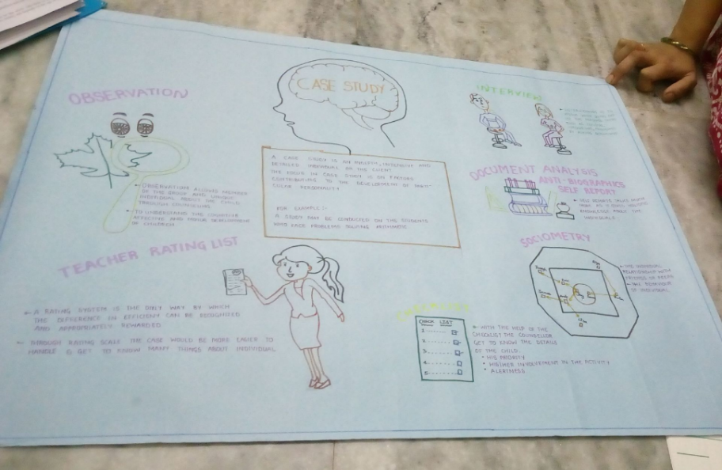
Figure 1.7 - Illustrated poster from a classroom describing a case study.

Surveys
Surveys are familiar to most people because they are so widely used. Surveys enhance accessibility to subjects because they can be conducted in person, over the phone, through the mail, or online. A survey involves asking a standard set of questions to a group of subjects. In a highly structured survey, subjects are forced to choose from a response set such as “strongly disagree, disagree, undecided, agree, strongly agree”; or “0, 1-5, 6-10, etc.” This is known as Likert Scale. Surveys are commonly used by sociologists, marketing researchers, political scientists, therapists, and others to gather information on many independent and dependent variables in a relatively short period of time. Surveys typically yield surface information on a wide variety of factors, but may not allow for in-depth understanding of human behavior.

Of course, surveys can be designed in a number of ways. They may include forced choice questions and semi-structured questions in which the researcher allows the respondent to describe or give details about certain events. One of the most difficult aspects of designing a good survey is wording questions in an unbiased way and asking the right questions so that respondents can give a clear response rather than choosing “undecided” each time. Knowing that 30% of respondents are undecided is of little use! So a lot of time and effort should be placed on the construction of survey items. One of the benefits of having forced choice items is that each response is coded so that the results can be quickly entered and analyzed using statistical software. Analysis takes much longer when respondents give lengthy responses that must be analyzed in a different way. Surveys are useful in examining stated values, attitudes, opinions, and reporting on practices. However, they are based on self-report or what people say they do rather than on observation and this can limit accuracy.

Developmental Designs
Developmental designs are techniques used in developmental research (and other areas as well). These techniques try to examine how age, cohort, gender, and social class impact development.

Longitudinal Research
Longitudinal research involves beginning with a group of people who may be of the same age and background, and measuring them repeatedly over a long period of time. One of the benefits of this type of research is that people can be followed through time and be compared with them when they were younger.

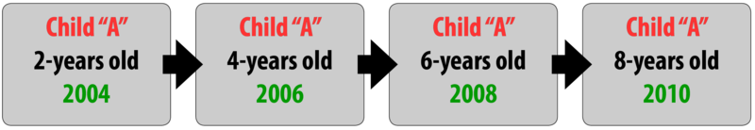
Figure 1.8 – A longitudinal research design.

A problem with this type of research is that it is very expensive and subjects may drop out over time. The Perry Preschool Project which began in 1962 is an example of a longitudinal study that continues to provide data on children’s development.

Cross-sectional Research
Cross-sectional research involves beginning with a sample that represents a cross-section of the population. Respondents who vary in age, gender, ethnicity, and social class might be asked to complete a survey about television program preferences or attitudes toward the use of the Internet. The attitudes of males and females could then be compared, as could attitudes based on age. In cross-sectional research, respondents are measured only once.
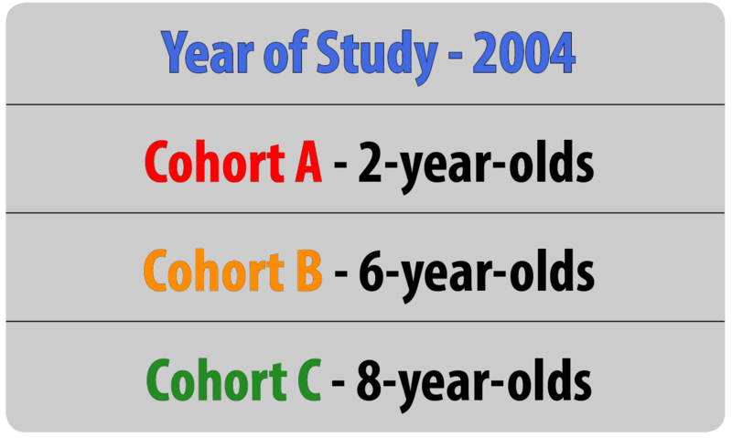
Figure 1.9 – A cross-sectional research design.

This method is much less expensive than longitudinal research but does not allow the researcher to distinguish between the impact of age and the cohort effect. Different attitudes about the use of technology, for example, might not be altered by a person’s biological age as much as their life experiences as members of a cohort.

Sequential Research
Sequential research involves combining aspects of the previous two techniques; beginning with a cross-sectional sample and measuring them through time.

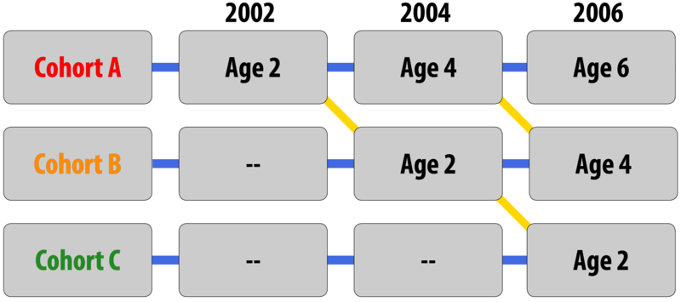
Figure 1.10 - A sequential research design.

This is the perfect model for looking at age, gender, social class, and ethnicity. But the drawbacks of high costs and attrition are here as well.
Table 1.1 - Advantages and Disadvantages of Different Research Designs

Type of Research Design | Advantages | Disadvantages
Longitudinal | - Examines changes within individuals over time  - Provides a developmental analysis | - Expensive  - Takes a long time  - Participant attrition  - Possibility of practice effects  - Cannot examine cohort effects
Cross-sectional | - Examines changes between participants of different ages at the same point in time  - Provides information on age-related change | - Cannot examine change over time  - Cannot examine cohort effects
Sequential | - Examines changes within individuals over time  - Examines changes between participants of different ages at the same point in time  - Can be used to examine cohort effects | - May be expensive  - Possibility of practice effects

Consent and Ethics in Research
Research should, as much as possible, be based on participants' freely volunteered informed consent. For minors, this also requires consent from their legal guardians. This implies a responsibility to explain fully and meaningfully to both the child and their guardians what the research is about and how it will be disseminated. Participants and their legal guardians should be aware of the research purpose and procedures, their right to refuse to participate; the extent to which confidentiality will be maintained; the potential uses to which the data might be put; the foreseeable risks and expected benefits; and that participants have the right to discontinue at any time.

But consent alone does not absolve the responsibility of researchers to anticipate and guard against potential harmful consequences for participants. It is critical that researchers protect all rights of the participants including confidentiality.
Child development is a fascinating field of study – but care must be taken to ensure that researchers use appropriate methods to examine infant and child behavior, use the correct experimental design to answer their questions, and be aware of the special challenges that are part-and-parcel of developmental research. Hopefully, this information helped you develop an understanding of these various issues and to be ready to think more critically about research questions that interest you. There are so many interesting questions that remain to be examined by future generations of developmental scientists – maybe you will make one of the next big discoveries!

Another really important framework to use when trying to understand children’s development are theories of development. Let’s explore what theories are and introduce you to some major theories in child development.

Developmental Theories

What is a theory?
Students sometimes feel intimidated by theory; even the phrase, “Now we are going to look at some theories…” is met with blank stares and other indications that the audience is now lost. But theories are valuable tools for understanding human behavior; in fact they are proposed explanations for the “how” and “whys” of development. Have you ever wondered, “Why is my 3 year old so inquisitive?” or “Why are some fifth graders rejected by their classmates?” Theories can help explain these and other occurrences. Developmental theories offer explanations about how we develop, why we change over time and the kinds of influences that impact development.

A theory guides and helps us interpret research findings as well. It provides the researcher with a blueprint or model to be used to help piece together various studies. Think of theories as guidelines much like directions that come with an appliance or other object that requires assembly. The instructions can help one piece together smaller parts more easily than if trial and error are used.

Theories can be developed using induction in which a number of single cases are observed and after patterns or similarities are noted, the theorist develops ideas based on these examples. Established theories are then tested through research; however, not all theories are equally suited to scientific investigation. Some theories are difficult to test but are still useful in stimulating debate or providing concepts that have practical application. Keep in mind that theories are not facts; they are guidelines for investigation and practice, and they gain credibility through research that fails to disprove them.

Let’s take a look at some key theories in Child Development.

Sigmund Freud’s Psychosexual Theory
We begin with the often controversial figure, Sigmund Freud (1856-1939). Freud has been a very influential figure in the area of development; his view of development and psychopathology dominated the field of psychiatry until the growth of behaviorism in the 1950s. His assumptions that personality forms during the first few years of life and that the ways in which parents or other caregivers interact with children have a long-lasting impact on children’s emotional states have guided parents, educators, clinicians, and policy-makers for many years. We have only recently begun to recognize that early childhood experiences do not always result in certain personality traits or emotional states. There is a growing body of literature addressing resilience in children who come from harsh backgrounds and yet develop without damaging emotional scars (O’Grady and Metz, 1987). Freud has stimulated an enormous amount of research and generated many ideas. Agreeing with Freud’s theory in its entirety is hardly necessary for appreciating the contribution he has made to the field of development.

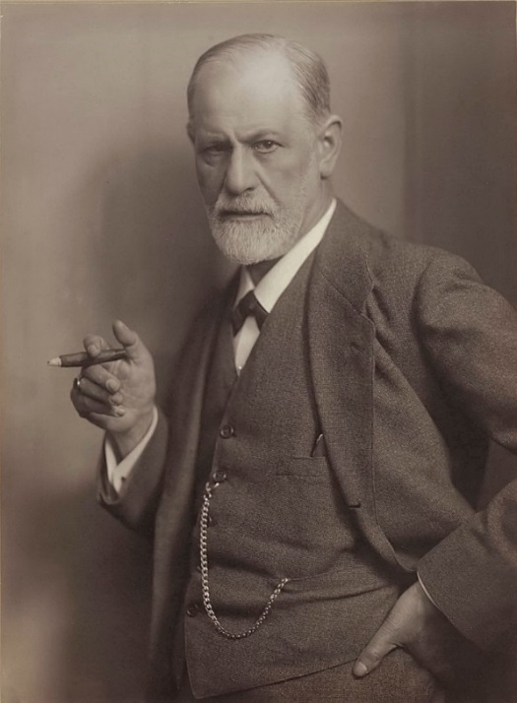
Figure 1.11 - Sigmund Freud.

Freud’s theory of self suggests that there are three parts of the self.

The id is the part of the self that is inborn. It responds to biological urges without pause and is guided by the principle of pleasure: if it feels good, it is the thing to do. A newborn is all id. The newborn cries when hungry, defecates when the urge strikes.

The ego develops through interaction with others and is guided by logic or the reality principle. It has the ability to delay gratification. It knows that urges have to be managed. It mediates between the id and superego using logic and reality to calm the other parts of the self.
The superego represents society’s demands for its members. It is guided by a sense of guilt. Values, morals, and the conscience are all part of the superego.

The personality is thought to develop in response to the child’s ability to learn to manage biological urges. Parenting is important here. If the parent is either overly punitive or lax, the child may not progress to the next stage. Here is a brief introduction to Freud’s stages.

Table 1.2 - Sigmund Freud’s Psychosexual Theory

Name of Stage | Descriptions of Stage
Oral Stage | The oral stage lasts from birth until around age 2. The infant is all id. At this stage, all stimulation and comfort is focused on the mouth and is based on the reflex of sucking. Too much indulgence or too little stimulation may lead to fixation.
Anal Stage | The anal stage coincides with potty training or learning to manage biological urges. The ego is beginning to develop in this stage. Anal fixation may result in a person who is compulsively clean and organized or one who is sloppy and lacks self-control.
Phallic Stage | The phallic stage occurs in early childhood and marks the development of the superego and a sense of masculinity or femininity as culture dictates.
Latency | Latency occurs during middle childhood when a child’s urges quiet down and friendships become the focus. The ego and superego can be refined as the child learns how to cooperate and negotiate with others.
Genital Stage | The genital stage begins with puberty and continues through adulthood. Now the preoccupation is that of sex and reproduction.

Strengths and Weaknesses of Freud’s Theory
Freud’s theory has been heavily criticized for several reasons. One is that it is very difficult to test scientifically. How can parenting in infancy be traced to personality in adulthood? Are there other variables that might better explain development? The theory is also considered to be sexist in suggesting that women who do not accept an inferior position in society are somehow psychologically flawed. Freud focuses on the darker side of human nature and suggests that much of what determines our actions is unknown to us. So why do we study Freud? As mentioned above, despite the criticisms, Freud’s assumptions about the importance of early childhood experiences in shaping our psychological selves have found their way into child development, education, and parenting practices. Freud’s theory has heuristic value in providing a framework from which to elaborate and modify subsequent theories of development. Many later theories, particularly behaviorism and humanism, were challenges to Freud’s views.

Main Points to Note About Freud’s Psychosexual Theory

Freud believed that:
- Development in the early years has a lasting impact.
- There are three parts of the self: the id, the ego, and the superego
- People go through five stages of psychosexual development: the oral stage, the anal stage, the phallic stage, latency, and the genital stage

We study Freud because his assumptions the importance of early childhood experience provide a framework for later theories (the both elaborated and contradicted/challenged his work).

Erik Erikson’s Psychosocial Theory
Now, let’s turn to a less controversial theorist, Erik Erikson. Erikson (1902-1994) suggested that our relationships and society’s expectations motivate much of our behavior in his theory of psychosocial development. Erikson was a student of Freud’s but emphasized the importance of the ego, or conscious thought, in determining our actions. In other words, he believed that we are not driven by unconscious urges. We know what motivates us and we consciously think about how to achieve our goals. He is considered the father of developmental psychology because his model gives us a guideline for the entire life span and suggests certain primary psychological and social concerns throughout life.

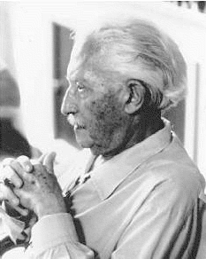
Figure 1.12 - Erik Erikson.

Erikson expanded on his Freud’s by emphasizing the importance of culture in parenting practices and motivations and adding three stages of adult development (Erikson, 1950; 1968). He believed that we are aware of what motivates us throughout life and the ego has greater importance in guiding our actions than does the id. We make conscious choices in life and these choices focus on meeting certain social and cultural needs rather than purely biological ones. Humans are motivated, for instance, by the need to feel that the world is a trustworthy place, that we are capable individuals, that we can make a contribution to society, and that we have lived a meaningful life. These are all psychosocial problems.

Erikson divided the lifespan into eight stages. In each stage, we have a major psychosocial task to accomplish or crisis to overcome. Erikson believed that our personality continues to take shape throughout our lifespan as we face these challenges in living. Here is a brief overview of the eight stages:

Table 1.3 - Erik Erikson’s Psychosocial Theory

Name of Stage | Description of Stage
Trust vs. mistrust (0-1) | The infant must have basic needs met in a consistent way in order to feel that the world is a trustworthy place.
Autonomy vs. shame and doubt (1-2) | Mobile toddlers have newfound freedom they like to exercise and by being allowed to do so, they learn some basic independence.
Initiative vs. Guilt (3-5) | Preschoolers like to initiate activities and emphasize doing things “all by myself.”
Industry vs. inferiority (6-11) | School aged children focus on accomplishments and begin making comparisons between themselves and their classmates
Identity vs. role confusion (adolescence) | Teenagers are trying to gain a sense of identity as they experiment with various roles, beliefs, and ideas.
Intimacy vs. Isolation (young adulthood) | In our 20s and 30s we are making some of our first long-term commitments in intimate relationships.
Generativity vs. stagnation (middle adulthood) | The 40s through the early 60s we focus on being productive at work and home and are motivated by wanting to feel that we’ve made a contribution to society.
Integrity vs. Despair (late adulthood) | We look back on our lives and hope to like what we see-that we have lived well and have a sense of integrity because we lived according to our beliefs.
These eight stages form a foundation for discussions on emotional and social development during the life span. Keep in mind, however, that these stages or crises can occur more than once. For instance, a person may struggle with a lack of trust beyond infancy under certain circumstances. Erikson’s theory has been criticized for focusing so heavily on stages and assuming that the completion of one stage is prerequisite for the next crisis of development. His theory also focuses on the social expectations that are found in certain cultures, but not in all. For instance, the idea that adolescence is a time of searching for identity might translate well in the middle-class culture of the United States, but not as well in cultures where the transition into adulthood coincides with puberty through rites of passage and where adult roles offer fewer choices.

Main Points to Note About Erikson’s Psychosocial Theory
Erikson was a student of Freud but focused on conscious thought.

- His stages of psychosocial development address the entire lifespan and suggest primary psychosocial crisis in some cultures that adults can use to understand how to support children’s social and emotional development.
- The stages include: trust vs. mistrust, autonomy vs. shame and doubt, initiative vs. guilt, industry vs. inferiority, identity vs. role confusion, intimacy vs. isolation, generativity vs. stagnation, and integrity vs. despair.

Behaviorism
While Freud and Erikson looked at what was going on in the mind, behaviorism rejected any reference to mind and viewed overt and observable behavior as the proper subject matter of psychology. Through the scientific study of behavior, it was hoped that laws of learning could be derived that would promote the prediction and control of behavior.

Ivan Pavlov
Ivan Pavlov (1880-1937) was a Russian physiologist interested in studying digestion. As he recorded the amount of salivation his laboratory dogs produced as they ate, he noticed that they actually began to salivate before the food arrived as the researcher walked down the hall and toward the cage. “This,” he thought, “is not natural!” One would expect a dog to automatically salivate when food hit their palate, but BEFORE the food comes? Of course, what had happened was . . . you tell me. That’s right! The dogs knew that the food was coming because they had learned to associate the footsteps with the food. The key word here is “learned”. A learned response is called a “conditioned” response.

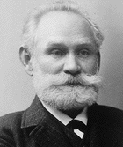
Figure 1.13 - Ivan Pavlov.

Pavlov began to experiment with this concept of classical conditioning. He began to ring a bell, for instance, prior to introducing the food. Sure enough, after making this connection several times, the dogs could be made to salivate to the sound of a bell. Once the bell had become an event to which the dogs had learned to salivate, it was called a conditioned stimulus. The act of salivating to a bell was a response that had also been learned, now termed in Pavlov’s jargon, a conditioned response. Notice that the response, salivation, is the same whether it is conditioned or unconditioned (unlearned or natural). What changed is the stimulus to which the dog salivates. One is natural (unconditioned) and one is learned (conditioned).

Let’s think about how classical conditioning is used on us. One of the most widespread applications of classical conditioning principles was brought to us by the psychologist, John B. Watson.

John B. Watson
John B. Watson (1878-1958) believed that most of our fears and other emotional responses are classically conditioned. He had gained a good deal of popularity in the 1920s with his expert advice on parenting offered to the public.

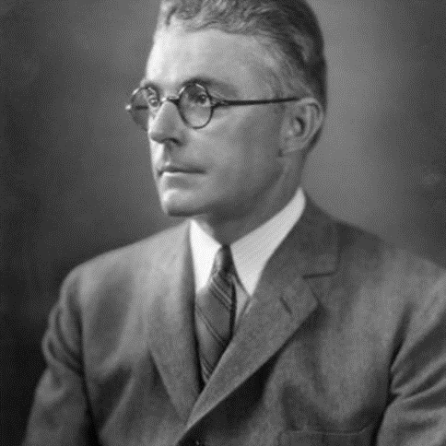
Figure 1.14 - John B. Watson.
He tried to demonstrate the power of classical conditioning with his famous experiment with an 18 month old boy named “Little Albert”. Watson sat Albert down and introduced a variety of seemingly scary objects to him: a burning piece of newspaper, a white rat, etc. But Albert remained curious and reached for all of these things. Watson knew that one of our only inborn fears is the fear of loud noises so he proceeded to make a loud noise each time he introduced one of Albert’s favorites, a white rat. After hearing the loud noise several times paired with the rat, Albert soon came to fear the rat and began to cry when it was introduced. Watson filmed this experiment for posterity and used it to demonstrate that he could help parents achieve any outcomes they desired, if they would only follow his advice. Watson wrote columns in newspapers and in magazines and gained a lot of popularity among parents eager to apply science to household order.

Operant conditioning, on the other hand, looks at the way the consequences of a behavior increase or decrease the likelihood of a behavior occurring again. So let’s look at this a bit more.

B.F. Skinner and Operant Conditioning
B. F. Skinner (1904-1990), who brought us the principles of operant conditioning, suggested that reinforcement is a more effective means of encouraging a behavior than is criticism or punishment. By focusing on strengthening desirable behavior, we have a greater impact than if we emphasize what is undesirable. Reinforcement is anything that an organism desires and is motivated to obtain.

Figure 1.15 - B. F. Skinner.

A reinforcer is something that encourages or promotes a behavior. Some things are natural rewards. They are considered intrinsic or primary because their value is easily understood. Think of what kinds of things babies or animals such as puppies find rewarding.

Extrinsic or secondary reinforcers are things that have a value not immediately understood. Their value is indirect. They can be traded in for what is ultimately desired.

The use of positive reinforcement involves adding something to a situation in order to encourage a behavior. For example, if I give a child a cookie for cleaning a room, the addition of the cookie makes cleaning more likely in the future. Think of ways in which you positively reinforce others.

Negative reinforcement occurs when taking something unpleasant away from a situation encourages behavior. For example, I have an alarm clock that makes a very unpleasant, loud sound when it goes off in the morning. As a result, I get up and turn it off. By removing the noise, I am reinforced for getting up. How do you negatively reinforce others?

Punishment is an effort to stop a behavior. It means to follow an action with something unpleasant or painful. Punishment is often less effective than reinforcement for several reasons. It doesn’t indicate the desired behavior, it may result in suppressing rather than stopping a behavior, (in other words, the person may not do what is being punished when you’re around, but may do it often when you leave), and a focus on punishment can result in not noticing when the person does well.
Not all behaviors are learned through association or reinforcement. Many of the things we do are learned by watching others. This is addressed in social learning theory.

Social Learning Theory
Albert Bandura (1925-) is a leading contributor to social learning theory. He calls our attention to the ways in which many of our actions are not learned through conditioning; rather, they are learned by watching others (1977). Young children frequently learn behaviors through imitation

Figure 1.16 - Albert Bandura.

Sometimes, particularly when we do not know what else to do, we learn by modeling or copying the behavior of others. A kindergartner on his or her first day of school might eagerly look at how others are acting and try to act the same way to fit in more quickly. Adolescents struggling with their identity rely heavily on their peers to act as role-models. Sometimes we do things because we’ve seen it pay off for someone else. They were operantly conditioned, but we engage in the behavior because we hope it will pay off for us as well. This is referred to as vicarious reinforcement (Bandura, Ross and Ross, 1963).

Bandura (1986) suggests that there is interplay between the environment and the individual. We are not just the product of our surroundings, rather we influence our surroundings. Parents not only influence their child’s environment, perhaps intentionally through the use of reinforcement, etc., but children influence parents as well. Parents may respond differently with their first child than with their fourth. Perhaps they try to be the perfect parents with their firstborn, but by the time their last child comes along they have very different expectations both of themselves and their child. Our environment creates us and we create our environment.

Bandura and the Bobo Doll Experiment & Today’s Children and the Media
Other social influences: TV or not TV? Bandura (et als. 1963) began a series of studies to look at the impact of television, particularly commercials, on the behavior of children. Are children more likely to act out aggressively when they see this behavior modeled? What if they see it being reinforced? Bandura began by conducting an experiment in which he showed children a film of a woman hitting an inflatable clown or “bobo” doll. Then the children were allowed in the room where they found the doll and immediately began to hit it. This was without any reinforcement whatsoever. Not only that, but they found new ways to behave aggressively. It’s as if they learned an aggressive role.

Children view far more television today than in the 1960s; so much, in fact, that they have been referred to as Generation M (media). The amount of screen time varies by age. As of 2017, children 0-8 spend an average of 2 hours and 19 minutes. Children 8-12 years of age spend almost 6 hours a day on screen media. And 13- to 18-year-olds spend an average of just under 9 hours a day in entertainment media use.

The prevalence of violence, sexual content, and messages promoting foods high in fat and sugar in the media are certainly cause for concern and the subjects of ongoing research and policy review. Many children spend even more time on the computer viewing content from the internet. The amount of time spent connected to the internet continues to increase with the use of smartphones that essentially serve as mini-computers. And the ways children and adolescents interact with the media continues to change. The popularity of YouTube and the various social media platforms are examples of this. What might be the implications of this?

Main Points to Note About Behaviorism
Behaviorists look at observable behavior and how it can be predicted and controlled.

- Pavlov experimented with classical conditioning, the process of conditioning a response to stimulus (the dog’s salivating to the bell).
- Watson offered advice to parents to show them how classical conditioning can be used. His most famous experiment was conditioning Little Albert to fear a white rate.
- Skinner believed that reinforcing behavior is the most effective way of increasing desirable behavior. This is done through operant conditioning.
- Bandura noted that many behaviors are not learned through any type of conditioning, but rather through imitation. And he believed that people are not only influenced by their surroundings, but that they also have an impact on their surroundings.

Theories also explore cognitive development and how mental processes change over time.

Jean Piaget’s Theory of Cognitive Development
Jean Piaget (1896-1980) is one of the most influential cognitive theorists. Piaget was inspired to explore children’s ability to think and reason by watching his own children’s development. He was one of the first to recognize and map out the ways in which children’s thought differs from that of adults. His interest in this area began when he was asked to test the IQ of children and began to notice that there was a pattern in their wrong answers. He believed that children’s intellectual skills change over time through maturation. Children of differing ages interpret the world differently.

Figure 1.17 – Jean Piaget.

Piaget believed our desire to understand the world comes from a need for cognitive equilibrium. This is an agreement or balance between what we sense in the outside world and what we know in our minds. If we experience something that we cannot understand, we try to restore the balance by either changing our thoughts or by altering the experience to fit into what we do understand. Perhaps you meet someone who is very different from anyone you know. How do you make sense of this person? You might use them to establish a new category of people in your mind or you might think about how they are similar to someone else.

A schema or schemes are categories of knowledge. They are like mental boxes of concepts. A child has to learn many concepts. They may have a scheme for “under” and “soft” or “running” and “sour”. All of these are schema. Our efforts to understand the world around us lead us to develop new schema and to modify old ones.

One way to make sense of new experiences is to focus on how they are similar to what we already know. This is assimilation. So the person we meet who is very different may be understood as being “sort of like my brother” or “his voice sounds a lot like yours.” Or a new food may be assimilated when we determine that it tastes like chicken!

Another way to make sense of the world is to change our mind. We can make a cognitive accommodation to this new experience by adding new schema. This food is unlike anything I’ve tasted before. I now have a new category of foods that are bitter-sweet in flavor, for instance. This is accommodation. Do you accommodate or assimilate more frequently? Children accommodate more frequently as they build new schema. Adults tend to look for similarity in their experience and assimilate. They may be less inclined to think “outside the box.”
Piaget suggested different ways of understanding that are associated with maturation. He divided this into four stages:

Table 1.4 - Jean Piaget’s Theory of Cognitive Development

Name of Stage | Description of Stage
Sensorimotor Stage | During the sensorimotor stage children rely on use of the senses and motor skills. From birth until about age 2, the infant knows by tasting, smelling, touching, hearing, and moving objects around. This is a real hands on type of knowledge.
Preoperational Stage | In the preoperational stage, children from ages 2 to 7, become able to think about the world using symbols. A symbol is something that stands for something else. The use of language, whether it is in the form of words or gestures, facilitates knowing and communicating about the world. This is the hallmark of preoperational intelligence and occurs in early childhood. However, these children are preoperational or pre-logical. They still do not understand how the physical world operates. They may, for instance, fear that they will go down the drain if they sit at the front of the bathtub, even though they are too big.
Concrete Operational | Children in the concrete operational stage, ages 7 to 11, develop the ability to think logically about the physical world. Middle childhood is a time of understanding concepts such as size, distance, and constancy of matter, and cause and effect relationships. A child knows that a scrambled egg is still an egg and that 8 ounces of water is still 8 ounces no matter what shape of glass contains it.
Formal Operational | During the formal operational stage children, at about age 12, acquire the ability to think logically about concrete and abstract events. The teenager who has reached this stage is able to consider possibilities and to contemplate ideas about situations that have never been directly encountered. More abstract understanding of religious ideas or morals or ethics and abstract principles such as freedom and dignity can be considered.

Criticisms of Piaget’s Theory
Piaget has been criticized for overemphasizing the role that physical maturation plays in cognitive development and in underestimating the role that culture and interaction (or experience) plays in cognitive development. Looking across cultures reveals considerable variation in what children are able to do at various ages. Piaget may have underestimated what children are capable of given the right circumstances.

Main Points To Note About Piaget’s Theory of Cognitive Development
Piaget, one of the most influential cognitive theorists, believed that
- Understanding is motivated by trying to balance what we sense in the world and what we know in our minds.
- Understanding is organized through creating categories of knowledge. When presented with new knowledge we may add new schema or modify existing ones.

Children’s understanding of the world of the world changes are their cognitive skills mature through 4 stages: sensorimotor stage, preoperational stage, concreate operational stage, and formal operational stage.

Lev Vygotsky’s Sociocultural Theory
Lev Vygotsky (1896-1934) was a Russian psychologist who wrote in the early 1900s but whose work was discovered in the United States in the 1960s but became more widely known in the 1980s. Vygotsky differed with Piaget in that he believed that a person not only has a set of abilities, but also a set of potential abilities that can be realized if given the proper guidance from others. His sociocultural theory emphasizes the importance of culture and interaction in the development of cognitive abilities. He believed that through guided participation known as scaffolding, with a teacher or capable peer, a child can learn cognitive skills within a certain range known as the zone of proximal development. His belief was that development occurred first through children’s immediate social interactions, and then moved to the individual level as they began to internalize their learning.

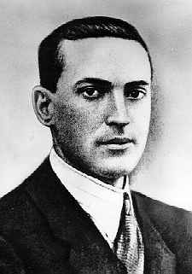
Figure 1.18- Lev Vygotsky.

Have you ever taught a child to perform a task? Maybe it was brushing their teeth or preparing food. Chances are you spoke to them and described what you were doing while you demonstrated the skill and let them work along with you all through the process. You gave them assistance when they seemed to need it, but once they knew what to do-you stood back and let them go. This is scaffolding and can be seen demonstrated throughout the world. This approach to teaching has also been adopted by educators. Rather than assessing students on what they are doing, they should be understood in terms of what they are capable of doing with the proper guidance. You can see how Vygotsky would be very popular with modern day educators.

Main Points to Note About Vygotsky’s Sociocultural Theory
Vygotsky concentrated on the child’s interactions with peers and adults. He believed that the child was an apprentice, learning through sensitive social interactions with more skilled peers and adults.

Comparing Piaget and Vygotsky
Vygotsky concentrated more on the child’s immediate social and cultural environment and his or her interactions with adults and peers. While Piaget saw the child as actively discovering the world through individual interactions with it, Vygotsky saw the child as more of an apprentice, learning through a social environment of others who had more experience and were sensitive to the child’s needs and abilities.

Like Vygotsky’s, Bronfenbrenner looked at the social influences on learning and development.

Urie Bronfenbrenner’s Ecological Systems Model
Urie Bronfenbrenner (1917-2005) offers us one of the most comprehensive theories of human development. Bronfenbrenner studied Freud, Erikson, Piaget, and learning theorists and believed that all of those theories could be enhanced by adding the dimension of context. What is being taught and how society interprets situations depends on who is involved in the life of a child and on when and where a child lives.

Figure 1.19 - Urie Bronfenbrenner.

Bronfenbrenner’s ecological systems model explains the direct and indirect influences on an individual’s development.

Table 1.5 - Urie Bronfenbrenner’s Ecological Systems Model

Name of System | Description of System
Microsystems | Microsystems impact a child directly. These are the people with whom the child interacts such as parents, peers, and teachers. The relationship between individuals and those around them need to be considered. For example, to appreciate what is going on with a student in math, the relationship between the student and teacher should be known.
Mesosystems | Mesosystems are interactions between those surrounding the individual. The relationship between parents and schools, for example will indirectly affect the child.
Exosystem | Larger institutions such as the mass media or the healthcare system are referred to as the exosystem. These have an impact on families and peers and schools who operate under policies and regulations found in these institutions.
Macrosystems | We find cultural values and beliefs at the level of macrosystems. These larger ideals and expectations inform institutions that will ultimately impact the individual.
Chronosystem | All of this happens in an historical context referred to as the chronosystem. Cultural values change over time, as do policies of educational institutions or governments in certain political climates. Development occurs at a point in time.

For example, in order to understand a student in math, we can’t simply look at that individual and what challenges they face directly with the subject. We have to look at the interactions that occur between teacher and child. Perhaps the teacher needs to make modifications as well. The teacher may be responding to regulations made by the school, such as new expectations for students in math or constraints on time that interfere with the teacher’s ability to instruct. These new demands may be a response to national efforts to promote math and science deemed important by political leaders in response to relations with other countries at a particular time in history.
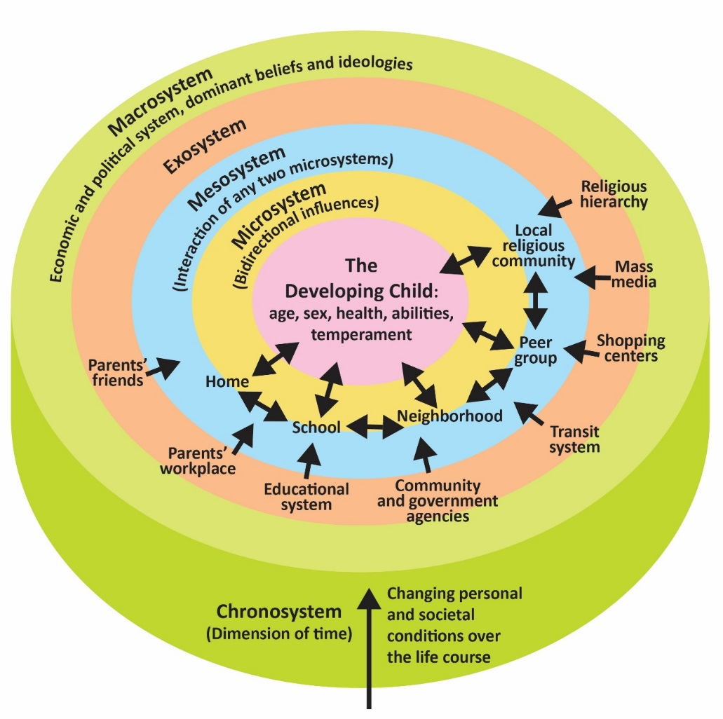
Figure 1.20 - Bronfenbrenner's ecological systems theory.

Bronfenbrenner’s ecological systems model challenges us to go beyond the individual if we want to understand human development and promote improvements.

Main Points to Note About Bronfenbrenner’s Ecological Model
After studying all of the prior theories, Bronfenbrenner added an important element of context to the discussion of influences on human development.

- He believed that the people involved in children’s lives and when and where they live are important considerations.
- He created a model of nested systems that influence the child (and are influenced by the child) that include: microsystems, mesosystems, the exosystem, macrosystems, and chronosystems.

Conclusion
In this chapter we looked at:
- underlying principles of development
- the five periods of development
- three issues in development
- Various methods of research
- important theories that help us understand development

Next, we are going to be examining where we all started with conception, heredity, and prenatal development.

Chapter 2: Conception, Heredity, & Prenatal Development

Chapter Objectives
After this chapter, you should be able to:
- Evaluate roles of nature and nurture in development.
- Define genes and chromosomes.
- Differentiate mitosis and meiosis.
- Explain dominant and recessive patterns on inheritance.
- List common genetic disorders and chromosomal abnormalities.
- Describe changes that occur within each of the three periods of prenatal development.
- Recognize the risks to prenatal development posed by exposure to teratogens.
- Evaluate different types of prenatal assessment.

Introduction
In this chapter, we will begin by examining some of the ways in which heredity helps to shape the way we are. We will look at what happens genetically during conception, and describe some known genetic and chromosomal disorders. Next we will consider what happens during prenatal development, including the impact of teratogens. We will also discuss the impact that both the mother and father have on the developing fetus.

Heredity

Nature and Nurture
Most scholars agree that there is a constant interplay between nature (heredity) and nurture (the environment). It is difficult to isolate the root of any single characteristic as a result solely of nature or nurture, and most scholars believe that even determining the extent to which nature or nurture impacts a human feature is difficult to answer. In fact, almost all human features are polygenic (a result of many genes) and multifactorial (a result of many factors, both genetic and environmental). It’s as if one’s genetic make-up sets up a range of possibilities, which may or may not be realized depending upon one’s environmental experiences. For instance, a person might be genetically predisposed to develop diabetes, but the person’s lifestyle may determine whether or not they actually develop the disease.

This bidirectional interplay between nature and nurture is the epigenetic framework, which suggests that the environment can affect the expression of genes just as genetic predispositions can impact a person’s potentials. And environmental circumstances can trigger symptoms of a genetic disorder.

Environment Correlations
Environment Correlations refer to the processes by which genetic factors contribute to variations in the environment (Plomin, DeFries, Knopik, & Neiderhiser, 2013). There are three types of genotype-environment correlations:

Passive genotype-environment correlation occurs when children passively inherit the genes and the environments their family provides. Certain behavioral characteristics, such as being athletically inclined, may run in families. The children have inherited both the genes that would enable success at these activities, and given the environmental encouragement to engage in these actions.

Figure 2.1 – Two skiers.

Evocative genotype-environment correlation refers to how the social environment reacts to individuals based on their inherited characteristics. For example, whether one has a more outgoing or shy temperament will affect how he or she is treated by others.

Active genotype-environment correlation occurs when individuals seek out environments that support their genetic tendencies. This is also referred to as niche picking. For example, children who are musically inclined seek out music instruction and opportunities that facilitate their natural musical ability.

Conversely, Genotype-Environment Interactions involve genetic susceptibility to the environment. Adoption studies provide evidence for genotype-environment interactions. For example, the Early Growth and Development Study (Leve, Neiderhiser, Scaramella, & Reiss, 2010) followed 360 adopted children and their adopted and biological parents in a longitudinal study. Results have shown that children whose biological parents exhibited psychopathology, exhibited significantly fewer behavior problems when their adoptive parents used more structured parenting than unstructured. Additionally, elevated psychopathology in adoptive parents increased the risk for the children’s development of behavior problems, but only when the biological parents’ psychopathology was high. Consequently, the results show how environmental effects on behavior differ based on the genotype, especially stressful environments on genetically at-risk children.

Genes and Chromosomes
Now, let’s look more closely at just nature. Nature refers to the contribution of genetics to one’s development. The basic building block of the nature perspective is the gene. Genes are recipes for making proteins, while proteins influence the structure and functions of cells. Genes are located on the chromosomes and there are an estimated 20,500 genes for humans, according to the Human Genome Project (NIH, 2015).

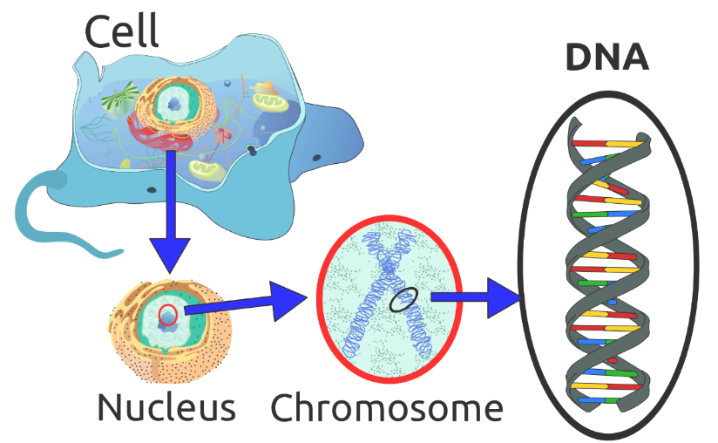
Figure 2.2 – DNA’s location in the cell.

Normal human cells contain 46 chromosomes (or 23 pairs; one from each parent) in the nucleus of the cells. After conception, most cells of the body are created by a process called mitosis. Mitosis is defined as the cell’s nucleus making an exact copy of all the chromosomes and splitting into two new cells.

However, the cells used in sexual reproduction, called the gametes (sperm or ova), are formed in a process called meiosis. In meiosis, the gamete’s chromosomes duplicate, and then divide twice resulting in four cells containing only half the genetic material of the original gamete. Thus, each sperm and egg possesses only 23 chromosomes and combine to produce the normal 46.

Table 2.1 - Mitosis & Meiosis

Type of Cell Division | Explanation | Steps
Mitosis | All cells, except those used in sexual reproduction, are created by mitosis | - Chromosomes make a duplicate copy
 |  | - Two identical cells are created
Meiosis | Cells used in sexual reproduction are created by meiosis | - Exchange of gene between the chromosomes (crossing over)
 |  | - Chromosomes make a duplicate
 |  | - First cell division
 |  | - Second cell division

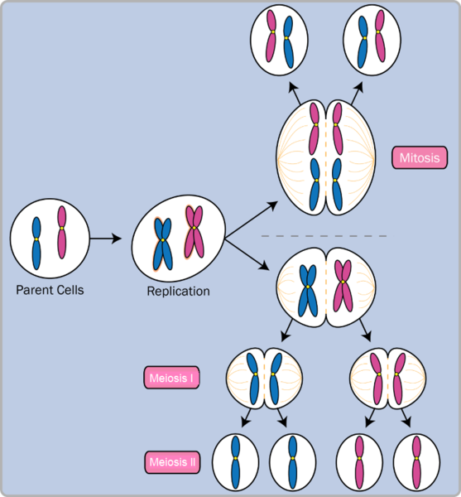
Figure 2.3 – Mitosis and Meiosis.

Given the amount of genes present and the unpredictability of the meiosis process, the likelihood of having offspring that are genetically identical (and not twins) is one in trillions (Gould & Keeton, 1997).

Of the 23 pairs of chromosomes created at conception, 22 pairs are similar in length. These are called autosomes. The remaining pair, or sex chromosomes, may differ in length. If a child receives the combination of XY, the child will be genetically male. If the child receives the combination XX, the child will be genetically female.

Here is an image (called a karyogram) of what the 23 pairs of chromosomes look like. Notice the differences between the sex chromosomes in female (XX) and male (XY).

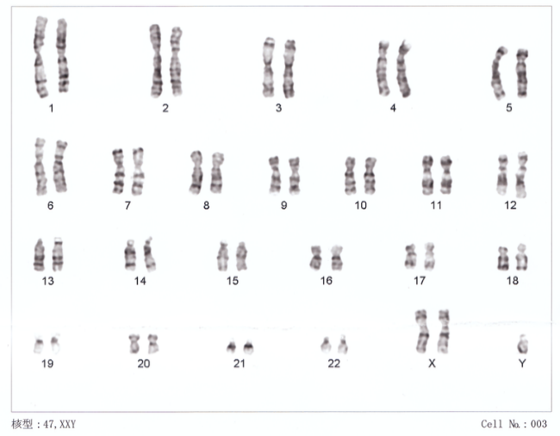
Figure 2.4 – The 23 pairs of chromosomes.

Genotypes and Phenotypes & Patterns on Inheritance
The word genotype refers to the sum total of all the genes a person inherits. The word phenotype refers to the features that are actually expressed. Look in the mirror. What do you see, your genotype or your phenotype? What determines whether or not genes are expressed?
Because genes are inherited in pairs on the chromosomes, we may receive either the same version of a gene from our mother and father, that is, be homozygous for that characteristic the gene influences. If we receive a different version of the gene from each parent, that is referred to as heterozygous.

In the homozygous situation we will display that characteristic. It is in the heterozygous condition that it becomes clear that not all genes are created equal. Some genes are dominant, meaning they express themselves in the phenotype even when paired with a different version of the gene, while their silent partner is called recessive. Recessive genes express themselves only when paired with a similar version gene. Geneticists refer to different versions of a gene as alleles. Some dominant traits include having facial dimples, curly hair, normal vision, and dark hair. Some recessive traits include red hair, being nearsighted, and straight hair.

Most characteristics are not the result of a single gene; they are polygenic, meaning they are the result of several genes. In addition, the dominant and recessive patterns described above are usually not that simple either. Sometimes the dominant gene does not completely suppress the recessive gene; this is called incomplete dominance.

Genetic Disorders
Most of the known genetic disorders are dominant gene-linked; however, the vast majority of dominant gene linked disorders are not serious or debilitating. For example, the majority of those with Tourette's Syndrome suffer only minor tics from time to time and can easily control their symptoms. When dominant-gene linked diseases are serious, they do not tend to become symptomatic until later in life. Huntington's Disease is a dominant gene linked disorder that affects the nervous system and is fatal, but does not appear until midlife.

Recessive gene disorders, such as cystic fibrosis and sickle-cell anemia, are less common but may actually claim more lives because they are less likely to be detected as people are unaware that they are carriers of the disease.

Some genetic disorders are sex-linked; the defective gene is found on the X-chromosome. Males have only one X chromosome so are at greater risk for sex-linked disorders due to a recessive gene such as hemophilia, color-blindness, and baldness. For females to be affected by recessive genetic defects, they need to inherit the recessive gene on both X-chromosomes. But if the defective gene is dominant, females are equally at risk.

Here are tables of some genetic disorders:

Recessive Disorders (Homozygous): The individual inherits a gene change from both parents. If the gene is inherited from just one parent, the person is a carrier and does not have the condition.

Table 2.2 - Recessive Disorders (Homozygous)

Disorder | Description | Cases per Birth
Sickle Cell Disease (SCD) | A condition in which the red blood cells in the body are shaped like a sickle (like the letter C) and affect the ability of the blood to transport oxygen. | 1 in 500 Black births  1 in 36,000 Hispanic births
Cystic Fibrosis (CF) | A condition that affects breathing and digestion due to thick mucus building up in the body, especially the lungs and digestive system. In CF, the mucus is thicker than normal and sticky. | 1 in 3500
Phenylketonuria (PKU) | A metabolic disorder in which the individual cannot metabolize phenylalanine, an amino acid. Left untreated, intellectual deficits occur. PKU is easily detected and is treated with a special diet. | 1 in 10,000
Tay Sachs Disease | Caused by an enzyme deficiency resulting in the accumulation of lipids in the nerves cells of the brain. This accumulation results in progressive damage to the cells and a decrease in cognitive and physical development. Death typically occurs by age five. | 1 in 4000  1 in 30 American Jews is a carrier  1 in 20 French Canadians is a carrier
Albinism | When the individual lacks melanin and processes little to no pigment in the skin, hair, and eyes. Vision problems can also occur. | Fewer than 20,000 US cases per year

Autosomal Dominant Disorders (Heterozygous): In order to have the disorder, the individual only needs to inherit the gene change from one parent.

Table 2.3 - Autosomal Dominant Disorders (Heterozygous)

Disorder | Description | Cases per Birth
Huntington’s Disease | A condition that affects the individual’s nervous system. Nerve cells become damaged, causing various parts of the brain to deteriorate. The disease affects movement, behavior and cognition. It is fatal, and occurs at midlife. | 1 in 10,000
Tourette Syndrome | A tic disorder which results in uncontrollable motor and vocal tics as well as body jerking | 1 in 250
Achondroplasia | The most common form of disproportionate short stature. The individual has abnormal bone growth resulting in short stature, disproportionately short arms and legs, short fingers, a large head, and specific facial features. | 1 in 15,000-40,000

Sex-Linked Disorders: When the X chromosome carries the mutated gene, the disorder is referred to as an X-linked disorder. Males are more affected than females because they possess only one X chromosome without an additional X chromosome to counter the harmful gene.

Table 2.4 - Sex-Linked Disorders

Disorder | Description | Cases per Birth
Fragile X Syndrome | Occurs when the body cannot make enough of a protein it needs for the brain to grow and problems with learning and behavior can occur. Fragile X syndrome is caused from an abnormality in the X chromosome, which then breaks. If a female has a fragile X, her second X chromosome usually is healthy, but males with fragile X don’t have a second healthy X chromosome. This is why symptoms of Fragile X usually are more serious in males. | 1 in 4000 males  1 in 8000 females
Hemophilia | Occurs when there are problems in blood clotting causing both internal and external bleeding. | 1 in 10,000 males
Duchenne Muscular Dystrophy | A weakening of the muscles resulting in an inability to move, wasting away, and possible death. | 1 in 3500 males

Chromosomal Abnormalities: A chromosomal abnormality occurs when a child inherits too many or two few chromosomes. The most common cause of chromosomal abnormalities is the age of the mother. As the mother ages, the ovum is more likely to suffer abnormalities due to longer term exposure to environmental factors. Consequently, some gametes do not divide evenly when they are forming. Therefore, some cells have more than 46 chromosomes. In fact, it is believed that close to half of all zygotes have an odd number of chromosomes. Most of these zygotes fail to develop and are spontaneously aborted by the mother’s body.

Here is a table of some autosomal chromosomal disorders:

Autosomal Chromosome Disorders: The individual inherits too many or two few chromosomes.

Table 2.5 - Autosomal Chromosomal Disorders

Disorder | Description
Down Syndrome/Trisomy 21 | Caused by an extra chromosome 21 and includes a combination of birth defects. Affected individuals have some degree of intellectual disability, characteristic facial features, often heart defects, and other health problems. The severity varies greatly among affected individuals.
Trisomy 9 Mosaicism | Caused by having an extra chromosome 9 in some cells. The severity of effects relates to the proportion of cells with extra chromosomes. The effects include fetal growth restriction resulting in low birth weight and multiple anomalies, including facial, cardiac, musculoskeletal, genital, kidney, and respiratory abnormalities.
Trisomy 13 | Caused by an extra chromosome 13. Affected individuals have multiple birth defects and generally die in the first weeks or months of life.
Trisomy 18 | Caused by an extra chromosome 18 and the affected individual also has multiple birth defects and early death.

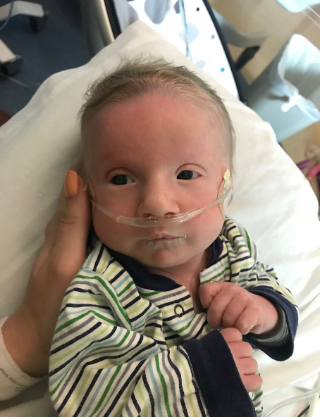 | 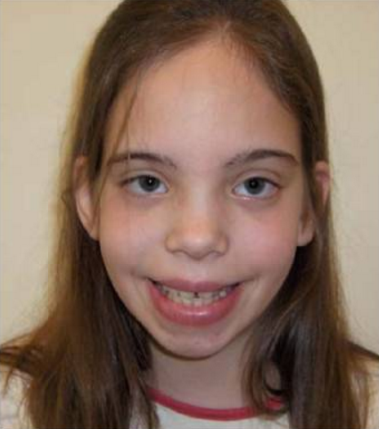
Figure 2.5 - Infant boy with Trisomy 9 Mosaicism. | Figure 2.6 - Girl with XXX Syndrome.

When the abnormality is on 23rd pair, the result is a sex-linked chromosomal abnormality. This happens when a person has less than or more than two sex chromosomes.

Here is a table of some sex-linked chromosomal disorders:

Table 2.6 - Sex-Linked Chromosomal Disorders

Disorder | Description
Turner Syndrome (XO) | Caused when all or part of one of the X chromosomes is lost before or soon after conception due to a random event. The resulting zygote has an XO composition. Turner Syndrome affects cognitive functioning and sexual maturation in girls. Infertility and a short stature may be noted.
Klinefelter Syndrome (XXY) | Caused when an extra X chromosome is present in the cells of a male due to a random event. The Y chromosome stimulates the growth of male genitalia, but the additional X chromosome inhibits this development. The male can have some breast development, infertility, and low levels of testosterone.
XYY Syndrome | Caused when an extra Y chromosome is present in the cells of a male. There are few symptoms. They may include being taller than average, acne, and an increased risk of learning problems. The person is generally otherwise normal, including normal fertility.
Triple X Syndrome (XXX) | Caused when an extra X chromosome is present in the cells of a female. It may result in being taller than average, learning difficulties, decreased muscle tone, seizures, and kidney problems.

Prenatal Development
Now we turn our attention to prenatal development which is divided into three periods: The germinal period, the embryonic period, and the fetal period. The following is an overview of some of the changes that take place during each period.

The Germinal Period
The germinal period (about 14 days in length) lasts from conception to implantation of the fertilized egg in the lining of the uterus. At ejaculation millions of sperm are released into the vagina, but only a few reach the egg and typically only one fertilizes the egg. Once a single sperm has entered the wall of the egg, the wall becomes hard and prevents other sperm from entering. After the sperm has entered the egg, the tail of the sperm breaks off and the head of the sperm, containing the genetic information from the father, unites with the nucleus of the egg. It is typically fertilized in the top section of the fallopian tube and continues its journey to the uterus. As a result, a new cell is formed. This cell, containing the combined genetic information from both parents, is referred to as a zygote.

Figure 2.7 - Sperm and ovum at conception.

During this time, the organism begins cell division through mitosis. After five days of mitosis there are 100 cells, which is now called a blastocyst. The blastocyst consists of both an inner and outer group of cells. The inner group of cells, or embryonic disk will become the embryo, while the outer group of cells, or trophoblast, becomes the support system which nourishes the developing organism. This stage ends when the blastocyst fully implants into the uterine wall (U.S. National Library of Medicine, 2015).
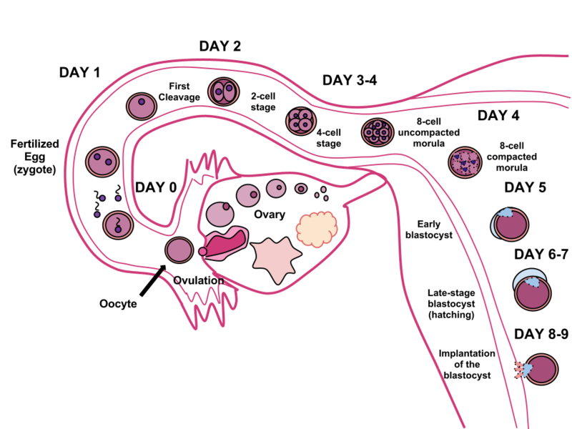
Figure 2.8 – The cycle of fertilization.

Mitosis is a fragile process and fewer than one half of all zygotes survive beyond the first two weeks (Hall, 2004). Some of the reasons for this include: the egg and sperm do not join properly, thus their genetic material does not combine, there is too little or damaged genetic material, the zygote does not replicate, or the blastocyst does not implant into the uterine wall. The failure rate is higher for in vitro conceptions. The figure below illustrates the journey of the ova from its release to its fertilization, cell duplication, and implantation into the uterine lining.

The Embryonic Period
Starting the third week, the blastocyst has implanted in the uterine wall. Upon implantation this multi-cellular organism is called an embryo. Now blood vessels grow forming the placenta. The placenta is a structure connected to the uterus that provides nourishment and oxygen from the mother to the developing embryo via the umbilical cord.

During this period, cells continue to differentiate. Growth during prenatal development occurs in two major directions: from head to tail called cephalocaudal development and from the midline outward referred to as proximodistal development. This means that those structures nearest the head develop before those nearest the feet and those structures nearest the torso develop before those away from the center of the body (such as hands and fingers). You will see that this pattern continues after birth.

The head develops in the fourth week and the precursor to the heart begins to pulse. In the early stages of the embryonic period, gills and a tail are apparent. However, by the end of this stage they disappear and the organism takes on a more human appearance.

Figure 2.9 – A human embryo.

About 20 percent of organisms fail during the embryonic period, usually due to gross chromosomal abnormalities, often before the mother even knows that she is pregnant. It is during this stage that the major structures of the body are taking form, making the embryonic period the time when the organism is most vulnerable to the greatest amount of damage if exposed to harmful substances. Prospective mothers are not often aware of the risks they introduce to the developing embryo during this time. The embryo is approximately 1 inch in length and weighs about 4 grams at the end of eight weeks. The embryo can move and respond to touch at this time.

The Fetal Period
From the ninth week until birth (which is forty weeks for a full-term pregnancy), the organism is referred to as a fetus. During this stage, the major structures are continuing to develop. By the third month, the fetus has all its body parts including external genitalia. The fetus is about 3 inches long and weighs about 28 grams. In the following weeks, the fetus will develop hair, nails, teeth and the excretory and digestive systems will continue to develop.

Figure 2.10 – A human fetus.

During the 4th - 6th months, the eyes become more sensitive to light and hearing develops. The respiratory system continues to develop, and reflexes such as sucking, swallowing and hiccupping, develop during the 5th month. Cycles of sleep and wakefulness are present at this time as well. The first chance of survival outside the womb, known as the age of viability is reached at about 24 weeks (Morgan, Goldenberg, & Schulkin, 2008). Many practitioners hesitate to resuscitate before 24 weeks. The majority of the neurons in the brain have developed by 24 weeks, although they are still rudimentary, and the glial or nurse cells that support neurons continue to grow. At 24 weeks the fetus can feel pain (Royal College of Obstetricians and Gynecologists, 1997).

Between the 7th - 9th months, the fetus is primarily preparing for birth. It is exercising its muscles and its lungs begin to expand and contract. The fetus gains about 5 pounds and 7 inches during this last trimester of pregnancy, and during the 8th month a layer of fat develops under the skin. This layer of fat serves as insulation and helps the baby regulate body temperature after birth.

At around 36 weeks the fetus is almost ready for birth. It weighs about 6 pounds and is about 18.5 inches long. By week 37 all of the fetus’s organ systems are developed enough that it could survive outside the mother’s uterus without many of the risks associated with premature birth. The fetus continues to gain weight and grow in length until approximately 40 weeks. By then the fetus has very little room to move around and birth becomes imminent. The progression through the stages is shown in the following figure.

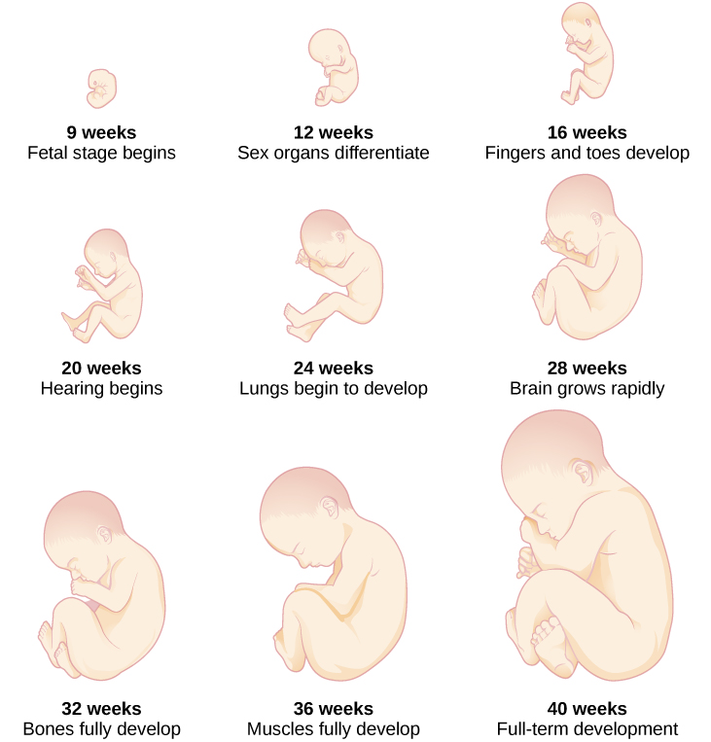
Figure 2.11 – The development of a fetus.
Monozygotic and Dizygotic Twins
Monozygotic or identical twins occur when a fertilized egg splits apart in the first two weeks of development. The result is the creation of two separate, but genetically identical offspring. That is, they possess the same genotype and often the same phenotype. About one-third of twins are monozygotic twins.

Sometimes, however, two eggs or ova are released and fertilized by two separate sperm. The result is dizygotic or fraternal twins. These two individuals share the same amount of genetic material as would any two children from the same mother and father. In other words, they possess a different genotype and phenotype.

Older mothers are more likely to have dizygotic twins than are younger mothers, and couples who use fertility drugs are also more likely to give birth to dizygotic twins.

Monozygotic Twins | Dizygotic Twins
Figure 2.12 | Figure 2.13

Teratogens
Good prenatal care is essential to protect against maternal and fetal/infant mortality and birth complications. The embryo and fetus is most at risk for some of the most severe problems during the first three months of development. Unfortunately, this is a time at which many mothers are unaware that they are pregnant. Today, we know many of the factors that can jeopardize the health of the developing child. The study of factors that contribute to birth defects is called teratology. Teratogens are environmental factors that can contribute to birth defects, and include some maternal diseases, pollutants, drugs and alcohol.
Factors influencing prenatal risks: There are several considerations in determining the type and amount of damage that might result from exposure to a particular teratogen (Berger, 2005). These include:
- The timing of the exposure: Structures in the body are vulnerable to the most severe damage when they are forming. If a substance is introduced during a particular structure's critical period (time of development), the damage to that structure may be greater. For example, the ears and arms reach their critical periods at about 6 weeks after conception. If a mother exposes the embryo to certain substances during this period, the arms and ears may be malformed. (see figure below)
- The amount of exposure: Some substances are not harmful unless the amounts reach a certain level. The critical level depends in part on the size and metabolism of the mother.
- The number of teratogens: Fetuses exposed to multiple teratogens typically have more problems than those exposed to only one.
- Genetics: Genetic makeup also plays a role on the impact a particular teratogen might have on the child. This is suggested by fraternal twins exposed to the same prenatal environment, but they do not experience the same teratogenic effects. The genetic makeup of the mother can also have an effect; some mothers may be more resistant to teratogenic effects than others.
- Being male or female: Males are more likely to experience damage due to teratogens than are females. It is believed that the Y chromosome, which contains fewer genes than the X, may have an impact.

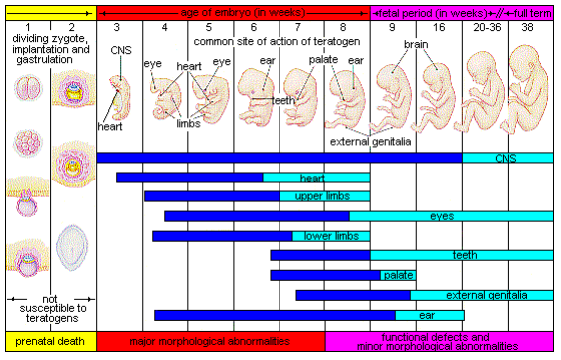
Figure 2.14 – The development of an embryo into a fetus.
There are four categories of teratogens:
- Physical teratogens: These could be saunas, hot tubs, or infections that raise a pregnant woman's body temperature to 102 degrees Fahrenheit or higher. This is associated with neural tube defects, spontaneous abortions, and various cardiovascular abnormalities.
- Metabolic conditions affecting pregnant females: Metabolic conditions are abnormalities in the chemical process of producing energy from food, and thereby affect the development and function of the body. If a pregnant woman is malnourished, then her fetus likely lacks the nutrients essential for its development. These include: malnutrition, diabetes, and thyroid disorders.
- Infections: Different maternal infections, including rubella virus, herpes simplex virus, and syphilis can cause congenital abnormalities in fetuses.
- Drugs and chemicals: When pregnant females ingest or absorb these, they may cause a variety of different effects based on specific agent, amount of exposure, and timing. This category includes: radiation, heavy metals (including lead), insecticides and herbicides, prescription and over the counter drugs, illicit and recreational drugs, alcohol, cigarettes, nicotine, caffeine, and even some vitamins.

While there are many, many potential teratogens, the following tables look at the effects of some different types of teratogens. The risks of exposure vary based on lifestyle and health. The effects may vary greatly depending on the factors mentioned previously. Protection and prevention will vary based on the method of exposure.

Table 2.7 – Drugs as Teratogens

Teratogen | Potential Effects
Caffeine | Moderate amounts of caffeine (200 mg or around 12 ounces of coffee) appear to be safe during pregnancy. Some studies have shown a link between higher amounts of caffeine and miscarriage and preterm birth.
Tobacco | Tobacco use has been associated with low birth weight, placenta previa, preterm delivery, fetal growth restriction, sudden infant death syndrome, cleft lip or palate, and later health problems (such as high blood pressure and diabetes).
Alcohol | There is no safe amount of alcohol a woman can drink while pregnant. Alcohol can slow down the baby's growth, affect the baby's brain, and cause birth defects, and may results in fetal alcohol spectrum disorder (FASD). The effects can be mild to severe. Children born with a severe form of FASD can have abnormal facial features, severe learning disabilities, behavioral problems, and other problems.
Cocaine | Cocaine use has connected with low birth weight, stillbirths, spontaneous abortion, placental abruption, premature birth, miscarriage, and neonatal abstinence syndrome (fetal addiction leads the newborn to experiences withdrawal).
Marijuana | No amount of marijuana has been proven safe to use during pregnancy. Heavy use has been associated with brain damage, premature birth, and stillbirth.
Heroin | Using heroin during pregnancy can cause birth defects, placental abruption, premature birth, low birthweight, neonatal abstinence syndrome, still birth, and sudden infant death syndrome.
Over-the-Counter (OTC) medication | Some OTC medications are safe to use during pregnancy and others may cause health problems during pregnancy. Pregnant women should consult their health care provider before using OTC medications.
Prescription drugs | Some prescription drugs can cause birth defects that change the shape or function of one or more parts of the body that can affect overall health. Pregnant women should consult their health care provider before discontinuing or starting new medications.
Herbal or dietary supplements | Except for some vitamins, little is known about using herbal or dietary supplements while pregnant. Most often there are no good studies to show if the herb can cause harm to you or your baby. Also, some herbs that are safe when used in small amounts as food might be harmful when used in large amounts as medicines.

Table 2.8 - Environmental Teratogens

Teratogen | Potential Effects
Lead | Exposure to high levels of lead before and during pregnancy can lead to high blood pressure, problems with fetal brain and nervous system development, premature birth, low birthweight, and miscarriage.
Mercury | Exposure to mercury in the womb can cause brain damage and hearing and vision problems.
Radiation | Exposure to radiation during pregnancy (especially between 2 and 18 weeks of pregnancy) can slow growth, cause birth defects, affect brain development, cause cancer, and cause miscarriage.
Solvents | These chemicals include degreasers, paint thinners, stain and varnish removers, paints, and more Maternal inhalation of solvents can cause fetal exposure than may cause miscarriage, slow fetal growth, premature birth, and birth defects.

Table 2.9 - Maternal Infections as Teratogens

Teratogen | Potential Effects
Rubella | Congenital infection (becoming infected while in the womb) can damage the development of the eyes, ears, heart, and brain and result in deafness.
Zika | Congenital infection can cause microcephaly and other severe brain abnormalities.
Varicella (chicken pox) | Congenital infection can cause a severe form of the infection affecting the eyes, limbs, skin, and central nervous system.
Sexually transmitted infections | Infections such as HIV, gonorrhea, syphilis, and chlamydia can be passed from the mother during pregnancy and/or delivery.
Listeria | Pregnant women are more susceptible to this food-borne illness. Congenital infection can cause miscarriage, stillbirth, premature labor, and neonatal sepsis.

Figure 2.10 - Teratogens from Animals/Pets

Teratogen | Potential Effects
Toxoplamosis | This parasite can be passed through cat feces and undercooked meat (especially pork, lamb, or deer meet). If the fetus is infected it can cause miscarriage, stillbirth, hydrocephalus, macro or microcephalus, vision issues, and damage to the nervous system.
Lymphocytic choriomeningitis | This virus carried by rodents including mice, hamsters, and guinea pigs. If an infected mother passes it to her fetus it can cause issues with brain development, long-term neurological and/or visual impairment, and higher mortality rates after birth.

Maternal Factors
There are additional factors that affect the outcome of pregnancy for both mother and child. Let’s look at these next.

Figure 2.15 – A pregnant woman relaxing in a tub.

Mothers over 35
Most women over 35 who become pregnant are in good health and have healthy pregnancies. However, according to the March of Dimes (2016d), women over age 35 are more likely to have an increased risk of:
- Fertility problems
- High blood pressure
- Diabetes
- Miscarriages
- Placenta Previa
- Cesarean section
- Premature birth
- Stillbirth
- A baby with a genetic disorder or other birth defects

Because a woman is born with all her eggs, environmental teratogens can affect the quality of the eggs as women get older. Also, a woman’s reproductive system ages which can adversely affect the pregnancy. Some women over 35 choose special prenatal screening tests, such as a maternal blood screening, to determine if there are any health risks for the baby.

Although there are medical concerns associated with having a child later in life, there are also many positive consequences to being a more mature parent. Older parents are more confident, less stressed, and typically married, providing family stability. Their children perform better on math and reading tests, and they are less prone to injuries or emotional troubles (Albert, 2013). Women who choose to wait are often well educated and lead healthy lives. According to Gregory (2007), older women are more stable, demonstrate a stronger family focus, possess greater self-confidence, and have more money. Having a child later in one’s career equals overall higher wages. In fact, for every year a woman delays motherhood, she makes 9% more in lifetime earnings. Lastly, women who delay having children actually live longer.

Teenage Pregnancy
A teenage mother is at a greater risk for having pregnancy complications including anemia, and high blood pressure. These risks are even greater for those under age 15. Infants born to teenage mothers have a higher risk for being premature and having low birthweight or other serious health problems. Premature and low birthweight babies may have organs that are not fully developed which can result in breathing problems, bleeding in the brain, vision loss, serious intestinal problems, and higher likelihood of dying. Reasons for these health issues include that teenagers are the least likely of all age groups to get early and regular prenatal care and they may engage in negative behaviors including eating unhealthy food, smoking, drinking alcohol, and taking drugs.

Gestational Diabetes
Seven percent of pregnant women develop gestational diabetes (March of Dimes, 2015b). Diabetes is a condition where the body has too much glucose in the bloodstream.

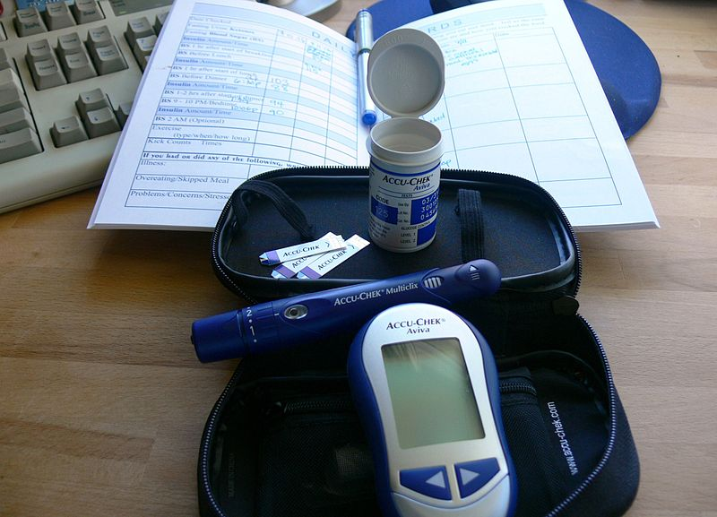
Figure 2.16 – A gestational diabetes kit.
Most pregnant women have their glucose level tested between 24 to 28 weeks of pregnancy. Gestational diabetes usually goes away after the mother gives birth, but it might indicate a risk for developing diabetes later in life. If untreated, gestational diabetes can cause premature birth, stillbirth, the baby having breathing problems at birth, jaundice, or low blood sugar. Babies born to mothers with gestational diabetes can also be considerably heavier (more than 9 pounds) making the labor and birth process more difficult. For expectant mothers, untreated gestational diabetes can cause preeclampsia (high blood pressure and signs that the liver and kidneys may not be working properly) discussed later in the chapter.

Risk factors for gestational diabetes include age (being over age 25), being overweight or gaining too much weight during pregnancy, family history of diabetes, having had gestational diabetes with a prior pregnancy, and race and ethnicity (African-American, Native American, Hispanic, Asian, or Pacific Islander have a higher risk). Eating healthy and maintaining a healthy weight during pregnancy can reduce the chance of gestational diabetes. Women who already have diabetes and become pregnant need to attend all their prenatal care visits, and follow the same advice as those for women with gestational diabetes as the risk of preeclampsia, premature birth, birth defects, and stillbirth are the same.

High Blood Pressure (Hypertension)
Hypertension is a condition in which the pressure against the wall of the arteries becomes too high. There are two types of high blood pressure during pregnancy, gestational and chronic. Gestational hypertension only occurs during pregnancy and goes away after birth. Chronic high blood pressure refers to women who already had hypertension before the pregnancy or to those who developed it during pregnancy and it did not go away after birth.

Figure 2.17 – A woman having her blood pressure taken.

According to the March of Dimes (2015c), about 8 in every 100 pregnant women have high blood pressure. High blood pressure during pregnancy can cause premature birth and low birth weight (under five and a half pounds), placental abruption, and mothers can develop preeclampsia.

Rh Disease
Rh is a protein found in the blood. Most people are Rh positive, meaning they have this protein. Some people are Rh negative, meaning this protein is absent. Mothers who are Rh negative are at risk of having a baby with a form of anemia called Rh disease (March of Dimes, 2009). A father who is Rh-positive and mother who is Rh-negative can conceive a baby who is Rh-positive. Some of the fetus’s blood cells may get into the mother’s bloodstream and her immune system is unable to recognize the Rh factor.

The immune system starts to produce antibodies to fight off what it thinks is a foreign invader. Once her body produces immunity, the antibodies can cross the placenta and start to destroy the red blood cells of the developing fetus. As this process takes time, often the first Rh positive baby is not harmed, but as the mother’s body will continue to produce antibodies to the Rh factor across her lifetime, subsequent pregnancies can pose greater risk for an Rh positive baby. In the newborn, Rh disease can lead to jaundice, anemia, heart failure, brain damage and death.

Weight Gain during Pregnancy
According to March of Dimes (2016f), during pregnancy most women need only an additional 300 calories per day to aid in the growth of the fetus. Gaining too little or too much weight during pregnancy can be harmful. Women who gain too little may have a baby who is low-birth weight, while those who gain too much are likely to have a premature or large baby. There is also a greater risk for the mother developing preeclampsia and diabetes, which can cause further problems during the pregnancy.

The table below shows the healthy weight gain during pregnancy. Putting on the weight slowly is best. Mothers who are concerned about their weight gain should talk to their health care provider.

Table 2.10 - Weight Gain during Pregnancy

If you were a healthy weight before pregnancy: | If you were underweight before pregnancy: | If you were overweight before pregnancy: | If you were obese before pregnancy:
- Gain 25-35 pounds  - 1-4½ pounds in the 1st trimester  - 1 pound per week in the 2nd and 3rd trimesters | - Gain 28-30 pounds  - 1-4½ pounds in the 1st trimester  - A little more than 1 pound per week thereafter | - Gain 12-25 pounds  - 1-4½ pounds in the 1st trimester  - A little more than ½ pound per week in 2nd and 3rd trimesters | - 11-20 pounds  - 1-4½ pounds in the 1st trimester  - A little more than ½ pound per week in 2nd and 3rd trimesters
Mothers of twins or higher order multiples need to gain more in each category.

Stress
Feeling stressed is common during pregnancy, but high levels of stress can cause complications including having a premature baby or a low-birthweight baby. Babies born early or too small are at an increased risk for health problems. Stress-related hormones may cause these complications by affecting a woman’s immune systems resulting in an infection and premature birth. Additionally, some women deal with stress by smoking, drinking alcohol, or taking drugs, which can lead to problems in the pregnancy. High levels of stress in pregnancy have also been correlated with problems in the baby’s brain development and immune system functioning, as well as childhood problems such as trouble paying attention and being afraid (March of Dimes, 2012b).

Depression
Depression is a significant medical condition in which feelings of sadness, worthlessness, guilt, and fatigue interfere with one’s daily functioning. Depression can occur before, during, or after pregnancy, and 1 in 7 women are treated for depression sometime between the year before pregnancy and year after pregnancy (March of Dimes, 2015a). Women who have experienced depression previously are more likely to have depression during pregnancy. Consequences of depression include the baby being born premature, having a low birthweight, being more irritable, less active, less attentive, and having fewer facial expressions.

About 13% of pregnant women take an antidepressant during pregnancy. It is important that women taking antidepressants during pregnancy discuss the medication with a health care provider as some medications can cause harm to the developing organism.

Paternal Impact
The age of fathers at the time of conception is also an important factor in health risks for children. According to Nippoldt (2015), offspring of men over 40 face an increased risk of miscarriages, autism, birth defects, achondroplasia (bone growth disorder) and schizophrenia. These increased health risks are thought to be due to accumulated chromosomal aberrations and mutations during the maturation of sperm cells in older men (Bray, Gunnell, & Smith, 2006). However, like older women, the overall risks are small.

In addition, men are more likely than women to work in occupations where hazardous chemicals, many of which have teratogenic effects or may cause genetic mutations, are used (Cordier, 2008). These may include petrochemicals, lead, and pesticides that can cause abnormal sperm and lead to miscarriages or diseases. Men are also more likely to be a source of second hand smoke for their developing offspring. As noted earlier, smoking by either the mother or around the mother can hinder prenatal development.
Figure 2.18 – A USDA employee pouring hazardous chemicals into a storage container.

Prenatal Assessment
A number of assessments are suggested to women as part of their routine prenatal care to find conditions that may increase the risk of complications for the mother and fetus (Eisenberg, Murkoff, & Hathaway, 1996). These can include blood and urine analyses and screening and diagnostic tests for birth defects.

Figure 2.19 – A woman receiving an ultrasound.

Ultrasound is one of the main screening tests done in combination with blood tests. The ultrasound is a test in which sound waves are used to examine the fetus. There are two general types. Transvaginal ultrasounds are used in early pregnancy, while transabdominal ultrasounds are more common and used after 10 weeks of pregnancy (typically, 16 to 20 weeks).

Ultrasounds are used to check the fetus for defects or problems. It can also find out the age of the fetus, location of the placenta, fetal position, movement, breathing and heart rate, amount of amniotic fluid in the uterus, and number of fetuses. Most women have at least one ultrasound during pregnancy, but if problems are noted, additional ultrasounds may be recommended.

When diagnosis of a birth defect is necessary, ultrasounds help guide the more invasive diagnostic tests of amniocentesis and chorionic villus sampling. Amniocentesis is a procedure in which a needle is used to withdraw a small amount of amniotic fluid and cells from the sac surrounding the fetus and later tested.
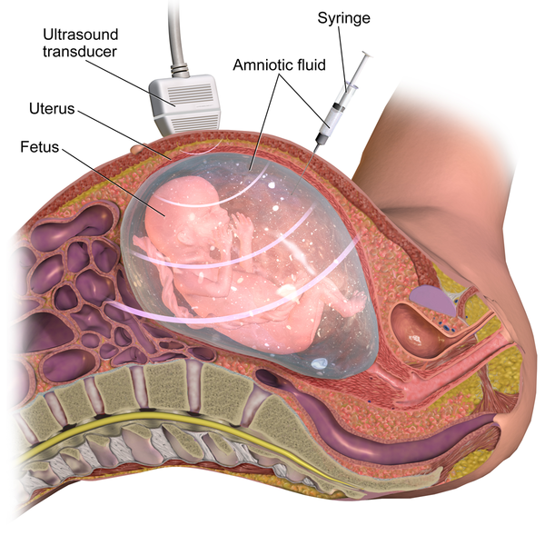
Figure 2.20 – Amniocentesis.

Chorionic Villus Sampling is a procedure in which a small sample of cells is taken from the placenta and tested. Both amniocentesis and chorionic villus sampling have a risk of miscarriage, and consequently they are not done routinely.

Complications of Pregnancy
There are a number of common side effects of pregnancy. Not everyone experiences all of these, nor to the same degree. And although they are considered "minor", this is not to say that these problems are not potentially very uncomfortable. These side effects include nausea (particularly during the first 3-4 months of pregnancy as a result of higher levels of estrogen in the system), heartburn, gas, hemorrhoids, backache, leg cramps, insomnia, constipation, shortness of breath or varicose veins (as a result of carrying a heavy load on the abdomen). These are minor issues.

But there are also serious complications of pregnancy which can pose health risks to mother and child and that often require hospitalization.

Hyperemesis gravidarum is characterized by severe nausea, vomiting, weight loss, and possibly dehydration. Signs and symptoms may also include vomiting many times a day and feeling faint. The exact causes of hyperemesis gravidarum are unknown. Risk factors include the first pregnancy, multiple pregnancy, obesity, prior or family history of HG, trophoblastic disorder, and a history of eating disorders. Treatment includes drinking fluids and a bland diet. Medication, intravenous fluids, and hospitalization may be required. Hyperemesis gravidarum is estimated to affect 0.3–2.0% of pregnant women. Those affected have a low risk of miscarriage but a higher risk of premature birth.

Ectopic Pregnancy occurs when the zygote becomes attached to the fallopian tube before reaching the uterus. About 1 in 50 pregnancies in the United States are tubal pregnancies and this number has been increasing because of the higher rates of pelvic inflammatory disease and Chlamydia (Carroll, 2007). Abdominal pain, vaginal bleeding, nausea and fainting are symptoms of ectopic pregnancy.

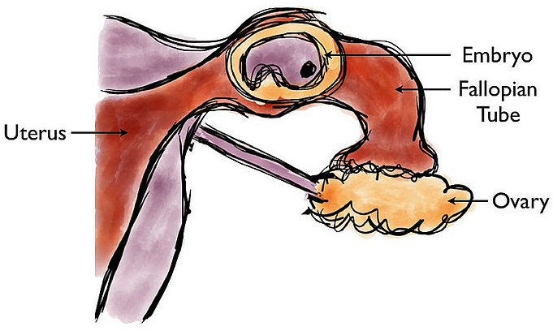
Figure 2.21 – An ectopic pregnancy.

Spontaneous abortion is experienced in an estimated 20-40 percent of undiagnosed pregnancies and in another 10 percent of diagnosed pregnancies. Usually the body aborts due to chromosomal abnormalities, and this typically happens before the 12th week of pregnancy. Cramping and bleeding result and normal periods return after several months. Some women are more likely to have repeated miscarriages due to chromosomal, amniotic, or hormonal problems, but miscarriage can also be a result of defective sperm (Carrell et. al., 2003).

Preeclampsia, also known as Toxemia, is characterized by a sharp rise in blood pressure, a leakage of protein into the urine as a result of kidney problems, and swelling of the hands, feet, and face during the third trimester of pregnancy. Preeclampsia is the most common complication of pregnancy. When preeclampsia causes seizures, the condition is known as eclampsia, which is the second leading cause of maternal death in the United States. Preeclampsia is also a leading cause of fetal complications, which include low birth weight, premature birth, and stillbirth. Treatment is typically bed rest and sometimes medication. If this treatment is ineffective, labor may be induced.

Maternal Mortality: Approximately 1000 women die in childbirth around the world each day (World Health Organization, 2010). Rates are highest in Sub-Saharan Africa and South Asia, although there has been a substantial decrease in these rates. The campaign to make childbirth safe for everyone has led to the development of clinics accessible to those living in more isolated areas and training more midwives to assist in childbirth.

Infertility and Building Families
Infertility
When a couple has failed to conceive a child in a year, they receive the diagnosis of infertility. Infertility affects about 10 to 15 percent of couples in the United States (Mayo Clinic, 2015).
Male factors create infertility in about a third of the cases. For men, the most common cause is a lack of sperm production or low sperm production.

Female factors cause infertility in another third of cases. For women, one of the most common causes of infertility is the failure to ovulate. Another cause of infertility in women is Pelvic Inflammatory Disease (PID), which is an infection of a woman’s reproductive organs (Carroll, 2007).

Both male and female factors contribute to the remainder of cases of infertility.

Options for Building Families
There are numerous options to pursue parenthood and building families. Let’s briefly explore some of these.

Assisted Reproductive Technology
Assisted reproductive technology (ART) is the technology used to achieve pregnancy in procedures such as fertility medication (to stimulate ovulation), surgical procedures, artificial insemination IUI), in vitro fertilization (IVF) and surrogacy. These options are available for people who are experiencing infertility or cannot conceive children naturally (which also includes single parents, and gay/lesbian couples).
Intrauterine insemination: (IUI) as a type of artificial insemination involves the placement of sperm directly into the uterus at the time of ovulation, either in a natural menstrual cycle or following ovarian stimulation.

In vitro fertilization (IVF): IVF generally starts with stimulating the ovaries to increase egg production. Most fertility medications are agents that stimulate the development of follicles in the ovary. Examples are gonadotropins and gonadotropin releasing hormone. After stimulation, the physician surgically extracts one or more eggs from the ovary, and unites them with sperm in a laboratory setting, with the intent of producing one or more embryos. Fertilization takes place outside the body, and the fertilized egg is reinserted into the woman's reproductive tract, in a procedure called embryo transfer.

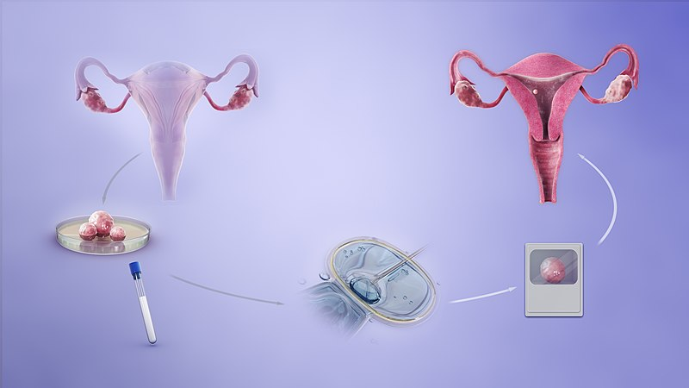
Figure 2.22 – The IVF process.

Donor Gametes & Embryos: People can also use sperm, ova (eggs), and embryos from donors in conjunction with ART. These donations take place through agencies and donor banks or between private individuals. In the U.S., donors can be compensated for their donations.

Surrogacy: In surrogacy, one woman (surrogate mother) carries a child for another person/s (commissioning person/couple), based on a legal agreement before conception requiring the child to be relinquished to the commissioning person/couple following birth. There are different types of surrogacy which relate to whether or not the ova used to conceive the child are her own (traditional surrogacy) or not (gestational surrogacy).
Adoption: People can also choose to pursue adoption to build their families (with or without experiencing infertility). Adoption can take place through the foster care system, privately, or through agencies. Adoptions can be domestic (within the U.S.) or international. And they can be open (with differing amounts of contact between biological/birth families and adoptive families) or closed.

Family Built with Surrogacy | Family Built through Adoption
Figure 2.23 - This same-sex couple used a surrogate. | Figure 2.24 - This single mother adopted her daughter.

Conclusion
In this chapter we looked at:
- Heredity, including genetic disorders and chromosomal abnormalities
- Conception
- The germinal, embryonic, and fetal stages of prenatal development
- Influences on prenatal development including teratogens and maternal and paternal factors
- Complications of pregnancy
- Infertility and options for building families
Now let’s explore birth and the newborn baby.

Chapter 3: Birth and the Newborn

Chapter Objectives
After this chapter, you should be able to:
- Compare and contrast different methods of childbirth preparation.
- Describe the stages of vaginal delivery.
- Explain why induction or Caesarean section may be necessary.
- Differentiate the common procedures for assessing the condition of the newborn.
- Examine problems newborns experience before, during, and after birth.

Introduction
After around 266 days of developing inside the womb (for a full-term pregnancy), comes the arduous process of childbirth. After birth, newborns have to regulate their own body temperature, breathe for themselves, and take in all of their nutrition through feeding. Let’s look at both the process of birth and some attributes of the newborn.

Preparing for Childbirth
Prepared childbirth refers to being not only in good physical condition to help provide a healthy environment for the baby to develop, but also helping individuals to prepare to accept their new roles as parents. Additionally, parents can receive information and training that will assist them for delivery and life with the baby. The more future parents can learn about childbirth and the newborn, the better prepared they will be for the adjustment they must make to a new life.

Approaches to Childbirth
There are many different approaches to childbirth that influence how expectant parents prepare. The following table describes a few of these:

Table 3.1 - Approaches to Childbirth

Method | Description
The Lamaze Method | The emphasis of this method is on teaching the woman to be in control in the process of delivery. It includes learning muscle relaxation, breathing through contractions, having a focal point (usually a picture to look at) during contractions and having a support person who goes through the training process with the mother and serves as a coach during delivery.
The Leboyer Method | This method involves giving birth in a quiet, dimly lit room and allowing the newborn to lie on the mother’s stomach with the umbilical cord intact for several minutes while being given a warm bath.
Dick-Read Method / Mongan Method / Hypnobirthing | This method comes from the suggestion that the fear of childbirth increases tension and makes the process of childbearing more painful. It emphasizes the use of relaxation and proper breathing with contractions as well as family support and education.
Bradley Method | “The Bradley Method focuses on preparing the mother for a natural childbirth coached by her partner. They learn techniques to reduce the perception of pain and stay relaxed. The emphasis is on being prepared for an unassisted vaginal birth without medication.”
Alexander Technique | This is a technique that can be used during childbirth that involves training to stop habitual reactions to pain, such as tensing muscles and increase conscious awareness and control over posture and movement. This involves being able to move freely and stay upright during labor and using body positioning that is beneficial to the labor process.
Waterbirth | Involves immersion in warm water. Proponents believe this method is safe and provides many benefits for both mother and infant, including pain relief and a less traumatic birth experience for the baby. However, critics argue that the procedure introduces unnecessary risks to the infant such as infection and water inhalation.
Lotus Birth | Or umbilical cord nonseverance – UCNS, is the practice of leaving the umbilical cord uncut after childbirth so that the baby is left attached to the placenta until the cord naturally separates at the umbilicus. This usually occurs within 3–10 days after birth. The practice is performed mainly for spiritual purposes of the parents, including for the perceived spiritual connection between placenta and newborn.
Silent Birth | Sometimes known as quiet birth, is a birthing procedure advised by L. Ron Hubbard and advocated by Scientologists in which "everyone attending the birth should refrain from spoken words as much as possible."
Medicated Childbirth | Health care providers can provide pain relief during labor with different types of medication, including epidurals, spinal blocks, combined spinal-epidurals, and systemic and local analgesia. There are benefits and side effects of each.

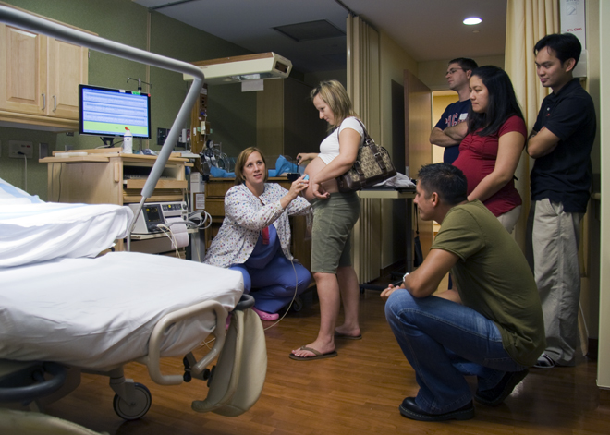
Figure 3.1 - Expectant parents in a childbirth preparation class.

Choosing Location of Childbirth & Who Will Deliver
The vast majority of births occur in a hospital setting. However, one percent of women choose to deliver at home (Martin, Hamilton, Osterman, Curtin, & Mathews, 2015). Women who are at low risk for birth complications can successfully deliver at home. More than half (67%) of home deliveries are by certified nurse midwives. Midwives are trained and licensed to assist in delivery and are far less expensive than the cost of a hospital delivery. However, because of the potential for a complication during the birth process, most medical professionals recommend that delivery take place in a hospital. In addition to home births, one-third of out-of-hospital births occur in freestanding clinics, birthing centers, in physician’s offices, or other locations.

Childbirth

Onset of Labor
Childbirth typically occurs within a week of a woman’s due date, unless the woman is pregnant with more than one fetus, which usually causes her to go into labor early. As a pregnancy progresses into its final weeks, several physiological changes occur in response to hormones that trigger labor.

A common sign that labor is beginning is the so-called “bloody show.” During pregnancy, a plug of mucus accumulates in the cervical canal, blocking the entrance to the uterus. Approximately 1–2 days prior to the onset of true labor, this plug loosens and is expelled, along with a small amount of blood.

As labor nears, the mothers’ pituitary gland produces oxytocin. This begins to stimulate stronger, more painful uterine contractions, which—in a positive feedback loop—stimulate the secretion of prostaglandins from fetal membranes. Like oxytocin, prostaglandins also enhance uterine contractile strength. The fetal pituitary gland also secretes oxytocin, which increases prostaglandins even further.

And the stretching of the cervix by a full-term fetus in the head-down position is regarded as a stimulant to uterine contractions. Combined, these stimulate true labor.

Stages of Birth for Vaginal Delivery

The First Stage
Uterine contractions signify that the first stage of labor has begun. These contractions may initially last about 30 seconds and be spaced 15 to 20 minutes apart. These increase in duration and frequency to more than a minute in length and about 3 to 4 minutes apart. Typically, doctors advise that they be called when contractions are coming about every 5 minutes. Some women experience false labor or Braxton-Hicks Contractions, especially with the first child. These may come and go. They tend to diminish when the mother begins walking around. Real labor pains tend to increase with walking. In one out of 8 pregnancies, the amniotic sac or water in which the fetus is suspended may break before labor begins. In such cases, the physician may induce labor with the use of medication if it does not begin on its own in order to reduce the risk of infection. Normally this sac does not rupture until the later stages of labor.

The first stage of labor is typically the longest. During this stage the cervix or opening to the uterus dilates to 10 centimeters or just under 4 inches. This may take around 12-16 hours for first children or about 6-9 hours for women who have previously given birth. Labor may also begin with a discharge of blood or amniotic fluid.

Figure 3.2 - Early cervical dilation.

The Second Stage
The passage of the baby through the birth canal is the second stage of labor. This stage takes about 10-40 minutes. Contractions usually come about every 2-3 minutes. The mother pushes and relaxes as directed by the medical staff. Normally the head is delivered first. The baby is then rotated so that one shoulder can come through and then the other shoulder. The rest of the baby quickly passes through. At this stage, an episiotomy, or incision made in the tissue between the vaginal opening and anus, may be performed to avoid tearing the tissue of the back of the vaginal opening (Mayo Clinic, 2016). The baby's mouth and nose are suctioned out. The umbilical cord is clamped and cut.

Figure 3.3 - Full dilation and expulsion of the newborn.

The Third Stage
The third and final stage of labor is relatively painless. During this stage, the placenta or afterbirth is delivered. This is typically within 20 minutes after delivery. If an episiotomy was performed it is stitched up during this stage.

Figure 3.4 - delivery of the placenta and associated fetal membranes.

Additional Considerations
More than 50% of women giving birth at hospitals use an epidural anesthesia during delivery (American Pregnancy Association, 2015). An epidural block is a regional analgesic that can be used during labor and alleviates most pain in the lower body without slowing labor. The epidural block can be used throughout labor and has little to no effect on the baby. Medication is injected into a small space outside the spinal cord in the lower back. It takes 10 to 20 minutes for the medication to take effect. An epidural block with stronger medications, such as anesthetics, can be used shortly before a Cesarean Section or if a vaginal birth requires the use of forceps or vacuum extraction.

Women giving birth can also receive other pain medications (although medications given through injection can have negative side effects on the baby). In emergency situations (such as the need for a C-section), women may be given general anesthesia. They can also choose not to utilize any pain medications. That is often referred to as natural childbirth.

Figure 3.5 – Natural childbirth.

Women can also use alternate positions (including standing, squatting, being on hands and knees, and using a birthing stool) and laboring, and even delivering in tubs of warm water to help relieve the pain of childbirth.

Medical Interventions in Childbirth
Sometimes women cannot go into labor on their own and/or deliver vaginally. Let’s look at induction of labor and Cesarean Sections.

Sometimes a baby’s arrival may need to be induced before labor begins naturally. Induction of labor may be recommended for a variety of reasons when there is concern for the health of the mother or baby. For example:
- The mother is approaching two weeks beyond her due date and labor has not started naturally
- The mother’s water has broken, but contractions have not begun
- There is an infection in the mother’s uterus
- The baby has stopped growing at the expected pace
- There is not enough amniotic fluid surrounding the baby
- The placenta peels away, either partially or completely, from the inner wall of the uterus before delivery
- The mother has a medical condition that might put her or her baby at risk, such as high blood pressure or diabetes (Mayo Clinic, 2014).

A Cesarean Section (C-section) is surgery to deliver the baby by being removed through the mother's abdomen. In the United States, about one in three women have their babies delivered this way (Martin et al., 2015). Most C-sections are done when problems occur during delivery unexpectedly. These can include:
- Health problems in the mother
- Signs of distress in the baby
- Not enough room for the baby to go through the vagina
- The position of the baby, such as a breech presentation where the head is not in the downward position.

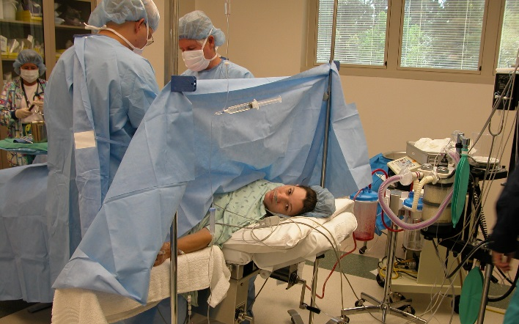 | 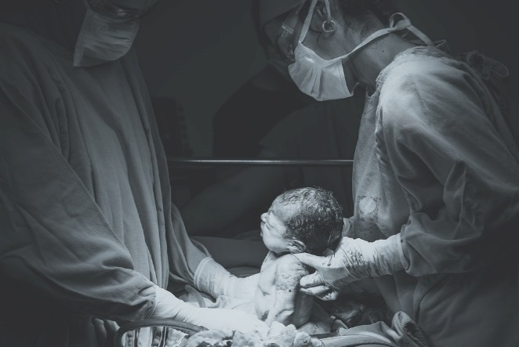
Figure 3.6 – A woman receiving a C-section. | Figure 3.7 – A baby being delivered by C-section.

C-sections are also more common among women carrying more than one baby. Although the surgery is relatively safe for mother and baby, it is considered major surgery and carries health risks. Additionally, it also takes longer to recover from a C-section than from vaginal birth. After healing, the incision may leave a weak spot in the wall of the uterus. This could cause problems with an attempted vaginal birth later. In the past, doctors were hesitant to allow a vaginal birth after a C-section. However, now more than half of women who have a C-section go on to have a vaginal birth later. This is referred to as a Vaginal Birth After Cesarean (VBAC).

The Newborn
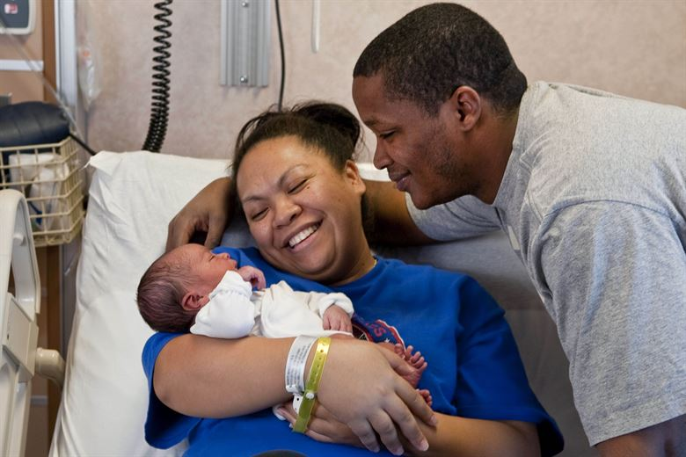
Figure 3.8 – A new mother holding her newborn.

Assessing the Newborn
The Apgar assessment is conducted one minute and five minutes after birth. This is a very quick way to assess the newborn's overall condition. Five measures are assessed: Heart rate, respiration, muscle tone (assessed by touching the baby's palm), reflex response (the Babinski reflex is tested), and color. A score of 0 to 2 is given on each feature examined. An Apgar of 5 or less is cause for concern. The second Apgar should indicate improvement with a higher score.

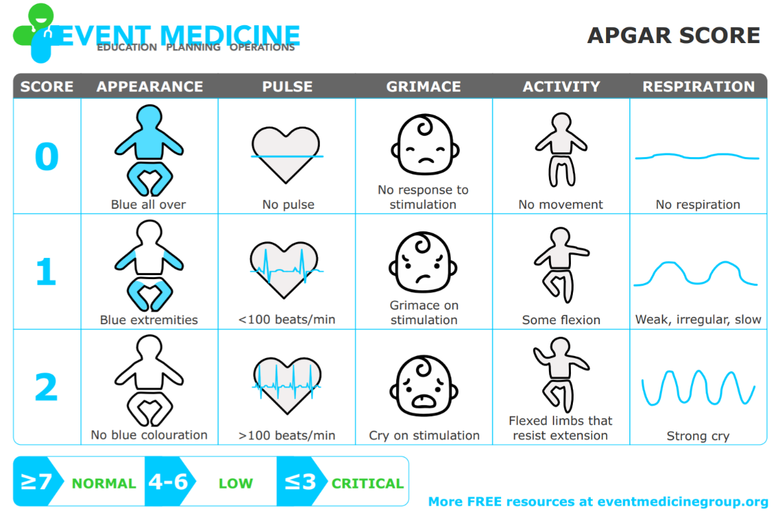
Figure 3.9 – The Apgar assessment.

Another way to assess the condition of the newborn is the Neonatal Behavioral Assessment Scale (NBAS). The baby's motor development, muscle tone, and stress response are assessed. This tool has been used around the world to further assess the newborn, especially those with low Apgar scores, and to make comparisons of infants in different cultures (Brazelton & Nugent, 1995).

Newborns are also routinely screened for different conditions. Within the first 24 to 48 hours after birth, babies born in hospitals undergo a simple heel stick and a few drops of blood are collected on a special paper card. Providers test those dried blood spots for a variety of different congenital disorders, or conditions that are present when the baby is born. In California, newborns are now screened for 80 different genetic and congenital disorders.
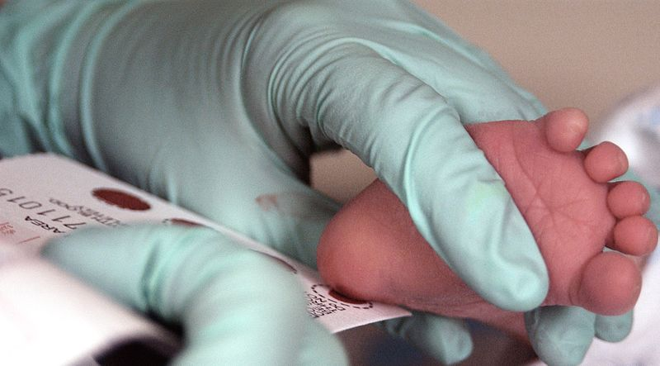
Figure 3.10 – A medical professional performing the heel stick test.

Newborns are also screened for hearing disorders and certain serious heart problems using methods other than dried blood spots.

Problems of the Newborn

Anoxia
Anoxia is a temporary lack of oxygen to the brain. Difficulty during delivery may lead to anoxia which can result in brain damage or in severe cases, death. Babies who suffer both low birth weight and anoxia are more likely to suffer learning disabilities later in life as well.

Low Birth Weight
A child is considered low birth weight if he or she weighs less than 5 pounds 8 ounces (2500 grams). About 8.2 percent of babies born in the United States are of low birth weight (Center for Disease Control, 2015a). Sixty-seven percent of these babies are also preterm.

A low birth weight baby has difficulty maintaining adequate body temperature because it lacks the fat that would otherwise provide insulation. Such a baby is also at more risk for infection.
Very low birth weight babies (2 pounds or less) have an increased risk of developing cerebral palsy. Many causes of low birth weight are preventable with proper prenatal care.

Preterm
A newborn might also have a low birth weight if it is born at less than 37 weeks gestation, which qualifies it as a preterm baby (CDC, 2015c). Early birth can be triggered by anything that disrupts the mother's system. For instance, vaginal infections can lead to premature birth because such infection causes the mother to release anti-inflammatory chemicals which, in turn, can trigger contractions. Smoking and the use of other teratogens can lead to preterm birth. A significant consequence of preterm birth includes respiratory distress syndrome, which is characterized by weak and irregular breathing (see the image below). Premature babies often cannot yet regulate their own temperature or feed by nursing or bottle. They may struggle to regulate their heart rate effectively and may experience jaundice. They often require care in the Neonatal Intensive Care Unit (NICU) until they are as healthy as a full-term baby.

Figure 3.11 - a premature baby on CPAP in the NICU.

Small-for-Date Infants
Infants that have birth weights that are below expectation based on their gestational age are referred to as small-for-date. These infants may be full term or preterm (see image below), but still weigh less than 90% of all babies of the same gestational age. This is a very serious situation for newborns as their growth was adversely affected. Regev et al. (2003) found that small-for-date infants died at rates more than four times higher than other infants.

Figure 3.12 - This baby was born at 32 weeks and only weighed 2 pounds and 15 ounces.

Postmature
When babies are not born by 42 weeks gestation, or two weeks after their due date, they are considered overdue or postmature. There are some concerns about how long the placenta can function and most doctors will consider induction for overdue babies.

Stillborn
When a fetus (unborn baby) dies while still inside the mother (after 20-24 weeks gestation) or dies during delivery (childbirth). It is said that the delivered baby is stillborn. The causes of many stillbirths are unknown, even when special tests are done to learn the cause. Possible causes include: nicotine, alcohol, or drugs taken by the mother during pregnancy, physical trauma, radiation poisoning, Rh disease, and umbilical cord problems. The number of stillbirths in the United States is about 1 in 115 births, which is about 26,000 a year, or one every 20 minutes.

Characteristics of Newborns

Size
The average newborn in the United States weighs about 7.5 pounds and is about 20 inches in length. For the first few days of life, infants typically lose about 5 percent of their body weight as they eliminate waste and get used to feeding. This often goes unnoticed by most parents, but can be cause for concern for those who have a smaller infant. This weight loss is temporary, however, and is followed by a rapid period of growth.

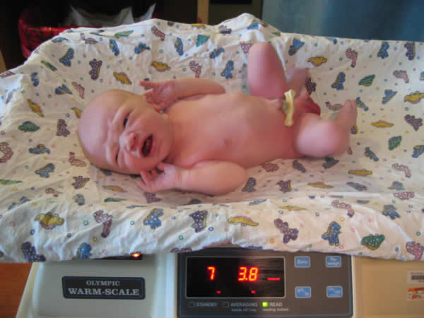
Figure 3.13 – A newborn being weighed.

Body Proportions
The head initially makes up about 50 percent of our entire length when we are developing in the womb. At birth, the head makes up about 25 percent of our length (think about how much of your length would be head if the proportions were still the same!).

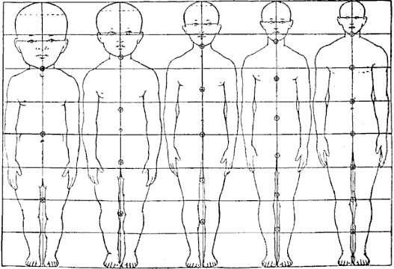
Figure 3.14 – Body proportions from infancy to adulthood.

Brain Development
Some of the most dramatic physical change that occurs during this period is in the brain. At birth, the brain is about 25 percent its adult weight and this is not true for any other part of the body. While most of the brain’s 100 to 200 billion neurons are present at birth, they are not fully mature. During the next several years dendrites or connections between neurons will undergo a period of transient exuberance or temporary dramatic growth.

Appearance at Birth
During labor and birth, the infant's skull changes shape to fit through the birth canal, sometimes causing the child to be born with a misshapen or elongated head. It will usually return to normal on its own within a few days or weeks.

Some newborns have a fine, downy body hair called lanugo. It may be particularly noticeable on the back, shoulders, forehead, ears and face of premature infants. Lanugo disappears within a few weeks. Likewise, not all infants are born with lush heads of hair. Some may be nearly bald while others may have very fine, almost invisible hair. Some babies are even born with a full head of hair. Amongst fair-skinned parents, this fine hair may be blond, even if the parents are not. The picture on the left shows lanugo on the shoulders of newborn twins.

Figure 3.15 - Lanugo on the shoulder and back of twin girls. | Figure 3.16 - A newborn baby covered in vernix.

Immediately after birth, a newborn's skin is often grayish to dusky blue in color. As soon as the newborn begins to breathe, usually within a minute or two, the skin's color returns to its normal tone. Newborns are wet, covered in streaks of blood, and coated with a white substance known as vernix, which is thought to act as an antibacterial barrier, seen in the picture on the right.

The scalp may also be temporarily bruised or swollen, especially in hairless newborns, and the area around the eyes may be puffy.

The newborn may also have Mongolian spots (blue or blue black birthmark on the lower back), various other birthmarks, or peeling skin, particularly on the wrists, hands, ankles, and feet.

A newborn's genitals are enlarged and reddened, with male infants having an unusually large scrotum. The breasts may also be enlarged, even in male infants. This is caused by naturally-occurring maternal hormones and is a temporary condition.

The umbilical cord of a newborn is bluish-white in color. After birth, the umbilical cord is normally cut, leaving a 1–2 inch stub. The umbilical stub will dry out, shrivel, darken, and spontaneously fall off within about 3 weeks. Occasionally, hospitals may apply triple dye to the umbilical stub to prevent infection, which may temporarily color the stub and surrounding skin purple.
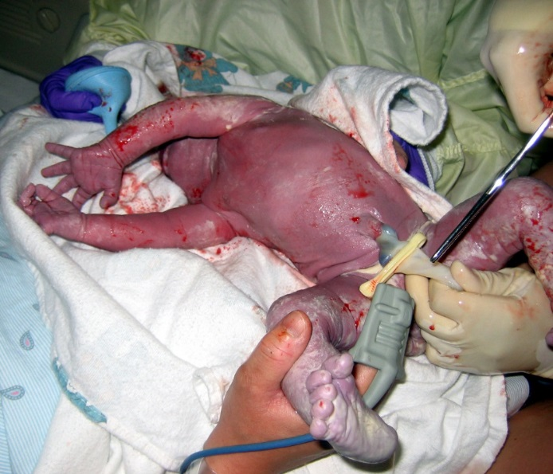
Figure 3.17 - The clamping and cutting of a newborn’s umbilical cord.

Newborns lose many of the above physical characteristics quickly. Thus older babies look very different. While older babies are considered "cute," newborns can be "unattractive" by the same criteria and first time parents may need to be educated in this regard.

Sleep
A newborn typically sleeps approximately 16.5 hours per 24-hour period. The infant sleeps in several periods throughout the day and night, which means they wake often throughout the day and night. (Salkind, 2005).

Figure 3.18 – An older newborn baby.

Reflexes
Newborns are equipped with a number of reflexes, which are involuntary movements in response to stimulation. Some of the more common reflexes, such as the sucking reflex and rooting reflex, are important to feeding. The grasping and stepping reflexes are eventually replaced by more voluntary behaviors. Within the first few months of life these reflexes disappear, while other reflexes, such as the eye-blink, swallowing, sneezing, gagging, and withdrawal reflex stay with us as they continue to serve important functions.

Sensory Capacities
Throughout much of history, the newborn was considered a passive, disorganized being who possessed minimal abilities. However, current research techniques have demonstrated just how developed the newborn is with especially organized sensory and perceptual abilities.

Vision
The womb is a dark environment void of visual stimulation. Consequently, vision is the most poorly developed sense at birth and time is needed to build those neural pathways between the eye and the brain. Newborns typically cannot see further than 8 to 16 inches away from their faces, and their visual acuity is about 20/400, which means that an infant can see something at 20 feet that an adult with normal vision could see at 400 feet. Thus, the world probably looks blurry to young infants.

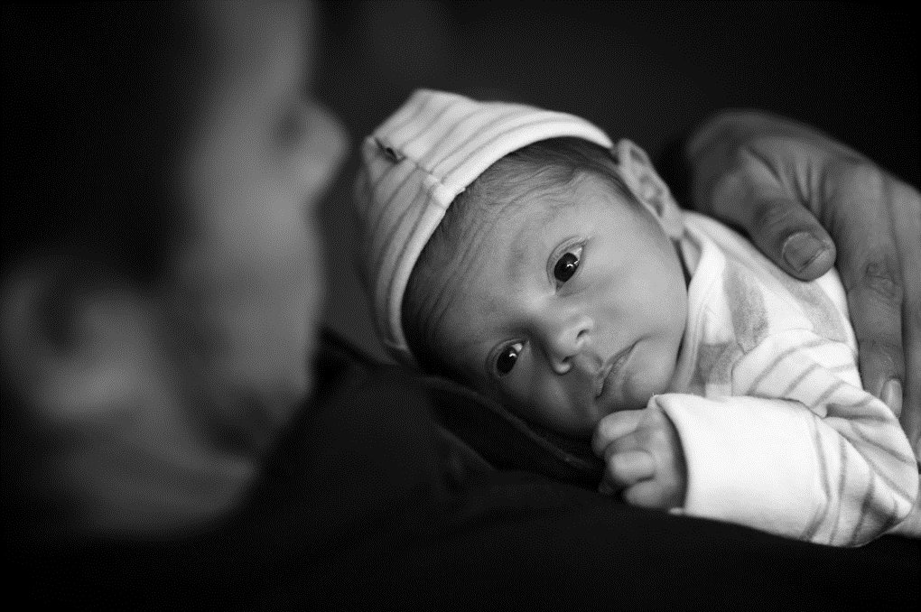
Figure 3.19 – A newborn gazing up at a parent.

Hearing
The infant’s sense of hearing is very keen at birth, and the ability to hear is evidenced as soon as the 7th month of prenatal development. In fact, an infant can distinguish between very similar sounds as early as one month after birth and can distinguish between a familiar and unfamiliar voice even earlier. Infants are especially sensitive to the frequencies of sounds in human speech and prefer the exaggeration of infant-directed speech, which will be discussed later. Newborns also prefer their mother’s voices over another female when speaking the same material (DeCasper & Fifer, 1980). Additionally, they will register in utero specific information heard from their mother’s voice.

Early Hearing
DeCasper and Spence (1986) tested 16 infants whose mothers had previously read to them prenatally. The mothers read several passages to their fetuses, including the first 28 paragraphs of The Cat in the Hat, beginning when they were 7 months pregnant. The fetuses had been exposed to the stories on average of 67 times or 3.5 hours.

During the testing, the infants were able to choose between recordings of two stories, one of which was a story their mothers read to them while in the womb, based on how fast they sucked on their pacifiers. They showed a preference for the stories that their mothers read to them while in the womb.

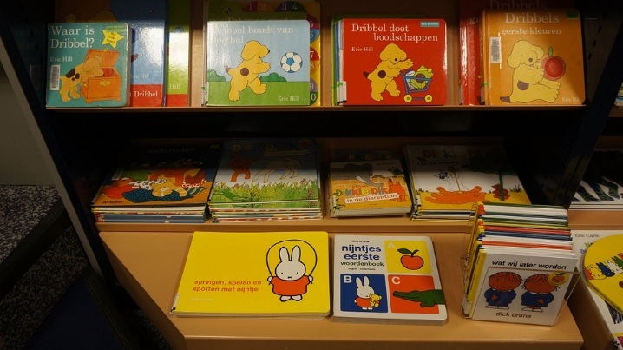
Figure 3.20 – A collection of children’s books.

Touch and Pain
Immediately after birth, a newborn is sensitive to touch and temperature, and is also highly sensitive to pain, responding with crying and cardiovascular responses (Balaban & Reisenauer, 2013). Newborns who are circumcised, which is the surgical removal of the foreskin of the penis, without anesthesia experience pain as demonstrated by increased blood pressure, increased heart rate, decreased oxygen in the blood, and a surge of stress hormones (United States National Library of Medicine, 2016). Research has demonstrated that infants who were circumcised without anesthesia experienced more pain and fear during routine childhood vaccines. Fortunately, many circumcisions are now done with the use of local anesthetics.

Taste and Smell
Studies of taste and smell demonstrate that babies respond with different facial expressions, suggesting that certain preferences are innate. Newborns can distinguish between sour, bitter, sweet, and salty flavors and show a preference for sweet flavors. Newborns also prefer the smell of their mothers. An infant only 6 days old is significantly more likely to turn toward its own mother’s breast pad than to the breast pad of another baby’s mother (Porter, Makin, Davis, & Christensen, 1992), and within hours of birth an infant also shows a preference for the face of its own mother (Bushnell, 2001; Bushnell, Sai, & Mullin, 1989).

Infants seem to be born with the ability to perceive the world in an intermodal way; that is, through stimulation from more than one sensory modality. For example, infants who sucked on a pacifier with a smooth surface preferred looking at visual models of a pacifier with a smooth surface. But those that were given a pacifier with a textured surface preferred to look at a visual model of a pacifier with a textured surface.

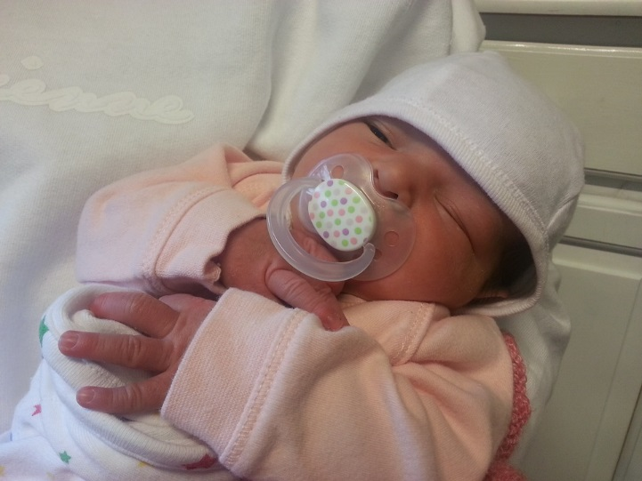
Figure 3.21 – A baby sucking on a pacifier.

Conclusion
In this chapter we looked at:
- methods of childbirth preparation
- the process of childbirth (for both vaginal and Cesarean deliveries)
- assessing newborn health
- problems for the newborn
- characteristics of newborns (including appearance, reflexes, and perceptual abilities)

In the next three chapters we will explore the first three years of life more. Many rapid changes occur during these foundational years.

Chapter 4: Physical Development in Infancy & Toddlerhood

Chapter Objectives
After this chapter, you should be able to:
- Describe the physical changes that occur during the first two years of life.
- Identify common infant reflexes.
- Discuss the sleep needs during the first two years of life.
- Summarize the sequence of both fine and gross motor skills.
- Recognize the developing sensory capacities of infants and toddlers.
- Explain how to meet the evolving nutritional needs of infants and toddlers.

Introduction
Welcome to the story of development from infancy through toddlerhood; from birth until about two years of age. Researchers have given this part of the life span more attention than any other period, perhaps because changes during this time are so dramatic and so noticeable and perhaps because we have assumed that what happens during these years provides a foundation for one’s life to come. However, it has been argued that the significance of development during these years has been overstated (Bruer, 1999). Nevertheless, this is the period of life that contemporary educators, healthcare providers, and parents have focused on most heavily. We will examine growth and nutrition during infancy, as well as other prominent physical changes that take place during this time.

Figure 4.1 – A sleeping newborn.

Rapid Physical Changes
As mentioned in the previous chapter, the average newborn in the United States weighs about 7.5 pounds and is about 20 inches in length. After about a 5% weight loss in the first few days, there is a period of rapid growth. By the time an infant is 4 months old, it usually doubles in weight and by one year has tripled its birth weight. By age 2, the weight has quadrupled. The average length at one year is about 26-32 inches.

Two hormones are very important to this growth process. The first is Human Growth Hormone (HGH) which influences all growth except that in the Central Nervous System (CNS). The hormone influencing growth in the CNS is called Thyroid Stimulating Hormone. Together these hormones influence the growth in early childhood.

Sleep is very important to the growth process as these hormones are released as children sleep each night. As a result, children need 11 to 14 hours of sleep from 2 to 6 years old. Parents may establish rituals, such as reading a story, taking a bath, brushing teeth, etc. to help children wind down and get the sleep they so desperately need.

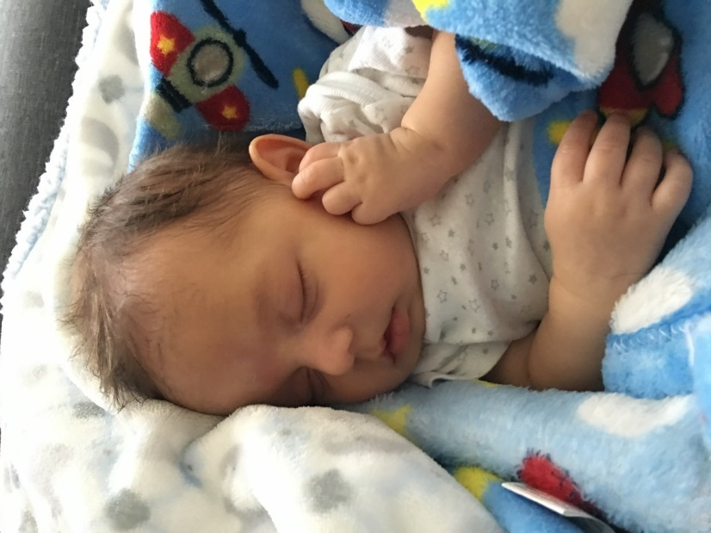
Figure 4.2 – An infant sleeping.

Proportions of the Body
Another dramatic physical change that takes place in the first several years of life is the change in body proportions. The head initially makes up about 50 percent of our entire length when we are developing in the womb. At birth, the head makes up about 25 percent of our length (think about how much of your length would be head if the proportions were still the same!). By age 25 it comprises about 20 percent our length. Imagine now how difficult it must be to raise one’s head during the first year of life! And indeed, if you have ever seen a 2 to 4 month old infant lying on the stomach trying to raise the head, you know how much of a challenge this is. The comparison in this graphic was originally introduced in the last chapter.

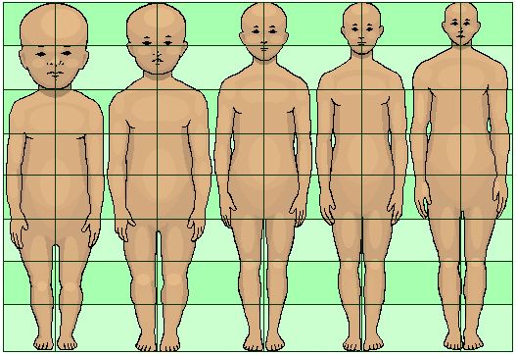
Figure 4.3 - Shown from left to right: Human body proportions at birth, at 2 years, at 6 years, at 12 years, and at 19 years.

Some of the most dramatic physical change that occurs during this period is in the brain. At birth, the brain is about 25 percent its adult weight and this is not true for any other part of the body. By age 2, it is at 75 percent its adult weight, at 95 percent by age 6 and at 100 percent by age 7 years.

While most of the brain’s 100 to 200 billion neurons are present at birth, they are not fully mature and during the next several years dendrites or connections between neurons will undergo a period of transient exuberance or temporary dramatic growth.

Components of the Neuron
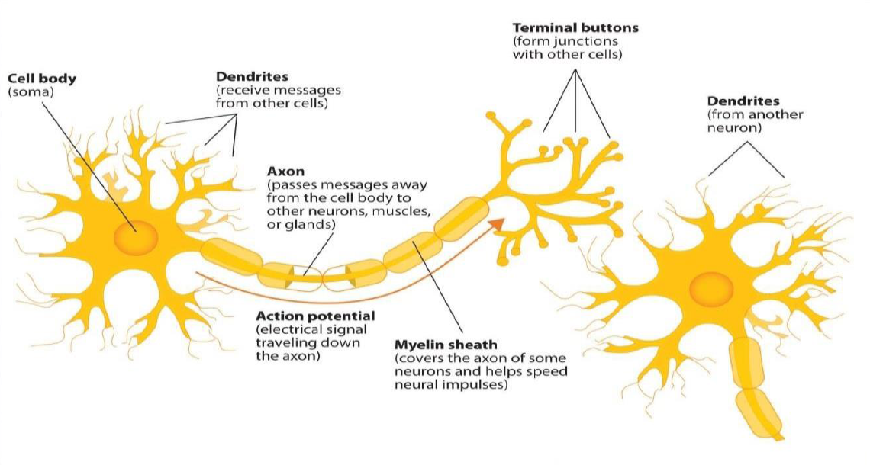
Figure 4.4 – The neuron.

There is a proliferation of these dendrites during the first two years so that by age 2, a single neuron might have thousands of dendrites. After this dramatic increase, the neural pathways that are not used will be eliminated thereby making those that are used much stronger.. Because of this proliferation of dendrites, by age two a single neuron might have thousands of dendrites.

Synaptogenesis, or the formation of connections between neurons, continues from the prenatal period forming thousands of new connections during infancy and toddlerhood. This period of rapid neural growth is referred to as Synaptic Blooming. This activity is occurring primarily in the cortex or the thin outer covering of the brain involved in voluntary activity and thinking.

The prefrontal cortex that is located behind our forehead continues to grow and mature throughout childhood and experiences an additional growth spurt during adolescence. It is the last part of the brain to mature and will eventually comprise 85 percent of the brain’s weight. Experience will shape which of these connections are maintained and which of these are lost. Ultimately, about 40 percent of these connections will be lost (Webb, Monk, and Nelson, 2001). As the prefrontal cortex matures, the child is increasingly able to regulate or control emotions, to plan activity, strategize, and have better judgment. Of course, this is not fully accomplished in infancy and toddlerhood, but continues throughout childhood and adolescence.

Another major change occurring in the central nervous system is the development of myelin, a coating of fatty tissues around the axon of the neuron. Myelin helps insulate the nerve cell and speed the rate of transmission of impulses from one cell to another. This enhances the building of neural pathways and improves coordination and control of movement and thought processes. The development of myelin continues into adolescence but is most dramatic during the first several years of life.

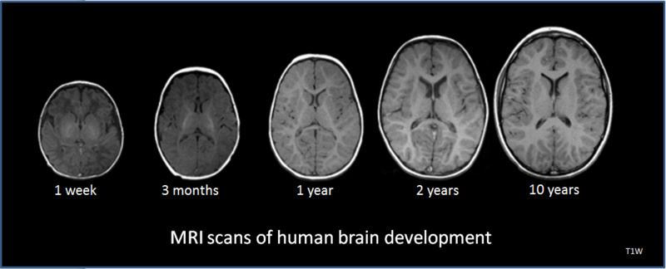
Figure 4.5 – MRI scans of the human brain.

Reflexes
Infants are equipped with a number of reflexes which are involuntary movements in response to stimulation. These include the sucking reflex (infants suck on objects that touch their lips automatically), the rooting reflex (which involves turning toward any object that touches the cheek), the palmar grasp (the infant will tightly grasp any object placed in its palm), and the dancing reflex (evident when the infant is held in a standing position and moves its feet up and down alternately as if dancing). These movements occur automatically and are signals that the infant is functioning well neurologically. Within the first several weeks of life these reflexes are replaced with voluntary movements or motor skills.

Infants and children grow and develop at a rapid pace during the first few years of life. The development of both gross and fine motor skills helps a child go from a completely dependent newborn to an independently functioning toddler in about a 3-year span.

Table 4.1 - Some Common Infant Reflexes

Reflex | Description | Image | Reflex | Description | Image
Sucking | Suck on anything that touches the lips | 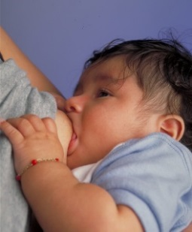  Figure 4.6 | Moro | A sudden noise or loss of support to the head and neck will cause infants to spread out their arms and legs then quickly contract the limbs inward | 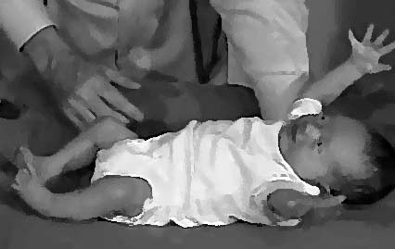  Figure 4.7
Rooting | Turning the head when the cheek is touched | 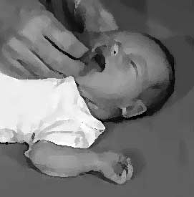  Figure 4.8 | Tonic Neck | When lying on the back with the head to one side infants will extend the arm and leg on that side while flexing the limbs on the opposite side (looks like a fencer pose). | Figure 4.9
Grasp | Fingers automatically grip anything that touches the palm of the hand | Figure 4.10 | Stepping | Legs move in stepping like motion when feet touch a smooth surface | Figure 4.11
Babinski | The toes will fan out and curl when the sole of the foot is stroked from heel to toe | 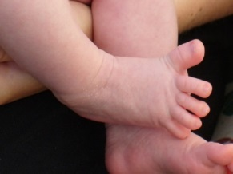  Figure 4.12

Gross Motor Skills
Voluntary movements involve the use of large muscle groups and are typically large movements of the arms, legs, head, and torso. They are referred to as gross motor skills (or large motor skills). These skills begin to develop first. Examples include moving to bring the chin up when lying on the stomach, moving the chest up, rocking back and forth on hands and knees, and then crawling. But it also includes exploring an object with one’s feet as many babies do as early as 8 weeks of age if seated in a carrier or other device that frees the hips. This may be easier than reaching for an object with the hands, which requires much more practice (Berk, 2007). And sometimes an infant will try to move toward an object while crawling and surprisingly move backward because of the greater amount of strength in the arms than in the legs! This also tends to lead infants to pulling up on furniture, usually with the goal of reaching a desired object. Usually this will also lead to taking steps and eventually walking.

Physical Gross Motor Milestones
As stated above, children grow very quickly and meet physical milestones rapidly in the first few years of life. The following is a table of the major milestones (behaviors or physical skills seen in infants and children as they grow and develop that typically occur within normal range) that occur in children during those first formative years.

Table 4.2 - Gross Motor Milestones

Typical Age | What Most Children Do by This Age
2 months | - Can hold head up and begins to push up when lying on tummy  - Makes smoother movements with arms and legs
4 months | - Holds head steady, unsupported  - Pushes down on legs when feet are on a hard surface  - May be able to roll over from tummy to back  - Brings hands to mouth  - When lying on stomach, pushes up to elbows
6 months | - Rolls over in both directions (front to back, back to front)  - Begins to sit without support  - When standing, supports weight on legs and might bounce  - Rocks back and forth, sometimes crawling backward before moving forward
9 months | - Stands, holding on  - Can get into sitting position  - Sits without support  - Pulls to stand  - Crawls
1 year | - Gets to a sitting position without help  - Pulls up to stand, walks holding on to furniture (“cruising”)  - May take a few steps without holding on  - May stand alone
18 months | - Walks alone  - May walk up steps and run  - Pulls toys while walking  - Can help undress self
2 years | - Stands on tiptoe  - Kicks a ball  - Begins to run  - Climbs onto and down from furniture without help  - Walks up and down stairs holding on  - Throws ball overhand

Figure 4.13 – An infant playing in the sand.

Fine Motor Skills
More exact movements of the feet, toes, hands, and fingers are referred to as fine motor skills (or small motor skills). These include the ability to reach and grasp an object in coordination with vision. Newborns cannot grasp objects voluntarily but do wave their arms toward objects of interest. At about 4 months of age, the infant is able to reach for an object, first with both arms and within a few weeks, with only one arm. Grasping an object involves the use of the fingers and palm, but no thumbs.
Use of the thumb comes at about 9 months of age when the infant is able to grasp an object using the forefinger and thumb. This is known as the pincer grip. This ability greatly enhances the ability to control and manipulate an object and infants take great delight in this newfound ability. They may spend hours picking up small objects from the floor and placing them in containers. And as those objects will often next go into the mouth, caregivers must be vigilant about keeping items small enough to be choking hazards out of reach of little fingers. By 9 months, an infant can also watch a moving object, reach for it as it approaches and grab it. This is quite a complicated set of actions if we remember how difficult this would have been just a few months earlier.

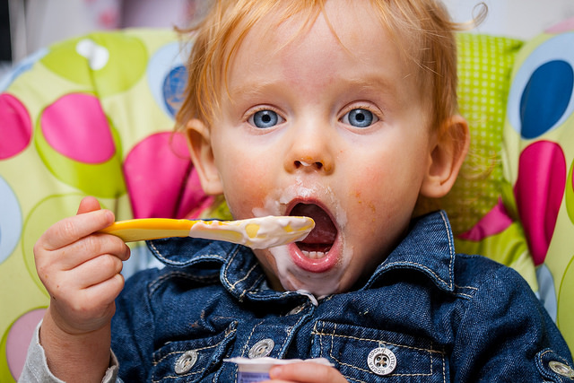
Figure 4.14 – An infant feeding themselves.

Physical Fine Motor Milestones
While fine motor skills are slower to develop (in accordance with proximodistal development), pretty remarkable progress is made in fine motor development during the first two years. As stated above, in the first few years of life children go from having no intentional fine motor control to being able to manipulate objects to play and learn, as well as beginning to care of themselves. The following is a table of the major milestones in fine motor development.

Table 4.3 - Fine Motor Milestones

Typical Age | What Most Children Do by This Age
2 months | - Grasps reflexively  - Does not reach for objects  - Holds hands in fist
4 months | - Brings hands to mouth  - Uses hands and eyes together, such as seeing a toy and reaching for it  - Follows moving things with eyes from side to side  - Can hold a toy with whole hand (palmar grasp) and shake it and swing at dangling toys
6 months | - Reaches with both arms  - Brings things to mouth  - Begins to pass things from one hand to the other
9 months | - Puts things in mouth  - Moves things smoothly from one hand to the other  - Picks up things between thumb and index finger (pincer grip)
1 year | - Reaches with one hand  - Bangs two things together  - Puts things in a container, takes things out of a container  - Lets things go without help  - Pokes with index (pointer) finger
18 months | - Scribbles on own  - Can help undress herself  - Drinks from a cup  - Eats with a spoon with some accuracy  - Stacks 2-4 objects
2 years | - Builds towers of 4 or more blocks  - Might use one hand more than the other  - Makes copies of straight lines and circles  - Enjoys pouring and filling  - Unbuttons large buttons  - Unzips large zippers  - Drinks and feeds self with more accuracy

Sensory Capacities
Throughout much of history, the newborn was considered a passive, disorganized being who possessed minimal abilities. William James, an early psychologist, had described the newborn’s world as “a blooming, buzzing confusion,” (Shaffer, 1985). However, current research techniques have demonstrated just how developed the newborn is with especially organized sensory and perceptual abilities.

Vision
The womb is a dark environment void of visual stimulation. Consequently, vision is the most poorly developed sense at birth and time is needed to build those neural pathways between the eye and the brain. Newborns typically cannot see further than 8 to 16 inches away from their faces (which is about the distance from the newborn's face to the mother/caregiver when an infant is breastfeeding/bottle-feeding). Their visual acuity is about 20/400, which means that an infant can see something at 20 feet that an adult with normal vision could see at 400 feet. Thus, the world probably looks blurry to young infants. Because of their poor visual acuity, they look longer at checkerboards with fewer large squares than with many small squares. Infants' thresholds for seeing a visual pattern are higher than adults'. Thus, toys for infants are sometimes manufactured with black and white patterns rather than pastel colors because the higher contrast between black and white makes the pattern more visible to the immature visual system. By about 6 months, infants' visual acuity improves and approximates adult 20/25 acuity.

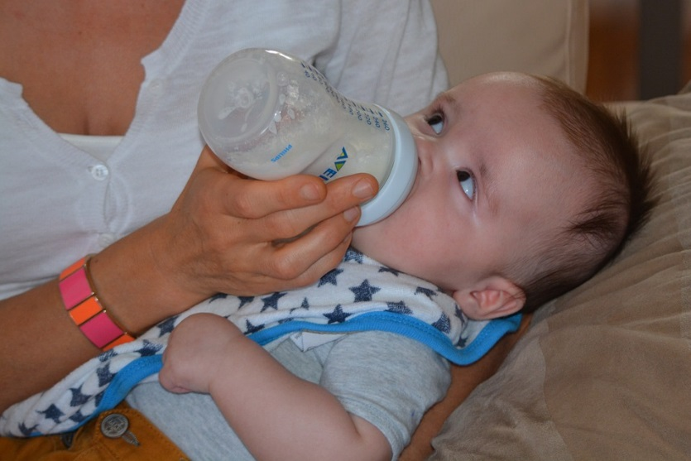
Figure 4.15 – An infant looking up at the person feeding them.

When viewing a person’s face, newborns do not look at the eyes the way adults do; rather, they tend to look at the chin—a less detailed part of the face. However, by 2 or 3 months, they will seek more detail when exploring an object visually and begin showing preferences for unusual images over familiar ones, for patterns over solids, for faces over patterns, and for three-dimensional objects over flat images. Newborns have difficulty distinguishing between colors, but within a few months they are able to discriminate between colors as well as adults do. Sensitivity to binocular depth cues, which require inputs from both eyes, is evident by about 3 months and continues to develop during the first 6 months. By 6 months, the infant can perceive depth perception in pictures as well (Sen, Yonas, & Knill, 2001). Infants who have experience crawling and exploring will pay greater attention to visual cues of depth and modify their actions accordingly (Berk, 2007).

Hearing
The infant’s sense of hearing is very keen at birth, and the ability to hear is evident as soon as the 7th month of prenatal development. In fact, an infant can distinguish between very similar sounds as early as one month after birth and can distinguish between a familiar and unfamiliar voice even earlier. Infants are especially sensitive to the frequencies of sounds in human speech and prefer the exaggeration of infant-directed speech, which will be discussed later. Additionally, infants are innately ready to respond to the sounds of any language, but some of this ability will be lost by 7 or 8 months as the infant becomes familiar with the sounds of a particular language and less sensitive to sounds that are part of an unfamiliar language.

Newborns also prefer their mother’s voices over another female when speaking the same material (DeCasper & Fifer, 1980). Additionally, they will register in utero specific information heard from their mother’s voice. You may remember the Cat in the Hat study featured in the last chapter that illustrates this.

Touch and Pain
Immediately after birth, a newborn is sensitive to touch and temperature, and is also highly sensitive to pain, responding with crying and cardiovascular responses (Balaban & Reisenauer, 2013). Newborns who are circumcised, which is the surgical removal of the foreskin of the penis, without anesthesia experience pain as demonstrated by increased blood pressure, increased heart rate, decreased oxygen in the blood, and a surge of stress hormones (United States National Library of Medicine, 2016). Research has demonstrated that infants who were circumcised without anesthesia experienced more pain and fear during routine childhood vaccines. Fortunately, local painkillers are now used during many circumcision.

Taste and Smell
Studies of taste and smell demonstrate that babies respond with different facial expressions, suggesting that certain preferences are innate. Newborns can distinguish between sour, bitter, sweet, and salty flavors and show a preference for sweet flavors. Newborns also prefer the smell of their mothers. An infant only 6 days old is significantly more likely to turn toward its own mother’s breast pad than to the breast pad of another baby’s mother (Porter, Makin, Davis, & Christensen, 1992), and within hours of birth an infant also shows a preference for the face of its own mother (Bushnell, 2001; Bushnell, Sai, & Mullin, 1989).

Infants seem to be born with the ability to perceive the world in an intermodal way; that is, through stimulation from more than one sensory modality. For example, infants who sucked on a pacifier with either a smooth or textured surface preferred to look at a corresponding (smooth or textured) visual model of the pacifier. By 4 months, infants can match lip movements with speech sounds and can match other audiovisual events. Although sensory development emphasizes the afferent processes used to take in information from the environment, these sensory processes can be affected by the infant's developing motor abilities. Reaching, crawling, and other actions allow the infant to see, touch, and organize his or her experiences in new ways..

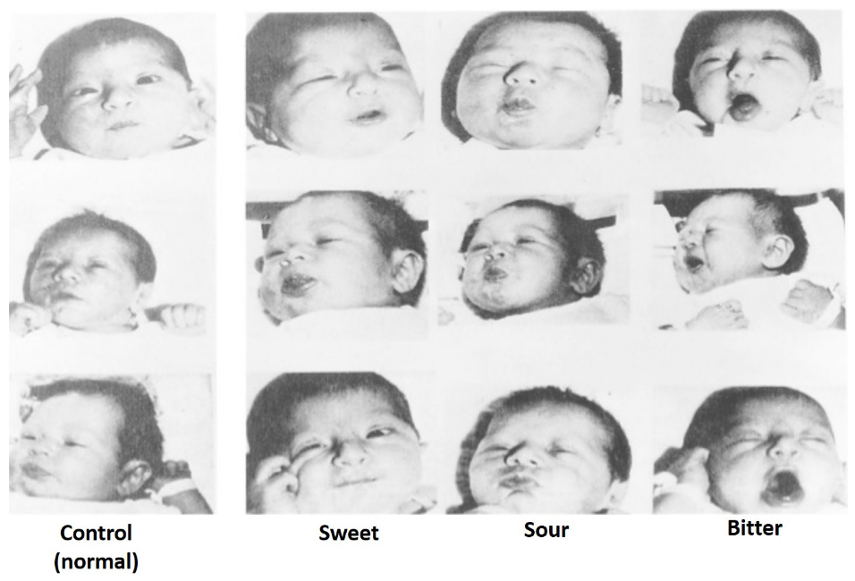
Figure 4.16 – The responses of infants to different tastes.

Nutrition
Nutritional needs change with age. Let’s examine how caregivers should nourish children during the first years of life and some risks to nutrition that they should be aware of.

Breastfeeding
Breast milk is considered the ideal diet for newborns. Colostrum, the first breast milk produced during pregnancy and just after birth has been described as “liquid gold” (United States Department of Health and Human Services (USDHHS), 2011). It is very rich in nutrients and antibodies. Breast milk changes by the third to fifth day after birth, becoming much thinner, but containing just the right amount of fat, sugar, water and proteins to support overall physical and neurological development. For most babies, breast milk is also easier to digest than formula. Formula fed infants experience more diarrhea and upset stomachs. The absence of antibodies in formula often results in a higher rate of ear infections and respiratory infections. Children who are breastfed have lower rates of childhood leukemia, asthma, obesity, type 1 and 2 diabetes, and a lower risk of SIDS. The USDHHS recommends that mothers breastfeed their infants until at least 6 months of age and that breast milk be used in the diet throughout the first year or two.

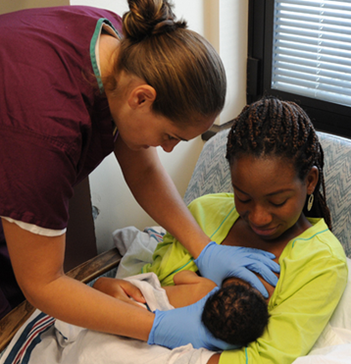
Figure 4.17 – A nurse helping a new mother to breastfeed.

Maternal Benefits of Breastfeeding
Several recent studies have reported that it is not just babies that benefit from breastfeeding. Breastfeeding stimulates contractions in the mother’s uterus to help it regain its normal size, and women who breastfeed are more likely to space their pregnancies further apart. Mothers who breastfeed are at lower risk of developing breast cancer (Islami et al., 2015), especially among higher risk racial and ethnic groups (Islami et al., 2015; Redondo et al., 2012). Women who breastfeed have lower rates of ovarian cancer (Titus-Ernstoff, Rees, Terry, & Cramer, 2010), reduced risk for developing Type 2 diabetes (Schwarz et al., 2010; Gunderson, et al., 2015), and rheumatoid arthritis (Karlson, Mandl, Hankinson, & Grodstein, 2004). In most studies these benefits have been seen in women who breastfeed longer than 6 months.

Challenges to Breastfeeding
However, most mothers who breastfeed in the United States stop breastfeeding at about 6-8 weeks, often in order to return to work outside the home (USDHHS, 2011). Mothers can certainly continue to provide breast milk to their babies by expressing and freezing the milk to be bottle-fed at a later time or by being available to their infants at feeding time. However, some mothers find that after the initial encouragement they receive in the hospital to breastfeed, the outside world is less supportive of such efforts. Some workplaces support breastfeeding mothers by providing flexible schedules and welcoming infants, but many do not. In addition, not all women may be able to breastfeed. Women with HIV are routinely discouraged from breastfeeding as the infection may pass to the infant. Similarly, women who are taking certain medications or undergoing radiation treatment may be told not to breastfeed (USDHHS, 2011).

Cost of Breastfeeding
In addition to the nutritional benefits of breastfeeding, breast milk does not have to be purchased. Anyone who has priced formula recently can appreciate this added incentive to breastfeeding. Prices for a year’s worth of formula and feeding supplies can cost well over $1,500 (USDHHS, 2011).

But there are also those who challenge the belief that breast milk is free. For breastmilk to be completely beneficial for infants the mother's life choices will ultimately affect the quality of the nutrition an infant will receive. Let's consider the nutritional intake of the mother. Breastfeeding will both limit some food and drink choices as well as necessitate an increased intake of healthier options. A simple trip down the supermarket aisles will show you that nutritious and healthier options can be more expensive than some of the cheaper more processed options. A large variety of vegetable and fruits must be consumed, accompanied by the right proportions and amounts of the whole grains, dairy products, and fat food groups. Additionally, it is also encouraged for breastfeeding mothers to take vitamins regularly. That raises the question of how free breastfeeding truly is.

A Historic Look at Breastfeeding
The use of wet nurses, or lactating women hired to nurse others' infants, during the middle ages eventually declined and mothers increasingly breastfed their own infants in the late 1800s. In the early part of the 20th century, breastfeeding began to go through another decline. By the 1950s, it was practiced less frequently as formula began to be viewed as superior to breast milk.

In the late 1960s and 1970s, greater emphasis began to be placed on natural childbirth and breastfeeding and the benefits of breastfeeding were more widely publicized. Gradually rates of breastfeeding began to climb, particularly among middle-class educated mothers who received the strongest messages to breastfeed.

Today, women receive consultation from lactation specialists before being discharged from the hospital to ensure that they are informed of the benefits of breastfeeding and given support and encouragement to get their infants to get used to taking the breast. This does not always happen immediately and first time mothers, especially, can become upset or discouraged. In this case, lactation specialists and nursing staff can encourage the mother to keep trying until baby and mother are comfortable with the feeding.

Alternatives to Breastfeeding
There are many reasons that mothers struggle to breastfeed or should not breastfeed, including: low milk supply, previous breast surgeries, illicit drug use, medications, infectious disease, and inverted nipples. Other mothers choose not to breastfeed. Some reasons for this include: lack of personal comfort with nursing, the time commitment of nursing, inadequate or unhealthy diet, and wanting more convenience and flexibility with who and when an infant can be fed. For these mothers and infants, formula is available. Besides breast milk, infant formula is the only other milk product that the medical community considers nutritionally acceptable for infants under the age of one year (as opposed to cow's milk, goat's milk, or follow-on formula). It can be used in addition to breastfeeding (supplementing) or as an alternative to breastmilk.

The most commonly used infant formulas contain purified cow's milk whey and casein as a protein source, a blend of vegetable oils as a fat source, lactose as a carbohydrate source, a vitamin-mineral mix, and other ingredients depending on the manufacturer. In addition, there are infant formulas which use soybeans as a protein source in place of cow's milk (mostly in the United States and Great Britain) and formulas which use protein hydrolysed into its component amino acids for infants who are allergic to other proteins.

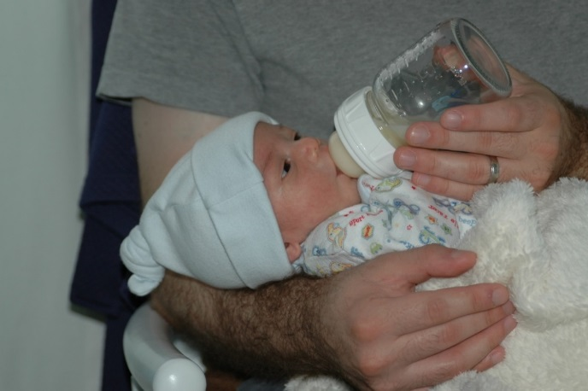
Figure 4.18 – A father bottle-feeding his infant.

One early argument given to promote the practice of breastfeeding was that it promoted bonding and healthy emotional development for infants. However, this does not seem to be the case. Breastfed and bottle-fed infants adjust equally well emotionally (Ferguson & Woodward, 1999). This is good news for mothers who may be unable to breastfeed for a variety of reasons and for fathers who might feel left out.

When, What, and How to Introduce Solid Foods
The American Academy of Pediatrics recommends children be introduced to foods other than breast milk or infant formula when they are about 6 months old. Every child is different. Here are some signs that show that an infant is ready for foods other than breast milk or infant formula:
- Child can sit with little or no support.
- Child has good head control.
- Child opens his or her mouth and leans forward when food is offered.

How Should Foods Be Introduced?
The American Academy of Pediatrics says that for most children, foods do not need to be given in a certain order. Children can begin eating solid foods at about 6 months old. By the time they are 7 or 8 months old, children can eat a variety of foods from different food groups. These foods include infant cereals, meat or other proteins, fruits, vegetables, grains, yogurts and cheeses, and more.

If feeding infant cereals, it is important to offer a variety of fortified infant cereals such as oat, barley, and multi-grain instead of only rice cereal. The Food and Drug Administration does not recommend only providing infant rice cereal because there is a risk for children to be exposed to arsenic.

Children should be allowed to try one food at a time at first and there should be 3 to 5 days before another food is introduced. This helps caregivers see if the child has any problems with that food, such as food allergies.

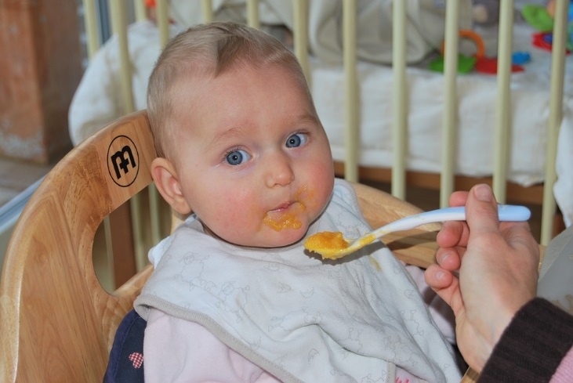
Figure 4.19 – A baby being fed solid food.

The eight most common allergenic foods are milk, eggs, fish, shellfish, tree nuts, peanuts, wheat, and soybeans. It is no longer recommended that caregivers delay introducing these foods to all children, but if there is a family history of food allergies, the child’s doctor or nurse should be consulted.

It may take numerous attempts before a child gains a taste for it. So caregivers should not give up if a food is refused on first offering.

USDA Infant Meal Patterns
The United States Department of Agriculture Food and Nutrition Service provides the following guidance for the day time feeding of infants and toddlers.

Infant Meal Patterns

Table 4.4

Meal | 0-5 months | 6-11 months
Breakfast | 4-6 fluid ounces breastmilk or formula | 6-8 fluid ounces breastmilk or formula  0-4 tablespoons infant cereal, meat, fish, poultry, whole eggs, cooked dry beans or peas; or  0-2 ounces cheese; or  0-4 ounces (volume) cottage cheese; or  0-4 ounces yogurt; or a combination*  0-2 tablespoons vegetable, fruit, or both*
Lunch or Supper | 4-6 fluid ounces breastmilk or formula | 6-8 fluid ounces breastmilk or formula  0-4 tablespoons infant cereal, meat, fish, poultry, whole eggs, cooked dry beans or peas; or 0-2 ounces cheese; or  0-4 ounces (volume) cottage cheese; or  0-4 ounces yogurt; or a combination*  0-2 tablespoons vegetable, fruit, or both*
Snack | 4-6 fluid ounces breastmilk or formula | 2-4 fluid ounces breastmilk or formula  0-½ bread slice; or  0-2 crackers; or  0-4 tablespoons infant cereal or ready-to-eat cereal*  0-2 tablespoons vegetable, fruit, or both*
*Required when infant is developmentally ready. All serving sizes are minimum quantities of the food components that are required to be served.

The nutrition recommendations for toddlers are on the following page.

Meal Patterns for Children (1-2 years)

Table 4.5

Meal | Ages 1-2
Breakfast | ½ cup milk  ¼ cup vegetables, fruit, or both  ½ ounce equivalent grains
Lunch or Supper | ½ cup milk  1 ounce meat or meat alternative  1/8 cup vegetables  1/8 cup fruits  ½ ounce equivalent of grains
Snack | Select two of the following:  ½ cup of milk  ½ ounce meat or meat alternative  ½ cup vegetables  ½ cup fruit  ½ ounce equivalent of grains
Note: All serving sizes are minimum quantities of the food components that are required to be served.

Child Malnutrition
There can be serious effects for children when there are deficiencies in their nutrition. Let’s explore a few types of nutritional concerns.

Wasting
Children in developing countries and countries experiencing the harsh conditions of war are at risk for two major types of malnutrition, also referred to as wasting. Infantile marasmus refers to starvation due to a lack of calories and protein. Children who do not receive adequate nutrition lose fat and muscle until their bodies can no longer function. Babies who are breastfed are much less at risk of malnutrition than those who are bottle-fed.

After weaning, children who have diets deficient in protein may experience kwashiorkor or the “disease of the displaced child,” often occurring after another child has been born and taken over breastfeeding. This results in a loss of appetite and swelling of the abdomen as the body begins to break down the vital organs as a source of protein.

Around the world the rates of wasting have been dropping. However, according to the World Health Organization and UNICEF, in 2014 there were 50 million children under the age of five that experienced these forms of wasting, and 16 million were severely wasted (UNICEF, 2015). Worldwide, these figures indicate that nearly 1 child in every 13 suffers from some form of wasting. The majority of these children live in Asia (34.3 million) and Africa (13.9 million). Wasting can occur as a result of severe food shortages, regional diets that lack certain proteins and vitamins, or infectious diseases that inhibit appetite (Latham, 1997).

Figure 4.20 – A child suffering from wasting.

The consequences of wasting depend on how late in the progression of the disease parents and guardians seek medical treatment for their children. Unfortunately, in some cultures families do not seek treatment early, and as a result by the time a child is hospitalized the child often dies within the first three days after admission (Latham, 1997). Several studies have reported long- term cognitive effects of early malnutrition (Galler & Ramsey, 1989; Galler, Ramsey, Salt & Archer, 1987; Richardson, 1980), even when home environments were controlled (Galler, Ramsey, Morley, Archer & Salt, 1990). Lower IQ scores (Galler et al., 1987), poor attention (Galler & Ramsey, 1989), and behavioral issues in the classroom (Galler et al., 1990) have been reported in children with a history of serious malnutrition in the first few years of life.

Milk Anemia
Milk Anemia in the United States: About 9 million children in the United States are malnourished (Children’s Welfare, 1998). More still suffer from milk anemia, a condition in which milk consumption leads to a lack of iron in the diet. This can be due to the practice of giving toddlers milk as a pacifier-when resting, when riding, when waking, and so on. Appetite declines somewhat during toddlerhood and a small amount of milk (especially with added chocolate syrup) can easily satisfy a child’s appetite for many hours. The calcium in milk interferes with the absorption of iron in the diet as well. Many preschools and daycare centers give toddlers a drink after they have finished their meal in order to prevent spoiling their appetites.

Failure to Thrive
Failure to thrive (FTT) occurs in children whose nutritional intake is insufficient for supporting normal growth and weight gain. FTT typically presents before two years of age, when growth rates are highest. Parents may express concern about picky eating habits, poor weight gain, or smaller size compared relative to peers of similar age. Physicians often identify FTT during routine office visits, when a child's growth parameters are not tracking appropriately on growth curves.

FTT can be caused by physical or mental issues within the child (such as errors of metabolism, acid reflux, anemia, diarrhea, Cystic fibrosis, Crohn’s disease, celiac disease, cleft palate, tongue tie, milk allergies, hyperthyroidism, congenital heart disease, etc.) It can also be caused by caregiver’s actions (environmental), including inability to produce enough breastmilk, inadequate food supply, providing an insufficient number of feedings, and neglect. These causes may also co-exist. For instance, a child who is not getting sufficient nutrition may act content so that caregivers do not offer feedings of sufficient frequency or volume, and a child with severe acid reflux who appears to be in pain while eating may make a caregiver hesitant to offer sufficient feedings.

Health
Infants depend on the adults that care for them to promote and protect their health. The following section addresses common physical conditions that can affect infants, the danger of shaking babies, and the importance of immunizations.

Common Physical Conditions and Issues during Infancy
Some physical conditions and issues are very common during infancy. Many are normal, and the infant's caregivers can deal with them if they occur. Mostly, it is a matter of the caregivers learning about what is normal for their infant and getting comfortable with the new routine in the household. New parents and caregivers often have questions about the following:
- Bowel Movements
- Colic
- Diaper Rash
- Spitting Up/Vomiting
- Teething
- Urination
- Jaundice

Bowel Movements
Infants' bowel movements go through many changes in color and consistency, even within the first few days after birth. While the color, consistency, and frequency of stool will vary, hard or dry stools may indicate dehydration and increased frequency of watery stools may indicate diarrhea.

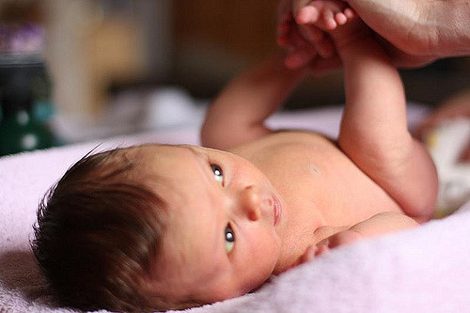
Figure 4.21 – An infant getting their diaper changed.

Colic
Many infants are fussy in the evenings, but if the crying does not stop and gets worse throughout the day or night, it may be caused by colic. According to the American Academy of Pediatrics, about one-fifth of all infants develop colic, usually starting between 2 and 4 weeks of age. They may cry inconsolably or scream, extend or pull up their legs, and pass gas. Their stomachs may be enlarged. The crying spells can occur anytime, although they often get worse in the early evening.

The colic will likely improve or disappear by the age of 3 or 4 months. There is no definite explanation for why some infants get colic. Health care providers can help ensure there is no medical reason behind the crying.

Some infants seem to be soothed by being held, rocked, or wrapped snugly in a blanket. Some like a pacifier.

Figure 4.22 – A father holding a crying infant.

Shaken Baby Syndrome
Here is a PSA from the Center for Disease Control (CDC)
The crying.
The late-night feedings.
The diaper changes.
The exhaustion.
If you’ve ever been around a baby who won’t stop crying, you know there’s potential to get frustrated. Focus on calming yourself and understand that you may not be able to calm your baby. It’s not your fault or your baby’s.

It’s normal for healthy babies to cry and some babies cry much more than others. And they cannot always be consoled and caregivers can feel pushed to the limit. When caregivers lose control and shake a baby it can have devastating effects.

Shaken Baby Syndrome (SBS) is a severe form of physical child abuse. SBS may be caused from vigorously shaking an infant by the shoulders, arms, or legs. The “whiplash” effect can cause intracranial (within the brain) or intraocular (within the eyes) bleeding. Often there is no obvious external head trauma. Still, children with SBS may display some outward signs:
- Change in sleeping pattern or inability to be awakened
- Confused, restless, or agitated state
- Convulsions or seizures
- Loss of energy or motivation
- Slurred speech
- Uncontrollable crying
- Inability to be consoled
- Inability to nurse or eat

SBS can result in death, mental retardation or developmental delays, paralysis, severe motor dysfunction, spasticity, blindness, and seizures.

Who’s at Risk?
Small children are especially vulnerable to this type of abuse. Their heads are large in comparison to their bodies, and their neck muscles are weak. Children under one year of age are at highest risk, but SBS has been reported in children up to five years of age. Shaking often occurs in response to a baby crying or having a toilet-training accident. The perpetrator tends to be male and is primarily the biological father or the mother’s boyfriend or partner. Caregivers are responsible for about 9%-21% of cases. The explanation typically provided by the caregiver—”I was playing with the baby”—does not begin to account for the severity of trauma. Many times there is also a history of child abuse.

Can It Be Prevented?
SBS is completely preventable. However, it is not known whether educational efforts will effectively prevent this type of abuse. Home visitation programs are shown to prevent child abuse in general. Because the child’s father or the mother’s partner often causes SBS, they should be included in home visitation programs. Home visits bring community resources to families in their homes. Health professionals provide information, healthcare, psychological support, and other services that can help people to be more effective parents and care-givers.

The Bottom Line
- Shaking a baby can cause death or permanent brain damage. It can result in life-long disability.
- Healthy strategies for dealing with a crying baby include:
  - finding the reason for the crying
  - checking for signs of illness or discomfort, such as diaper rash, teething, tight clothing;
  - feeding or burping;
  - soothing the baby by rubbing its back; gently rocking; offering a pacifier; singing or talking;
  - taking a walk using a stroller or a drive in a properly-secured car seat;
  - or calling the doctor if sickness is suspected
- All babies cry. Caregivers often feel overwhelmed by a crying baby. Calling a friend, relative, or neighbor for support or assistance lets the caregiver take a break from the situation. If immediate support is not available, the caregiver could place the baby in a crib (making sure the baby is safe), close the door, and check on the baby every five minutes.

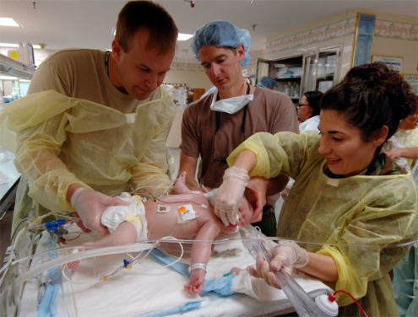
Figure 4.23 – Medical professionals caring for an infant.

Abusive Head Trauma
Shaken baby syndrome is part abusive head trauma (AHT), severe form of physical child abuse that results in an injury to the brain of a child. This is important to note because:
- Abusive head trauma is a leading cause of physical child abuse deaths in children under 5 in the United States.
- Abusive head trauma accounts for approximately one third of all child maltreatment deaths.
- The most common trigger for abusive head trauma is inconsolable crying.
- Babies less than one year old are at greatest risk of injury from abusive head trauma.

Teething
Although newborns usually have no visible teeth, baby teeth begin to appear generally about 6 months after birth. During the first few years, all 20 baby teeth will push through the gums, and most children will have their full set of these teeth in place by age 3.

An infant's front four teeth usually appear first, at about 6 months of age, although some children don't get their first tooth until 12-14 months. As their teeth break through the gums, some infants become fussy, and irritable; lose their appetite; or drool more than usual.

The FDA does not recommend gum-numbing medications with an ingredient called benzocaine because they can cause a potentially fatal condition in young children. Safe forms of relief include a chilled teething ring or gently rubbing the child's gums with a clean finger.

Spitting Up/Vomiting
Spitting up is a common occurrence for young infants and is usually not a sign of a more serious problem. But if an infant is not gaining weight or shows other signs of illness, a health care provider should be consulted.

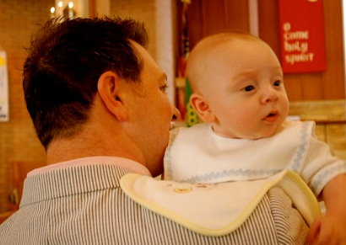
Figure 4.24 – A father holding his baby with a cloth protecting his shoulder from spit-up.

Urination
Infants urinate as often as every 1 to 3 hours or as infrequently as every 4 to 6 hours. In case of sickness or if the weather is very hot, urine output might drop by half and still be normal. If an infant shows any signs of distress while urinating or if any blood is found in a wet diaper medical care should be sought.

Diaper Rash
A rash on the skin covered by a diaper is quite common. It is usually caused by irritation of the skin from being in contact with stool and urine. It can get worse during bouts of diarrhea. Diaper rash usually can be prevented by frequent diaper changes.

Jaundice
Jaundice can cause an infant's skin, eyes, and mouth to turn a yellowish color. The yellow color is caused by a buildup of bilirubin, a substance that is produced in the body during the normal process of breaking down old red blood cells and forming new ones.

Normally the liver removes bilirubin from the body. But, for many infants, in the first few days after birth, the liver is not yet working at its full power. As a result, the level of bilirubin in the blood gets too high, causing the infant's color to become slightly yellow—this is jaundice.
Although jaundice is common and usually not serious, in some cases, high levels of bilirubin could cause brain injury. All infants with jaundice need to be seen by a health care provider.
Many infants need no treatment. Their livers start to catch up quickly and begin to remove bilirubin normally, usually within a few days after birth. For some infants, health care providers prescribe phototherapy—a treatment using a special lamp—to help break down the bilirubin in their bodies.
Figure 4.25 – An infant receiving treatment for jaundice.

Protecting Health through Immunization
One way we can protect a child’s health (and those around them) is through immunization. The vaccines (given through injection) may hurt a little…but the diseases they can prevent can hurt a lot more! Immunization shots, or vaccinations, are essential. They protect against things like measles, mumps, rubella, hepatitis B, polio, diphtheria, tetanus and pertussis (whooping cough). Immunizations are important for adults as well as for children. Here’s why.

The immune system helps the human body fight germs by producing substances to combat them. Once it does, the immune system “remembers” the germ and can fight it again. Vaccines contain germs that have been killed or weakened. When given to a healthy person, the vaccine triggers the immune system to respond and thus build immunity.

Before vaccines, people became immune only by actually getting a disease and surviving it. Immunizations are an easier and less risky way to become immune.

Vaccines are the best defense we have against serious, preventable, and sometimes deadly contagious diseases. Vaccines are some of the safest medical products available, but like any other medical product, there may be risks. Accurate information about the value of vaccines as well as their possible side effects helps people to make informed decisions about vaccination.

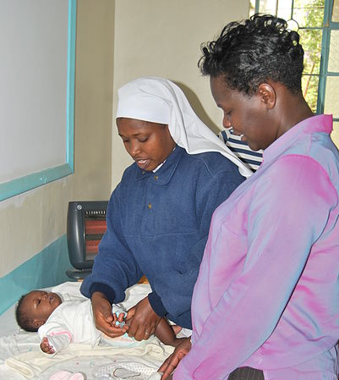
Figure 4.26 – A nurse giving an infant vaccinations.

Potential Side Effects
Vaccines, like all medical products, may cause side effects in some people. Most of these side effects are minor, such as redness or swelling at the injection site. Read further to learn about possible side effects from vaccines.

Any vaccine can cause side effects. For the most part these are minor (for example, a sore arm or low-grade fever) and go away within a few days. Serious side effects after vaccination, such as severe allergic reaction, are very rare.

Remember, vaccines are continually monitored for safety, and like any medication, vaccines can cause side effects. However, a decision not to immunize a child also involves risk and could put the child and others who come into contact with him or her at risk of contracting a potentially deadly disease.

How Well Do Vaccines Work?
Vaccines work really well. No medicine is perfect, of course, but most childhood vaccines produce immunity about 90–100% of the time.

What about the argument made by some people that vaccines don’t work that well . . . that diseases would be going away on their own because of better hygiene or sanitation, even if there were no vaccines?

That simply isn’t true. Certainly better hygiene and sanitation can help prevent the spread of disease, but the germs that cause disease will still be around, and as long as they are they will continue to make people sick.
All vaccines must be licensed (approved) by the Food and Drug Administration (FDA) before being used in the United States, and a vaccine must go through extensive testing to show that it works and that it is safe before the FDA will approve it. Among these tests are clinical trials, which compare groups of people who get a vaccine with groups of people who get a control. A vaccine is approved only if FDA makes the determination that it is safe and effective for its intended use.

If you look at the history of any vaccine-preventable disease, you will virtually always see that the number of cases of disease starts to drop when a vaccine is licensed. Vaccines are the most effective tool we have to prevent infectious diseases.

Opposition to Vaccines
In 2010, a pertussis (whooping cough) outbreak in California sickened 9,143 people and resulted in 10 infant deaths: the worst outbreak in 63 years (Centers for Disease Control 2011b). Researchers, suspecting that the primary cause of the outbreak was the waning strength of pertussis vaccines in older children, recommended a booster vaccination for 11–12-year-olds and also for pregnant women (Zacharyczuk 2011). Pertussis is most serious for babies; one in five needs to be hospitalized, and since they are too young for the vaccine themselves, it is crucial that people around them be immunized (Centers for Disease Control 2011b). Several states, including California, have been requiring the pertussis booster for older children in recent years with the hope of staving off another outbreak.

But what about people who do not want their children to have this vaccine, or any other? That question is at the heart of a debate that has been simmering for years. Vaccines are biological preparations that improve immunity against a certain disease. Vaccines have contributed to the eradication and weakening of numerous infectious diseases, including smallpox, polio, mumps, chicken pox, and meningitis.

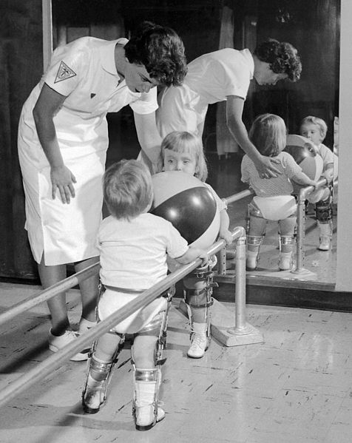
Figure 4.27 - These two young children contracted polio.
However, many people express concern about potential negative side effects from vaccines. These concerns range from fears about overloading the child’s immune system to controversial reports about devastating side effects of the vaccines.

Although children continue to get several vaccines up to their second birthday, these vaccines do not overload the immune system. Every day, an infant’s healthy immune system successfully fights off thousands of antigens – the parts of germs that cause their immune system to respond. Even if your child receives several vaccines in one day, vaccines contain only a tiny amount of antigens compared to the antigens your baby encounters every day.

This is the case even if your child receives combination vaccines. Combination vaccines take two or more vaccines that could be given individually and put them into one shot. Children get the same protection as they do from individual vaccines given separately—but with fewer shots.

One misapprehension is that the vaccine itself might cause the disease it is supposed to be immunizing against. Vaccines help develop immunity by imitating an infection, but this “imitation” infection does not cause illness. Instead it causes the immune system to develop the same response as it does to a real infection so the body can recognize and fight the vaccine-preventable disease in the future. Sometimes, after getting a vaccine, the imitation infection can cause minor symptoms, such as fever. Such minor symptoms are normal and should be expected as the body builds immunity.

Another commonly circulated concern is that vaccinations, specifically the MMR vaccine (MMR stands for measles, mumps, and rubella), are linked to autism. The autism connection has been particularly controversial. In 1998, a British physician named Andrew Wakefield published a study in Great Britain’s Lancet magazine that linked the MMR vaccine to autism. The report received a lot of media attention, resulting in British immunization rates decreasing from 91 percent in 1997 to almost 80 percent by 2003, accompanied by a subsequent rise in measles cases (Devlin 2008). A prolonged investigation by the British Medical Journal proved that not only was the link in the study nonexistent, but that Dr. Wakefield had falsified data in order to support his claims (CNN 2011). Dr. Wakefield was discredited and stripped of his license, but the doubt still lingers in many parents’ minds.

In the United States, many parents still believe in the now discredited MMR-autism link and refuse to vaccinate their children. Other parents choose not to vaccinate for various reasons like religious or health beliefs. In one instance, a boy whose parents opted not to vaccinate returned home to the U.S. after a trip abroad; no one yet knew he was infected with measles. The boy exposed 839 people to the disease and caused 11 additional cases of measles, all in other unvaccinated children, including one infant who had to be hospitalized.

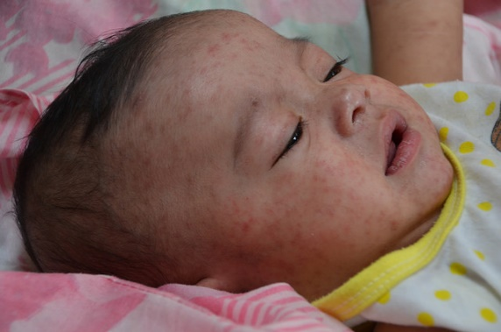
Figure 4.28 - A baby with measles

According to a study published in Pediatrics (2010), the outbreak cost the public sector $10,376 per diagnosed case. The study further showed that the intentional non-vaccination of those infected occurred in students from private schools, public charter schools, and public schools in upper-socioeconomic areas (Sugerman et al. 2010).

The Immunization Schedule
On-time vaccination throughout childhood is essential because it helps provide immunity before children are exposed to potentially life-threatening diseases. Vaccines are tested to ensure that they are safe and effective for children to receive at the recommended ages.
Fully vaccinated children in the U.S. are protected against sixteen potentially harmful diseases. Vaccine-preventable diseases can be very serious, may require hospitalization, or even be deadly — especially in infants and young children.

Here is the schedule from the CDC to ensure a child is fully vaccinated:

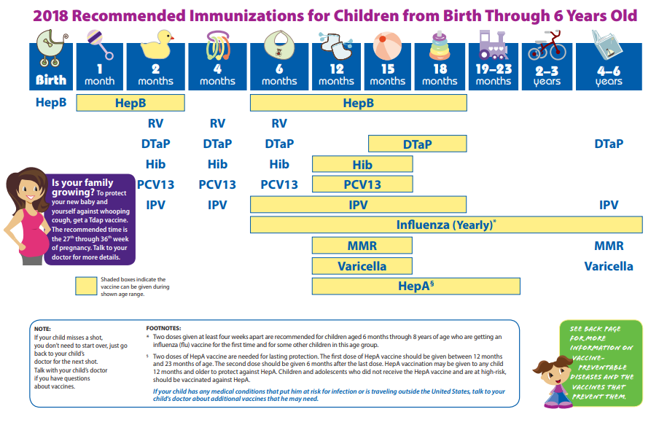
Figure 4.29 – Immunizations schedule.
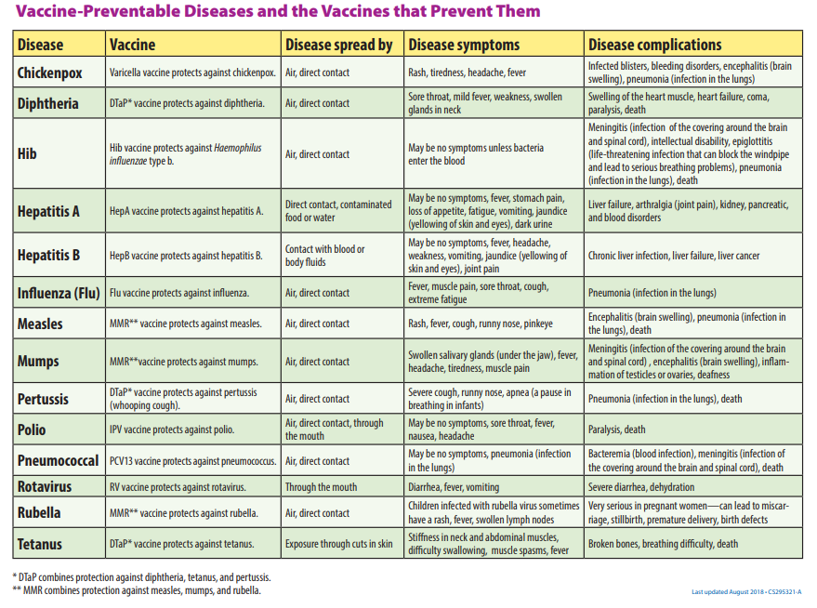
Figure 4.30 – Vaccine-Preventable Diseases.

Safety
There are different risks to infant safety. According to the CDC, nonfatal injury rates varied by age group.
- Nonfatal suffocation rates were highest for those less than 1 year of age.
- Rates for fires or burns, and drowning were highest for children 4 years and younger.
- Children 1 to 4 years of age had the highest rates of nonfatal falls and poisoning.

And the leading causes of injury death also differed by age group.
- For children less than 1 year of age, two–thirds of injury deaths were due to suffocation.
- Drowning was the leading cause of injury or death for those 1 to 4 years of age.

Car Seat Safety
Motor vehicle injuries are a leading cause of death among children in the United States. But many of these deaths can be prevented.
- In the United States, 723 children ages 12 years and younger died as occupants in motor vehicle crashes during 2016, and more than 128,000 were injured in 2016.
- One CDC study found that, in one year, more than 618,000 children ages 0-12 rode in vehicles without the use of a child safety seat or booster seat or a seat belt at least some of the time.
- Of the children ages 12 years and younger who died in a crash in 2016 (for which restraint use was known), 35% were not buckled up.

Buckling children in age- and size-appropriate car seats, booster seats, and seat belts reduces the risk of serious and fatal injuries:
- Car seat use reduces the risk for injury in a crash by 71-82% for children when compared to seat belt use alone.
- Booster seat use reduces the risk for serious injury by 45% for children aged 4–8 years when compared with seat belt use alone.
- For older children and adults, seat belt use reduces the risk for death and serious injury by approximately half.

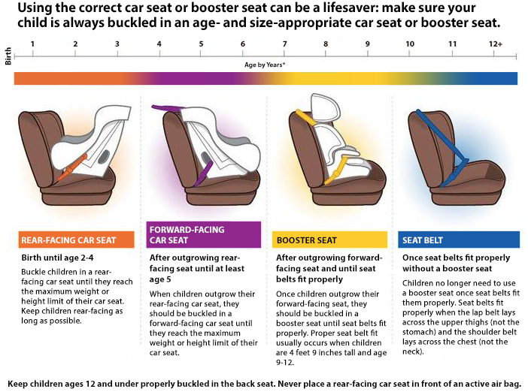
Figure 4.31 – The different types of car seats based on age.

Sleep
A newborn typically sleeps approximately 16.5 hours per 24-hour period. This is usually polyphasic sleep in that the infant is accumulating the 16.5 hours over several sleep periods throughout the day (Salkind, 2005). The infant is averaging 15 hours per 24-hour period by one month, and 14 hours by 6 months. By the time children turn two, they are averaging closer to 10 hours per 24 hours. Additionally, the average newborn will spend close to 50% of the sleep time in the Rapid Eye Movement (REM) phase, which decreases to 25% to 30% in childhood.

Sudden Infant Death Syndrome and Safe Sleep
Sudden Infant Death Syndrome (SIDS) is identified when the death of a healthy infant occurs suddenly and unexpectedly, and medical and forensic investigation findings (including an autopsy) are inconclusive. SIDS is the leading cause of death in infants 1 to 12 months old, and approximately 1,500 infants died of SIDS in 2013 (CDC, 2015). Because SIDS is diagnosed when no other cause of death can be determined, possible causes of SIDS are regularly researched. One leading hypothesis suggests that infants who die from SIDS have abnormalities in the area of the brainstem responsible for regulating breathing (Weekes-Shackelford & Shackelford, 2005).

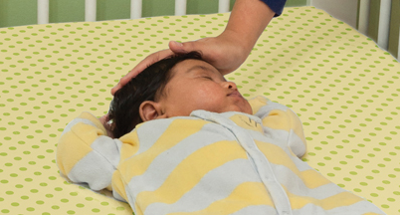
Figure 4.33 – A baby sleeping safely.

Risk Factors
Babies are at higher risk for SIDS if they:
- Sleep on their stomachs
- Sleep on soft surfaces, such as an adult mattress, couch, or chair or under soft coverings
- Sleep on or under soft or loose bedding
- Get too hot during sleep
- Are exposed to cigarette smoke in the womb or in their environment, such as at home, in the car, in the bedroom, or other areas
- Sleep in an adult bed with parents, other children, or pets; this situation is especially dangerous if:
  - The adult smokes, has recently had alcohol, or is tired.
  - The baby is covered by a blanket or quilt.
  - The baby sleeps with more than one bed-sharer.
  - The baby is younger than 11 to 14 weeks of age.

Reducing the Risks
There have been dramatic improvements in reducing baby deaths during sleep since the 1990s, when recommendations were introduced to place babies on their back for sleep. However, since the late 1990s, declines have slowed.

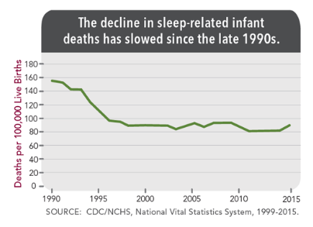
Figure 4.32 – A graph showing the decline in sleep-related infant deaths.

In 2012, the Back to Sleep campaign became the Safe to Sleep campaign. Safe to Sleep aims to educate all caregivers about SIDS and safe sleep practices. Current recommendations to reduce the risk of SIDS and other sleep related causes of infant death:
- Always place baby on his or her back to sleep (for naps and at night).
- Use a firm and flat surface.
- Use only a tight fitting sheet on the sleep surface; no other bedding or soft items in the sleep area.
- Breastfeed.
- Share your room with a baby, but on a separate surface designed for infants (not your bed).
- Do not put soft objects, toys, crib bumpers, or loose bedding under, over, or anywhere near baby’s sleep area.
- Do no smoke during pregnancy or allow smoking around baby.
- Consider giving baby a pacifier.
- Do not let baby get too hot during sleep.
- Get regular health care (including vaccines).
- Avoid products that go against safe sleep recommendations, especially those that claim to prevent or reduce the risk of SIDS.
- Do not use heart or breathing monitors to reduce the risk of SIDS.

Conclusion
In this chapter we looked at:
- Physical changes during the first two years
- Some common infant reflexes
- How fine and gross motor skills develop
- Sensory capacities during the first two years
- Health and safety for infants and toddlers
- The sleep needs during the first two years and ways to reduce the risk of SIDS

In the next chapter we are going to be taking a closer look at theories that help us explain the cognitive and language development during infancy and toddlerhood.

Chapter 5: Cognitive Development in Infancy and Toddlerhood

Objectives
After this chapter, you should be able to:
- Describe the substages of the Piaget’s sensorimotor stage.
- Explain how the social environment affects cognitive development according to Vygotsky’s theory.
- Discuss the progression of language development during the first two years.
- Compare the theories of language development.
- Define classical and operant conditioning.
- Summarize the different types of memory

Introduction
In an effort to better understand the large spectrum of cognition that infants and toddlers go through, it is important to analyze and comprehend various theories that relate to their growth and development. This chapter will take a look at the following theorists: Piaget, Vygotsky, Chomsky, Skinner, Pavlov, Watson, Bandura, and Bronfenbrenner.

Piaget
Jean Piaget is the most noted theorist when it comes to children's cognitive development. He believed that children's cognition develops in stages. He explained this growth in the following stages:
- Sensory Motor Stage (Birth through 2 years old)
- Preoperational Stage (2-7 years old)
- Concrete Operational Stage (7-11 years old)
- Formal Operational Stage (12 years old- adulthood)
In this cognitive chapter we will focus on his first stage which occurs in infancy.

Piaget and Sensorimotor Intelligence
Piaget describes intelligence in infancy as sensorimotor or based on direct, physical contact. Infants taste, feel, pound, push, hear, and move in order to experience the world. Let’s explore the transition infants make from responding to the external world reflexively as newborns to solving problems using mental strategies as two years old.

Table 5.1 - Substages of Piaget’s Sensorimotor Stage

Substage | Age | Description
Substage One: Simple Reflexes | Birth to 1 month | This active learning begins with automatic movements or reflexes. A ball comes into contact with an infant’s cheek and is automatically sucked on and licked.
Substage Two: Primary Circular Reactions | 1 to 4 months | The infant begins to discriminate between objects and adjust responses accordingly as reflexes are replaced with voluntary movements. An infant may accidentally engage in a behavior and find it interesting such as making a vocalization. This interest motivates trying to do it again and helps the infant learn a new behavior that originally occurred by chance. At first, most actions have to do with the body, but in months to come, will be directed more toward objects.
Substage Three: Secondary Circular Reactions | 4 to 8 months | The infant becomes more and more actively engaged in the outside world and takes delight in being able to make things happen. Repeated motion brings particular interest as the infant is able to bang two lids together from the cupboard when seated on the kitchen floor.
Substage Four: Coordination of circular reactions | 8 to 12 months | The infant can engage in behaviors that others perform and anticipate upcoming events. Perhaps because of continued maturation of the prefrontal cortex, the infant becomes capable of having a thought and carrying out a planned, goal-directed activity such as seeking a toy that has rolled under the couch. The object continues to exist in the infant’s mind even when out of sight and the infant now is capable of making attempts to retrieve it.
Substage Five: Tertiary Circular Reactions | 12 to 18 months | The infant more actively engages in experimentation to learn about the physical world. Gravity is learned by pouring water from a cup or pushing bowls from high chairs. The caregiver tries to help the child by picking it up again and placing it on the tray. And what happens? Another experiment! The child pushes it off the tray again causing it to fall and the caregiver to pick it up again!
Substage Six: Internalization of Schemes and Early Representational thought | 18 months to 2 years | The child is now able to solve problems using mental strategies, to remember something heard days before and repeat it, to engage in pretend play, and to find objects that have been moved even when out of sight. Take for instance, the child who is upstairs in a room with the door closed, supposedly taking a nap. The doorknob has a safety device on it that makes it impossible for the child to turn the knob. After trying several times in vain to push the door or turn the doorknob, the child carries out a mental strategy learned from prior experience to get the door opened-he knocks on the door! The child is now better equipped with mental strategies for problem-solving.
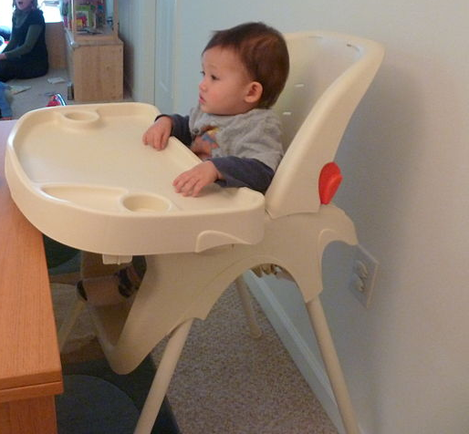
Figure 5.1 – An infant sitting in a highchair.

Evaluating Piaget’s Sensorimotor Stage
Piaget opened up a new way of looking at infants with his view that their main task is to coordinate their sensory impressions with their motor activity. However, the infant’s cognitive world is not as neatly packaged as Piaget portrayed it, and some of Piaget’s explanations for the cause of change are debated. In the past several decades, sophisticated experimental techniques have been devised to study infants, and there have been a large number of research studies on infant development. Much of the new research suggests that Piaget’s view of sensorimotor development needs to be modified (Baillargeon, 2014; Brooks & Meltzoff, 2014; Johnson & Hannon, 2015).

Object Permanence
One necessary modification would be to when children develop object permanence. Infants seem to be able to recognize that objects have permanence at much younger ages than Piaget proposed (even as young as 3.5 months of age).

The A-not-B Error
The data does not always support Piaget’s claim that certain processes are crucial in transitions from one stage to the next. For example, in Piaget’s theory, an important feature in the progression into substage 4, coordination of secondary circular reactions, is an infant’s inclination to search for a hidden object in a familiar location rather than to look for the object in a new location. Thus, if a toy is hidden twice, initially at location A and subsequently at location B, 8- to 12-month-old infants search correctly at location A initially. But when the toy is subsequently hidden at location B, they make the mistake of continuing to search for it at location A. A-not-B error is the term used to describe this common mistake. Older infants are less likely to make the A-not-B error because their concept of object permanence is more complete.

Researchers have found, however, that the A-not-B error does not show up consistently (Sophian, 1985). The evidence indicates that A-not-B errors are sensitive to the delay between hiding the object at B and the infant’s attempt to find it (Diamond, 1985). Thus, the A-not-B error might be due to a failure in memory. Another explanation is that infants tend to repeat a previous motor behavior (Clearfield & others, 2006; Smith, 1999).

Vygotsky

Development Is Determined By Environmental Factors
Piaget set the tone for much of current-day research but his theory has also received a great deal of criticism. Many believe that Piaget ignored the huge influence that society and culture have in shaping a child’s development. At a similar time, another researcher named Lev Vygotsky (1896–1934) had come to similar conclusions as Piaget about children’s development, in thinking that children learned about the world through physical interaction with it. However, where Piaget felt that children moved naturally through different stages of development, based on biological predispositions and their own individual interactions with the world, Vygotsky claimed that adult or peer intervention was a much more important part of the developmental process.

Vygotsky concentrated more on the child’s immediate social and cultural environment and his or her interactions with adults and peers. He argued that development occurred first through children’s immediate social interactions, and then moved to the individual level as they began to internalize their learning. While Piaget saw the child as actively discovering the world through individual interactions with it, Vygotsky saw the child as more of an apprentice, learning through a social environment of others who had more experience and were sensitive to the child’s needs and abilities.

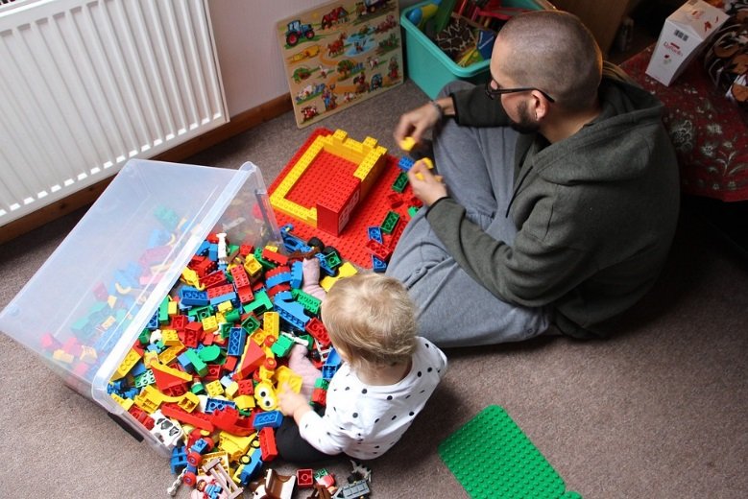
Figure 5.2 – An adult playing Legos with a child.

Cognitive Milestones
Children are actively learning about the world as they perceive it from the time they are in the womb. Here is a table of some of the cognitive milestones infants and toddlers typically develop.

Table 5.2 - Cognitive Milestones

Typical Age | What Most Children Do by This Age
2 months | - Pays attention to faces  - Begins to follow things with eyes and recognize people at a distance  - Begins to act bored (cries, fussy) if activity doesn’t change
4 months | - Lets you know if she is happy or sad  - Responds to affection  - Reaches for toy with one hand  - Uses hands and eyes together, such as seeing a toy and reaching for it  - Follows moving things with eyes from side to side  - Watches faces closely  - Recognizes familiar people and things at a distance
6 months | - Looks around at things nearby  - Brings things to mouth  - Shows curiosity about things and tries to get things that are out of reach  - Begins to pass things from one hand to the other
9 months | - Watches the path of something as it falls  - Looks for things he sees you hide  - Plays peek-a-boo  - Puts things in mouth  - Moves things smoothly from one hand to the other  - Picks up things like cereal o’s between thumb and index finger
1 year | - Explores things in different ways, like shaking, banging, throwing  - Finds hidden things easily  - Looks at the right picture or thing when it’s named  - Copies gestures  - Starts to use things correctly; for example, drinks from a cup, brushes hair  - Bangs two things together  - Puts things in a container, takes things out of a container  - Lets things go without help  - Pokes with index (pointer) finger  - Follows simple directions like “pick up the toy”
18 months | - Knows what ordinary things are for; for example, telephone, brush, spoon  - Points to get the attention of others  - Shows interest in a doll or stuffed animal by pretending to feed  - Points to one body part  - Scribbles on own  - Can follow 1-step verbal commands without any gestures; for example, sits when you say “sit down”
2 years | - Finds things even when hidden under two or three covers  - Begins to sort shapes and colors  - Completes sentences and rhymes in familiar books  - Plays simple make-believe games  - Builds towers of 4 or more blocks  - Might use one hand more than the other  - Follows two-step instructions such as “Pick up your shoes and put them in the closet.”  - Names items in a picture book such as a cat, bird, or dog

Language Development
Do newborns communicate? Absolutely! However, they do not communicate with the use of language. Instead, they communicate their thoughts and needs with body posture (being relaxed or still), gestures, cries, and facial expressions. A person who spends adequate time with an infant can learn which cries indicate pain and which ones indicate hunger, discomfort, or frustration as well as translate their vocalizations, movements, gestures and facial expressions.
Figure 5.3 – An infant looking up at the camera.

Stages of Language Development
- Intentional Vocalizations: Cooing and taking turns: Infants begin to vocalize and repeat vocalizations within the first couple of months of life. That gurgling, musical vocalization called cooing can serve as a source of entertainment to an infant who has been laid down for a nap or seated in a carrier on a car ride. Cooing serves as practice for vocalization as well as the infant hears the sound of his or her own voice and tries to repeat sounds that are entertaining. Infants also begin to learn the pace and pause of conversation as they alternate their vocalization with that of someone else and then take their turn again when the other person’s vocalization has stopped. Cooing initially involves making vowel sounds like “oooo”. Later, consonants are added to vocalizations such as “nananananana”.
- Babbling and gesturing: At about four to six months of age, infants begin making even more elaborate vocalizations that include the sounds required for any language. Guttural sounds, clicks, consonants, and vowel sounds stand ready to equip the child with the ability to repeat whatever sounds are characteristic of the language heard. Eventually, these sounds will no longer be used as the infant grows more accustomed to a particular language. Deaf babies also use gestures to communicate wants, reactions, and feelings. Because gesturing seems to be easier than vocalization for some toddlers, sign language is sometimes taught to enhance one’s ability to communicate by making use of the ease of gesturing. The rhythm and pattern of language is used when deaf babies sign just as it is when hearing babies babble.
- Understanding: At around ten months of age, the infant can understand more than he or she can say. You may have experienced this phenomenon as well if you have ever tried to learn a second language. You may have been able to follow a conversation more easily than to contribute to it.
- Holophrastic speech: Children begin using their first words at about 12 or 13 months of age and may use partial words to convey thoughts at even younger ages. These one word expressions are referred to as holophrastic speech. For example, the child may say “ju” for the word “juice” and use this sound when referring to a bottle. The listener must interpret the meaning of the holophrase and when this is someone who has spent time with the child, interpretation is not too difficult. They know that “ju” means “juice” which means the baby wants some milk! But, someone who has not been around the child will have trouble knowing what is meant. Imagine the parent who to a friend exclaims, “Ezra’s talking all the time now!” The friend hears only “ju da ga” which, the parent explains, means “I want some milk when I go with Daddy.”

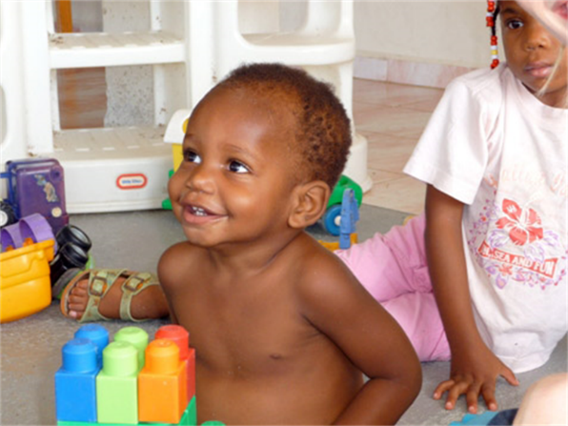
Figure 5.4 – Two children playing with toys.
- Underextension: A child who learns that a word stands for an object may initially think that the word can be used for only that particular object. Only the family’s Irish Setter is a “doggie”. This is referred to as underextension. More often, however, a child may think that a label applies to all objects that are similar to the original object. In overextension all animals become “doggies”, for example.
- First words and cultural influences: First words if the child is using English tend to be nouns. The child labels objects such as cup or ball. In a verb-friendly language such as Chinese, however, children may learn more verbs. This may also be due to the different emphasis given to objects based on culture. Chinese children may be taught to notice action and relationship between objects while children from the United States may be taught to name an object and its qualities (color, texture, size, etc.). These differences can be seen when comparing interpretations of art by older students from China and the United States.
- Vocabulary growth spurt: One year olds typically have a vocabulary of about 50 words. But by the time they become toddlers, they have a vocabulary of about 200 words and begin putting those words together in telegraphic speech (I think of it now as 'text message' speech because texting is more common and is similar in that text messages typically only include the minimal amount of words to convey the message).
- Two word sentences and telegraphic speech: Words are soon combined and 18 month old toddlers can express themselves further by using expressions such as “baby bye-bye” or “doggie pretty”. Words needed to convey messages are used, but the articles and other parts of speech necessary for grammatical correctness are not yet used. These expressions sound like a telegraph (or perhaps a better analogy today would be that they read like a text message) where unnecessary words are not used. “Give baby ball” is used rather than “Give the baby the ball.” Or a text message of “Send money now!” rather than “Dear Mother. I really need some money to take care of my expenses.”

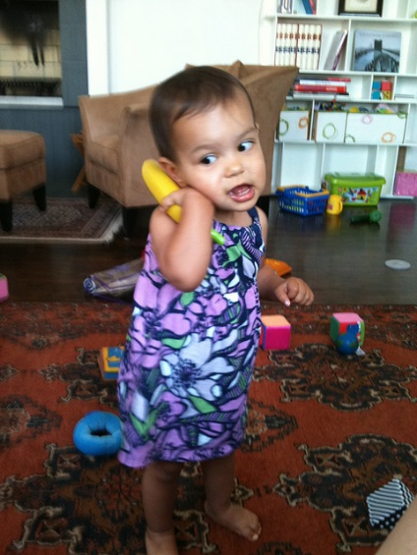
Figure 5.5 – A toddler playing with a toy telephone.

Language Milestones
In the first two years of life, children go from communicating by crying to being able to express themselves with words. Here is a table of common language milestones for infants and toddlers.

Table 5.3 - Language Milestones

Typical Age | What Most Children Do By This Age
2 months | - Coos, makes gurgling sounds  - Turns head toward sounds
4 months | - Begins to babble  - Babbles with expression and copies sounds he hears  - Cries in different ways to show hunger, pain, or being tired
6 months | - Responds to sounds by making sounds  - Strings vowels together when babbling (“ah,” “eh,” “oh”) and likes taking turns with parent while making sounds  - Responds to own name  - Makes sounds to show joy and displeasure  - Begins to say consonant sounds (jabbering with “m,” “b”)
9 months | - Understands “no”  - Makes a lot of different sounds like “mamamama” and “bababababa”  - Copies sounds and gestures of others  - Uses fingers to point at things
1 year | - Responds to simple spoken requests  - Uses simple gestures, like shaking head “no” or waving “bye-bye”  - Makes sounds with changes in tone (sounds more like speech)  - Says “mama” and “dada” and exclamations like “uh-oh!”  - Tries to say words you say
18 months | - Says several single words  - Says and shakes head now  - Points to show others what is wanted
2 years | - Points to things or pictures when they are named  - Knows names of familiar people and body parts  - Says sentences with 2 to 4 words  - Follows simple instructions  - Repeats words overheard in conversation  - Points to things in a book

Child-Directed Speech
Why is a horse a “horsie”? Have you ever wondered why adults tend to use “baby talk” or that sing-song type of intonation and exaggeration used when talking to children? This represents a universal tendency and is known as child-directed speech or parentheses (historically referred to as motherese). It involves exaggerating the vowel and consonant sounds, using a high-pitched voice, and delivering the phrase with great facial expression. Why is this done? It may be in order to clearly articulate the sounds of a word so that the child can hear the sounds involved. Or it may be because when this type of speech is used, the infant pays more attention to the speaker and this sets up a pattern of interaction in which the speaker and listener are in tuned with one another.

Theories of Language Development
The following two theories of language development represent two extremes in the level of interaction required for language to occur (Berk, 2007).

Chomsky and the Language Acquisition Device
The view known as nativism advocated by Noam Chomsky suggests that infants are equipped with a neurological construct referred to as the language acquisition device or LAD that makes infants ready for language. Language develops as long as the infant is exposed to it. No teaching, training, or reinforcement is required for language to develop.

Social Pragmatics
Another view emphasizes the child’s active engagement in learning language out of a need to communicate. The child seeks information, memorizes terms, imitates the speech heard from others and learns to conceptualize using words as language is acquired. Many would argue that all three of these dynamics foster the acquisition of language (Berger, 2004).

Theories of Cognitive Development, Learning, and Memory

Pavlov
Ivan Pavlov (1880-1937) was a Russian physiologist interested in studying digestion. As he recorded the amount of salivation his laboratory dogs produced as they ate, he noticed that they actually began to salivate before the food arrived as the researcher walked down the hall and toward the cage. The dogs knew that the food was coming because they had learned to associate the footsteps with the food. The key word here is “learned”. A learned response is called a “conditioned” response.

Pavlov began to experiment with this “psychic” reflex. He began to ring a bell, for instance, prior to introducing the food. Sure enough, after making this connection several times, the dogs could be made to salivate to the sound of a bell. Once the bell had become an event to which the dogs had learned to salivate, it was called a conditioned stimulus. The act of salivating to a bell was a response that had also been learned, now termed in Pavlov’s jargon, a conditioned response.

Notice that the response, salivation, is the same whether it is conditioned or unconditioned (unlearned or natural). What changed is the stimulus to which the dog salivates. One is natural (unconditioned) and one is learned (conditioned).

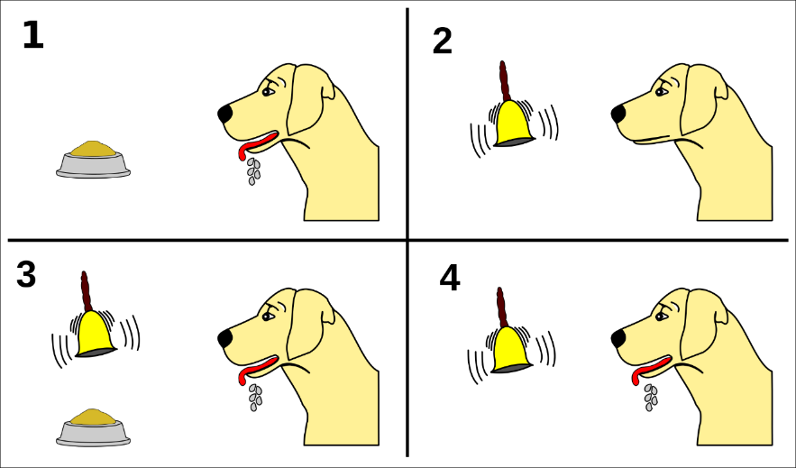
Figure 5.6 – Pavlov’s experiments with dogs and conditioning.

Let’s think about how classical conditioning is used on us. One of the most widespread applications of classical conditioning principles was brought to us by the psychologist, John B. Watson.

Classical Conditioning
Classical conditioning is a form of learning whereby a conditioned stimulus (CS) becomes associated with an unrelated unconditioned stimulus (US), in order to produce a behavioral response known as a conditioned response (CR). The conditioned response is the learned response to the previously neutral stimulus. The unconditioned stimulus is usually a biologically significant stimulus such as food or pain that elicits an unconditioned response (UR) from the start. The conditioned stimulus is usually neutral and produces no particular response at first, but after conditioning it elicits the conditioned response.

If we look at Pavlov's experiment, we can identify these four factors at work:
- The unconditioned response was the salivation of dogs in response to seeing or smelling their food.
- The unconditioned stimulus was the sight or smell of the food itself.
- The conditioned stimulus was the ringing of the bell. During conditioning, every time the animal was given food, the bell was rung. This was repeated during several trials. After some time, the dog learned to associate the ringing of the bell with food and to respond by salivating. After the conditioning period was finished, the dog would respond by salivating when the bell was rung, even when the unconditioned stimulus (the food) was absent.
- The conditioned response, therefore, was the salivation of the dogs in response to the conditioned stimulus (the ringing of the bell).

Neurological Response to Conditioning
Consider how the conditioned response occurs in the brain. When a dog sees food, the visual and olfactory stimuli send information to the brain through their respective neural pathways, ultimately activating the salivary glands to secrete saliva. This reaction is a natural biological process as saliva aids in the digestion of food. When a dog hears a buzzer and at the same time sees food, the auditory stimuli activates the associated neural pathways. However, since these pathways are being activated at the same time as the other neural pathways, there are weak synapse reactions that occur between the auditory stimuli and the behavioral response. Over time, these synapses are strengthened so that it only takes the sound of a buzzer to activate the pathway leading to salivation.

Operant Conditioning
Operant conditioning is a theory of behaviorism, a learning perspective that focuses on changes in an individual's observable behaviors. In operant conditioning theory, new or continued behaviors are impacted by new or continued consequences. Research regarding this principle of learning was first studied by Edward L. Thorndike in the late 1800's, then brought to popularity by B.F. Skinner in the mid-1900's. Much of this research informs current practices in human behavior and interaction.

Skinner's Research
Thorndike's initial research was highly influential on another psychologist, B.F. Skinner. Almost half a century after Thorndike's first publication of the principles of operant conditioning, Skinner attempted to prove an extension to this theory—that all behaviors were in some way a result of operant conditioning. Skinner theorized that if a behavior is followed by reinforcement, that behavior is more likely to be repeated, but if it is followed by punishment, it is less likely to be repeated. He also believed that this learned association could end, or become extinct, if the reinforcement or punishment was removed.

To prove this, he placed rats in a box with a lever that when tapped would release a pellet of food. Over time, the amount of time it took for the rat to find the lever and press it became shorter and shorter, until finally the rat would spend most of its time near the lever eating. This behavior became less consistent when the relationship between the lever and the food was compromised. This basic theory of operant conditioning is still used by psychologists, scientists, and educators today.

Shaping, Reinforcement Principles, and Schedules of Reinforcement
Operant conditioning can be viewed as a process of action and consequence. Skinner used this basic principle to study the possible scope and scale of the influence of operant conditioning on animal behavior. His experiments used shaping, reinforcement, and reinforcement schedules in order to prove the importance of the relationship that animals form between behaviors and results.

All of these practices concern the setup of an experiment. Shaping is the conditioning paradigm of an experiment. The form of the experiment in successive trials is gradually changed to elicit a desired target behavior. This is accomplished through reinforcement, or reward, of the segments of the target behavior, and can be tested using a large variety of actions and rewards.
The experiments were taken a step further to include different schedules of reinforcement that become more complicated as the trials continued. By testing different reinforcement schedules, Skinner learned valuable information about the best ways to encourage a specific behavior, or the most effective ways to create a long-lasting behavior. Much of this research has been replicated on humans, and now informs practices in various environments of human behavior.

Positive and Negative Reinforcement
Sometimes, adding something to the situation is reinforcing as in the cases we described above with cookies, praise and money. Positive reinforcement involves adding something to the situation in order to encourage a behavior. Other times, taking something away from a situation can be reinforcing. For example, the loud, annoying buzzer on your alarm clock encourages you to get up so that you can turn it off and get rid of the noise. Children whine in order to get their parents to do something and often, parents give in just to stop the whining. In these instances, negative reinforcement has been used.

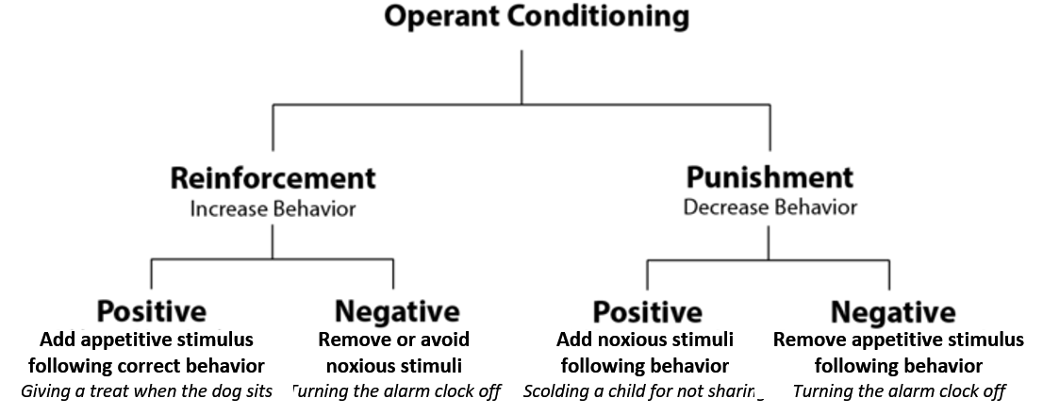
Figure 5.7 – Reinforcement in operant conditioning.

Operant conditioning tends to work best if you focus on trying to encourage a behavior or move a person into the direction you want them to go rather than telling them what not to do. Reinforcers are used to encourage a behavior; punishers are used to stop behavior. A punisher is anything that follows an act and decreases the chance it will reoccur. But often a punished behavior doesn’t really go away. It is just suppressed and may reoccur whenever the threat of punishment is removed. For example, a child may not cuss around you because you’ve washed his mouth out with soap, but he may cuss around his friends. Or a motorist may only slow down when the trooper is on the side of the freeway. Another problem with punishment is that when a person focuses on punishment, they may find it hard to see what the other does right or well. And punishment is stigmatizing; when punished, some start to see themselves as bad and give up trying to change.

Reinforcement can occur in a predictable way, such as after every desired action is performed, or intermittently, after the behavior is performed a number of times or the first time it is performed after a certain amount of time. The schedule of reinforcement has an impact on how long a behavior continues after reinforcement is discontinued. So a parent who has rewarded a child’s actions each time may find that the child gives up very quickly if a reward is not immediately forthcoming. Think about the kinds of behaviors that may be learned through classical and operant conditioning. But sometimes very complex behaviors are learned quickly and without direct reinforcement. Bandura’s Social Learning covered later in the chapter explains how.

Watson and Behaviorism
Another theorist who added to the spectrum of the behavioral movement was John B. Watson. Watson believed that most of our fears and other emotional responses are classically conditioned. He had gained a good deal of popularity in the 1920s with his expert advice on parenting offered to the public. He believed that parents could be taught to help shape their children’s behavior and tried to demonstrate the power of classical conditioning with his famous experiment with an 18 month old boy named “Little Albert”. Watson sat Albert down and introduced a variety of seemingly scary objects to him: a burning piece of newspaper, a white rat, etc. But Albert remained curious and reached for all of these things. Watson knew that one of our only inborn fears is the fear of loud noises so he proceeded to make a loud noise each time he introduced one of Albert’s favorites, a white rat. After hearing the loud noise several times paired with the rat, Albert soon came to fear the rat and began to cry when it was introduced.

Watson filmed this experiment for posterity and used it to demonstrate that he could help parents achieve any outcomes they desired, if they would only follow his advice. Watson wrote columns in newspapers and in magazines and gained a lot of popularity among parents eager to apply science to household order. Parenting advice was not the legacy Watson left us, however. Where he really made his impact was in advertising. After Watson left academia, he went into the world of business and showed companies how to tie something that brings about a natural positive feeling to their products to enhance sales. Thus the union of sex and advertising!.
Sometimes we do things because we’ve seen it pay off for someone else. They were operantly conditioned, but we engage in the behavior because we hope it will pay off for us as well. This is referred to as vicarious reinforcement (Bandura, Ross and Ross, 1963).

Figure 5.8 – A photograph taken during Little Albert research.

Do parents socialize children or do children socialize parents?
Bandura (1986) suggests that there is interplay between the environment and the individual. We are not just the product of our surroundings, rather we influence our surroundings. There is interplay between our personality and the way we interpret events and how they influence us. This concept is called reciprocal determinism. An example of this might be the interplay between parents and children. Parents not only influence their child’s environment, perhaps intentionally through the use of reinforcement, etc., but children influence parents as well. Parents may respond differently with their first child than with their fourth. Perhaps they try to be the perfect parents with their firstborn, but by the time their last child comes along they have very different expectations both of themselves and their child. Our environment creates us and we create our environment.

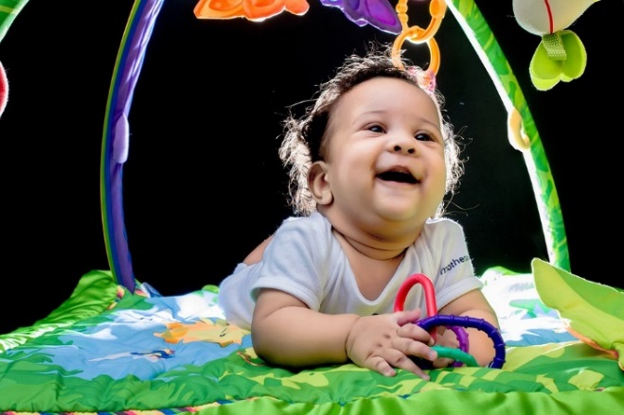
Figure 5.9 – A smiling infant playing with toys.

Social Learning Theory
Albert Bandura is a leading contributor to social learning theory. He calls our attention to the ways in which many of our actions are not learned through conditioning; rather, they are learned by watching others (1977). Young children frequently learn behaviors through imitation. Sometimes, particularly when we do not know what else to do, we learn by modeling or copying the behavior of others. A new employee, on his or her first day of a new job might eagerly look at how others are acting and try to act the same way to fit in more quickly. Adolescents struggling with their identity rely heavily on their peers to act as role-models. Newly married couples often rely on roles they may have learned from their parents and begin to act in ways they did not while dating and then wonder why their relationship has changed.

Memory and Attention

Memory
If we want to remember something tomorrow, we have to consolidate it into long-term memory today. Long-term memory is the final, semi-permanent stage of memory. Unlike sensory and short-term memory, long-term memory has a theoretically infinite capacity, and information can remain there indefinitely. Long-term memory has also been called reference memory, because an individual must refer to the information in long-term memory when performing almost any task. Long-term memory can be broken down into two categories: explicit and implicit memory.

Explicit Memory
Explicit memory, also known as conscious or declarative memory, involves memory of facts, concepts, and events that require conscious recall of the information. In other words, the individual must actively think about retrieving the information from memory. This type of information is explicitly stored and retrieved—hence its name. Explicit memory can be further subdivided into semantic memory, which concerns facts, and episodic memory, which concerns primarily personal or autobiographical information.

Episodic Memory
Episodic memory is used for more contextualized memories. They are generally memories of specific moments, or episodes, in one's life. As such, they include sensations and emotions associated with the event, in addition to the who, what, where, and when of what happened. An example of an episodic memory would be recalling your family's trip to the beach. Autobiographical memory (memory for particular events in one's own life) is generally viewed as either equivalent to, or a subset of, episodic memory. One specific type of autobiographical memory is a flashbulb memory, which is a highly detailed, exceptionally vivid "snapshot" of the moment and circumstances in which a piece of surprising and consequential (or emotionally arousing) news was heard. For example, many people remember exactly where they were and what they were doing when they heard of the terrorist attacks on September 11, 2001. This is because it is a flashbulb memory.

Semantic and episodic memory are closely related; memory for facts can be enhanced with episodic memories associated with the fact, and vice versa. For example, the answer to the factual question "Are all apples red?" might be recalled by remembering the time you saw someone eating a green apple. Likewise, semantic memories about certain topics, such as football, can contribute to more detailed episodic memories of a particular personal event, like watching a football game. A person that barely knows the rules of football will remember the various plays and outcomes of the game in much less detail than a football expert.

Implicit Memory
In contrast to explicit (conscious) memory, implicit (also called "unconscious" or "procedural") memory involves procedures for completing actions. These actions develop with practice over time. Athletic skills are one example of implicit memory. You learn the fundamentals of a sport, practice them over and over, and then they flow naturally during a game. Rehearsing for a dance or musical performance is another example of implicit memory. Everyday examples include remembering how to tie your shoes, drive a car, or ride a bicycle. These memories are accessed without conscious awareness—they are automatically translated into actions without us even realizing it. As such, they can often be difficult to teach or explain to other people. Implicit memories differ from the semantic scripts described above in that they are usually actions that involve movement and motor coordination, whereas scripts tend to emphasize social norms or behaviors.

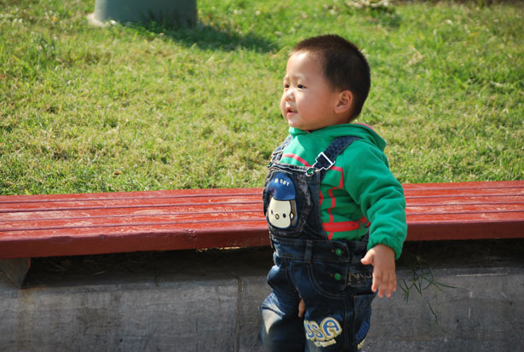
Figure 5.10 – A toddler walking.

Short-Term Memory Storage
Short-term memory is the ability to hold information for a short duration of time (on the order of seconds). In the process of encoding, information enters the brain and can be quickly forgotten if it is not stored further in the short-term memory. George A. Miller suggested that the capacity of short-term memory storage is approximately seven items plus or minus two, but modern researchers are showing that this can vary depending on variables like the stored items' phonological properties. When several elements (such as digits, words, or pictures) are held in short-term memory simultaneously, their representations compete with each other for recall, or degrade each other. Thereby, new content gradually pushes out older content, unless the older content is actively protected against interference by rehearsal or by directing attention to it.

Information in the short-term memory is readily accessible, but for only a short time. It continuously decays, so in the absence of rehearsal (keeping information in short-term memory by mentally repeating it) it can be forgotten.

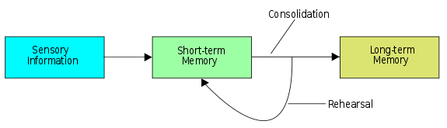
Figure 5.11 – Diagram of the memory storage process.

Long-Term Memory Storage
In contrast to short-term memory, long-term memory is the ability to hold semantic information for a prolonged period of time. Items stored in short-term memory move to long-term memory through rehearsal, processing, and use. The capacity of long-term memory storage is much greater than that of short-term memory, and perhaps unlimited. However, the duration of long-term memories is not permanent; unless a memory is occasionally recalled, it may fail to be recalled on later occasions. This is known as forgetting.

Long-term memory storage can be affected by traumatic brain injury or lesions. Amnesia, a deficit in memory, can be caused by brain damage. Anterograde amnesia is the inability to store new memories; retrograde amnesia is the inability to retrieve old memories. These types of amnesia indicate that memory does have a storage process.

Conclusion
In this chapter we looked at:
- Piaget’s sensorimotor stage.
- The impact of the social environment on children’s learning.
- The progression and theories of language development.
- Classical and operant conditioning and systems of reinforcement.
- The types of memory and how they work together.
In the following chapter, we will finish looking at the first two years of life by examining social and emotional development, including temperament and attachment.

Chapter 6: Social and Emotional Development in Infancy and Toddlerhood

Objectives
After this chapter, you should be able to:
- Classify types of temperament.
- Discuss the roles of culture and gender in socialization.
- Describe the sequence of emotional development during the first two years.
- Compare different theories of attachment and attachment styles.
- Explain Erikson’s stage of trust versus mistrust.
- Contrast child care options for families.

Introduction
While temperament is determined by genetics and emotions develop through maturation, the early interactions we have with the adults that care for us as infants and toddlers are very important for healthy emotional development. Let’s examine some of the important interactions and milestones in social and emotional development during the first two years of life.

Temperament
Perhaps you have spent time with a number of infants. How were they alike? How did they differ? How do you compare with your siblings or other children you have known well? You may have noticed that some seemed to be in a better mood than others and that some were more sensitive to noise or more easily distracted than others. These differences may be attributed to temperament. Temperament is the innate characteristics of the infant, including mood, activity level, and emotional reactivity, noticeable soon after birth.

In a 1956 landmark study, Chess and Thomas (1996) evaluated 141 children’s temperament based on parental interviews. Referred to as the New York Longitudinal Study, infants were assessed on 10 dimensions of temperament including:

- activity level
- rhythmicity (regularity of biological functions)
- approach/withdrawal (how children deal with new things)
- adaptability to situations
- intensity of reactions
- threshold of responsiveness (how intense a stimulus has to be for the child to react)
- quality of mood
- distractibility
- attention span
- persistence

Based on the infants’ behavioral profiles, they were categorized into three general types of temperament:

Table 6.1 - Types of Temperament

Type | Percentage | Description
Easy | 40% | - Able to quickly adapt to routine and new situations  - Remains calm  - Easy to soothe  - Usually in positive mood
Difficult | 10% | - Reacts negatively to new situations  - Has trouble adapting to routine  - Usually negative in mood  - Cries frequently
Slow-to-warm-up | 15% | - Low activity level  - Adjusts slowly to new situations  - Often negative in mood

As can be seen the percentages do not equal 100% as some children were not able to be placed neatly into one of the categories. Think about how each type of child should be approached to improve interactions with them. An easy child requires less intervention, but still has needs that must not be overlooked. A slow-to-warm-up child may need to be given advance warning if new people or situations are going to be introduced. A child with a difficult temperament may need to be given extra time to burn off their energy.

A caregiver's ability to work well and accurately read the child will enjoy a goodness- of-fit, meaning their styles match and communication and interaction can flow. Parents who recognize each child’s temperament and accept it, will nurture more effective interactions with the child and encourage more adaptive functioning.

Figure 6.1 – This adventurous child’s parents provide a good “fit” to her temperament.

Parenting Is Bidirectional
Not only do parents affect their children, children influence their parents. A child’s characteristics, such as temperament, affect parenting behaviors and roles. For example, an infant with an easy temperament may enable parents to feel more effective, as they are easily able to soothe the child and elicit smiling and cooing. On the other hand, a cranky or fussy infant elicits fewer positive reactions from his or her parents and may result in parents feeling less effective in the parenting role (Eisenberg et al., 2008). Over time, parents of more difficult children may become more punitive and less patient with their children (Clark, Kochanska, & Ready, 2000; Eisenberg et al., 1999; Kiff, Lengua, & Zalewski, 2011). Parents who have a fussy, difficult child are less satisfied with their marriages and have greater challenges in balancing work and family roles (Hyde, Else-Quest, & Goldsmith, 2004). Thus, child temperament is one of the child characteristics that influences how parents behave with their children.

Personality
Temperament does not change dramatically as we grow up, but we may learn how to work around and manage our temperamental qualities. Temperament may be one of the things about us that stays the same throughout development. In contrast, personality, defined as an individual’s consistent pattern of feeling, thinking, and behaving, is the result of the continuous interplay between biological disposition and experience.

Personality also develops from temperament in other ways (Thompson, Winer, & Goodvin, 2010). As children mature biologically, temperamental characteristics emerge and change over time. A newborn is not capable of much self-control, but as brain-based capacities for self- control advance, temperamental changes in self-regulation become more apparent. For example, a newborn who cries frequently doesn’t necessarily have a grumpy personality; over time, with sufficient parental support and increased sense of security, the child might be less likely to cry.

In addition, personality is made up of many other features besides temperament. Children’s developing self-concept, their motivations to achieve or to socialize, their values and goals, their coping styles, their sense of responsibility and conscientiousness, as well as many other qualities are encompassed into personality. These qualities are influenced by biological dispositions, but even more by the child’s experiences with others, particularly in close relationships, that guide the growth of individual characteristics. Indeed, personality development begins with the biological foundations of temperament but becomes increasingly elaborated, extended, and refined over time. The newborn that parents gazed upon thus becomes an adult with a personality of depth and nuance.

Culture and Personality
The term culture refers to all of the beliefs, customs, ideas, behaviors, and traditions of a particular society that are passed through generations. Culture is transmitted to people through language as well as through the modeling of behavior, and it defines which traits and behaviors are considered important, desirable, or undesirable.

Within a culture there are norms and behavioral expectations. These cultural norms can dictate which personality traits are considered important. The researcher Gordon Allport considered culture to be an important influence on traits and defined common traits as those that are recognized within a culture. These traits may vary from culture to culture based on differing values, needs, and beliefs. Positive and negative traits can be determined by cultural expectations: what is considered a positive trait in one culture may be considered negative in another, thus resulting in different expressions of personality across cultures.

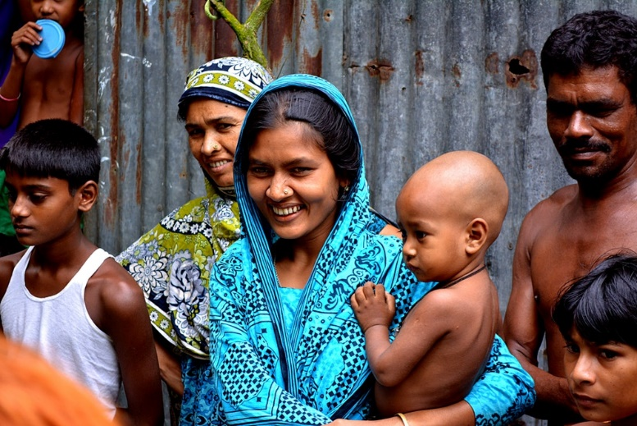
Figure 6.2 – A family from a non-Western culture.

Considering cultural influences on personality is important because Western ideas and theories are not necessarily applicable to other cultures (Benet-Martinez & Oishi, 2008). There is a great deal of evidence that the strength of personality traits varies across cultures, and this is especially true when comparing individualist cultures (such as European, North American, and Australian cultures) and collectivist cultures (such as Asian, African, and South American cultures). People who live in individualist cultures tend to believe that independence, competition, and personal achievement are important. In contrast, people who live in collectivist cultures tend to value social harmony, respectfulness, and group needs over individual needs. These values influence personality in different but substantial ways; for example, Yang (2006) found that people in individualist cultures displayed more personally-oriented personality traits, whereas people in collectivist cultures displayed more socially-oriented personality traits.

Gender and Personality
In much the same manner that cultural norms can influence personality and behavior, gender norms (the behaviors that males and females are expected to conform to in a given society) can also influence personality by emphasizing different traits between different genders.

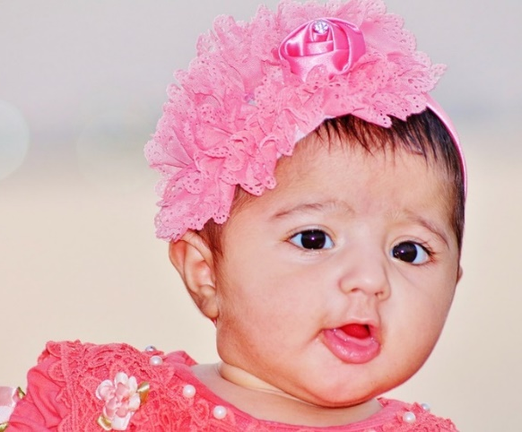  Figure 6.3 – A female infant wearing stereotypically feminine clothing and accessories. | 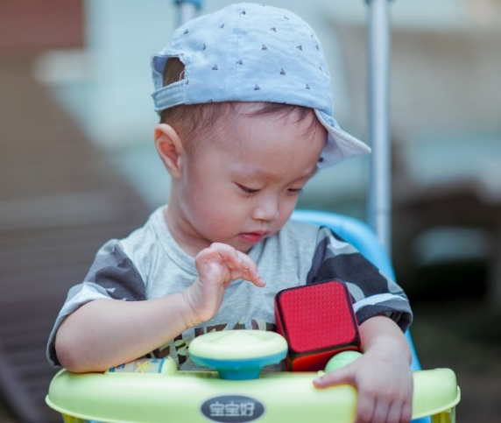  Figure 6.4 – A male infant wearing stereotypically masculine clothing.

Ideas of appropriate behavior for each gender (masculine and feminine) vary among cultures and tend to change over time. For example, aggression and assertiveness have historically been emphasized as positive masculine personality traits in the United States. Meanwhile, submissiveness and caretaking have historically been held as ideal feminine traits. While many gender roles remain the same, others change over time. In 1938, for example, only 1 out of 5 Americans agreed that a married woman should earn money in industry and business. By 1996, however, 4 out of 5 Americans approved of women working in these fields. This type of attitude change has been accompanied by behavioral shifts that coincide with changes in trait expectations and shifts in personal identity for men and women.

Infant Emotions
At birth, infants exhibit two emotional responses: attraction and withdrawal. They show attraction to pleasant situations that bring comfort, stimulation, and pleasure, and they withdraw from unpleasant stimulation such as bitter flavors or physical discomfort. At around two months, infants exhibit social engagement in the form of social smiling as they respond with smiles to those who engage their positive attention (Lavelli & Fogel, 2005).

Social smiling becomes more stable and organized as infants learn to use their smiles to engage their parents in interactions. Pleasure is expressed as laughter at 3 to 5 months of age, and displeasure becomes more specific as fear, sadness, or anger between ages 6 and 8 months. Anger is often the reaction to being prevented from obtaining a goal, such as a toy being removed (Braungart-Rieker, Hill-Soderlund, & Karrass, 2010). In contrast, sadness is typically the response when infants are deprived of a caregiver (Papousek, 2007). Fear is often associated with the presence of a stranger, known as stranger wariness, or the departure of significant others known as separation anxiety. Both appear sometime between 6 and 15 months after object permanence has been acquired. Further, there is some indication that infants may experience jealousy as young as 6 months of age (Hart & Carrington, 2002).

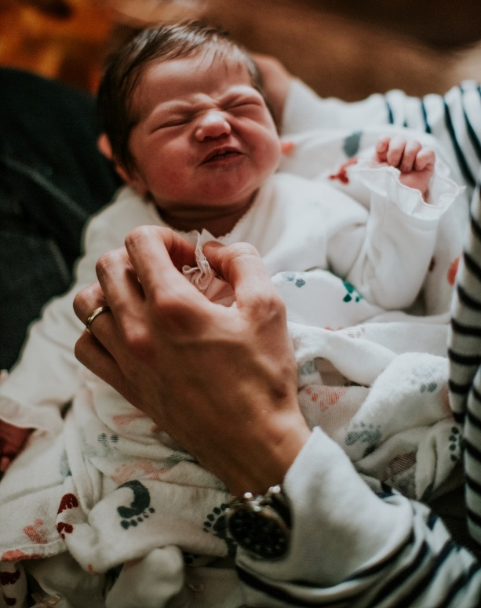
Figure 6.5 – An infant making an angry facial expression.

Emotions are often divided into two general categories: Basic emotions (primary emotions), such as interest, happiness, anger, fear, surprise, sadness and disgust, which appear first, and self-conscious emotions (secondary emotions), such as envy, pride, shame, guilt, doubt, and embarrassment. Unlike primary emotions, secondary emotions appear as children start to develop a self-concept, and require social instruction on when to feel such emotions. The situations in which children learn self-conscious emotions varies from culture to culture. Individualistic cultures teach us to feel pride in personal accomplishments, while in more collective cultures children are taught to not call attention to themselves, unless you wish to feel embarrassed for doing so (Akimoto & Sanbinmatsu, 1999).
Figure 6.6 – An infant making a sad facial expression.

Facial expressions of emotion are important regulators of social interaction. In the developmental literature, this concept has been investigated under the concept of social referencing; that is, the process whereby infants seek out information from others to clarify a situation and then use that information to act (Klinnert, Campos, & Sorce, 1983). To date, the strongest demonstration of social referencing comes from work on the visual cliff. In the first study to investigate this concept, Campos and colleagues (Sorce, Emde, Campos, & Klinnert, 1985) placed mothers on the far end of the “cliff” from the infant. Mothers first smiled to the infants and placed a toy on top of the safety glass to attract them; infants invariably began crawling to their mothers. When the infants were in the center of the table, however, the mother then posed an expression of fear, sadness, anger, interest, or joy. The results were clearly different for the different faces; no infant crossed the table when the mother showed fear; only 6% did when the mother posed anger, 33% crossed when the mother posed sadness, and approximately 75% of the infants crossed when the mother posed joy or interest.

Other studies provide similar support for facial expressions as regulators of social interaction. Researchers posed facial expressions of neutral, anger, or disgust toward babies as they moved toward an object and measured the amount of inhibition the babies showed in touching the object (Bradshaw, 1986). The results for 10- and 15-month olds were the same: Anger produced the greatest inhibition, followed by disgust, with neutral the least. This study was later replicated using joy and disgust expressions, altering the method so that the infants were not allowed to touch the toy (compared with a distractor object) until one hour after exposure to the expression (Hertenstein & Campos, 2004). At 14 months of age, significantly more infants touched the toy when they saw joyful expressions, but fewer touched the toy when the infants saw disgust.

A final emotional change is in self-regulation. Emotional self-regulation refers to strategies we use to control our emotional states so that we can attain goals (Thompson & Goodvin, 2007). This requires effortful control of emotions and initially requires assistance from caregivers (Rothbart, Posner, & Kieras, 2006). Young infants have very limited capacity to adjust their emotional states and depend on their caregivers to help soothe themselves. Caregivers can offer distractions to redirect the infant’s attention and comfort to reduce the emotional distress. As areas of the infant’s prefrontal cortex continue to develop, infants can tolerate more stimulation. By 4 to 6 months, babies can begin to shift their attention away from upsetting stimuli (Rothbart et al, 2006). Older infants and toddlers can more effectively communicate their need for help and can crawl or walk toward or away from various situations (Cole, Armstrong, & Pemberton, 2010). This aids in their ability to self-regulate. Temperament also plays a role in children’s ability to control their emotional states, and individual differences have been noted in the emotional self-regulation of infants and toddlers (Rothbart & Bates, 2006).

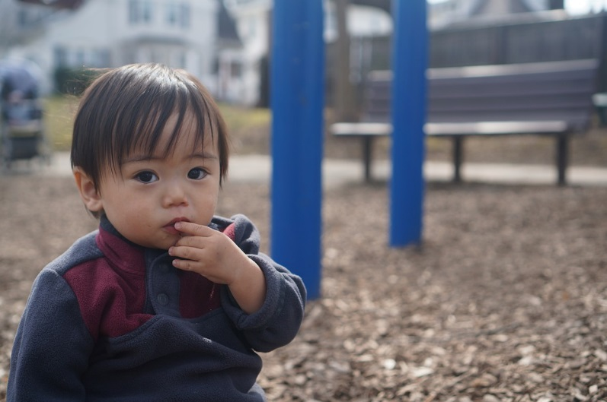
Figure 6.7 – A toddler at a park.

Development of sense of self: During the second year of life, children begin to recognize themselves as they gain a sense of self as separate from their primary caregiver. In a classic experiment by Lewis and Brooks (1978) children 9 to 24 months of age were placed in front of a mirror after a spot of rouge was placed on their nose as their mothers pretended to wipe something off the child’s face. If the child reacted by touching his or her own nose rather than that of the “baby” in the mirror, it was taken to suggest that the child recognized the reflection as him or herself. Lewis and Brooks found that somewhere between 15 and 24 months most infants developed a sense of self-awareness. Self-awareness is the realization that you are separate from others (Kopp, 2011). Once a child has achieved self-awareness, the child is moving toward understanding social emotions such as guilt, shame or embarrassment, as well as, sympathy or empathy.

Social Emotional Milestones
As infants and toddlers interact with other people, their social and emotional skills develop. Here is a table of social and emotional milestones that they typically experience during the first two years.

Table 6.2 - Social and Emotional Milestones

Typical Age | What Most Children Do By This Age
2 months | - Begins to smile at people  - Can briefly calm self (may bring hands to mouth and suck on hand)  - Tries to look at parent
4 months | - Smiles spontaneously, especially at people  - Likes to play with people and might cry when playing stops  - Copies some movements and facial expressions, like smiling or frowning
6 months | - Knows familiar faces and begins to know if someone is a stranger  - Likes to play with others, especially parents  - Responds to other people’s emotions and often seems happy  - Likes to look at self in a mirror
9 months | - May be afraid of strangers  - May be clingy with familiar adults  - Has favorite toys
1 year | - Is shy or nervous with strangers  - Cries when mom or dad leaves  - Has favorite things and people  - Shows fear in some situations  - Hands you a book when wants to hear a story  - Repeats sounds or actions to get attention  - Puts out arm or leg to help with dressing  - Plays games such as “peek-a-boo” and “pat-a-cake”
18 months | - Likes to hand things to others as play  - May have temper tantrums  - May be afraid of strangers  - Shows affection to familiar people  - Plays simple pretend, such as feeding a doll  - May cling to caregivers in new situations  - Points to show others something interesting  - Explores alone but with parent close by
2 years | - Copies others, especially adults and older children  - Gets excited when with other children  - Shows more and more independence  - Shows defiant behavior (doing what he has been told not to)  - Plays mainly beside other children, but is beginning to include other children, such as in chase games

Forming Attachments
Attachment is the close bond with a caregiver from which the infant derives a sense of
security. The formation of attachments in infancy has been the subject of considerable research as attachments have been viewed as foundations for future relationships. Additionally, attachments form the basis for confidence and curiosity as toddlers, and as important influences on self- concept.

Figure 6.8 – The formation of attachment in action as a father snuggles a newborn.

Freud’s Psychoanalytic Theory
According to Freud (1938) infants are oral creatures who obtain pleasure from sucking and mouthing objects. Freud believed the infant will become attached to a person or object that provides this pleasure. Consequently, infants were believed to become attached to their mother because she was the one who satisfied their oral needs and provided pleasure. Freud further believed that the infants will become attached to their mothers “if the mother is relaxed and generous in her feeding practices, thereby allowing the child a lot of oral pleasure,” (Shaffer, 1985, p. 435).

Harlow’s Research
In one classic study, Wisconsin University psychologists Harry and Margaret Harlow investigated the responses of young rhesus monkeys to explore if breastfeeding was the most important factor to attachment.

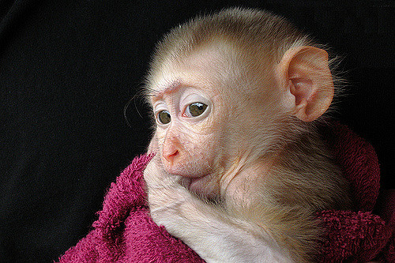
Figure 6.8 – A rhesus monkey sucking its thumb.

The infant monkeys were separated from their biological mothers, and two surrogate mothers were introduced to their cages. The first mother (the wire mother) consisted of a round wooden head, a mesh of cold metal wires, and a bottle of milk from which the baby monkey could drink. The second mother was a foam-rubber form wrapped in a heated terry-cloth blanket. The infant monkeys went to the wire mother for food, but they overwhelmingly preferred and spent significantly more time with the warm terry-cloth mother. The warm terry-cloth mother provided no food but did provide comfort (Harlow, 1958). The infant's need for physical closeness and touching is referred to as contact comfort. Contact comfort is believed to be the foundation for attachment. The Harlows’ studies confirmed that babies have social as well as physical needs. Both monkeys and human babies need a secure base that allows them to feel safe. From this base, they can gain the confidence they need to venture out and explore their worlds.

Bowlby’s Theory
Building on the work of Harlow and others, John Bowlby developed the concept of attachment theory. He defined attachment as the affectional bond or tie that an infant forms with the mother (Bowlby, 1969). An infant must form this bond with a primary caregiver in order to have normal social and emotional development. In addition, Bowlby proposed that this attachment bond is very powerful and continues throughout life. He used the concept of secure base to define a healthy attachment between parent and child (Bowlby, 1982). A secure base is a parental presence that gives the child a sense of safety as the child explores the surroundings.

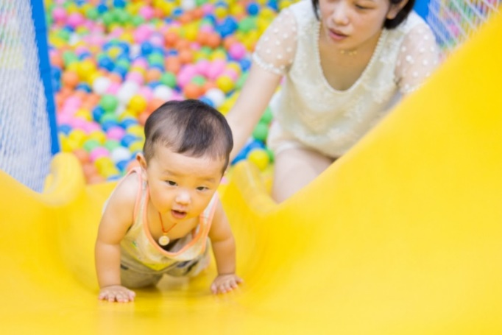
Figure 6.9 – A mother offering a secure base as her infant plays on a slide.

Bowlby said that two things are needed for a healthy attachment: The caregiver must be responsive to the child’s physical, social, and emotional needs; and the caregiver and child must engage in mutually enjoyable interactions (Bowlby, 1969). Additionally, Bowlby observed that infants would go to extraordinary lengths to prevent separation from their parents, such as crying, refusing to be comforted, and waiting for the caregiver to return.

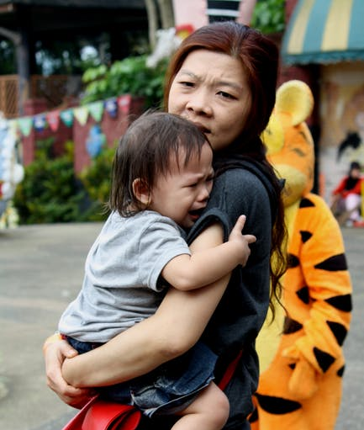
Figure 6.10 - This child is seeking comfort from an attachment figure.
Bowlby also observed that these same expressions were common to many other mammals, and consequently argued that these negative responses to separation serve an evolutionary function. Because mammalian infants cannot feed or protect themselves, they are dependent upon the care and protection of adults for survival. Thus, those infants who were able to maintain proximity to an attachment figure were more likely to survive and reproduce.

Erikson: Trust vs. Mistrust
As previously discussed in chapter 1, Erikson formulated an eight-stage theory of psychosocial development. Erikson was in agreement on the importance of a secure base, arguing that the most important goal of infancy was the development of a basic sense of trust in one’s caregivers. Consequently, the first stage, trust vs. mistrust, highlights the importance of attachment. Erikson maintained that the first year to year and a half of life involves the establishment of a sense of trust (Erikson, 1982). Infants are dependent and must rely on others to meet their basic physical needs as well as their needs for stimulation and comfort. A caregiver who consistently meets these needs instills a sense of trust or the belief that the world is a trustworthy place. The caregiver should not worry about overly indulging a child’s need for comfort, contact or stimulation.

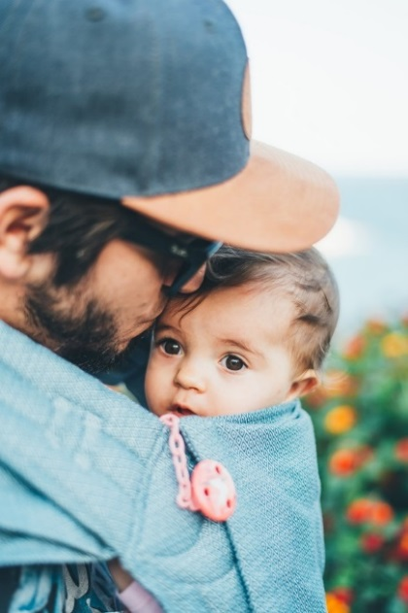
Figure 6.11 – This baby-wearing father is creating trust with his infant child.

Problems Establishing Trust
Erikson (1982) believed that mistrust could contaminate all aspects of one’s life and deprive the individual of love and fellowship with others. Consider the implications for establishing trust if a caregiver is unavailable or is upset and ill-prepared to care for a child. Or if a child is born prematurely, is unwanted, or has physical problems that make him or her more challenging to parent. Under these circumstances, we cannot assume that the parent is going to provide the child with a feeling of trust.

Mary Ainsworth and the Strange Situation
Developmental psychologist Mary Ainsworth, a student of John Bowlby, continued studying the development of attachment in infants. Ainsworth and her colleagues created a laboratory test that measured an infant’s attachment to his or her parent. The test is called The Strange Situation because it is conducted in a context that is unfamiliar to the child and therefore likely to heighten the child’s need for his or her parent (Ainsworth, 1979).

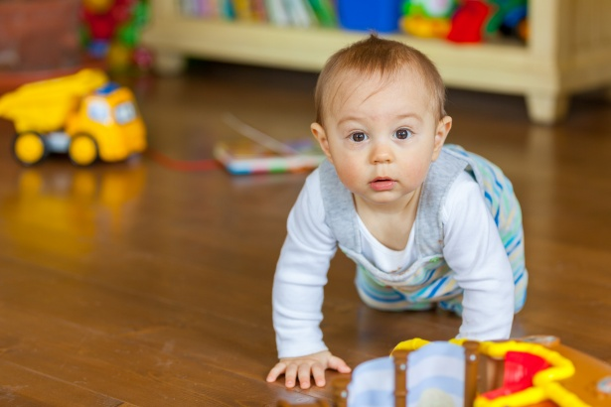
Figure 6.12 – An infant crawling on the floor with toys around as done in the Strange Situation.

During the procedure, which lasts about 20 minutes, the parent and the infant are first left alone, while the infant explores the room full of toys. Then a strange adult enters the room and talks for a minute to the parent, after which the parent leaves the room. The stranger stays with the infant for a few minutes, and then the parent again enters and the stranger leaves the room. During the entire session, a video camera records the child’s behaviors, which are later coded by the research team. The investigators were especially interested in how the child responded to the caregiver leaving and returning to the room, referred to as the “reunion.” On the basis of their behaviors, the children are categorized into one of four groups where each group reflects a different kind of attachment relationship with the caregiver. One style is secure and the other three styles are referred to as insecure.
- A child with a secure attachment style usually explores freely while the caregiver is present and may engage with the stranger. The child will typically play with the toys and bring one to the caregiver to show and describe from time to time. The child may be upset when the caregiver departs, but is also happy to see the caregiver return.
- A child with an ambivalent (sometimes called resistant) attachment style is wary about the situation in general, particularly the stranger, and stays close or even clings to the caregiver rather than exploring the toys. When the caregiver leaves, the child is extremely distressed and is ambivalent when the caregiver returns. The child may rush to the caregiver, but then fails to be comforted when picked up. The child may still be angry and even resist attempts to be soothed.
- A child with an avoidant attachment style will avoid or ignore the mother, showing little emotion when the mother departs or returns. The child may run away from the mother when she approaches. The child will not explore very much, regardless of who is there, and the stranger will not be treated much differently from the mother.
- A child with a disorganized/disoriented attachment style seems to have an inconsistent way of coping with the stress of the strange situation. The child may cry during the separation, but avoid the mother when she returns, or the child may approach the mother but then freeze or fall to the floor.

How common are the attachment styles among children in the United States? It is estimated that about 65 percent of children in the United States are securely attached. Twenty percent exhibit avoidant styles and 10 to 15 percent are ambivalent. Another 5 to 10 percent may be characterized as disorganized.

Some cultural differences in attachment styles have been found (Rothbaum, Weisz, Pott, Miyake, & Morelli, 2010). For example, German parents value independence and Japanese mothers are typically by their children’s sides. As a result, the rate of insecure-avoidant attachments is higher in Germany and insecure-resistant attachments are higher in Japan. These differences reflect cultural variation rather than true insecurity, however (van Ijzendoorn and Sagi, 1999).

Keep in mind that methods for measuring attachment styles have been based on a model that reflects middle-class, U. S. values and interpretation. Newer methods for assessment attachment styles involve using a Q-sort technique in which a large number of behaviors are recorded on cards and the observer sorts the cards in a way that reflects the type of behavior that occurs within the situation (Waters, 1987). There are 90 items in the third version of the Q-sort technique, and examples of the behaviors assessed include:
- When child returns to mother after playing, the child is sometimes fussy for no clear reason.
- When the child is upset or injured, the child will accept comforting from adults other than mother.
- Child often hugs or cuddles against mother, without her asking or inviting the child to do so.
- When the child is upset by mother’s leaving, the child continues to cry or even gets angry after she is gone.
At least two researchers observe the child and parent in the home for 1.5-2 hours per visit. Usually two visits are sufficient to gather adequate information. The parent is asked if the behaviors observed are typical for the child. This information is used to test the validity of the Strange Situation classifications across age, cultures, and with clinical populations.

Caregiver Consistency
Having a consistent caregiver may be jeopardized if the infant is cared for in a child care setting with a high turnover of staff or if institutionalized and given little more than basic physical care. Infants who, perhaps because of being in orphanages with inadequate care, have not had the opportunity to attach in infancy may still form initial secure attachments several years later. However, they may have more emotional problems of depression, anger, or be overly friendly as they interact with others (O’Connor et. al., 2003).

Social Deprivation
Severe deprivation of parental attachment can lead to serious problems. According to studies of children who have not been given warm, nurturing care, they may show developmental delays, failure to thrive, and attachment disorders (Bowlby, 1982). Non-organic failure to thrive is the diagnosis for an infant who does not grow, develop, or gain weight on schedule. In addition, postpartum depression can cause even a well-intentioned mother to neglect her infant.

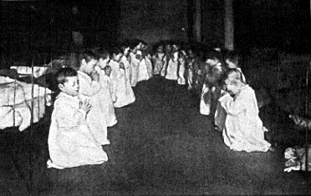
Figure 6.13 - This is a residential nursery in 1888.

Reactive Attachment Disorder
Children who experience social neglect or deprivation, repeatedly change primary caregivers that limit opportunities to form stable attachments, or are reared in unusual settings (such as institutions) that limit opportunities to form stable attachments can certainly have difficulty forming attachments. According to the Diagnostic and Manual of Mental Disorders, 5th edition (American Psychiatric Association, 2013), those children experiencing neglectful situations and also displaying markedly disturbed and developmentally inappropriate attachment behavior, such as being inhibited and withdrawn, minimal social and emotional responsiveness to others, and limited positive affect, may be diagnosed with Reactive Attachment Disorder. This disorder often occurs with developmental delays, especially in cognitive and language areas. Fortunately, the majority of severely neglected children do not develop Reactive Attachment Disorder, which occurs in less than 10% of such children. The quality of the caregiving environment after serious neglect affects the development of this disorder.

Resiliency
Being able to overcome challenges and successfully adapt is resiliency. Even young children can exhibit strong resilience to harsh circumstances. Resiliency can be attributed to certain personality factors, such as an easy-going temperament. Some children are warm, friendly, and responsive, whereas others tend to be more irritable, less manageable, and difficult to console, and these differences play a role in attachment (Gillath, Shaver, Baek, & Chun, 2008; Seifer, Schiller, Sameroff, Resnick, & Riordan, 1996). It seems safe to say that attachment, like most other developmental processes, is affected by an inter play of genetic and socialization influences.

Receiving support from others also leads to resiliency. A positive and strong support group can help a parent and child build a strong foundation by offering assistance and positive attitudes toward the newborn and parent. In a direct test of this idea, Dutch researcher van den Boom (1994) randomly assigned some babies’ mothers to a training session in which they learned to better respond to their children’s needs. The research found that these mothers’ babies were more likely to show a secure attachment style in comparison to the mothers in a control group that did not receive training.

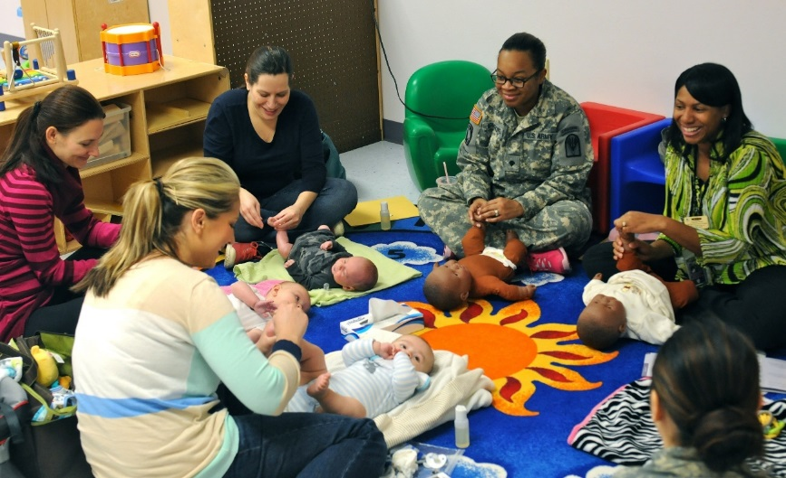
Figure 6.14 - This infant massage class for new mothers could provide training and support for mothers.

Child Care
According to the U.S. Census Bureau in 2011, over sixty percent of families with children under five relied on regular child care arrangements. Around a quarter of those families used organized child care facilities as their primary arrangement.

Child care involves supervising a child or children, usually from infancy to age thirteen, and typically refers to work done by somebody outside the child's immediate family. Child care is a broad topic covering a wide spectrum of contexts, activities, social and cultural conventions, and institutions. The majority of child care institutions that are available require that child care providers have extensive training in first aid and are CPR certified. In addition, background checks, drug testing, and reference verification are normally required.

It is traditional in Western society for children to be cared for by their parents or their legal guardians. In families where children live with one or both of their parents, the child care role may also be taken on by the child's extended family. If a parent or extended family is unable to care for the children, orphanages and foster homes are a way of providing for children's care, housing, and schooling.

Child Care in the United States
Formal child care options include center-based care and family child care homes. Each state has different regulations for licensing child care centers, including teacher requirements. In some states, teaching in a child care center requires an associate’s degree in child development. States with quality standards built into their licensing programs may have higher requirements for support staff, such as teacher assistants. Head Start (a federally funded child care program for income qualified families) lead teachers must have a bachelor’s degree in Early Childhood Education. States vary in other standards set for daycare providers, such as teacher to child ratios.

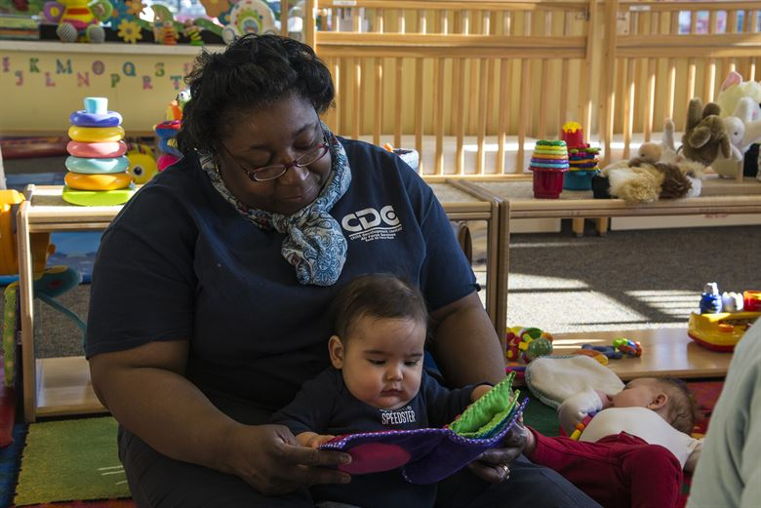
Figure 6.15 – A caretaker reading to an infant.

State legislation may regulate the number and ages of children allowed before the home is considered an official family child care program and subject to licensing regulations. Often the nationally recognized Child Development Associate credential is the minimum standard for the individual leading this home care program.

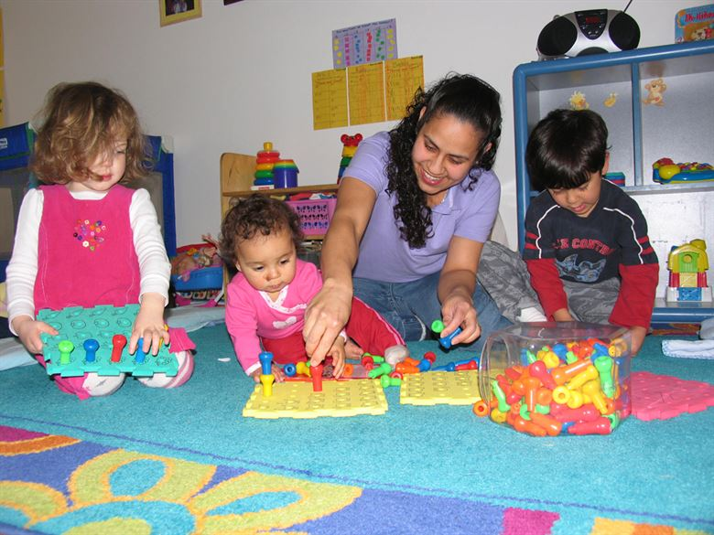
Figure 6.16 – A caretaker playing with a group of children.

In addition to these licensed options, parents may also choose to find their own caregiver or arrange childcare exchanges/swaps with another family. This care is typically provided by nannies, au pairs, or friends and family. The child is watched inside their own home or the caregiver's home, reducing exposure to outside children and illnesses. Depending on the number of children in the home, the children utilizing in-home care can enjoy the greatest amount of interaction with their caregiver and form a close bond.

There are no required licensing or background checks for this type of in-home care, making parental vigilance essential in choosing an appropriate caregiver. The cost of in-home care is the highest of childcare options per child, though a household with many children may find this the most convenient and affordable option.

Conclusion
In this chapter, we looked at:
- Temperament and goodness-of-fit.
- Cultural and gender influences.
- The development of emotions.
- Theories and styles of attachment.
- Erikson’s stage of trust versus distrust.
- Importance of attachment and things that can impede it.
- The types of child care available to families.

Chapter 7: Physical Development in Early Childhood

Objectives
After this chapter, you should be able to:
- Describe the physical changes that occur in early childhood.
- Explain how to provide health nutrition for 3- to 5-year-olds.
- Summarize how to support the progression of motor skills with age appropriate activities.
- Discuss the sleep needs during early childhood and sleep disorders that may affect children.
- Explain the development behind toilet training and some elimination disorders that children may experience.
- Recognize the importance of awareness of sexual development in early childhood.
- Discuss risks to and a variety of ways to promote and protect children’s health and safety.

Introduction
During the early childhood years of three to five we see significant changes in the way children look, think, communicate, regulate their emotions, and interact with others. Children are often referred to as preschoolers during this time period. We’ll examine the physical changes of the preschooler in this chapter.

Figure 7.1 – Two children walking across a bridge.

Growth in Early Childhood
Children between the ages of 2 and 6 years tend to grow about 3 inches in height each year and gain about 4 to 5 pounds in weight each year. The 3 year old is very similar to a toddler with a large head, large stomach, short arms and legs. But by the time the child reaches age 6, the torso has lengthened and body proportions have become more like those of adults. The average 6 year old weighs approximately 46 pounds and is about 46 inches in height. This growth rate is slower than that of infancy.

Nutritional Concerns
That slower rate of growth is accompanied by a reduced appetite between the ages of 2 and 6. This change can sometimes be surprising to parents and lead to the development of poor eating habits. However, children between the ages of 2 and 3 need 1,000 to 1,400 calories, while children between the ages of 4 and 8 need 1,200 to 2,000 calories (Mayo Clinic, 2016a).

Caregivers who have established a feeding routine with their child can find the reduction in appetite a bit frustrating and become concerned that the child is going to starve. However, by providing adequate, sound nutrition, and limiting sugary snacks and drinks, the caregiver can be assured that 1) the child will not starve; and 2) the child will receive adequate nutrition. Preschoolers can experience iron deficiencies if not given well-balanced nutrition or if they are given too much milk as calcium interferes with the absorption of iron in the diet as well.

Caregivers need to keep in mind that they are setting up taste preferences at this age. Young children who grow accustomed to high fat, very sweet and salty flavors may have trouble eating foods that have more subtle flavors such as fruits and vegetables. Consider the following advice about establishing eating patterns for years to come (Rice, F.P., 1997). Notice that keeping mealtime pleasant, providing sound nutrition and not engaging in power struggles over food are the main goals.

Tips for Establishing Healthy Eating Habits
- Don’t try to force your child to eat or fight over food. Of course, it is impossible to force someone to eat. But the real advice here is to avoid turning food into a power struggle so that food doesn’t become a way to gain favor with or express anger toward someone else.
- Recognize that appetite varies. Children may eat well at one meal and have no appetite at another. Rather than seeing this as a problem, it may help to realize that appetites do vary. Continue to provide good nutrition at each mealtime (even if children don’t choose to eat the occasional meal).
- Keep it pleasant. This tip is designed to help caregivers create a positive atmosphere during mealtime. Mealtimes should not be the time for arguments or expressing tensions. You do not want the child to have painful memories of mealtimes together or have nervous stomachs and problems eating and digesting food due to stress.
- No short order chefs. While it is fine to prepare foods that children enjoy, preparing a different meal for each child or family member sets up an unrealistic expectation from others. Children probably do best when they are hungry and a meal is ready. Limiting snacks rather than allowing children to “graze” continuously can help create an appetite for whatever is being served.
- Limit choices. If you give your preschool aged child choices, make sure that you give them one or two specific choices rather than asking “What would you like for lunch?” If given an open choice, children may change their minds or choose whatever their sibling does not choose!
- Serve balanced meals. Meals prepared at home tend to have better nutritional value than fast food or frozen dinners. Prepared foods tend to be higher in fat and sugar content as these ingredients enhance taste and profit margin because fresh food is often more costly and less profitable. However, preparing fresh food at home is not costly. It does, however, require more activity. Including children in meal preparation can provide a fun and memorable experience.
- Don’t bribe. Bribing a child to eat vegetables by promising dessert is not a good idea. First, the child will likely find a way to get the dessert without eating the vegetables (by whining or fidgeting, perhaps, until the caregiver gives in). Secondly, it teaches the child that some foods are better than others. Children tend to naturally enjoy a variety of foods until they are taught that some are considered less desirable than others. A child, for example, may learn the broccoli they have enjoyed is seen as yucky by others unless it’s smothered in cheese sauce!

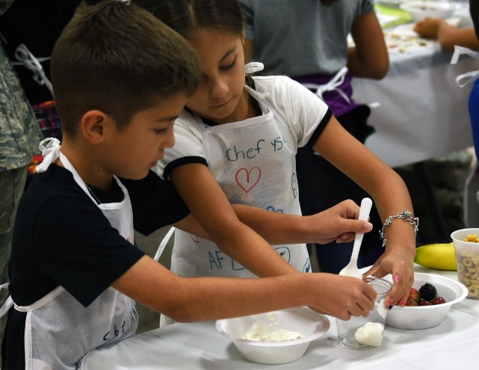
Figure 7.2 – Two children cooking together.

USDA Meal Patterns for Young Children
The United States Department of Agriculture Food and Nutrition Service provides the following guidance for the daytime feeding of children age 3 to 5.

Meal Patterns

Table 7.1

Meal | Ages 3-5
Breakfast | 3/4 cup milk  1/2 cup vegetables, fruit, or both  ½ ounce equivalent grains
Lunch or Supper | 3/4 cup milk  1½ ounces meat or meat alternative  1/4 cup vegetables  1/4 cup fruits  ½ ounce equivalent of grains
Snack | Select two of the following:  ½ cup of milk  ½ ounce meat or meat alternative  ½ cup vegetables  ½ cup fruit  ½ ounce equivalent of grains

Brain Maturation

Brain Weight
The brain is about 75 percent its adult weight by two years of age. By age 6, it is approximately 95 percent its adult weight. Myelination and the development of dendrites continues to occur in the cortex and as it does, we see a corresponding change in the child’s abilities. Significant development in the prefrontal cortex (the area of the brain behind the forehead that helps us to think, strategize, and control emotion) makes it increasingly possible to control emotional outbursts and to understand how to play games. Consider 4- or 5-year-old children and how they might approach a game of soccer. Chances are, every move would be a response to the commands of a coach standing nearby calling out, “Run this way! Now, stop. Look at the ball. Kick the ball!” And when the child is not being told what to do, he or she is likely to be looking at the clover on the ground or a dog on the other side of the fence! Understanding the game, thinking ahead, coordinating movement, and handling losing improve with practice and myelination.

Visual Pathways
Children’s drawings are representative of the development of visual pathways; as children’s brains mature the images in their drawings change. Early scribbles and dots illustrate the use of simple motor skills. No real connection is made between an image being visualized and what is created on paper.
At age 3, the child begins to draw wispy creatures with heads and not much other detail. Gradually pictures begin to have more detail and incorporate more parts of the body. Arm buds become arms and faces take on noses, lips and eventually eyelashes.

Figure 7.3 – Early scribbles. | Figure 7.4 – Creatures with heads. | 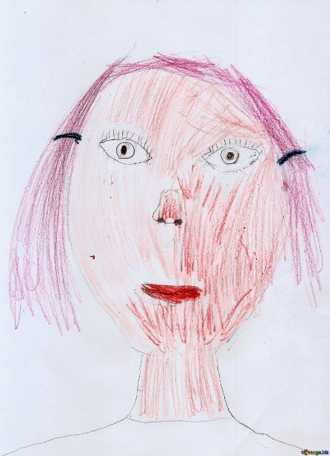  Figure 7.5 – A detailed face.

Growth in the Hemispheres and Corpus Callosum
Between ages 3 and 6, the left hemisphere of the brain grows dramatically. This side of the brain or hemisphere is typically involved in language skills. The right hemisphere continues to grow throughout early childhood and is involved in tasks that require spatial skills such as recognizing shapes and patterns. The corpus callosum which connects the two hemispheres of the brain undergoes a growth spurt between ages 3 and 6 and results in improved coordination between right and left hemisphere tasks.

Motor Skill Development
Early childhood is a time when children are especially attracted to motion and song. Days are filled with jumping, running, swinging and clapping and every place becomes a playground. Even the booth at a restaurant affords the opportunity to slide around in the seat or disappear underneath and imagine being a sea creature in a cave! Of course, this can be frustrating to a caregiver, but it’s the business of early childhood.

Gross Motor Skills
Children continue to improve their gross motor skills as they run and jump. They frequently ask their caregivers to “look at me” while they hop or roll down a hill. Children’s songs are often accompanied by arm and leg movements or cues to turn around or move from left to right.

Gross Motor Milestones
Here is a table showing the progression of gross motor skills that children will typically develop during early childhood:

Table 7.2 - Gross Motor Milestones

Typical Age | What Most Children Do by This Age
3 years | - Climbs well  - Runs easily  - Pedals a tricycle (3-wheel bike)  - Walks up and down stairs, one foot on each step
4 years | - Hops and stands on one foot up to 2 seconds  - Catches a bounced ball most of the time
5 years | - Stands on one foot for 10 seconds or longer  - Hops; may be able to skip  - Can do a somersault  - Can use the toilet on own  - Swings and climbs

Activities to Support Gross Motor Skills
Here are some activities focused on play that young children enjoy and that support their gross motor skill development.
- Tricycle
- Slides
- Swings
- Sit-n-Spin
- Mini trampoline
- Bowling pins (can use plastic soda bottles also)
- Tent (try throwing blankets over chairs and other furniture to make a fort)
- Playground ladders
- Suspension bridge on playground
- Tunnels (try throwing a bean bag chair underneath for greater challenge)
- Ball play (kick, throw, catch)
- Simon Says
- Target games with bean bags, ball, etc.
- Dancing/moving to music
- Pushing self on scooter or skateboard while on stomach

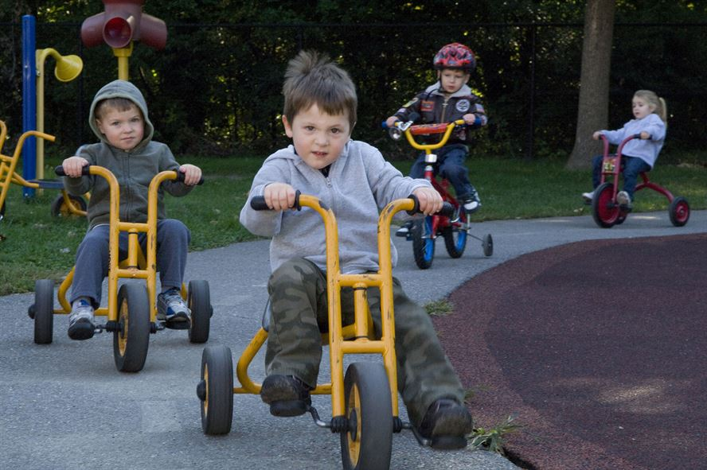
Figure 7.6 – Children riding tricycles together.

Fine Motor Skills
Fine motor skills are also being refined as they continue to develop more dexterity, strength, and endurance. Fine motor skills are very important as they are foundational to self-help skills and later academic abilities (such as writing).

Fine Motor Milestones
Here is a table showing how fine motor skills progress during early childhood for children that are typically developing.

Table 7.3 - Fine Motor Milestones

Typical Age | What Most Children Do by This Age
3 years | - Copies a circle with pencil or crayon  - Turns book pages one at a time  - Builds towers of more than 6 blocks  - Screws and unscrews jar lids or turns door handle
4 years | - Pours, cuts with supervision, and mashes own food  - Draws a person with 2 to 4 body parts  - Uses scissors  - Starts to copy some capital letters
5 years | - Can draw a person with at least 6 body parts  - Can print some letters or numbers  - Copies a triangle and other geometric shapes  - Uses a fork and spoon and sometimes a table knife

Activities to Support Fine Motor Skills
Here are some fun activities that will help children continue to refine their fine motor abilities. Fine motor skills are slower to develop than gross motor skills, so it is important to have age appropriate expectations and play-based activities for children.
- Pouring water into a container
- Drawing and coloring
- Using scissors
- Finger painting
- Fingerplays and songs (such as the Itsy, Bitsy Spider)
- Play dough
- Lacing and beading
- Practicing with large tweezers, tongs, and eye droppers

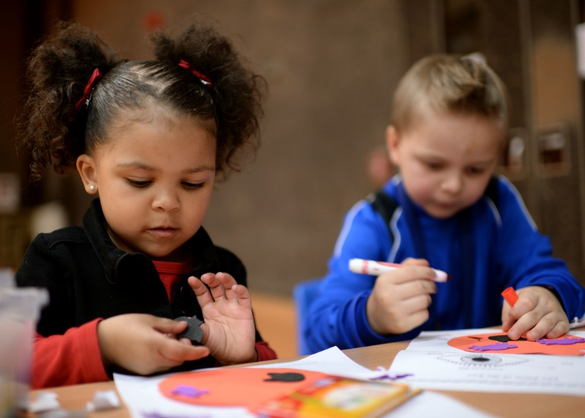
Figure 7.7 – Children coloring.

Sleep and Early Childhood
Along with food and water, sleep is one of the human body's most important physiological needs—we cannot live without it. Extended sleeplessness (i.e., lack of sleep for longer than a few days) has severe psychological and physical effects. Research on rats has found that a week of no sleep leads to loss of immune function, and two weeks of no sleep leads to death.
Recently, neuroscientists have learned that at least one vital function of sleep is related to learning and memory. New findings suggest that sleep plays a critical role in flagging and storing important memories, both intellectual and physical, and perhaps in making subtle connections that were invisible during waking hours.

How Much Sleep Do We Need?
The amount of sleep an individual needs varies depending on multiple factors including age, physical condition, psychological condition, and energy exertion. Just like any other human characteristic, the amount of sleep people need to function best differs among individuals, even those of the same age and gender.

Though there is no magic sleep number, there are general rules for how much sleep certain age groups need. For instance, children need more sleep per day in order to develop and function properly: up to 18 hours for newborn babies, with a declining rate as a child ages. A newborn baby spends almost 9 hours a day in REM sleep. By the age of five, only slightly over two hours is spent in REM. Studies show that young children need about 10 to 11 hours of sleep, adolescents need between 8.5 and 9.25, and adults generally need between 7 and 9 hours.

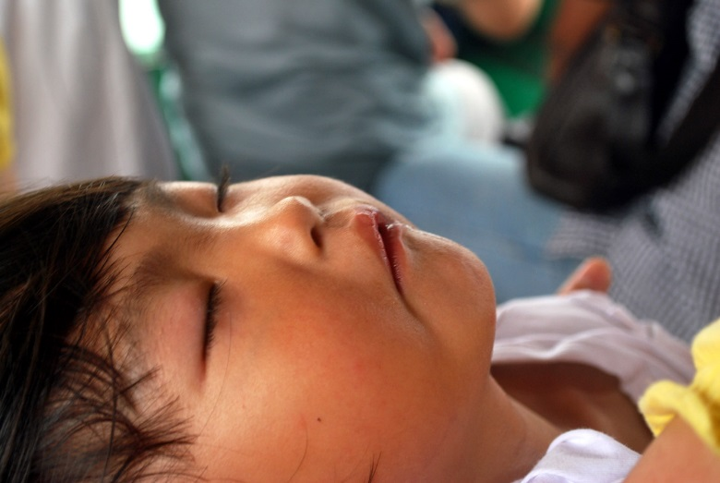
Figure 7.8 – A child sleeping.

Sleepwalking (Somnambulism)
Sleepwalking (sometimes called sleepwalking disorder, somnambulism, or noctambulation) causes a person to get up and walk during the early hours of sleep. The person may sit up and look awake (though they're actually asleep), get up and walk around, move items, or dress or undress themselves. They will have a blank stare and still be able to perform complex tasks. Some individuals also talk while in their sleep, saying meaningless words and even having arguments with people who are not there. A person who sleepwalks will be confused upon waking up and may also experience anxiety and fatigue.

Sleepwalking can be dangerous—people have been known to seriously hurt themselves during sleepwalking episodes. It is most common in children, but it also occurs occasionally in adults. For adults, alcohol, sedatives, medications, medical conditions and mental disorders are all associated with sleepwalking.

Sleep Terrors and Nightmare Disorder
Sleep terrors are characterized by a sudden arousal from deep sleep with a scream or cry, accompanied by some behavioral manifestations of intense fear. Sleep terrors typically occur in the first few hours of sleep, during stage 3 NREM sleep. Night terrors tend to happen during periods of arousal from delta sleep (i.e., slow-wave sleep). They are worse than nightmares, causing significant disorientation, panic, and anxiety. They can last up to 10 minutes, and the person may be screaming and difficult to wake. In some cases, sleep terrors continue into adulthood.

Distinct from sleep terrors is nightmare disorder. Also known as "dream anxiety disorder," nightmare disorder is characterized by frequent nightmares. The nightmares, which often portray the individual in a situation that jeopardizes their life or personal safety, usually occur during the second half of the sleeping process, called the REM stage. Though many people experience nightmares, those with nightmare disorder experience them more frequently.

Toilet Training
Toilet training typically occurs after the second birthday. Some children show interest by age 2, but others may not be ready until months later. The average age for girls to be toilet trained is 29 months and for boys it is 31 months, and 98% of children are trained by 36 months (Boyse & Fitzgerald, 2010). The child’s age is not as important as his/her physical and emotional readiness. If started too early, it might take longer to train a child.

According to The Mayo Clinic (2016b) the following questions can help parents determine if a child is ready for toilet training:
- Does your child seem interested in the potty chair or toilet, or in wearing underwear?
- Can your child understand and follow basic directions?
- Does your child tell you through words, facial expressions or posture when he or she needs to go?
- Does your child stay dry for periods of two hours or longer during the day?
- Does your child complain about wet or dirty diapers?
- Can your child pull down his or her pants and pull them up again?
- Can your child sit on and rise from a potty chair?

If a child resists being trained or it is not successful after a few weeks, it is best to take a break and try again when they show more significant interest in the process. Most children master daytime bladder control first, typically within two to three months of consistent toilet training. However, nap and nighttime training might take months or even years.

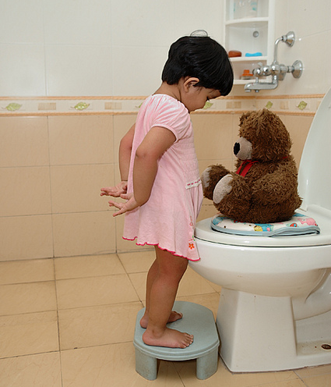
Figure 7.9 – A child learning to be toilet trained.

Elimination Disorders
Some children experience elimination disorders including:
- enuresis - the repeated voiding of urine into bed or clothes (involuntary or intentional) after age 5
- encopresis - the repeated passage of feces into inappropriate places (involuntary or intentional).

The prevalence of enuresis is 5%-10% for 5 year-olds, 3%-5% for 10 year-olds and approximately 1% for those 15 years of age or older. Around 1% of 5 year- olds have encopresis, and it is more common in males than females. These are diagnosed by a medical professional and may require treatment.

Sexual Development in Early Childhood
Self-stimulation is common in early childhood for both boys and girls. Curiosity about the body and about others’ bodies is a natural part of early childhood as well. Consider this example. A girl asks her mother: “So it’s okay to see a boy’s privates as long as it’s the boy’s mother or a doctor?” The mother hesitates a bit and then responds, “Yes. I think that’s alright.” “Hmmm,” the girl begins, “When I grow up, I want to be a doctor!” While this subject can feel uncomfortable to deal with, caregivers can teach children to be safe and know what is appropriate without frightening them or causing shame.

As children grow, they are more likely to show their genitals to siblings or peers, and to take off their clothes and touch each other (Okami et al., 1997). Masturbation is common for both boys and girls. Boys are often shown by other boys how to masturbate. But girls tend to find out accidentally. And boys masturbate more often and touch themselves more openly than do girls (Schwartz, 1999).

Caregivers should respond to this without undue alarm and without making the child feel guilty about their bodies. Instead, messages about what is going on and the appropriate time and place for such activities help the child learn what is appropriate.

Health in Early Childhood
While preschoolers are becoming more and more independent, they depend on their caregivers to keep protecting and promoting their health.

Childhood Obesity
Childhood obesity is a complex health issue. It occurs when a child is well above the normal or healthy weight for his or her age and height. Childhood obesity is a serious problem in the United States putting children at risk for poor health. In 2015-2016, 13.9% of 2- to 5-year-olds were obese.

Where people live can affect their ability to make healthy choices. Obesity disproportionally affects children from low-income families.

Causes of Obesity
The causes of excess weight gain in young people are similar to those in adults, including factors such as a person’s behavior and genetics. Behaviors that influence excess weight gain include:
- eating high calorie, low-nutrient foods
- not getting enough physical exercise
- sedentary activities (such as watching television or other screen devices)
- medication use
- sleep routines

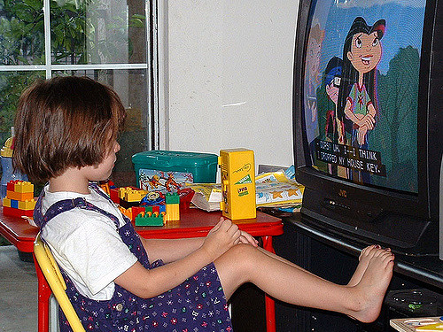
Figure 7.10 – A child watching TV instead of playing.

Consequences of Obesity
The consequences of childhood obesity are both immediate and long term. It can affect physical as well as social and emotional well-being.
- More Immediate Health Risks
  - High blood pressure and high cholesterol, which are risk factors for cardiovascular disease (CVD).
  - Increased risk of impaired glucose tolerance, insulin resistance, and type 2 diabetes.
  - Breathing problems, such as asthma and sleep apnea.
  - Joint problems and musculoskeletal discomfort.
  - Fatty liver disease, gallstones, and gastro-esophageal reflux (i.e., heartburn).
- Childhood obesity is also related to
  - Psychological problems such as anxiety and depression.
  - Low self-esteem and lower self-reported quality of life.
  - Social problems such as bullying and stigma.
- Future Health Risks
  - Children who have obesity are more likely to become adults with obesity.¹¹ Adult obesity is associated with increased risk of a number of serious health conditions including heart disease, type 2 diabetes, and cancer.
  - If children have obesity, their obesity and disease risk factors in adulthood are likely to be more severe.

Food Allergies
A food allergy occurs when the body has a specific and reproducible immune response to certain foods. The body’s immune response can be severe and life threatening, such as anaphylaxis. Although the immune system normally protects people from germs, in people with food allergies, the immune system mistakenly responds to food as if it were harmful.

Eight foods or food groups account for 90% of serious allergic reactions in the United States: milk, eggs, fish, crustacean shellfish, wheat, soy, peanuts, and tree nuts.

The symptoms and severity of allergic reactions to food can be different between individuals, and can also be different for one person over time. Anaphylaxis is a sudden and severe allergic reaction that may cause death.⁴Not all allergic reactions will develop into anaphylaxis.
- Children with food allergies are two to four times more likely to have asthma or other allergic conditions than those without food allergies.
- The prevalence of food allergies among children increased 18% during 1997-2007, and allergic reactions to foods have become the most common cause of anaphylaxis in community health settings.
- Although difficult to measure, research suggests that approximately 4% of children and adolescents are affected by food allergies.

The CDC recommends that as part of maintaining a healthy and safe environment for children, caregivers should:
- Be aware of any food allergies.
- Educate other children and all adults that care for a child with food allergies.
- Ensure the daily management of food allergies.
- Prepare for food allergy emergencies.

Oral Health
Tooth decay (cavities) is one of the most common chronic conditions of childhood in the United States. Untreated tooth decay can cause pain and infections that may lead to problems with eating, speaking, playing, and learning. The good news is that tooth decay is preventable.
Fluoride varnish, a high concentration fluoride coating that is painted on teeth, can prevent about one-third (33%) of decay in the primary (baby) teeth. Children living in communities with fluoridated tap water have fewer decayed teeth than children who live in areas where their tap water is not fluoridated. Similarly, children who brush daily with fluoride toothpaste will have less tooth decay.

Applying dental sealants to the chewing surfaces of the back teeth is another way to prevent tooth decay. Studies in children show that sealants reduce decay in the permanent molars by 81% for 2 years after they are placed on the tooth and continue to be effective for 4 years after placement.

The first visit to the dentist should happen after the first tooth erupts. After that, children should be seeing the dentist every six months.

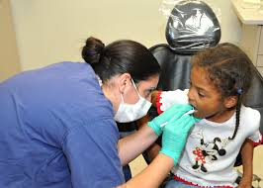
Figure 7.11 – A dentist checking a child’s teeth.

Protection from Illness
Two important ways to help protect children from illness are immunization and handwashing.

Immunizations
While vaccines begin in infancy, it is important for children to receive additional doses of vaccines to keep them protected. These boosters, given between ages 4 and 6, are doses of the vaccines they received earlier in life to help them maintain the best protection against vaccine-preventable diseases.

Figure 7.12 – Vaccines.

Many states require children to be fully vaccinated (unless they have a medical reason to be exempt) before they can enroll in licensed child care or public school. If vaccinations were missed, a health care provider can help the child’s caregivers to create a catch up schedule to ensure the child correctly “catches up” with the recommended childhood vaccination schedule.

Handwashing
Handwashing is one of the best ways to prevent the spread of illness. It’s important for children (and adults) to wash their hands often, especially when they are likely to get and spread germs, including:
- Before, during, and after preparing food.
- Before eating food.
- After blowing nose, coughing, or sneezing.
- After using the toilet.
- After touching an animal, animal feed, or animal waste.
- After touching garbage.

It’s important for children to learn how to properly wash their hands. When washing hands children (and adults) should follow these five steps every time.
- Wet your hands with clean, running water (warm or cold), turn off the tap, and apply soap.
- Lather your hands by rubbing them together with the soap. Lather the backs of your hands, between your fingers, and under your nails.
- Scrub your hands for at least 20 seconds. Need a timer? Hum or sing the Happy Birthday song or ABCs from beginning to end twice.
- Rinse your hands well under clean, running water.
- Dry your hands using a clean towel or air dry them.

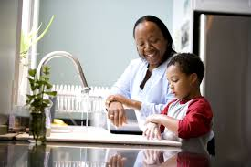
Figure 7.13 – A mother helping her son wash his hands.
Caregivers can help keep children healthy by:
- Teaching them good handwashing techniques.
- Reminding their kids to wash their hands.
- Washing their own hands with the children.

Safety
Child injuries are preventable, yet more than 9,000 children (from 0-19 years) died from injuries in the US in 2009. Car crashes, suffocation, drowning, poisoning, fires, and falls are some of the most common ways children are hurt or killed. The number of children dying from injury dropped nearly 30% over the last decade. However, injury is still the number 1 cause of death among children.

Children during early childhood are more at risk for certain injuries. Using data from 2000-2006, the CDC determined that:
- Drowning was the leading cause of injury death between 1 and 4 years of age.
- Falls were the leading cause of nonfatal injury for all age groups less than 15.
- For children ages 0 to 9, the next two leading causes were being struck by or against an object and animal bites or insect stings.
- Rates for fires or burns, and drowning were highest for children 4 years and younger.

Here is a table summarizing some tips from the CDC to protect children from these injuries:

Table 7.4 – Preventing Injuries

Type of Injury | Prevention Tips
Burns | - Have smoke alarms on every floor and in all rooms people sleep in  - Involve children in creating and practicing an escape plan  - Never leave food cooking on the stove unattended; supervise any use of microwave  - Make sure the water heater is set to 120 degrees or lower
Drowning | - Make sure caregivers are trained in CPR  - Fence off pools; gates should be self-closing and self-latching  - Have children wear life jackets in and around natural bodies of water  - Supervise children in or near water (including the bathtub)
Falls | - Make sure playground surfaces are safe, soft, and made of impact absorbing material (such as wood chips or sand) at an appropriate depth and are well maintained  - Use safety devices (such as window guards)  - Make sure children are wearing protective gear during sports and recreation (such as bicycle helmets)  - Supervise children around fall hazards at all times
Poisoning | - Lock up all medications and toxic products (such as cleaning solutions and detergents) in original packaging out of sight and reach of children  - Know the number to poison control (1-800-222-1222)  - Read and follow labels of all medications  - Safely dispose of unused, unneeded, or expired prescription drugs and over the counter drugs, vitamins, and supplements
Motor-accident, in vehicle | - Children should still be safely restrained in a five point harnessed car seat  - Children should be in back seat  - Children should not be seated in front of an airbag
Motor-accident, pedestrian | - Teach children about safety including:  - Walking on the sidewalk  - Not assuming vehicles see you or will stop  - Crossing only in crosswalks  - Looking both ways before crossing  - Never playing in the road  - Not crossing a road without an adult  - Supervise children near all roadways and model safe behavior

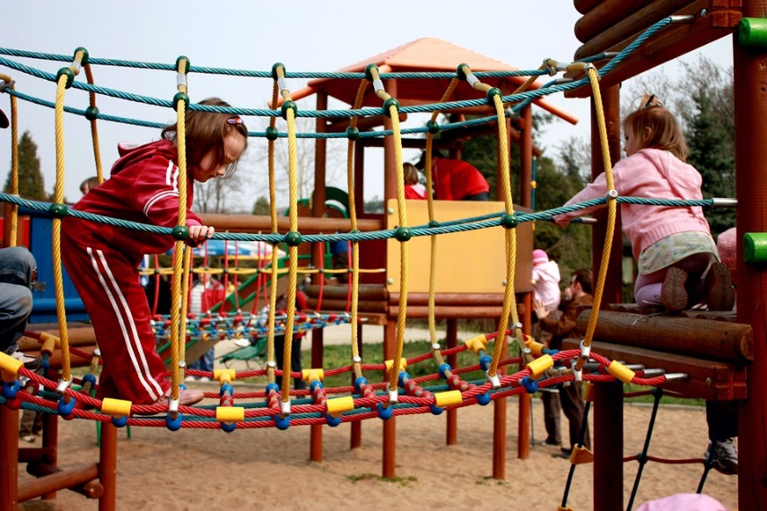
Figure 7.14 – Children playing on a jungle gym at a park.

Conclusion
In this chapter we looked at:
- The physical characteristics of preschoolers.
- Healthy nutrition.
- The changes in the brain.
- The progression of motor skills and developmentally appropriate ways to support that development.
- Sleep and sleep disorders.
- Toilet training and elimination disorders
- Sexual development in early childhood.
- And ways to keep children healthy and safe.
In the next chapter we’ll investigate how children understand the world and their communication abilities.

Chapter 8: Cognitive Development in Early Childhood

Objectives
After reading this chapter, you should be able to:
- Compare and contrast Piaget and Vygotsky’s beliefs about cognitive development.
- Explain the role of information processing in cognitive development.
- Discuss how preschool-aged children understand their worlds.
- Put cognitive and language milestones into the order in which they appear in typically developing children.
- Discuss how early child education supports development and how our understanding of development influence education.
- Describe autism spectrum disorder, including characteristics and possible interventions.

Introduction
Early childhood is a time of pretending, blending fact and fiction, and learning to think of the world using language. As young children move away from needing to touch, feel, and hear about the world toward learning some basic principles about how the world works, they hold some pretty interesting initial ideas. For example, while adults have no concerns with taking a bath, a child of three might genuinely worry about being sucked down the drain.

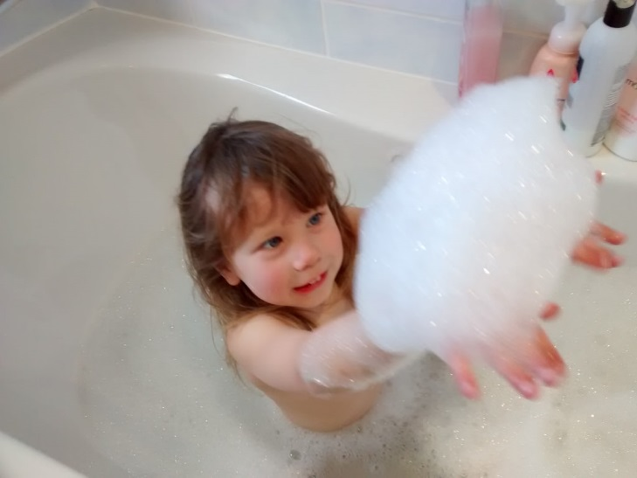
Figure 8.1 – A child in a bathtub.

A child might protest if told that something will happen “tomorrow” but be willing to accept an explanation that an event will occur “today after we sleep.” Or the young child may ask, “How long are we staying? From here to here?” while pointing to two points on a table. Concepts such as tomorrow, time, size and distance are not easy to grasp at this young age. Understanding size, time, distance, fact and fiction are all tasks that are part of cognitive development in the preschool years.

Piaget’s Preoperational Intelligence
Piaget’s stage that coincides with early childhood is the preoperational stage. The word operational means logical, so these children were thought to be illogical. However, they were learning to use language or to think of the world symbolically. Let’s examine some of Piaget’s assertions about children’s cognitive abilities at this age.

Pretend Play
Pretending is a favorite activity at this time. A toy has qualities beyond the way it was designed to function and can now be used to stand for a character or object unlike anything originally intended. A teddy bear, for example, can be a baby or the queen of a faraway land!

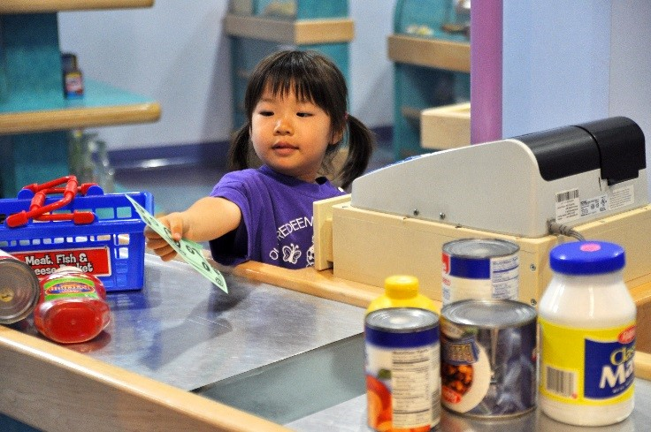
Figure 8.2 – A child pretending to buy items at a toy grocery store.

According to Piaget, children’s pretend play helps them solidify new schemes they were developing cognitively. This play, then, reflects changes in their conceptions or thoughts. However, children also learn as they pretend and experiment. Their play does not simply represent what they have learned (Berk, 2007).

Egocentrism
Egocentrism in early childhood refers to the tendency of young children to think that everyone sees things in the same way as the child. Piaget’s classic experiment on egocentrism involved showing children a 3-dimensional model of a mountain and asking them to describe what a doll that is looking at the mountain from a different angle might see. Children tend to choose a picture that represents their own view, rather than that of the doll. However, children tend to use different sentence structures and vocabulary when addressing a younger child or an older adult. This indicates some awareness of the views of others.

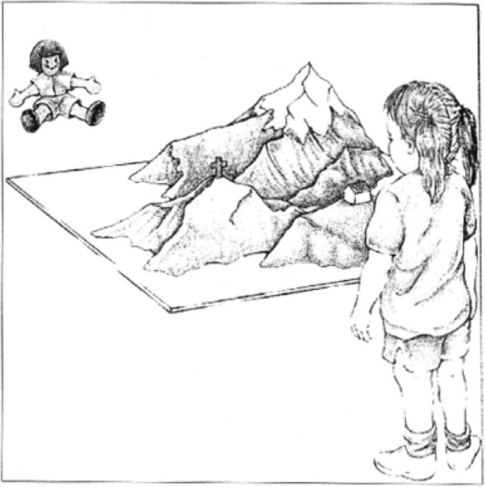
Figure 8.3 – Piaget’s egocentrism experiment.

Syncretism
Syncretism refers to a tendency to think that if two events occur simultaneously, one caused the other. An example of this is a child putting on their bathing suit to turn it to summertime.

Animism
Attributing lifelike qualities to objects is referred to as animism. The cup is alive, the chair that falls down and hits the child’s ankle is mean, and the toys need to stay home because they are tired. Cartoons frequently show objects that appear alive and take on lifelike qualities. Young children do seem to think that objects that move may be alive but after age 3, they seldom refer to objects as being alive (Berk, 2007).

Classification Errors
Preoperational children have difficulty understanding that an object can be classified in more than one way. For example, if shown three white buttons and four black buttons and asked whether there are more black buttons or buttons, the child is likely to respond that there are more black buttons. As the child’s vocabulary improves and more schemes are developed, the ability to classify objects improves.

Conservation Errors
Conservation refers to the ability to recognize that moving or rearranging matter does not change the quantity. Let’s look at an example. A father gave a slice of pizza to 10-year-old Keiko and another slice to 3-year-old Kenny. Kenny’s pizza slice was cut into five pieces, so Kenny told his sister that he got more pizza than she did. Kenny did not understand that cutting the pizza into smaller pieces did not increase the overall amount. This was because Kenny exhibited Centration, or focused on only one characteristic of an object to the exclusion of others.

Kenny focused on the five pieces of pizza to his sister’s one piece even though the total amount was the same. Keiko was able to consider several characteristics of an object than just one. Because children have not developed this understanding of conservation, they cannot perform mental operations.

The classic Piagetian experiment associated with conservation involves liquid (Crain, 2005). As seen below, the child is shown two glasses (as shown in a) which are filled to the same level and asked if they have the same amount. Usually the child agrees they have the same amount. The researcher then pours the liquid from one glass to a taller and thinner glass (as shown in b). The child is again asked if the two glasses have the same amount of liquid. The preoperational child will typically say the taller glass now has more liquid because it is taller. The child has concentrated on the height of the glass and fails to conserve.

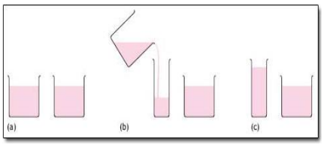
Figure 8.4 – Piagetian liquid conservation experiments.

Cognitive Schemas
As introduced in the first chapter, Piaget believed that in a quest for cognitive equilibrium, we use schemas (categories of knowledge) to make sense of the world. And when new experiences fit into existing schemas, we use assimilation to add that new knowledge to the schema. But when new experiences do not match an existing schema, we use accommodation to add a new schema. During early childhood, children use accommodation often as they build their understanding of the world around them.

Vygotsky’s Sociocultural Theory of Cognitive Development
As introduced in Chapter 1, Lev Vygotsky was a Russian psychologist who argued that culture has a major impact on a child’s cognitive development. He believed that the social interactions with adults and more knowledgeable peers can facilitate a child’s potential for learning. Without this interpersonal instruction, he believed children’s minds would not advance very far as their knowledge would be based only on their own discoveries. Let’s review some of Vygotsky’s key concepts.

Zone of Proximal Development and Scaffolding
Vygotsky’s best known concept is the zone of proximal development (ZPD). Vygotsky stated that children should be taught in the ZPD, which occurs when they can perform a task with assistance, but not quite yet on their own. With the right kind of teaching, however, they can accomplish it successfully. A good teacher identifies a child’s ZPD and helps the child stretch beyond it. Then the adult (teacher) gradually withdraws support until the child can then perform the task unaided. Researchers have applied the metaphor of scaffolds (the temporary platforms on which construction workers stand) to this way of teaching. Scaffolding is the temporary support that parents or teachers give a child to do a task.

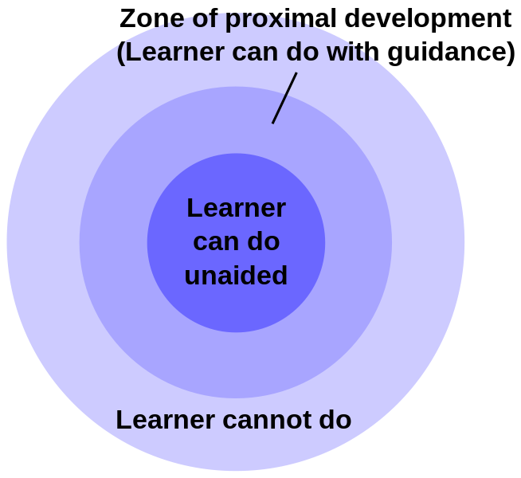
Figure 8.5 – Zone of proximal development.

Private Speech
Do you ever talk to yourself? Why? Chances are, this occurs when you are struggling with a problem, trying to remember something, or feel very emotional about a situation. Children talk to themselves too. Piaget interpreted this as egocentric speech or a practice engaged in because of a child’s inability to see things from another’s point of view. Vygotsky, however, believed that children talk to themselves in order to solve problems or clarify thoughts. As children learn to think in words, they do so aloud before eventually closing their lips and engaging in private speech or inner speech.

Thinking out loud eventually becomes thought accompanied by internal speech, and talking to oneself becomes a practice only engaged in when we are trying to learn something or remember something. This inner speech is not as elaborate as the speech we use when communicating with others (Vygotsky, 1962).

Contrast with Piaget
Piaget was highly critical of teacher-directed instruction, believing that teachers who take control of the child’s learning place the child into a passive role (Crain, 2005). Further, teachers may present abstract ideas without the child’s true understanding, and instead they just repeat back what they heard. Piaget believed children must be given opportunities to discover concepts on their own. As previously stated, Vygotsky did not believe children could reach a higher cognitive level without instruction from more learned individuals. Who is correct? Both theories certainly contribute to our understanding of how children learn.

Information Processing
Information processing researchers have focused on several issues in cognitive development for this age group, including improvements in attention skills, changes in the capacity, and the emergence of executive functions in working memory. Additionally, in early childhood memory strategies, memory accuracy, and autobiographical memory emerge. Early childhood is seen by many researchers as a crucial time period in memory development (Posner & Rothbart, 2007).

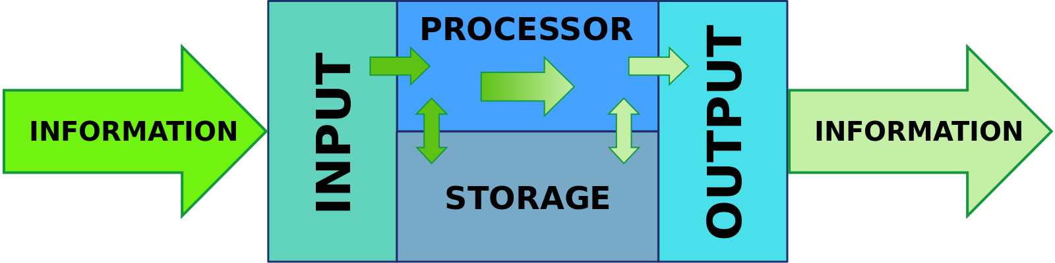
Figure 8.6 – How information is processed.

Attention
Changes in attention have been described by many as the key to changes in human memory (Nelson & Fivush, 2004; Posner & Rothbart, 2007). However, attention is not a unified function; it is comprised of sub-processes. The ability to switch our focus between tasks or external stimuli is called divided attention or multitasking. This is separate from our ability to focus on a single task or stimulus, while ignoring distracting information, called selective attention. Different from these is sustained attention, or the ability to stay on task for long periods of time. Moreover, we also have attention processes that influence our behavior and enable us to inhibit a habitual or dominant response, and others that enable us to distract ourselves when upset or frustrated.

Divided Attention
Young children (age 3-4) have considerable difficulties in dividing their attention between two tasks, and often perform at levels equivalent to our closest relative, the chimpanzee, but by age five they have surpassed the chimp (Hermann, Misch, Hernandez-Lloreda & Tomasello, 2015; Hermann & Tomasello, 2015). Despite these improvements, 5-year-olds continue to perform below the level of school-age children, adolescents, and adults.

Selective Attention
Children’s ability with selective attention tasks improve as they age. However, this ability is also greatly influenced by the child’s temperament (Rothbart & Rueda, 2005), the complexity of the stimulus or task (Porporino, Shore, Iarocci & Burack, 2004), and along with whether the stimuli are visual or auditory (Guy, Rogers & Cornish, 2013). Guy et al. (2013) found that children’s ability to selectively attend to visual information outpaced that of auditory stimuli. This may explain why young children are not able to hear the voice of the teacher over the cacophony of sounds in the typical preschool classroom (Jones, Moore & Amitay, 2015). Jones and his colleagues found that 4 to 7 year-olds could not filter out background noise, especially when its frequencies were close in sound to the target sound. In comparison, 8- to 11-year-old children often performed similar to adults.

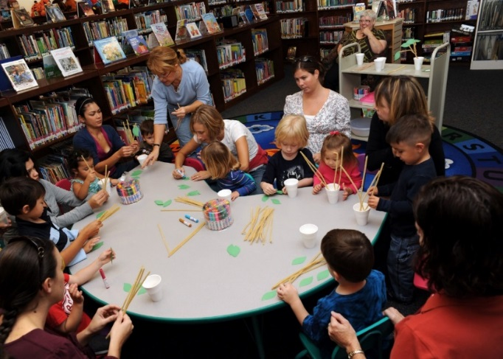
Figure 8.7 – A group of children making crafts.

Sustained Attention
Most measures of sustained attention typically ask children to spend several minutes focusing on one task, while waiting for an infrequent event, while there are multiple distractors for several minutes. Berwid, Curko-Kera, Marks & Halperin (2005) asked children between the ages of 3 and 7 to push a button whenever a “target” image was displayed, but they had to refrain from pushing the button when a non-target image was shown. The younger the child, the more difficulty he or she had maintaining their attention.

Figure 8.8 – A child playing a game that measures her sustained attention.

Memory
Based on studies of adults, people with amnesia, and neurological research on memory, researchers have proposed several “types” of memory (see Figure 4.14). Sensory memory (also called the sensory register) is the first stage of the memory system, and it stores sensory input in its raw form for a very brief duration; essentially long enough for the brain to register and start processing the information. Studies of auditory sensory memory show that it lasts about one second in 2 year-olds, two seconds in 3-year-olds, more than two seconds in 4-year-olds, and three to five seconds in 6-year-olds (Glass, Sachse, & von Suchodoletz, 2008). Other researchers have also found that young children hold sounds for a shorter duration than do older children and adults, and that this deficit is not due to attentional differences between these age groups, but reflects differences in the performance of the sensory memory system (Gomes et al., 1999). The second stage of the memory system is called short-term or working memory. Working memory is the component of memory in which current conscious mental activity occurs.

Working memory often requires conscious effort and adequate use of attention to function effectively. As you read earlier, children in this age group struggle with many aspects of attention and this greatly diminishes their ability to consciously juggle several pieces of information in memory. The capacity of working memory, that is the amount of information someone can hold in consciousness, is smaller in young children than in older children and adults. The typical adult and teenager can hold a 7 digit number active in their short-term memory. The typical 5-year-old can hold only a 4 digit number active. This means that the more complex a mental task is, the less efficient a younger child will be in paying attention to, and actively processing, information in order to complete the task.

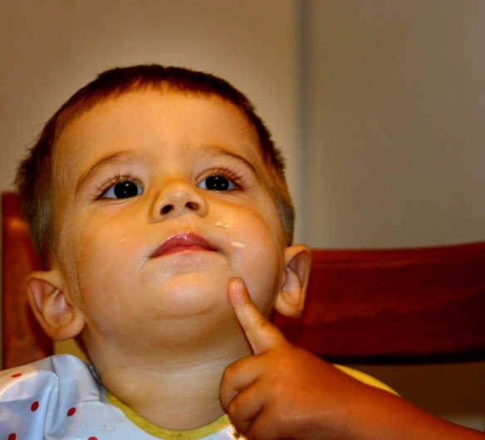
Figure 8.8 – A child thinking.

Changes in attention and the working memory system also involve changes in executive function. Executive function (EF) refers to self-regulatory processes, such as the ability to inhibit a behavior or cognitive flexibility, that enable adaptive responses to new situations or to reach a specific goal. Executive function skills gradually emerge during early childhood and continue to develop throughout childhood and adolescence. Like many cognitive changes, brain maturation, especially the prefrontal cortex, along with experience influence the development of executive function skills.

A child shows higher executive functioning skills when the parents are more warm and responsive, use scaffolding when the child is trying to solve a problem, and provide cognitively stimulating environments for the child (Fay-Stammbach, Hawes & Meredith, 2014). For instance, scaffolding was positively correlated with greater cognitive flexibility at age two and inhibitory control at age four (Bibok, Carpendale & Müller, 2009). In Schneider, Kron-Sperl and Hunnerkopf’s (2009) longitudinal study of 102 kindergarten children, the majority of children used no strategy to remember information, a finding that was consistent with previous research. As a result, their memory performance was poor when compared to their abilities as they aged and started to use more effective memory strategies.

The third component in memory is long-term memory, which is also known as permanent memory. A basic division of long-term memory is between declarative and non-declarative memory.
- Declarative memories, sometimes referred to as explicit memories, are memories for facts or events that we can consciously recollect. Declarative memory is further divided into semantic and episodic memory.
  - Semantic memories are memories for facts and knowledge that are not tied to a timeline,
  - Episodic memories are tied to specific events in time.
- Non- declarative memories, sometimes referred to as implicit memories, are typically automated skills that do not require conscious recollection.

Autobiographical memory is our personal narrative. Adults rarely remember events from the first few years of life. In other words, we lack autobiographical memories from our experiences as an infant, toddler and very young preschooler. Several factors contribute to the emergence of autobiographical memory including brain maturation, improvements in language, opportunities to talk about experiences with parents and others, the development of theory of mind, and a representation of “self” (Nelson & Fivush, 2004). Two-year-olds do remember fragments of personal experiences, but these are rarely coherent accounts of past events (Nelson & Ross, 1980). Between 2 and 2 1⁄2 years of age children can provide more information about past experiences. However, these recollections require considerable prodding by adults (Nelson & Fivush, 2004). Over the next few years children will form more detailed autobiographical memories and engage in more reflection of the past.

Neo-Piagetians
As previously discussed, Piaget’s theory has been criticized on many fronts, and updates to reflect more current research have been provided by the Neo-Piagetians, or those theorists who provide “new” interpretations of Piaget’s theory. Morra, Gobbo, Marini and Sheese (2008) reviewed Neo-Piagetian theories, which were first presented in the 1970s, and identified how these “new” theories combined Piagetian concepts with those found in Information Processing. Similar to Piaget’s theory, Neo-Piagetian theories believe in constructivism, assume cognitive development can be separated into different stages with qualitatively different characteristics, and advocate that children’s thinking becomes more complex in advanced stages. Unlike Piaget, Neo-Piagetians believe that aspects of information processing change the complexity of each stage, not logic as determined by Piaget.

Neo-Piagetians propose that working memory capacity is affected by biological maturation, and therefore restricts young children’s ability to acquire complex thinking and reasoning skills. Increases in working memory performance and cognitive skills development coincide with the timing of several neurodevelopmental processes. These include myelination, axonal and synaptic pruning, changes in cerebral metabolism, and changes in brain activity (Morra et al., 2008).

Myelination especially occurs in waves between birth and adolescence, and the degree of myelination in particular areas explains the increasing efficiency of certain skills. Therefore, brain maturation, which occurs in spurts, affects how and when cognitive skills develop. Additionally, all Neo-Piagetian theories support that experience and learning interact with biological maturation in shaping cognitive development.

Children’s Understanding of the World
Both Piaget and Vygotsky believed that children actively try to understand the world around them. More recently developmentalists have added to this understanding by examining how children organize information and develop their own theories about the world.

Theory-Theory
The tendency of children to generate theories to explain everything they encounter is called theory-theory. This concept implies that humans are naturally inclined to find reasons and generate explanations for why things occur. Children frequently ask question about what they see or hear around them. When the answers provided do not satisfy their curiosity or are too complicated for them to understand, they generate their own theories. In much the same way that scientists construct and revise their theories, children do the same with their intuitions about the world as they encounter new experiences (Gopnik & Wellman, 2012). One of the theories they start to generate in early childhood centers on the mental states; both their own and those of others.

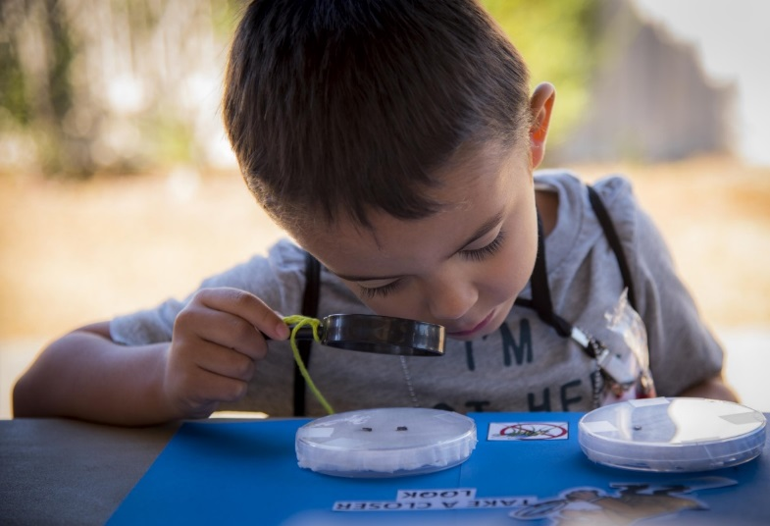
Figure 8.9 - What theories might this boy be creating?

Theory of Mind
Theory of mind refers to the ability to think about other people’s thoughts. This mental mind reading helps humans to understand and predict the reactions of others, thus playing a crucial role in social development. One common method for determining if a child has reached this mental milestone is the false belief task, described below.

The research began with a clever experiment by Wimmer and Perner (1983), who tested whether children can pass a false-belief test (see Figure 4.17). The child is shown a picture story of Sally, who puts her ball in a basket and leaves the room. While Sally is out of the room, Anne comes along and takes the ball from the basket and puts it inside a box. The child is then asked where Sally thinks the ball is located when she comes back to the room. Is she going to look first in the box or in the basket? The right answer is that she will look in the basket, because that’s where she put it and thinks it is; but we have to infer this false belief against our own better knowledge that the ball is in the box.

Figure 8.10 – A ball. | Figure 8.11 – A basket. | Figure 8.12 – A box.

This is very difficult for children before the age of four because of the cognitive effort it takes. Three-year-olds have difficulty distinguishing between what they once thought was true and what they now know to be true. They feel confident that what they know now is what they have always known (Birch & Bloom, 2003). Even adults need to think through this task (Epley, Morewedge, & Keysar, 2004).

To be successful at solving this type of task the child must separate what he or she “knows” to be true from what someone else might “think” is true. In Piagetian terms, they must give up a tendency toward egocentrism. The child must also understand that what guides people’s actions and responses are what they “believe” rather than what is reality. In other words, people can mistakenly believe things that are false and will act based on this false knowledge. Consequently, prior to age four children are rarely successful at solving such a task (Wellman, Cross & Watson, 2001).

Researchers examining the development of theory of mind have been concerned by the overemphasis on the mastery of false belief as the primary measure of whether a child has attained theory of mind. Wellman and his colleagues (Wellman, Fang, Liu, Zhu & Liu, 2006) suggest that theory of mind is comprised of a number of components, each with its own developmental timeline (see Table 4.2).

Two-year-olds understand the diversity of desires, yet as noted earlier it is not until age four or five that children grasp false belief, and often not until middle childhood do they understand that people may hide how they really feel. In part, because children in early childhood have difficulty hiding how they really feel.

Cultural Differences in Theory of Mind
Those in early childhood in the US, Australia, and Germany develop theory of mind in the sequence outlined above. Yet, Chinese and Iranian preschoolers acquire knowledge access before diverse beliefs (Shahaeian, Peterson, Slaughter & Wellman, 2011). Shahaeian and colleagues suggested that cultural differences in childrearing may account for this reversal.
Parents in collectivistic cultures, such as China and Iran, emphasize conformity to the family and cultural values, greater respect for elders, and the acquisition of knowledge and academic skills more than they do autonomy and social skills (Frank, Plunkett & Otten, 2010). This could reduce the degree of familial conflict of opinions expressed in the family. In contrast, individualistic cultures encourage children to think for themselves and assert their own opinion, and this could increase the risk of conflict in beliefs being expressed by family members.

Figure 8.13 – A family from a non-Western culture.

As a result, children in individualistic cultures would acquire insight into the question of diversity of belief earlier, while children in collectivistic cultures would acquire knowledge access earlier in the sequence. The role of conflict in aiding the development of theory of mind may account for the earlier age of onset of an understanding of false belief in children with siblings, especially older siblings (McAlister & Petersen, 2007; Perner, Ruffman & Leekman, 1994).

This awareness of the existence of theory of mind is part of social intelligence, such as recognizing that others can think differently about situations. It helps us to be self-conscious or aware that others can think of us in different ways and it helps us to be able to be understanding or be empathetic toward others. Moreover, this mind reading ability helps us to anticipate and predict people’s actions. The awareness of the mental states of others is important for communication and social skills.

Milestones of Cognitive Development
The many theories of cognitive development and the different research that has been done about how children understand the world, has allowed researchers to study the milestones that children who are typically developing experience in early childhood. Here is a table that summarizes those.

Table 8.1 - Cognitive Milestones

Typical Age | What Most Children Do by This Age
3 years | - Can work toys with buttons, levers, and moving parts  - Plays make-believe with dolls, animals, and people  - Does puzzles with 3 or 4 pieces  - Understands what “two” means
4 years | - Names some colors and some numbers  - Understands the idea of counting  - Starts to understand time  - Remembers parts of a story  - Understands the idea of “same” and “different”  - Plays board or card games  - Tells you what he thinks is going to happen next in a book
5 years | - Counts 10 or more things  - Knows about things used every day, like money and food

Language Development

Vocabulary Growth
A child’s vocabulary expands between the ages of 2 to 6 from about 200 words to over 10,000 words through a process called fast-mapping. Words are easily learned by making connections between new words and concepts already known. The parts of speech that are learned depend on the language and what is emphasized. Children speaking verb-friendly languages such as Chinese and Japanese, tend to learn nouns more readily. But, those learning less verb-friendly languages such as English, seem to need assistance in grammar to master the use of verbs (Imai, et al, 2008).

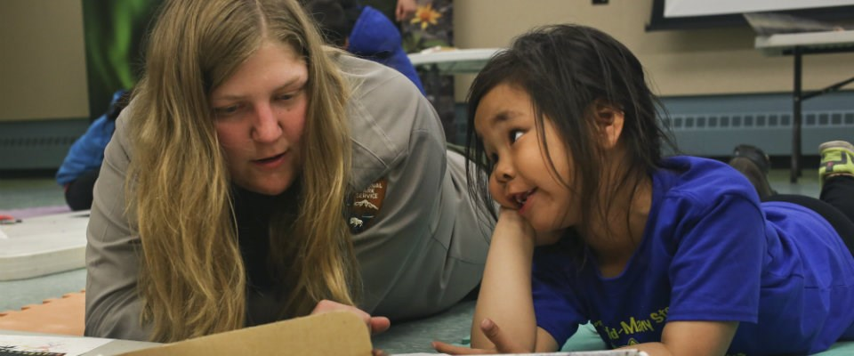
Figure 8.14 – A woman instructing a girl on vocabulary.

Literal Meanings
Children can repeat words and phrases after having heard them only once or twice. But they do not always understand the meaning of the words or phrases. This is especially true of expressions or figures of speech which are taken literally. For example, two preschool-aged girls began to laugh loudly while listening to a tape-recording of Disney’s “Sleeping Beauty” when the narrator reports, “Prince Phillip lost his head!” They imagine his head popping off and rolling down the hill as he runs and searches for it. Or a classroom full of preschoolers hears the teacher say, “Wow! That was a piece of cake!” The children began asking “Cake? Where is my cake? I want cake!”

Overregularization
Children learn rules of grammar as they learn language but may apply these rules inappropriately at first. For instance, a child learns to add “ed” to the end of a word to indicate past tense. Then form a sentence such as “I goed there. I doed that.” This is typical at ages 2 and 3. They will soon learn new words such as “went” and “did” to be used in those situations.

The Impact of Training
Remember Vygotsky and the zone of proximal development? Children can be assisted in learning language by others who listen attentively, model more accurate pronunciations and encourage elaboration. The child exclaims, “I goed there!” and the adult responds, “You went there? Say, ‘I went there.’ Where did you go?” Children may be ripe for language as Chomsky suggests, but active participation in helping them learn is important for language development as well. The process of scaffolding is one in which the adult (or more skilled peer) provides needed assistance to the child as a new skill is learned.

Language Milestones
The prior aspects of language development in early childhood can also be summarized into the progression of milestones children typically experience from ages 3 to 5. Here is a table of those.
Table 8.2 - Language Milestones

Typical Age | What Most Children Do By This Age
3 years | - Follows instructions with 2 or 3 steps  - Can name most familiar things  - Understands words like “in,” “on,” and “under”  - Says first name, age, and sex  - Names a friend  - Says words like “I,” “me,” “we,” and “you” and some plurals (cars, dogs, cats)  - Talks well enough for strangers to understand most of the time  - Carries on a conversation using 2 to 3 sentences
4 years | - Knows some basic rules of grammar, such as correctly using “he” and “she”  - Sings a song or says a poem from memory such as the “Itsy Bitsy Spider” or the “Wheels on the Bus”  - Tells stories  - Can say first and last name
5 years | - Speaks very clearly  - Tells a simple story using full sentences  - Uses future tense; for example, “Grandma will be here.”  - Says name and address

Now that we have addressed some of the cognitive areas of growth in early childhood, let’s take a look at the topic of school and its various applications.

Early Childhood Education
Providing universal preschool has become an important lobbying point for federal, state, and local leaders throughout our country. In his 2013 State of the Union address, President Obama called upon congress to provide high quality preschool for all children. He continued to support universal preschool in his legislative agenda, and in December 2014 the President convened state and local policymakers for the White House Summit on Early Education (White House Press Secretary, 2014).

However, universal preschool covering all four-year olds in the country would require significant funding. Further, how effective preschools are in preparing children for elementary school, and what constitutes high quality early childhood education have been debated.
To set criteria for designation as a high quality preschool, the National Association for the Education of Young Children (NAEYC) identifies 10 standards (NAEYC, 2016). These include:
- Positive relationships among all children and adults are promoted.
- A curriculum that supports learning and development in social, emotional, physical, language, and cognitive areas.
- Teaching approaches that are developmentally, culturally and linguistically appropriate.
- Assessment of children’s progress to provide information on learning and development.
- The health and nutrition of children are promoted, while they are protected from illness and injury.
- Teachers possess the educational qualifications, knowledge, and commitment to promote children’s learning.
- Collaborative relationships with families are established and maintained.
- Relationships with agencies and institutions in the children’s communities are established to support the program’s goals.
- The indoor and outdoor physical environments are safe and well-maintained.
- Leadership and management personnel are well qualified, effective, and maintain licensure status with the applicable state agency.

Parents should review preschool programs using the NAEYC criteria as a guide and template for asking questions that will assist them in choosing the best program for their child.

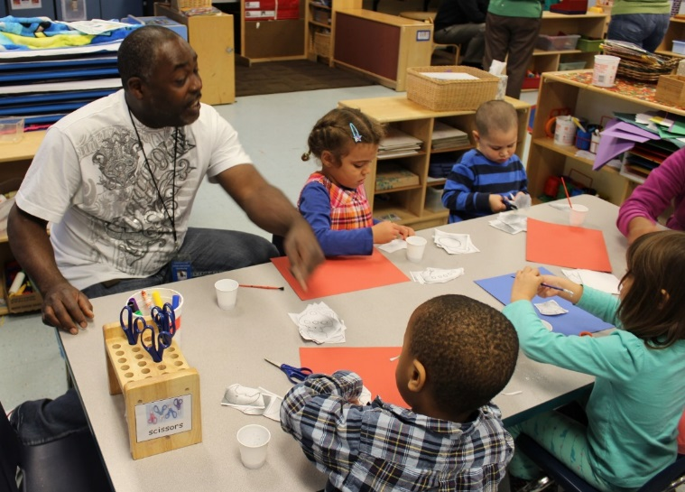
Figure 8.15 – Children making crafts at preschool.

Selecting the right preschool is also difficult because there are so many types of preschools available. Zachry (2013) identified Montessori, Waldorf, Reggio Emilia, High Scope, Creative Curriculum and Bank Street as types of early childhood education programs that focus on children learning through discovery. Teachers act as facilitators of children’s learning and development and create activities based on the child’s developmental level. Here is a table summarizes characteristics of each type of program.

Table 8.3 - Types of Early Childhood Education Programs

Program | Founder | Characteristics
Montessori | Dr. Maria Montessori | - Refers to children’s activity as work (not play); children are given long periods of time to work  - Focus on individual learning  - Features child-sized furniture and defined work areas  - Materials are carefully chosen and introduced to children by teacher  - Features mixed-aged grouping  - Teachers should be certified
Waldorf | Rudolf Steiner | - Focus on whole child  - Features connections to nature, sensory learning, and imagination  - Provides large blocks of time for play  - Delay formal academic instruction  - Environment protects children from negative influences  - Relationships are important so groupings last for several years (looping)  - Teachers should be certified
Reggio Emilia | Loris Malaguzzi | - Teachers and children co-construct the curriculum  - Teachers are researchers  - Environment is the third teacher and features beauty and order  - Children’s learning is documented through the multiple methods (100 languages of children)  - Have atelier (art studio) with an atelierista (artist) to instruct children  - Believe children are competent and capable  - Children stay together for 3 years  - Parents partner with teachers  - Community is extension of school
High Scope | David Weikart | - Features defined learning areas  - Has 8 content areas with 58 key developmental indicators  - Consistency of daily routine is important  - Uses plan-do-review sequence in which they make a plan, act on it, and then reflect on the results  - Teachers are partners and use the Child Observation Record (COR) to help assess children and plan curriculum  - Utilizes 6 step process to teach children conflict resolution
Bank Street | Lucy Sprague Mitchell | - Also referred to as the Developmental-Interactionist Approach  - Environment is arranged into learning centers  - Focus on hands-on experience with long periods of time given  - Teacher uses questions to further children’s exploration  - Blocks are primary material in the classroom  - Field trips are frequently used
Creative Curriculum | Diane Trister Dodge | - Focus on children’s play and self-selected activities  - Environment is arranged into learning areas  - Large blocks of time are given for self-selected play  - Uses projects as basis for curriculum  - Is researched based and includes assessment system

Head Start
For children who live in poverty, Head Start has been providing preschool education since 1965 when it was begun by President Lyndon Johnson as part of his war on poverty. It currently serves nearly one million children and annually costs approximately 7.5 billion dollars (United States Department of Health and Human Services, 2015). However, concerns about the effectiveness of Head Start have been ongoing since the program began. Armor (2015) reviewed existing research on Head Start and found there were no lasting gains, and the average child in Head Start had not learned more than children who did not receive preschool education.
Figure 8.16 – A photograph from when Head Start began.

A recent report dated July 2015 evaluating the effectiveness of Head Start comes from the What Works Clearinghouse. The What Works Clearinghouse identifies research that provides reliable evidence of the effectiveness of programs and practices in education, and is managed by the Institute of Education Services for the United States Department of Education. After reviewing 90 studies on the effectiveness of Head Start, only one study was deemed scientifically acceptable and this study showed disappointing results (Barshay, 2015). This study showed that 3- and 4-year-old children in Head Start received “potentially positive effects” on general reading achievement, but no noticeable effects on math achievement and social-emotional development.

Nonexperimental designs are a significant problem in determining the effectiveness of Head Start programs because a control group is needed to show group differences that would demonstrate educational benefits. Because of ethical reasons, low income children are usually provided with some type of pre-school programming in an alternative setting. Additionally, Head Start programs are different depending on the location, and these differences include the length of the day or qualification of the teachers. Lastly, testing young children is difficult and strongly dependent on their language skills and comfort level with an evaluator (Barshay, 2015).

Applications to Early Education
Understanding how children think and learn has proven useful for improving education. Activities like playing games that involve working with numbers and spatial relationships can give young children a developmental advantage over peers who have less exposure to the same concepts.

Mathematics
Even before they enter kindergarten, the mathematical knowledge of children from low-income backgrounds lags far behind that of children from more affluent backgrounds. Ramani and Siegler (2008) hypothesized that this difference is due to the children in middle- and upper-income families engaging more frequently in numerical activities, for example playing numerical board games such as Chutes and Ladders. Chutes and Ladders is a game with a number in each square; children start at the number one and spin a spinner or throw a dice to determine how far to move their token. Playing this game seemed likely to teach children about numbers, because in it, larger numbers are associated with greater values on a variety of dimensions. In particular, the higher the number that a child’s token reaches, the greater the distance the token will have traveled from the starting point, the greater the number of physical movements the child will have made in moving the token from one square to another, the greater the number of number-words the child will have said and heard, and the more time will have passed since the beginning of the game. These spatial, kinesthetic, verbal, and time-based cues provide a broad-based, multisensory foundation for knowledge of numerical magnitudes (the sizes of numbers), a type of knowledge that is closely related to mathematics achievement test scores (Booth & Siegler, 2006).

Playing this numerical board game for roughly 1 hour, distributed over a 2-week period, improved low-income children’s knowledge of numerical magnitudes, ability to read printed numbers, and skill at learning novel arithmetic problems. The gains lasted for months after the game-playing experience (Ramani & Siegler, 2008; Siegler & Ramani, 2009). An advantage of this type of educational intervention is that it has minimal if any cost—a parent could just draw a game on a piece of paper.

Reading
Cognitive developmental research has shown that phonemic awareness—that is, awareness of the component sounds within words—is a crucial skill in learning to read. To measure awareness of the component sounds within words, researchers ask children to decide whether two words rhyme, to decide whether the words start with the same sound, to identify the component sounds within words, and to indicate what would be left if a given sound were removed from a word. Kindergartners’ performance on these tasks is the strongest predictor of reading achievement in third and fourth grade, even stronger than IQ or social class background (Nation, 2008). Moreover, teaching these skills to randomly chosen 4- and 5-year-olds results in their being better readers years later (National Reading Panel, 2000).

Continuing Brain Maturation
Understanding of cognitive development is advancing on many different fronts. One exciting area is linking changes in brain activity to changes in children’s thinking (Nelson et al., 2006). Although many people believe that brain maturation is something that occurs before birth, the brain actually continues to change in large ways for many years thereafter. For example, a part of the brain called the prefrontal cortex, which is located at the front of the brain and is particularly involved with planning and flexible problem solving, continues to develop throughout adolescence (Blakemore & Choudhury, 2006). Such new research domains, as well as enduring issues such as nature and nurture, continuity and discontinuity, and how to apply cognitive development research to education, insure that cognitive development will continue to be an exciting area of research in the coming years.

Cognitive Differences
Sometimes children’s brains work differently. One form of this neurodiversity is Autism spectrum disorder.

Autism: Defining Spectrum Disorder
Autism spectrum disorder (ASD) describes a range of conditions classified as neuro-developmental disorders in the fifth revision of the American Psychiatric Association's Diagnostic and Statistical Manual of Mental Disorders (DSM-5). The DSM-5, published in 2013, redefined the autism spectrum to encompass the previous (DSM-IV-TR) diagnoses of autism, Asperger syndrome, pervasive developmental disorder not otherwise specified (PDD-NOS), and childhood disintegrative disorder. These disorders are characterized by social deficits and communication difficulties, repetitive behaviors and interests, sensory issues, and in some cases, cognitive delays.

Asperger syndrome was distinguished from autism in the earlier DSM-IV by the lack of delay or deviance in early language development. Additionally, individuals diagnosed with Asperger syndrome did not have significant cognitive delays. PDD-NOS was considered "subthreshold autism" and "atypical autism" because it was often characterized by milder symptoms of autism or symptoms in only one domain (such as social difficulties). In the DSM-5, both of these diagnoses have been subsumed into autism spectrum disorder.

Autism spectrum disorders are considered to be on a spectrum because each individual with ASD expresses the disorder uniquely and has varying degrees of functionality. Many have above-average intellectual abilities and excel in visual skills, music, math, and the arts, while others have significant disabilities and are unable to live independently. About 25 percent of individuals with ASD are nonverbal; however, they may learn to communicate using other means.

Social Communication Symptoms
Social impairments in children with autism can be characterized by a distinctive lack of intuition about others. Unusual social development becomes apparent early in childhood. Infants with ASD show less attention to social stimuli, smile and look at others less often, and respond less to their own name. Toddlers with ASD differ more strikingly from social norms; for example, they may show less eye contact and turn-taking and may not have the ability to use simple movements to express themselves. Individuals with severe forms of ASD do not develop enough natural speech to meet their daily communication needs.

Restricted and Repetitive Behaviors
Children with ASD may exhibit repetitive or restricted behavior, including:
- Stereotypy—repetitive movement, such as hand flapping, head rolling, or body rocking.
- Compulsive behavior—exhibiting intention to follow rules, such as arranging objects in stacks or lines.
- Sameness—resistance to change; for example, insisting that the furniture not be moved or sticking to an unvarying pattern of daily activities.
- Restricted behavior—limits in focus, interest, or activity, such as preoccupation with a single television program, toy, or game.
- Self-injury—movements that injure or can injure the person, such as eye poking, skin picking, hand biting, and head banging.

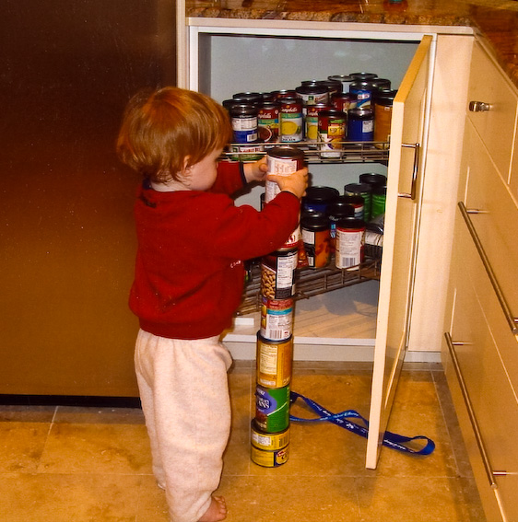
Figure 8.17 – A boy stacking cans.

Etiology
While specific causes of ASD have yet to be found, many risk factors have been identified in the research literature that may contribute to its development. These risk factors include genetics, prenatal and perinatal factors, neuroanatomical abnormalities, and environmental factors. It is possible to identify general risk factors, but much more difficult to pinpoint specific factors.

Genetics
ASD affects information processing in the brain by altering how nerve cells and their synapses connect and organize; thus, it is categorized as a neuro-developmental disorder. The results of family and twin studies suggest that genetic factors play a role in the etiology of ASD and other pervasive developmental disorders. Studies have consistently found that the prevalence of ASD in siblings of children with ASD is approximately 15 to 30 times greater than the rate in the general population. In addition, research suggests that there is a much higher concordance rate among monozygotic (identical) twins compared to dizygotic (fraternal) twins. It appears that there is no single gene that can account for ASD; instead, there seem to be multiple genes involved, each of which is a risk factor for part of the autism syndrome through various groups. It is unclear whether ASD is explained more by rare mutations or by combinations of common genetic variants.

The Diversity of the Autism Spectrum
The rainbow-colored infinity symbol represents the diversity of the autism spectrum as well as the greater neurodiversity movement. The neurodiversity movement suggests that diverse neurological conditions appear as a result of normal variations in the human genome. It challenges the idea that such neurological differences are inherently pathological, instead asserting that differences should be recognized and respected as a social category on a par with gender, ethnicity, sexual orientation, or disability status.

Figure 8.18 – A symbol of the autism spectrum.

Prenatal and Perinatal Factors
A number of prenatal and perinatal complications have been reported as possible risk factors for ASD. These risk factors include maternal gestational diabetes, maternal and paternal age over 30, bleeding after first trimester, use of prescription medication (such as valproate) during pregnancy, and meconium (the earliest stool of an infant) in the amniotic fluid. While research is not conclusive on the relation of these factors to ASD, each of these factors has been identified more frequently in children with ASD than in developing youth without ASD.

Environmental Factors
Evidence for environmental causes is anecdotal and has not been confirmed by reliable studies. In the last few decades, controversy surrounded the idea that vaccinations may be the cause for many cases of autism; however, these theories lack scientific evidence and are biologically implausible. Even still, parental concern about a potential vaccine link with autism has led to lower rates of childhood immunizations, outbreaks of previously controlled childhood diseases in some countries, and the preventable deaths of several children.

Treatment
There is no known cure for ASD, and treatment tends to focus on management of symptoms. The main goals when treating children with ASD are to lessen associated deficits and family distress and to increase quality of life and functional independence. Treatment for ASD should begin as soon as possible after diagnosis. Early treatment for ASD is important as proper care can reduce individuals’ difficulties while helping them learn new skills and make the most of their strengths.

The wide range of issues facing people with ASD means that there is no single best treatment for ASD. So treatment is typically tailored to the individual person's needs. Intensive, sustained special-education programs and behavior therapy yearly in life can help children acquire self-care, social, and job skills. The most widely used therapy is applied behavior analysis (ABA); other available approaches include developmental models, structured teaching, speech and language therapy, social skills therapy, and occupational therapy.

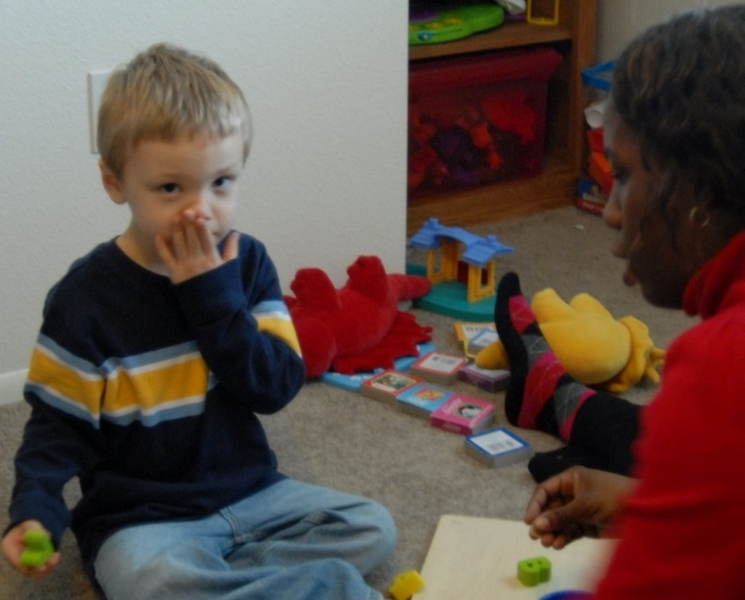
Figure 8.19 – A boy with ASD receiving therapy.

There has been increasing attention to the development of evidenced-based interventions for young children with ASD. Although evidence-based interventions for children with ASD vary in their methods, many adopt a psychoeducational approach to enhancing cognitive, communication, and social skills while minimizing behaviors that are thought to be problematic.

Conclusion
In this chapter we covered,
- Piaget’s preoperational stage.
- Vygotsky’s sociocultural theory.
- Information processing.
- How young children understand the world.
- Typical progression of cognitive and language development (milestones).
- Early childhood education.
- Autism spectrum disorder.

In the next chapter, we will finish covering early childhood education by looking at how children understand themselves and interact with the world.

Chapter 9: Social Emotional Development in Early Childhood

Objectives
After reading this chapter, you should be able to:
- Describe how preschoolers view themselves.
- Summarize Erikson’s stage of initiative versus guilt.
- Discuss the progression of social emotional development during early childhood.
- Explain how children develop their understanding of gender.
- Compare and contrast different styles of parenting.
- Define characteristics of high quality child care.
- Discuss the role of siblings and peers.
- Describe the types of play.
- Summarize the influence on social and emotional competence.
- Identify the effects of stress on three- to five-year olds.

Introduction
In early childhood, children’s understanding of themselves and their role in the world expands greatly.

Social and Emotional Milestones
That expanding understanding of themselves and others develops with age. Here is a table of social and emotional milestones that children typically experience during early childhood.

Table 9.1 - Social and Emotional Milestones

Typical Age | What Most Children Do by This Age
3 years | - Copies adults and friends  - Shows affection for friends without prompting  - Takes turns in games  - Shows concern for a crying friend  - Dresses and undresses self  - Understands the idea of “mine” and “his” or “hers”  - Shows a wide range of emotions  - Separates easily from mom and dad  - May get upset with major changes in routine
4 years | - Enjoys doing new things  - Is more and more creative with make-believe play  - Would rather play with other children than by self  - Cooperates with other children  - Plays “mom” or “dad”  - Often can’t tell what’s real and what’s make-believe  - Talks about what she likes and what she is interested in
5 years | - Wants to please friends  - Wants to be like friends  - More likely to agree with rules  - Likes to sing, dance, and act  - Is aware of gender  - Can tell what’s real and what’s make-believe  - Shows more independence  - Is sometimes demanding and sometimes very cooperative

Many things influence how children develop those milestones as how they view themselves and how they interact with those around them changes. Let’s look more at these.

Interactionism and Views of Self
Early childhood is a time of forming an initial sense of self. A self-concept or idea of who we are, what we are capable of doing, and how we think and feel is a social process that involves taking into consideration how others view us. So, in order to develop a sense of self, you must have interaction with others. Interactionist theorists, Cooley and Mead offer two interesting explanations of how a sense of self develops.

Cooley
Charles Horton Cooley (1964) suggests that our self-concept comes from looking at how others respond to us. This process, known as the looking-glass self involves looking at how others seem to view us and interpreting this as we make judgments about whether we are good or bad, strong or weak, beautiful or ugly, and so on. Of course, we do not always interpret their responses accurately so our self-concept is not simply a mirror reflection of the views of others. After forming an initial self-concept, we may use it as a mental filter screening out those responses that do not seem to fit our ideas of who we are. Some compliments may be negated, for example. The process of the looking-glass self is pronounced when we are preschoolers, or perhaps when we are in a new school or job or are taking on a new role in our personal lives and are trying to gauge our own performances. When we feel more sure of who we are, we focus less on how we appear to others.

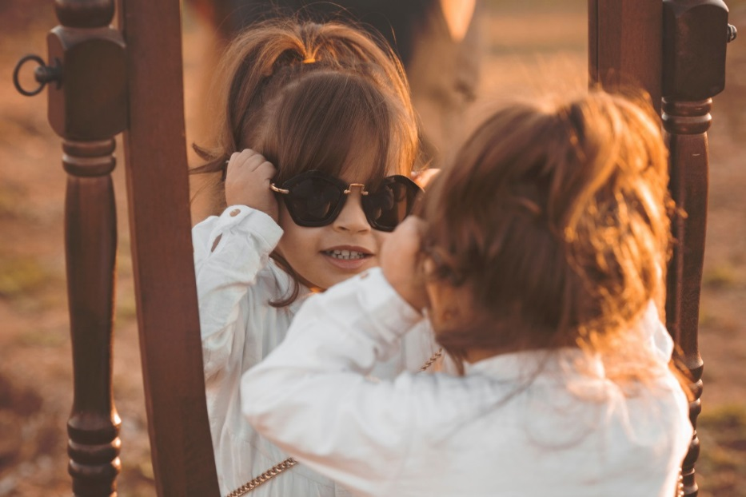
Figure 9.1 – A child looking at herself wearing glasses in a mirror.

Mead
Herbert Mead (1967) offers an explanation of how we develop a social sense of self by being able to see ourselves through the eyes of others. There are two parts of the self: the “I” which is the part of the self that is spontaneous, creative, innate, and is not concerned with how others view us and the “me” or the social definition of who we are.

When we are born, we are all “I” and act without concern about how others view us. But the socialized self begins when we are able to consider how one important person views us. This initial stage is called “taking the role of the significant other”. For example, a child may pull a cat’s tail and be told by his mother, “No! Don’t do that, that’s bad” while receiving a slight slap on the hand. Later, the child may mimic the same behavior toward the self and say aloud, “No, that’s bad” while patting his own hand. What has happened? The child is able to see himself through the eyes of the mother. As the child grows and is exposed to many situations and rules of culture, he begins to view the self in the eyes of many others through these cultural norms or rules. This is referred to as “taking the role of the generalized other” and results in a sense of self with many dimensions. The child comes to have a sense of self as student, as friend, as son, and so on.

Exaggerated Sense of Self
One of the ways to gain a clearer sense of self is to exaggerate those qualities that are to be incorporated into the self. Preschoolers often like to exaggerate their own qualities or to seek validation as the biggest, smartest, or child who can jump the highest. This exaggeration tends to be replaced by a more realistic sense of self in middle childhood.

Self-Esteem
Early childhood is a time of forming an initial sense of self. Self-concept is our self-description according to various categories, such as our external and internal qualities. In contrast, self- esteem is an evaluative judgment about who we are. The emergence of cognitive skills in this age group results in improved perceptions of the self, but they tend to focus on external qualities, which are referred to as the categorical self. When researchers ask young children to describe themselves, their descriptions tend to include physical descriptors, preferred activities, and favorite possessions. Thus, the self-description of a 3-year-old might be a 3-year-old girl with red hair, who likes to play with blocks. However, even children as young as three know there is more to themselves than these external characteristics.

Harter and Pike (1984) challenged the method of measuring personality with an open-ended question as they felt that language limitations were hindering the ability of young children to express their self-knowledge. They suggested a change to the method of measuring self-concept in young children, whereby researchers provide statements that ask whether something is true of the child (e.g., “I like to boss people around”, “I am grumpy most of the time”). They discovered that in early childhood, children answer these statements in an internally consistent manner, especially after the age of four (Goodvin, Meyer, Thompson & Hayes, 2008) and often give similar responses to what others (parents and teachers) say about the child (Brown, Mangelsdorf, Agathen, & Ho, 2008; Colwell & Lindsey, 2003).

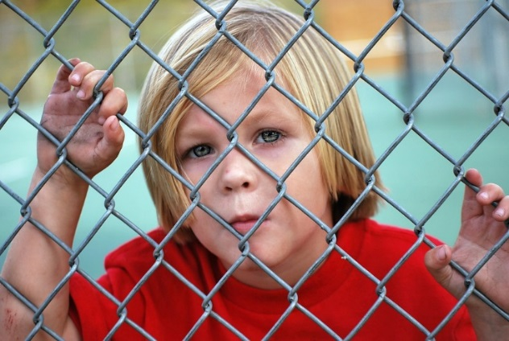
Figure 9.2 – Young children don’t always feel good about themselves.

Young children tend to have a generally positive self-image. This optimism is often the result of a lack of social comparison when making self-evaluations (Ruble, Boggiano, Feldman, & Loeble, 1980), and with comparison between what the child once could do to what they can do now (Kemple, 1995). However, this does not mean that preschool children are exempt from negative self-evaluations. Preschool children with insecure attachments to their caregivers tend to have lower self-esteem at age four (Goodvin et al., 2008). Maternal negative affect (emotional state) was also found by Goodwin and her colleagues to produce more negative self-evaluations in preschool children.

Self-Control
Self-control is not a single phenomenon, but is multi-facetted. It includes response initiation, the ability to not initiate a behavior before you have evaluated all of the information, response inhibition, the ability to stop a behavior that has already begun, and delayed gratification, the ability to hold out for a larger reward by forgoing a smaller immediate reward (Dougherty, Marsh, Mathias, & Swann, 2005). It is in early childhood that we see the start of self-control, a process that takes many years to fully develop. In the now classic “Marshmallow Test” (Mischel, Ebbesen, & Zeiss, 1972) children are confronted with the choice of a small immediate reward (a marshmallow) and a larger delayed reward (more marshmallows). Walter Mischel and his colleagues over the years have found that the ability to delay gratification at the age of four predicted better academic performance and health later in life (Mischel, et al., 2011). Self- control is related to executive function, discussed earlier in the chapter. As executive function improves, children become less impulsive (Traverso, Viterbori, & Usai, 2015).

Self-Control and Play
Thanks to the new Centre for Research on Play in Education, Development and Learning (PEDaL), Whitebread, Baker, Gibson and a team of researchers hope to provide evidence on the role played by play in how a child develops.

“A strong possibility is that play supports the early development of children’s self-control,” explains Baker. “These are our abilities to develop awareness of our own thinking processes – they influence how effectively we go about undertaking challenging activities.”

In a study carried out by Baker with toddlers and young preschoolers, she found that children with greater self-control solved problems quicker when exploring an unfamiliar set-up requiring scientific reasoning, regardless of their IQ. “This sort of evidence makes us think that giving children the chance to play will make them more successful and creative problem-solvers in the long run.”

If playful experiences do facilitate this aspect of development, say the researchers, it could be extremely significant for educational practices because the ability to self-regulate has been shown to be a key predictor of academic performance.

Gibson adds: “Playful behavior is also an important indicator of healthy social and emotional development. In my previous research, I investigated how observing children at play can give us important clues about their well being and can even be useful in the diagnosis of neurodevelopmental disorders like autism.”

Erikson: Initiative vs. Guilt
Psychologist Erik Erikson argues that children in early childhood go through a stage of “initiative vs. guilt”. If the child is placed in an environment where he/she can explore, make decisions, and initiate activities, they have achieved initiative. On the other hand, if the child is put in an environment where initiation is repressed through criticism and control, he/she will develop a sense of guilt.

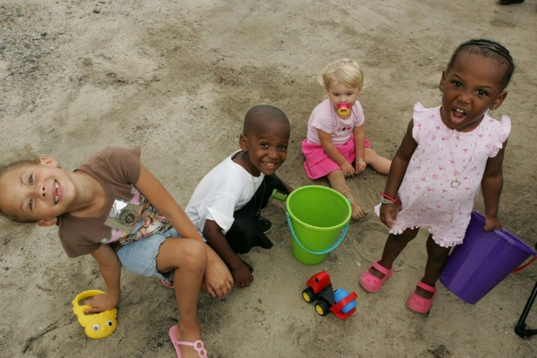
Figure 9.3 – Children playing in the sand.

The trust and autonomy of previous stages develop into a desire to take initiative or to think of ideas and initiative action. Children may want to build a fort with the cushions from the living room couch or open a lemonade stand in the driveway or make a zoo with their stuffed animals and issue tickets to those who want to come. Or they may just want to get themselves ready for bed without any assistance. To reinforce taking initiative, caregivers should offer praise for the child’s efforts and avoid being critical of messes or mistakes. Soggy washrags and toothpaste left in the sink pales in comparison to the smiling face of a five-year-old that emerges from the bathroom with clean teeth and pajamas!

Gender Identity, Gender Constancy, and Gender Roles
Another important dimension of the self is the sense of self as male or female. Preschool-aged children become increasingly interested in finding out the differences between boys and girls both physically and in terms of what activities are acceptable for each. While 2 year olds can identify some differences and learn whether they are boys or girls, preschoolers become more interested in what it means to be male or female. This self-identification or gender identity is followed sometime later with gender constancy or the knowledge that gender does not change. Gender roles or the rights and expectations that are associated with being male or female are learned throughout childhood and into adulthood.

Freud and the Phallic Stage
Freud believed that masculinity and femininity were learned during the phallic stage of psychosexual development. According to Freud, during the phallic stage, the child develops an attraction to the opposite-sex parent but after recognizing that that they cannot actually be romantically involved with that parent, the child learns to model their own behavior after the same-sex parent. The child develops his or her own sense of masculinity or femininity from this resolution. And, according to Freud, a person who does not exhibit gender appropriate behavior, such as a woman who competes with men for jobs or a man who lacks self-assurance and dominance, has not successfully completed this stage of development. Consequently, such a person continues to struggle with his or her own gender identity.

Chodorow and Mothering
Chodorow, a Neo-Freudian, believed that mothering promotes gender stereotypic behavior. Mothers push their sons away too soon and direct their attention toward problem-solving and independence. As a result, sons grow up confident in their own abilities but uncomfortable with intimacy. Girls are kept dependent too long and are given unnecessary and even unwelcome assistance from their mothers. Girls learn to underestimate their abilities and lack assertiveness, but feel comfortable with intimacy.

Figure 9.4 – A boy showing independence and confidence. | Figure 9.5 – A girl showing dependence and comfort within a relationship.
Both of these models assume that early childhood experiences result in lifelong gender self-concepts. However, gender socialization is a process that continues throughout life. Children, teens, and adults refine and can modify their sense of self based on gender.

Learning through Reinforcement and Modeling
Learning theorists suggest that gender role socialization is a result of the ways in which parents, teachers, friends, schools, religious institutions, media and others send messages about what is acceptable or desirable behavior as males or females. This socialization begins early-in fact, it may even begin the moment a parent learns that a child is on the way. Knowing the sex of the child can conjure up images of the child’s behavior, appearance, and potential on the part of a parent. And this stereotyping continues to guide perception through life. Consider parents of newborns, shown a 7 pound, 20 inch baby, wrapped in blue (a color designating males) describe the child as tough, strong, and angry when crying. Shown the same infant in pink (a color used in the United States for baby girls), these parents are likely to describe the baby as pretty, delicate, and frustrated when crying. (Maccoby & Jacklin, 1987). Female infants are held more, talked to more frequently and given direct eye contact, while male infants play is often mediated through a toy or activity.

Sons are given tasks that take them outside the house and that have to be performed only on occasion while girls are more likely to be given chores inside the home such as cleaning or cooking that is performed daily. Sons are encouraged to think for themselves when they encounter problems and daughters are more likely to be given assistance even when they are working on an answer. This impatience is reflected in teachers waiting less time when asking a female student for an answer than when asking for a reply from a male student (Sadker and Sadker, 1994). Girls are given the message from teachers that they must try harder and endure in order to succeed while boys’ successes are attributed to their intelligence. Of course, the stereotypes of advisors can also influence which kinds of courses or vocational choices girls and boys are encouraged to make.

Friends discuss what is acceptable for boys and girls and popularity may be based on modeling what is considered ideal behavior or looks for the sexes. Girls tend to tell one another secrets to validate others as best friends while boys compete for position by emphasizing their knowledge, strength or accomplishments. This focus on accomplishments can even give rise to exaggerating accomplishments in boys, but girls are discouraged from showing off and may learn to minimize their accomplishments as a result.

Gender messages abound in our environment. But does this mean that each of us receives and interprets these messages in the same way? Probably not. In addition to being recipients of these cultural expectations, we are individuals who also modify these roles (Kimmel, 2008). Based on what young children learn about gender from parents, peers, and those who they observe in society, children develop their own conceptions of the attributes associated with maleness or femaleness which is referred to as gender schemas.

How much does gender matter? In the United States, gender differences are found in school experiences (even into college and professional school, girls are less vocal in the classrooms and much more at risk for sexual harassment from teachers, coaches, classmates, and professors), in social interactions and in media messages. The stereotypes that boys should be strong, forceful, active, dominant, and rational and that girls should be pretty, subordinate, unintelligent, emotional, and gabby are portrayed in children’s toys, books, commercials, video games, movies, television shows and music.

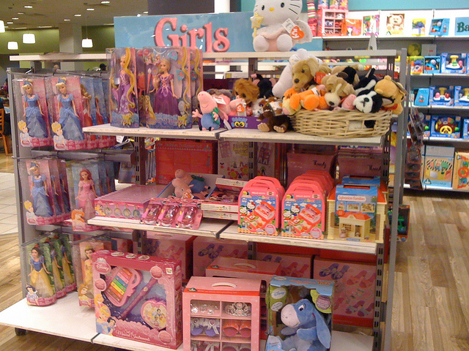  Figure 9.6 – Store shelves filled with pink and purple colors and girls’ toys. | Figure 9.7 – Store shelves filled with primary colors and boys’ toys.

In adulthood, these differences are reflected in income gaps between men and women where women working full-time earn about 74 percent the income of men, in higher rates of women suffering rape and domestic violence, higher rates of eating disorders for females, and in higher rates of violent death for men in young adulthood. Each of these differences will be explored further in subsequent chapters.

Gender Dysphoria
A growing body of research is now focused on Gender Dysphoria, or the distress accompanying a mismatch between one’s gender identity and biological sex (American Psychiatric Association, 2013). Although prevalence rates are low, at approximately 0.3 percent of the United States population (Russo, 2016), children who later identified as transgender, often stated that they were the opposite gender as soon as they began talking. Comments such as stating they prefer the toys, clothing and anatomy of the opposite sex, while rejecting the toys, clothing, and anatomy of their assigned sex are criteria for a diagnosis of Gender Dysphoria in children. Certainly, many young children do not conform to the gender roles modeled by the culture and even push back against assigned roles. However, they do not experience discomfort regarding their gender identity and would not be identified with Gender Dysphoria. A more comprehensive description of Gender Dysphoria, including current treatments, will be discussed in the chapter on adolescence.

Family Life
Relationships between parents and children continue to play a significant role in children’s development during early childhood. We will explore two models of parenting styles. Keep in mind that most parents do not follow any model completely. Real people tend to fall somewhere in between these styles. And sometimes parenting styles change from one child to the next or in times when the parent has more or less time and energy for parenting. Parenting styles can also be affected by concerns the parent has in other areas of his or her life. For example, parenting styles tend to become more authoritarian when parents are tired and perhaps more authoritative when they are more energetic. Sometimes parents seem to change their parenting approach when others are around, maybe because they become more self-conscious as parents or are concerned with giving others the impression that they are a “tough” parent or an “easy-going” parent. And of course, parenting styles may reflect the type of parenting someone saw modeled while growing up.

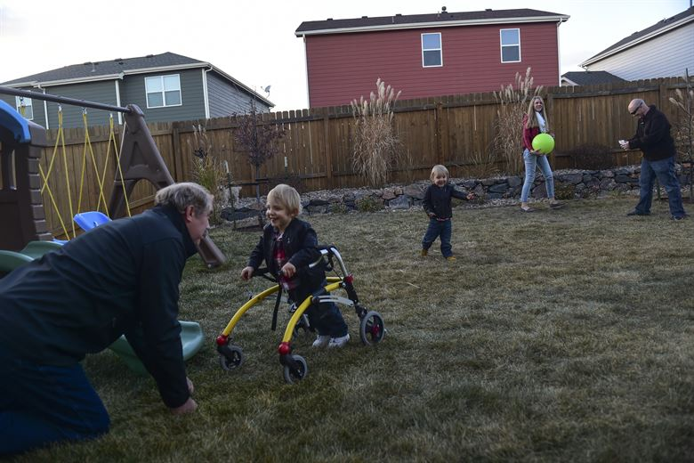
Figure 9.8 – A family playing outside together.

Baumrind
Baumrind (1971) offers a model of parenting that includes four styles. The first, authoritarian, is the traditional model of parenting in which parents make the rules and children are expected to be obedient. Baumrind suggests that authoritarian parents tend to place maturity demands on their children that are unreasonably high and tend to be aloof and distant. Consequently, children reared in this way may fear rather than respect their parents and, because their parents do not allow discussion, may take out their frustrations on safer targets-perhaps as bullies toward peers.

Permissive parenting involves holding expectations of children that are below what could be reasonably expected from them. Children are allowed to make their own rules and determine their own activities. Parents are warm and communicative, but provide little structure for their children. Children fail to learn self-discipline and may feel somewhat insecure because they do not know the limits.
Authoritative parenting involves being appropriately strict, reasonable, and affectionate. Parents allow negotiation where appropriate and discipline matches the severity of the offense. A popular parenting program that is offered in many school districts is called “Love and Logic” and reflects the authoritative or democratic style of parenting just described.

Uninvolved parents (also referred to as rejecting/neglecting) are disengaged from their children. They do not make demands on their children and are non-responsive. These children can suffer in school and in their relationships with their peers (Gecas & Self, 1991).

Lemasters and Defrain
Lemasters and Defrain (1989) offer another model of parenting. This model is interesting because it looks more closely at the motivations of the parent and suggests that parenting styles are often designed to meet the psychological needs of the parent rather than the developmental needs of the child.

The martyr is a parent who will do anything for the child; even tasks that the child should do for himself or herself. All of the good deeds performed for the child, in the name of being a “good parent”, may be used later should the parent want to gain compliance from the child. If a child goes against the parent’s wishes, the parent can remind the child of all of the times the parent helped the child and evoke a feeling of guilt so that the child will do what the parent wants. The child learns to be dependent and manipulative as a result.

The pal is like the permissive parent described previously in Baumrind’s model. The pal wants to be the child’s friend. Perhaps the parent is lonely or perhaps the parent is trying to win a popularity contest against an ex-spouse. Pals let children do what they want and focus mostly on being entertaining and fun and set few limitations. Consequently, the child may have little self-discipline and may try to test limits with others.

The police officer/drill sergeant style of parenting is similar to the authoritarian parent described by Baumrind. The parent focuses primarily on making sure that the child is obedient and that the parent has full control of the child. Sometimes this can be taken to extreme by giving the child tasks that are really designed to check on their level of obedience. For example, the parent may require that the child fold the clothes and place items back in the drawer in a particular way. If not, the child might be scolded or punished for not doing things “right”. This type of parent has a very difficult time allowing the child to grow and learn to make decisions independently. And the child may have a lot of resentment toward the parent that is displaced on others.

The teacher-counselor parent is one who pays a lot of attention to expert advice on parenting and who believes that as long as all of the steps are followed, the parent can rear a perfect child. “What’s wrong with that?” you might ask. There are two major problems with this approach. First, the parent is taking all of the responsibility for the child’s behavior-at least indirectly. If the child has difficulty, the parent feels responsible and thinks that the solution lies in reading more advice and trying more diligently to follow that advice.

Parents can certainly influence children, but thinking that the parent is fully responsible for the child’s outcome is misguided. A parent can only do so much and can never have full control over the child. Another problem with this approach is that the child may get an unrealistic sense of the world and what can be expected from others. For example, if a teacher-counselor parent decides to help the child build self-esteem and has read that telling the child how special he or she is or how important it is to compliment the child on a job well done, the parent may convey the message that everything the child does is exceptional or extraordinary. A child may come to expect that all of his efforts warrant praise and in the real world, this is not something one can expect. Perhaps children get more of a sense of pride from assessing their own performance than from having others praise their efforts.

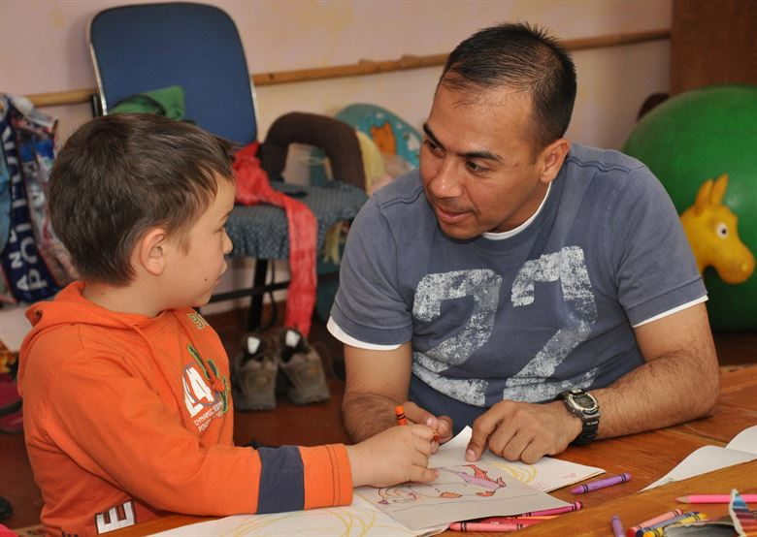
Figure 9.9 – A father interacting with his son who is drawing a picture. He could be portraying the style of teacher-counselor or athletic coach

So what is left? Lemasters and Defrain (1989) suggest that the athletic coach style of parenting is best. Before you draw conclusions here, set aside any negative experiences you may have had with coaches in the past. The principles of coaching are what are important to Lemasters and Defrain. A coach helps players form strategies, supports their efforts, gives feedback on what went right and what went wrong, and stands at the sideline while the players perform. Coaches and referees make sure that the rules of the game are followed and that all players adhere to those rules. Similarly, the athletic coach as parent helps the child understand what needs to happen in certain situations whether in friendships, school, or home life, and encourages and advises the child about how to manage these situations. The parent does not intervene or do things for the child. Their role is to provide guidance while the child learns firsthand how to handle these situations. And the rules for behavior are consistent and objective and presented in that way. So, a child who is late for dinner might hear the parent respond in this way, “Dinner was at six o’clock.” Rather than, “You know good and well that we always eat at six. If you expect me to get up and make something for you now, you have got another thing coming! Just who do you think you are showing up late and looking for food? You’re grounded until further notice!”

The most important thing to remember about parenting is that you can be a better, more objective parent when you are directing your actions toward the child’s needs and while considering what they can reasonably be expected to do at their stage of development. Parenting is more difficult when you are tired and have psychological needs that interfere with the relationship. Some of the best advice for parents is to try not to take the child’s actions personally and be as objective as possible.

Cultural Influences on Parenting Styles
The impact of class and culture cannot be ignored when examining parenting styles. The two models of parenting described above assume that authoritative and athletic coaching styles are best because they are designed to help the parent raise a child who is independent, self-reliant and responsible. These are qualities favored in “individualistic” cultures such as the United States, particularly by the white middle class. African-American, Hispanic and Asian parents tend to be more authoritarian than non-Hispanic whites.

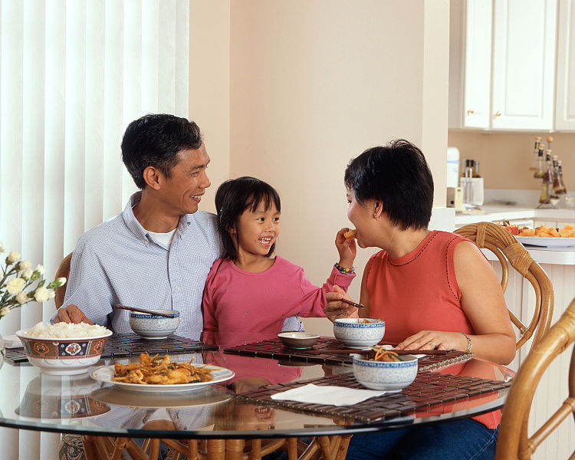
Figure 9.10 – A family from a collectivistic culture.

In “collectivistic” cultures such as China or Korea, being obedient and compliant are favored behaviors. Authoritarian parenting has been used historically and reflects cultural need for children to do as they are told. In societies where family members’ cooperation is necessary for survival, as in the case of raising crops, rearing children who are independent and who strive to be on their own makes no sense. But in an economy based on being mobile in order to find jobs and where one’s earnings are based on education, raising a child to be independent is very important.

Working class parents are more likely than middle class parents to focus on obedience and honesty when raising their children. In a classic study on social class and parenting styles called Class and Conformity, Kohn (1977) explains that parents tend to emphasize qualities that are needed for their own survival when parenting their children. Working class parents are rewarded for being obedient, reliable, and honest in their jobs. They are not paid to be independent or to question the management; rather, they move up and are considered good employees if they show up on time, do their work as they are told, and can be counted on by their employers. Consequently, these parents reward honesty and obedience in their children.

Middle class parents who work as professionals are rewarded for taking initiative, being self-directed, and assertive in their jobs. They are required to get the job done without being told exactly what to do. They are asked to be innovative and to work independently. These parents encourage their children to have those qualities as well by rewarding independence and self-reliance. Parenting styles can reflect many elements of culture.

Spanking
Many adults can remember being spanked as a child. This method of discipline continues to be endorsed by the majority of parents (Smith, 2012). Just how effective is spanking, however, and are there any negative consequences? After reviewing the research, Smith (2012) states “many studies have shown that physical punishment, including spanking, hitting and other means of causing pain, can lead to increased aggression, antisocial behavior, physical injury and mental health problems for children” (p. 60).

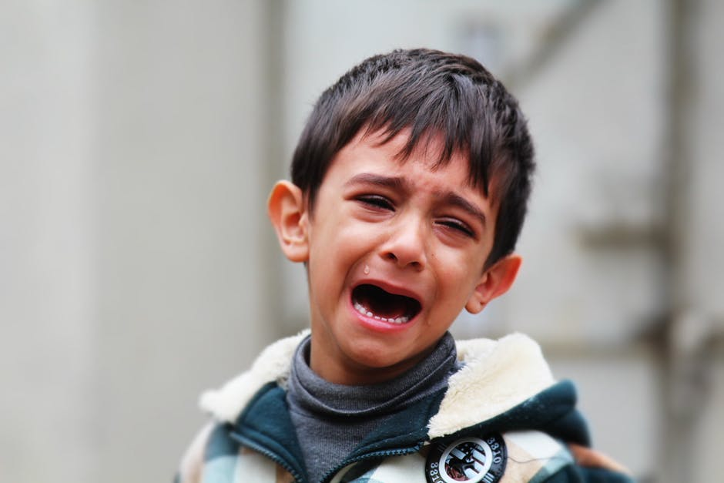
Figure 9.11 – A boy crying.

Gershoff, (2008) reviewed decades of research and recommended that parents and caregivers make every effort to avoid physical punishment and called for the banning of physical discipline in all U.S. schools. Gershoff and Grogan-Kaylor (2016) completed another metanalysis that looked at research over 160,927 children . They found increased risk for negative outcomes for children who are spanked and that effects of spanking were similar to that of physical abuse.

In a longitudinal study that followed more than 1500 families from 20 U.S. cities, parents’ reports of spanking were assessed at ages three and five (MacKenzie, Nicklas, Waldfogel, & Brooks-Gunn, 2013). Measures of externalizing behavior (aggression and rule-breaking) and receptive vocabulary were assessed at age nine.

Overall, 57% of mothers and 40% of fathers engaged in spanking when children were age 3, and 52% of mothers and 33% of fathers engaged in spanking at age 5. Maternal spanking at age 5, even at low levels, was associated with higher levels of aggression at age 9, even after an array of risks and earlier child behavior were controlled for. Father's high-frequency spanking at age 5 was associated with lower child receptive vocabulary scores at age 9. This study revealed the negative cognitive effects of spanking in addition to the increase in aggressive behavior.

Internationally, physical discipline is increasingly being viewed as a violation of children’s human rights. Thirty countries have banned the use of physical punishment, and the United Nations Committee on the Rights of the Child (2014) called physical punishment “legalized violence against children” and advocated that physical punishment be eliminated in all settings.

Alternatives to spanking are advocated by child development specialists and include:
- Praising and modeling appropriate behavior
- Providing time-outs for inappropriate behavior
- Giving choices
- Helping the child identify emotions and learning to calm down
- Ignoring small annoyances
- Withdrawing privileges

Changing Families in a Changing Society
The sociology of the family examines the family as an institution and a unit of socialization. Sociological studies of the family look at demographic characteristics of the family members: family size, age, ethnicity and gender of its members, social class of the family, the economic level and mobility of the family, professions of its members, and the education levels of the family members.

Currently, one of the biggest issues that sociologists study are the changing roles of family members. Often, each member is restricted by the gender roles of the traditional family. These roles, such as the father as the breadwinner and the mother as the homemaker, are declining. Now, the mother is often the supplementary provider while retaining the responsibilities of child rearing. In this scenario, females' role in the labor force is "compatible with the demands of the traditional family." Sociology studies the adaptation of males' role to caregiver as well as provider. The gender roles are increasingly interwoven.

Diverse Family Forms
A single parent family usually refers to a parent who has most of the day-to-day responsibilities in the raising of the child or children, who is not living with a spouse or partner, or who is not married. The dominant caregiver is the parent with whom the children reside the majority of the time. If the parents are separated or divorced, children live with their custodial parent and have visitation with their noncustodial parent. In western society in general, following separation a child will end up with the primary caregiver, usually the mother, and a secondary caregiver, usually the father. There is a growing community of single parent by choice families in which a family is built by a single adult (through foster care, adoption, donor gametes and embryos, and surrogacy).

Figure 9.12 – A single-parent family.

Cohabitation is an arrangement where two people who are not married live together in an intimate relationship, particularly an emotionally and/or sexually intimate one, on a long-term or permanent basis. Today, cohabitation is a common pattern among people in the Western world. More than two-thirds of married couples in the U.S. say that they lived together before getting married.

Gay and lesbian couples are categorized as same-sex relationships. After a Supreme Court ruling in 2015, all 50 states in the U.S. must recognize same-sex marriage, there are still some counties in several states that will not issue a marriage license to a same-sex couple.

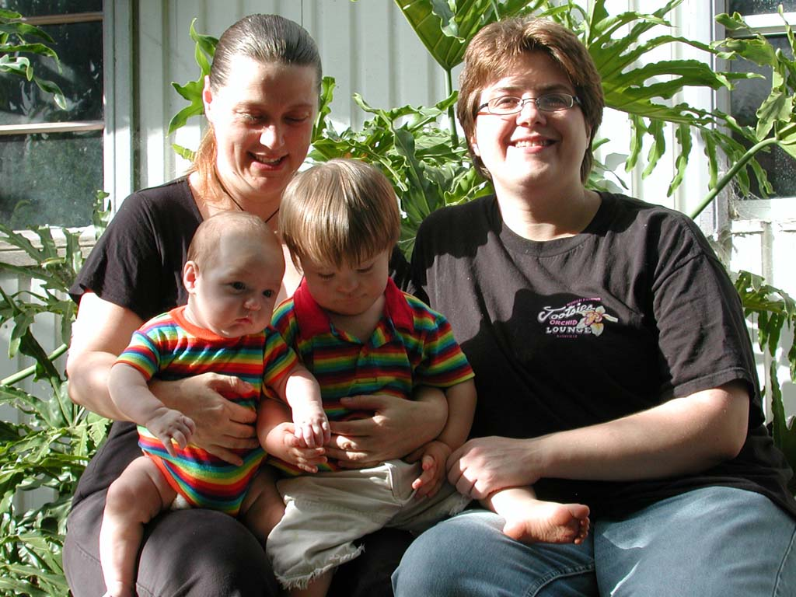
Figure 9.13 – A family with parents of the same sex.

Sibling Relationships
Siblings spend a considerable amount of time with each other and offer a unique relationship that is not found with same-age peers or with adults. Siblings play an important role in the development of social skills. Cooperative and pretend play interactions between younger and older siblings can teach empathy, sharing, and cooperation (Pike, Coldwell, & Dunn, 2005) as well as negotiation and conflict resolution (Abuhatoum & Howe, 2013). However, the quality of sibling relationships is often mediated by the quality of the parent-child relationship and the psychological adjustment of the child (Pike et al., 2005). For instance, more negative interactions between siblings have been reported in families where parents had poor patterns of communication with their children (Brody, Stoneman, & McCoy, 1994). Children who have emotional and behavioral problems are also more likely to have negative interactions with their siblings. However, the psychological adjustment of the child can sometimes be a reflection of the parent-child relationship. Thus, when examining the quality of sibling interactions, it is often difficult to tease out the separate effect of adjustment from the effect of the parent-child relationship.

While parents want positive interactions between their children, conflicts are going to arise, and some confrontations can be the impetus for growth in children’s social and cognitive skills. The sources of conflict between siblings often depend on their respective ages. Dunn and Munn (1987) revealed that over half of all sibling conflicts in early childhood were disputes about property rights. By middle childhood this starts shifting toward control over social situations, such as what games to play, disagreements about facts or opinions, or rude behavior (Howe, Rinaldi, Jennings, & Petrakos, 2002). Researchers have also found that the strategies children use to deal with conflict change with age, but that this is also tempered by the nature of the conflict.

Abuhatoum and Howe (2013) found that coercive strategies (e.g., threats) were preferred when the dispute centered on property rights, while reasoning was more likely to be used by older siblings and in disputes regarding control over the social situation. However, younger siblings also use reasoning, frequently bringing up the concern of legitimacy (e.g., “You’re not the boss”) when in conflict with an older sibling. This is a very common strategy used by younger siblings and is possibly an adaptive strategy in order for younger siblings to assert their autonomy (Abuhatoum & Howe, 2013). A number of researchers have found that children who can use non-coercive strategies are more likely to have a successful resolution, whereby a compromise is reached and neither child feels slighted (Ram & Ross, 2008; Abuhatoum & Howe, 2013).

Not surprisingly, friendly relationships with siblings often lead to more positive interactions with peers. The reverse is also true. A child can also learn to get along with a sibling, with, as the song says “a little help from my friends” (Kramer & Gottman, 1992).

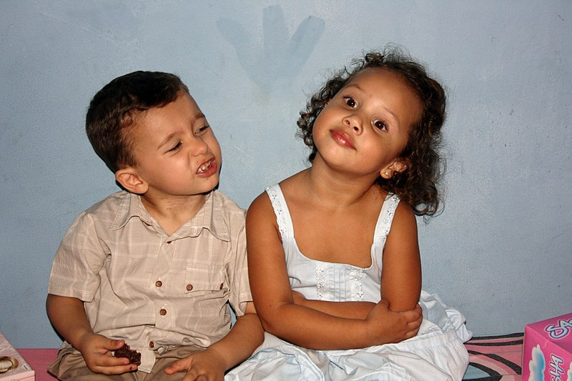
Figure 9.14 – Siblings.

Child Care Concerns
About 77.3 percent of mothers of school-aged and 64.2 percent of mothers of preschool-aged children in the United States work outside the home (Cohen and Bianchi, 1999; Bureau of Labor Statistics, 2010). Seventy-five percent of children under age 5 are in scheduled childcare programs. Others are cared for by family members or friends. Older children are often in after school programs, before school programs, or stay at home alone after school once they are older.
Quality childcare programs can enhance a child’s social skills and can provide rich learning experiences. But long hours in poor quality care can have negative consequences, especially for young children.

Quality of Care
What determines the quality of child care? One consideration is the teacher/child ratio. States specify the maximum number of children that can be supervised by one teacher. In general, the younger the children, the more teachers required for a given number of children. The lower the teacher to child ratio, the more time the teacher has for involvement with the children and the less stressed the teacher may be so that the interactions can be more relaxed, stimulating and positive. Larger group sizes present challenges to quality as well. The program may be more rigid in rules and structure to accommodate the large number of children in the facility.

The physical environment should be engaging, clean, and safe. The philosophy of the organization and the curriculum available should be child-centered, positive, and stimulating. Providers should be trained in early childhood education. A majority of states do not require training for their childcare providers. And while formal education is not required for a person to provide a warm, loving relationship to a child, knowledge of a child’s development is useful for addressing their social, emotional, and cognitive needs in an effective way.

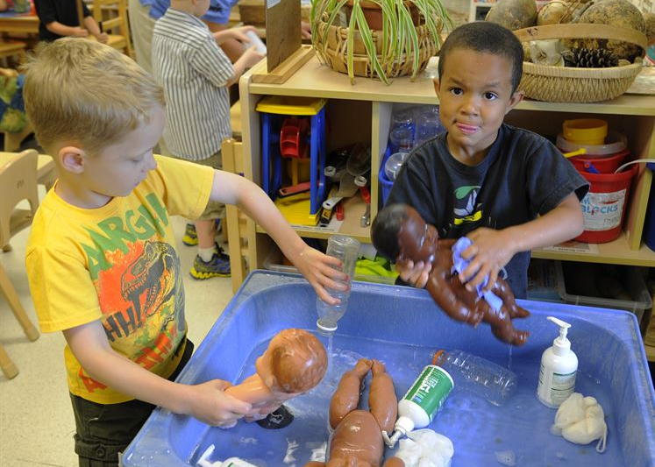
Figure 9.15 – Children playing in a quality childcare environment.

By working toward improving the quality of childcare and increasing family-friendly workplace policies such as more flexible scheduling and perhaps childcare facilities at places of employment, we can accommodate families with smaller children and relieve parents of the stress sometimes associated with managing work and family life.

Peers
Relationships within the family (parent-child and siblings) are not the only significant relationships in a child’s life. Peer relationships are also important. Social interaction with another child who is similar in age, skills, and knowledge provokes the development of many social skills that are valuable for the rest of life (Bukowski, Buhrmester, & Underwood, 2011). In peer relationships, children learn how to initiate and maintain social interactions with other children. They learn skills for managing conflict, such as turn-taking, compromise, and bargaining. Play also involves the mutual, sometimes complex, coordination of goals, actions, and understanding. For example, as preschoolers engage in pretend play they create narratives together, choose roles, and collaborate to act out their stories. Through these experiences, children develop friendships that provide additional sources of security and support to those provided by their parents.

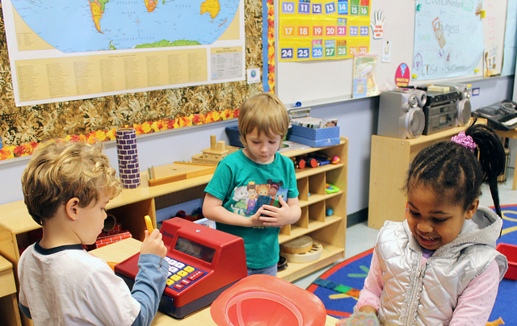
Figure 9.16 – Navigating dramatic play provides great opportunities to
continue to develop social skills with same-age peers .

However, peer relationships can be challenging as well as supportive (Rubin, Coplan, Chen, Bowker, & McDonald, 2011). Being accepted by other children is an important source of affirmation and self-esteem, but peer rejection can foreshadow later behavior problems (especially when children are rejected due to aggressive behavior).

Peer relationships require developing very different social and emotional skills than those that emerge in parent-child relationships. They also illustrate the many ways that peer relationships influence the growth of personality and self-concept.

Play
Freud saw play as a means for children to release pent-up emotions and to deal with emotionally distressing situations in a more secure environment. Vygotsky and Piaget saw play as a way of children developing their intellectual abilities (Dyer & Moneta, 2006). Piaget created stages of play that correspond with his stages of cognitive development. The stages are:

Table 9.2 - Piaget’s Stages of Play

Stage | Description
Functional Play | Exploring, inspecting, and learning through repetitive physical activity.
Symbolic Play | The ability to use objects, actions, or ideas to represent other objects, actions, or ideas and may include taking on roles.
Constructive Play | Involves experimenting with objects to build things; learning things that were previously unknown with hands on manipulations of materials.
Games with Rules | Imposes rules that must be followed by everyone that is playing; the logic and order involved forms that the foundations for developing game playing strategy

While Freud, Piaget, and Vygostsky looked at play slightly differently, all three theorists saw play as providing positive outcomes for children.

Mildred Parten (1932) observed two to five year-old children and noted six types of play. Three types she labeled as non-social (unoccupied, solitary, and onlooker) and three types were categorized as social play (parallel, associative, and cooperative). The table below describes each type of play. Younger children engage in non-social play more than those who are older; by age five associative and cooperative play are the most common forms of play (Dyer & Moneta, 2006).

Table 9.3 - Parten’s Classification of Types of Play

Category | Description
Unoccupied Play | Children’s behavior seems more random and without a specific goal. This is the least common form of play.
Solitary Play | Children play by themselves, do not interact with others, nor are they engaging in similar activities as the children around them.
Onlooker Play | Children are observing other children playing. They may comment on the activities and even make suggestions, but will not directly join the play.
Parallel Play | Children play alongside each other, using similar toys, but do not directly act with each other
Associative Play | Children will interact with each other and share toys, but are not working toward a common goal.
Cooperative Play | Children are interacting to achieve a common goal. Children may take on different tasks to reach that goal.

Social Understanding
As we have seen, children’s experience of relationships at home and the peer group contributes to an expanding repertoire of social and emotional skills and also to broadened social understanding. In these relationships, children develop expectations for specific people (leading, for example, to secure or insecure attachments to parents), understanding of how to interact with adults and peers, and developing self-concept based on how others respond to them. These relationships are also significant forums for emotional development.

Remarkably, young children begin developing social understanding very early in life. Before the end of the first year, infants are aware that other people have perceptions, feelings, and other mental states that affect their behavior, and which are different from the child’s own mental states. Carefully designed experimental studies show that by late in the preschool years, young children understand that another’s beliefs can be mistaken rather than correct, that memories can affect how you feel, and that one’s emotions can be hidden from others (Wellman, 2011). Social understanding grows significantly as children’s theory of mind develops.

How do these achievements in social understanding occur? One answer is that young children are remarkably sensitive observers of other people, making connections between their emotional expressions, words, and behavior to derive simple inferences about mental states (e.g., concluding, for example, that what Mommy is looking at is in her mind) (Gopnik, Meltzoff, & Kuhl, 2001). This is especially likely to occur in relationships with people whom the child knows well, consistent with the ideas of attachment theory discussed above.

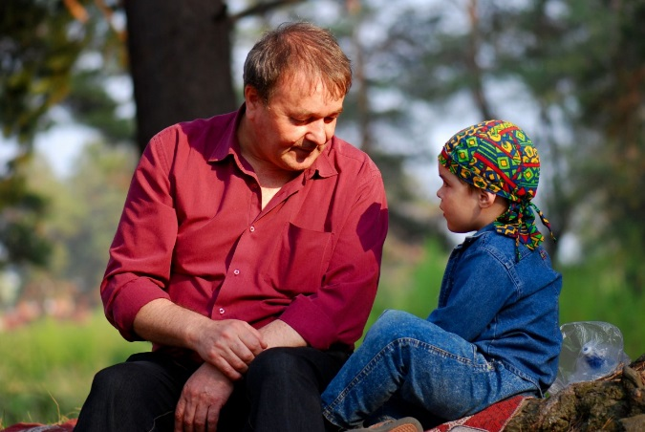
Figure 9.17 – A father speaking to his child.

Growing language skills give young children words with which to represent these mental states (e.g., “mad,” “wants”) and talk about them with others. Thus in conversation with their parents about everyday experiences, children learn much about people’s mental states from how adults talk about them (“Your sister was sad because she thought Daddy was coming home.”) (Thompson, 2006b).

Developing social understanding is based on children’s everyday interactions with others and their careful interpretations of what they see and hear. There are also some scientists who believe that infants are biologically prepared to perceive people in a special way, as organisms with an internal mental life, and this facilitates their interpretation of people’s behavior with reference to those mental states (Leslie, 1994).

Personality
Parents often scrutinize their child’s preferences, characteristics, and responses for clues of a developing personality. They are quite right to do so, because temperament is a foundation for personality growth. But temperament (defined as early-emerging differences in reactivity and self-regulation) is not the whole story. Although temperament is biologically based, it interacts with the influence of experience from the moment of birth (if not before) to shape personality (Rothbart, 2011). Temperamental dispositions are affected, for example, by the support level of parental care. More generally, personality is shaped by the goodness of fit between the child’s temperamental qualities and characteristics of the environment (Chess & Thomas, 1999). For example, an adventurous child whose parents regularly take her on weekend hiking and fishing trips would be a good “fit” to her lifestyle, supporting personality growth. Personality is the result, therefore, of the continuous interplay between biological disposition and experience, as is true for many other aspects of social and personality development.

Personality develops from temperament in other ways (Thompson, Winer, & Goodvin, 2010). As children mature biologically, temperamental characteristics emerge and change over time. A newborn is not capable of much self-control, but as brain-based capacities for self-control advance, temperamental changes in self-regulation become more apparent. So an infant that cries frequently doesn’t necessarily have a grumpy personality. With sufficient parental support and increased sense of security, the child may develop into a content preschooler that is not likely to cry to get her needs met.

Figure 9.18 – A girl enjoying nature.

In addition, personality is made up of many other features besides temperament. Children’s developing self-concept, their motivations to achieve or to socialize, their values and goals, their coping styles, their sense of responsibility and conscientiousness, and many other qualities are encompassed into personality. These qualities are influenced by biological dispositions, but even more by the child’s experiences with others, particularly in close relationships, that guide the growth of individual characteristics.

Indeed, personality development begins with the biological foundations of temperament but becomes increasingly elaborated, extended, and refined over time. The newborn that parents observed in wonder upon becomes an adult with a personality of depth and nuance.

Social and Emotional Competence
Social and personality development is built from the social, biological, and representational influences discussed above. These influences result in important developmental outcomes that matter to children, parents, and society: a young adult’s capacity to engage in socially constructive actions (helping, caring, sharing with others), to curb hostile or aggressive impulses, to live according to meaningful moral values, to develop a healthy identity and sense of self, and to develop talents and achieve success in using them. These are some of the developmental outcomes that denote social and emotional competence.

These achievements of social and personality development derive from the interaction of many social, biological, and representational influences. Consider, for example, the development of conscience, which is an early foundation for moral development.

Conscience consists of the cognitive, emotional, and social influences that cause young children to create and act consistently with internal standards of conduct (Kochanska, 2002). It emerges from young children’s experiences with parents, particularly in the development of a mutually responsive relationship that motivates young children to respond constructively to the parents’ requests and expectations. Biologically based temperament is involved, as some children are temperamentally more capable of motivated self-regulation (a quality called effortful control) than are others, while some children are more prone to the fear and anxiety that parental disapproval can evoke. The development of conscience is influenced by having good fit between the child’s temperamental qualities and how parents communicate and reinforce behavioral expectations.

Conscience development also expands as young children begin to represent moral values and think of themselves as moral beings. By the end of the preschool years, for example, young children develop a “moral self” by which they think of themselves as people who want to do the right thing, who feel badly after misbehaving, and who feel uncomfortable when others misbehave. In the development of conscience, young children become more socially and emotionally competent in a manner that provides a foundation for later moral conduct (Thompson, 2012).

Figure 9.19 – This child might be experiencing a guilty conscience.

Childhood Stress and Development
What is the impact of stress on child development? Children experience different types of stressors. Normal, everyday stress can provide an opportunity for young children to build coping skills and poses little risk to development. Even more long-lasting stressful events such as changing schools or losing a loved one can be managed fairly well. But children who experience toxic stress or who live in extremely stressful situations of abuse over long periods of time can suffer long-lasting effects. The structures in the midbrain or limbic system such as the hippocampus and amygdala can be vulnerable to prolonged stress during early childhood (Middlebrooks and Audage, 2008). High levels of the stress hormone cortisol can reduce the size of the hippocampus and effect the child's memory abilities. Stress hormones can also reduce immunity to disease. The brain exposed to long periods of severe stress can develop a low threshold making the child hypersensitive to stress in the future. However, the effects of stress can be minimized if the child has the support of caring adults. Let's take a look at childhood stressors.

Effects of Domestic Abuse
3.3 million children witness domestic violence each year in the US. There has been an increase in acknowledgment that children exposed to domestic abuse during their upbringing will suffer in their developmental and psychological welfare. Because of the awareness of domestic violence that some children have to face, it also generally impacts how the child develops emotionally, socially, behaviorally as well as cognitively. Some emotional and behavioral problems that can result due to domestic violence include increased aggressiveness, anxiety, and changes in how a child socializes with friends, family, and authorities. Bruises, broken bones, head injuries, lacerations, and internal bleeding are some of the acute effects of a domestic violence incident that require medical attention and hospitalization.

Child Maltreatment
Child abuse is the physical, sexual, or emotional mistreatment or neglect of a child or children. Different jurisdictions have developed their own definitions of what constitutes child abuse for the purposes of removing a child from his/her family and/or prosecuting a criminal charge. There are four major categories of child abuse: neglect, physical abuse, psychological/emotional abuse, and sexual abuse. Neglect is the most common type of abuse in the United States and accounts for over 60 percent of child abuse cases.

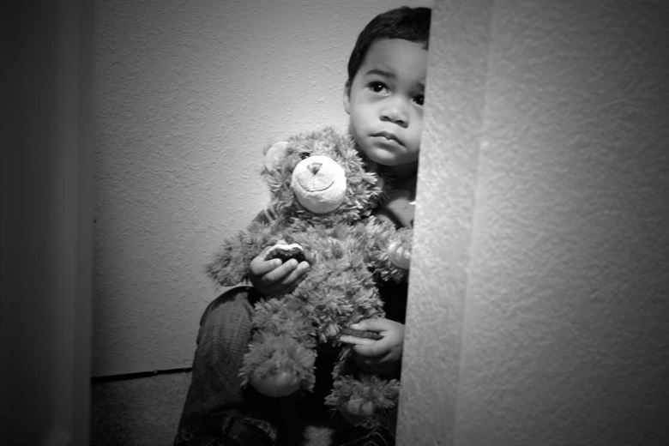
Figure 9.20 – A child hiding.

Physical Abuse
Physical abuse involves physical aggression directed at a child by an adult. Most nations with child-abuse laws consider the deliberate infliction of serious injuries, or actions that place the child at obvious risk of serious injury or death, to be illegal. Beyond this, there is considerable variation. The distinction between child discipline and abuse is often poorly defined. Cultural norms about what constitutes abuse vary widely among professionals as well as the wider public. Some professionals claim that cultural norms that sanction physical punishment are one of the causes of child abuse, and have undertaken campaigns to redefine such norms.

Sexual Abuse
Child sexual abuse is a form of child abuse in which an adult or older adolescent abuses a child for sexual stimulation. Effects of child sexual abuse include guilt and self-blame, flashbacks, nightmares, insomnia, and fear of things associated with the abuse. Approximately 15 percent to 25 percent of women and 5 percent to 15 percent of men were sexually abused when they were children.

Emotional Abuse
Out of all the possible forms of abuse, emotional abuse is the hardest to define. It could include name-calling, ridicule, degradation, destruction of personal belongings, torture or killing of a pet, excessive criticism, inappropriate or excessive demands, withholding communication, and routine labeling or humiliation.

Neglect
Neglect is a passive form of abuse in which a perpetrator is responsible to provide care for a victim who is unable to care for himself or herself, but fails to provide adequate care. Neglect may include the failure to provide sufficient supervision, nourishment, or medical care, or the failure to fulfill other needs for which the victim is helpless to provide for himself or herself. The term is also applied when necessary care is withheld by those responsible for providing it from animals, plants, and even inanimate objects. Neglect can have many long-term side effects, such as physical injuries, low self-esteem, attention disorders, violent behavior, and even death. In the U.S., neglect is defined as the failure to meet the basic needs of children: housing, clothing, food, and access to medical care. Researchers found over 91,000 cases of neglect in one year using information from a database of cases verified by protective services agencies.

Conclusion
In this chapter we covered,
- The development of self-concept and self-esteem.
- Erikson’s psychosocial stage of initiative versus guilt.
- Gender identity, gender constancy, gender roles, and gender dysphoria.
- Family life, including parenting styles, diverse forms of families, using child care, and the role of siblings.
- The role of peers.
- The types of play.
- The social understanding of preschoolers.
- Personality development
- Social and emotional competences.
- The effects of stress on children, including maltreatment.

In the next chapter we begin exploring middle childhood and how children from 6 to 11 grow and develop.

Chapter 10: Middle Childhood - Physical Development

Chapter Objectives
After this chapter, you should be able to:
- Describe the patterns of physical growth
- Summarize nutrition needs
- Explain the causes of obesity and the negative consequences of excessive weight gain
- Discuss the pros and cons of organized sports
- Compare and contrast developmental disorders
- Summarize several different mental health disorders

Introduction
Children in middle childhood go through tremendous changes in the growth and development of their brain. During this period of development children’s bodies are not only growing, but they are becoming more coordinated and physically capable. These children are more mindful of their greater abilities in school and are becoming more responsible for their health and diet. Some children may be challenged with physical or mental health concerns. It’s important to know what typical development looks like in order to identify and to help those that are struggling with health concerns.

Brain Development
The brain reaches its adult size at about age 7. Then between 10 and 12 years of age, the frontal lobes become more developed and improvements in logic, planning, and memory are evident (van der Molen & Molenaar, 1994). The school-aged child is better able to plan and coordinate activity using both the left and right hemispheres of the brain, which control the development of emotions, physical abilities, and intellectual capabilities. The attention span also improves as the prefrontal cortex matures. The myelin also continues to develop and the child's reaction time improves as well. Myelination improvement is one factor responsible for these growths.

From age 6 to 12, the nerve cells in the association areas of the brain, that is those areas where sensory, motor, and intellectual functioning connect, become almost completely myelinated (Johnson, 2005). This myelination contributes to increases in information processing speed and the child’s reaction time. The hippocampus, which is responsible for transferring information from the short-term to long-term memory, also shows increases in myelination resulting in improvements in memory functioning (Rolls, 2000).

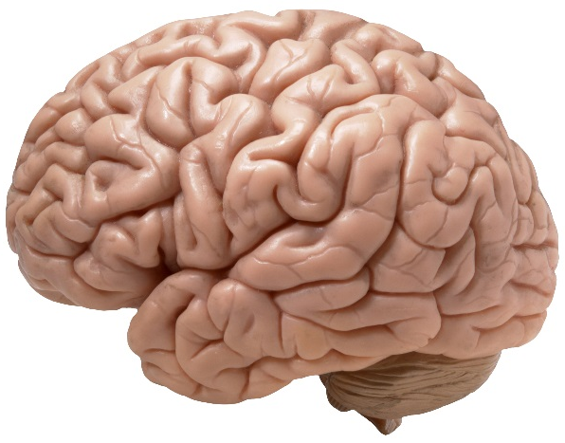
Figure 10.1 – The human brain.

Changes in the brain during this age enable not only physical development, but also allow children to understand what others think of them and dealing socially with the positive and negative consequences of that. Within this development period, children may struggle with mental health disorders or other health problems. As children are growing and becoming more capable, adults need to remember that children don’t grow physically in isolation. The development of their bodies isn't separate from the changes that are occurring socially, emotionally, and cognitively. Awareness and understanding of their other developmental domains and needs will support the child during these changes.

Physical Growth
Middle childhood spans the years between early childhood and adolescence, children are approximately 6 to 11 years old. These children come in all shapes and sizes: height, weight, abilities, and disabilities. Physical growth rates are generally slow and steady during these years. However, growth spurts do occur during middle to late childhood (Spreen, Riser, & Edgell, 1995). Typically, a child will gain about 5-7 pounds a year and grow about 2 inches per year. They also tend to slim down and gain muscle strength. As bones lengthen and broaden and muscles strengthen, many children want to engage in strenuous physical activity and can participate for longer periods of time. In addition, the rate of growth for the extremities is faster than for the trunk, which results in more adult-like proportions. Long-bone growth stretches muscles and ligaments, which results in many children experiencing growing pains, at night, in particular.

Children between ages 6 and 9, show significant improvement in their abilities to perform motor skills. This development growth allows children to gain greater control over the movement of their bodies, mastering many gross and fine motor skills that were beyond that of the younger child. Riding a bike that is bigger or running longer and further is a big improvement in gross motor skills. Eye-hand coordination and fine motor skills allow for children to become better at writing and cutting. Sports and extracurricular activities may become a part of the lives of children during middle childhood due to their physical growth and capabilities.

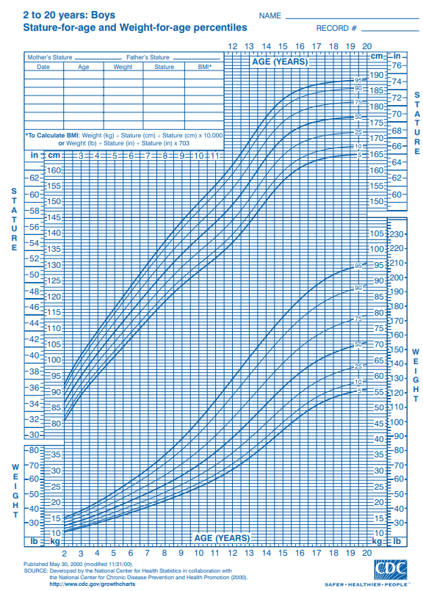
Figure 10.2 – Stature for age and weight for age percentiles.

Nutritional Needs
A number of factors can influence children’s eating habits and attitudes toward food. Family environment, societal trends, taste preferences, and messages in the media all impact the emotions that children develop in relation to their diet. Television commercials can entice children to consume sugary products, fatty fast foods, excess calories, refined ingredients, and sodium. Therefore, it is critical that parents and caregivers direct children toward healthy choices.

Parents greatly impact their child’s nutritional choices. This time in a child’s life provides an opportunity for parents and other caregivers to reinforce good eating habits and to introduce new foods into the diet, while remaining mindful of a child’s preferences. Parents should also serve as role models for their children, who will often mimic their behavior and eating habits. Parents must continue to help their school-aged child establish healthy eating habits and attitudes toward food. Their primary role is to bring a wide variety of health-promoting foods into the home, so that their children can make good choices.

Let’s think for a moment about what our parents and grandparents used to eat? What are some of the differences that you may have experienced as a child?

One hundred years ago, as families sat down to dinner, they might have eaten boiled potatoes or corn, leafy vegetables such as cabbage or collards, fresh-baked bread, and, if they were fortunate, a small amount of beef or chicken. Young and old alike benefitted from a sound diet that packed a real nutritional punch. Times have changed. Many families today fill their dinner plates with fatty foods, such as French Fries cooked in vegetable oil, a hamburger that contains several ounces of ground beef, and a white-bread bun, with a single piece of lettuce and a slice or two of tomato as the only vegetables served with the meal.

Figure 10.3 – A modern meal.

Our diet has changed drastically as processed foods, which did not exist a century ago, and animal-based foods now account for a large percentage of our calories. Not only has what we eat changed, but the amount of it that we consume has greatly increased as well, as plates and portion sizes have grown much larger. All of these choices impact our health, with short- and long-term consequences as we age. Possible effects in the short-term include excess weight gain and constipation. The possible long-term effects, primarily related to obesity, include the risk of cardiovascular disease, diabetes, hypertension, as well as other health and emotional problems for children. Centers for Disease Control and Prevention. “Overweight and Obesity: Health Consequences.”

During middle childhood, a healthy diet facilitates physical and mental development and helps to maintain health and wellness. School-aged children experience steady, consistent growth, but at a slower rate than they did in early childhood. This slowed growth rate can have lasting a lasting impact if nutritional, caloric, and activity levels aren't adjusted in middle childhood which can lead to excessive weight gain early in life and can lead to obesity into adolescence and adulthood.

Making sure that children have proper nutrients will allow for optimal growth and development. Look at the figure below to familiarize yourself with food and the place setting for healthy meals.

Figure 10.4 – Nutrition guidelines from the USDA.

One way to encourage children to eat healthy foods is to make meal and snack time fun and interesting. Parents should include children in food planning and preparation, for example selecting items while grocery shopping or helping to prepare part of a meal, such as making a salad. At this time, parents can also educate children about kitchen safety. It might be helpful to cut sandwiches, meats, or pancakes into small or interesting shapes. In addition, parents should offer nutritious desserts, such as fresh fruits, instead of calorie-laden cookies, cakes, salty snacks, and ice cream. Studies show that children who eat family meals on a frequent basis consume more nutritious foods.

Energy
Children’s energy needs vary, depending on their growth and level of physical activity. Energy requirements also vary according to gender. Girls require 1,200 to 1,400 calories a day from age 2 to 8 and 1,400-1,800 for age 9 to 13. Boys also need 1,200 to 1.400 calories daily from age 4 to 8 but their daily caloric needs go up to 1,600-2,000 from age 9 to 13. This range represents individual differences, including how active the child is.

Recommended intakes of macronutrients (protein, carbohydrates, and fats) and most micronutrients (vitamins and minerals) are higher relative to body size, compared with nutrient needs during adulthood. Therefore, children should be provided nutrient-dense food at meal- and snack-time. However, it is important not to overfeed children, as this can lead to childhood obesity, which is discussed in the next section.

Children and Vegetarianism
Another issue that some parents face with school-aged children is the decision to encourage a child to become a vegetarian or a vegan. Some parents and caregivers decide to raise their children as vegetarians for health, cultural, or other reasons. Preteens and teens may make the choice to pursue vegetarianism on their own, due to concerns about animals or the environment. No matter the reason, parents with vegetarian children must take care to ensure vegetarian children get healthy, nutritious foods that provide all the necessary nutrients.

Types of Vegetarian Diets
There are several types of vegetarians, each with certain restrictions in terms of diet:
- Ovo-vegetarians. Ovo-vegetarians eat eggs, but do not eat any other animal products.
- Lacto-ovo-vegetarians. Lacto-ovo-vegetarians eat eggs and dairy products, but do not eat any meat.
- Lacto-vegetarians. Lacto-vegetarians eat dairy products, but do not eat any other animal products.
- Vegans. Vegans eat food only from plant sources, no animal products at all.

Figure 10.5 – An example of a school lunch.

Children who consume some animal products, such as eggs, cheese, or other forms of dairy, can meet their nutritional needs. For a child following a strict vegan diet, planning is needed to ensure adequate intake of protein, iron, calcium, vitamin B₁₂, and vitamin D. Legumes and nuts can be eaten in place of meat, soy or almond milk fortified with calcium and vitamins D and B₁₂ can replace cow’s milk. Parents must be informed and knowledgeable in order to support proper development for children with a vegetarian or vegan diet.

Children and Malnutrition
Many may not know that malnutrition is a problem that many children face, in both developing nations and the developed world. Even with the wealth of food in North America, many children grow up malnourished, or even hungry. The US Census Bureau characterizes households into the following groups:
- food secure
- food insecure without hunger
- food insecure with moderate hunger
- food insecure with severe hunger

Millions of children grow up in food-insecure households with inadequate diets due to both the amount of available food and the quality of food. In the United States, about 20 percent of households with children are food insecure to some degree. In half of those, only adults experience food insecurity, while in the other half both adults and children are considered to be food insecure, which means that children did not have access to adequate, nutritious meals at times.

Growing up in a food-insecure household can lead to a number of problems. Deficiencies in iron, zinc, protein, and vitamin A can result in stunted growth, illness, and limited development. Federal programs, such as the National School Lunch Program, the School Breakfast Program, and Summer Feeding Programs, work to address the risk of hunger and malnutrition in school-aged children. They help to fill the gaps and provide children living in food-insecure households with greater access to nutritious meals.

School Lunch Programs
Many school age children eat breakfast, snacks, and lunch at their schools. Therefore, it is important for schools to provide meals that are nutritionally sound. In the United States, more than thirty-one million children from low-income families are given meals provided by the National School Lunch Program. This federally funded program offers low-cost or free breakfast, snacks, and lunches to school facilities. School districts that take part receive subsidies from the US Department of Agriculture (USDA) for every meal they serve that must meet 2015 Dietary Guidelines for Americans.

Knowing that many children in the United States buy or receive free lunches in the school cafeteria, it might be worthwhile to look at the nutritional content of school lunches. You can obtain this information through your local school district’s website. An example of a school menu from a school district in north central Texas is a meal consisting of pasta alfredo, bread stick, peach cup, tomato soup, a brownie, and 2% milk which is in compliance with Federal Nutritional Guidelines. Consider another menu from an elementary school in the state of Washington. This sample meal consists of chicken burger, tater tots, fruit, veggies, and 1% or nonfat milk. This meal is also in compliance with Federal Nutrition Guidelines but has about 300 fewer calories than the menu in Texas. This is a big difference in calories and nutritional value of these prepared lunches that are chosen and approved of by officials on behalf of children in these districts.

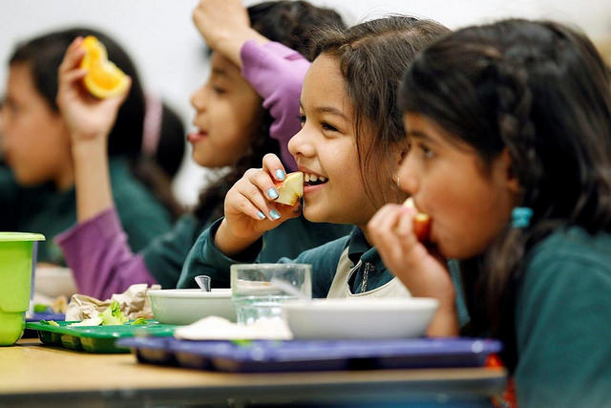
Figure 10.6 – Children eating lunch together at school.

Healthy School Lunch Campaigns helps to promote children’s health. This is done by educating government officials, school officials, food-service workers, and parents and is sponsored by the Physicians Committee for Responsible Medicine. They educate and encourage schools to offer low-fat, cholesterol-free options in school cafeterias and in vending machines and work to improve the food served to children at school. Unfortunately, many school districts in the nation allow students to purchase chips, cookies, and ice cream along with their meals. These districts rely on the sale of these items in the lunchrooms to earn additional revenues. Not only are they making money off of children and families with junk food, they are also adding additional empty calories to their daily intake. These districts need to look at the menus and determine the rationale for offering additional snacks and desserts for children at their schools. Whether children receive free lunches, buy their own, or bring their lunch from home, quality nutrition is what is best for these growing bodies and minds.

Food Allergies and Food Intolerance
Food intolerance and food allergies are an issue for some school-aged children. Recent studies show that three million children under age eighteen are allergic to at least one type of food.
Some of the most common food allergies come from foods that include peanuts, milk, eggs, soy, wheat, and shellfish. An allergy occurs when a protein in food triggers an immune response, which results in the release of antibodies, histamine, and other defenders that attack foreign bodies. Possible symptoms include itchy skin, hives, abdominal pain, vomiting, diarrhea, and nausea. Symptoms usually develop within minutes to hours after consuming a food allergen. Children can outgrow a food allergy, especially allergies to wheat, milk, eggs, or soy.

Anaphylaxis is a life-threatening reaction that results in difficulty breathing, swelling in the mouth and throat, decreased blood pressure, shock, or even death. Milk, eggs, wheat, soybeans, fish, shellfish, peanuts, and tree nuts are the most likely to trigger this type of response. A dose of the drug epinephrine is often administered via a “pen” to treat a person who goes into anaphylactic shock.

Figure 10.7 – An EpiPen.

Some children experience a food intolerance, which does not involve an immune response. A food intolerance is marked by unpleasant symptoms that occur after consuming certain foods. Lactose intolerance, though rare in very young children, is one example. Children who suffer from this condition experience an adverse reaction to the lactose in milk products. It is a result of the small intestine’s inability to produce enough of the enzyme lactase. Symptoms of lactose intolerance usually affect the gastro-intestinal tract and can include bloating, abdominal pain, gas, nausea, and diarrhea. An intolerance is best managed by making dietary changes and avoiding any foods that trigger the reaction.

Being Overweight and Obesity in Children
Excess weight and obesity in children is associated with a variety of medical conditions including high blood pressure, insulin resistance, inflammation, depression, and lower academic achievement (Lu, 2016). Being overweight has also been linked to impaired brain functioning, which includes deficits in executive functioning, working memory, mental flexibility, and decision making (Liang, Matheson, Kaye, & Boutelle, 2014). Children who ate more saturated fats performed worse on relational memory tasks, while eating a diet high in omega-3 fatty acids promoted relational memory skills (Davidson, 2014). Using animal studies, Davidson et al. (2013) found that large amounts of processed sugars and saturated fat weakened the blood-brain barrier, especially in the hippocampus. This can make the brain more vulnerable to harmful substances that can impair its functioning. Another important executive functioning skill is controlling impulses and delaying gratification. Children who are overweight show less inhibitory control than normal weight children, which may make it more difficult for them to avoid unhealthy foods (Lu, 2016). Overall, being overweight as a child increases the risk for cognitive decline as one ages.

Figure 10.8 – There are certain health risks associated with being overweight.

The current measurement for determining excess weight is the Body Mass Index (BMI) which expresses the relationship of height to weight. According to the Centers for Disease Control and Prevention (CDC), childrens whose BMI is at or above the 85th percentile for their age are considered overweight, while children who are at or above the 95th percentile are considered obese (Lu, 2016). In 2011-2012 approximately 8.4% of 2-5 year-olds were considered overweight or obese, and 17.7% of 6-11 year-olds were overweight or obese (CDC, 2014b).

Obesity Rates for Children: About 16 to 33 percent of American children are obese (U. S. Department of Health and Human Services, 2005). This is defined as being at least 20 percent over their ideal weight. The percentage of obesity in school-aged children has increased substantially since the 1960s and has in fact doubled since the 1980s. This is true in part because of the introduction of a steady diet of television and other sedentary activities. In addition, we have come to emphasize high fat, fast foods as a culture. Pizza, hamburgers, chicken nuggets and “lunchables” with soda have replaced more nutritious foods as staples. The decreased participation in school physical education and youth sports is just one of many factors that has led to an increase in children being overweight or obese.

Being Overweight Can Be a Lifelong Struggle
A growing concern is the lack of recognition from parents that children are overweight or obese. Katz (2015) referred to this as “oblivobesity”. Black et al. (2015) found that parents in the United Kingdom (UK) only recognized their children as obese when they were above the 99.7th percentile while the official cut-off for obesity is at the 85th percentile. Oude Luttikhuis, Stolk, and Sauer (2010) surveyed 439 parents and found that 75% of parents of overweight children said the child had a normal weight and 50% of parents of obese children said the child had a normal weight. For these parents, overweight was considered normal and obesity was considered normal or a little heavy. Doolen, Alpert, and Miller (2009) reported on several studies from the United Kingdom, Australia, Italy, and the United States, and in all locations parents were more likely to misperceive their children’s weight. Black, Park, and Gregson (2015) concluded that as the average weight of children rises, what parents consider normal also rises. If parents cannot identify if their children are overweight they will not be able to intervene and assist their children with proper weight management.

An added concern is that the children themselves are not accurately identifying if they are overweight. In a United States sample of 8-15 year-olds, more than 80% of overweight boys and 70% of overweight girls misperceived their weight as normal (Sarafrazi, Hughes, & Borrud, 2014). Also noted was that as the socioeconomic status of the children rose, the frequency of these misconceptions decreased. It appeared that families with more resources were more conscious of what defines a healthy weight.

Results of Childhood Obesity
Children who are overweight tend to be rejected, ridiculed, teased and bullied by others (Stopbullying.gov, 2016). This can certainly be damaging to their self-image and popularity. In addition, obese children run the risk of suffering orthopedic problems such as knee injuries, and they have an increased risk of heart disease and stroke in adulthood (Lu, 2016). It is hard for a child who is obese to become a non-obese adult. In addition, the number of cases of pediatric diabetes has risen dramatically in recent years.

Behavioral interventions, including training children to overcome impulsive behavior, are being researched to help overweight children (Lu, 2016). Practicing inhibition has been shown to strengthen the ability to resist unhealthy foods. Parents can help their overweight children the best when they are warm and supportive without using shame or guilt. They can also act like the child’s frontal lobe until it is developed by helping them make correct food choices and praising their efforts (Liang, et al., 2014). Research also shows that exercise, especially aerobic exercise, can help improve cognitive functioning in overweight children (Lu, 2016). Parents should take caution against emphasizing diet alone to avoid the development of any obsession about dieting that can lead to eating disorders. Instead, increasing a child's activity level is most helpful.

Dieting is not really the answer. If you diet, your basal metabolic rate tends to decrease thereby making the body burn even fewer calories in order to maintain the weight. Increased activity is much more effective in lowering the weight and improving the child’s health and psychological well-being. Exercise reduces stress and being an overweight child, subjected to the ridicule of others can certainly be stressful. Parents should take caution against emphasizing diet alone to avoid the development of any obsession about dieting that can lead to eating disorders as teens. Again, helping children to make healthy food choices and increasing physical activity will help prevent childhood obesity.

Exercise, Physical Fitness, and Sports
Recess and Physical Education: Recess is a time for free play and Physical Education (PE) is a structured program that teaches skills, rules, and games. They’re a big part of physical fitness for school age children. For many children, PE and recess are the key component in introducing children to sports. After years of schools cutting back on recess and PE programs, there has been a turn around, prompted by concerns over childhood obesity and the related health issues. Despite these changes, currently only the state of Oregon and the District of Columbia meet PE guidelines of a minimum of 150 minutes per week of physical activity in elementary school and 225 minutes in middle school (SPARC, 2016).

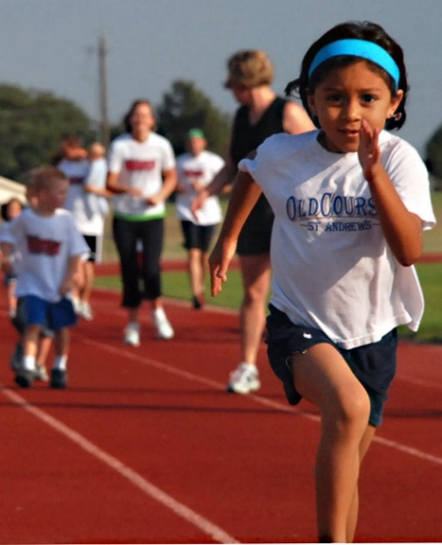
Figure 10.10 – A girl running on a track field.

Organized Sports: Pros and Cons
Middle childhood seems to be a great time to introduce children to organized sports, and in fact, many parents do. Nearly 3 million children play soccer in the United States (United States Youth Soccer, 2012). This activity promises to help children build social skills, improve athletically and learn a sense of competition. However, the emphasis on competition and athletic skill can be counterproductive and lead children to grow tired of the game and want to quit. In many respects, it appears that children's activities are no longer children's activities once adults become involved and approach the games as adults rather than children. The U. S. Soccer Federation recently advised coaches to reduce the amount of drilling engaged in during practice and to allow children to play more freely and to choose their own positions. The hope is that this will build on their love of the game and foster their natural talents.

Sports are important for children. Children’s participation in sports has been linked to:
- Higher levels of satisfaction with family and overall quality of life in children
- Improved physical and emotional development
- Better academic performance

Yet, a study on children’s sports in the United States (Sabo & Veliz, 2008) has found that gender, poverty, location, ethnicity, and disability can limit opportunities to engage in sports. Girls were more likely to have never participated in any type of sport.

This study also found that fathers may not be providing their daughters as much support as they do their sons. While boys rated their fathers as their biggest mentor who taught them the most about sports, girls rated coaches and physical education teachers as their key mentors. Sabo and Veliz also found that children in suburban neighborhoods had a much higher participation in sports than boys and girls living in rural or urban centers. In addition, Caucasian girls and boys participated in organized sports at higher rates than minority children. With a renewed focus, males and females can benefit from all sports and physical activity.

Figure 10.11 – Community sports.

Welcome to the World of E-Sports
The recent Sport Policy and Research Collaborative (2016) report on the “State of Play” in the United States highlights a disturbing trend. One in four children between the ages of 5 and 16 rate playing computer games with their friends as a form of exercise. In addition, e-sports, which as SPARC writes is about as much a sport as poker, involves children watching other children play video games. Over half of males, and about 20% of females, aged 12-19, say they are fans of e-sports. Play is an important part of childhood and physical activity has been proven to help children develop and grow. Adults and caregivers should look at what children are doing within their day to prioritize the activities that should be focused on.

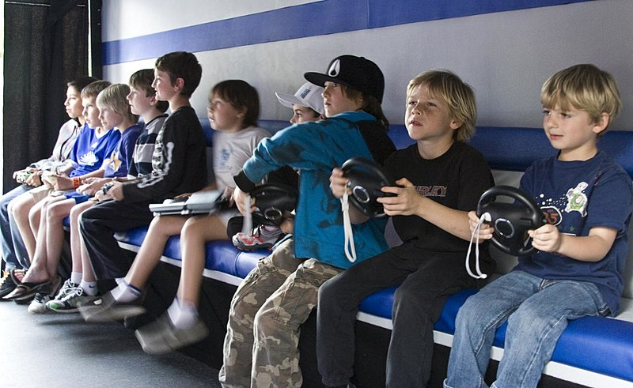
Figure 10.12 – A group of boys playing video sports.

Physical Health

Vision and Hearing
The most common vision problem in middle childhood is being nearsighted, otherwise known as Myopic. 25% of children will be diagnosed by the end of middle childhood. Being nearsighted can be corrected by wearing glasses with corrective lenses.

Figure 10.13 – A child receiving an eye exam.
Children may have many ear infections in early childhood, but it’s not as common within the 6-12 year age range. Numerous ear infections during middle childhood may lead to headaches and migraines, which may result in hearing loss.

Dental Health
Children in middle childhood will start or continue to loose teeth. They experience the loss of deciduous, or “baby,” teeth and the arrival of permanent teeth, which typically begins at age six or seven. It is important for children to continue seeing a dentist twice a year to be sure that these teeth are healthy.

The foods and nutrients that children consume are also important for dental health. Offer healthy foods and snacks to children and when children do eat sugary or sticky foods, they should brush their teeth afterward.

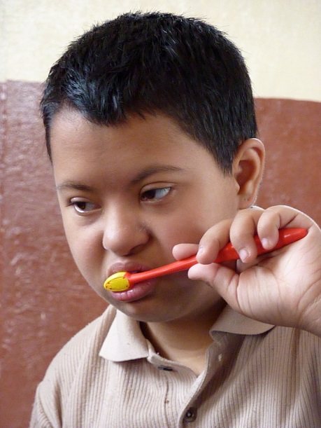
Figure 10.14 – A boy brushing his teeth.

Children should floss daily and brush their teeth at least twice daily: in the morning, at bedtime, and preferably after meals. Younger children need help brushing their teeth properly. Try brushing their teeth first and letting them finish. You might try using a timer or a favorite song so that your child learns to brush for 2 minutes. Parents or caregivers are encouraged to supervise brushing until your child is 7 or 8 years old to avoid tooth decay.

The best defense against tooth decay is flossing, brushing and adding fluoride; a mineral found in most tap water. If your water doesn’t have fluoride, ask a dentist about fluoride drops, gel or varnish. Also ask your child’s dentist about sealants—a simple, pain-free way to prevent tooth decay. These thin plastic coatings are painted on the chewing surfaces of permanent back teeth. They quickly harden to form a protective shield against germs and food. If a small cavity is accidentally covered by a sealant, the decay won’t spread because germs trapped inside are sealed off from their food supply.

Children’s dental health needs continuous monitoring as children loose teeth and new teeth come in. Many children have some malocclusion (when the way upper teeth aren’t correctly positioned slightly over the lower teeth, including under- and overbites) or malposition of their teeth, which can affect their ability to chew food, floss, and brush properly. Dentists may recommend that it’s time to see an orthodontist to maintain proper dental health. Dental health is exceedingly important as children grow more independent by making food choices and as they start to take over flossing and brushing. Parents can ease this transition by promoting healthy eating and proper dental hygiene.

Diabetes in Childhood
Until recently diabetes in children and adolescents was thought of almost exclusively as type 1, but that thinking has evolved. Type 1 diabetes is the most common form of diabetes in children and is the result of a lack or production of insulin due to an overactive immune system. Type 2 diabetes is the most common form of diabetes in the U.S. It used to be referred to as adult-onset diabetes as it was not common during childhood. But with increasing rates of overweight and obesity in children and adolescents, more diagnoses are happening before adulthood. It is also important to note that Type 2 disproportionately affects minority youth.

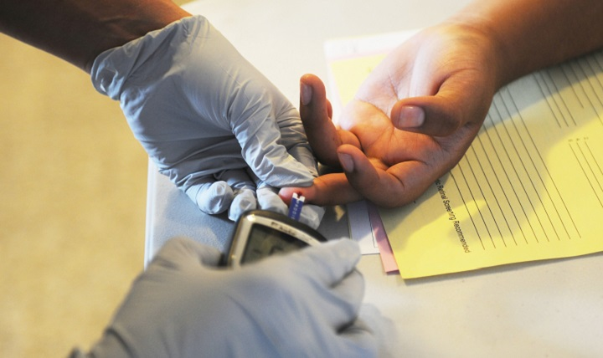
Figure 10.15 – The finger-prick test.

Asthma
Childhood asthma that is unmanaged may make it difficult for children to develop to their fullest potential. Asthma is a chronic lung disease that inflames and narrows the airways. Asthma causes recurring periods of wheezing (a whistling sound when you breathe), chest tightness, shortness of breath, and coughing. The coughing often occurs at night or early in the morning. Asthma affects people of all ages, but it most often starts during childhood. In the United States, more than 25 million people are known to have asthma. About 7 million of these people are children.

To understand asthma, it helps to know how the airways work. The airways are tubes that carry air into and out of your lungs. People who have asthma have inflamed airways. The inflammation makes the airways swollen and very sensitive. The airways tend to react strongly to certain inhaled substances. When the airways react, the muscles around them tighten. This narrows the airways, causing less air to flow into the lungs. The swelling also can worsen, making the airways even narrower. Cells in the airways might make more mucus than usual. Mucus is a sticky, thick liquid that can further narrow the airways. This chain reaction can result in asthma symptoms. Symptoms can happen each time the airways are inflamed.

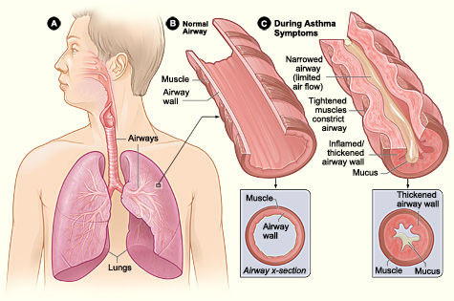
Figure 10.16 - Figure A shows the location of the lungs and airways in the body. Figure B shows a cross-section of a normal airway. Figure C shows a cross-section of an airway during asthma symptoms.

Sometimes asthma symptoms are mild and go away on their own or after minimal treatment with asthma medicine. Other times, symptoms continue to get worse. When symptoms get more intense and/or more symptoms occur, you're having an asthma attack. Asthma attacks also are called flare-ups or exacerbations (eg-zas-er-BA-shuns).
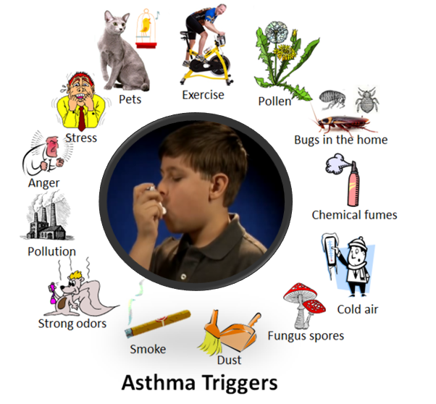
Figure 10.17 – The different things that can trigger asthma.

Treating symptoms when you first notice them is important. This will help prevent the symptoms from worsening and causing a severe asthma attack. Severe asthma attacks may require emergency care, and they can be fatal. Asthma has no cure. Even when you feel fine, you still have the disease and it can flare up at any time.

However, with today's knowledge and treatments, most people who have asthma are able to manage the disease. They have few, if any, symptoms. They can live normal, active lives and sleep through the night without interruption from asthma. If you have asthma, you can take an active role in managing the disease. For successful, thorough, and ongoing treatment, build strong partnerships with your doctor and other health care providers.

Childhood Stress
Take a moment to think about how you deal with and how stress affects you. Now think about what the impact of stress may have on a child and their development?

Of course children experience stress and different types of stressors differently. Not all stress is bad. Normal, everyday stress can provide an opportunity for young children to build coping skills and poses little risk to development. Even more long-lasting stressful events such as changing schools or losing a loved one can be managed fairly well. But children who experience toxic stress or who live in extremely stressful situations of abuse over long periods of time can suffer long-lasting effects. The structures in the midbrain or limbic system such as the hippocampus and amygdala can be vulnerable to prolonged stress during early childhood (Middlebrooks and Audage, 2008). High levels of the stress hormone cortisol can reduce the size of the hippocampus and effect the child’s memory abilities. Stress hormones can also reduce immunity to disease. If the brain is exposed to long periods of severe stress it can develop a low threshold making the child hypersensitive to stress in the future. Whatever the effects of stress, it can be minimized if a child learns to deal with stressors and develop coping strategies with the support of caring adults. It’s easy to know when your child has a fever or other physical symptoms. However, a child’s mental health problems may be harder to identify. In the next section, we’ll look at childhood Mental Health Disorders.

Figure 10.18 – High, constant levels of stress can negatively impact the brain.

Childhood Mental Health
Mental health problems can disrupt daily life at home, at school or in the community. Without help, mental health problems can lead to school failure, alcohol or other drug abuse, family discord, violence or even suicide. However, help is available. Talk to your health care provider if you have concerns about your child’s behavior.

Mental health disorders are diagnosed by a qualified professional using the Diagnostic and Statistical Manual of Mental Disorders (DSM). This is a manual that is used as a standard across the profession for diagnosing and treating mental disorders.
When You Have a Concern About a Child. What’s in a Label?
Children are continually evaluated as they enter and progress through school. If a child is showing a need, they should be assessed by a qualified professional who would make a recommendation or diagnosis of the child and give the type of instruction, resources, accommodations, and support that they should receive.

Ideally, a proper diagnosis or label is extremely beneficial for children who have educational, social, emotional, or developmental needs. Once their difficulty, disorder, or disability is labeled then the child will receive the help they need from parents, educators and any other professionals who will work as a team to meet the student’s individual goals and needs.

However, it’s important to consider that children that are labeled without proper support and accommodations or worse they may be misdiagnosed will have negative consequences. A label can also influence the child’s self-concept, for example, if a child is misdiagnosed as having a learning disability; the child, teachers, and family member interpret their actions through the lens of that label. Labels are powerful and can be good for the child or they can go detrimental for their development all depending on the accuracy of the label and if they are accurately applied.

A team of people who include parents, teachers, and any other support staff will look at the child’s evaluation assessment in a process called an Individual Education Plan (IEP). The team will discuss the diagnosis, recommendations, and the accommodations or help and a decisions will be made regarding what is the best for the child. This is time when parents or caregivers decide if they would like to follow this plan or they can dispute any part of the process. During an IEP, the team is able to voice concerns and questions. Most parents feel empowered when they leave these meetings. They feel as if they are a part of the team and that they know what, when, why, and how their child will be helped.

Childhood Mental Health Disorders
Social and Emotional Disorders
- Phobias
- Anxiety
- Post-Traumatic Stress Syndrome - PTSD
- Obsessive Compulsive Disorder –OCD
- Depression
Developmental Disorders
- Autism Spectrum Disorder (ASD)
- Attention Deficit Disorder (ADHD)
- Pervasive Developmental Disorder (PDD)

Phobias
When a child who has a phobia (an extreme or irrational fear of or aversion to something) is exposed to the phobic stimulus (the stimuli varies), it almost invariably provokes an immediate anxiety response, which may take the form of a situational bound or situational predisposed panic attack. Children can show effects and characteristics when it comes to specific phobias. The effects of anxiety show up by crying, throwing tantrums, experiencing freezing, or clinging to the parent that they have the most connection with. Related Conditions include anxiety.

Anxiety
Many children have fears and worries, and will feel sad and hopeless from time to time. Strong fears will appear at different times during development. For example, toddlers are often very distressed about being away from their parents, even if they are safe and cared for. Although fears and worries are typical in children, persistent or extreme forms of fear and sadness feelings could be due to anxiety or depression. Because the symptoms primarily involve thoughts and feelings, they are called internalizing disorders.

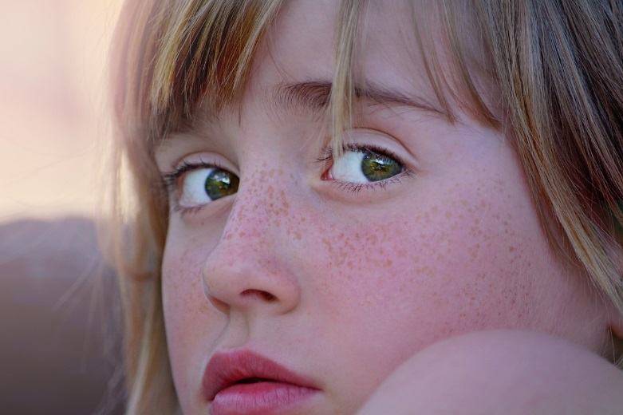
Figure 10.19 – An anxious child.

When children do not outgrow the fears and worries that are typical in young children, or when there are so many fears and worries that interfere with school, home, or play activities, the child may be diagnosed with an anxiety disorder. Examples of different types of anxiety disorders include:
- Being very afraid when away from parents (separation anxiety)
- Having extreme fear about a specific thing or situation, such as dogs, insects, or going to the doctor (phobias)
- Being very afraid of school and other places where there are people (social anxiety)
- Being very worried about the future and about bad things happening (general anxiety)
- Having repeated episodes of sudden, unexpected, intense fear that come with symptoms like heart pounding, having trouble breathing, or feeling dizzy, shaky, or sweaty (panic disorder)
Anxiety may present as fear or worry, but can also make children irritable and angry. Anxiety symptoms can also include trouble sleeping, as well as physical symptoms like fatigue, headaches, or stomachaches. Some anxious children keep their worries to themselves and, thus, the symptoms can be missed.

Related conditions include Obsessive-Compulsive Disorder and Post Traumatic Stress Disorder.

Post-Traumatic Stress Syndrome (PTSD)
Exposure to traumatic events can have major developmental influences on children. While the majority of children will not develop PTSD after a trauma, best estimates from the literature are that around a third of them will, higher than adult estimates. Some reasons for this could include more limited knowledge about the world, differential coping mechanisms employed, and the fact that children’s reactions to trauma are often highly influenced by how their parents and caregivers react.

The impact of PTSD on children weeks after a trauma, show that up to 90% of children may experience heightened physiological arousal, diffuse anxiety, survivor guilt, and emotional liability. These are all normal reactions and should be understood as such (similar things are seen in adults. Those children still having these symptoms three or four months after a disaster, however, may be in need of further assessment, particularly if they show the following symptoms as well. For older children, warning signs of problematic adjustment include: repetitious play reenacting a part of the disaster; preoccupation with danger or expressed concerns about safety; sleep disturbances and irritability; anger outbursts or aggressiveness; excessive worry about family or friends; school avoidance, particularly involving somatic complaints; behaviors characteristic of younger children; and changes in personality, withdrawal, and loss of interest in activities.

Obsessive Compulsive Disorder (OCD)
Although a diagnosis of OCD requires only that a person either has obsessions or compulsions, not both, approximately 96% of people experience both. For almost all people with OCD, being exposed to a certain stimuli (internal or external) will then trigger an upsetting or anxiety-causing obsession, which can only be relieved by doing a compulsion. For example, a person touches a doorknob in a public building, which causes an obsessive thought that they will get sick from the germs, which can only be relieved by compulsively washing their hands to an excessive degree. Some of the most common obsessions include unwanted thoughts of harming loved ones, persistent doubts that one has not locked doors or switched off electrical appliances, intrusive thoughts of being contaminated, and morally or sexually repugnant.

Depression
Occasionally being sad or feeling hopeless is a part of every child’s life. However, some children feel sad or uninterested in things that they used to enjoy, or feel helpless or hopeless in situations where they could do something to address the situations. When children feel persistent sadness and hopelessness, they may be diagnosed with depression.

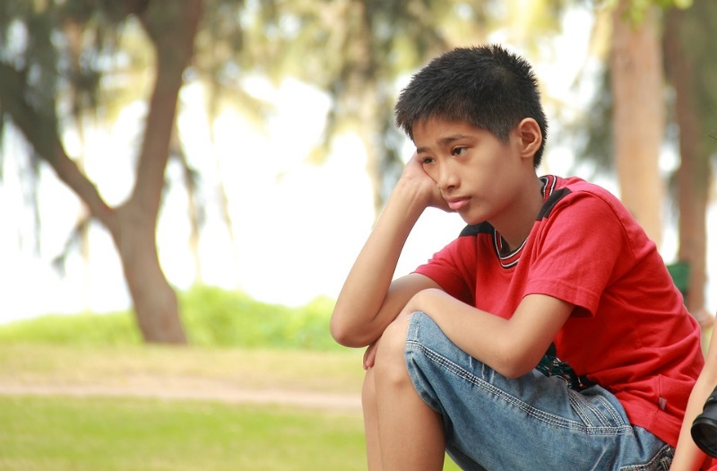
Figure 10.20 – Persistent sadness is a symptom of depression.

Symptoms
We now know that youth who have depression may show signs that are slightly different from the typical adult symptoms of depression. Children who are depressed may complain of feeling sick, refuse to go to school, cling to a parent or caregiver, feel unloved, hopelessness about the future, or worry excessively that a parent may die. Older children and teens may sulk, get into trouble at school, be negative or grouchy, are irritable, indecisive, have trouble concentrating, or feel misunderstood. Because normal behaviors vary from one childhood stage to another, it can be difficult to tell whether a child who shows changes in behavior is just going through a temporary “phase” or is suffering from depression.

Treatment
With medication, psychotherapy, or combined treatment, most youth with depression can be effectively treated. Youth are more likely to respond to treatment if they receive it early in the course of their illness.

Developmental Disorders

Autism Spectrum Disorder
As introduced in chapter 8, autism spectrum disorder (ASD) is a developmental disorder that affects communication and behavior. Although autism can be diagnosed at any age, it is said to be a “developmental disorder” because symptoms generally appear in the first two years of life.
According to the Diagnostic and Statistical Manual of Mental Disorders (DSM-5), a guide created by the American Psychiatric Association used to diagnose mental disorders, people with ASD have:
- Difficulty with communication and interaction with other people
- Restricted interests and repetitive behaviors
- Symptoms that hurt the person’s ability to function properly in school, work, and other areas of life

Autism is known as a “spectrum” disorder because there is wide variation in the type and severity of symptoms people experience. ASD occurs in all ethnic, racial, and economic groups. Although ASD can be a lifelong disorder, treatments and services can improve a person’s symptoms and ability to function. The American Academy of Pediatrics recommends that all children be screened for autism.

Changes to the diagnosis of ASD
In 2013, a revised version of the Diagnostic and Statistical Manual of Mental Disorders (DSM) was released. This revision changed the way autism is classified and diagnosed. Using the previous version of the DSM, people could be diagnosed with one of several separate conditions:
- Autistic disorder
- Asperger’s’ syndrome
- Pervasive developmental disorder not otherwise specified (PDD-NOS)

In the current revised version of the DSM (the DSM-5), these separate conditions have been combined into one diagnosis called “autism spectrum disorder.” Using the DSM-5, for example, people who were previously diagnosed as having Asperger’s syndrome would now be diagnosed as having autism spectrum disorder. Although the “official” diagnosis of ASD has changed, there is nothing wrong with continuing to use terms such as Asperger’s syndrome to describe oneself or to identify with a peer group.

Signs and Symptoms of ASD
People with ASD have difficulty with social communication and interaction, restricted interests, and repetitive behaviors. The list below gives some examples of the types of behaviors that are seen in people diagnosed with ASD. Not all people with ASD will show all behaviors, but most will show several.

Social communication / interaction behaviors may include:
- Making little or inconsistent eye contact
- Tending not to look at or listen to people
- Rarely sharing enjoyment of objects or activities by pointing or showing things to others
- Failing to, or being slow to, respond to someone calling their name or to other verbal attempts to gain attention
- Having difficulties with the back and forth of conversation
- Often talking at length about a favorite subject without noticing that others are not interested or without giving others a chance to respond
- Having facial expressions, movements, and gestures that do not match what is being said
- Having an unusual tone of voice that may sound sing-song or flat and robot-like
- Having trouble understanding another person’s point of view or being unable to predict or understand other people’s actions

Restrictive / repetitive behaviors may include:
- Repeating certain behaviors or having unusual behaviors. For example, repeating words or phrases, a behavior called echolalia
- Having a lasting intense interest in certain topics, such as numbers, details, or facts
- Having overly focused interests, such as with moving objects or parts of objects
- Getting upset by slight changes in a routine
- Being more or less sensitive than other people to sensory input, such as light, noise, clothing, or temperature

People with ASD may also experience sleep problems and irritability. Although people with ASD experience many challenges, they may also have many strengths, including:
- Being able to learn things in detail and remember information for long periods of time
- Being strong visual and auditory learners
- Excelling in math, science, music, or art

Causes and Risk Factors
While scientists don’t know the exact causes of ASD, research suggests that genes can act together with influences from the environment to affect development in ways that lead to ASD. Although scientists are still trying to understand why some people develop ASD and others don’t, some risk factors include:
- Having a sibling with ASD
- Having older parents
- Having certain genetic conditions—people with conditions such as Down syndrome, fragile X syndrome, and Rett syndrome are more likely than others to have ASD
- Very low birth weight

Treatments and Therapies
Treatment for ASD should begin as soon as possible after diagnosis. Early treatment for ASD is important as proper care can reduce individuals’ difficulties while helping them learn new skills and make the most of their strengths.

The wide range of issues facing people with ASD means that there is no single best treatment for ASD. Working closely with a doctor or health care professional is an important part of finding the right treatment program.

A doctor may use medication to treat some symptoms that are common with ASD. With medication, a person with ASD may have fewer problems with:
- Irritability
- Aggression
- Repetitive behavior
- Hyperactivity
- Attention problems
- Anxiety and depression

People with ASD may be referred to doctors who specialize in providing behavioral, psychological, educational, or skill-building interventions. These programs are typically highly structured and intensive and may involve parents, siblings, and other family members. Programs may help people with ASD:
- Learn life-skills necessary to live independently
- Reduce challenging behaviors
- Increase or build upon strengths
- Learn social, communication, and language skills

Figure 10.21 - Rich and Nubia Quick have put their autistic 8-year-old son, Matthew, through therapy to help him open up and relate more to others. The Quicks maintain a structured environment so Matthew can better adjust to the world around him.

Attention Deficit/Hyperactivity Disorder (AD/HD)
The exact causes of AD/HD are unknown; however, research has demonstrated that factors that many people associate with the development of AD/HD do not cause the disorder including, minor head injuries, damage to the brain from complications during birth, food allergies, excess sugar intake, too much television, poor schools, or poor parenting. Research has found a number of significant risk factors affecting neurodevelopment and behavior expression. Events such as maternal alcohol and tobacco use that affect the development of the fetal brain can increase the risk for AD/HD. Injuries to the brain from environmental toxins such as lack of iron have also been implicated.

Symptoms
People with AD/HD show a persistent pattern of inattention and/or hyperactivity–impulsivity that interferes with functioning or development:
- Inattention: Six or more symptoms of inattention for children up to age 16, or five or more for adolescents 17 and older and adults; symptoms of inattention have been present for at least 6 months, and they are inappropriate for developmental level:
- Often fails to give close attention to details or makes careless mistakes in schoolwork, at work, or with other activities.
- Often has trouble holding attention on tasks or play activities.
- Often does not seem to listen when spoken to directly.
- Often does not follow through on instructions and fails to finish schoolwork, chores, or duties in the workplace (e.g., loses focus, side-tracked).
- Often has trouble organizing tasks and activities.
- Often avoids, dislikes, or is reluctant to do tasks that require mental effort over a long period of time (such as schoolwork or homework).
- Often loses things necessary for tasks and activities (e.g. school materials, pencils, books, tools, wallets, keys, paperwork, eyeglasses, mobile telephones).
- Is often easily distracted
- Is often forgetful in daily activities.

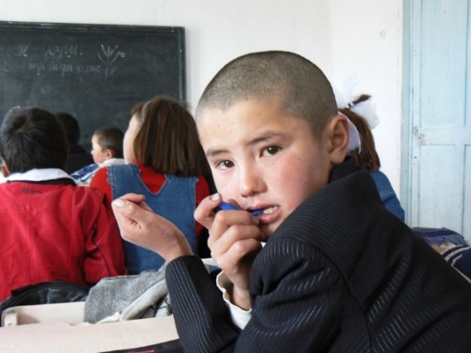
Figure 10.22 – This child is exhibiting inattention.

- Hyperactivity and Impulsivity: Six or more symptoms of hyperactivity-impulsivity for children up to age 16, or five or more for adolescents 17 and older and adults; symptoms of hyperactivity-impulsivity have been present for at least 6 months to an extent that is disruptive and inappropriate for the person’s developmental level:
- Often fidgets with or taps hands or feet, or squirms in seat.
- Often leaves seat in situations when remaining seated is expected.
- Often runs about or climbs in situations where it is not appropriate (adolescents or adults may be limited to feeling restless).
- Often unable to play or take part in leisure activities quietly.
- Is often “on the go” acting as if “driven by a motor”.
- Often talks excessively.
- Often blurts out an answer before a question has been completed.
- Often has trouble waiting his/her turn.
- Often interrupts or intrudes on others (e.g., butts into conversations or games)

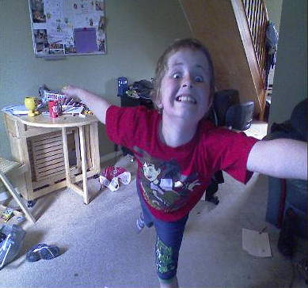
Figure 10.23 – This child is exhibiting hyperactivity and impulsivity.

In addition, the following conditions must be met:
- Several inattentive or hyperactive-impulsive symptoms were present before age 12 years.
- Several symptoms are present in two or more settings, (such as at home, school or work; with friends or relatives; in other activities).
- There is clear evidence that the symptoms interfere with, or reduce the quality of, social, school, or work functioning.
- The symptoms are not better explained by another mental disorder (such as a mood disorder, anxiety disorder, dissociative disorder, or a personality disorder). The symptoms do not happen only during the course of schizophrenia or another psychotic disorder.

Based on the types of symptoms, three kinds (presentations) of AD/HD can occur:
- Combined Presentation: if enough symptoms of both criteria inattention and hyperactivity-impulsivity were present for the past 6 months
- Predominantly Inattentive Presentation: if enough symptoms of inattention, but not hyperactivity-impulsivity, were present for the past six months
- Predominantly Hyperactive-Impulsive Presentation: if enough symptoms of hyperactivity-impulsivity, but not inattention, were present for the past six months.

Because symptoms can change over time, the presentation may change over time as well.
The diagnosis of AD/HD can be made reliably using well-tested diagnostic interview methods. However, as of yet, there is no independent valid test for ADHD.

Among children, AD/HD frequently occurs along with other learning, behavior, or mood problems such as learning disabilities, oppositional defiant disorder, anxiety disorders, and depression.

Treatment
A variety of medications and behavioral interventions are used to treat AD/HD. The most widely used medications are methylphenidate (Ritalin), D-amphetamine, and other amphetamines. These drugs are stimulants that affect the level of the neurotransmitter dopamine at the synapse. Nine out of 10 children improve while taking one of these drugs.

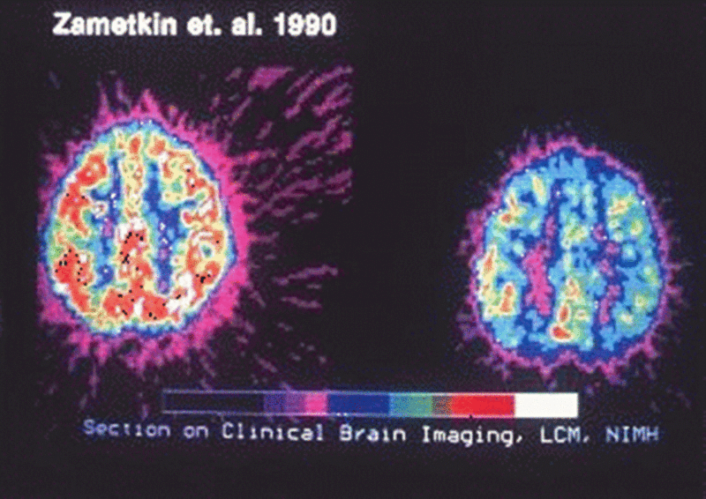
Figure 10.24 – Brain scans of brains with and without ADHD.

In addition to the well-established treatments described above, some parents and therapists have tried a variety of nutritional interventions to treat AD/HD. A few studies have found that some children benefit from such treatments. Nevertheless, no well-established nutritional interventions have consistently been shown to be effective for treating AD/HD.

Pervasive Developmental Disorder (PDD) or PPD (NOS) Not Otherwise Specified PDD –NOS
Pervasive developmental disorder (PDD) is a term used to refer to difficulties in socialization and delays in developing communicative skills. This is usually recognized before 3 years of age. A child with PDD may interact in unusual ways with toys, people, or situations, and may engage in repetitive movement. PDD is diagnosed and treatment is similar to ADHA and ASD. In 2013 the DSM- 5 discontinued using this as a diagnosis, however it is still used informally.

Managing Symptoms: Staying Healthy
Being healthy is important for all children and can be especially important for children with mental health disorders. In addition to getting the right treatment, leading a healthy lifestyle can play a role in managing symptoms. Here are some healthy behaviors that may help:
- Eating a healthful diet centered on fruits, vegetables, whole grains, legumes (for example, beans, peas, and lentils), lean protein sources, and nuts and seeds
- Participating in physical activity for at least 60 minutes each day
- Getting the recommended amount of sleep each night based on age
- Practicing mindfulness or relaxation techniques

Figure 10.25 – Staying healthy is critical for all children, especially those who may have mental health disorders.

Conclusion
In this chapter we looked at:
- Patterns of growth in the brain and body
- Health and nutrition
- Causes and results of obesity
- Exercise, fitness, and organized sports
- Physical health concerns
- Mental health disorders

In the next chapter we will be examining cognitive development theories and theorists. We will learn about information processing; attention, memory, and planning in middle childhood. We will also see how school age children learn language and how intelligence is measured.

Chapter 11: Middle Childhood – Cognitive Development

Chapter Objectives
After this chapter, you should be able to:
- Describe what cognitive theorists share about children and their thinking
- Explain how intelligence is measured, the tests used to assess intelligence, the extremes in intelligence, and the concern of bias
- Describe the Information Processing Theory
- Explain several theories of language development
- Compare typical language development with language difficulties

Introduction
Cognitive skills continue to expand in middle and late childhood. Children in middle childhood have thought processes that become more logical and organized when dealing with concrete information. Children at this age understand concepts such as past, present, and future, giving them the ability to plan and work toward goals. Additionally, they can process complex ideas such as addition and subtraction and cause-and effect relationships.

Cognitive Theories of Intelligence
Theorists are able to give different perspectives to the cognitive development of children and psychologists have long debated how to best conceptualize and measure intelligence (Sternberg, 2003). In the next section we’ll look at Piaget’s theory of cognitive development, Sternberg’s alternative view to intelligence, and Gardener’s theory of multiple intelligence. Lastly, you’ll learn about the Information Processing Theory that looks at the cognitive function of children in middle childhood.

Figure 11.1 - Jean Piaget.

Piaget’s Theory of Cognitive Development

Concrete Operational Thought
As children continue into elementary school, they develop the ability to represent ideas and events more flexibly and logically. Their rules of thinking still seem very basic by adult standards and usually operate unconsciously, but they allow children to solve problems more systematically than before, and therefore to be successful with many academic tasks. In the concrete operational stage, for example, a child may unconsciously follow the rule: “If nothing is added or taken away, then the amount of something stays the same.” This simple principle helps children to understand certain arithmetic tasks, such as in adding or subtracting zero from a number, as well as to do certain classroom science experiments, such as ones involving judgments of the amounts of liquids when mixed. Piaget called this period the concrete operational stage because children mentally “operate” on concrete objects and events.

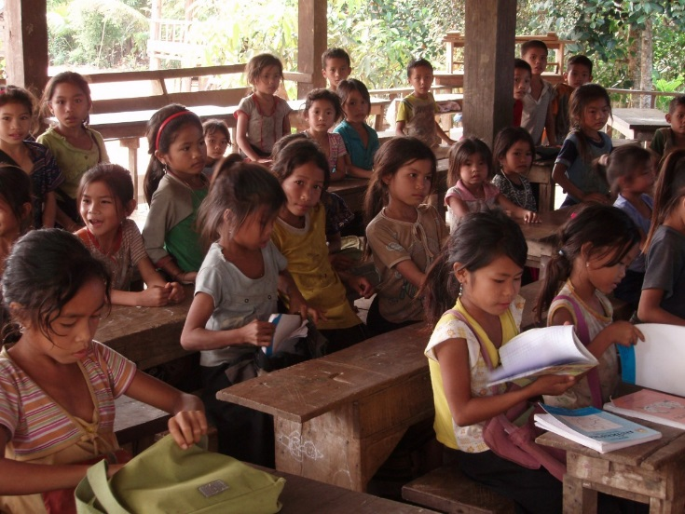
Figure 11.2 – Children studying.

The concrete operational stage is defined as the third in Piaget's theory of cognitive development. This stage takes place around 7 years old to 11 years of age, and is characterized by the development of organized and rational thinking. Piaget (1954a) considered the concrete stage a major turning point in the child's cognitive development, because it marks the beginning of logical or operational thought. The child is now mature enough to use logical thought or operations (i.e. rules) but can only apply logic to physical objects (hence concrete operational). Children gain the abilities of conservation (number, area, volume, orientation) and reversibility.

Let’s look at the following cognitive skills that children typically master during Piaget’s concrete operational stage. :

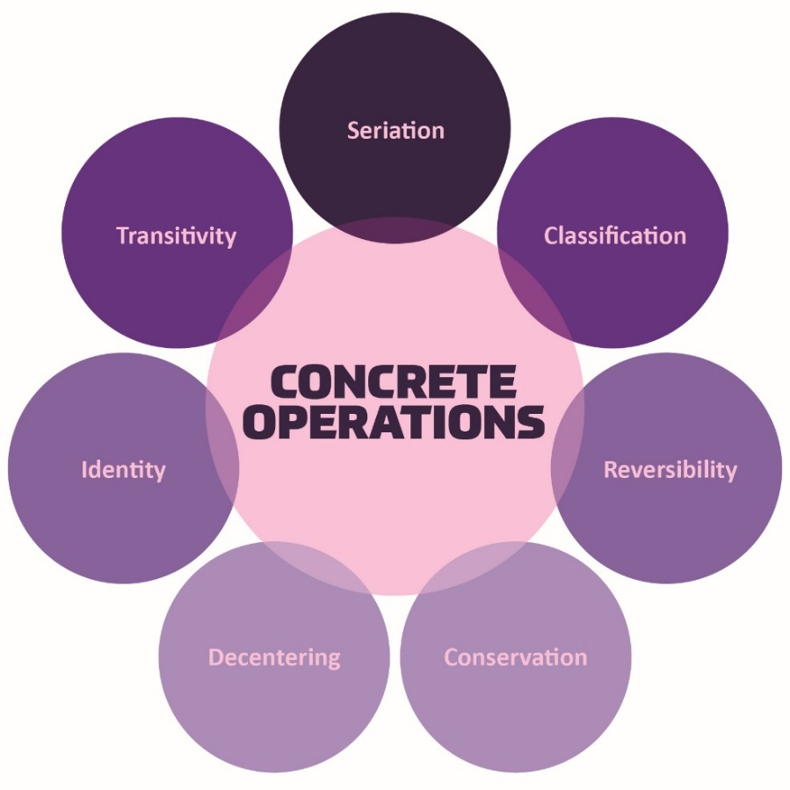
Figure 11.3 – The cognitive skills developed during the concrete operational stage.

Seriation: Arranging items along a quantitative dimension, such as length or weight, in a methodical way is now demonstrated by the concrete operational child. For example, they can methodically arrange a series of different-sized sticks in order by length, while younger children approach a similar task in a haphazard way.

Figure 11.4 - Caption: Putting these rectangles from smallest to largest is seriation.
Classification: As children's experiences and vocabularies grow, they build schema and are able to organize objects in many different ways. They also understand classification hierarchies and can arrange objects into a variety of classes and subclasses.

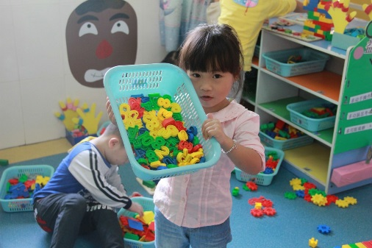
Figure 11.5 – This child might use classification if she sorts these toys by color.

Reversibility: The child learns that some things that have been changed can be returned to their original state. Water can be frozen and then thawed to become liquid again. But eggs cannot be unscrambled. Arithmetic operations are reversible as well: 2 + 3 = 5 and 5 – 3 = 2. Many of these cognitive skills are incorporated into the school's curriculum through mathematical problems and in worksheets about which situations are reversible or irreversible.

Figure 11.6 – Understanding that ice cubes melt is an example of reversibility.

Conservation: An example of the preoperational child’s thinking; if you were to fill a tall beaker with 8 ounces of water this child would think that it was "more" than a short, wide bowl filled with 8 ounces of water? Concrete operational children can understand the concept of conservation, which means that changing one quality (in this example, height or water level) can be compensated for by changes in another quality (width). Consequently, there is the same amount of water in each container, although one is taller and narrower and the other is shorter and wider.

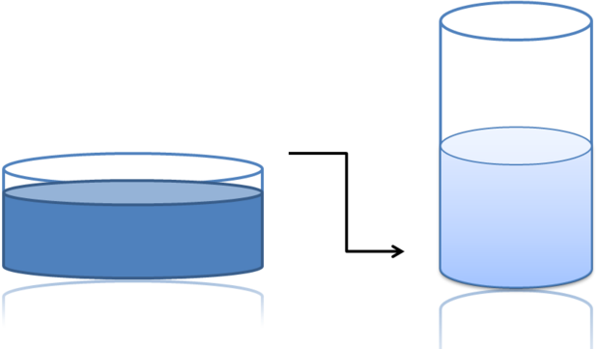
Figure 11.7 – Beakers displaying the idea of conservation.

Decentration: Concrete operational children no longer focus on only one dimension of any object (such as the height of the glass) and instead consider the changes in other dimensions too (such as the width of the glass). This allows for conservation to occur.

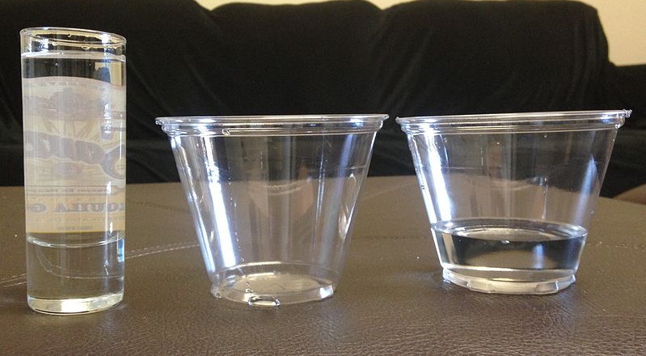
Figure 11.8 – Children looking at these glasses demonstrate decentration when looking at more than one attribute i.e. tall, short, and wide narrow.

Identity: One feature of concrete operational thought is the understanding that objects have qualities that do not change even if the object is altered in some way. For instance, mass of an object does not change by rearranging it. A piece of chalk is still chalk even when the piece is broken in two.

Figure 11.9 – A broken egg is  still an egg. | Figure 11.10 – A deflated  balloon is still a balloon. | Figure 11.11 – Broken chalk is  still chalk.

Transitivity: Being able to understand how objects are related to one another is referred to as transitivity, or transitive inference. This means that if one understands that a dog is a mammal, and that a boxer is a dog, then a boxer must be a mammal.

Figure 11.12 - Transitivity allows children to understand that this boxer puppy, is a dog and a mammal.

Looking at Piaget’s Theory
Researchers have obtained findings indicating that cognitive development is considerably more continuous than Piaget claimed. Thus, the debate between those who emphasize discontinuous, stage-like changes in cognitive development and those who emphasize gradual continuous changes remains a lively one.

Triarchic Theory of Intelligence
An alternative view of intelligence is presented by Sternberg (1997; 1999). Sternberg offers three types of intelligences. Sternberg provided background information about his view of intelligence in a conference, where he described his frustration as a committee member charged with selecting graduate students for a program in psychology. He was concerned that there was too much emphasis placed on aptitude test scores (we will discuss this later in the chapter) and believed that there were other, less easily measured, qualities necessary for success in a graduate program and in the world of work. Aptitude test scores indicate the first type of intelligence-academic
- Analytical (componential) sometimes described as academic: includes the ability to solve problems of logic, verbal comprehension, vocabulary, and spatial abilities.
- Creative (experiential): the ability to apply newly found skills to novel situations
- Practical (contextual): the ability to use common sense and to know what is called for in a situation.

Analytical  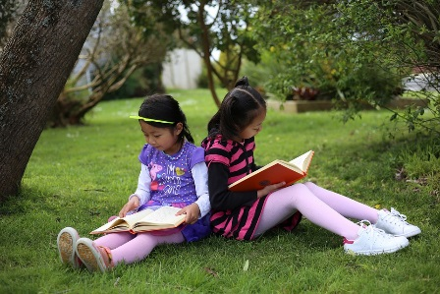  Figure 11.1 - Reading supports analytical intelligence | Creative  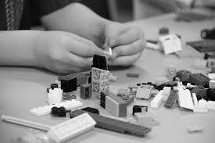  Figure 11.14 - Building with shows creative intelligence | Practical  Figure 11.15 - Navigating social settings is practical intelligence

Howard Gardner’s Theory of Multiple Intelligences
Another champion of the idea of specific types of intelligences rather than one overall intelligence is the psychologist Howard Gardner (1983, 1999). Gardner argued that it would be evolutionarily functional for different people to have different talents and skills, and proposed that there are nine intelligences that can be differentiated from each other.

Figure 11.16 – Howard Gardner.

Gardner contends that these are also forms of intelligence. A high IQ does not always ensure success in life or necessarily indicate that a person has common sense, good interpersonal skills, or other abilities important for success. Gardner investigated intelligences by focusing on children who were talented in one or more areas. He identified these 9 intelligences based on other criteria including a set developmental history and psychometric findings.

Howard Gardner (1983, 1998, 1999) suggests that there are not one, but nine domains of intelligence. The first three are skills that are measured by IQ tests:

Table 11.1 - Howard Gardner’s Multiple Intelligences

Intelligence | Description
Linguistic | The ability to speak and write well
Logical- mathematical | The ability to use logic and mathematical skills to solve problems
Spatial | The ability to think and reason about objects in three dimensions
Musical | The ability to perform and enjoy music
Kinesthetic (body) | The ability to move the body in sports, dance, or other physical activities
Interpersonal | The ability to understand and interact effectively with others
Intrapersonal | The ability to have insight into the self
Naturalistic | The ability to recognize, identify, and understand animals, plants, and other living things
Existential | The ability to understand and have concern from life’s larger questions, the meaning of life, and other spiritual matters

The concept of multiple intelligences has been influential in the field of education, and teachers have used these ideas to try to teach differently for individual students. For instance, to teach math problems to students who have particularly good kinesthetic intelligence, a teacher might encourage the students to move their bodies or hands according to the numbers. On the other hand, some have argued that these “intelligences” sometimes seem more like “abilities” or “talents” rather than real intelligence. There is no clear conclusion about how many intelligences there are. Are a sense of humor, artistic skills, dramatic skills, and so forth also separate intelligences?

Information Processing: Learning, Memory, and Problem Solving
During middle and late childhood children make strides in several areas of cognitive function including the capacity of working memory, their ability to pay attention, and their use of memory strategies. Both changes in the brain and experience foster these abilities.
In this section, we will look at how children process information, think and learn, allowing them to increase their ability to learn and remember due to an improvement in the ways they attend to, store information, and problem solve.

Working Memory: The capacity of working memory expands during middle and late childhood, research has suggested that both an increase in processing speed and the ability to inhibit irrelevant information from entering memory are contributing to the greater efficiency of working memory during this age (de Ribaupierre, 2002). Changes in myelination and synaptic pruning in the cortex are likely behind the increase in processing speed and ability to filter out irrelevant stimuli (Kail, McBride-Chang, Ferrer, Cho, & Shu, 2013).

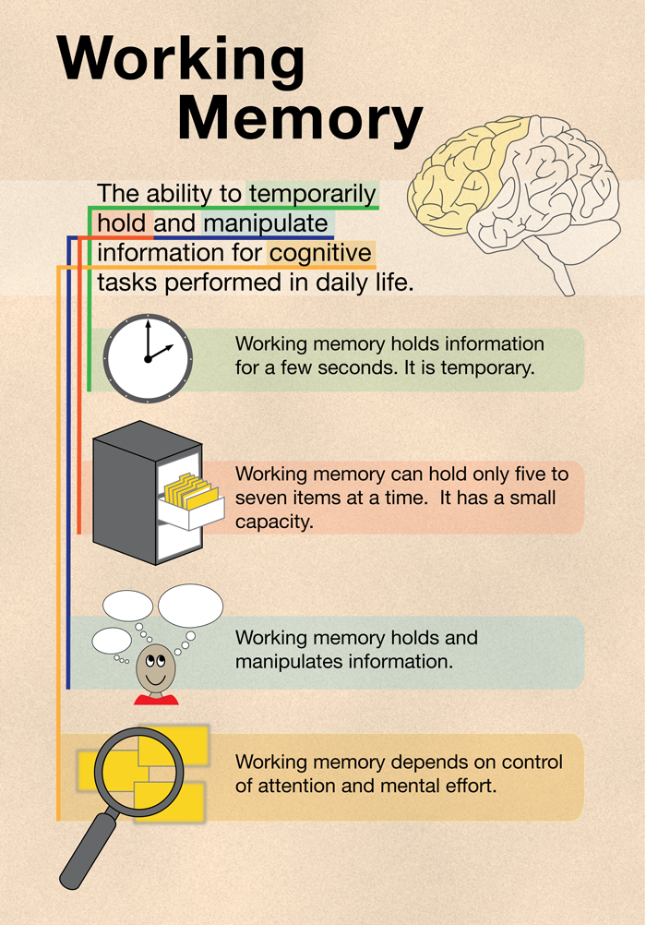
Figure 11.17 – Working memory expands during middle and late childhood.

Attention: As noted above, the ability to inhibit irrelevant information improves during this age group, with there being a sharp improvement in selective attention from age six into adolescence (Vakil, Blachstein, Sheinman, & Greenstein, 2009). Children also improve in their ability to shift their attention between tasks or different features of a task (Carlson, Zelazo, & Faja, 2013). A younger child who is asked to sort objects into piles based on type of object, car versus animal, or color of object, red versus blue, would likely have no trouble doing so. But if you ask them to switch from sorting based on type to now having them sort based on color, they would struggle because this requires them to suppress the prior sorting rule. An older child has less difficulty making the switch, meaning there is greater flexibility in their intentional skills. These changes in attention and working memory contribute to children having more strategic approaches to challenging tasks.

Memory Strategies: Bjorklund (2005) describes a developmental progression in the acquisition and use of memory strategies. Such strategies are often lacking in younger children, but increase in frequency as children progress through elementary school. Examples of memory strategies include rehearsing information you wish to recall, visualizing and organizing information, creating rhymes, such as “i” before “e” except after “c”, or inventing acronyms, such as “roygbiv” to remember the colors of the rainbow. Schneider, Kron-Sperl, and Hünnerkopf (2009) reported a steady increase in the use of memory strategies from ages six to ten in their longitudinal study. Moreover, by age ten many children were using two or more memory strategies to help them recall information. Schneider and colleagues found that there were considerable individual differences at each age in the use of strategies, and that children who utilized more strategies had better memory performance than their same aged peers.

Cognitive Processes
As children enter school and learn more about the world, they develop more categories for concepts and learn more efficient strategies for storing and retrieving information. One significant reason is that they continue to have more experiences on which to tie new information. In other words, their knowledge base, knowledge in particular areas that makes learning new information easier, expands (Berger, 2014).

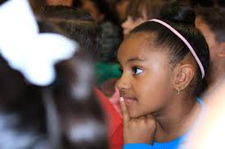
Figure 11.18 – As children learn more about the world, their knowledge base grows.

Metacognition: refers to the knowledge we have about our own thinking and our ability to use this awareness to regulate our own cognitive processes (Bruning, Schraw, Norby, & Ronning, 2004). Children in this developmental stage also have a better understanding of how well they are performing a task, and the level of difficulty of a task. As they become more realistic about their abilities, they can adapt studying strategies to meet those needs. Young children spend as much time on an unimportant aspect of a problem as they do on the main point, while older children start to learn to prioritize and gauge what is significant and what is not. As a result, they develop metacognition.

Critical thinking, or a detailed examination of beliefs, courses of action, and evidence, involves teaching children how to think. The purpose of critical thinking is to evaluate information in ways that help us make informed decisions. Critical thinking involves better understanding a problem through gathering, evaluating, and selecting information, and also by considering many possible solutions. Ennis (1987) identified several skills useful in critical thinking. These include: Analyzing arguments, clarifying information, judging the credibility of a source, making value judgments, and deciding on an action. Metacognition is essential to critical thinking because it allows us to reflect on the information as we make decisions.

Children differ in their cognitive process and these differences predict both their readiness for school, academic performance, and testing in school. (Prebler, Krajewski, & Hasselhorn, 2013).

Intelligence Testing: The What, the Why, and the Who

Measuring Intelligence: Standardization and the Intelligence Quotient
The goal of most intelligence tests is to measure “g”, the general intelligence factor. Good intelligence tests are reliable, meaning that they are consistent over time, and also demonstrate validity, meaning that they actually measure intelligence rather than something else. Because intelligence is such an important part of individual differences, psychologists have invested substantial effort in creating and improving measures of intelligence, and these tests are now considered the most accurate of all psychological tests.

Intelligence changes with age. A 3-year-old who could accurately multiply 183 by 39 would certainly be intelligent, but a 25-year-old who could not do so would be seen as unintelligent. Thus understanding intelligence requires that we know the norms or standards in a given population of people at a given age. The standardization of a test involves giving it to a large number of people at different ages and computing the average score on the test at each age level.

Once the standardization has been accomplished, we have a picture of the average abilities of people at different ages and can calculate a person’s mental age, which is the age at which a person is performing intellectually. If we compare the mental age of a person to the person’s chronological age, the result is the Intelligence Quotient (IQ), a measure of intelligence that is adjusted for age. A simple way to calculate IQ is by using the following formula:

IQ = mental age ÷ chronological age × 100.

Thus a 10-year-old child who does as well as the average 10-year-old child has an IQ of 100 (10 ÷ 10 × 100), whereas an 8-year-old child who does as well as the average 10-year-old child would have an IQ of 125 (10 ÷ 8 × 100). Most modern intelligence tests are based on the relative position of a person’s score among people of the same age, rather than on the basis of this formula, but the idea of intelligence “ratio” or “quotient” provides a good description of the score’s meaning.

The Flynn Effect
It is important that intelligence tests be standardized on a regular basis, because the overall level of intelligence in a population may change over time. The Flynn effect refers to the observation that scores on intelligence tests worldwide have increased substantially over the past decades (Flynn, 1999). Although the increase varies somewhat from country to country, the average increase is about 3 IQ points every 10 years. There are many explanations for the Flynn effect, including better nutrition, increased access to information, and more familiarity with multiple-choice tests (Neisser, 1998). But whether people are actually getting smarter is debatable (Neisser,1997).

The Value of IQ Testing
The value of IQ testing is most evident in educational or clinical settings. Children who seem to be experiencing learning difficulties or severe behavioral problems can be tested to ascertain whether the child’s difficulties can be partly attributed to an IQ score that is significantly different from the mean for her age group. Without IQ testing—or another measure of intelligence—children and adults needing extra support might not be identified effectively. People also use IQ testing results to seek disability benefits from the Social Security Administration.

While IQ tests have sometimes been used as arguments in support of insidious purposes, such as the eugenics movement, which was the science of improving a human population by controlled breeding to increase desirable heritable characteristics. However, the value of this test is important to help those in need.

Intelligence Tests and Those Who Created Them

Alfred Binet & Théodore Simon - Stanford- Binet Intelligence Test
From 1904- 1905 the French psychologist Alfred Binet (1857–1914) and his colleague Théodore Simon (1872–1961) began working on behalf of the French government to develop a measure that would identify children who would not be successful with the regular school curriculum. The goal was to help teachers better educate these students (Aiken, 1994).

Binet and Simon developed what most psychologists today regard as the first intelligence test, which consisted of a wide variety of questions that included the ability to name objects, define words, draw pictures, complete sentences, compare items, and construct sentences. Binet and Simon (Binet, Simon, & Town, 1915; Siegler, 1992) believed that the questions they asked the children all assessed the basic abilities to understand, reason, and make judgments.

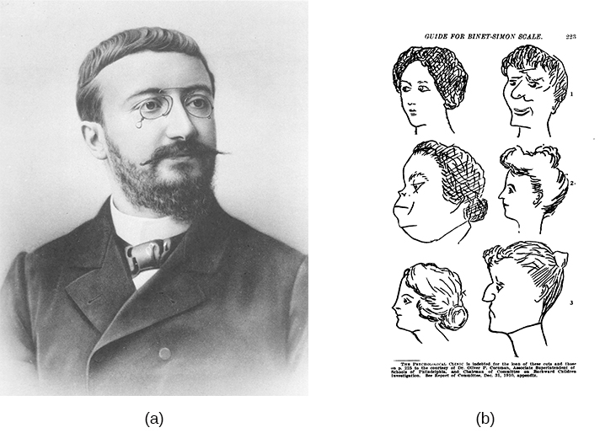
Figure 11.19 (a) Alfred Binet (b) This page is from a 1908 version of the Binet-Simon
Intelligence Scale. Children being tested were asked which face, of each pair, was prettier.

Soon after Binet and Simon introduced their test, the American psychologist Lewis Terman at Stanford University (1877–1956) developed an American version of Binet’s test that became known as the Stanford- Binet Intelligence Test. The Stanford-Binet is a measure of general intelligence made up of a wide variety of tasks including vocabulary, memory for pictures, naming of familiar objects, repeating sentences, and following commands.

David Wechsler- Wechsler-Bellevue Intelligence Scale
In 1939, David Wechsler, a psychologist who spent part of his career working with World War I veterans, developed a new IQ test in the United States. Wechsler combined several subtests from other intelligence tests used between 1880 and World War I. These subtests tapped into a variety of verbal and nonverbal skills, because Wechsler believed that intelligence encompassed “the global capacity of a person to act purposefully, to think rationally, and to deal effectively with his environment” (Wechsler, 1958, p. 7). He named the test the Wechsler-Bellevue Intelligence Scale (Wechsler, 1981). This combination of subtests became one of the most extensively used intelligence tests in the history of psychology.

Figure 11.20 - David Wechsler

Today, there are three intelligence tests credited to Wechsler, the Wechsler Adult Intelligence Scale-fourth edition (WAIS-IV), the Wechsler Intelligence Scale for Children (WISC-V), and the Wechsler Preschool and Primary Scale of Intelligence—Revised (WPPSI-III) (Wechsler, 2002). These tests are used widely in schools and communities throughout the United States, and they are periodically normed and standardized as a means of recalibration.

Bias of IQ Testing
Intelligence tests and psychological definitions of intelligence have been heavily criticized since the 1970s for being biased in favor of Anglo-American, middle-class respondents and for being inadequate tools for measuring non-academic types of intelligence or talent. Intelligence changes with experience, and intelligence quotients or scores do not reflect that ability to change. What is considered smart varies culturally as well, and most intelligence tests do not take this variation into account. For example, in the West, being smart is associated with being quick. A person who answers a question the fastest is seen as the smartest, but in some cultures being smart is associated with considering an idea thoroughly before giving an answer. A well- thought out, contemplative answer is the best answer.

A Spectrum of Intellectual Development
The results of studies assessing the measurement of intelligence show that IQ is distributed in the population in the form of a Normal Distribution (or bell curve), which is the pattern of scores usually observed in a variable that clusters around its average. In a normal distribution, the bulk of the scores fall toward the middle, with many fewer scores falling at the extremes. The normal distribution of intelligence shows that on IQ tests, as well as on most other measures, the majority of people cluster around the average (in this case, where IQ = 100), and fewer are either very smart or very dull (see below).

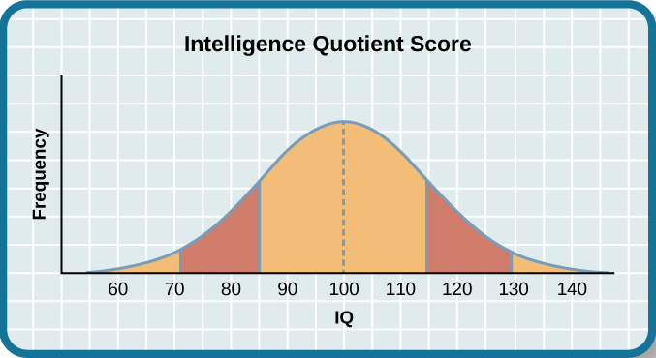
Figure 11.21 - The majority of people have an IQ score between 85 and 115.

Distribution of IQ Scores in the General Population
This means that about 2% of people score above an IQ of 130, often considered the threshold for giftedness, and about the same percentage score below an IQ of 70, often being considered the threshold for an intellectual disability.

Intellectual Disabilities
One end of the distribution of intelligence scores is defined by people with very low IQ. Intellectual disability (or intellectual developmental disorder) is assessed based on cognitive capacity (IQ) and adaptive functioning. The severity of the disability is based on adaptive functioning, or how well the person handles everyday life tasks. About 1% of the United States population, most of them males, fulfill the criteria for intellectual developmental disorder, but some children who are given this diagnosis lose the classification as they get older and better learn to function in society. A particular vulnerability of people with low IQ is that they may be taken advantage of by others, and this is an important aspect of the definition of intellectual developmental disorder (Greenspan, Loughlin, & Black, 2001).

One example of an intellectual developmental disorder is Down syndrome, a chromosomal disorder caused by the presence of all or part of an extra 21st chromosome. The incidence of Down syndrome is estimated at approximately 1 per 700 births, and the prevalence increases as the mother’s age increases (CDC, 2014a). People with Down syndrome typically exhibit a distinctive pattern of physical features, including a flat nose, upwardly slanted eye, a protruding tongue, and a short neck.

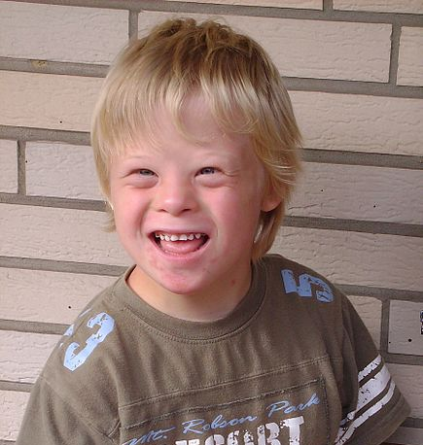
Figure 11.22 – Down Syndrome is caused by the presence of all or part of an extra 21st chromosome.

Fortunately, societal attitudes toward individuals with intellectual disabilities have changed over the past decades. We no longer use terms such as “retarded,” “moron,” “idiot,” or “imbecile” to describe people with intellectual differences, although these were the official psychological terms used to describe degrees of what was referred to as mental retardation in the past. Laws such as the Americans with Disabilities Act (ADA) have made it illegal to discriminate on the basis of mental and physical disability.

The normal distribution of IQ scores in the general population shows that most people have about average intelligence, while very few have extremely high or extremely low intelligence.

Giftedness
Being gifted refers to children who have an IQ of 130 or higher (Lally & Valentine-French, 2015). Having an extremely high IQ is clearly less of a problem than having an extremely low IQ but there may also be challenges to being particularly smart. It is often assumed that school children who are labeled as “gifted” may have adjustment problems that make it more difficult for them to create and maintain social relationships.

Figure 11.23 – Children who get a score on an intelligence test
showing an IQ of 130 or higher are labeled as gifted.

As you might expect based on our discussion of intelligence, there are also different types and areas of intelligence and giftedness. Some children are particularly good at math or science, some at automobile repair or carpentry, some at music or art, some at sports or leadership, and so on. There is a lively debate among scholars about whether it is appropriate or beneficial to label some children as “gifted and talented” in school and to provide them with accelerated special classes and other programs that are not available to everyone. Although doing so may help the gifted kids (Colangelo & Assouline, 2009), it also may isolate them from their peers and make such provisions unavailable to those who are not classified as “gifted.” Testing for high IQ or for disabilities needs to be critically looked at so that the good that these tests were created for are not used for undesirable purposes.

How do we know so much about what children learn in schools? In the next section we’ll look at the different types of tests and what the schools are testing.

Testing in Schools
Children's academic performance is often measured with the use of standardized tests. Those tests include, but are not limited to Achievement and Aptitude tests.

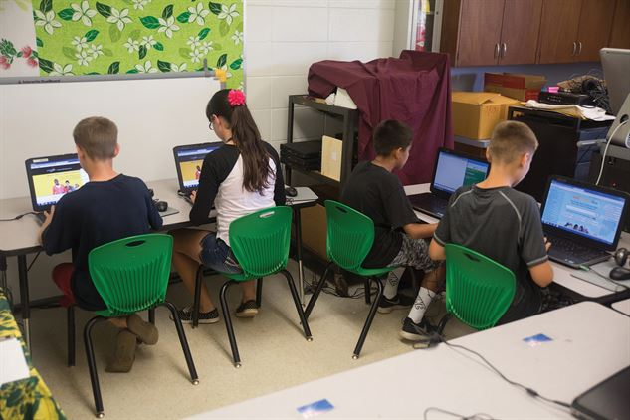
Figure 11.24 – Standardized tests are used to measure academic performance.

Achievement tests are used to measure what a child has already learned. Achievement tests are often used as measures of teaching effectiveness within a school setting and as a method to make schools that receive tax dollars (such as public schools, charter schools, and private schools that receive vouchers) accountable to the government for their performance.

Aptitude tests are designed to measure a student’s ability to learn or to determine if a person has potential in a particular program. These are often used at the beginning of a course of study or as part of college entrance requirements. The Scholastic Aptitude Test (SAT) and Preliminary Scholastic Aptitude Test (PSAT) are perhaps the most familiar aptitude tests to students in grades 6 and above. Learning test taking skills and preparing for SATs has become part of the training that some students in these grades receive as part of their pre-college preparation. Other aptitude tests include the MCAT (Medical College Admission Test), the LSAT (Law School Admission Test), and the GRE (Graduate Record Examination). Intelligence tests are also a form of aptitude test, which designed to measure a person’s ability to learn.

What Happened to No Child Left Behind?
In 2001, President Bush signed into effect Public Law 107-110, better known as the No Child Left Behind Act mandating that schools administer achievement tests to students and publish those results so that parents have an idea of their children's performance. Additionally, the government would have information on the gaps in educational achievement between children from various social class, racial, and ethnic groups.

Schools that showed significant gaps in these levels of performance were mandated to work toward narrowing these gaps. Educators criticized the policy for focusing too much on testing as the only indication of student performance. Target goals were considered unrealistic and set by the federal government rather than individual states. Because these requirements became increasingly unworkable for schools, changes to the law were requested.

Figure 11.25 – The No Child Left Behind Act was signed into effect in 2001. | Figure 11.26 – The Every Student Succeeds Act was signed into effect in 2015.

On December 12, 2015 President Obama signed into law the Every Student Succeeds Act (ESSA). This law is state driven and focuses on expanding educational opportunities and improving student outcomes, including in the areas of high school graduation, drop-out rates, and college attendance.

Language Development in the School-Age Child
Human language is the most complex behavior on the planet and, at least as far as we know, in the universe. Language involves both the ability to comprehend (receptive) spoken and written (expressive) words and to create communication in real time when we speak or write. Most languages are oral, generated through speaking. Speaking involves a variety of complex cognitive, social, and biological processes including operation of the vocal cords, and the coordination of breath with movements of the throat and mouth, and tongue. Other languages are sign languages, in which the communication is expressed by movements of the hands. The most common sign language is American Sign Language (ASL), currently spoken by more than 500,000 people in the United States alone.

Although language is often used for the transmission of information (“turn right at the next light and then go straight,” “Place tab A into slot B”), this is only its most mundane function. Language also allows us to access existing knowledge, to draw conclusions, to set and accomplish goals, and to understand and communicate complex social relationships. Language is fundamental to our ability to think, and without it we would be nowhere near as intelligent as we are.

Language can be conceptualized in terms of sounds, meaning, and the environmental factors that help us understand it. Phonemes are the elementary sounds of our language, morphemes are the smallest units of meaning in a language, syntax is the set of grammatical rules that control how words are put together, and contextual information is the elements of communication that are not part of the content of language but that help us understand its meaning. Understanding how language works means reaching across many branches of psychology—everything from basic neurological functioning to high-level cognitive processing. Language shapes our social interactions and brings order to our lives. Complex language is one of the defining factors that make us human.

Introduction to Linguistics
Language is such a special topic that there is an entire field, linguistics, devoted to its study. Linguistics views language in an objective way, using the scientific method and rigorous research to form theories about how humans acquire, use, and sometimes abuse language. There are a few major branches of linguistics, which it is useful to understand in order to learn about language from a psychological perspective.

Major Branches of Linguistics
This diagram outlines the various subfields of linguistics, the study of language. These include phonetics, phonology, morphology, syntax, semantics, and pragmatics.

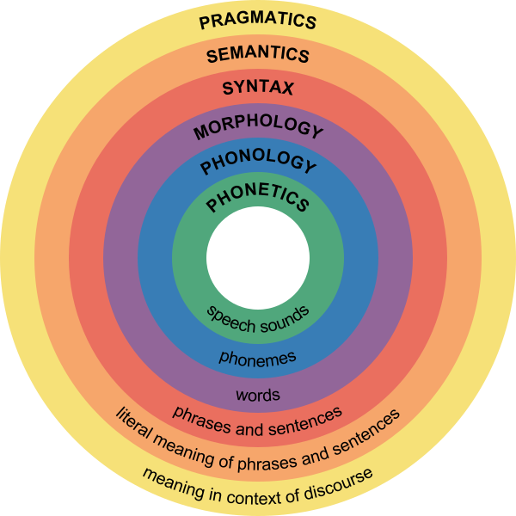
Figure 11.27 – Major branches of linguistics.

Phonetics and Phonology
A phoneme is the smallest unit of sound that makes a meaningful difference in a language. The word “bit” has three phonemes, /b/, /i/, and /t/ (in transcription, phonemes are placed between slashes), and the word “pit” also has three: /p/, /i/, and /t/. In spoken languages, phonemes are produced by the positions and movements of the vocal tract, including our lips, teeth, tongue, vocal cords, and throat, whereas in sign languages phonemes are defined by the shapes and movement of the hands. English contains about 45 phonemes.

Whereas phonemes are the smallest units of sound in language, phonetics is the study of individual speech sounds; phonology is the study of phonemes, which are the speech sounds of an individual language. These two heavily overlapping subfields cover all the sounds that humans can make, as well as which sounds make up different languages.

Morpheme and Morphology
A morpheme is a string of one or more phonemes that makes up the smallest units of meaning in a language. Some morphemes, such as one-letter words like “I” and “a,” are also phonemes, but most morphemes are made up of combinations of phonemes. Some morphemes are prefixes and suffixes used to modify other words. For example, the syllable “re-” as in “rewrite” or “repay” means “to do again,” and the suffix “-est” as in “happiest” or “coolest” means “to the maximum.”

Morphology is the study of words and other meaningful units of language like suffixes and prefixes. A morphologist would be interested in the relationship between words like “dog” and “dogs” or “walk” and “walking,” and how people figure out the differences between those words.

Syntax
Syntax is the set of rules of a language by which we construct sentences. Each language has a different syntax. The syntax of the English language requires that each sentence have a noun and a verb, each of which may be modified by adjectives and adverbs. Some syntaxes make use of the order in which words appear, while others do not.

Syntax is the study of sentences and phrases, or how people put words into the right order so that they can communicate meaningfully. All languages have underlying rules of syntax, which, along with morphological rules, make up every language’s grammar. An example of syntax coming into play in language is “Eugene walked the dog” versus “The dog walked Eugene.” The order of words is not arbitrary—in order for the sentence to convey the intended meaning, the words must be in a certain order.

Semantics and Pragmatics
Semantics, generally, is about the meaning of sentences. Someone who studies semantics is interested in words and what real-world object or concept those words denote, or point to.

Pragmatics is an even broader field that studies how the context of a sentence contributes to meaning. For example, someone shouting “Fire!” has a very different meaning if they are in charge of a seven-gun salute than it does if they are sitting in a crowded movie theater. Every language is different. In English, an adjective comes before a noun (“red house”), whereas in Spanish, the adjective comes after (“casa [house] roja [red].”) In German, you can put noun after noun together to form giant compound words; in Chinese, the pitch of your voice determines the meaning of your words. in American Sign Language, you can convey full, grammatical sentences with tense and aspect by moving your hands and face. But all languages have structural underpinnings that make them logical for the people who speak and understand them.

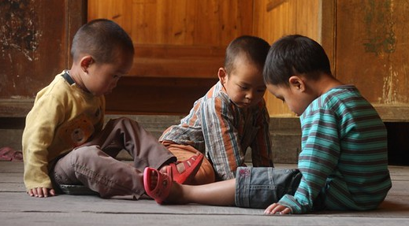
Figure 11.28 – As speakers of Chinese, these boys would understand the importance of pitch.

Cognitive Language and Communication
When learning one or more languages in middle childhood, children are able to understand that there are many complex parts including comprehension, fluency, and meaning when communicating. The following are areas of cognitive language and communication.

Lexicon
Every language has its rules, which act as a framework for meaningful communication. But what do people fill that framework up with? The answer is, of course, words. Every human language has a lexicon—the sum total of all of the words in that language. By using grammatical rules to combine words into logical sentences, humans can convey an infinite number of concepts.

Grammar
Because all language obeys a set of combinatory rules, we can communicate an infinite number of concepts. While every language has a different set of rules, all languages do obey rules. These rules are known as grammar. Speakers of a language have internalized the rules and exceptions for that language’s grammar. There are rules for every level of language—word formation (for example, native speakers of English have internalized the general rule that -ed is the ending for past-tense verbs, so even when they encounter a brand-new verb, they automatically know how to put it into past tense); phrase formation (for example, knowing that when you use the verb “buy,” it needs a subject and an object; “She buys” is wrong, but “She buys a gift” is okay); and sentence formation.

Older children are also able to learn new rules of grammar with more flexibility. While younger children are likely to be reluctant to give up saying "I goed there", older children will learn this rather quickly along with other rules of grammar.

Vocabulary
One of the reasons that children can classify objects in so many ways is that they have acquired a vocabulary to do so. By fifth grade, a child's vocabulary has grown to 40,000 words. It grows at a rate that exceeds that of those in early childhood. This language explosion, however, differs from that of younger children because it is facilitated by being able to associate new words with those already known, and because it is accompanied by a more sophisticated understanding of the meanings of a word.

Context
Words do not possess fixed meanings but change their interpretation as a function of the context in which they are spoken. We use contextual information—the information surrounding language—to help us interpret it. Context is how everything within language works together to convey a particular meaning. Context includes tone of voice, body language, and the words being used. Depending on how a person says something, holds his or her body, or emphasizes certain points of a sentence, a variety of different messages can be conveyed. For example, the word “awesome,” when said with a big smile, means the person is excited about a situation. “Awesome,” said with crossed arms, rolled eyes, and a sarcastic tone, means the person is not thrilled with the situation.

Figure 11.29 – Context helps us understand meaning.

New Understanding
Those in middle and late childhood are also able to think of objects in less literal ways. For example, if asked for the first word that comes to mind when one hears the word "pizza", the younger child is likely to say "eat" or some word that describes what is done with a pizza. However, the older child is more likely to place pizza in the appropriate category and say "food". This sophistication of vocabulary is also evidenced by the fact that older children tell jokes and delight in doing so. They may use jokes that involve plays on words such as "knock- knock" jokes or jokes with punch lines. Young children do not understand play on words and tell "jokes" that are literal or slapstick, such as "A man fell down in the mud! Isn't that funny?"

Bilingualism - also known as Dual Language Learners or English Language Learners
Although monolingual speakers (those that only speak one language) often do not realize it, the majority of children around the world are bilingual, (they understand and use two languages). (Meyers- Sutton, 2005). Even in the United States, which is a relatively monolingual society, more than 47 million people speak a language other than English at home, and about 10 million of these people are children or youth in public schools (United States Department of Commerce, 2003). The large majority of bilingual students (75%) are Hispanic, but the rest represent more than a hundred different language groups from around the world. In larger communities throughout the United States, it is therefore common for a single classroom to contain students from several language backgrounds at once. In classrooms, as in other social settings, bilingualism exists in different forms and degrees.

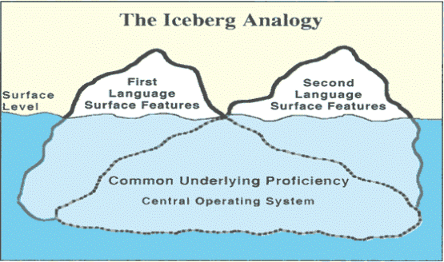
Figure 11.30 – The Iceberg Analogy.

The student who speaks both languages fluently has a definite cognitive advantage. As you might suspect and research confirmed, a fully fluent bilingual student is in a better position to express concepts or ideas in more than one way, and to be aware of doing so (Jimenez, Garcia, & Pearson, 1995; Francis, 2006). Having a large vocabulary in a first language has been shown to save time in learning vocabulary in a second language (Hansen, Umeda & McKinney, 2002).

Theories of Language Development
Humans, especially children, have an amazing ability to learn language. Within the first year of life, children will have learned many of the necessary concepts to have functional language, although it will still take years for their capabilities to develop fully. As we just explained, some people learn two or more languages fluently and are bilingual or multilingual. Here is a recap of the theorists and theories that have been proposed to explain the development of language, and related brain structures, in children.

Skinner: Operant Conditioning
B. F. Skinner believed that children learn language through operant conditioning; in other words, children receive “rewards” for using language in a functional manner. For example, a child learns to say the word “drink” when she is thirsty; she receives something to drink, which reinforces her use of the word for getting a drink, and thus she will continue to do so. This follows the four-term contingency that Skinner believed was the basis of language development—motivating operations, discriminative stimuli, response, and reinforcing stimuli. Skinner also suggested that children learn language through imitation of others, prompting, and shaping.

Chomsky: Language Acquisition Device
Noam Chomsky’s work discusses the biological basis for language and claims that children have innate abilities to learn language. Chomsky terms this innate ability the “language acquisition device.” He believes children instinctively learn language without any formal instruction. He also believes children have a natural need to use language, and that in the absence of formal language children will develop a system of communication to meet their needs. He has observed that all children make the same type of language errors, regardless of the language they are taught. Chomsky also believes in the existence of a “universal grammar,” which posits that there are certain grammatical rules all human languages share. However, his research does not identify areas of the brain or a genetic basis that enables humans’ innate ability for language.

Piaget: Assimilation and Accommodation
Jean Piaget’s theory of language development suggests that children use both assimilation and accommodation to learn language. Assimilation is the process of changing one’s environment to place information into an already-existing schema (or idea). Accommodation is the process of changing one’s schema to adapt to the new environment. Piaget believed children need to first develop mentally before language acquisition can occur. According to him, children first create mental structures within the mind (schemas) and from these schemas, language development happens.

Vygotsky: Zone of Proximal Development
Lev Vygotsky’s theory of language development focused on social learning and the zone of proximal development (ZPD). The ZPD is a level of development obtained when children engage in social interactions with others; it is the distance between a child’s potential to learn and the actual learning that takes place. Vygotsky’s theory also demonstrated that Piaget underestimated the importance of social interactions in the development of language.
Piaget’s and Vygotsky’s theories are often compared with each other, and both have been used successfully in the field of education.

Figure 11.31 – This park ranger is using the ZPD to increase these boys understanding.

Learning to Read
A huge milestone in middle childhood is learning to read and write. While the foundations of this were laid in infancy and early childhood, formal instruction on this process usually happens during the school-age years. There isn’t always complete agreement on how children are best taught to read. The following approaches to teaching reading are separated by their methodology, but today, models of reading strive for a balance between the two types of reading methods because they are both recognized as essential for learning to read.
- A phonics-based approach teaches reading by making sure children can understand letter-sound correspondences (how letters sound), automatically recognize familiar words, and decode unfamiliar words. This ability to break the code of reading allows children to read words they have never heard spoken before.
- The whole-language approach attempts to teach reading as naturally as possible. As the sounds of words don’t have meaning, the focus is on reading words and sentences in context (such as real books), rather than learning the sounds and phonemes that make up words.

Learning Difficulties
When children don’t seem to be developing or learning in the typical pattern one might be assessed for a disorder or disability. What is a learning disorder or disability? In the next section we’ll learn about the spectrum of disorders and how they may impact many areas of the child's life.
- A learning disorder is a classification of disorders in which a person has difficulty learning in a typical manner within one of several domains. Types of learning disorders include difficulties in reading (dyslexia), mathematics (dyscalculia), and writing (dysgraphia). These disorders are diagnosed with certain criteria.
- A learning disability has problems in a specific area or with a specific task or type of activity related to education.

Children with learning challenges are usually identified in school because this is when their academic abilities are being tested, compared, and measured. In the Diagnostic and Statistical Manual of Mental Disorders -DSM-5, a qualified person will make a diagnosis, identified causes, and will make a treatment plan for disorders and disabilities. The diagnosis of specific learning disorder was added to the DSM-5 in 2013.

The DSM does not require that a single domain of difficulty (such as reading, mathematics, or written expression) be identified—instead, it is a single diagnosis that describes a collection of potential difficulties with general academic skills, simply including detailed specifies for the areas of reading, mathematics, and writing. Academic performance must be below average in at least one of these fields, and the symptoms may also interfere with daily life or work. In addition, the learning difficulties cannot be attributed to other sensory, motor, developmental, or neurological disorders.

The following is an example of the DSM-5 - learning disorders.

Learning Disorders:
- Dyslexia - Reading
- Dyscalculia – Mathematics
- Dyspraxia - Motor Coordination
- Dysgraphia - Writing
- Auditory Processing Disorder - Hearing
- Visual Processing Disorder - Visual

Speech and Language Disorders:
- Aphasia - Loss of language - expressive and receptive
- Articulation Disorder - An articulation disorder
- Fluency Disorders - Fluency disorders
- Voice Disorders - Disorders of the voice

Learning Disorders or Disabilities

Dyslexia
Dyslexia, sometimes called “reading disorder,” is the most common learning disability; of all students with specific learning disabilities, 70%–80% have deficits in reading. The term "developmental dyslexia" is often used as a catchall term, but researchers assert that dyslexia is just one of several types of reading disabilities. A reading disability can affect any part of the reading process, including word recognition, word decoding, reading speed, prosody (oral reading with expression), and reading comprehension.

Dyscalculia
Dyscalculia is a form of math-related disability that involves difficulties with learning math-related concepts (such as quantity, place value, and time), memorizing math-related facts, organizing numbers, and understanding how problems are organized on the page. Dyscalculics are often referred to as having poor "number sense."

Dyspraxia
Children who have motor skills substantially below what is expected for their age are diagnosed with dyspraxia – or developmental coordination disorder (DCD) as it is more formally known. They are not lazy, clumsy or unintelligent – in fact, their intellectual ability is in line with the general population – but they do struggle with everyday tasks that require coordination.

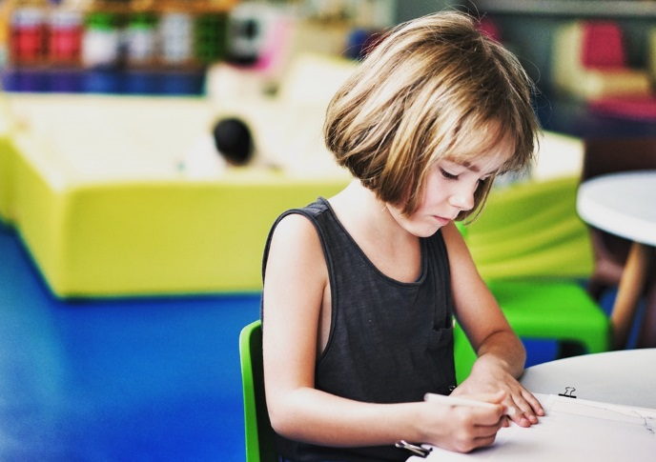
Figure 11.32 - Children with learning challenges are usually identified in school because this is when their academic abilities are being tested, compared, and measured.

Dysgraphia
The term dysgraphia is often used as an overarching term for all disorders of written expression. Individuals with dysgraphia typically show multiple writing-related deficiencies, such as grammatical and punctuation errors within sentences, poor paragraph organization, multiple spelling errors, and excessively poor penmanship.

Auditory Processing Disorder
A processing deficit in the auditory modality that spans multiple processes is auditory processing disorder (APD). To date, APD diagnosis is mostly based on the utilization of speech material. Unfortunately, acceptable non-speech tests that allow differentiation between an actual central hearing disorder and related disorders such as specific language impairments are still not adequately available.

Visual Processing Disorder
Difficulty processing or interpreting visual information is referred to as visual processing disorder (VPD). Kids with visual processing issues may have difficulty telling the difference between two shapes or finding a specific piece of information on a page.

Table 11.2 - Summary of Learning Disabilities

Disability | Difficulties | Effects
Dyslexia | Difficulty with reading | Problems reading, writing, spelling
Dyscalculia | Difficulty with math | Problems doing math problems, understanding time, using money
Dyspraxia (Sensory Integration Disorder) | Difficulty with fine motor skills | Problems with hand-eye coordination, balance manual dexterity
Dysgraphia | Difficulty with writing | Problems with handwriting, spelling, organizing ideas
Auditory Processing Disorder | Difficulty hearing difference between sounds | Problems with reading, comprehension, language
Visual Processing Disorder | Difficulty interpreting visual information | Problems with reading, math, maps, charts, symbols, pictures

Speech and Language Disorders

Aphasia
A loss of the ability to produce or understand language is referred to as aphasia. Without the brain, there would be no language. The human brain has a few areas that are specific to language processing and production. When these areas are damaged or injured, capabilities for speaking or understanding can be lost, a disorder known as aphasia. These areas must function together in order for a person to develop, use, and understand language.

Articulation disorder
An articulation disorder refers to the inability to correctly produce speech sounds (phonemes) because of imprecise placement, timing, pressure, speed, or flow of movement of the lips, tongue, or throat (NIDCD, 2016). Sounds can be substituted, left off, added or changed. These errors may make it hard for people to understand the speaker. They can range from problems with specific sounds, such as lisping to severe impairment in the phonological system. Most children have problems pronouncing words early on while their speech is developing. However, by age three, at least half of what a child says should be understood by a stranger. By age five, a child's speech should be mostly intelligible. Parents should seek help if by age six the child is still having trouble producing certain sounds. It should be noted that accents are not articulation disorders (Medline Plus, 2016a).

Fluency disorders
Fluency disorders affect the rate of speech. Speech may be labored and slow, or too fast for listeners to follow. The most common fluency disorder is stuttering.

Stuttering is a speech disorder in which sounds, syllables, or words are repeated or last longer than normal. These problems cause a break in the flow of speech, which is called dysfluency (Medline Plus, 2016b). About 5% of young children, aged two-five, will develop some stuttering that may last from several weeks to several years (Medline Plus, 2016c). Approximately 75% of children recover from stuttering. For the remaining 25%, stuttering can persist as a lifelong communication disorder (National Institute on Deafness and other Communication Disorders, NIDCD, 2016). This is called developmental stuttering and is the most common form of stuttering.

Brain injury, and in very rare instances, emotional trauma may be other triggers for developing problems with stuttering. In most cases of developmental stuttering, other family members share the same communication disorder. Researchers have recently identified variants in four genes that are more commonly found in those who stutter (NIDCD, 2016).

Voice disorders
Disorders of the voice involve problems with pitch, loudness, and quality of the voice (American Speech-Language and Hearing Association, 2016). It only becomes a disorder when problems with the voice make the child unintelligible. In children, voice disorders are significantly more prevalent in males than in females. Between 1.4% and 6% of children experience problems with the quality of their voice. Causes can be due to structural abnormalities in the vocal cords and/or larynx, functional factors, such as vocal fatigue from overuse, and in rarer cases psychological factors, such as chronic stress and anxiety.

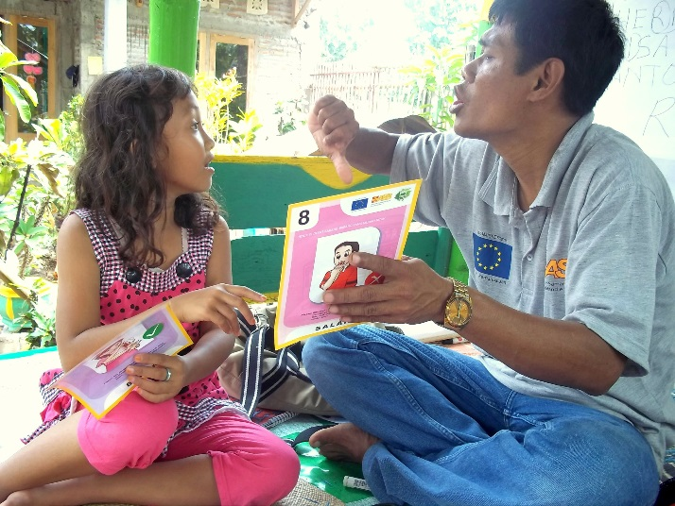
Figure 11.33 – Speech therapy.

Children with Disabilities: Legislation
Since the 1970s political and social attitudes have moved increasingly toward including people with disabilities into a wide variety of “regular” activities. In the United States, the shift is illustrated clearly in the Federal legislation that was enacted during this time. Three major laws were passed that guaranteed the rights of persons with disabilities, and of children and students with disabilities in particular. The third law has had the biggest impact on education.

The Rehabilitation Act of 1973, Section 504
This law, the first of its kind, required that individuals with disabilities be accommodated in any program or activity that receives Federal funding (PL93-112, 1973). Although this law was not intended specifically for education, in practice it has protected students' rights in some extra-curricular activities (for older students) and in some childcare or after-school care programs (for younger students). If those programs receive Federal funding of any kind, the programs are not allowed to exclude children or youths with disabilities, and they have to find reasonable ways to accommodate the individuals' disabilities.

Americans with Disabilities Act of 1990 (or ADA)
This legislation also prohibited discrimination on the basis of disability, just as Section 504 of the Rehabilitation Act had done (PL 101-336, 1990). Although the ADA also applies to all people (not just to students), its provisions are more specific and “stronger” than those of Section 504. In particular, ADA extends to all employment and jobs, not just those receiving Federal funding. It also specifically requires accommodations to be made in public facilities such as with buses, restrooms, and telephones. ADA legislation is therefore responsible for some of the “minor” renovations in schools that you may have noticed in recent years, like wheelchair-accessible doors, ramps, and restrooms, and public telephones with volume controls.

Figure 11.34 - President George H. W. Bush Signs the Americans with Disabilities Act, 07/26/1990.

Individuals with Disabilities Education Act (or IDEA)
As its name implied this legislation was more focused on education than either Section 504 or ADA. It was first passed in 1975 and has been amended several times since, including most recently in 2004 (PL 108-446, 2004). In its current form, the law guarantees the following rights related to education for anyone with a disability from birth to age 21.

The first two rights influence schooling in general, but the last three affect the work of classroom teachers rather directly:
- Free, appropriate education: An individual or an individual's family should not have to pay for education simply because the individual has a disability, and the educational program should be truly educational; i.e., not merely caretaking or babysitting.
- Due process: In case of disagreements between an individual with a disability and the schools or other professionals, there must be procedures for resolving the disagreements that are fair and accessible to all parties, including the person himself or herself or the person's representative.
- Fair evaluation of performance in spite of disability: Tests or other evaluations should not assume test taking skills that a person with a disability cannot reasonably be expected to have, such as holding a pencil, hearing or seeing questions, working quickly, or understanding and speaking orally. Evaluation procedures should be modified to allow for these differences. This provision of the law applies both to evaluations made by teachers and to school-wide or “high-stakes” testing programs.
- Education in the “least restrictive environment”: Education for someone with a disability should provide as many educational opportunities and options for the person as possible, both in the short term and in the long term. In practice, this requirement has meant including students in regular classrooms and school activities as much as possible.
- An Individualized Educational Plan (IEP): Given that every disability is unique, instructional planning for a person with a disability should be unique or individualized as well. In practice, this provision has led to classroom teachers planning individualized programs jointly with other professionals (like reading specialists, psychologists, or medical personnel) as part of a team.

Special Education Process
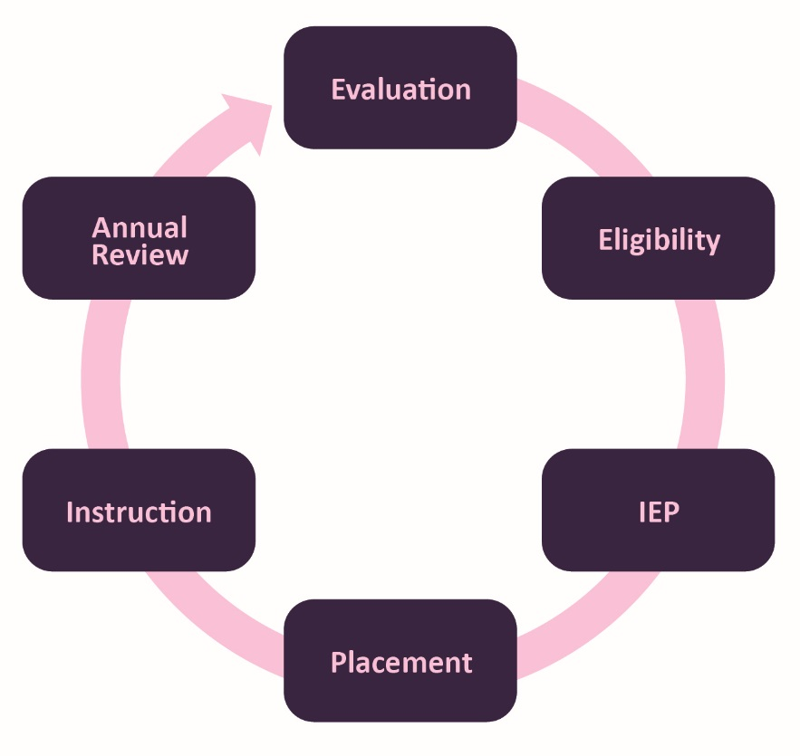
Figure 11.35 – The special education process.

Conclusion
In this chapter we looked at:
- Piaget’s concrete operational stage of cognitive development.
- Theories of intelligence.
- How children process information.
- Intelligence testing.
- The spectrum of intellectual abilities.
- Language and communication development.
- Learning difficulties.
In the next chapter, we will be examining school-aged children’s developing understanding of themselves and the world around them and the widening influences on their social and emotional development.

Chapter 12: Middle Childhood - Social Emotional Development

Chapter Objectives
After this chapter, you should be able to:
- Describe the social emotional theories of development
- Examine the importance of positive friendships and peer relationships
- Describe self-understanding in childhood
- Identify the types of families children are part of
- Explain aggression, antisocial behavior, and bullying

Introduction
As children get older, their experiences allow them to develop a more realistic understanding of themselves, including both their strengths and weaknesses. This developing self-concept is influenced by messages they receive from their peers, their family, and the media.

Social Emotional Theories of Development

Erik Erikson- Industry vs. Inferiority
Erik Erikson proposed that we are motivated by a need to achieve competence in certain areas of our lives. As we’ve learned in previous chapters, Erikson’s psychosocial theory has eight stages of development over the lifespan, from infancy through late adulthood. At each stage there is a conflict, or task, that we need to resolve. Successful completion of each developmental task results in a sense of competence and a healthy personality. Failure to master these tasks leads to feelings of inadequacy.

During the elementary school stage (ages 6-12), children face the task of Industry versus Inferiority. Children begin to compare themselves to their peers to see how they measure up.

Figure 12.1 – The academic award this boy is receiving may contribute to his sense of industry.
They either develop a sense of pride and accomplishment in their schoolwork, sports, social activities, and family life, or they feel inferior and inadequate when they don’t measure up.

According to Erikson, children in middle childhood are very busy or industrious. They are constantly doing, planning, playing, getting together with friends, achieving. This is a very active time and a time when they are gaining a sense of how they measure up when compared with friends. Erikson believed that if these industrious children can be successful in their endeavors, they will get a sense of confidence for future challenges. If not, a sense of inferiority can be particularly haunting during middle childhood.

Sigmund Freud - Psychoanalytic Theory
The great psychoanalyst Sigmund Freud (1856–1939) focused on unconscious, biological forces that he felt shape individual personality. Freud (1933) thought that the personality consists of three parts: the id, the ego, and the superego. The id is the selfish part of the personality and consists of biological instincts that all babies have, including the need for food and, more generally, the demand for immediate gratification. As babies get older, they learn that not all their needs can be immediately satisfied and thus develop the ego, or the rational part of the personality. As children get older still, they internalize society’s norms and values and thus begin to develop their superego, which represents society’s conscience. If a child does not develop normally and the superego does not become strong enough, the individual is more at risk for being driven by the id to commit antisocial behavior.

Figure 12.2 – Development of the superego helps children overcome their unconscious desire to behave antisocially.

Lawrence Kohlberg’s Stages of Moral Development
Kohlberg (1963) built on the work of Piaget and was interested in finding out how our moral reasoning changes as we get older. He wanted to find out how people decide what is right and what is wrong. Just as Piaget believed that children’s cognitive development follows specific patterns, Kohlberg (1984) argued that we learn our moral values through active thinking and reasoning, and that moral development follows a series of stages. Kohlberg's six stages are generally organized into three levels of moral reasons. To study moral development, Kohlberg looked at how children (and adults) respond to moral dilemmas. One of Kohlberg’s best known moral dilemmas is the Heinz dilemma:
In Europe, a woman was near death from a special kind of cancer. There was one drug that the doctors thought might save her. It was a form of radium that a druggist in the same town had recently discovered. The drug was expensive to make but the druggist was charging ten times what the drug cost him to make. He paid $200 for the radium and charged $2,000 for a small dose of the drug. The sick woman’s husband, Heinz, went to everyone he knew to borrow the money but he could only get together about $1,000, about half of what the drug cost. He told the druggist that his wife was dying and asked him to sell it cheaper or let him pay later. But the druggist said: “No, I discovered the drug and I’m going to make money from it.” Heinz got desperate and broke into the man’s store to steal the drug for his wife. Should the husband have done that? (Kohlberg, 1969, p. 379)

Level One - Preconventional Morality
In stage one, moral reasoning is based on concepts of punishment. The child believes that if the consequence for an action is punishment, then the action was wrong. In the second stage, the child bases his or her thinking on self-interest and reward ("You scratch my back, I'll scratch yours"). The youngest subjects seemed to answer based on what would happen to the man as a result of the act. For example, they might say the man should not break into the pharmacy because the pharmacist might find him and beat him. Or they might say that the man should break in and steal the drug and his wife will give him a big kiss. Right or wrong, both decisions were based on what would physically happen to the man as a result of the act. This is a self-centered approach to moral decision-making. He called this most superficial understanding of right and wrong preconventional morality. Preconventional morality focuses on self-interest. Punishment is avoided and rewards are sought. Adults can also fall into these stages, particularly when they are under pressure.

Level Two - Conventional Morality
Those tested who based their answers on what other people would think of the man as a result of his act, were placed in Level Two. For instance, they might say he should break into the store, then everyone would think he was a good husband, or he should not because it is against the law. In either case, right and wrong is determined by what other people think. In stage three, the person wants to please others. At stage four, the person acknowledges the importance of social norms or laws and wants to be a good member of the group or society. A good decision is one that gains the approval of others or one that complies with the law. This he called conventional morality, people care about the effect of their actions on others. Some older children, adolescents, and adults use this reasoning.

Level Three, post conventional morality, is not included because it focuses on adolescence and adulthood. However, it is in the table below if you’d like an overview of Level Three - Stages 5 and 6.

Table 12.1 - Lawrence Kohlberg’s Levels of Moral Reasoning

Preconventional Morality (young children)
Stage | Description
Stage 1 | Focus is on self-interest and punishment is avoided. The man shouldn’t steal the drug, as he may get caught and go to jail.
Stage 2 | Rewards are sought. A person at this level will argue that the man should steal the drug because he does not want to lose his wife who takes care of him.

Conventional Morality (older children, adolescents, most adults)
Stage | Description
Stage 3 | Focus is on how situational outcomes impact others and wanting to please and be accepted. The man should steal the drug because that is what good husbands do.
Stage 4 | People make decisions based on laws or formalized rules. The man should obey the law because stealing is a crime.

Post Conventional Morality (rare in adolescents, a few adults)
Stage | Description
Stage 5 | Individuals employ abstract reasoning to justify behaviors. The man should steal the drug because laws can be unjust and you have to consider the whole situation.
Stage 6 | Moral behavior is based on self-chosen ethical principles. The man should steal the drug because life is more important than property.

Although research has supported Kohlberg’s idea that moral reasoning changes from an early emphasis on punishment and social rules and regulations to an emphasis on more general ethical principles, as with Piaget’s approach, Kohlberg’s stage model is probably too simple. For one, people may use higher levels of reasoning for some types of problems but revert to lower levels in situations where doing so is more consistent with their goals or beliefs (Rest, 1979). Second, it has been argued that the stage model is particularly appropriate for Western, rather than non-Western, samples in which allegiance to social norms, such as respect for authority, may be particularly important (Haidt, 2001). In addition, there is frequently little correlation between how we score on the moral stages and how we behave in real life. Perhaps the most important critique of Kohlberg’s theory is that it may describe the moral development of males better than it describes that of females (Jaffee & Hyde, 2000).

Self-Understanding
Children in middle childhood have a more realistic sense of self than do those in early childhood. That exaggerated sense of self as “biggest” or “smartest” or “tallest” gives way to an understanding of one’s strengths and weaknesses. This can be attributed to greater experience in comparing one’s own performance with that of others and to greater cognitive flexibility. A child’s self-concept can be influenced by peers and family and the messages they send about a child’s worth. Contemporary children also receive messages from the media about how they should look and act. Movies, music videos, the internet, and advertisers can all create cultural images of what is desirable or undesirable and this too can influence a child’s self-concept.

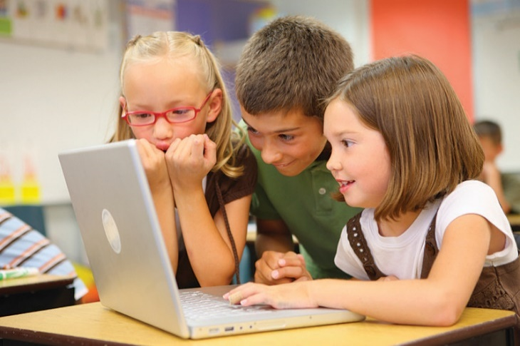
Figure 12.3 – Interactions with the media children’s perception of themselves.

Remarkably, young children begin developing social understanding very early in life and are also able to include other peoples’ appraisals of them into their self-concept, including parents, teachers, peers, culture, and media. Internalizing others’ appraisals and creating social comparison affect children’s self-esteem, which is defined as an evaluation of one’s identity. Children can have individual assessments of how well they perform a variety of activities and also develop an overall, global self-assessment. If there is a discrepancy between how children view themselves and what they consider to be their ideal selves, their self-esteem can be negatively affected.

Self-concept refers to beliefs about general personal identity (Seiffert, 2011). These beliefs include personal attributes, such as one’s age, physical characteristics, behaviors, and competencies. Children in middle and late childhood have a more realistic sense of self than do those in early childhood, and they better understand their strengths and weaknesses. This can be attributed to greater experience in comparing their own performance with that of others, and to greater cognitive flexibility. Children in middle and late childhood are also able to include other peoples’ appraisals of them into their self-concept, including parents, teachers, peers, culture, and media.

Another important development in self-understanding is self-efficacy, which is the belief that you are capable of carrying out a specific task or of reaching a specific goal (Bandura, 1977, 1986, 1997). Large discrepancies between self-efficacy and ability can create motivational problems for the individual (Seifert, 2011). If a student believes that he or she can solve mathematical problems, then the student is more likely to attempt the mathematics homework that the teacher assigns.

Unfortunately, the converse is also true. If a student believes that he or she is incapable of math, then the student is less likely to attempt the math homework regardless of the student's actual ability in math. Since self-efficacy is self-constructed, it is possible for students to miscalculate or misperceive their true skill, and these misperceptions can have complex effects on students' motivations. It is possible to have either too much or too little self-efficacy, and according to Bandura (1997) the optimal level seems to be either at, or slightly above, true ability.

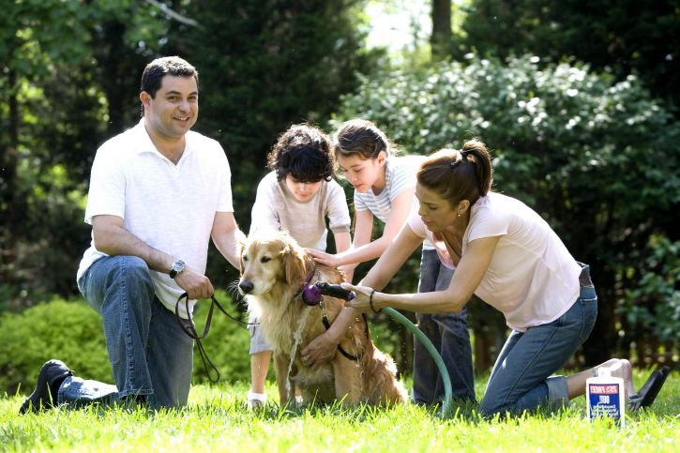
Figure 12.4 – Families can support children’s social and emotional skills.

As we have seen, children’s experience of relationships at home and the peer group contributes to an expanding repertoire of social and emotional skills and also to broadened social understanding. In these relationships, children develop expectations for specific people (leading, for example, to secure or insecure attachments to parents), understanding of how to interact with adults and peers, and self-concept based on how others respond to them. These relationships are also significant forums for emotional development.

Motivation as Self-Efficacy
In addition to being influenced by their goals, interests, and attributions, students’ motives are affected by specific beliefs about the student’s personal capacities. In self-efficacy theory the beliefs become a primary, explicit explanation for motivation (Bandura, 1977, 1986, 1997). Self-efficacy is the belief that you are capable of carrying out a specific task or of reaching a specific goal. As mentioned previously, the optimal level seems to be either at or slightly above true capacity (Bandura, 1997). As we indicate below, large discrepancies between self-efficacy and ability can create motivational problems for the individual.

Motivation
Motivation refers to a desire, need, or drive that contributes to and explains behavioral changes. In general, motivators provide some sort of incentive for completing a task. One definition of a motivator explains it as a force “acting either on or within a person to initiate behavior.” In addition to biological motives, motivations can be either intrinsic (arising from internal factors) or extrinsic (arising from external factors).

Extrinsic vs. Intrinsic Motivation
Intrinsically motivated behaviors are performed because of the sense of personal satisfaction that they bring. According to Deci (1971), these behaviors are defined as ones for which the reward is the satisfaction of performing the activity itself. Intrinsic motivation thus represents engagement in an activity for its own sake. For example, if comforting a friend makes a child feel good, they are intrinsically motivated to respond to their friend’s distress.

Extrinsically motivated behaviors, on the other hand, are performed in order to receive something from others or avoid certain negative outcomes. The extrinsic motivator is outside of, and acts on, the individual. Rewards—such as a sticker, or candy—are good examples of extrinsic motivators. Social and emotional incentives like praise and attention are also extrinsic motivators since they are bestowed on the individual by another person.

Figure 12.5 – A lollipop can be an extrinsic motivator.

Learned Helplessness and Self-Efficacy
If a person’s sense of self-efficacy is very low, he or she can develop learned helplessness, a perception of complete lack of control in mastering a task. The attitude is similar to depression, a pervasive feeling of apathy and a belief that effort makes no difference and does not lead to success. Learned helplessness was originally studied from the behaviorist perspective of classical and operant conditioning by the psychologist Martin Seligman (1995). In people, learned helplessness leads to characteristic ways of dealing with problems. They tend to attribute the source of a problem to themselves, to generalize the problem to many aspects of life, and to see the problem as lasting or permanent. More optimistic individuals, in contrast, are more likely to attribute a problem to outside sources, to see it as specific to a particular situation or activity, and to see it as temporary or time-limited. Consider, for example, two students who each fail a test. The one with a lot of learned helplessness is more likely to explain the failure by saying something like: “I’m stupid; I never perform well on any schoolwork, and I never will perform well at it.” The other, more optimistic student is more likely to say something like: “The teacher made the test too hard this time, so the test doesn’t prove anything about how I will do next time or in other subjects.”

Figure 12.6 – If this girl thinks that studying won’t help her do well on the
test, her low self-efficacy may develop into learned helplessness.

What is noteworthy about these differences in perception is how much the more optimistic of these perspectives resembles high self-efficacy and how much learned helplessness seems to contradict or differ from it. As already noted, high self-efficacy is a strong belief in one’s capacity to carry out a specific task successfully. By definition, therefore, self-efficacy focuses attention on a temporary or time-limited activity (the task), even though the cause of successful completion (oneself) is “internal.”

Gender Identity
The development of gender and gender identity is likewise an interaction among social, biological, and representational influences (Ruble, Martin, & Berenbaum, 2006). Young children learn about gender from parents, peers, and others in society, and develop their own conceptions of the attributes associated with maleness or femaleness (called gender schemas). They also negotiate biological transitions (such as puberty) that cause their sense of themselves and their sexual identity to mature.

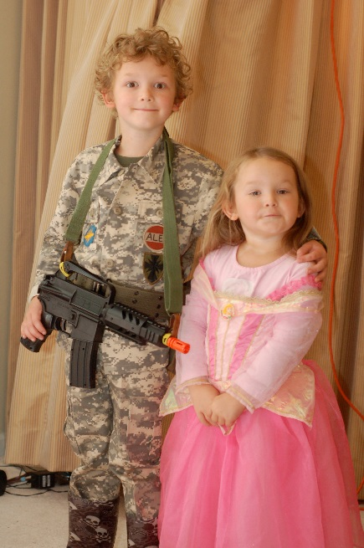
Figure 12.7 - Social influences such as cultural norms impact children's interests, dress, style of speech and even life aspirations.

Each of these examples of the growth of social and emotional competence illustrates not only the interaction of social, biological, and representational influences, but also how their development unfolds over an extended period. Early influences are important, but not determinative, because the capabilities required for mature moral conduct, gender identity, and other outcomes continue to develop throughout childhood, adolescence, and even the adult years.

As the preceding sentence suggests, social and personality development continues through adolescence and the adult years, and it is influenced by the same constellation of social, biological, and representational influences discussed for childhood. Changing social relationships and roles, biological maturation and (much later) decline, and how the individual represents both experience and the self continue to form the bases for development throughout life. In this respect, when an adult looks forward rather than retrospectively to ask, “What kind of person am I becoming?”—A similarly fascinating, complex, multifaceted interaction of developmental processes lies ahead.

Child and the Family
The reason we turn out much like our parents, for better or worse, is that our families are such an important part of our socialization process. When we are born, our primary caregivers are almost always one or both of our parents. For several years we have more contact with them than with any other adults. Because this contact occurs in our most formative years, our parents’ interaction with us and the messages they teach us can have a profound impact throughout our lives. During middle childhood, children spend less time with parents and more time with peers. Parents may have to modify their approach to parenting to accommodate the child’s growing independence. Using reason and engaging in joint decision-making whenever possible may be the most effective approach (Berk, 2007).

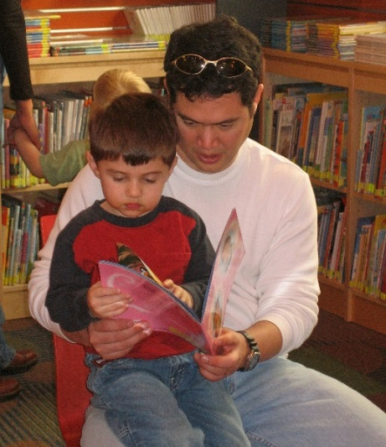
Figure 12.8 - When children grow up to love reading, may have been influenced by the positive experiences of being read to in their families. .

Family Atmosphere
One of the ways to assess the quality of family life is to consider the tasks of families. Berger (2005) lists five family functions:
- Providing food, clothing and shelter
- Encouraging learning
- Developing self-esteem
- Nurturing friendships with peers
- Providing harmony and stability

Notice that in addition to providing food, shelter, and clothing, families are responsible for helping the child learn, relate to others, and have a confident sense of self. The family provides a harmonious and stable environment for living. A good home environment is one in which the child’s physical, cognitive, emotional, and social needs are adequately met. Sometimes families emphasize physical needs but ignore cognitive or emotional needs. Other times, families pay close attention to physical needs and academic requirement, but may fail to nurture the child’s friendships with peers or guide the child toward developing healthy relationships. Parents might want to consider how it feels to live in the household. Is it stressful and conflict-ridden? Is it a place where family members enjoy being?

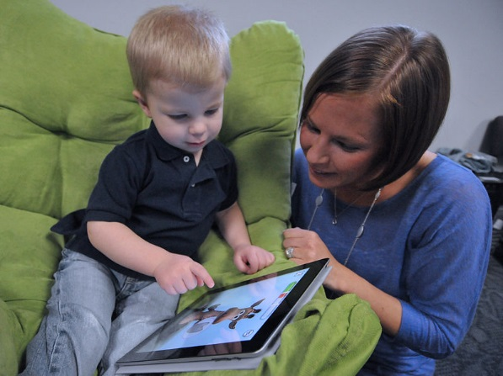
Figure 12.8 – This mother is helping her son navigate using a tablet.

The Family Stress Model
Family relationships are significantly affected by conditions outside the home. For instance, the Family Stress Model describes how financial difficulties are associated with parents’ depressed moods, which in turn lead to marital problems and poor parenting that contributes to poorer child adjustment (Conger, Conger, & Martin, 2010). Within the home, parental marital difficulty or divorce affects more than half the children growing up today in the United States. Divorce is typically associated with economic stresses for children and parents, the renegotiation of parent-child relationships (with one parent typically as primary custodian and the other assuming a visiting relationship), and many other significant adjustments for children. Divorce is often regarded by children as a sad turning point in their lives, although for most it is not associated with long-term problems of adjustment (Emery, 1999).

Family Forms
As discussed previously in chapter 9, the sociology of the family examines the family as an institution and a unit of socialization. Sociological studies of the family look at demographic characteristics of the family members: family size, age, ethnicity and gender of its members, social class of the family, the economic level and mobility of the family, professions of its members, and the education levels of the family members.

Currently, one of the biggest issues that sociologists study are the changing roles of family members. Often, each member is restricted by the gender roles of the traditional family. These roles, such as the father as the breadwinner and the mother as the homemaker, are declining. Now, the mother is often the supplementary provider while retaining the responsibilities of child rearing. In this scenario, females' role in the labor force is "compatible with the demands of the traditional family.” Sociology studies have examined the adaptation of males' role to caregiver as well as provider. The gender roles are becoming increasingly interwoven and various other family forms are becoming more common.

What Families Look Like
Figure 12.9 – a childless family | Figure 12.10 – a single parent (father) family
Figure 12.11 – an extended family |  |  | Figure 12.12 – a same-sex family
Figure 12.13 – a single parent (mother) family |  | 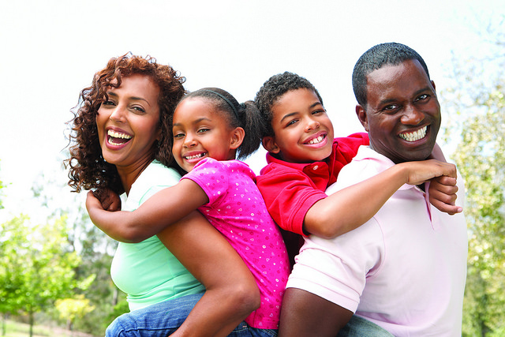  Figure 12.14 – a two-parent (nuclear) family
Throughout this textbook and in the preceding images, you can see a variety of types of families. A few of these family types (the ones that are not bolded) were introduced in Chapter 9. Here is a list of some of the diverse types of families:

Families Without Children
Singlehood family contains a person who is not married or in a common law relationship. He or she may share a relationship with a partner but lead a single lifestyle.

Couples that are childless are often overlooked in the discussion of families.

Families with One Parent
A single parent family usually refers to a parent who has most of the day-to-day responsibilities in the raising of the child or children, who are not living with a spouse or partner, or who is not married. The dominant caregiver is the parent with whom the children reside for the majority of the time; if the parents are separated or divorced, children live with their custodial parent and have visitation with their noncustodial parent. In western society in general, following a separation a child will end up with the primary caregiver, usually the mother, and a secondary caregiver, usually the father.

Single parent by choice families refer to a family that a single person builds by choice. These families can be built with the use of assisted reproductive technology and donor gametes (sperm and/or egg) or embryos, surrogacy, foster or kinship care, and adoption.

Two Parent Families
The nuclear family is often referred to as the traditional family structure. It includes two married parents and children. While common in industrialized cultures (such as the U.S.), it is not actually the most common type of family worldwide.

Cohabitation is an arrangement where two people who are not married live together in an intimate relationship, particularly an emotionally and/or sexually intimate one, on a long-term or permanent basis. Today, cohabitation is a common pattern among people in the Western world. More than two-thirds of married couples in the U.S. say that they lived together before getting married.

Gay and lesbian couples with children have same-sex families. While now recognized legally in the United States, discrimination against same-sex families is not uncommon. According to the American Academy of Pediatrics, there is “ample evidence to show that children raised by same-gender parents fare as well as those raised by heterosexual parents. More than 25 years of research have documented that there is no relationship between parents' sexual orientation and any measure of a child's emotional, psychosocial, and behavioral adjustment. Conscientious and nurturing adults, whether they are men or women, heterosexual or homosexual, can be excellent parents. The rights, benefits, and protections of civil marriage can further strengthen these families.”

Blended families describe families with mixed parents: one or both parents remarried, bringing children of the former family into the new family. Blended families are complex in a number of ways that can pose unique challenges to those who seek to form successful stepfamily relationships (Visher & Visher, 1985). These families are also referred to as stepfamilies.

Families That Include Additional Adults
Extended families include three generations, grandparents, parents, and children. This is the most common type of family worldwide.

Families by choice are relatively newly recognized. Popularized by the LGBTQ community to describe a family not recognized by the legal system. It may include adopted children, live-in partners, kin of each member of the household, and close friends. Increasingly family by choice is being practiced by those who see benefit to including people beyond blood relatives in their families.

While most families in the U.S. are monogamous, some families have more than two married parents. These families are polygamous. Polygamy is illegal in all 50 states, but it is legal in other parts of the world.

Additional Forms of Families
Kinship families are those in which the full-time care, nurturing, and protection of a child is provided by relatives, members of their Tribe or clan, godparents, stepparents, or other adults who have a family relationship to a child. When children cannot be cared for by their parents, research finds benefits to kinship care.

When a person assumes the parenting of another, usually a child, from that person's biological or legal parent or parents this creates adoptive families. Legal adoption permanently transfers all rights and responsibilities and is intended to affect a permanent change in status and as such requires societal recognition, either through legal or religious sanction. As introduced in Chapter 3, adoption can be done privately, through an agency, or through foster care and in the U.S. or from abroad. Adoptions can be closed (no contact with birth/biological families or open, with different degrees of contact with birth/biological families). Couples, both opposite and same-sex, and single parents can adopt (although not all agencies and foreign countries will work with unmarried, single, or same-sex intended parents).

When parents are not of the same ethnicity, they build interracial families. Until the decision in Loving v Virginia in 1969, this was not legal in the U.S. There are other parts of the world where marrying someone outside of your race (or social class) has legal and social ramifications. These families may experience issues unique to each individual family’s culture.

Changes in Families - Divorce
The tasks of families listed above are functions that can be fulfilled in a variety of family types—not just intact, two-parent households. Harmony and stability can be achieved in many family forms and when it is disrupted, either through divorce, or efforts to blend families, or any other circumstances, the child suffers (Hetherington & Kelly, 2002). Changes continue to happen, but for children they are especially vulnerable. Divorce and how it impacts children depends on how the caregivers handle the divorce as well as how they support the emotional needs of the child.

Figure 12.15 – How divorce impacts children largely depends on how parents handle it.

Divorce
A lot of attention has been given to the impact of divorce on the life of children. The assumption has been that divorce has a strong, negative impact on the child and that single-parent families are deficient in some way. However, 75-80 percent of children and adults who experience divorce suffer no long-term effects (Hetherington & Kelly, 2002). An objective view of divorce, repartnering, and remarriage indicates that divorce, remarriage and life in stepfamilies can have a variety of effects.

Factors Affecting the Impact of Divorce
As you look at the consequences (both pro and con) of divorce and remarriage on children, keep these family functions in mind. Some negative consequences are a result of financial hardship rather than divorce per se (Drexler, 2005). Some positive consequences reflect improvements in meeting these functions. For instance, we have learned that a positive self-esteem comes in part from a belief in the self and one’s abilities rather than merely being complimented by others. In single-parent homes, children may be given more opportunity to discover their own abilities and gain independence that fosters self-esteem. If divorce leads to fighting between the parents and the child is included in these arguments, their self-esteem may suffer.

The impact of divorce on children depends on a number of factors. The degree of conflict prior to the divorce plays a role. If the divorce means a reduction in tensions, the child may feel relief. If the parents have kept their conflicts hidden, the announcement of a divorce can come as a shock and be met with enormous resentment. Another factor that has a great impact on the child concerns financial hardships they may suffer, especially if financial support is inadequate. Another difficult situation for children of divorce is the position they are put into if the parents continue to argue and fight—especially if they bring the children into those arguments.

Short-term consequences: In roughly the first year following divorce, children may exhibit some of these short-term effects:
- Grief over losses suffered. The child will grieve the loss of the parent they no longer see as frequently. The child may also grieve about other family members that are no longer available. Grief sometimes comes in the form of sadness but it can also be experienced as anger or withdrawal. Older children may feel depressed.
- Reduced Standard of Living. Very often, divorce means a change in the amount of money coming into the household. Children experience new constraints on spending or entertainment. School-aged children, especially, may notice that they can no longer have toys, clothing or other items to which they’ve grown accustomed. Or it may mean that there is less eating out or being able to afford cable television, and so on. The custodial parent may experience stress at not being able to rely on child support payments or having the same level of income as before. This can affect decisions regarding healthcare, vacations, rents, mortgages and other expenditures. And the stress can result in less happiness and relaxation in the home. The parent who has to take on more work may also be less available to the children.
- Adjusting to Transitions. Children may also have to adjust to other changes accompanying a divorce. The divorce might mean moving to a new home and changing schools or friends. It might mean leaving a neighborhood that has meant a lot to them as well.

Long-Term consequences: Here are some effects that go beyond just the first year following divorce.
- Economic/Occupational Status. One of the most commonly cited long-term effects of divorce is that children of divorce may have lower levels of education or occupational status. This may be a consequence of lower income and resources for funding education rather than to divorce per se. In those households where economic hardship does not occur, there may be no impact on economic status (Drexler, 2005).
- Improved Relationships with the Custodial Parent (usually the mother): Most children of divorce lead happy, well-adjusted lives and develop stronger, positive relationships with their custodial parent (Seccombe and Warner, 2004). Others have also found that relationships between mothers and children become closer and stronger (Guttman, 1993) and suggest that greater equality and less rigid parenting is beneficial after divorce (Steward, Copeland, Chester, Malley, and Barenbaum, 1997).
- Greater emotional independence in sons. Drexler (2005) notes that sons who are raised by mothers only develop an emotional sensitivity to others that is beneficial in relationships.
- Feeling more anxious in their own love relationships. Children of divorce may feel more anxious about their own relationships as adults. This may reflect a fear of divorce if things go wrong, or it may be a result of setting higher expectations for their own relationships.
- Adjustment of the custodial parent. Furstenberg and Cherlin (1991) believe that the primary factor influencing the way that children adjust to divorce is the way the custodial parent adjusts to the divorce. If that parent is adjusting well, the children will benefit. This may explain a good deal of the variation we find in children of divorce.

Figure 12.16 - Jeanette Wilinski is the mother of Elizabeth, Logan and Alexis. As a single mom, she has to find a balance between taking care of the Air Force mission and taking care of her children.

Families are the most important part of the 6 to 11-year-old life. However, peers and friendships become more and more important to the child in middle childhood.

Friendships, Peers, and Peer groups
Parent-child relationships are not the only significant relationships in a child’s life. Friendships take on new importance as judges of one’s worth, competence, and attractiveness. Friendships provide the opportunity for learning social skills such as how to communicate with others and how to negotiate differences. Children get ideas from one another about how to perform certain tasks, how to gain popularity, what to wear, say, and listen to, and how to act. This society of children marks a transition from a life focused on the family to a life concerned with peers. Peers play a key role in a child’s self-esteem at this age as any parent who has tried to console a rejected child will tell you. No matter how complimentary and encouraging the parent may be, being rejected by friends can only be remedied by renewed acceptance.

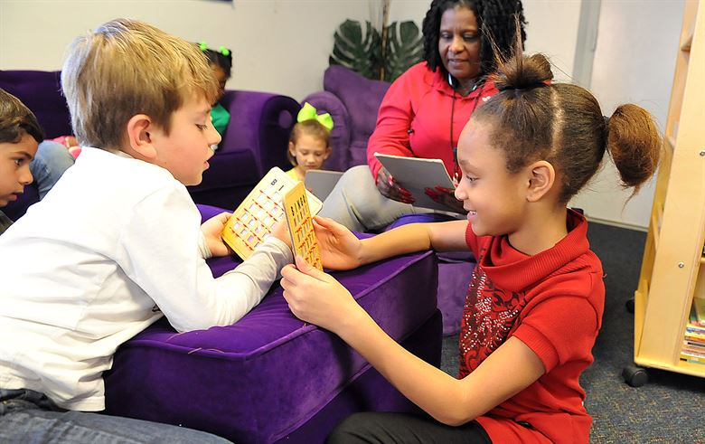
Figure 12.17 – Peers influence a child’s self-esteem.

Children’s conceptualization of what makes someone a “friend” changes from a more egocentric understanding to one based on mutual trust and commitment. Both Bigelow (1977) and Selman (1980) believe that these changes are linked to advances in cognitive development. Bigelow and La Gaipa (1975) outline three stages to children’s conceptualization of friendship.

Table 12.2 - Three Stages to Children’s Conceptualization of Friendship

Stage | Descriptions
Stage One | In stage one, reward-cost, friendship focuses on mutual activities. Children in early, middle, and late childhood all emphasize similar interests as the main characteristics of a good friend.
Stage Two | In stage two, normative expectation, focuses on conventional morality; that is, the emphasis is on a friend as someone who is kind and shares with you. Clark and Bittle (1992) found that fifth graders emphasized this in a friend more than third or eighth graders.
Stage Three | In stage three, empathy and understanding, friends are people who are loyal, committed to the relationship, and share intimate information. Clark and Bittle (1992) reported eighth graders emphasized this more in a friend. They also found that as early as fifth grade, girls were starting to include the sharing of secrets and not betraying confidences as crucial to someone who is a friend.

Friendships are very important for children. The social interaction with another child who is similar in age, skills, and knowledge provokes the development of many social skills that are valuable for the rest of life (Bukowski, Buhrmester, & Underwood, 2011). In these relationships, children learn how to initiate and maintain social interactions with other children. They learn skills for managing conflict, such as turn-taking, compromise, and bargaining. Play also involves the mutual, sometimes complex, coordination of goals, actions, and understanding. Through these experiences, children develop friendships that provide additional sources of security and support to those provided by their parents.

Five Stages of Friendship from Early Childhood through Adulthood
Selman (1980) outlines five stages of friendship from early childhood through to adulthood.
- In stage 0, momentary physical interaction, a friend is someone who you are playing with at this point in time. Selman notes that this is typical of children between the ages of three and six. These early friendships are based more on circumstances (e.g., a neighbor) than on genuine similarities.
- In stage 1, one-way assistance, a friend is someone who does nice things for you, such as saving you a seat on the school bus or sharing a toy. However, children in this stage, do not always think about what they are contributing to the relationships. Nonetheless, having a friend is important and children will sometimes put up with a not so nice friend, just to have a friend. Children as young as five and as old as nine may be in this stage.
- In stage 2, fair-weather cooperation, children are very concerned with fairness and reciprocity, and thus, a friend is someone who returns a favor. In this stage, if a child does something nice for a friend there is an expectation that the friend will do something nice for them at the first available opportunity. When this fails to happen, a child may break off the friendship. Selman found that some children as young as seven and as old as twelve are in this stage.
- In stage 3, intimate and mutual sharing, typically between the ages of eight and fifteen, a friend is someone who you can tell them things you would tell no one else. Children and teens in this stage no longer “keep score,” and do things for a friend because they genuinely care for the person. If a friendship dissolves in this stage it is usually due to a violation of trust. However, children in this stage do expect their friend to share similar interests and viewpoints and may take it as a betrayal if a friend likes someone that they do not.
- In stage 4, autonomous interdependence, a friend is someone who accepts you and that you accept as they are. In this stage children, teens, and adults accept and even appreciate differences between themselves and their friends. They are also not as possessive, so they are less likely to feel threatened if their friends have other relationships or interests. Children are typically twelve or older in this stage.

Peer Groups
However, peer relationships can be challenging as well as supportive (Rubin, Coplan, Chen, Bowker, & McDonald, 2011). Being accepted by other children is an important source of affirmation and self-esteem, but peer rejection can foreshadow later behavior problems (especially when children are rejected due to aggressive behavior). With increasing age, children confront the challenges of bullying, peer victimization, and managing conformity pressures. Social comparison with peers is an important means by which children evaluate their skills, knowledge, and personal qualities, but it may cause them to feel that they do not measure up well against others. For example, a boy who is not athletic may feel unworthy of his football-playing peers and revert to shy behavior, isolating himself and avoiding conversation. Conversely, an athlete who doesn’t “get” Shakespeare may feel embarrassed and avoid reading altogether.

Figure 12.18 - Social comparison with peers is an important means by which children evaluate their value.

Also, with the approach of adolescence, peer relationships become focused on psychological intimacy, involving personal disclosure, vulnerability, and loyalty (or its betrayal)—which significantly affect a child’s outlook on the world. Each of these aspects of peer relationships require developing very different social and emotional skills than those that emerge in parent-child relationships. They also illustrate the many ways that peer relationships influence the growth of personality and self-concept.

Peer Relationships
Most children want to be liked and accepted by their friends. Some popular children are nice and have good social skills. These popular-prosocial children tend to do well in school and are cooperative and friendly. Popular-antisocial children may gain popularity by acting tough or spreading rumors about others (Cillessen & Mayeux, 2004). Rejected children are sometimes excluded because they are shy and withdrawn. The withdrawn-rejected children are easy targets for bullies because they are unlikely to retaliate when belittled (Boulton, 1999). Other rejected children are ostracized because they are aggressive, loud, and confrontational. The aggressive-rejected children may be acting out of a feeling of insecurity. Unfortunately, their fear of rejection only leads to behavior that brings further rejection from other children. Children who are not accepted are more likely to experience conflict, lack confidence, and have trouble adjusting.

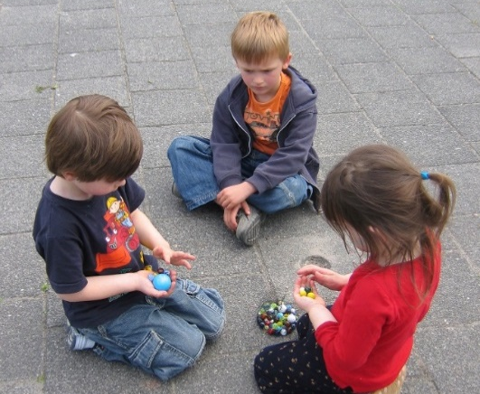
Figure 12.19 - Peer relationships are particularly important for children. They can be supportive but also challenging. Peer rejection may lead to behavioral problems later in life.

Peer Relationships are studied using sociometric assessment (which measures attraction between members of a group). Children are asked to mention the three children they like to play with the most, and those they do not like to play with. The number of times a child is nominated for each of the two categories (like and do not like) is tabulated. Based on those tabulations, children are categorized into the following:

Table 12.3 - Categories in Peer Relationships

Category | Description
Popular Children | Receive many votes in the “like” category, and very few in the “do not like” category.
Rejected children | Receive more unfavorable votes, and few favorable ones.
Controversial children | Mentioned frequently in each category, with several children liking them and several children placing them in the do not like category.
Neglected children | Rarely mentioned in either category.
Average children | Have a few positive votes with very few negative ones.
Popular-prosocial children | Are nice and have good social skills; tend to do well in school and are cooperative and friendly.
Popular-antisocial children | May gain popularity by acting tough or spreading rumors about others.
Rejected-withdrawn children | Are shy and withdrawn and are easy targets for bullies because they are unlikely to retaliate when belittled.
Rejected-aggressive children | Are ostracized because they are aggressive, loud, and confrontational. They may be acting out of a feeling of insecurity.

Unfortunately for rejected children, their fear of rejection only leads to behavior that brings further rejection from other children. Children who are not accepted are more likely to experience conflict, lack confidence, and have trouble adjusting. (Klima & Repetti, 2008; Schwartz, Lansford, Dodge, Pettit, & Bates, 2014).

Aggression, Antisocial Behavior, Bullies, & Victims

Aggression and Antisocial Behavior
Aggression may be physical or verbal/emotional. Aggression is activated in large part by the amygdala and regulated by the prefrontal cortex.

Figure 12.20 – This boy is threatening physical aggression.
Testosterone is associated with increased aggression in both males and females. Aggression is also caused by negative experiences and emotions, including frustration, pain, and heat. As predicted by principles of observational learning, research evidence makes it very clear that, on average, people who watch violent behavior become more aggressive. Early, antisocial behavior leads to befriending others who also engage in antisocial behavior, which only perpetuates the downward cycle of aggression and wrongful acts.

Bullying and Victims
According to Stopbullying.gov (2016), a federal government website managed by the U.S. Department of Health & Human Services, bullying is defined as unwanted, aggressive behavior among school aged children that involves a real or perceived power imbalance. Further, the aggressive behavior happens more than once or has the potential to be repeated. There are different types of bullying, including verbal bullying, which is saying or writing mean things, teasing, name-calling, taunting, threatening, or making inappropriate sexual comments. Social bullying, also referred to as relational bullying, involves spreading rumors, purposefully excluding someone from a group, or embarrassing someone on purpose. Physical bullying involves hurting a person’s body or possessions.

A more recent form of bullying is cyberbullying, which involves electronic technology. Examples of cyberbullying include sending mean text messages or emails, creating fake profiles, and posting embarrassing pictures, videos or rumors on social networking sites. Children who experience cyberbullying have a harder time getting away from the behavior because it can occur any time of day and without being in the presence of others (Stopbullying.gov, 2016).

Figure 12.21 – Cyberbullying can be devastating for children.

Those at Risk for Bullying
Bullying can happen to anyone but some students are at an increased risk for being bullied, including lesbian, gay, bisexual, transgendered (LGBT) youth, those with disabilities, and those who are socially isolated. Additionally, those who are perceived as different, weak, less popular, overweight, or having low self-esteem, have a higher likelihood of being bullied.

Those Who are More Likely to Bully
Bullies are often thought of as having low self-esteem, and then bully others to feel better about themselves. Although this can occur, many bullies in fact have high levels of self-esteem. They possess considerable popularity and social power and have well-connected peer relationships. They do not lack self-esteem, and instead lack empathy for others. They like to dominate or be in charge of others.

Bullied Children
Unfortunately, most children do not let adults know that they are being bullied. Some fear retaliation from the bully, while others are too embarrassed to ask for help. Those who are socially isolated may not know who to ask for help or believe that no one would care or assist them if they did ask for assistance. Consequently, it is important for parents and teachers to know the warning signs that may indicate a child is being bullied. These include: unexplainable injuries, lost or destroyed possessions, changes in eating or sleeping patterns, declining school grades, not wanting to go to school, loss of friends, decreased self-esteem and/or self-destructive behaviors.

Conclusion
In this chapter we looked at:
- Erikson’s fourth stage of industry vs. inferiority
- Kohlberg’s stages of moral development
- How school-age children continue to develop their self-understanding
- The role of the family and different forms of families
- Divorce and how it changes the family
- The importance of peers and friendships
- Children in peer groups and types of friendships
- Consequences of peer acceptance or rejection

In the next chapter we will be moving on to our last period of development and examining physical development in adolescence.

Chapter 13: Adolescence – Physical Development

Chapter Objectives
After this chapter, you should be able to:
- Explain the changes in physical growth and brain growth
- Compare and contrast different male and female changes that occur during puberty
- Discuss teenage pregnancy, birth control, and sexual health
- Summarize adolescent health: sleep, diet, and exercise
- Discuss drug and substance abuse
- Explain the prevalence, risk factors, and consequences of adolescent pregnancy and sexual health
- Describe several mental health issues for teens

Introduction
Adolescence is often defined as the period that begins with puberty and ends with the transition to adulthood. The commonly accepted beginning age for this period of development is age 12. When adolescence ends is harder to pin down. When does adulthood truly begin? Are we an adult at 18 years of age? Or 20? Or even older?

Adolescence physical development has evolved historically, with evidence indicating that this stage is lengthening as individuals start puberty earlier and transition to adulthood later than in the past. Puberty today begins, on average, at age 10–11 years for girls and 11–12 years for boys. This average age of onset has decreased gradually over time since the 19th century by 3–4 months per decade, which has been attributed to a range of factors including better nutrition, obesity, increased father absence, and other environmental factors (Steinberg, 2013). Completion of formal education, financial independence from parents, marriage, and parenthood have all been markers of the end of adolescence and beginning of adulthood, and all of these transitions happen, on average, later now than in the past.

Physical Growth
The adolescent growth spurt is a rapid increase in an individual’s height and weight during puberty resulting from the simultaneous release of growth hormones, thyroid hormones, and androgens. Males experience their growth spurt about two years later than females. The accelerated growth in various body parts happens at different times, but for all adolescents it has a fairly regular sequence. The first places to grow are the extremities (head, hands, and feet), followed by the arms and legs, and later the torso and shoulders. This non-uniform growth is one reason why an adolescent body may seem out of proportion. During puberty, bones become harder and more brittle.

Before puberty, there are nearly no differences between males and females in the distribution of fat and muscle. During puberty, males grow muscle much faster than females, and females experience a higher increase in body fat. An adolescent’s heart and lungs increase in both size and capacity during puberty; these changes contribute to increased strength and tolerance for exercise.

Figure 13.1 – An adolescent boy | Figure 13.2 – An adolescent girl

Brain Growth
Brain Growth continues into the early 20s. The development of the frontal lobe, in particular, is important during this stage. Adolescents often engage in increased risk-taking behaviors and experience heightened emotions during puberty; this may be due to the fact that the frontal lobes of their brains—which are responsible for judgment, impulse control, and planning—are still maturing until early adulthood (Casey, Tottenham, Liston, & Durston, 2005)

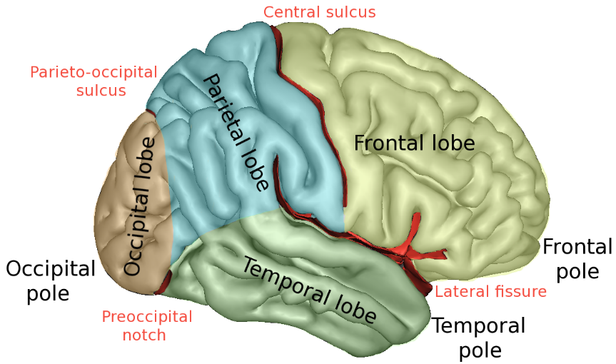
Figure 13.3 – The brain continues developing into early adulthood.
The brain undergoes dramatic changes during adolescence. Although it does not get larger, it matures by becoming more interconnected and specialized (Giedd, 2015). The myelination and development of connections between neurons continues. This results in an increase in the white matter of the brain, and allows the adolescent to make significant improvements in their thinking and processing skills. Different brain areas become myelinated at different times. For example, the brain’s language areas undergo myelination during the first 13 years. Completed insulation of the axons consolidates these language skills but makes it more difficult to learn a second language. With greater myelination, however, comes diminished plasticity as a myelin coating inhibits the growth of new connections (Dobbs, 2012).

Even as the connections between neurons are strengthened, synaptic pruning occurs more than during childhood as the brain adapts to changes in the environment. This synaptic pruning causes the gray matter of the brain, or the cortex, to become thinner but more efficient (Dobbs, 2012). The corpus callosum, which connects the two hemispheres, continues to thicken, allowing for stronger connections between brain areas. Additionally, the hippocampus becomes more strongly connected to the frontal lobes, allowing for greater integration of memory and experiences into our decision-making.

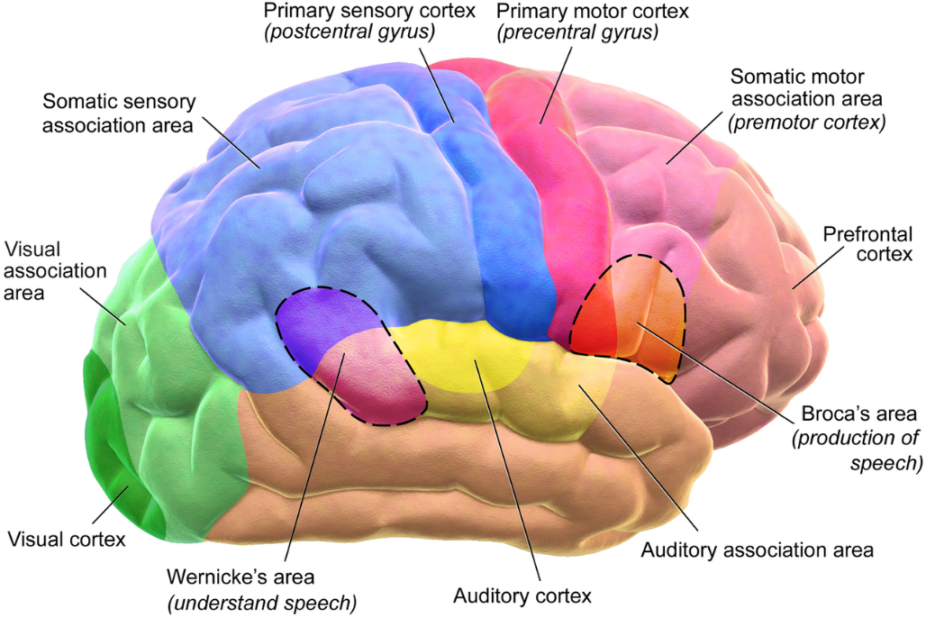
Figure 13.4 – During adolescence the brain becomes more interconnected and specialized.

The limbic system, which regulates emotion and reward, is linked to the hormonal changes that occur at puberty. The limbic system is also related to novelty seeking and a shift toward interacting with peers. In contrast, the prefrontal cortex, which is involved in the control of impulses, organization, planning, and making good decisions, does not fully develop until the mid-20s. According to Giedd (2015) the significant aspect of the later developing prefrontal cortex and early development of the limbic system is the “mismatch” in timing between the two. The approximately ten years that separates the development of these two brain areas can result in risky behavior, poor decision-making, and weak emotional control for the adolescent. When puberty begins earlier, this mismatch extends even further.

Teens often take more risks than adults and, according to research, it is because they weigh risks and rewards differently than adults do (Dobbs, 2012). For adolescents, the brain’s sensitivity to the neurotransmitter dopamine peaks, and dopamine is involved in reward circuits so the possible rewards outweigh the risks. Adolescents respond especially strongly to social rewards during activities, and they prefer the company of others their same age. In addition to dopamine, the adolescent brain is affected by oxytocin, which facilitates bonding and makes social connections more rewarding. With both dopamine and oxytocin engaged, it is no wonder that adolescents seek peers and excitement in their lives that could end up actually harming them.

Because of all the changes that occur in the adolescent brain, the chances for abnormal development can occur, including mental illness. In fact, 50% of mental illness occurs by the age 14 and 75% occurs by age 24 (Giedd, 2015). Additionally, during this period of development the adolescent brain is especially vulnerable to damage from drug exposure. For example, repeated exposure to marijuana can affect cellular activity in the endocannabinoid system. Consequently, adolescents are more sensitive to the effects of repeated marijuana exposure (Weir, 2015).

However, researchers have also focused on the highly adaptive qualities of the adolescent brain, which allow the adolescent to move away from the family towards the outside world (Dobbs, 2012; Giedd, 2015). Novelty seeking and risk taking can generate positive outcomes including meeting new people and seeking out new situations. Separating from the family and moving into new relationships and different experiences are actually quite adaptive for society.

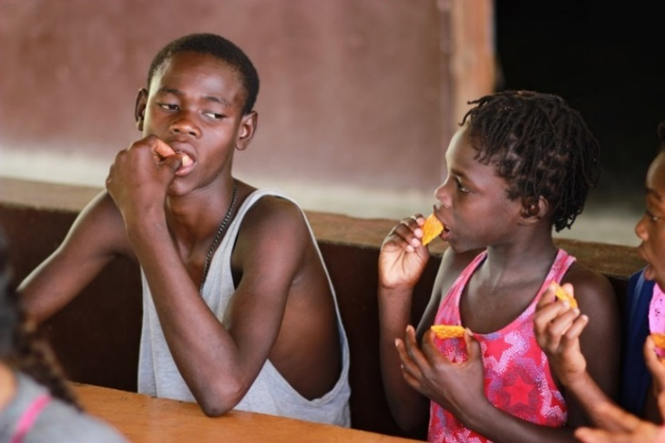
Figure 13.5 - Adolescents prefer the company of others their same age.
The physical growth and the changes of puberty mark the onset of adolescence (Lerner & Steinberg, 2009). For both boys and girls, these changes include a growth spurt in height, growth of pubic and underarm hair, and skin changes (e.g., pimples). Hormones drive these pubescent changes, particularly the increase in testosterone for boys and estrogen for girls.

Physical Changes in Adolescence
Adolescence begins with the onset of puberty, a developmental period in which hormonal changes cause rapid physical alterations in the body, culminating in sexual maturity. Although the timing varies to some degree across cultures, the average age range for reaching puberty is between 9 and 14 years for girls and between 10 and 17 years for boys (Marshall & Tanner, 1986). This period of physical development of the adolescent age 9-13 is divided into two phases.

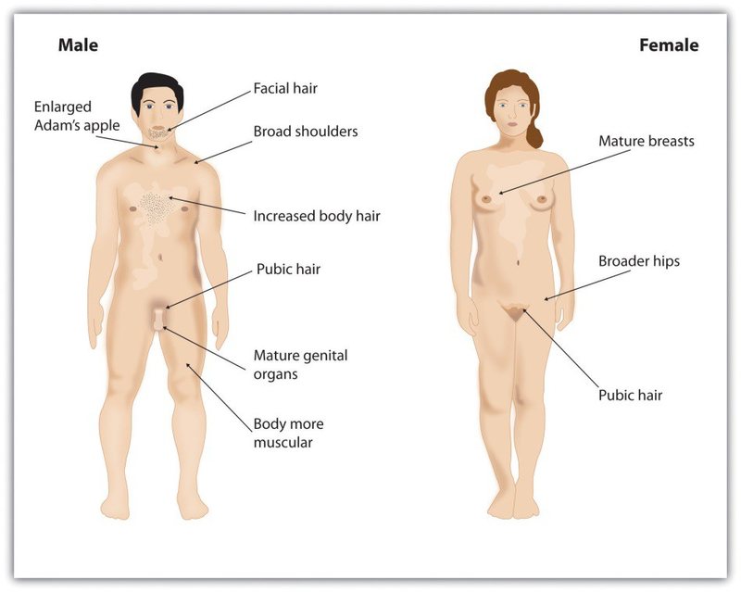
Figure 13.6 - Puberty brings dramatic changes in the body, including the development of primary and secondary sex characteristics.

The first phase of puberty begins when the pituitary gland begins to stimulate the production of the male sex hormone testosterone in boys and the female sex hormones estrogen and progesterone in girls. The release of these sex hormones triggers the development of the primary sex characteristics, the sex organs concerned with reproduction. It also involves height increases from 20 to 25 percent. Puberty is second to the prenatal period in terms of rapid growth as the long bones stretch to their final, adult size. Girls grow 2–8 inches (5–20 centimeters) taller, while boys grow 4–12 inches (10–30 centimeters) taller.

Secondary sexual characteristics are visible physical changes not directly linked to reproduction but signal sexual maturity. The growth spurt for girls usually occurs earlier than that for boys, with some boys continuing to grow into their 20s. For males this includes broader shoulders, an enlarged Adam’s apple, and a lower voice as the larynx grows. Boys typically begin to grow facial hair between ages 14 and 16, which becomes coarser and darker, and hair growth occurs in the pubic area, under the arms, and on the face.

For females the enlargement of breasts is usually the first sign of puberty and, on average, occurs between ages 10 and 12 (Marshall & Tanner, 1986). Girl’s hips broaden and pubic and underarm hair develops and becomes darker and coarser. Both boys and girls experience a rapid growth spurt during this stage. Males and females may begin shaving during this time period as well as showing signs of acne on their faces and bodies.

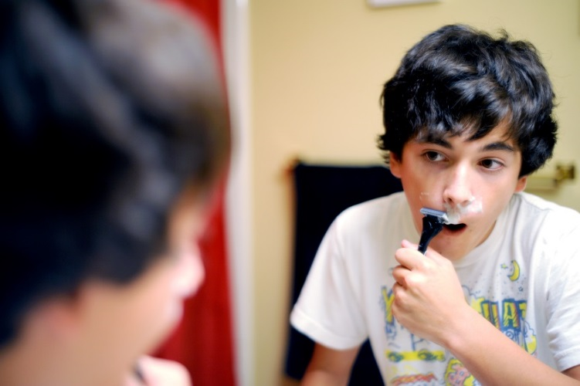
Figure 13.7 – Males often start shaving during puberty.

Acne is an unpleasant consequence of the hormonal changes in puberty. Acne is defined as pimples on the skin due to overactive sebaceous (oil-producing) glands (Dolgin, 2011). These glands develop at a greater speed than the skin ducts that discharge the oil. Consequently, the ducts can become blocked with dead skin and acne will develop. According to the University of California at Los Angeles Medical Center (2000), approximately 85% of adolescents develop acne, and boys develop acne more than girls because of greater levels of testosterone in their systems (Dolgin, 2011). Hormones that are also responsible for sexual development can also wreak havoc on the teenage skin.

A major milestone in puberty for girls is menarche, the first menstrual period, typically experienced at around 12 or 13 years of age (Anderson, Dannal, & Must, 2003). The age of menarche varies substantially and is determined by genetics, as well as by diet and lifestyle, since a certain amount of body fat is needed to attain menarche. Girls who are very slim, who engage in strenuous athletic activities, or who are malnourished may begin to menstruate later. Even after menstruation begins, girls whose level of body fat drops below the critical level may stop having their periods. The sequence of events for puberty is more predictable than the age at which they occur. Some girls may begin to grow pubic hair at age 10 but not attain menarche until age 15.

Male Anatomy
Males have both internal and external genitalia that are responsible for procreation and sexual intercourse. Males produce their sperm on a cycle, and unlike the female's ovulation cycle, the male sperm production cycle is constantly producing millions of sperm daily. The male sex organs are the penis and the testicles, the latter of which produce semen and sperm. The semen and sperm, as a result of sexual intercourse, can fertilize an ovum in the female's body; the fertilized ovum (zygote) develops into a fetus, which is later born as a child.

Male Reproductive System
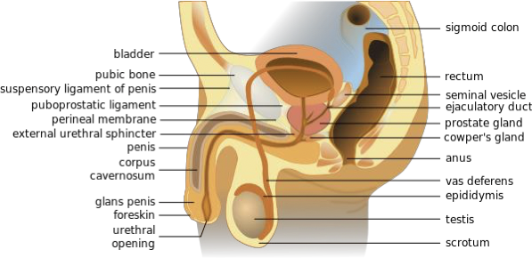
Figure 13.9

Female Anatomy
Female external genitalia is collectively known as the vulva, which includes the mons veneris, labia majora, labia minora, clitoris, vaginal opening, and urethral opening. Female internal reproductive organs consist of the vagina, uterus, fallopian tubes, and ovaries. The uterus hosts the developing fetus, produces vaginal and uterine secretions, and passes the male's sperm through to the fallopian tubes while the ovaries release the eggs. A female is born with all her eggs already produced. The vagina is attached to the uterus through the cervix, while the uterus is attached to the ovaries via the fallopian tubes. Females have a monthly reproductive cycle; at certain intervals the ovaries release an egg, which passes through the fallopian tube into the uterus. If, in this transit, it meets with sperm, the sperm might penetrate and merge with the egg, fertilizing it. If not fertilized, the egg and the tissue that was lining the uterus is flushed out of the system through menstruation (around every 28 days).

Female Reproductive System
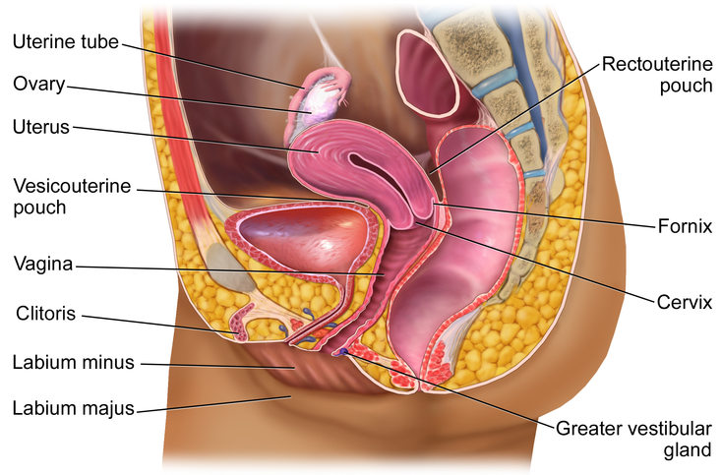
Figure 13.10

Effects of Puberty on Development
The age of puberty is getting younger for children throughout the world. A century ago the average age of a girl’s first period in the United States and Europe was 16, while today it is around 13. Because there is no clear marker of puberty for boys, it is harder to determine if boys are maturing earlier, too. In addition to better nutrition, less positive reasons associated with early puberty for girls include increased stress, obesity, and endocrine disrupting.

Because rates of physical development vary so widely among teenagers, puberty can be a source of pride or embarrassment. Girls and boys who develop more slowly than their peers may feel self-conscious about their lack of physical development; some research has found that negative feelings are particularly a problem for late maturing boys, who are at a higher risk for depression and conflict with parents (Graber et al., 1997) and more likely to be bullied (Pollack & Shuster, 2000). Additionally, problems are more likely to occur when the child is among the first in his or her peer group to develop. Because the preadolescent time is one of not wanting to appear different, early developing children stand out among their peer group and gravitate toward those who are older (Weir, 2016).

Early maturing boys tend to be physically stronger, taller, and more athletic than their later maturing peers; this can contribute to differences in popularity among peers, which can in turn influence the teenager’s confidence. Some studies show that boys who mature earlier tend to be more popular and independent but are also at a greater risk for substance abuse and early sexual activity (Flannery, Rowe, & Gulley, 1993; Kaltiala-Heino, Rimpela, Rissanen, & Rantanen, 2001).

Early maturing girls may face increased teasing and sexual harassment related to their developing bodies, which can contribute to self-consciousness and place them at a higher risk for anxiety, depression, substance abuse, and eating disorders (Ge, Conger, & Elder, 2001; Graber, Lewinsohn, Seeley, & Brooks-Gunn, 1997; Striegel-Moore & Cachelin, 1999).

The Brain and Sex
The brain is the structure that translates the nerve impulses from the skin into pleasurable sensations. It controls nerves and muscles used during sexual behavior. The brain regulates the release of hormones, which are believed to be the physiological origin of sexual desire. The cerebral cortex, which is the outer layer of the brain that allows for thinking and reasoning, is believed to be the origin of sexual thoughts and fantasies. Beneath the cortex is the limbic system, which consists of the amygdala, hippocampus, cingulate gyrus, and septal area. These structures are where emotions and feelings are believed to originate, and are important for sexual behavior.

The hypothalamus is the most important part of the brain for sexual functioning. This is the small area at the base of the brain consisting of several groups of nerve-cell bodies that receives input from the limbic system. Studies with lab animals have shown that destruction of certain areas of the hypothalamus causes complete elimination of sexual behavior. One of the reasons for the importance of the hypothalamus is that it controls the pituitary gland, which secretes hormones that control the other glands of the body.

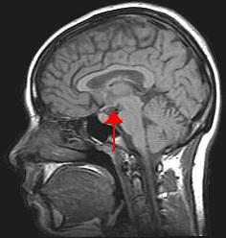
Figure 13.11 - Hypothalamus controls the pituitary gland.

Hormones
Several important sexual hormones are secreted by the pituitary gland. Oxytocin, also known as the hormone of love, is released during sexual intercourse when an orgasm is achieved. Oxytocin is also released in females when they give birth or are breast-feeding; it is believed that oxytocin is involved with maintaining close relationships. Both prolactin and oxytocin stimulate milk production in females. Follicle-stimulating hormone (FSH) is responsible for ovulation in females by triggering egg maturity; it also stimulates sperm production in males. Luteinizing hormone (LH) triggers the release of a mature egg in females during the process of ovulation.

In males, testosterone appears to be a major contributing factor to sexual motivation. Vasopressin is involved in the male arousal phase, and the increase of vasopressin during erectile response may be directly associated with increased motivation to engage in sexual behavior.

The relationship between hormones and female sexual motivation is not as well understood, largely due to the overemphasis on male sexuality in Western research. Estrogen and progesterone typically regulate motivation to engage in sexual behavior for females, with estrogen increasing motivation and progesterone decreasing it. The levels of these hormones rise and fall throughout a woman's menstrual cycle. Research suggests that testosterone, oxytocin, and vasopressin are also implicated in female sexual motivation in similar ways as they are in males, but more research is needed to understand these relationships.

Figure 13.12 - By the end of high school, more than half of boys and girls report engaging in sexual behaviors.

Sexuality will be discussed in Chapter 15, Adolescence Social Emotional Development. The following section will look at the reasons and the consequences of teenage pregnancy, forms of birth control, and sexually transmitted diseases.

Adolescent Pregnancy, Birth Control Methods, and Sexually Transmitted Infections
By the end of high school, more than half of boys and girls report having experienced sexual intercourse at least once, though it is hard to be certain of the proportion because of the sensitivity and privacy of the information. (Center for Disease Control, 2004; Rosenbaum, 2006).

Teen Pregnancy
Although adolescent pregnancy rates have declined since 1991, teenage birth rates in the United States are higher than most industrialized countries. In 2014, females aged 15–19 years experienced a birth rate of 24.2 per 1,000 women. This is a drop of 9% from 2013. Birth rates fell 11% for those aged 15–17 years and 7% for 18–19 year-olds. It appears that adolescents seem to be less sexually active than in previous years, and those who are sexually active seem to be using birth control (CDC, 2016).

Figure 13.13 – Birth rates for American teenagers. | Figure 13.14 – Birth rates by state.

Risk Factors for Adolescent Pregnancy
Miller, Benson, and Galbraith (2001) found that parent/child closeness, parental supervision, and parents' values against teen intercourse (or unprotected intercourse) decreased the risk of adolescent pregnancy. In contrast, residing in disorganized/dangerous neighborhoods, living in a lower SES family, living with a single parent, having older sexually active siblings or pregnant/parenting teenage sisters, early puberty, and being a victim of sexual abuse place adolescents at an increased risk of adolescent pregnancy.

Consequences of Adolescent Pregnancy
After a child is born life can be difficult for a teenage mother. Only 40% of teenagers who have children before age 18 graduate from high school. Without a high school degree, her job prospects are limited and economic independence is difficult. Teen mothers are more likely to live in poverty and more than 75% of all unmarried teen mothers receive public assistance within 5 years of the birth of their first child. Approximately, 64% of children born to an unmarried teenage high-school dropout live in poverty. Further, a child born to a teenage mother is 50% more likely to repeat a grade in school and is more likely to perform poorly on standardized tests and drop out before finishing high school (March of Dimes, 2012).

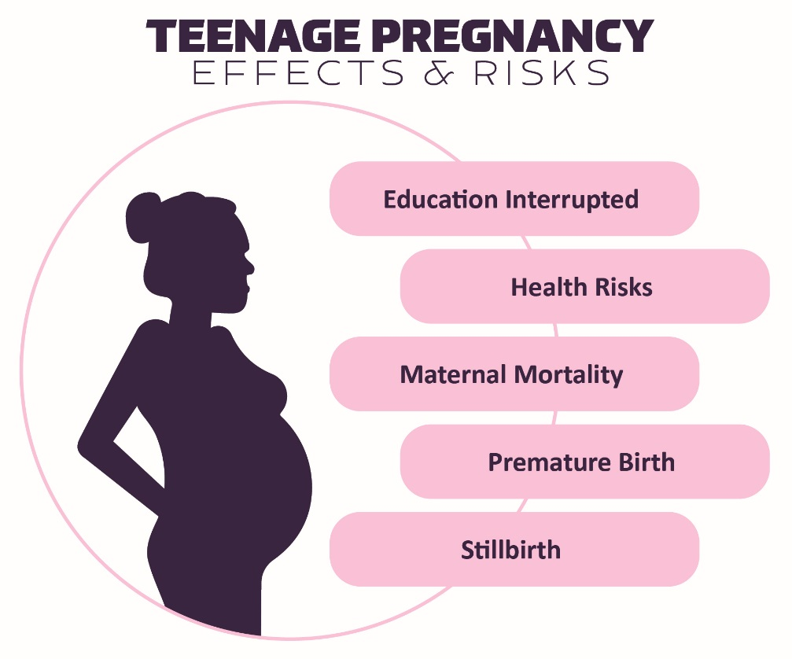
Figure 13.15 – Effects and risks of teenage pregnancy.

Sexually Transmitted Infections
Sexually transmitted infections (STIs), also referred to as sexually transmitted diseases (STDs) or venereal diseases (VDs), are illnesses that have a significant probability of transmission by means of sexual behavior, including vaginal intercourse, anal sex, and oral sex. It’s important to mention that some STIs can also be contracted by sharing intravenous drug needles with an infected person, through childbirth, or breastfeeding. Common STIs include:

- chlamydia;
- herpes (HSV-1 and HSV-2);
- human papillomavirus (HPV);
- gonorrhea;
- syphilis;
- trichomoniasis;
- HIV (human immunodeficiency virus) and AIDS (acquired immunodeficiency syndrome).

According to the Centers for Disease Control and Prevention (CDC) (2014), there was an increase in the three most common types of STDs in 2014. Those most affected by STDS include younger, gay/bisexual males, and females. The most effective way to prevent transmission of STIs is to practice abstinence, (not participating in sexual intercourse), safe sex, and to avoid direct contact of skin or fluids which can lead to transfer with an infected partner. Proper use of safe-sex supplies (such as male condoms, female condoms, gloves, or dental dams) reduces contact and risk and can be effective in limiting exposure; however, some disease transmission may occur even with these barriers.

Practicing safe sex is important to one’s physical health. In the following section we’ll look at elements of adolescent health, including sleep, diet, and exercise.

Contraceptive Methods and Protection from Sexually Transmitted Infection
There are many methods of contraception that sexually active adolescents can use to reduce the chances of pregnancy.

13.1 - Reversible Methods of Birth Control

Method | Description | Failure Rate
Intrauterine Contraception (IUD) | An IUD is a small device that is shaped in the form of a “T” placed inside the uterus | 0.1-0.8%
Implant | A single, thin rod that is inserted under the skin of a woman’s upper arm. | 0.01%
Injection | Injections or shots of hormones to prevent pregnancy are given in the buttocks or arm every three months. | 4%
Oral contraceptives | Also called “the pill,” contain the hormones to prevent pregnancy. A pill is taken at the same time each day. | 7%
Patch | This skin patch is worn on the lower abdomen, buttocks, or upper body and releases hormones to prevent pregnancy into the bloodstream. A new patch once a week for three weeks and then left off for a week. | 7%
Hormonal vaginal contraceptive ring | The ring is placed in the vagina and releases the hormones to prevent pregnancy. It is worn for three weeks. A week after it is removed a new ring is placed. | 7%
Spermicide | These kill sperm and come in several forms—foam, gel, cream, film, suppository, or tablet. They are placed in the vagina before intercourse. | 21%
Diaphragm or cervical cap | A cup that is placed inside the vagina to cover the cervix to block sperm. It is inserted with spermicide before sexual intercourse. | 17%
Sponge | This contains spermicide and is placed in the vagina where it fits over the cervix. | 14-27%
Male condom | Worn (single use) by the man over the penis to keep sperm from getting into a woman’s body. | 13%
Female condom | Worn (single use) by the woman inside the vagina to keep sperm from getting into a woman’s body. | 21%
Natural Family Planning | During a regular menstrual cycle, fertile days can be predicted. Sexual intercourse can be avoided on those days. | 2-23%
Copper IUD | Can be inserted up to 5 days after sexual intercourse | <1%
Emergency contraceptive pills | Can be taken up to 5 days after sexual intercourse and may be available over-the-counter. | 1-10%

In choosing a birth control method, dual protection from the simultaneous risk for HIV and other STIs also should be considered. Although hormonal contraceptives and IUDs are highly effective at preventing pregnancy, they do not protect against STIs, including HIV. Consistent and correct use of the male latex condom reduces the risk for HIV infection and other STIs, including chlamydial infection, gonococcal infection, and trichomoniasis.

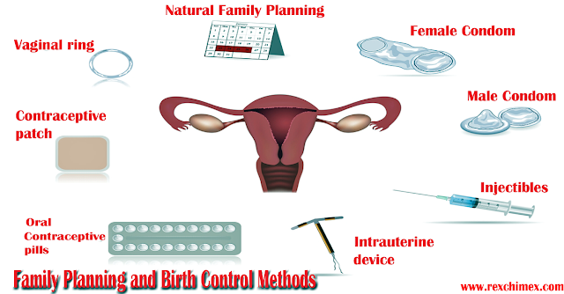
Figure 13.16 – There are many types of birth control methods.

Adolescent Health: Sleep, Diet, and Exercise

Sleep Health
According to the National Sleep Foundation (NSF) (2016), adolescents need about 8 to 10 hours of sleep each night to function best. The most recent Sleep in America poll in 2006 indicated that adolescents between sixth and twelfth grade were not getting the recommended amount of sleep. For the older adolescents, only about one in ten (9%) get an optimal amount of sleep, and they are more likely to experience negative consequences the following day. These include feeling too tired or sleepy, being cranky or irritable, falling asleep in school, having a depressed mood, and drinking caffeinated beverages (NSF, 2016). Additionally, they are at risk for substance abuse, car crashes, poor academic performance, obesity, and a weakened immune system (Weintraub, 2016).

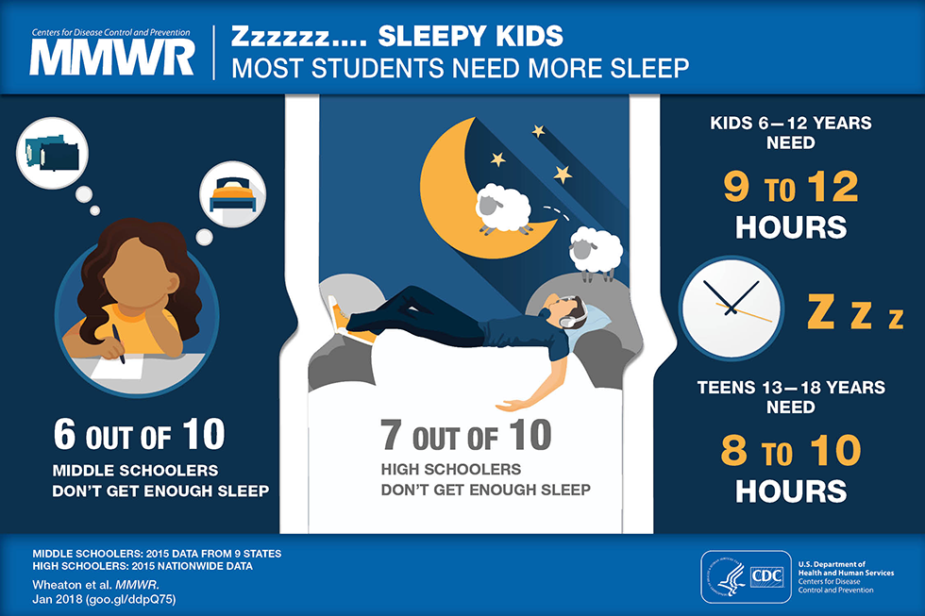
Figure 13.17 – Most teenagers aren’t sleeping enough.

Why don’t adolescents get adequate sleep? In addition to known environmental and social factors, including work, homework, media, technology, and socializing, the adolescent brain is also a factor. As adolescents go through puberty, their circadian rhythms change and push back their sleep time until later in the evening (Weintraub, 2016). This biological change not only keeps adolescents awake at night, it makes it difficult for them to get up in the morning. When they are awake too early, their brains do not function optimally. Impairments are noted in attention, behavior, and academic achievement, while increases in tardiness and absenteeism are also demonstrated. Psychologists and other professionals have been advocating for later school times, and they have produced research demonstrating better student outcomes for later start times. More middle and high schools have changed their start times to better reflect the sleep research.

Figure 13.18 – If adolescents get too little sleep, their brain doesn’t function optimally.

Eating: Healthy Habits = Healthy Lives
The Dietary Guidelines define late adolescence, as the period from ages fourteen to eighteen. After puberty, the rate of physical growth slows down. Girls stop growing taller around age sixteen, while boys continue to grow taller until ages eighteen to twenty. One of the psychological and emotional changes that take place during this life stage includes the desire for independence as adolescents develop individual identities apart from their families. As teenagers make more of their dietary decisions, parents, caregivers, and authority figures should guide them toward appropriate, nutritious choices.

Figure 13.19 - Adolescent food choices may not be healthy.

Some adolescents don’t have all the food necessary for proper development and may be food insecure. Most people have access to fresh water in all except the most extreme situations; the need for food is the most fundamental and important human need. More than 1 in 10 U.S. households contain people who live without enough nourishing food and this lack of proper nourishment has profound effects on their abilities to lead lives that will allow them to develop to their fullest potential. (Hunger Notes, n.d.).

When people are extremely hungry, their motivation to attain food completely changes their behavior. Hungry people become listless and apathetic to save energy and then become completely obsessed with food. Ancel Keys and his colleagues (Keys, Brožek, Henschel, Mickelsen, & Taylor, 1950) found that volunteers who were placed on severely reduced-calorie diets lost all interest in sex and social activities, becoming preoccupied with food. According to Maslow, meeting one’s basic needs is vital for proper growth and development.

Abraham Maslow’s Hierarchy of Needs
Maslow’s theory is based on a simple premise: human beings have needs that are hierarchically ranked. There are some needs that are basic to all human beings, and in their absence, nothing else matters. We are ruled by these needs until they are satisfied. After we satisfy our basic needs, they no longer serve as motivators and we can begin to satisfy higher-order needs.

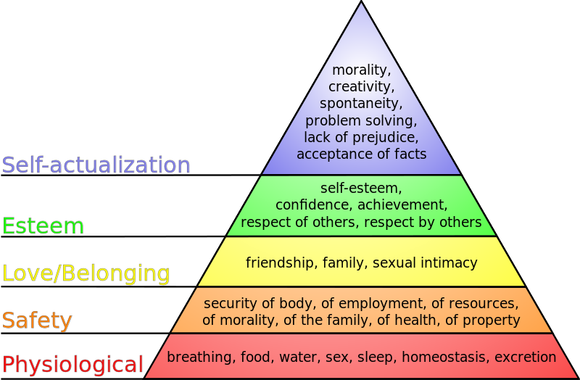
Figure 13.20 – Maslow’s Hierarchy of Needs.
Maslow organized human needs into a pyramid that includes (from lowest-level to highest-level) physiological, safety, love/belonging, esteem, and self-actualization needs. According to Maslow, one must satisfy lower-level needs before addressing needs that occur higher in the pyramid. For example, if someone is starving, it is quite unlikely that he will spend a lot of time, or any time at all, wondering whether other people think he is a good person. Instead, all of his energies are geared toward finding something to eat.

Weight Management
Forming good eating habits and engaging in fitness or exercise programs will help maintain a healthy weight and develop lifelong habits. Research says that the best way to control weight is: eat less (consume fewer calories) and exercise (burn more calories). To maintain a healthy weight, restricting your diet alone is difficult and can be substantially improved when it is accompanied by increased physical activity.

The energy (calorie) requirements for preteens differ according to gender, growth, and activity level. For ages nine to thirteen, girls should consume about 1,400 to 2,200 calories per day and boys should consume 1,600 to 2,600 calories per day. Physically active preteens who regularly participate in sports or exercise need to eat a greater number of calories to account for increased energy expenditures.

People who exercise regularly, and in particular those who combine exercise with dieting, are less likely to be obese (Borer, 2008).Borer, K. T. (2008). Exercise not only improves our waistline, but also improves our overall mental health by lowering stress and improving feelings of well-being. Exercise also increases cardiovascular capacity, lowers blood pressure, and helps improve diabetes, joint flexibility, and muscle strength (American Heart Association, 1998).

For long lasting change, it’s important to plan healthy meals, limit snacking, and to schedule exercise into our daily lives.

Diet Extremes - Obesity to Starvation
In this section, we’ll learn about the two ends of the spectrum (or extremes) of nutritional outcomes.

Obesity
Children need adequate caloric intake for growth, and it is important not to impose highly restrictive diets. However, exceeding caloric requirements on a regular basis can lead to childhood obesity, which has become a major problem in North America. Nearly one of three US children and adolescents are overweight or obese. (Let’s Move. “Learn the Facts.” Accessed March 5, 2012.http://www.letsmove.gov/learn-facts/epidemic-childhood-obesity.)

Figure 13.21 - Obesity can affect self-esteem, energy, and activity level.

There are a number of reasons behind the problem of obesity, including:
- larger portion sizes
- limited access to nutrient-rich foods
- increased access to fast foods and vending machines
- lack of breastfeeding support
- declining physical education programs in schools
- insufficient physical activity and a sedentary lifestyle
- media messages encouraging the consumption of unhealthy foods

Obesity has a profound effect on self-esteem, energy, and activity level. Even more importantly, it is a major risk factor for a number of diseases later in life, including cardiovascular disease, Type 2 diabetes, stroke, hypertension, and certain cancers.

A percentile for body mass index (BMI) specific to age and sex is used to determine if a child is overweight or obese. If a child gains weight inappropriate to growth, parents and caregivers should limit energy-dense, nutrient-poor snack foods. In addition, it is extremely beneficial to increase a child’s physical activity and limit sedentary activities, such as watching television, playing video games, or surfing the Internet. Programs to address childhood obesity can include behavior modification, exercise counseling, psychological support or therapy, family counseling, and family meal-planning advice.

Eating Disorders
Although eating disorders can occur in children and adults, they frequently appear during the teen years or young adulthood (National Institute of Mental Health (NIMH), 2016). Eating disorders affect both genders, although rates among women are 2 1⁄2 times greater than among men. Similar to women who have eating disorders, men also have a distorted sense of body image, including body dysmorphia or an extreme concern with becoming more muscular. (Hudson, Hiripi, Pope, & Kessler, 2007; Wade, Keski-Rahkonen, & Hudson, 2011).

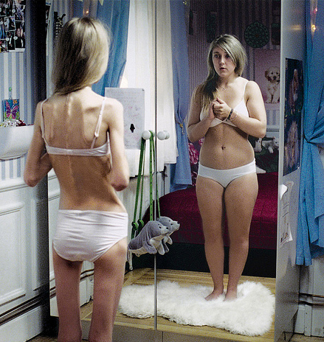
Figure 13.22 –This image portrays anorexia. No matter how thin she is, she will see herself being heavier.

Risk Factors for Eating Disorders
Researchers are finding that eating disorders are caused by a complex interaction of genetic, biological, behavioral, psychological, and social factors (NIMH, 2016). Eating disorders appear to run in families, and researchers are working to identify DNA variations that are linked to the increased risk of developing eating disorders. Researchers have also found differences in patterns of brain activity in women with eating disorders in comparison with healthy women.

The main criteria for the most common eating disorders: Anorexia nervosa, bulimia nervosa, and binge-eating disorder are described in the Diagnostic and Statistical Manual of Mental Disorders-Fifth Edition (DSM-5)(American Psychiatric Association, 2013) and listed in Table 6.1.

Table 13.2 - DSM-5 Eating Disorders

Eating Disorder | Description
Anorexia Nervosa | - Restriction of energy intake leading to a significantly low body weight  - Intense fear of gaining weight  - Disturbance in one’s self-evaluation regarding body weight
Bulimia Nervosa | - Recurrent episodes of binge eating  - Recurrent inappropriate compensatory behaviors to prevent weight gain, including purging, laxatives, fasting or excessive exercise  - Self-evaluation is unduly affected by body shape and weight
Binge-Eating Disorder | - Recurrent episodes of binge eating  - Marked distress regarding binge eating  - The binge eating is not associated with the recurrent use of inappropriate compensatory behavior

Health Consequences of Eating Disorders
For those suffering from anorexia, health consequences include an abnormally slow heart rate and low blood pressure, which increases the risk for heart failure. Additionally, there is a reduction in bone density (osteoporosis), muscle loss and weakness, severe dehydration, fainting, fatigue, and overall weakness. Individuals with this disorder may die from complications associated with Anorexia nervosa, which has the highest mortality rate of any psychiatric disorder.

The binge and purging cycle of bulimia can affect the digestives system and lead to electrolyte and chemical imbalances that can affect the heart and other major organs. Frequent vomiting can cause inflammation and possible rupture of the esophagus, as well as tooth decay and staining from stomach acids. Lastly, binge eating disorder results in similar health risks to obesity, including high blood pressure, high cholesterol levels, heart disease, Type II diabetes, and gall bladder disease (National Eating Disorders Association, 2016).

Eating Disorders Treatment
The foundations of treatment for eating disorders include adequate nutrition and discontinuing destructive behaviors, such as purging. Treatment plans are tailored to individual needs and include medical care, nutritional counseling, medications (such as antidepressants), and individual, group, and/or family psychotherapy (NIMH, 2016).

Figure 13.23 – Counseling is often a form of treatment for eating disorders.

Drug and Substance Abuse
Drug use and the possibility of abuse and addiction primarily manifest as physical problems. However, the effects of these substances are not only physical, but also have long lasting consequences on cognitive development as well as effect social emotional development in a variety of ways. In the next section we’ll learn about what drugs are, the different kinds of drugs, and what the effects are of each.

Drug Experimentation
Drug use is, in part, the result of socialization. Adolescents may try drugs when their friends convince them to, and these decisions are based on social norms about the risks and benefits of various drugs. Despite the fact that young people have experimented with cigarettes, alcohol, and other dangerous drugs for many generations, it would be better if they did not. All recreational drug use is associated with at least some risks, and those who begin using drugs earlier are also more likely to use more dangerous drugs. They may develop an addiction or substance abuse problem later on.

Figure 13.24 – Social norms and peers influence adolescents’ drug use.

What Are Drugs?
A psychoactive drug is a chemical that changes our states of consciousness, and particularly our perceptions and moods. These drugs are commonly found in everyday foods and beverages, including chocolate, coffee, and soft drinks, as well as in alcohol and in over-the-counter drugs, such as aspirin, Tylenol, and cold and cough medication. Psychoactive drugs are also frequently prescribed as sleeping pills, tranquilizers, and antianxiety medications, and they may be taken, illegally, for recreational purposes. The four primary classes of psychoactive drugs are stimulants, depressants, opioids, and hallucinogens.

Stimulants
A stimulant is a psychoactive drug that operates by blocking the reuptake of dopamine, norepinephrine, and serotonin in the synapses of the central nervous system (CNS). Because more of these neurotransmitters remain active in the brain, the result is an increase in the activity of the sympathetic division of the autonomic nervous system (ANS). Effects of stimulants include increased heart and breathing rates, pupil dilation, and increases in blood sugar accompanied by decreases in appetite. For these reasons, stimulants are frequently used to help people stay awake and to control weight.

Used in moderation, some stimulants may increase alertness, but used in an irresponsible fashion they can quickly create dependency. A major problem is the “crash” that results when the drug loses its effectiveness and the activity of the neurotransmitters returns to normal. The withdrawal from stimulants can create profound depression and lead to an intense desire to repeat the high.
Table 13.3 - Stimulants

Drug | Dangers and Side Effects | Psychological Dependence | Physical Dependence | Addiction Potential
Caffeine | May create dependence | Low | Low | Low
Nicotine | Has major negative health effects if smoked or chewed | High | High | High
Cocaine | Decreased appetite, headache | Low | Low | Moderate
Amphetamines | Possible dependence, accompanied by severe “crash” with depression as drug effects wear off, particularly if smoked or injected | Moderate | Low | Moderate to High

A Closer Look at the Danger of Adolescence Use of Nicotine
Nicotine is a psychoactive drug found in the nightshade family of plants, where it acts as a natural pesticide. Nicotine is the main cause for the dependence-forming properties of tobacco use, and tobacco use is a major health threat. Nicotine creates both psychological and physical addiction and it is one of the hardest addictions to break. Nicotine content in cigarettes has slowly increased over the years, making quitting smoking more and more difficult. Nicotine is also found in smokeless (chewing) tobacco and electronic cigarettes (vaping).

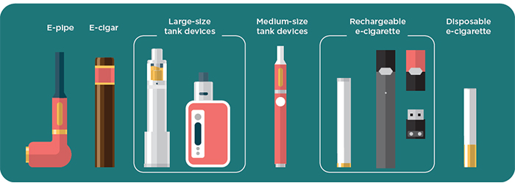
Figure 13.25 – Electronic devices are now common ways to consume nicotine.

Nicotine exposure can harm adolescent brain development by changing the way synapses form, which continues into the early to mid-20s. Using nicotine in adolescence may also increase risk for future addictions to other drugs. E-cigarette aerosol and cigarettes contain chemicals that are harmful to the lungs and chewing tobacco.

In many cases, people are able to get past the physical dependence, allowing them to quit using nicotine containing products at least temporarily. In the long run, however, the psychological enjoyment of smoking may lead to relapse.

Depressants
In contrast to stimulants, which work to increase neural activity, a depressant slows down consciousness. A depressant is a psychoactive drug that reduces the activity of the CNS. Depressants are widely used as prescription medicines to relieve pain, to lower heart rate and respiration, and as anticonvulsants. The outcome of depressant use (similar to the effects of sleep) is a reduction in the transmission of impulses from the lower brain to the cortex (Csaky & Barnes, 1984).

Table 13.4 - Depressants

Drug | Dangers and Side Effects | Psychological Dependence | Physical Dependence | Addiction Potential
Alcohol | Impaired judgment, loss of coordination, dizziness, nausea, and eventually a loss of consciousness | Moderate | Moderate | Moderate
Barbiturates and benzo-diazepines | Sluggishness, slowed speech, drowsiness, in severe cases, coma or death | Moderate | Moderate | Moderate
Toxic inhalants | Brain damage and death | High | High | High

A Closer Look at the Danger of Adolescent Alcohol Use
Alcohol is the most commonly used of the depressants and is a colorless liquid, produced by the fermentation of sugar or starch that is the intoxicating agent in fermented drinks. Alcohol is the oldest and most widely used drug of abuse in the world. In low to moderate doses, alcohol first acts to remove social inhibitions by slowing activity in the sympathetic nervous system. In higher doses, alcohol acts on the cerebellum to interfere with coordination and balance, producing the staggering gait of drunkenness. At high blood levels, further CNS depression leads to dizziness, nausea, and eventually a loss of consciousness. High enough blood levels such as those produced by “guzzling” large amounts of hard liquor at parties can be fatal. Alcohol is not a “safe” drug by any means.

Short-Term Health Risks
Excessive alcohol use has immediate effects that increase the risk of many harmful health conditions. These are most often the result of binge drinking (drinking 4-5 drinks during a single occasion) and include the following:
- Injuries, such as motor vehicle crashes (1 in 5 teen drivers involved in fatal crashes had some alcohol in their system in 2010), falls, drownings, and burns.
- Violence, including homicide, suicide, sexual assault, and intimate partner violence.
- Alcohol poisoning, a medical emergency that results from high blood alcohol levels.
- Risky sexual behaviors, including unprotected sex or sex with multiple partners. These behaviors can result in unintended pregnancy or sexually transmitted diseases, including HIV.
- Miscarriage and stillbirth or fetal alcohol spectrum disorders (FASDs) among pregnant women.

Long-Term Health Risks
Over time, excessive alcohol use can lead to the development of chronic diseases and other serious problems including:
- High blood pressure, heart disease, stroke, liver disease, and digestive problems.
- Cancer of the breast, mouth, throat, esophagus, liver, and colon.
- Learning and memory problems, including dementia and poor school performance.
- Mental health problems, including depression and anxiety.
- Social problems, including lost productivity, family problems, and unemployment.
- Alcohol dependence, or alcoholism.

Figure 13.26 – Adolescent alcohol use poses many health risks.

Opioids
Opioids are chemicals that increase activity in opioid receptor neurons in the brain and in the digestive system, producing euphoria, analgesia, slower breathing, and constipation. Their chemical makeup is similar to the endorphins, the neurotransmitters that serve as the body’s “natural pain reducers.” Natural opioids are derived from the opium poppy, which is widespread in Eurasia, but they can also be created synthetically.

Table 13.5 - Opioids

Drug | Dangers and Side Effects | Psychological Dependence | Physical Dependence | Addiction Potential
Opium | Side effects include nausea, vomiting, tolerance, and addiction. | Moderate | Moderate | Moderate
Morphine | Restlessness, irritability, headache and body aches, tremors, nausea, vomiting, and severe abdominal pain | High | Moderate | Moderate
Heroin | All side effects of morphine but about twice as addictive as morphine | High | Moderate | High

Hallucinogens
The drugs that produce the most extreme alteration of consciousness are the hallucinogens, psychoactive drugs that alter sensation and perception and that may create hallucinations. The hallucinogens are frequently known as “psychedelics.” Drugs in this class include lysergic acid diethylamide (LSD, or “Acid”), mescaline, and phencyclidine (PCP), as well as a number of natural plants including cannabis (marijuana), peyote, and psilocybin. The hallucinogens may produce striking changes in perception through one or more of the senses. The precise effects a user experiences are a function not only of the drug itself but also of the user’s preexisting mental state and expectations of the drug experience. In large part, the user tends to get out of the experience what he or she brings to it. The hallucinations that may be experienced when taking these drugs are strikingly different from everyday experience and frequently are more similar to dreams than to everyday consciousness.

Table 13.6 - Hallucinogens

Drug | Dangers and Side Effects | Psychological Dependence | Physical Dependence | Addiction Potential
Marijuana | Mild intoxication; enhanced perception | Low | Low | Low
LSD, mescaline, PCP, and peyote | Hallucinations; enhanced perception | Low | Low | Low

A Closer Look at the Danger of Adolescent Marijuana Use
Marijuana (cannabis) is the most widely used hallucinogen. Until it was banned in the United States under the Marijuana Tax Act of 1938, it was widely used for medical purposes. While medical and recreational marijuana is now legal in several American states, it is still banned under federal law, putting those states in conflict with the federal government. Marijuana also acts as a stimulant, producing giggling, laughing, and mild intoxication. It acts to enhance perception of sights, sounds, and smells, and may produce a sensation of time slowing down, and is much less likely to lead to antisocial acts than that other popular intoxicant, alcohol.

Using marijuana—can have harmful and long-lasting effects on an adolescent’s health and well-being.

Marijuana and the teen brain
Unlike adults, the teen brain is actively developing and often will not be fully developed until the mid 20s. Marijuana use during this period may harm the developing teen brain.
Negative effects include:
- Difficulty thinking and problem solving.
- Problems with memory and learning.
- Impaired coordination.
- Difficulty maintaining attention.

Figure 13.27 – Marijuana is a commonly used hallucinogen.

Negative effects on school and social life
Marijuana use in adolescence or early adulthood can have a serious impact on an adolescent’s life.
- Decline in school performance. Students who smoke marijuana may get lower grades and may be more likely to drop out of high school than their peers who do not use.
- Increased risk of mental health issues. Marijuana use has been linked to a range of mental health problems in teens such as depression or anxiety. Psychosis has also been seen in teens at higher risk like those with a family history.
- Impaired driving. Driving while impaired by any substance, including marijuana, is dangerous. Marijuana negatively affects a number of skills required for safe driving, such as reaction time, coordination, and concentration.
- Potential for addiction. Research shows that about 1 in 6 teens who repeatedly use marijuana can become addicted, which means that they may make unsuccessful efforts to quit using marijuana or may give up important activities with friends and family in favor of using marijuana.

In some cases, the effects of psychoactive drugs mimic other naturally occurring states of consciousness. For instance, sleeping pills are prescribed to create drowsiness, and benzodiazepines are prescribed to create a state of relaxation. In other cases psychoactive drugs are taken for recreational purposes with the goal of creating states of consciousness that are pleasurable or that help us escape our normal consciousness.

The use of psychoactive drugs, and especially those that are used illegally, has the potential to create very negative side effects. This does not mean that all drugs are dangerous, but rather that all drugs can be dangerous, particularly if they are used regularly over long periods of time. Psychoactive drugs create negative effects not so much through their initial use but through the continued use, accompanied by increasing doses, that ultimately may lead to drug abuse.

Substance Abuse
Many drugs create tolerance: an increase in the dose required to produce the same effect, which makes it necessary for the user to increase the dosage or the number of times per day that the drug is taken. As the use of the drug increases, the user may develop a dependence, defined as a need to use a drug or other substance regularly. Dependence can be psychological, in which the drug is desired and has become part of the everyday life of the user, but no serious physical effects result if the drug is not obtained; or physical, in which serious physical and mental effects appear when the drug is withdrawn. Cigarette smokers who try to quit, for example, experience physical withdrawal symptoms, such as becoming tired and irritable, as well as extreme psychological cravings to enjoy a cigarette in particular situations, such as after a meal or when they are with friends. Users may wish to stop using the drug, but when they reduce their dosage they experience withdrawal—negative experiences that accompany reducing or stopping drug use, including physical pain and other symptoms. When the user powerfully craves the drug and is driven to seek it out, over and over again, no matter what the physical, social, financial, and legal cost, we say that he or she has developed an addiction to the drug.

It is a common belief that addiction is an overwhelming, irresistibly powerful force, and that withdrawal from drugs is always an unbearably painful experience. But the reality is more complicated and in many cases less extreme. For one, even drugs that we do not generally think of as being addictive, such as caffeine, nicotine, and alcohol, can be very difficult to quit using, at least for some people. On the other hand, drugs that are normally associated with addiction, including amphetamines, cocaine, and heroin, do not immediately create addiction in their users. Even for a highly addictive drug like cocaine, only about 15% of users become addicted (Robinson & Berridge, 2003; Wagner & Anthony, 2002). Furthermore, the rate of addiction is lower for those who are taking drugs for medical reasons than for those who are using drugs recreationally. Patients who have become physically dependent on morphine administered during the course of medical treatment for a painful injury or disease are able to be rapidly weaned off the drug afterward, without becoming addicts.
People have used, and often abused, psychoactive drugs for thousands of years. Perhaps this should not be surprising, because many people find using drugs to be enjoyable. Even when we know the potential costs of using drugs, we may engage in them anyway because the pleasures of using the drugs are occurring right now, whereas the potential costs are abstract and occur in the future.

In the next section we will be looking at various psychological disorders. Learning about and supporting others seeking help when they have a substance abuse problem is just as important as seeking help when one is experiencing negative physical and mental health problems.

Maintaining Emotional Health
Emotional regulation is the ability to successfully control our emotions, which takes effort, but the ability to do so can have important positive health outcomes. Emotional responses such as the stress reaction are useful in warning us about potential danger and in mobilizing our response to it, so it is a good thing that we have them. However, we also need to learn how to control and regulate our emotions, to prevent them from letting our behavior get out of control.

Stress may not be a disorder, but if it continues and becomes more intense and debilitating, it may lead to a disorder. We experience stress in our everyday lives, including daily hassles. People who experience strong negative emotions as a result of these hassles, exhibit negative stress responses. Stress can be managed by using coping strategies and by becoming better at emotional regulation. The best antidote for stress is to think positively, have fun, and enjoy the company of others. People who express optimism, self-efficacy, and grit tend to cope better with stress and experience better health overall.

Disorders and Syndromes
A psychological disorder is an unusual, distressing, and dysfunctional pattern of thought, emotion, or behavior. Psychological disorders are often co-occurring or comorbid, meaning that a given person suffers from more than one disorder. Psychologists diagnose a disorder using the Diagnostic and Statistical Manual of Mental Disorders (DSM). When diagnosed, people feel that a mental disorder is a stigma, but mental illness is not a “fault,” and it is important to work to help overcome the stigma associated with disorder. The following are various disorders that may affect children, adolescence, and adults.

Table 13.7 – Disorders and Syndromes and their Descriptions

Disorder/Syndrome | Description
Anxiety Disorders | Psychological disturbances marked by irrational fears, often of everyday objects and situations. They include generalized anxiety disorder (GAD), panic disorder, phobia, obsessive-compulsive disorder (OCD), and posttraumatic stress disorder (PTSD). Anxiety disorders affect about 57 million Americans every year.
Dissociative Disorders | Conditions that involve disruptions or breakdowns of memory, awareness, and identity. They include dissociative amnesia, dissociative fugue, and dissociative identity disorder.
Mood Disorders | Psychological disorders in which the person’s mood negatively influences his or her physical, perceptual, social, and cognitive processes. They include dysthymia, major depressive disorder, and bipolar disorder. Mood disorders affect about 30 million Americans every year.
Schizophrenia | A serious psychological disorder marked by delusions, hallucinations, loss of contact with reality, inappropriate affect, disorganized speech, social withdrawal, and deterioration of adaptive behavior. About 3 million Americans have schizophrenia.
Personality Disorder | A long-lasting but frequently less severe disorder characterized by inflexible patterns of thinking, feeling, or relating to others that causes problems in personal, social, and work situations. They are characterized by odd or eccentric behavior, by dramatic or erratic behavior, or by anxious or inhibited behavior. Two of the most important personality disorders are borderline personality disorder (BPD) and antisocial personality disorder (APD).
Somatization Disorder | A psychological disorder in which a person experiences numerous long-lasting but seemingly unrelated physical ailments that have no identifiable physical cause. Somatization disorders include conversion disorder, body dysmorphic disorder (BDD), and hypochondriasis.
Factitious Disorder | When patients fake physical symptoms in large part because they enjoy the attention and treatment that they receive in the hospital.
Sexual Disorders | A variety of problems revolving around performing or enjoying sex. Sexual dysfunctions include problems relating to loss of sexual desire, sexual response or orgasm, and pain during sex.
Paraphilia | A sexual deviation where sexual arousal is obtained from a consistent pattern of inappropriate responses to objects or people, and in which the behaviors associated with the feelings are distressing and dysfunctional.
Depression | When symptoms cause serious distress and negatively influence physical, perceptual, social, and cognitive processes. Teens with depression were often dismissed as being moody or difficult. About 11 percent of adolescents have a depressive disorder by age 18 according to the National Comorbidity Survey-Adolescent Supplement (NCS-A). Depressed teens with coexisting (comorbid) disorders such as substance abuse problems are less likely to respond to treatment for depression. Studies focusing on conditions that frequently co-occur and how they affect one another may lead to more targeted screening tools and interventions. With medication, psychotherapy, or combined treatment, most youth with depression can be effectively treated. Youth are more likely to respond to treatment if they receive it early in the course of their illness.

The Importance of Maintaining Mental Health and Wellness
Most people don’t think twice before going to a doctor if they have an illness such as bronchitis, asthma, diabetes, or heart disease. However, many people who have a mental illness don’t get the treatment that would alleviate their suffering. Studies estimate that two-thirds of all young people with mental health problems are not receiving the help they need and that less than one-third of the children under age 18 who have a serious mental health problem receive any mental health services. Mental illness in adults often goes untreated, too.

Consequences of Mental Illness
The consequences of mental illness in children and adolescents can be substantial. Many mental health professionals speak of accrued deficits that occur when mental illness in children is not treated. To begin with, mental illness can impair a student’s ability to learn. Adolescents whose mental illness is not treated rapidly and aggressively tend to fall further and further behind in school. They are more likely to drop out of school and are less likely to be fully functional members of society when they reach adulthood.

We also now know that depressive disorders in young people confer a higher risk for illness and interpersonal and psychosocial difficulties that persist after the depressive episode is over. Furthermore, many adults who suffer from mental disorders have problems that originated in childhood. Depression in youth may predict more severe illness in adult life. Attention deficit hyperactivity disorder, once thought to affect children and adolescents only, may persist into adulthood and may be associated with social, legal, and occupational problems. Mental illness impairs a student’s ability to learn.
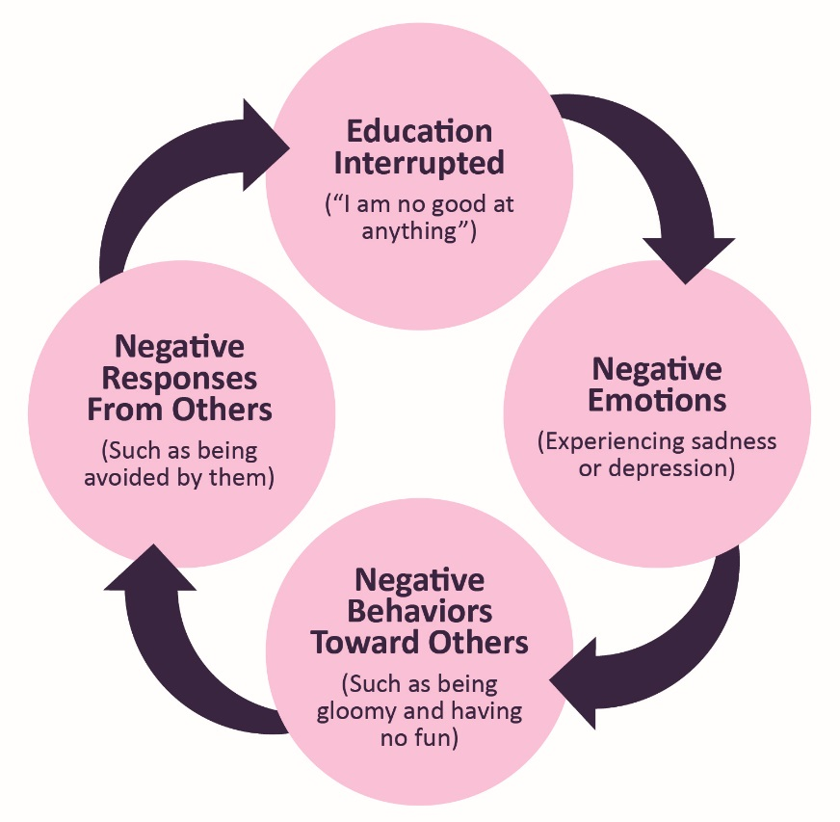
Figure 13.28 - Cycle of Depression: Negative emotions create negative behaviors, which lead people to respond negatively to the individual, creating even more depression.

Self-Harm or Self-Injury
Adolescents struggling with their mental health may engage in self-harm, or thinking about harming oneself. They may be distressed and have difficult feelings as well as the urge to hurt themselves. Some unhealthy ways people may try to relieve emotional pain include cutting, burning, or hitting themselves. These self-harm behaviors can be difficult to detect and are usually kept a secret by covering the wounds with clothing or jewelry. Self-injury is a sign that someone is struggling. People who are anxious, depressed, or have an eating disorder are also more likely to turn to self-injuring behaviors.

Indicators of self-harm include:
- frequent unexplained injuries
- clues like bandages in trash cans.
- clothing inappropriate for the weather (long pants or sleeves when it’s hot)

It’s important when someone confides in self-harm to try to be as nonreactive and nonjudgmental as possible. At this time there are no medications for treating self-injuring behaviors. But some medications can help treat mental disorders that the person may be dealing with, like depression or anxiety. Mental health counseling or therapy can also help.

Figure 13.29 – Self-injury can be difficult to detect because it can be hidden under clothing.

Suicidal Behavior
Adolescence who feel like there is no possible resolution to their mental health struggles may consider, attempt, or commit suicide. Suicidal behavior causes immeasurable pain, suffering, and loss to individuals, families, and communities nationwide. On average, 112 Americans die by suicide each day. Suicide is the second leading cause of death among 15-24 year olds and more than 9.4 million adults in the United States had serious thoughts of suicide within the past 12 months. But suicide is preventable.

Warning Signs of Suicide
If someone is showing one or more of the following behaviors, he or she may be thinking about suicide. The following warning signs should not be ignored. Help should be sought immediately.
- Talking about wanting to die or to kill oneself
- Looking for a way to kill oneself
- Talking about feeling hopeless or having no reason to live
- Talking about feeling trapped or in unbearable pain
- Talking about being a burden to others
- Increasing the use of alcohol or drugs
- Acting anxious or agitated
- Behaving recklessly
- Sleeping too little or too much
- Withdrawing or feeling isolated
- Showing rage or talking about seeking revenge
- Displaying extreme mood swings
GET HELP
If you or someone you know needs help, call the National Suicide Prevention Lifeline at 1-800-273-TALK (8255). Trained crisis workers are available to talk 24 hours a day, 7 days a week.

Conclusion
In this chapter we looked at:
- Physical growth and the changes in the body during puberty
- Weight management, obesity, and eating disorders
- Risk factors, and consequences of adolescent pregnancy and sexual health
- Substance and drug abuse
- Mental health issues for teens

In the next chapter we will look at adolescent cognitive development.

Chapter 14: Adolescence – Cognitive Development

Chapter Objectives
After this chapter, you should be able to:
- Describe Piaget’s formal operational stage and the characteristics of formal operational thought
- Compare Theories - Lawrence’s Kohlberg’s Moral Development and Carol Gilligan’s Morality of Care
- Explain the Information Processing Theory
- Describe the strategies for memory storage
- Explain the areas of transition for adolescence

Introduction
During adolescence more complex thinking abilities emerge. Researchers suggest this is due to increases in processing speed and efficiency rather than as the result of an increase in mental capacity—in other words, due to improvements in existing skills rather than development of new ones (Bjorkland, 1987; Case, 1985). Let’s explore these improvements.

Cognitive Development in Adolescence
During adolescence, teenagers move beyond concrete thinking and become capable of abstract thought. Teen thinking is also characterized by the ability to consider multiple points of view, imagine hypothetical situations, debate ideas and opinions (e.g., politics, religion, and justice), and form new ideas. In addition, it’s not uncommon for adolescents to question authority or challenge established societal norms.

Cognitive empathy, also known as theory-of-mind, which relates to the ability to take the perspective of others and feel concern for others (Shamay-Tsoory, Tomer, & Aharon-Peretz, 2005). Cognitive empathy begins to increase in adolescence and is an important component of social problem solving and conflict avoidance. According to one longitudinal study, levels of cognitive empathy begin rising in girls around 13 years old, and around 15 years old in boys (Van der Graaff et al., 2013).

Cognitive Changes in the Brain
Early in adolescence, changes in Dopamine, a chemical in the brain that is a neurotransmitter and produces feelings of pleasure, can contribute to increases in adolescents’ sensation-seeking and reward motivation. During adolescence, people tend to do whatever activities produce the most dopamine without fully considering the consequences of such actions. Later in adolescence, the prefrontal cortex, the area of the brain responsible for outcomes, forming judgments, controlling impulses and emotions, also continues to develop (Goldberg, 2001). The difference in timing of the development of these different regions of the brain contributes to more risk taking during middle adolescence because adolescents are motivated to seek thrills (Steinberg, 2008). One of the world’s leading experts on adolescent development, Laurence Steinberg, likens this to engaging a powerful engine before the braking system is in place. The result is that adolescents are prone to risky behaviors more often than children or adults.

Figure 14.2 - A simulation of the risky behavior of drinking and driving.

Although the most rapid cognitive changes occur during childhood, the brain continues to develop throughout adolescence, and even into the 20s (Weinberger, Elvevåg, & Giedd, 2005). The brain continues to form new neural connections and becomes faster and more efficient because it prunes, or casts off unused neurons and connections (Blakemore, 2008), and produces myelin, the fatty tissue that forms around axons and neurons, which helps speed transmissions between different regions of the brain (Rapoport et al., 1999). This time of rapid cognitive growth for teens, making them more aware of their potential and capabilities, causes a great amount of disequilibrium for them. Theorists have researched cognitive changes and functions and have formed theories based on this developmental period.

Cognitive Theorists: Piaget, Elkind, Kohlberg, and Gilligan

Jean Piaget: Formal Operational Stage of Cognitive Development
Cognition refers to thinking and memory processes, and cognitive development refers to long-term changes in these processes. One of the most widely known perspectives about cognitive development is the cognitive stage theory of a Swiss psychologist named Jean Piaget. Piaget created and studied an account of how children and youth gradually become able to think logically and scientifically. Because his theory is especially popular among educators, we focus on it in this chapter.
Piaget was a psychological constructivist: in his view, learning was proceeded by the interplay of assimilation (adjusting new experiences to fit prior concepts) and accommodation (adjusting concepts to fit new experiences). The to-and-fro of these two processes leads not only to short-term learning, but also to long-term developmental change. The long-term developments are really the main focus of Piaget’s cognitive theory.

As you might remember, Piaget proposed that cognition developed through distinct stages from birth through the end of adolescence. By stages he meant a sequence of thinking patterns with four key features:
- They always happen in the same order.
- No stage is ever skipped.
- Each stage is a significant transformation of the stage before it.
- Each later stage incorporated the earlier stages into itself.

Basically this is the “staircase” model of development. Piaget proposed four major stages of cognitive development, and called them (1) sensorimotor intelligence, (2) preoperational thinking, (3) concrete operational thinking, and (4) formal operational thinking. Each stage is correlated with an age period of childhood, but only approximately. Formal operational thinking appears in adolescence.

During the formal operational stage, adolescents are able to understand abstract principles. They are no longer limited by what can be directly seen or heard, and are able to contemplate such constructs as beauty, love, freedom, and morality. Additionally, while younger children solve problems through trial and error, adolescents demonstrate hypothetical-deductive reasoning, which is developing hypotheses based on what might logically occur. They are able to think about all the possibilities in a situation beforehand, and then test them systematically, (Crain, 2005) because they are able to engage in true scientific thinking.

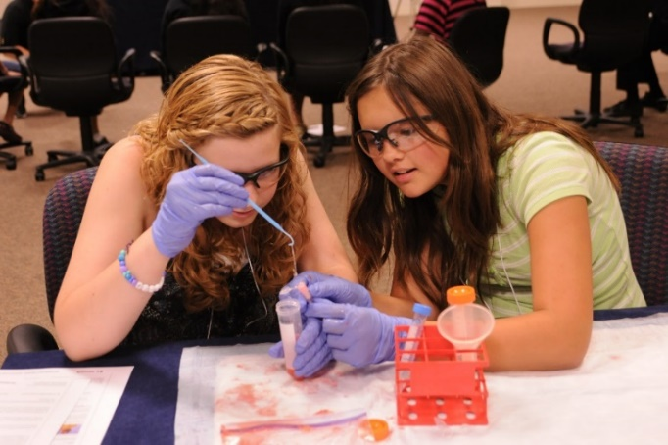
Figure 14.1 - Teenage thinking is characterized by the ability to reason logically and solve hypothetical problems such as how to design, plan, and build a structure.
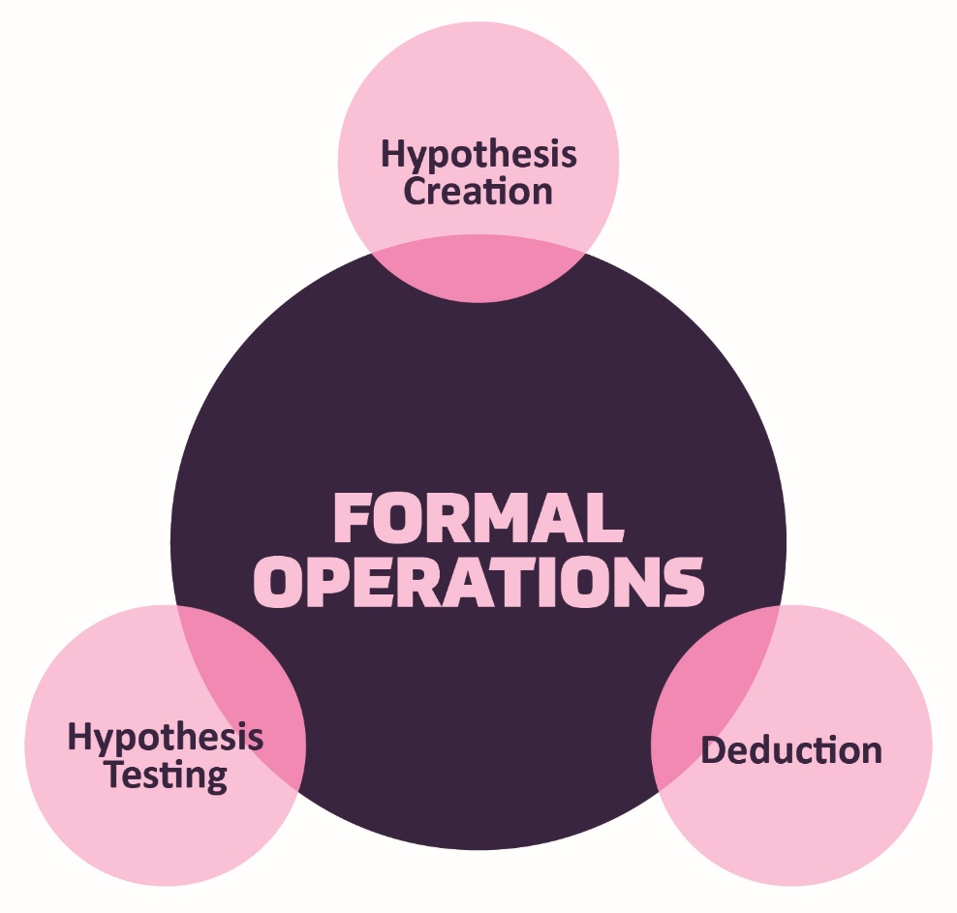
Figure 14.3 – Piaget proposed that formal operational thinking is the last stage in cognitive development.

Does everyone reach formal operations?
According to Piaget, most people attain some degree of formal operational thinking, but use formal operations primarily in the areas of their strongest interest (Crain, 2005). In fact, most adults do not regularly demonstrate formal operational thought. A possible explanation is that an individual’s thinking has not been sufficiently challenged to demonstrate formal operational thought in all areas.

Adolescent Egocentrism
Once adolescents can understand abstract thoughts, they enter a world of hypothetical possibilities and demonstrate egocentrism, a heightened self-focus. The egocentricity comes from attributing unlimited power to their own thoughts (Crain, 2005). Piaget believed it was not until adolescents took on adult roles that they would be able to learn the limits to their own thoughts.

David Elkind: On Piaget’s Theory
David Elkind (1967) expanded on the concept of Piaget’s adolescent egocentricity. Elkind theorized that the physiological changes that occur during adolescence result in adolescents being primarily concerned with themselves. Additionally, since adolescents fail to differentiate between what others are thinking and their own thoughts, they believe that others are just as fascinated with their behavior and appearance. This belief results in the adolescent anticipating the reactions of others, and consequently constructing an imaginary audience. The imaginary audience is the adolescent’s belief that those around them are as concerned and focused on their appearance as they themselves are (Schwartz, Maynard, & Uzelac, 2008, p. 441). Elkind thought that the imaginary audience contributed to the self-consciousness that occurs during early adolescence. The desire for privacy and the reluctance to share personal information may be a further reaction to feeling under constant observation by others.

Figure 14.4 - This teen is likely thinking, “they must be whispering about me.”

Another important consequence of adolescent egocentrism is the personal fable or belief that one is unique, special, and invulnerable to harm. Elkind (1967) explains that because adolescents feel so important to others (imaginary audience) they regard themselves and their feelings as being special and unique. Adolescents believe that only they have experienced strong and diverse emotions, and therefore others could never understand how they feel. This uniqueness in one’s emotional experiences reinforces the adolescent’s belief of invulnerability, especially to death. Adolescents will engage in risky behaviors, such as drinking and driving or unprotected sex, and feel they will not suffer any negative consequences. Elkind believed that adolescent egocentricity emerged in early adolescence and declined in middle adolescence, however, recent research has also identified egocentricity in late adolescence (Schwartz, et al., 2008).

Consequences of Formal Operational Thought
As adolescents are now able to think abstractly and hypothetically, they exhibit many new ways of reflecting on information (Dolgin, 2011). For example, they demonstrate greater introspection or thinking about one’s thoughts and feelings. They begin to imagine how the world could be, which leads them to become idealistic or insisting upon high standards of behavior. Because of their idealism, they may become critical of others, especially adults in their life. Additionally, adolescents can demonstrate hypocrisy, or pretend to be what they are not. Since they are able to recognize what others expect of them, they will conform to those expectations for their emotions and behavior seemingly hypocritical to themselves. Lastly, adolescents can exhibit pseudostupidity, which is when they approach problems at a level that is too complex and they fail because the tasks are too simple. Their new ability to consider alternatives is not completely under control and they appear “stupid” when they are in fact bright, just inexperienced.

Lawrence Kohlberg: Moral Development
Kohlberg (1963) built on the work of Piaget and was interested in finding out how our moral reasoning changes as we get older. He wanted to find out how people decide what is right and what is wrong (moral justice). Just as Piaget believed that children’s cognitive development follows specific patterns, Kohlberg argued that we learn our moral values through active thinking and reasoning, and that moral development follows a series of stages. Kohlberg's six stages are generally organized into three levels of moral reasons. To study moral development, Kohlberg posed moral dilemmas to children, teenagers, and adults. You may remember one such dilemma, the Heinz dilemma, that was introduced in Chapter 12:

A woman was on her deathbed. There was one drug that the doctors thought might save her. It was a form of radium that a druggist in the same town had recently discovered. The drug was expensive to make, but the druggist was charging ten times what the drug cost him to produce. He paid $200 for the radium and charged $2,000 for a small dose of the drug. The sick woman's husband, Heinz, went to everyone he knew to borrow the money, but he could only get together about $1,000 which is half of what it cost. He told the druggist that his wife was dying and asked him to sell it cheaper or let him pay later. But the druggist said: “No, I discovered the drug and I'm going to make money from it.” So Heinz got desperate and broke into the man's laboratory to steal the drug for his wife. Should Heinz have broken into the laboratory to steal the drug for his wife? Why or why not?

Based on their reasoning behind their responses (not whether they thought Heinz made the right choice or not), Kohlberg placed each person in one of the stages as described in the image on the following page:

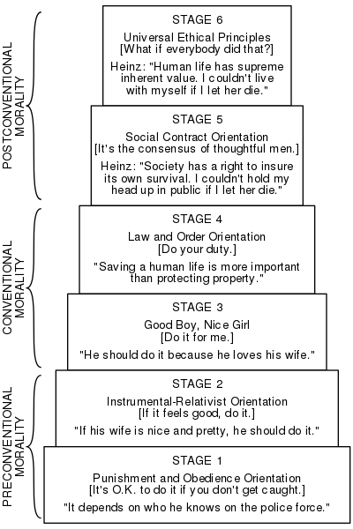
Figure 14.5 - Kohlberg's six stages of moral development.

Although research has supported Kohlberg’s idea that moral reasoning changes from an early emphasis on punishment and social rules and regulations to an emphasis on more general ethical principles, as with Piaget’s approach, Kohlberg’s stage model is probably too simple. For one, children may use higher levels of reasoning for some types of problems, but revert to lower levels in situations where doing so is more consistent with their goals or beliefs (Rest, 1979). Second, it has been argued that this stage model is particularly appropriate for Western countries, rather than non-Western, samples in which allegiance to social norms (such as respect for authority) may be particularly important (Haidt, 2001). In addition, there is little correlation between how children score on the moral stages and how they behave in real life.
Perhaps the most important critique of Kohlberg’s theory is that it may describe the moral development of boys better than it describes that of girls. Carol Gilligan has argued that, because of differences in their socialization, males tend to value principles of justice and rights, whereas females value caring for and helping others. Although there is little evidence that boys and girls score differently on Kohlberg’s stages of moral development (Turiel, 1998), it is true that girls and women tend to focus more on issues of caring, helping, and connecting with others than do boys and men (Jaffee & Hyde, 2000).

Carol Gilligan: Morality of Care
Carol Gilligan, whose ideas center on a morality of care, or system of beliefs about human responsibilities, care, and consideration for others, proposed three moral positions that represent different extents or breadth of ethical care. Unlike Kohlberg, or Piaget, she does not claim that the positions form a strictly developmental sequence, but only that they can be ranked hierarchically according to their depth or subtlety. In this respect her theory is “semi-developmental” in a way similar to Maslow’s theory of motivation (Brown & Gilligan, 1992; Taylor, Gilligan, & Sullivan, 1995). The following table summarizes the three moral positions from Gilligan’s theory:

Table 14.1 - Positions of Moral Development According to Gilligan

Moral Positions | Definition of What is Morally Good
Position 1: Survival Orientation | Action that considers one’s personal needs only
Position 2: Conventional Care | Action that considers others’ needs or preferences but no one’s own
Position 3: Integrated Care | Action that attempts to coordinate one’s own personal needs with those of others

Position 1: Caring as Survival
The most basic kind of caring is a survival orientation, in which a person is concerned primarily with his or her own welfare. As a moral position, a survival orientation is obviously not satisfactory for classrooms on a widespread scale. If every student only looked out for himself or herself alone, classroom life might become rather unpleasant. Nonetheless, there are situations in which caring primarily about yourself is both a sign of good mental health and also relevant to teachers. For a child who has been bullied at school or sexually abused at home, for example, it is both healthy and morally desirable to speak out about the bullying or abuse—essentially looking out for the victim’s own needs at the expense of others’, including the bully’s or abuser’s. Speaking out requires a survival orientation and is healthy because in this case, the child is at least caring about herself.

Position 2: Conventional Caring
A more subtle moral position is caring for others, in which a person is concerned about others’ happiness and welfare, and about reconciling or integrating others’ needs where they conflict with each other. In classrooms, students who operate from Position 2 can be very desirable in some ways; they can be kind, considerate, and good at fitting in and at working cooperatively with others. Because these qualities are very welcome in a busy classroom, it can be tempting for teachers to reward students for developing and using them for much of their school careers. The problem with rewarding Position 2 ethics, however, is that doing so neglects the student’s identity—his or her own academic and personal goals or values. Sooner or later, personal goals, values and identity need attention, and educators have a responsibility for assisting students to discover and clarify them. Unfortunately for teachers, students who know what they want may sometimes be more assertive and less automatically compliant than those who do not.

Position 3: Integrated Caring
The most developed form of moral caring in Gilligan’s model is integrated caring, the coordination of personal needs and values with those of others. Now the morally good choice takes account of everyone including yourself, not everyone except yourself.

In classrooms, integrated caring is most likely to surface whenever teachers give students wide, sustained freedom to make choices. If students have little flexibility about their actions, there is little room for considering anyone’s needs or values, whether their own or others’. If the teacher says simply, “Do the homework on page 50 and turn it in tomorrow morning,” then compliance becomes the main issue, not moral choice. But suppose instead that she says something like this: “Over the next two months, figure out an inquiry project about the use of water resources in our town. Organize it any way you want—talk to people, read widely about it, and share it with the class in a way that all of us, including yourself, will find meaningful.” Although an assignment this general or abstract may not suit some teachers or students, it does pose moral challenges for those who do use it. Why? For one thing, students cannot simply carry out specific instructions, but must decide what aspect of the topic really matters to them. The choice is partly a matter of personal values. For another thing, students have to consider how the topic might be meaningful or important to others in the class. Third, because the time line for completion is relatively far in the future, students may have to weigh personal priorities (like spending time with family on the weekend) against educational priorities (working on the assignment a bit more on the weekend). Some students might have trouble making good choices when given this sort of freedom—and their teachers might therefore be cautious about giving such an assignment. But in a way these hesitations are part of Gilligan’s point: integrated caring is indeed more demanding than the caring based on survival or orientation to others, and not all students may be ready for it.

We’ve learned that major changes in the structure and functioning of the brain occur during adolescence and result in the theories about cognitive and behavioral developments (Steinberg, 2008). These cognitive changes include how information is processed, and are fostered by improvements in cognitive function during early adolescence such as in memory, encoding, and storage as well as ability to think about thinking, therefore becoming better at information processing functions.

Information Processing Theory: Memory, Encoding, and Storage

Figure 14.6 – The brain’s developments during adolescence allow for greater information processing functions.

Memory
Memory is an information processing system that we often compare to a computer. Memory is the set of processes used to encode, store, and retrieve information over different periods of time.

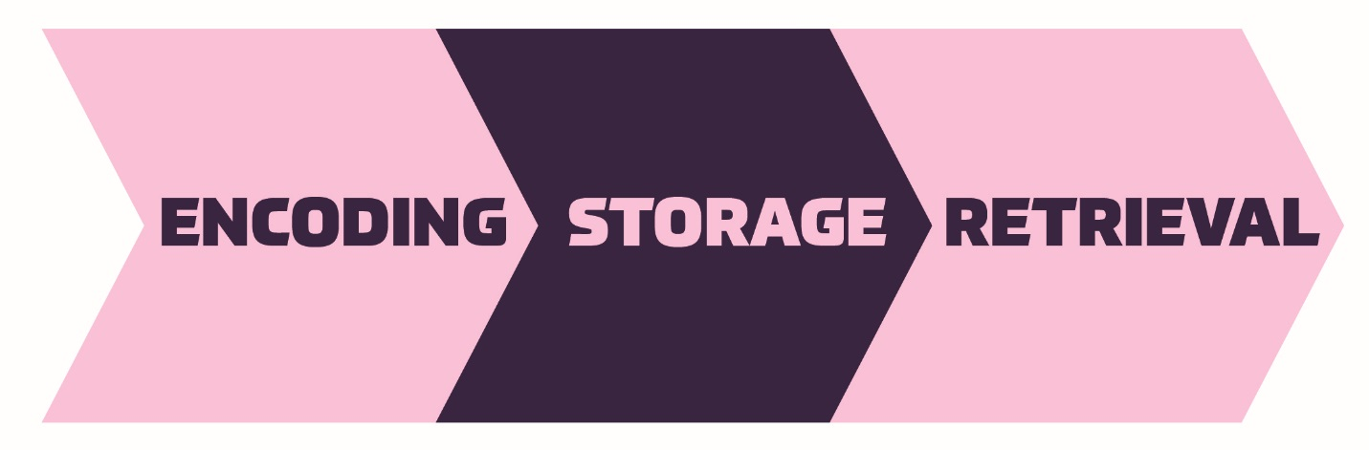
Figure 14.7 – The memory process.
Encoding involves the input of information into the memory system. Storage is the retention of the encoded information. Retrieval, or getting the information out of memory and back into awareness, is the third function.

Encoding (Input of Information to Memory)
We get information into our brains through a process called encoding, which is the input of information into the memory system. Once we receive sensory information from the environment, our brains label or code it. We organize the information with other similar information and connect new concepts to existing concepts. Encoding information occurs through both automatic processing and effortful processing. For example, if someone asks you what you ate for lunch today, more than likely you could recall this information quite easily. This is known as automatic processing, or the encoding of details like time, space, frequency, and the meaning of words. Automatic processing is usually done without any conscious awareness.

Recalling the last time you studied for a test is another example of automatic processing. But what about the actual test material you studied? It probably required a lot of work and attention on your part to encode that information; this is known as effortful processing. When you first learn new skills such as driving a car, you have to put forth effort and attention to encode information about how to start a car, how to brake, how to handle a turn, and so on. Once you know how to drive, you can encode additional information about this skill automatically.

Storage (Retaining Information in Memory)
Once the information has been encoded, we have to retain it. Our brains take the encoded information and place it in storage. Storage is the creation of a permanent record of information. In order for a memory to go into storage (i.e., long-term memory), it has to pass through three distinct stages: Sensory Memory, Short-Term Memory, and finally Long-Term Memory. These stages were first proposed by Richard Atkinson and Richard Shiffrin (1968). Their model of human memory, called Atkinson-Shiffrin (A-S), is based on the belief that we process memories in the same way that a computer processes information.

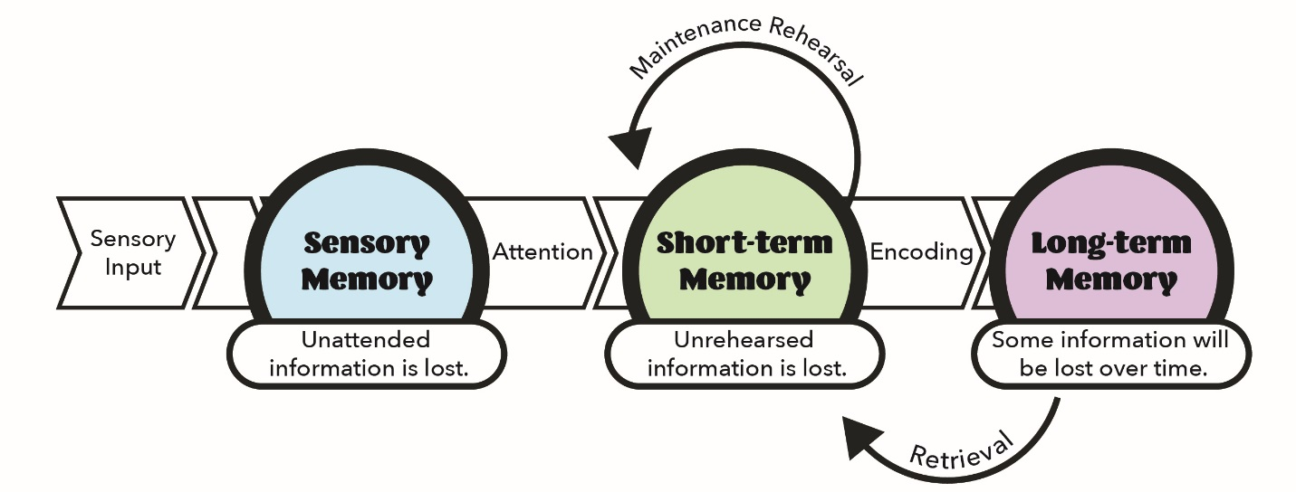
Figure 14.8 - According to the Atkinson-Shiffrin model of memory, information passes through three distinct stages in order for it to be stored in long-term memory.

Sensory Memory (First Stage of Storage)
In the Atkinson-Shiffrin model, stimuli from the environment are processed first in sensory memory, storage of brief sensory events, such as sights, sounds, and tastes. It is very brief storage—up to a couple of seconds. We are constantly bombarded with sensory information. We cannot absorb all of it, or even most of it. And most of it has no impact on our lives. For example, what was your professor wearing the last class period? As long as the professor was dressed appropriately, it does not really matter what they were wearing. Sensory information about sights, sounds, smells, and even textures, which we do not view as valuable information, we discard. If we view something as valuable, the information will move into our short-term memory system.

One study of sensory memory researched the significance of valuable information on short-term memory storage. J. R. Stroop discovered a memory phenomenon in the 1930s: you will name a color more easily if it appears printed in that color, which is called the Stroop effect.

The Stroop Effect describes why it is difficult for us to name a color when the word and the color of the word are different. To test this out a person is instructed not to read the words below, but to say the color the word is printed in. For example, upon seeing the word “yellow” in green print, they should say “green,” not “yellow.” This experiment is fun, but it’s not as easy as it seems.
Red  Orange  Green  Yellow  Purple | Blue  Purple  Yellow  Green  Blue | Yellow  Orange  Black  Red  Purple

Short-Term Memory or Working Memory (Second Stage of Storage)
Short-term memory is a temporary storage system that processes incoming sensory memory; sometimes it is called working memory. Short-term memory takes information from sensory memory and sometimes connects that memory to something already in long-term memory. Short-term memory storage lasts about 20 seconds. Think of short-term memory as the information you have displayed on your computer screen—a document, a spreadsheet, or a web page. Information in short-term memory either goes to long-term memory (when you save it to your hard drive) or it is discarded (when you delete a document or close a web browser).

George Miller (1956), in his research on the capacity of memory, found that most people can retain about seven items in short-term memory. Some remember five, some nine, so he called the capacity of short-term memory the range of seven items plus or minus two.

To explore the capacity and duration of short-term memory, two people can try this activity. One person reads the strings of random numbers below out loud to the other, beginning each string by saying, “Ready?” and ending each by saying, “Recall.” Then the second person should try to write down the string of numbers from memory.
9754  6419 | 68259  67148 | 913825  648327 | 5316842  5963827 | 86951372  51739826 | 719384273  163875942

This can be used to determine the longest string of digits that you can store. For most people, this will be close to seven, Miller’s famous seven plus or minus two. Recall is somewhat better for random numbers than for random letters (Jacobs, 1887) and is also often slightly better for information we hear (acoustic encoding, which is the encoding of sounds) rather than what we see (visual encoding, which is the encoding of images and words in particular) (Anderson, 1969).

Long-Term Memory (Third and Final Stage of Storage)
Long-term memory is the continuous storage of information. Unlike short-term memory, the storage capacity of long-term memory has no limits. It encompasses all the things you can remember that happened more than just a few minutes ago to all of the things that you can remember that happened days, weeks, and years ago. In keeping with the computer analogy, the information in your long-term memory would be like the information you have saved on the hard drive. It isn’t there on your desktop (your short-term memory), but you can pull up this information when you want it, at least most of the time. Not all long-term memories are strong memories. Some memories can only be recalled through prompts. For example, you might easily recall a fact— “What is the capital of the United States?”—or a procedure—“How do you ride a bike?”—but you might struggle to recall the name of the restaurant you had dinner at when you were on vacation in France last summer. A prompt, such as that the restaurant was named after its owner, who spoke to you about your shared interest in soccer, may help you recall (retrieve) the name of the restaurant.

Retrieval (Finding Memories)
So you have worked hard to encode via effortful processing (a lot of work and attention on your part in order to encode that information) and store some important information for your upcoming final exam. How do you get that information back out of storage when you need it? The act of getting information out of memory storage and back into conscious awareness is known as retrieval. This would be similar to finding and opening a paper you had previously saved on your computer’s hard drive. Now it’s back on your desktop, and you can work with it again. Our ability to retrieve information from long-term memory is vital to our everyday functioning. You must be able to retrieve information from memory in order to do everything from knowing how to brush your hair and teeth, to driving to work, to knowing how to perform your job once you get there.

Long-Term Memory Retrieval (Storage System): Recall, Recognition, Relearning, and Forgetting
There are three ways you can retrieve information out of your long-term memory storage system: recall, recognition, and relearning. Recall is what we most often think about when we talk about memory retrieval: it means you can access information without cues. For example, you would use recall for an essay test. Recognition happens when you identify information that you have previously learned after encountering it again. It involves a process of comparison. When you take a multiple-choice test, you are relying on recognition to help you choose the correct answer. The third form of retrieval is relearning, and it’s just what it sounds like, it involves learning information that you previously learned. Whitney took Spanish in high school, but after high school she did not have the opportunity to speak Spanish. Whitney is now 31, and her company has offered her an opportunity to work in their Mexico City office. In order to prepare herself, she enrolls in a Spanish course at the local community college. She’s surprised at how quickly she’s able to pick up the language after not speaking it for 13 years; this is an example of relearning.

Forgetting (It Wasn’t Locked In)
As we just learned, your brain must do some work (effortful processing) to encode information and move it into short-term, and ultimately long-term memory. This has strong implications for a student, as it can impact their learning – if one doesn’t work to encode and store information, it will likely be forgotten. Research indicates that people forget 80 percent of what they learn only a day later. This statistic may not sound very encouraging, given all that you’re expected to learn and remember as a college student. Really, though, it points to the importance of a study strategy other than waiting until the night before a final exam to review a semester’s worth of readings and notes. When you learn something new, the goal is to “lock it in” sooner rather than later, and move it from short-term memory to long-term memory, where it can be accessed when you need it (like at the end of the semester for your final exam or maybe years from now). The next section will explore a variety of strategies that can be used to process information more deeply and help improve retrieval.

Memory Strategies
Knowing What to Know
How can you decide what to study and what you need to know? The answer is to prioritize what you’re trying to learn and memorize, rather than trying to tackle all of it. Below are some strategies to help you do this:
- Think about concepts rather than facts: Most of the time instructors are concerned about you learning about the key concepts in a subject or course rather than specific facts.
- Take cues from your instructor: Pay attention to what your instructor writes on the board, mentions repeatedly in class, or includes in study guides and handouts, they are likely core concepts that you’ll want to focus on.
- Look for key terms: Textbooks will often put key terms in bold or italics.
- Use summaries: Read end of chapter summaries, or write your own, to check your understanding of the main elements of the reading.

Transferring Information from Short-Term Memory to Long-Term Memory
In the previous discussion of how memory works, the importance of making intentional efforts to transfer information from short-term to long-term memory was noted. Below are some strategies to facilitate this process:
- Start reviewing new material immediately: Remember that people typically forget a significant amount of new information within 24 hours of learning it.
- Study frequently for shorter periods of time: If you want to improve the odds of recalling course material by the time of an exam or in future class, try reviewing it a little bit every day.

Strengthening your Memory
How can you work to strengthen your overall memory? Some people have stronger memories than others but memorizing new information takes work for anyone. Below are some strategies that can aid memory:
- Rehearsal: One strategy is rehearsal, or the conscious repetition of information to be remembered (Craik & Watkins, 1973). Academic learning comes with time and practice, and at some point the skills become second nature.
- Incorporate visuals: Visual aids like note cards, concept maps, and highlighted text are ways of making information stand out. These aids make the information to be memorized seem more manageable and less daunting.
- Create mnemonics: Memory devices known as mnemonics can help you retain information while only needing to remember a unique phrase or letter pattern that stands out. They are especially useful when we want to recall larger bits of information such as steps, stages, phases, and parts of a system (Bellezza, 1981). There are different types of mnemonic devices:
  - Acronym: An acronym is a word formed by the first letter of each of the words you want to remember. Such as HOMES for the Great Lakes (Huron, Ontario, Michigan, Erie, and Superior)
  - Acrostic: In an acrostic, you make a phrase of all the first letters of the words. For example, if you need to remember the order of mathematical operations, recalling the sentence “Please Excuse My Dear Aunt Sally” will help you, because the order of mathematical operations is Parentheses, Exponents, Multiplication, Division, Addition, Subtraction.
  - Jingles: Rhyming tunes that contain key words related to the concept, such as “i before e, except after c” are jingles.
  - Visual: Using a visual to help you remember is also useful. Such as the knuckle mnemonic shown in the image below to help you remember the number of days in each month. Months with 31 days are represented by the protruding knuckles and shorter months fall in the spots between knuckles.

Figure 14.9 - You might use a mnemonic device to help you remember someone’s name, a mathematical formula, or the six levels of Bloom’s taxonomy.

- Chunking: Another strategy is chunking, where you organize information into manageable bits or chunks, such as turning a phone number you remember into chunks.
- Connect new information to old information: It’s easier to remember new information if you can connect it to old information, a familiar frame of reference, or a personal experience.
- Get quality sleep: Although some people require more or less sleep than the recommended amount, most people should aim for six to eight hours every night.

Adolescence (A Time of Transitions)
Cognitive growth and a new found sense of freedom and independence makes it both easier and more difficult for teens when making choices and coping with upcoming transitions and life decisions.

Academic Achievement, High School Dropouts, and Gap Years
As Adolescents grow older, they encounter age-related transition points that require them to progress into a new role, such as go to college, take a year off or Gap Year, or start to work towards a career. Educational expectations vary not only from culture to culture, but also from class to class. While middle- or upper-class families may expect their daughter or son to attend a four-year university after graduating from high school, other families may expect their child to immediately begin working full-time, as many within their families have done before.

Academic Achievement
Adolescents spend more waking time in school than in any other context (Eccles & Roeser, 2011). Academic achievement during adolescence is predicted by interpersonal (e.g., parental engagement in adolescents’ education), intrapersonal (e.g., intrinsic motivation), and institutional (e.g., school quality) factors. Academic achievement is important in its own right as a marker of positive adjustment during adolescence but also because academic achievement sets the stage for future educational and occupational opportunities. The most serious consequence of school failure, particularly dropping out of school, is the high risk of unemployment or underemployment in adulthood that follows. High achievement can set the stage for college or future vocational training and opportunities.

High School Dropouts
The status dropout rate refers to the percentage of 16 to 24 year-olds who are not enrolled in school and do not have high school credentials (either a diploma or an equivalency credential such as a General Educational Development [GED] certificate). The dropout rate is based on sample surveys of the civilian, non- institutionalized population, which excludes persons in prisons, persons in the military, and other persons not living in households. The dropout rate among high school students has declined from a rate of 9.7% in 2006, to 5.4% in 2017.

Gap Year: How: different Societies Socialize Young Adults
Age transition points require socialization into new roles that can vary widely between societies. For example, in the United Kingdom, when teens finish their secondary schooling (aka high school in the United States), they often take a year “off” before entering college. Frequently, they might take a job, travel, or find other ways to experience another culture. Prince William, the Duke of Cambridge, spent his gap year practicing survival skills in Belize, teaching English in Chile, and working on a dairy farm in the United Kingdom (Prince of Wales 2012a). His brother, Prince Harry, advocated for AIDS orphans in Africa and worked as a jackeroo (a novice ranch hand) in Australia (Prince of Wales 2012b).

Figure 14.10 – Prince William. | Figure 14.11 – Prince Harry.

In the United States, this life transition point is socialized quite differently, and taking a year off is generally frowned upon. Instead, U.S. youth are encouraged to pick career paths by their mid-teens, to select a college and a major by their late teens, and to have completed all collegiate schooling or technical training for their career by their early twenties.

In other nations, this phase of the life course is tied into conscription, a term that describes compulsory military service. Egypt, Switzerland, Turkey, and Singapore all have this system in place. Youth in these nations (often only the males) are expected to undergo a number of months or years of military training and service.

Adolescents and Independence: Career, Work Experience, and Driving

Adolescents in the Workforce
Many adolescents work either summer jobs, or during the school year, or may work in lieu of college. Holding a job may offer teenagers extra funds, provide the opportunity to learn new skills, foster ideas about future careers, and perhaps shed light on the true value of money. However, there are numerous concerns about teenagers working, especially during the school year. Several studies have found that working more than 20 hours per week can lead to declines in grades, a general disengagement from school (Staff, Schulenberg, & Bachman, 2010; Lee & Staff, 2007; Marsh & Kleitman, 2005), an increase in substance abuse (Longest & Shanahan, 2007), engaging in earlier sexual behavior, and pregnancy (Staff et al., 2011). Like many employee groups, teens have seen a drop in the number of jobs. The summer jobs of previous generations have been on a steady decline, according to the United States Department of Labor, Bureau of Labor Statistics (2016).

Figure 14.12 – How many hours and the reasons why this teen works, will influence the effects of her job.

The Working Poor
A major concern in the United States is the rising number of young people who choose to work rather than continue their education and are growing up or continuing to grow up in poverty. Growing up poor or entering the workforce too soon, can cut off access to the education and services people need to move out of poverty and into stable employment. Research states that education was often a key to stability, and those raised in poverty are the ones least able to find well-paying work, perpetuating a cycle. Those who work only part time, may it be teens or whomever, are more likely to be classified as working poor than are those with full-time employment; higher levels of education lead to less likelihood of being among the working poor. In 2017, the working poor included 6.9 million Americans, down from 7.6 million in 2011 (U.S. Bureau of Labor Statistics, 2019).

Teenage Drivers
Driving gives teens a sense of freedom and independence from their parents. It can also free up time for parents as they are not shuttling teens to and from school, activities, or work. The National Highway Traffic Safety Administration (NHTSA) reports that in 2014 young drivers (15 to 20 year-olds) accounted for 5.5% (11.7 million) of the total number of drivers (214 million) in the US (National Center for Statistics and Analysis (NCSA), 2016). However, almost 9% of all drivers involved in fatal crashes that year were young drivers (NCSA, 2016), and according to the National Center for Health Statistics (2014), motor vehicle accidents are the leading cause of death for 15 to 20 year-olds. “In all motorized jurisdictions around the world, young, inexperienced drivers have much higher crash rates than older, more experienced drivers” (NCSA, 2016, p. 1).

The rate of fatal crashes is higher for young males than for young females, although for both genders the rate was highest for the 15-20 year-old age group. For young males, the rate for fatal crashes was approximately 46 per 100,000 drivers, compared to 20 per 100,000 drivers for young females. The NHTSA (NCSA, 2016) reported that of the young drivers who were killed and who had alcohol in their system, 81% had a blood alcohol count past what was considered the legal limit. Fatal crashes involving alcohol use were higher among young men than young women. The NHTSA also found that teens were less likely to use seat belt restraints if they were driving under the influence of alcohol, and that restraint use decreased as the level of alcohol intoxication increased.

AAA completed a study in 2014 that showed that the following are risk factors for accidents for teen drivers:
- Following cars too closely
- Driving too fast for weather and road conditions
- Distraction from fellow passengers
- Distraction from cell phones

According to the NHTSA, 10% of drivers aged 15 to 19 years involved in fatal crashes were reported to be distracted at the time of the crash; the highest figure for any age group (NCSA, 2016). Distraction coupled with inexperience has been found to greatly increase the risk of an accident (Klauer et al., 2014).

The NHTSA did find that the number of accidents has been on a decline since 2005. They attribute this to greater driver training, more social awareness to the challenges of driving for teenagers, and to changes in laws restricting the drinking age. The NHTSA estimates that the raising of the legal drinking age to 21 in all 50 states and the District of Columbia has saved 30,323 lives since 1975.

Figure 14.13 – This teen needs to have solid driver training and awareness of driving challenges.

Wisdom and Risk-Taking
Whether it is a sense heightened of ability (we’ve learned a lot about the egocentrism, personal fable, imaginary audience, or the lack of development of prefrontal cortex), or just poor decision making, many teens tend to take unnecessary risks. Wisdom, or the capacity for insight and judgment that is developed through experience, increases between the ages of 14 and 25, and increases with maturity, life experiences, and cognitive development. Wisdom increases gradually and is not the same as intelligence, and adolescents do not improve substantially on IQ tests since their scores are relative to others in their age group, as everyone matures at approximately the same rate. Adolescents must be monitored because they are more likely to take risks than adults. The behavioral decision-making theory proposes that adolescents and adults both weigh the potential rewards and consequences of an action. However, adolescents seem to give more weight to rewards, particularly social rewards, than do adults. Scaffolding adolescents until they show consistent and appropriate judgment will likely allow for fewer negative consequences.

Conclusion
In this chapter we looked at:
- Piaget’s formal operational stage
- Moral Development and Morality of Care theories
- Memories in the Information Processing Theory
- Adolescent transitions and independence

In the next chapter we will be examining adolescent social emotional development.

Chapter 15: Adolescence – Social Emotional Development

Chapter Objectives
After this chapter, you should be able to:
- Compare Erikson and Marcia’s Theories
- Explain Identity and Self-concept
- Summarize the Stages of Ethnic Identity Development
- Explain the Development of Gender Identity
- Summarize Sexuality Identity and Orientation
- Describe Antisocial Behaviors
- Explain the Developmental Stage of Emerging Adulthood

Introduction
Adolescents continue to refine their sense of self as they relate to others. Adolescent’s main questions are “Who am I?” and “Who do I want to be?” Some adolescents adopt the values and roles that their parents expect of them. Other teens develop identities that align more with the peer groups rather than their parents’ expectations. This is common as adolescents work to form their identities. They pull away from their parents and the peer group becomes very important (Shanahan, McHale, Osgood, & Crouter, 2007). Despite spending less time with their parents, most teens report positive feelings toward them (Moore, Guzman, Hair, Lippman, & Garrett, 2004). Warm and healthy parent-child relationships have been associated with positive outcomes for the adolescent, such as better grades and fewer school behavior problems, in the United States as well as in other countries (Hair et al., 2005).

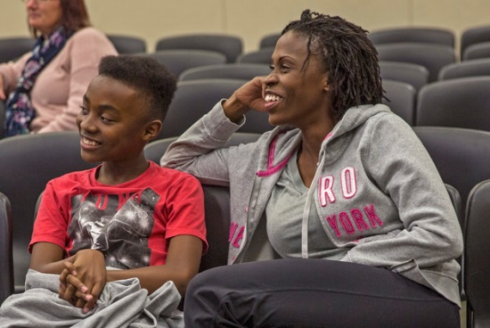
Figure 15.1 –The relationships between this teen and his mom will have positive outcomes for him.

Erik Erikson – Theory of Psychosocial Development
Erikson proposed that each period of life has a unique challenge or crisis that a person must face. This is referred to as a psychosocial development. According to Erikson, successful development involves dealing with and resolving the goals and demands of each of these crises in a positive way. These crises are usually called stages, although that is not the term Erikson used. If a person does not resolve a crisis successfully, it may hinder their ability to deal with later crises. For example, an individual who does not develop a clear sense of purpose and identity (Erikson’s fifth crisis - Identity vs. Role Confusion) may become self-absorbed and stagnate rather than working toward the betterment of others (Erikson’s seventh crisis - Generativity vs. Stagnation). However, most individuals are able to successfully complete the eight crises of his theory.

Identity vs. Role Confusion
Identity vs. Role Confusion is a major stage of development where the child has to learn the roles he will occupy as an adult. In adolescence, children (ages 12–18) face the task of identity vs. role confusion. Success in this stage will lead to the virtue of fidelity. Fidelity involves being able to commit one's self to others on the basis of accepting others, even when there may be ideological differences. According to Erikson, an adolescent’s main task is developing a sense of self. Adolescents struggle with questions such as “Who am I?” and “What do I want to do with my life?” Along the way, most adolescents try on many different selves to see which ones fit; they explore various roles and ideas, set goals, and attempt to discover their “adult” selves. Adolescents who are successful at this stage have a strong sense of identity and are able to remain true to their beliefs and values in the face of problems and other people’s perspectives. When adolescents are apathetic, do not make a conscious search for identity, or are pressured to conform to their parents’ ideas for the future, they may develop a weak sense of self and experience role confusion. They will be unsure of their identity and confused about the future. Teenagers who struggle to adopt a positive role will likely struggle to “find” themselves as adults.

Erikson saw this as a period of confusion and experimentation regarding identity and how one navigates along life’s path. During adolescence, we experience psychological moratorium, where teens put their current identity on hold while they explore their options for identity. The culmination of this exploration is a more coherent view of oneself. Those who are unsuccessful at resolving this stage may either withdraw further into social isolation or become lost in the crowd. However, more recent research suggests, that few leave this age period with identity achievement, and that most identity formation occurs during young adulthood (Côtè, 2006).

James Marcia – Theory of Identity Development
One approach to assessing identity development was proposed by James Marcia. In his approach, adolescents are asking questions regarding their exploration of and commitment to issues related to occupation, politics, religion, and sexual behavior. Studies assessing how teens pass through Marcia’s stages show that although most teens eventually succeed in developing a stable identity, the path to it is not always easy and there are many routes that can be taken. Some teens may simply adopt the beliefs of their parents or the first role that is offered to them, perhaps at the expense of searching for other more promising possibilities (foreclosure status). Other teens may spend years trying on different possible identities (moratorium status) before finally choosing one.

Marcia identified four identity statuses that represent the four possible combinations of the dimension of commitment and exploration.

Table 15.1 Identity Status

Identity Status | Description
Identity-Diffusion status is a status that characterizes those who have neither explored the options, nor made a commitment to an identity. | The individual does not have firm commitments regarding the issues in question and is not making progress toward them. Those who persist in this identity may drift aimlessly with little connection to those around them or have little sense of purpose in life.
Identity-Foreclosure status is the status for those who have made a commitment to an identity without having explored the options. | The individual has not engaged in any identity experimentation and has established an identity based on the choices or values of others. Some parents may make these decisions for their children and do not grant the teen the opportunity to make choices. In other instances, teens may strongly identify with parents and others in their life and wish to follow in their footsteps.
Identity-Moratorium status is a status that describes those who are exploring in an attempt to establish an identity but have yet to have made any commitment. | The individual is exploring various choices but has not yet made a clear commitment to any of them. This can be an anxious and emotionally tense time period as the adolescent experiments with different roles and explores various beliefs. Nothing is certain and there are many questions, but few answers.
Identity-Achievement status refers to the status for those who, after exploration, have made a commitment. | The individual has attained a coherent and committed identity based on personal decisions. This is a long process and is not often achieved by the end of adolescence

The least mature status, and one common in many children, is identity diffusion. During high school and the college years, teens and young adults move from identity diffusion and foreclosure toward moratorium and achievement. The biggest gains in the development of identity are in college, as college students are exposed to a greater variety of career choices, lifestyles, and beliefs. This is likely to spur on questions regarding identity. A great deal of the identity work we do in adolescence and young adulthood is about values and goals, as we strive to articulate a personal vision or dream for what we hope to accomplish in the future (McAdams, 2013).

To help them work through the process of developing an identity, teenagers may try out different identities in different social situations. They may maintain one identity at home and a different type of persona when they are with their peers. Eventually, most teenagers do integrate the different possibilities into a single self-concept and a comfortable sense of identity (identity-achievement status). For teenagers, the peer group provides valuable information about the self-concept. For instance, in response to the question “What were you like as a teenager? (e.g., cool, nerdy, awkward?),” posed on the website Answerbag, one teenager replied in this way:

I’m still a teenager now, but from 8th-9th grade I didn’t really know what I wanted at all. I was smart, so I hung out with the nerdy kids. I still do; my friends mean the world to me. But in the middle of 8th grade I started hanging out with which you may call the “cool” kids…and I also hung out with some stoners, just for variety. I pierced various parts of my body and kept my grades up. Now, I’m just trying to find who I am. I’m even doing my sophomore year in China so I can get a better view of what I want. (Answerbag, 2007). What were you like as a teenager? (e.g., cool, nerdy, awkward?). (Quoted from dojokills on http://www.answerbag.com/q_view/171753)

A big part of what the adolescent is learning is social identity, the part of the self-concept that is derived from one’s group memberships. Adolescents define their social identities according to how they are similar to and different from others, finding meaning in the sports, religious, school, gender, and ethnic categories they belong to.

Figure 15.2 | Figure 15.3 | Figure 15.3 | Figure 15.4

Adolescents search for stable attachments through the development of social identities.

Development of Identity and Self Concept: Who am I?
Developmental psychologists have researched several different areas of identity development for adolescence and some of the main areas include:

Religious Identity
The religious views of teens are often similar to that of their families (Kim- Spoon, Longo, & McCullough, 2012). Most teens may question specific customs, practices, or ideas in the faith of their parents, but few completely reject the religion of their families.

Figure 15.5 – A Muslim teen | Figure 15.6 – A Jewish teen | Figure 15.7 – A Catholic teen | Figure 15.8 – A Buddhist teen

Political Identity
The political ideology of teens is also influenced by their parents’ political beliefs. A new trend in the 21st century is a decrease in party affiliation among adults. Many adults do not align themselves with either the democratic or republican party, but view themselves as more of an “independent”. Their teenage children are often following suit or becoming more apolitical (Côtè, 2006).

Vocational Identity
While adolescents in earlier generations envisioned themselves as working in a particular job, and often worked as an apprentice or part-time, this is rarely the case today. Vocational identity takes longer to develop, as most of today’s occupations require specific skills and knowledge that will require additional education or are acquired on the job itself. In addition, many of the jobs held by teens are not in professions that most teens will seek as adults.

Gender Identity
This is also becoming an increasingly prolonged task as attitudes and norms regarding gender keep changing. The roles appropriate for males and females are evolving. Some teens may foreclose on a gender identity as a way of dealing with this uncertainty, and they may adopt more stereotypic male or female roles (Sinclair & Carlsson, 2013). We will be looking more closely at gender identity later in the chapter.

Self-Concept and Self-Esteem
In adolescence, teens continue to develop their self-concept. Their ability to think of the possibilities and to reason more abstractly may explain the further differentiation of the self during adolescence. However, the teen’s understanding of self is often full of contradictions. Young teens may see themselves as outgoing but also withdrawn, happy yet often moody, and both smart and completely clueless (Harter, 2012). These contradictions, along with the teen’s growing recognition that their personality and behavior seem to change depending on who they are with or where they are, can lead the young teen to feel like a fraud. With their parents they may seem angrier and sullen, with their friends they are more outgoing and goofy, and at work they are quiet and cautious. “Which one is really me?” may be the refrain of the young teenager. Harter (2012) found that adolescents emphasize traits such as being friendly and considerate more than do children, highlighting their increasing concern about how others may see them. Harter also found that older teens add values and moral standards to their self-descriptions.

Figure 15.9 – An adolescent’s understanding of their self is often full of contradictions. | Figure 15.10 – Adolescents are more likely to emphasize values in their self-descriptions.

As self-concept develops, so does self-esteem. In addition to the academic, social, appearance, and physical/athletic dimensions of self-esteem in middle and late childhood, teens also add perceptions of their competency in romantic relationships, on the job, and in close friendships (Harter, 2006). Self-esteem often decreases when children transition from one school setting to another, such as shifting from elementary to middle school, or junior high to high school (Ryan, Shim, & Makara, 2013). These decreases are usually temporary, unless there are additional stressors such as parental conflict, or other family disruptions (De Wit, Karioja, Rye, & Shain, 2011). Self-esteem rises from mid to late adolescence for most teenagers, especially if they feel confident in their peer relationships, their appearance, and athletic abilities (Birkeland, Melkivik, Holsen, & Wold, 2012).

Development of Gender Identity
From birth, children are assigned a gender and are socialized to conform to certain gender roles based on their biological sex. “Sex,” refers to physical or physiological differences between males, females, and intersex persons, including both their primary and secondary sex characteristics. “Gender,” on the other hand, refers to social or cultural distinctions associated with a given sex.

When babies are born, they are assigned a gender based on their biological sex—male babies are assigned as boys, female babies are assigned as girls, and intersex babies are born with sex characteristics that do not fit the typical definitions for male or female bodies, and are usually relegated into one gender category or another. Scholars generally regard gender as a social construct, meaning that it doesn’t exist naturally but is instead a concept that is created by cultural and societal norms. From birth, children are socialized to conform to certain gender roles based on their biological sex and the gender to which they are assigned.
A person’s subjective experience of their own gender and how it develops, or gender identity, is a topic of much debate. It is the extent to which one identifies with a particular gender; it is a person’s individual sense and subjective experience of being a man, a woman, or other gender. It is often shaped early in life and consists primarily of the acceptance (or non-acceptance) of one’s membership into a gender category. In most societies, there is a basic division between gender attributes assigned to males and females. In all societies, however, some individuals do not identify with some (or all) of the aspects of gender that are assigned to their biological sex.

Those that identify with the gender that corresponds to the sex assigned to them at birth (for example, they are assigned female at birth and continue to identify as a girl, and later a woman) are called cisgender. In many Western cultures, individuals who identify with a gender that is different from their biological sex (for example, they are assigned female at birth but feel inwardly that they are a boy or a gender other than a girl) are called transgender. Some transgender individuals, if they have access to resources and medical care, choose to alter their bodies through medical interventions such as surgery and hormonal therapy so that their physical being is better aligned with their gender identity.

Figure 15.11 - This person identifies as genderqueer.

Recent terms such as “genderqueer,” “genderfluid,” “gender variant,” “androgynous,” “agender,” and “gender nonconforming” are used by individuals who do not identify within the gender binary as either a man or a woman. Instead they identify as existing somewhere along a spectrum or continuum of genders, or outside of the spectrum altogether, often in a way that is continuously evolving.

The Gender Continuum
Viewing gender as a continuum allows us to perceive the rich diversity of genders, from trans- and cisgender to gender queer and agender. Most Western societies operate on the idea that gender is a binary, that there are essentially only two genders (men and women) based on two sexes (male and female), and that everyone must fit one or the other. This social dichotomy enforces conformance to the ideals of masculinity and femininity in all aspects of gender and sex—gender identity, gender expression, and biological sex.

According to supporters of queer theory, gender identity is not a rigid or static identity but can continue to evolve and change over time. Queer theory developed in response to the perceived limitations of the way in which identities are thought to become consolidated or stabilized (for instance, gay or straight), and theorists constructed queerness in an attempt to resist this. In this way, the theory attempts to maintain a critique rather than define a specific identity. While “queer” defies a simple definition, the term is often used to convey an identity that is not rigidly developed but is instead fluid and changing.

The Genderbread Person
In 2012, Sam Killerman created the Genderbread Person as an infographic to break down gender identity, gender expression, biological sex, and sexual orientation. In 2018, he updated it to version 2.0 to be more accurate, and inclusive.

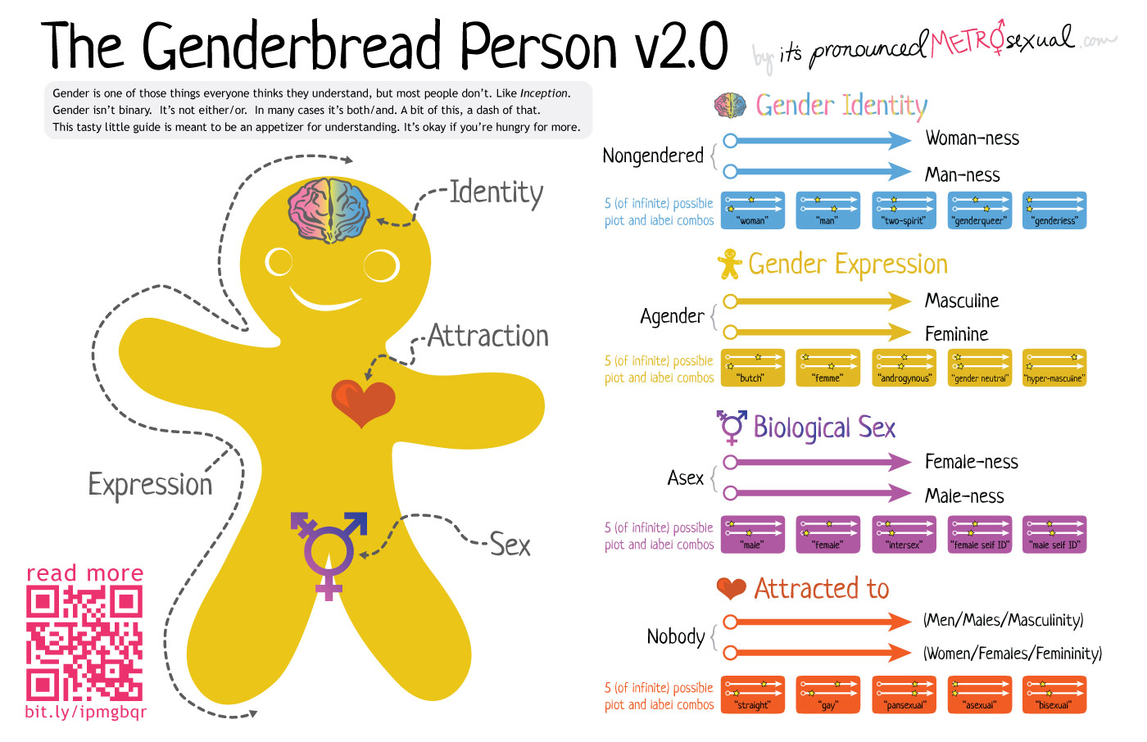
Figure 15.12 – The Genderbread Person explains gender identity, gender expression, biological sex, and sexual orientation.

Gender Pronouns
Pronouns are a part of language used to refer to someone or something without using proper nouns. In standard English, some singular third-person pronouns are "he" and "she," which are usually seen as gender-specific pronouns, referring to a man and a woman, respectively. A gender-neutral pronoun or gender-inclusive pronoun is one that gives no implications about gender, and could be used for someone of any gender.

Some languages only have gender-neutral pronouns, whereas other languages have difficulty establishing any that aren't gender-specific. People with non-binary gender identities often choose new third-person pronouns for themselves as part of their transition. They often choose gender-neutral pronouns so that others won't see them as female or male.

Here is a table based on the Rainbow Coalition of Yellowknife’s Handy Guide to Pronouns:

Table 15.2 Guide to Pronouns

Pronouns | Example
He/His/Him  (masculine pronouns) | He is going to the store to buy himself a hat. I saw him lose his old hat yesterday.
She/Her/Her  (feminine pronouns) | She is going to the store to buy herself a hat. I saw her lose her old hat yesterday.
They/Them/Their  (gender neutral pronouns) | They are going to the store to buy themselves a hat. I saw them lose their old hat yesterday.

Factors that Influence Gender Identity
Although the formation of gender identity is not completely understood, many factors have been suggested as influencing its development. Biological factors that may influence gender identity include pre- and post-natal hormone levels and genetic makeup. Social factors include ideas regarding gender roles conveyed by family, authority figures, mass media, and other influential people in a child’s life. According to social-learning theory, children develop their gender identity through observing and imitating the gender-linked behaviors of others; they are then “rewarded” for imitating the behaviors of people of the same gender and “punished” for imitating the behaviors of another gender. For example, male children will often be rewarded for imitating their father’s love of baseball but punished or redirected in some way if they imitate their older sister’s love of dolls. Children are shaped and molded by the people surrounding them, who they try to imitate and follow.

Gender Roles
The term “gender role” refers to society’s concept of how men and women are expected to act. As we grow, we learn how to behave from those around us. In this socialization process, children are introduced to certain roles that are typically linked to their biological sex. The term “gender role” refers to society’s concept of how men and women are expected to act and behave. Gender roles are based on norms, or standards, created by society. In American culture, masculine roles have traditionally been associated with strength, aggression, and dominance, while feminine roles have traditionally been associated with passivity, nurturing, and subordination.

Gender Socialization
The socialization process in which children learn these gender roles begins at birth. Today, our society is quick to outfit male infants in blue and girls in pink, even applying these color-coded gender labels while a baby is in the womb. It is interesting to note that these color associations with gender have not always been what they are today. Up until the beginning of the 20th century, pink was actually more associated with boys, while blue was more associated with girls—illustrating how socially constructed these associations really are.
Gender socialization occurs through four major agents: family, education, peer groups, and mass media. Each agent reinforces gender roles by creating and maintaining normative expectations for gender-specific behavior. Exposure also occurs through secondary agents, such as religion and the workplace. Repeated exposure to these agents over time leads people into a false sense that they are acting naturally based on their gender rather than following a socially constructed role.

Gender Stereotypes, Sexism, and Gender-Role Enforcement
The attitudes and expectations surrounding gender roles are not typically based on any inherent or natural gender differences, but on gender stereotypes, or oversimplified notions about the attitudes, traits, and behavior patterns of males and females. We engage in gender stereotyping when we do things like making the assumption that a teenage babysitter is female.

While it is somewhat acceptable for women to take on a narrow range of masculine characteristics without repercussions (such as dressing in traditionally male clothing), men are rarely able to take on more feminine characteristics (such as wearing skirts) without the risk of harassment or violence. This threat of punishment for stepping outside of gender norms is especially true for those who do not identify as male or female.

Figure 15.13 – Would girls likely pose this way for an image? What does this say about gender stereotypes?

Gender stereotypes form the basis of sexism, or the prejudiced beliefs that value males over females. Common forms of sexism in modern society include gender-role expectations, such as expecting women to be the caretakers of the household. Sexism also includes people’s expectations of how members of a gender group should behave. For example, girls and women are expected to be friendly, passive, and nurturing; when she behaves in an unfriendly or assertive manner, she may be disliked or perceived as aggressive because she has violated a gender role (Rudman, 1998). In contrast, a boy or man behaving in a similarly unfriendly or assertive way might be perceived as strong or even gain respect in some circumstances.

Socialization Agents During Adolescence
Adolescence is a crucial period in social development, research shows there are four main types of relationships that influence an adolescent: parents, peers, community, and society.

Parents and Teens: Autonomy and Attachment
While most adolescents get along with their parents, they do spend less time with them (Smetana, 2011). This decrease in the time spent with families may be a reflection of a teenager’s greater desire for independence or autonomy. It can be difficult for many parents to deal with this desire for autonomy. However, it is normal for teenagers to increasingly distance themselves and establish relationships outside of their families in preparation for adulthood.

Children in middle and late childhood are increasingly given greater freedom regarding basic decision making. This continues in adolescence, as teens demand more and more control over the decisions that affect their daily lives. Teens believe they should manage the areas that parents previously had considerable control over, which can increase tension between parents and their teenagers. Their arguments often center on issues of a power struggle or conflict in areas such as chores, homework, curfew, dating, personal appearance, and the right to privacy.

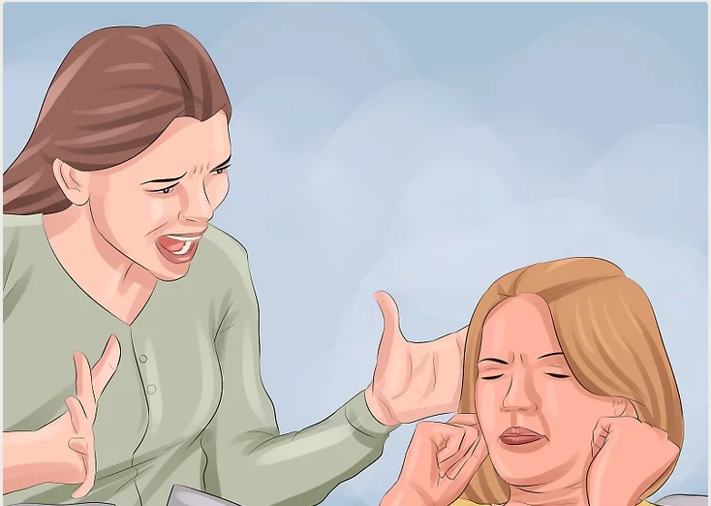
Figure 15.14 – Teenagers report more conflicts with their mothers.

As teens grow older, more compromise is reached between parents and teenagers (Smetana, 2011). Teens report more conflict with their mothers, as many mothers believe they should still have some control over many of these areas, yet often report their mothers to be more encouraging and supportive (Costigan, Cauce, & Etchison, 2007). Parents are more controlling of daughters, especially early maturing girls, than they are sons (Caspi, Lynam, Moffitt, & Silva, 1993). In addition, culture and ethnicity also play a role in how restrictive parents are with the daily lives of their children (Chen, Vansteenkiste, Beyers, Soensens, & Van Petegem, 2013).

Having supportive, less conflict ridden relationships with parents also benefits teenagers. Research on attachment in adolescence finds that teens who are still securely attached to their parents have less emotional problems (Rawatlal, Kliewer & Pillay, 2015), are less likely to engage in drug abuse and other criminal behaviors (Meeus, Branje & Overbeek, 2004), and have more positive peer relationships (Shomaker & Furman, 2009). This means that both parents and teenagers need to strike a balance between autonomy, while still maintaining close and caring familial relationships.

The Parent-Child Relationship
The relationship with parents may be a mitigating factor of the negative influence by peers. Communicating family rules and parental style have been inversely associated to substance, alcohol, and tobacco consumption during adolescence. This influence is essential for adolescents’ development up to adulthood. Communication between parents and adolescents emerges as a protective factor for alcohol, tobacco, and substance use (Newman, Harrison & Dashiff, 2008).

Sen (2010) observed that family meals could lead to creating a closer relation between parents and adolescents, by strengthening a positive relationship and avoiding certain risk behaviors, such as substance use amongst girls and alcohol consumption, physical violence, and robberies, amongst boys. These differences between genders may be due to a greater importance that girls attribute to family activities but they do not reveal that boys are indifferent to them, only that the relation between genders may differ. Huebner and Howell (2003) verified that parental monitoring and communication with parents protected adolescents of both genders from being involved in risk behaviors.

Figure 15.15 – if this father monitors and communicates with his son, he can reduce the teen’s risky behaviors.
Parental monitoring can be defined as parents’ knowledge about their children’s activities, who they hang out with and what they do. It has been associated to protection of various risk behaviors throughout adolescence, such as substance use or sexual behaviors. The greater the parental monitoring, the lower the adolescents’ involvement in risk behavior. It may vary according to age, gender or ethnicity and it generally decreases with age (Westling, Andrews, Hampson & Peterson, 2008).

Relationships with Peers and Peer Groups

Peer Relationships
In addition, peers also serve as an important source of social support and companionship during adolescence. As children become adolescents, they usually begin spending more time with their peers and less time with their families, and these peer interactions are increasingly unsupervised by adults. The level of influence that peers can have over an adolescent makes these relationships particularly important in their personal development. Adolescents with positive peer relationships are happier and better adjusted than those who are socially isolated or have conflictual peer relationships.

Adolescents’ notions of friendship increasingly focus on intimate exchanges of thoughts and feelings, which are important to forming friendships; these high quality friendships may enhance a child’s development regardless of the particular characteristics of those friends. In addition, peers also serve as an important source of social support and companionship during adolescence.

The peer group may serve as a model and influence behaviors and attitudes and also provide easy access, encouragement and an appropriate social setting for consumption (Glaser, Shelton & Bree, 2010). Social Learning Theory suggests that it is not necessary for adolescents to observe a given behavior and adopt it; it is sufficient to perceive that the peer group accepts it, in order to be able to opt for similar behaviors (Petraitis, Flay & Miller, 1995).

Peers can serve both positive and negative functions during adolescence. Relationships with peers are valuable opportunities for adolescents to practice their social and conflict resolution skills. But negative peer pressure can lead adolescents to make riskier decisions or engage in more problematic behavior than they would alone or in the presence of their family. One of the most widely studied aspects of adolescent peer influence is known as deviant peer contagion (Dishion & Tipsord, 2011), which is the process by which peers reinforce problem behavior by laughing or showing other signs of approval that then increase the likelihood of future problem behavior.
Peers may strongly determine preference in the way of dressing, speaking, using illicit substances, sexual behavior, adopting and accepting violence, adopting criminal and anti-social behaviors, and in many other areas of the adolescent’s life (Padilla, Walker & Bean, 2009; Tomé, Matos & Diniz, 2008). An example of this is that the main motives for alcohol consumption given by adolescents are related to social events, which usually take place in the company of friends, namely: drinking makes holidays more fun, it facilitates approaching others, it helps relaxing or facilitates sharing experiences and feelings (Kuntsche, Knibbe, Gmel & Engels, 2005). Also, mimicking risk behaviors may be greater when consumption begins in the context of a social event (Larsen, Engels, Souren, Granic & Overbeek, 2010).

Figure 15.16 - Adolescent boys drinking at a party.

On the other hand, having friends allows to share experiences and feelings and to learn how to solve conflicts. Not having friends, on the other hand, leads to social isolation and limited social contacts, as there are fewer opportunities to develop new relations and social interactional skills.

Friendship is also positively associated to psychological well-being (Ueno, 2004), Stronger friendships may provide adolescents with an appropriate environment to development in a healthy way and to achieve good academic results. Adolescents with reciprocal friendships mention high levels of feelings of belonging in school; at the same time, reciprocity and feelings of belonging have positive effects in academic results (Vaquera & Kao, 2008).

School is a setting where interpersonal relations are promoted, which are important for youngsters’ personal and social development (Ruini et al., 2009); it is responsible for the transmission of behavioral norms and standards and it represents an essential role in the adolescent’s socialization process. The school is able to gather different peer communities and to promote self-esteem and a harmonious development between adolescents, which makes it a privileged space for meetings and interactions (Baptista, Tomé, Matos, Gaspar & Cruz, 2008). Adolescents spend a great part of their time at school, which also makes it a privileged context for involvement in or protection from risk behaviors (Piko & Kovács, 2010). Camacho, Tomé, Matos, Gamito and Diniz (2010) confirmed that adolescents who like school were those that more often were part of a peer group without involvement in risk behaviors; while those that mentioned they did not have any friends reported that they liked school less and those in conflict with their peers had more negative health outcomes.

Figure 15.17 - These teens are at a concert together.

Despite the positive influence of the peer group during adolescence, the higher the adolescent’s autonomy from the peer group, the higher their resilience against its influence. This resilience seems to increase with age, which may mean that it is associated with youngsters’ maturity; and girls emerge in several studies as more resilient than boys (Sumter, Bokhorst, Steinberg & Westenberg, 2009).

Another factor that may be found in the influence of the peer group is the type of friendship, which adolescents maintain with their peer group: if friends are close they have a greater influence on the other’s behaviors (Glaser, Shelton & Bree, 2010). When the friendship is perceived as reciprocal and of quality, exerts greater influence (Mercken, Snijders, Steglich, Vartiainen & Vries, 2010). Another factor, which has been identified as a possible way of decreasing peer influence, is assertive refusal. Adolescents that are able to maintain an assertive refusal are less susceptible to the group’s influence (Glaser, Shelton & Bree, 2010). These are only some variables identified as possible factors decreasing peer influence.

Peers in Groups
During adolescence, it is common to have friends of the opposite sex much more than in childhood, peer groups evolve from primarily single-sex to mixed-sex. Teens within a peer group tend to be similar to one another in behavior and attitudes, which has been explained as a function of homophily, that is, adolescents who are similar to one another choose to spend time together in a “birds of a feather flock together” way. Adolescents who spend time together also shape each other’s behavior.

Crowds are an emerging level of peer relationships in adolescence. In contrast to friendships, which are reciprocal dyadic relationships, and cliques, which refer to groups of individuals who interact frequently, crowds are characterized by shared reputations or images (who people think they are). Crowds refer to different collections of people, like the “theater kids” or the “environmentalists.” In a way, they are kind of like clothing brands that label the people associated with that crowd.

Clique  Figure 15.18 | Crowd  Figure 15.19

Community, Society, and Culture
There are certain characteristics of adolescent development that are more rooted in culture than in human biology or cognitive structures. Culture is learned and socially shared, and it affects all aspects of an individual’s life. Social responsibilities, sexual expression, and belief-system development, for instance, are all likely to vary based on culture. Furthermore, many distinguishing characteristics of an individual (such as dress, employment, recreation, and language) are all products of culture.

Figure 15.20 – Culture is learned and socially shared.
Many factors that shape adolescent development vary by culture. For instance, the degree to which adolescents are perceived as autonomous, or independent beings varies widely in different cultures, as do the behaviors that represent this emerging autonomy. The lifestyle of an adolescent in a given culture is also profoundly shaped by the roles and responsibilities he or she is expected to assume. The extent to which an adolescent is expected to share family responsibilities, for example, is one large determining factor in normative adolescent behavior. Adolescents in certain cultures are expected to contribute significantly to household chores and responsibilities, while others are given more freedom or come from families with more privilege where responsibilities are fewer. Differences between families in the distribution of financial responsibilities or provision of allowance may reflect various socioeconomic backgrounds, which are further influenced by cultural norms and values.

Adolescents begin to develop unique belief systems through their interaction with social, familial, and cultural environments. These belief systems encompass everything from religion and spirituality to gender, sexuality, work ethics, and politics. The range of attitudes that a culture embraces on a particular topic affects the beliefs, lifestyles, and perceptions of its adolescents, and can have both positive and negative impacts on their development.

Development of Ethnic Identity
Adolescent development does not necessarily follow the same pathway for all individuals. Certain features of adolescence, particularly with respect to biological changes associated with puberty and cognitive changes associated with brain development, are relatively universal. But other features of adolescence depend largely on circumstances that are more environmentally variable. For example, adolescents growing up in one country might have different opportunities for risk taking than adolescents in a different country, and supports and sanctions for different behaviors in adolescence depend on laws and values that might be specific to where adolescents live.

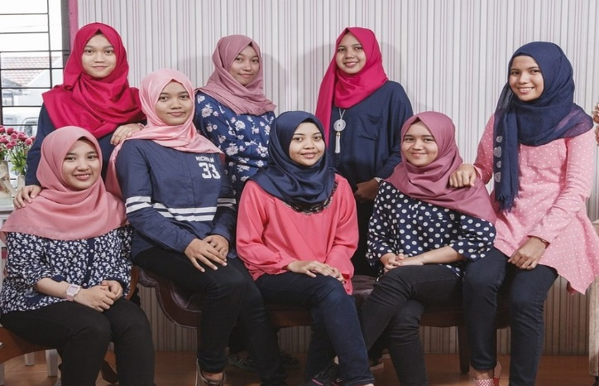
Figure 15.21 – These values of these adolescent girls’ families and communities will influence their development.

Different cultural norms regarding family and peer relationships shape adolescents’ experiences in these domains. For example, in some countries, adolescents’ parents are expected to remain in control over major decisions, whereas in other countries, adolescents are expected to begin sharing in or taking control of decision making . Even within the same country, adolescents’ gender, ethnicity, immigrant status, religion, sexual orientation, socioeconomic status, and personality can shape both how adolescents behave and how others respond to them, creating diverse developmental contexts for different adolescents.

Ethnic Identity refers to how people come to terms with who they are based on their ethnic or racial ancestry. “The task of ethnic identity formation involves sorting out and resolving positive and negative feelings and attitudes about one’s own ethnic group and about other groups and identifying one’s place in relation to both” (Phinney, 2006, p. 119). When groups differ in status in a culture—those from the non-dominant group have to be cognizant of the customs and values of those from the dominant culture. The reverse is rarely the case. This makes ethnic identity far less important for members of the dominant culture.

In the United States, those of European ancestry engage in less exploration of ethnic identity, than do those of non-European ancestry (Phinney, 1989). However, according to the U.S. Census (2012) more than 40% of Americans under the age of 18 are from ethnic minorities. For many ethnic minority teens, discovering one’s ethnic identity is an important part of identity formation. Phinney’s model of ethnic identity formation is based on Erikson and Marcia’s model of identity formation (Phinney, 1990; Syed & Juang, 2014). Through the process of exploration and commitment, individual’s come to understand and create an ethnic identity.

Phinney’s Three Stages or Statuses of Ethnic Identity
Phinney’s model of ethnic identity formation is based on Erikson’s and Marcia’s model of identity formation (Phinney, 1990; Syed & Juang, 2014). Through the process of exploration and commitment, individual’s come to understand and create an ethic identity. Phinney suggests three stages or statuses with regard to ethnic identity:

Table 15.3 - Phinney’s Three Stages of Ethnic Identity

Stage | Descriptions
Stage 1: Unexamined Ethnic Identity | Adolescents and adults who have not been exposed to ethnic identity issues may be in the first stage, unexamined ethnic identity. This is often characterized with a preference for the dominant culture, or where the individual has given little thought to the question of their ethnic heritage. This is similar to diffusion in Marcia’s model of identity. Included in this group are also those who have adopted the ethnicity of their parents and other family members with little thought about the issues themselves, similar to Marcia’s foreclosure status (Phinney, 1990).
Stage 2: Ethnic Identity Search | Adolescents and adults who are exploring the customs, culture, and history of their ethnic group are in the ethnic identity search stage, similar to Marcia’s moratorium status (Phinney, 1990). Often some event “awakens” a teen or adult to their ethnic group; either a personal experience with prejudice, a highly profiled case in the media, or even a more positive event that recognizes the contribution of someone from the individual’s ethnic group. Teens and adults in this stage will immerse themselves in their ethnic culture. For some, “it may lead to a rejection of the values of the dominant culture” (Phinney, 1990, p. 503).
Stage 3: Achieved Ethnic Identity | Those who have actively explored their culture are likely to have a deeper appreciation and understanding of their ethnic heritage, leading to progress toward an achieved ethnic identity (Phinney, 1990). An achieved ethnic identity does not necessarily imply that the individual is highly involved in the customs and values of their ethnic culture. One can be confident in their ethnic identity without wanting to maintain the language or other customs.

The development of ethnic identity takes time, with about 25% of tenth graders from ethnic minority backgrounds having explored and resolved the issues (Phinney, 1989). The more ethnically homogeneous the high school, the less identity exploration and achievement (Umana-Taylor, 2003). Moreover, even in more ethnically diverse high schools, teens tend to spend more time with their own group, reducing exposure to other ethnicities. This may explain why, for many, college becomes the time of ethnic identity exploration. “[The] transition to college may serve as a consciousness-raising experience that triggers exploration” (Syed & Azmitia, 2009, p. 618).

It is also important to note that those who do achieve ethnic identity may periodically reexamine the issues of ethnicity. This cycling between exploration and achievement is common not only for ethnic identity formation, but in other aspects of identity development (Grotevant, 1987) and is referred to (from Marcia’s Theory: Stages of Identity) as MAMA cycling or moving back and forth between moratorium and achievement.

Bicultural/Multiracial Identity
Ethnic minorities must wrestle with the question of how, and to what extent, they will identify with the culture of their surroundings, thus society and with the culture of their family. Phinney (2006) suggests that people may handle it in different ways. Some may keep the identities separate, others may combine them in some way, while others may reject some of them.

Bicultural identity means individuals sees themselves as part of both the ethnic minority group and the larger society. Those who are multiracial, that is whose parents come from two or more ethnic or racial groups, have a more challenging task. In some cases their appearance may be ambiguous. This can lead to others constantly asking them to categorize themselves. Phinney (2006) notes that the process of identity formation may start earlier and take longer to accomplish in those who are not monoracial or a single ethnicity.

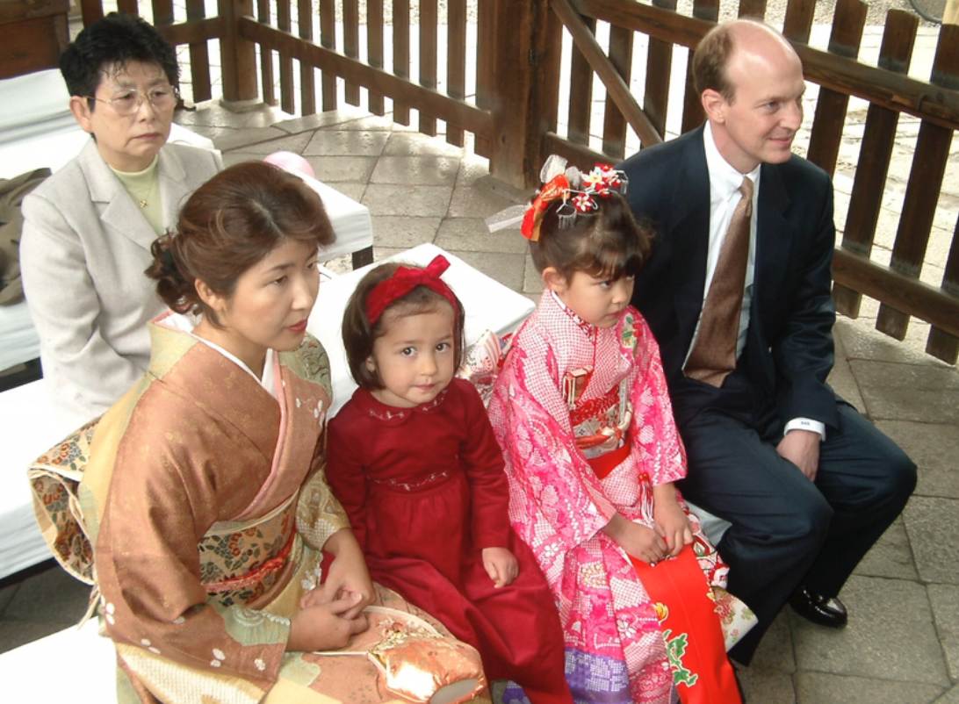
Figure 15.22 – A bicultural family.

Media: Influences on Teens
Media is another agent of socialization that influences our political views; our tastes in popular culture; our views of women, people of color, and the LGBTQ+ community; and many other beliefs and practices. In an ongoing controversy, the media is often blamed for youth violence and many other of society’s ills. The average child sees thousands of acts of violence on television and in the movies before reaching young adulthood. Rap lyrics often seemingly extol ugly violence, including violence against women. Commercials can greatly influence our choice of soda, shoes, and countless other products. The mass media may also reinforce racial and gender stereotypes, including the belief that women are sex objects and suitable targets of male violence. In the General Social Survey (GSS), about 28% of respondents said that they watch four or more hours of television every day, while another 46% watch 2-3 hours daily (see "Average Number of Hours of Television Watched Daily"). The media certainly are an important source of socialization that was unimaginable a half-century ago.

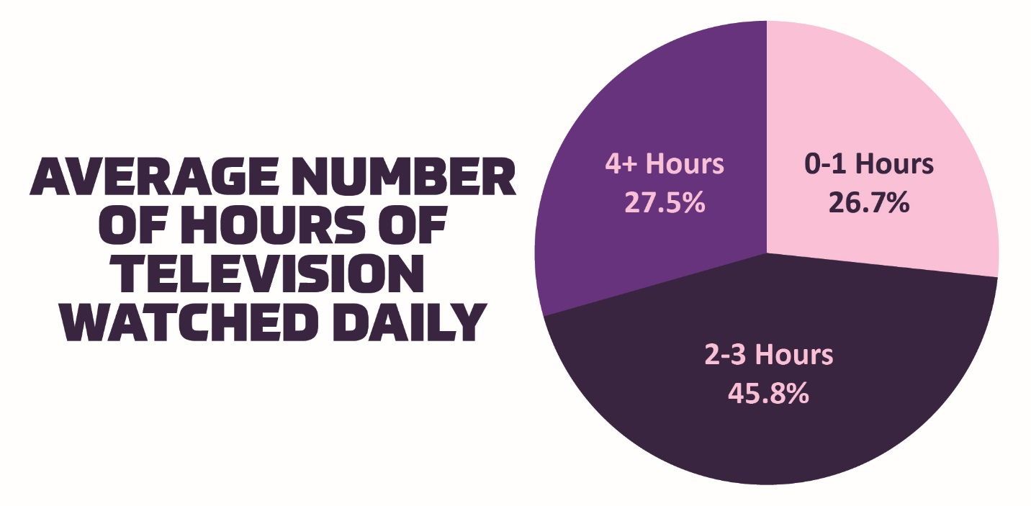
Figure 15.23 – Daily television viewing time.

As the media socializes children, adolescents, and even adults, a key question is the extent to which media violence causes violence in our society. Studies consistently uncover a strong correlation between watching violent television shows and movies and committing violence. However, this does not necessarily mean that watching the violence actually causes violent behavior: perhaps people watch violence because they are already interested in it and perhaps even committing it. Scholars continue to debate the effect of media violence on youth violence. In a free society, this question is especially important, as the belief in this effect has prompted calls for monitoring the media and the banning of certain acts of violence. Civil libertarians argue that such calls smack of censorship that violates the First Amendment to the Constitution, while others argue that they fall within the First Amendment and would make for a safer society. Certainly the concern and debate over mass media violence will continue for years to come.

Development of Sexual Identity

Dating and Romantic Relationships
Adolescence is the developmental period during which romantic relationships typically first emerge. By the end of adolescence, most American teens have dated others and have had at least one romantic relationship (Dolgin, 2011). However, culture does play a role as Asian Americans and Latinas are less likely to date than other ethnic groups (Connolly, Craig, Goldberg, & Pepler, 2004). Dating serves many purposes for teens, including having fun, companionship, status, socialization, intimacy, sexual experimentation, and partner selection for those in late adolescence (Dolgin, 2011). There are several stages in the dating process, beginning with engaging in mixed-sex group activities in early adolescence (Dolgin, 2011).
Table 15.4 - Romantic Relationships in Adolescence

Age | Relationship
Early Adolescence | Romantic relationships often form in the context of these mixed-sex peer groups (Connolly, Furman, & Konarski, 2000). Interacting in mixed-sex groups is easier for teens as they are among a supportive group of friends, can observe others interacting, and are kept safe from becoming intimate too soon.
Middle Adolescence | By middle adolescence, teens are engaging in brief, casual dating, or in group dating with other couples (Dolgin, 2011).
Late Adolescence | In late adolescence, dating involves exclusive, intense relationships that are short-lived or are long-term committed partnerships, either way their importance should not be minimized. Adolescents spend a great deal of time focused on romantic relationships or lack thereof. Their positive and negative emotions are tied to this intense interest more than they are to friendships, family relationships, or school (Furman & Shaffer, 2003).

Furthermore, romantic relationships are centrally connected to adolescents’ emerging sexuality. Parents, policymakers, and researchers have devoted a great deal of attention to adolescents’ sexuality, in large part because of concerns related to sexual intercourse, contraception, and preventing teen pregnancies. However, sexuality involves more than this narrow focus, for example, adolescence is often when individuals who are lesbian, gay, bisexual, or transgender come to understand and define what their sexual identity is (Russell, Clarke, & Clary, 2009). Thus, romantic relationships are a domain in which adolescents experiment with new behaviors and identities.

Figure 15.24 – Romantic relationships emerge in adolescence.
Violence by Someone You Know
Violence can be committed against someone that the victim knows well, referred to as an intimate, in many ways: an intimate can hit with their fists, slap with an open hand, throw an object, push or shove, or use or threaten to use a weapon. While we can never be certain of the exact number of intimates that are attacked, the U.S. Department of Justice estimates from its National Crime Victimization Survey that almost 600,000 acts of violence (2008 data) are committed annually by one intimate against another intimate.

According to a fact sheet from the National Coalition Against Domestic Violence that compiled the results of several studies:
- In 2013, 35% of 10th graders reported that they had been physically or verbally abused and 31% reported having perpetrated such abuse
- In 2014, 10% of teenage students in dating relationships reported being coerced into sexual intercourse in the previous year
- In 2015, 20.9% of female and 13.4% of male high school students reported being physically or sexually assaulted by a dating partner
- But only 33% of teenage dating abuse victims reported having ever told anyone about it (according to a 2005 study)

A 2010 report by the CDC shows the larger pictures of intimate partner violence
- 1 in 3 women and 1 in 4 women have been victims of some form of physical violence by an intimate partner in their lifetime
- 1 in 7 women and 1 in 18 men have been stalked by an intimate partner to the point that they were fearful for their safety

Figure 15.25 – Almost a quarter of U.S. women have been physically assaulted by a spouse or partner.

This topic is an important one because “domestic violence is prevalent in every community, and affects all people regardless of age, socio-economic status, sexual orientation, gender, race, religion, or nationality. Physical violence is often accompanied by emotionally abusive and controlling behavior as part of a much larger, systematic pattern of dominance and control. Domestic violence can result in physical injury, psychological trauma, and even death. The devastating consequences of domestic violence can cross generations and last a lifetime.”

Sexual Orientation
A person's sexual orientation is their emotional and sexual attraction to a particular sex or gender. A continuing pattern of romantic or sexual attraction (or a combination of these) to persons of a given sex or gender. According to the American Psychological Association (APA) (2016), sexual orientation also refers to a person's sense of identity based on those attractions, related behaviors, and membership in a community of others who share those attractions. Some specific orientation is defined in many ways, including heterosexuality (attraction to the opposite sex/gender), same-sex attraction (previously referred to as homosexuality, which is an outdated term that many people find offensive because it was previously classified as a mental illness), bisexuality, polysexuality, or pansexuality (attraction to two, multiple, or all sexes/genders respectively), and asexuality (no sexual attraction to any sex/gender).

Sexual Orientation on a Continuum
Sexuality researcher Alfred Kinsey was among the first to conceptualize sexuality as a continuum rather than a strict dichotomy of gay or straight. To classify this continuum of heterosexuality and homosexuality, Kinsey et al. (1948) created a seven-point rating scale that ranged from exclusively heterosexual to exclusively homosexual. Research done over several decades has supported this idea that sexual orientation ranges along a continuum, from exclusive attraction to the opposite sex/gender to exclusive attraction to the same sex/gender (Carroll, 2016).

A more contemporary look at sexual orientation as infinite variations of attraction. A closer examination of The Genderbread Person v2.0 introduced earlier in the chapter illustrates this:

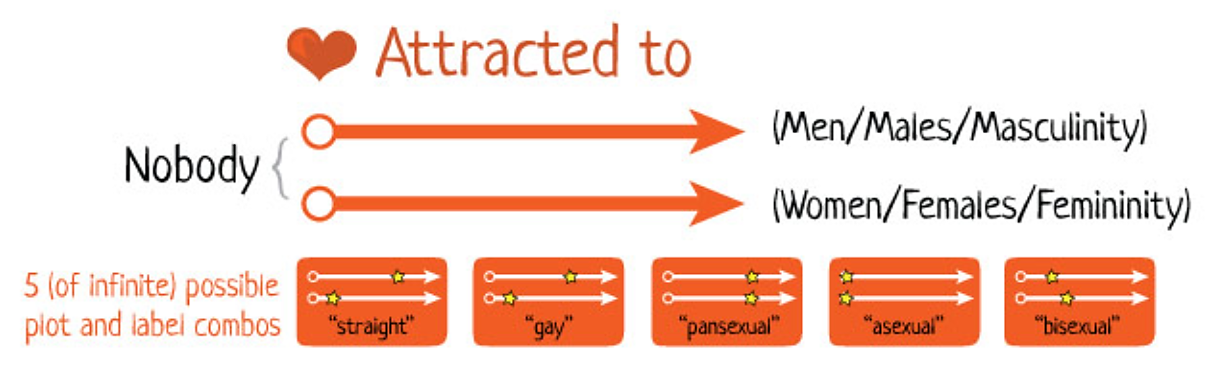
Figure 15.26 – A spectrum of sexual orientation.

Development of Sexual Orientation
According to current scientific understanding, individuals are usually aware of their sexual orientation between middle childhood and early adolescence. However, this is not always the case, and some do not become aware of their sexual orientation until much later in life. It is not necessary to participate in sexual activity to be aware of these emotional, romantic, and physical attractions; people can be celibate and still recognize their sexual orientation. Some researchers argue that sexual orientation is not static and inborn, but is instead fluid and changeable throughout the lifespan.

Figure 15.27 – This teen couple is at a LGBTQIA pride event.

There is no scientific consensus regarding the exact reasons why an individual holds a particular sexual orientation. Research has examined possible biological, developmental, social, and cultural influences on sexual orientation, but there has been no evidence that links sexual orientation to one factor (APA, 2016). Biological explanations, that include genetics, hormones, and birth order, will be explored further. Excess or deficient exposure to hormones during prenatal development has also been theorized as an explanation for sexual orientation. One-third of females exposed to abnormal amounts of prenatal androgens, a condition called congenital adrenal hyperplasia (CAH), identify as bisexual or lesbian (Cohen-Bendahan, van de Beek, & Berenbaum, 2005). In contrast, too little exposure to prenatal androgens may affect male sexual orientation (Carlson, 2011).
Sexual Orientation Discrimination: The United States is heteronormative, meaning that society supports heterosexuality as the norm. Consider, for example, that homosexuals are often asked, "When did you know you were gay?" but heterosexuals are rarely asked, "When did you know you were straight?" (Ryle, 2011). Living in a culture that privileges heterosexuality has a significant impact on the ways in which non-heterosexual people are able to develop and express their sexuality.

Understanding the Acronyms: LGBT, LGBTQ, LGBTQ+
The letters LGBT refer to a group of individuals that identify as Lesbian, Gay, Bisexual, and Transgender. This community includes a diverse group of people from all backgrounds, races, ethnicities, ages, and socioeconomic statuses.

A Little History
LGB was used to replace the term, “Gay,” in the mid-1980s, but the acronym LGBT became common in the 1990s. However, recently the term has evolved with the preferred acronym to LGBTQ. The added “Q” means Questioning or Queer. The addition of “Q” as a term of questioning includes people that are in the process of exploring their gender or sexual orientation.

Additionally, the term, “Queer,” can be used as an umbrella term, as the community has accepted this word to represent anything outside of the dominant narrative. Queer is not specific to sexual orientation or gender identity and can be used to refer to the community as a whole. While Queer was used as a derogatory term for decades, it was reclaimed by the LGBTQ community in the 1990s with the rise of an organization called Queer Nation. As an activist group out of New York, Queer Nation opposed discrimination of the LGBTQ community and rejected the heteronormative ideals of society.

What does the plus sign mean?
Recently LGBTQ is also used as LGBTQ+. The plus sign, “+” accounts for many additional identifications in the community, including transsexual, two-spirit, intersex, asexual, pansexual, and gender queer. Gender Queer is an umbrella term that can be used for all gender identities not exclusive to masculine or feminine, including gender fluid, agender, bigender, pan gender, gender free, genderless, gender variant, and gender non-conforming. The plus also includes allies or people in support of the LGBTQ community.

While LGBTQ+ or Queer are currently the most common terms, additionally the term, Rainbow Community, may be used. The important takeaway is that the community will continue to evolve, and the terminology will evolve with it.

Open identification of one's sexual orientation may be hindered by homophobia, which encompasses a range of negative attitudes and feelings toward homosexuality or people who are identified or perceived as being lesbian, gay, bisexual, or transgender (LGBT). It can be expressed as antipathy, contempt, prejudice, aversion, or hatred; it may be based on irrational fear and is sometimes related to religious beliefs (Carroll, 2016). Homophobia is observable in critical and hostile behavior, such as discrimination and violence on the basis of sexual orientations that are non- heterosexual. Recognized types of homophobia include institutionalized homophobia, such as religious and state-sponsored homophobia, and internalized homophobia in which people with same-sex attractions internalize, or believe, society's negative views and/or hatred of themselves.

Gay, lesbian, and bisexual people regularly experience stigma, harassment, discrimination, and violence based on their sexual orientation (Carroll, 2016). Research has shown that gay, lesbian, and bisexual teenagers are at a higher risk of depression and suicide due to exclusion from social groups, rejection from peers and family, and negative media portrayals of homosexuals (Bauermeister et al., 2010). Discrimination can occur in the workplace, in housing, at schools, and in numerous public settings. Much of this discrimination is based on stereotypes and misinformation. Major policies to prevent discrimination based on sexual orientation have only come into effect in the United States in the last few years.

Figure 15.28 - This is an example of discrimination that is portrayed in a high school play. These students from Mercer Island High School are playing Westboro Baptist Church protestors in the play The Laramie Project that tells the story of the murder of a gay college student, Matthew Shephard.

Adolescent Sexuality
Human sexuality refers to people's sexual interest in and attraction to others, as well as their capacity to have erotic experiences and responses. Sexuality may be experienced and expressed in a variety of ways, including thoughts, fantasies, desires, beliefs, attitudes, values, behaviors, practices, roles, and relationships. These may manifest themselves in biological, physical, emotional, social, or spiritual aspects. The biological and physical aspects of sexuality largely concern the human reproductive functions, including the human sexual-response cycle and the basic biological drive that exists in all species. Emotional aspects of sexuality include bonds between individuals that are expressed through profound feelings or physical manifestations of love, trust, and care. Social aspects deal with the effects of human society on one's sexuality, while spirituality concerns an individual's spiritual connection with others through sexuality. Sexuality also impacts, and is impacted by cultural, political, legal, philosophical, moral, ethical, and religious aspects of life.

The Human Sexual Response Cycle: Sexual motivation, often referred to as libido, is a person's overall sexual drive or desire for sexual activity. This motivation is determined by biological, psychological, and social factors. In most mammalian species, sex hormones control the ability to engage in sexual behaviors. However, sex hormones do not directly regulate the ability to have sexual intercourse or to copulate in primates (including humans); rather, they are only one influence on the motivation to engage in sexual behaviors. Social factors, such as work and family also have an impact, as do internal psychological factors like personality and stress. Sex drive may also be affected by hormones, medical conditions, medications, lifestyle stress, pregnancy, and relationship issues.

The human sexual response cycle is a model that describes the physiological responses that take place during sexual activity. According to Kinsey, Pomeroy, and Martin (1948), the cycle consists of four phases: excitement, plateau, orgasm, and resolution.

Table 15.5 Human Sexual Response Cycle

Phase | Description
Excitement Phase | the phase in which the intrinsic (inner) motivation to pursue sex arises
Plateau Phase | the period of sexual excitement with increased heart rate and circulation that sets the stage for orgasm
Orgasm Phase | the climax
Resolution Phase | the un-arousal state before the cycle begins again
Societal Views on Sexuality: Society's views on sexuality are influenced by everything from religion to philosophy, and they have changed throughout history and are continuously evolving. Historically, religion has been the greatest influence on sexual behavior in the United States; however, in more recent years, peers and the media have emerged as two of the strongest influences, particularly among American teens (Potard, Courtois, & Rusch, 2008).

Media Influences on Sexuality: Media in the form of television, magazines, movies, music, online, etc., continues to shape what is deemed appropriate or normal sexuality, targeting everything from body image to products meant to enhance sex appeal. Media serves to perpetuate a number of social scripts about sexual relationships and the sexual roles of men and women, many of which have been shown to have both empowering and problematic effects on people's (especially women's) developing sexual identities and sexual attitudes.

Cultural Differences with Sexuality: In the West, premarital sex is normative by the late teens, more than a decade before most people enter marriage. In the United States and Canada, and in northern and Eastern Europe, cohabitation is also normative; most people have at least one cohabiting partnership before marriage. In southern Europe, cohabiting is still taboo, but premarital sex is tolerated in emerging adulthood. In contrast, both premarital sex and cohabitation remain rare and forbidden throughout Asia. Even dating is discouraged until the late twenties, when it would be a prelude to a serious relationship leading to marriage. In cross-cultural comparisons, about three fourths of emerging adults in the United States and Europe report having had premarital sexual relations by age 20, versus less than one fifth in Japan and South Korea (Hatfield & Rapson, 2006).

Antisocial Behavior in Adolescence

Bullies, Victims, and the Bystander
Bullying is defined as unwanted, aggressive behavior among school aged children that involves a real or perceived power imbalance. Further, the aggressive behavior happens more than once or has the potential to be repeated. There are different types of bullying. They are detailed in the table below.

15.6 - Types of Bullying

Type of Bullying | Description
Verbal Bullying | Includes saying or writing mean things, teasing, name calling, taunting, threatening, or making inappropriate sexual comments.
Social bullying (also referred to as relational bullying) | Includes spreading rumors, purposefully excluding someone from a group, or embarrassing someone on purpose.
Physical Bullying | Includes hurting a person’s body or possessions.
Cyberbullying | Involves electronic technology. Examples of cyberbullying include sending mean text messages or emails, creating fake profiles, and posting embarrassing pictures, videos or rumors on social networking sites.

Figure 15.29 – Cyberbullying.

The Bystander Effect
The discussion of bullying highlights the problem of witnesses not intervening to help a victim. Researchers Latané and Darley (1968) described a phenomenon called the bystander effect. The bystander effect is a phenomenon in which a witness or bystander does not volunteer to help a victim or person in distress. Instead, they just watch what is happening. Social psychologists hold that we make these decisions based on the social situation, not our own personality variables. Why do you think bystanders don’t get help? What are the benefits to helping? What are the risks? It is very likely you listed more costs than benefits to helping. In many situations, bystanders likely feared for their own lives—if they went to help, the attacker might harm them. However, how difficult would it be to make a phone call to the police? Social psychologists claim that diffusion of responsibility is the likely explanation. Diffusion of responsibility is the tendency for no one in a group to help because the responsibility to help is spread throughout the group (Bandura, 1999). Have you ever passed an accident on the freeway and assumed that a victim or certainly another motorist has already reported the accident? In general, the greater the number of bystanders, the less likely any one person will help.

Antisocial Behaviors, Violence, and Child Abuse

Antisocial Behaviors
According to the American Academy of Psychiatry (2018),

Most kids will act up or become disruptive or defiant sometimes. Disruptive and conduct disorders, however, involve much more severe and longer-lasting behaviors than typical, short-lived episodes. Disruptive, impulse-control and conduct disorders refer to a group of disorders that include oppositional defiant disorder, conduct disorder, intermittent explosive disorder, kleptomania and pyromania. These disorders can cause people to behave angrily or aggressively toward people or property. They may have difficulty controlling their emotions and behavior and may break rules or laws. An estimated 6 percent of children are affected by oppositional defiant disorder or conduct disorder.

Oppositional Defiant Disorder (ODD): There is a recurrent pattern of negative, defiant, disobedient, and hostile behavior toward authority figures. It is important to remember that this is toward authority figures and not their peers. This occurs outside of normal developmental levels and leads to impairment in functioning (Lack, 2010).

Conduct Disorder (CD): Children with Conduct Disorder (CD) show acts of aggression towards others and animals. Children with conduct disorder (CD) usually show little to no compassion or concern for others or their feelings. Also, concern for the well-being of others is at a minimum. Children also perceive the actions and intentions of others as more harmful and threatening than they actually are and respond with what they feel is reasonable and justified aggression. They may lack feelings of guilt or remorse. Since these individuals learn that expressing guilt or remorse may help in avoiding or lessening punishment, it may be difficult to evaluate when their guilt or remorse is genuine. Individuals will also try and place blame on others for the wrong doings that they had committed.

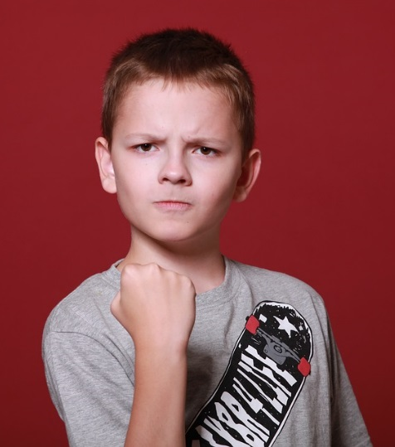
Figure 15.30 - Children with conduct disorders show acts of aggression towards others and animals.

Children with conduct disorders (CD) tend to have lower levels of self-esteem. Children diagnosed with conduct disorders (CD) are typically characterized as being easily irritable and often reckless, as well as having many temper tantrums despite their projected “tough” image portrayed to society. Conduct Disorder (CD) often accompanies early onset of sexual behavior, drinking, smoking, use of illegal drugs, and reckless acts. Illegal drug use may increase the risk of the disorder persisting. The disorder may lead to school suspension or expulsion, problems at work, legal difficulties, STD’s, unplanned pregnancy, and injury from fights or accidents. Suicidal ideation and attempts occur at a higher rate than expected.

Violence and Abuse
Violence and abuse are among the most disconcerting of the challenges that today’s families face. Abuse can occur between spouses, between parent and child, as well as between other family members. The frequency of violence among families is difficult to determine because many cases of spousal abuse and child abuse go unreported. In any case, studies have shown that abuse (reported or not) has a major impact on families and society as a whole.

Adolescent Child Abuse
Children and teens are among the most helpless victims of abuse. In 2010, there were more than 3.3 million reports of child abuse involving an estimated 5.9 million children (Child Help 2011). Three-fifths of child abuse reports are made by professionals, including teachers, law enforcement personnel, and social services staff. The rest are made by anonymous sources, other relatives, parents, friends, and neighbors. Child abuse may come in several forms, the most common is neglect (78.3 percent), followed by physical abuse (10.8 percent), sexual abuse (7.6 percent), psychological maltreatment (7.6 percent), and medical neglect (2.4 percent) (Child Help 2011). Some children suffer from a combination of these forms of abuse. The majority (81.2 percent) of perpetrators are parents; 6.2 percent are other relatives.

Figure 15.31 - Children and teens are among the most helpless victims of abuse.
Does Corporal Punishment Constitute Child Abuse?
Physical abuse in children may come in the form of beating, kicking, throwing, choking, hitting with objects, burning, or other methods. Injury inflicted by such behavior is considered abuse even if the parent or caregiver did not intend to harm the child. Other types of physical contact that are characterized as discipline (spanking, for example) are not considered abuse as long as no injury results (Child Welfare Information Gateway 2008).

This issue is rather controversial among modern-day people in the United States. While some parents feel that physical discipline, or corporal punishment, is an effective way to respond to bad behavior, others feel that it is a form of abuse. According to a poll conducted by ABC News, 65 percent of respondents approve of spanking and 50 percent said that they sometimes spank their child. But in the U.S., the majority of mental health professionals, as well as other professionals such as physicians and child welfare personnel, do not support the use of physical punishment.

Tendency toward physical punishment may be affected by culture and education. Those who live in the South are more likely than those who live in other regions to spank their child. Those who do not have a college education are also more likely to spank their child (Crandall 2011). Currently, 23 states officially allow spanking in the school system; however, many parents may object and school officials must follow a set of clear guidelines when administering this type of punishment (Crandall 2011).

Decades of research have yielded more than 500 studies examining the impact of physical punishment on children (Gershoff & Grogan-Kaylor, 2016). Within the past 15 years, several meta-analyses have attempted to synthesize this body of research. In a highly publicized meta-analysis, Gershoff (2002) concluded that physical punishment is not only ineffective, but also harmful. It may lead to aggression by the victim, particularly in those who are spanked at a young age (Berlin 2009).

Debates about parental use of physical punishment have been ongoing in the USA for decades. Calls to “move beyond” the research, or to “end the debate,” have become commonplace (e.g., Durrant & Ensom, 2017; MacMillan & Mikton, 2017). Three questions, it seems, sit at the center of these debates. Is physical punishment of children a Human Rights Issue? Is physical punishment effective? Is physical punishment harmful?

Emerging Adulthood: The Bridge Between Adolescence and Adulthood
The next stage of development is emerging adulthood and is characterized as an in-between time where identity exploration is focused on work and love, which occurs from approximately 18 years of age to the mid to late 20s.

When does a person become an adult? There are many ways to answer this question. In the United States, you are legally considered an adult at 18 years old, but other definitions of adulthood vary widely; in sociology, for example, a person may be considered an adult when they become self-supporting, choose a career, get married, or start a family. The ages at which we achieve these milestones vary from person to person as well as from culture to culture. For example, 50 years ago, a young adult with a high school diploma could immediately enter the workforce and climb the corporate ladder. That is no longer the case, a Bachelor’s and even graduate degrees are required more and more often—even for entry-level jobs (Arnett, 2000). In addition, many students are taking longer (five or six years) to complete a college degree as a result of working and going to school at the same time. After graduation, many young adults return to the family home because they have difficulty finding a job.

Figure 15.32 – Emerging adulthood.

This is a relatively newly defined period of lifespan development, Jeffrey Arnett (2000) explains that emerging adulthood is neither adolescence nor is it young adulthood. Individuals in this age period have left behind the relative dependency of childhood and adolescence, but have not yet taken on the responsibilities of adulthood. “Emerging adulthood is a time of life when many different directions remain possible, when little about the future is decided for certain, when the scope of independent exploration of life’s possibilities is greater for most people than it will be at any other period of the life course” (Arnett, 2000, p. 469).

Conclusion
In this chapter we finished our exploration of childhood and adolescence having looked at:
- Theories from Erikson and Marcia
- Self -concept and identity
- Gender identity
- Ethnic identity
- Sexuality
- Parent and adolescent relationships
- Peers and peer groups
- Antisocial behaviors
- Emerging adulthood

Introduction to Lifespan, Growth and Development by Lumen Learning is licensed under CC BY 4.0
Lifespan Development: A Psychological Perspective by Martha Lally and Suzanne Valentine-French is licensed under CC BY-NC-SA 3.0 (modified by Jennifer Paris)
Introduction to Lifespan, Growth and Development by Lumen Learning is licensed under CC BY 4.0
Image by lunar caustic is licensed under CC BY 2.0
Image by Han Myo Htwe on Unsplash
Image by Alaric Sim on Unsplash
Image by Wayne Lee-Sing on Unsplash
Periods of Development by Lumen Learning is licensed under CC BY 4.0
Image by Matheus Ferrero on Unsplash
Image by NOBA is licensed under CC BY-NC-SA 4.0
Lifespan Development: A Psychological Perspective by Martha Lally and Suzanne Valentine-French is licensed under CC BY-NC-SA 3.0
Image by MaryGeorge is licensed under CC BY-SA 4.0
Image by NOBA is licensed under CC BY-NC-SA 4.0
Image by NOBA is licensed under CC BY-NC-SA 4.0
Image by NOBA is licensed under CC BY-NC-SA 4.0
Research Methods by Lumen Learning is licensed under CC BY 4.0
Research Methods in Developmental Psychology by Angela Lukowski and Helen Milojevich is licensed under a CC BY-NC-SA 4.0
Confidentiality and Informed Consent: Issues for Consideration in the Preservation of and Provision of Access to Qualitative Data Archives by Louise Corti, Annette Day & Gill BackhouseSource is licensed under CC BY 4.0 (modified by Jennifer Paris); "No thank you, not today": Supporting Ethical and Professional Relationships in Large Qualitative Studies by Lisa J. Blodgett, Wanda Boyer & Emily TurkSource is licensed under CC BY 4.0 (modified by Jennifer Paris)
Research Methods in Developmental Psychology by Angela Lukowski and Helen Milojevich is licensed under a CC BY-NC-SA 4.0
Introduction to Developmental Theories by Lumen Learning is licensed under CC BY 4.0
Image is in the public domain
Psychodynamic Theory by Lumen Learning is licensed under CC BY 4.0; Lecture Transcript: Developmental Theories by Lumen Learning is licensed under CC BY 4.0
Image is in the public domain
Psychosocial Theory by Lumen Learning is licensed under CC BY 4.0
History of Psychology by David B. Baker and Heather Sperry is licensed under CC BY-NC-SA 4.0
Image is in the public domain
Image is in the public domain
Image is in the public domain
Image by Albert Bandura is licensed under CC BY-SA 4.0
Exploring Behavior by Lumen Learning is licensed under CC BY 4.0; Lecture Transcript: Developmental Theories by Lumen Learning is licensed under CC BY 4.0
Exploring Behavior by Lumen Learning is licensed under CC BY 4.0 Rasmussen, Eric (2017, Oct 19). Screen Time and Kids: Insights from a New Report. Retrieved from https://www.pbs.org/parents/thrive/screen-time-and-kids-insights-from-a-new-report
Image is in the public domain
Lecture Transcript: Developmental Theories by Lumen Learning is licensed under CC BY 4.0 (modified by Jennifer Paris) Exploring Cognition by Lumen Learning is licensed under CC BY 4.0
Exploring Cognition by Lumen Learning is licensed under CC BY 4.0
Children’s Development by Ana R. Leon is licensed under CC BY 4.0
Image by The Vigotsky Project is licensed under CC BY-SA 3.0
Exploring Cognition by Lumen Learning is licensed under CC BY 4.0
Children’s Development by Ana R. Leon is licensed under CC BY 4.0
Image by Marco Vicente González is licensed under CC BY-SA 4.0
Image by Ian Joslin is licensed under CC BY 4.0
Children’s Development by Ana R. Leon is licensed under CC BY 4.0
Lifespan Development: A Psychological Perspective (page 34) by Martha Lally and Suzanne Valentine-French is licensed under CC BY-NC-SA 3.0
Lifespan Development - Module 3: Prenatal Development by Lumen Learning references Psyc 200 Lifespan Psychology by Laura Overstreet, licensed under CC BY 4.0
Image by Alexey Ruban on Unsplash
Lifespan Development: A Psychological Perspective (page 40) by Martha Lally and Suzanne Valentine-French is licensed under CC BY-NC-SA 3.0
Image by Radio89 is licensed under CC BY-SA 3.0 (original image has been modified)
Lifespan Development: A Psychological Perspective (page 34) by Martha Lally and Suzanne Valentine-French is licensed under CC BY-NC-SA 3.0 (content modified: image made into table)
Image by Community College Consortium for Bioscience Credentials is licensed under CC BY 3.0
Lifespan Development: A Psychological Perspective (page 34-35) by Martha Lally and Suzanne Valentine-French is licensed under CC BY-NC-SA 3.0
Image by Nami-ja is in the public domain
Lifespan Development: A Psychological Perspective (page 35) by Martha Lally and Suzanne Valentine-French is licensed under CC BY-NC-SA 3.0
Lifespan Development: A Psychological Perspective (pages 36-37) by Martha Lally and Suzanne Valentine-French is licensed under CC BY-NC-SA 3.0
Lifespan Development: A Psychological Perspective (pages 36-37) by Martha Lally and Suzanne Valentine-French is licensed under CC BY-NC-SA 3.0
Lifespan Development: A Psychological Perspective (pages 36-37) by Martha Lally and Suzanne Valentine-French is licensed under CC BY-NC-SA 3.0
Lifespan Development: A Psychological Perspective (page 38) by Martha Lally and Suzanne Valentine-French is licensed under CC BY-NC-SA 3.0
Trisomy 9 Mosaicism Diagnosed In Utero by Hironori Takahashi, Satoshi Hayashi, Yumiko Miura, Keiko Tsukamoto, Rika Kosaki, Yushi Itoh, and Haruhiko Sago is licensed under CC BY 3.0; Lifespan Development: A Psychological Perspective (page 39) by Martha Lally and Suzanne Valentine-French is licensed under CC BY-NC-SA 3.0
Image by Ashley Onken used with permission
Image is in the public domain
Lifespan Development: A Psychological Perspective (page 38) by Martha Lally and Suzanne Valentine-French is licensed under CC BY-NC-SA 3.0
XYY Syndrome by Wikipedia is licensed under CC BY-SA 3.0; Triple X Syndrome by Wikipedia is licensed under CC BY-SA 3.0; Lifespan Development: A Psychological Perspective (page 39) by Martha Lally and Suzanne Valentine-French is licensed under CC BY-NC-SA 3.0
Image is in the public domain
Image by Ttrue12 is licensed under CC BY-SA 3.0
Lifespan Development: A Psychological Perspective (pages 42-43) by Martha Lally and Suzanne Valentine-French is licensed under CC BY-NC-SA 3.0
Image by Anatomist90 is licensed under CC BY-SA 3.0
Lifespan Development: A Psychological Perspective (page 43) by Martha Lally and Suzanne Valentine-French is licensed under CC BY-NC-SA 3.0
Image by lunar caustic is licensed under CC BY-SA 2.0
Lifespan Development: A Psychological Perspective (pages 44-45) by Martha Lally and Suzanne Valentine-French is licensed under CC BY-NC-SA 3.0
Image by CNX Psychology is licensed under CC BY 4.0
Lifespan Development: A Psychological Perspective (page 36) by Martha Lally and Suzanne Valentine-French is licensed under CC BY-NC-SA 3.0
Image is in the public domain
Image by Jennifer Paris used with permission
Lifespan Development: A Psychological Perspective (pages 46-47) by Martha Lally and Suzanne Valentine-French is licensed under CC BY-NC-SA 3.0
Image by Laura Overstreet is licensed under CC BY-NC-SA 3.0
The Embryo Project Encyclopedia by Chanapa Tantibanchachai is licensed under CC BY-NC-SA 3.0
Staying healthy and safe by OWH is in the public domain
Chapter 3: Prenatal Development – Environmental Risks references Psyc 200 Lifespan Psychology by Laura Overstreet, which is licensed under CC BY 4.0; Staying healthy and safe by OWH is in the public domain
Staying healthy and safe by OWH is in the public domain
Chapter 3: Prenatal Development – Environmental Risks references Psyc 200 Lifespan Psychology by Laura Overstreet, which is licensed under CC BY 4.0; Prescription drugs, over-the-counter drugs, supplements and herbal products (n.d.). Retrieved from: https://www.marchofdimes.org/pregnancy/prescription-drugs-over-the-counter-drugs-supplements-and-herbal-products.aspx
Chapter 3: Prenatal Development – Environmental Risks references Psyc 200 Lifespan Psychology by Laura Overstreet, which is licensed under CC BY 4.0; Prescription drugs, over-the-counter drugs, supplements and herbal products (n.d.). Retrieved from: https://www.marchofdimes.org/pregnancy/prescription-drugs-over-the-counter-drugs-supplements-and-herbal-products.aspx
Prescription drugs, over-the-counter drugs, supplements and herbal products (n.d.). Retrieved from: https://www.marchofdimes.org/pregnancy/prescription-drugs-over-the-counter-drugs-supplements-and-herbal-products.aspx
Prescription drugs, over-the-counter drugs, supplements and herbal products (n.d.). Retrieved from: https://www.marchofdimes.org/pregnancy/prescription-drugs-over-the-counter-drugs-supplements-and-herbal-products.aspx
Prescription drugs, over-the-counter drugs, supplements and herbal products (n.d.). Retrieved from: https://www.marchofdimes.org/pregnancy/prescription-drugs-over-the-counter-drugs-supplements-and-herbal-products.aspx
Chapter 3: Prenatal Development – Environmental Risks references Psyc 200 Lifespan Psychology by Laura Overstreet, which is licensed under CC BY 4.0
Prescription drugs, over-the-counter drugs, supplements and herbal products (n.d.). Retrieved from: https://www.marchofdimes.org/pregnancy/prescription-drugs-over-the-counter-drugs-supplements-and-herbal-products.aspx
Prescription drugs, over-the-counter drugs, supplements and herbal products (n.d.). Retrieved from: https://www.marchofdimes.org/pregnancy/prescription-drugs-over-the-counter-drugs-supplements-and-herbal-products.aspx
Prescription drugs, over-the-counter drugs, supplements and herbal products (n.d.). Retrieved from: https://www.marchofdimes.org/pregnancy/prescription-drugs-over-the-counter-drugs-supplements-and-herbal-products.aspx
Prescription drugs, over-the-counter drugs, supplements and herbal products (n.d.). Retrieved from: https://www.marchofdimes.org/pregnancy/prescription-drugs-over-the-counter-drugs-supplements-and-herbal-products.aspx
Chapter 3: Prenatal Development – Environmental Risks references Psyc 200 Lifespan Psychology by Laura Overstreet, which is licensed under CC BY 4.0
Protocols on prenatal care for pregnant women with Zika infection and children with microcephaly: nutritional approach by Rachel de Sá Barreto Luna Callou Cruz, Malaquias Batista Filho, Maria de Fátima Costa Caminha, and Edvaldo da Silva Souza is licensed under CC BY 4.0
Congenital Varicella syndrome by WikiDoc is licensed under CC BY-SA 3.0
Chapter 3: Prenatal Development – Environmental Risks references Psyc 200 Lifespan Psychology by Laura Overstreet, which is licensed under CC BY 4.0
https://www.ncbi.nlm.nih.gov/pmc/articles/PMC2860824/
Prescription drugs, over-the-counter drugs, supplements and herbal products (n.d.). Retrieved from: https://www.marchofdimes.org/pregnancy/prescription-drugs-over-the-counter-drugs-supplements-and-herbal-products.aspx
Prescription drugs, over-the-counter drugs, supplements and herbal products (n.d.). Retrieved from: https://www.marchofdimes.org/pregnancy/prescription-drugs-over-the-counter-drugs-supplements-and-herbal-products.aspx
Image by Thomas Pompernigg is licensed under CC BY-SA 2.0
Image by Jessica Merz is licensed under CC BY 2.0
Image by rawpixel on Unsplash
Lifespan Development: A Psychological Perspective (pages 52-55) by Martha Lally and Suzanne Valentine-French is licensed under CC BY-NC-SA 3.0
Image by USDA is in the public domain
Image by MedicalPrudens is licensed under CC0 1.0
Image by BruceBlaus is licensed under CC BY-SA 4.0
Lifespan Development: A Psychological Perspective by Martha Lally and Suzanne Valentine-French is licensed under CC BY-NC-SA 3.0
Image by Takatakatakumi is licensed under CC BY-SA 3.0
Hyperemesis Gravidarum by Wikipedia is licensed under CC BY-SA 3.0 Lifespan Development: A Psychological Perspective (page 58) by Martha Lally and Suzanne Valentine-French is licensed under CC BY-NC-SA 3.0
Lifespan Development: A Psychological Perspective (page 57) by Martha Lally and Suzanne Valentine-French is licensed under CC BY-NC-SA 3.0
Assisted Reproductive Technology by Fertilitypedia is licensed under CC BY-SA 4.0
Intrauterine Insemination by Fertilitypedia is licensed under CC BY-SA 4.0
Assisted Reproductive Technology by Fertilitypedia is licensed under CC BY-SA 4.0
Image by Manu5 is licensed under CC BY-SA 4.0
Surrogacy by Fertilitypedia is licensed under CC BY-SA 4.0
Photo by Daryn Crawford used with permission
Photo by Michaela Szidloski used with permission
Lifespan Development: A Psychological Perspective (page 59) by Martha Lally and Suzanne Valentine-French is licensed under CC BY-NC-SA 3.0; Lifespan Development - Module 3: Prenatal Development by Lumen Learning references Psyc 200 Lifespan Psychology by Laura Overstreet, licensed under CC BY 4.0
Oberg, Erica (n.d.). Childbirth Delivery Methods and Types. Retrieved from https://www.medicinenet.com/7_childbirth_and_delivery_methods/article.htm#childbirth_and_delivery_methods_and_types_facts.
Machover, Ilana. (n.d.). The Alexander Technique in Natural Childbirth. Retrieved from https://www.alexandertechnique.com/articles/childbirth/.
Water Birth by Wikidoc is licensed under CC BY-SA 3.0
Lotus Birth by Wikipedia is licensed under CC BY-SA 3.0
Silent Birth by Wikipedia is licensed under CC BY-SA 3.0
Epidural and Spinal Anesthesia Use During Labor: 27-state Reporting Area, 2008 by Michelle J.K. Osterman and Joyce A. Martin is in the public domain
Image by liz.schrenk is licensed under CC BY-NC-ND 2.0
Lifespan Development: A Psychological Perspective (page 59) by Martha Lally and Suzanne Valentine-French is licensed under CC BY-NC-SA 3.0; Lifespan Development - Module 3: Prenatal Development by Lumen Learning references Psyc 200 Lifespan Psychology by Laura Overstreet, licensed under CC BY 4.0
28.4 Maternal Changes During Pregnancy, Labor, and Birth by Lindsay M. Biga, Sierra Dawson, Amy Harwell, Robin Hopkins, Joel Kaufmann, Mike LeMaster, Philip Matern, Katie Morrison-Graham, Devon Quick, and Jon Runyeon is licensed under CC BY-NC-SA 4.0
Image by OpenStax is licensed under CC BY 3.0
Lifespan Development: A Psychological Perspective (page 60) by Martha Lally and Suzanne Valentine-French is licensed under CC BY-NC-SA 3.0
Image by OpenStax is licensed under CC BY 3.0
Lifespan Development: A Psychological Perspective (page 60) by Martha Lally and Suzanne Valentine-French is licensed under CC BY-NC-SA 3.0
Image by OpenStax is licensed under CC BY 3.0
Lifespan Development: A Psychological Perspective (page 60) by Martha Lally and Suzanne Valentine-French is licensed under CC BY-NC-SA 3.0
Image by U.S. Army Alaska is licensed under CC BY 2.0
Image by Tammra M is licensed under CC BY 2.0
Image by Patricia Prudente on Unsplash
Lifespan Development: A Psychological Perspective (page 61) by Martha Lally and Suzanne Valentine-French is licensed under CC BY-NC-SA 3.0
Image by the U.S. Air Force is in the public domain
Lifespan Development: A Psychological Perspective (page 63) by Martha Lally and Suzanne Valentine-French is licensed under CC BY-NC-SA 3.0
Image by Event Medicine Group
Image by the U.S. Air Force is in the public domain
Newborn Screening is in the public domain ; Newborn Screening Program (NBS) by the California Department of Public Health is in the public domain
Photo by Jennifer Paris used with permission
Photo by Jennifer Paris used with permission
Lifespan Development: A Psychological Perspective (pages 62-63) by Martha Lally and Suzanne Valentine-French is licensed under CC BY-NC-SA 3.0; Stillbirth by Wikipedia by Wikipedia is licensed under CC BY-SA 3.0
Image by Trei Brundrett is licensed under CC BY-SA 2.0
Image is in the public domain
Lifespan Development - Chapter 4: Infancy - Physical Development by Lumen Learning references Psyc 200 Lifespan Psychology by Laura Overstreet, licensed under CC BY 4.0
Image is in the public domain
Image by Upsilon Andromedae is licensed under CC BY 2.0
Mongolian Spot by Wiktionary is licensed under CC BY-SA 3.0
Image by NNethala is licensed under CC BY-SA 3.0
Infant by WikiDoc is licensed under CC BY-SA 3.0
Lifespan Development: A Psychological Perspective (page 71) by Martha Lally and Suzanne Valentine-French is licensed under CC BY-NC-SA 3.0
Image by brytny.com on Unsplash
Lifespan Development: A Psychological Perspective (page 73) by Martha Lally and Suzanne Valentine-French is licensed under CC BY-NC-SA 3.0
Image is in the public domain
Lifespan Development: A Psychological Perspective (pages 76-77) by Martha Lally and Suzanne Valentine-French is licensed under CC BY-NC-SA 3.0
Lifespan Development: A Psychological Perspective (page 76) by Martha Lally and Suzanne Valentine-French is licensed under CC BY-NC-SA 3.0
Image by kamiel79 on pixabay
Lifespan Development: A Psychological Perspective (pages 76-77) by Martha Lally and Suzanne Valentine-French is licensed under CC BY-NC-SA 3.0
Image by Beeki is licensed under CC0 1.0
Lifespan Development - Module 4: Infancy by Lumen Learning references Psyc 200 Lifespan Psychology by Laura Overstreet, licensed under CC BY 4.0
Image by Carlo Navarro on Unsplash
Lifespan Development - Module 4: Infancy by Lumen Learning references Psyc 200 Lifespan Psychology by Laura Overstreet, licensed under CC BY 4.0
Children’s Development by Ana R. Leon is licensed under CC BY 4.0
Image by Andres and Antoinette Ricardo used with permission
Image by Ephert is licensed under CC BY-SA 4.0
Image by Martha Lally and Suzanne Valentine-French is licensed under CC BY-NC-SA 3.0
Lifespan Development - Module 4: Infancy by Lumen Learning references Psyc 200 Lifespan Psychology by Laura Overstreet, licensed under CC BY 4.0
Lifespan Development: A Psychological Perspective by Martha Lally and Suzanne Valentine-French is licensed under CC BY-NC-SA 3.0
Lifespan Development - Module 4: Infancy by Lumen Learning references Psyc 200 Lifespan Psychology by Laura Overstreet, licensed under CC BY 4.0
Image is in the public domain
Lifespan Development - Module 4: Infancy by Lumen Learning references Psyc 200 Lifespan Psychology by Laura Overstreet, licensed under CC BY 4.0
Children’s Development by Ana R. Leon is licensed under CC BY 4.0
Lifespan Development: A Psychological Perspective (page 74) by Martha Lally and Suzanne Valentine-French is licensed under CC BY-NC-SA 3.0 (modified by Antoinette Ricardo)
Image is in the public domain
Image is in the public domain
Image is in the public domain
Image by Samuel Finlayson is licensed under CC BY-SA 4.0
Image by Raul Luna is licensed under CC BY 2.0
Image is in the public domain
Image by Medicus of Borg is licensed under CC BY-SA 3.0
Children’s Development by Ana R. Leon is licensed under CC BY 4.0
Developmental milestones record by the U.S. National Library of Medicine is in the public domain
Developmental Milestones by the CDC is in the public domain
Image by Andres and Antoinette Ricardo used with permission
Children’s Development by Ana R. Leon is licensed under CC BY 4.0
Image by Matt Preston is licensed under CC BY-SA 2.0
Developmental Milestones by the CDC is in the public domain
Image by Ben_Kerckx on Pixabay
Lifespan Development: A Psychological Perspective by Martha Lally and Suzanne Valentine-French is licensed under CC BY-NC-SA 3.0
Image by Alice Vilela and Fernanda Cosme is licensed under CC BY 4.0
Image by the Military Health System is in the public domain
Children’s Development by Ana R. Leon is licensed under CC BY 4.0
Infant Formula by Wikipedia is licensed under CC BY-SA 3.0
Image by Ilya Haykinson is licensed under CC BY-SA 2.0
Image by Ben_Kerckx on Pixabay
When, What, and How to Introduce Solid Foods by the CDC is in the public domain
Infant Meals by the USDA is in the public domain
Child and Adult Meals by the USDA is in the public domain
Image by the CDC is in the public domain
Lifespan Development: A Psychological Perspective by Martha Lally and Suzanne Valentine-French is licensed under CC BY-NC-SA 3.0
Children’s Development by Ana R. Leon is licensed under CC BY 4.0
Failure to Thrive by Wikipedia is licensed under CC BY-SA 3.0
Image by Kevin Phillips is licensed under CC BY 2.0
Image by David D is licensed under CC BY 2.0
Coping with Crying 3 PSA by the CDC is in the public domain
Shaken Baby Syndrome by the CDC is in the public domain
Image by the U.S. Air Force is in the public domain
Preventing Abusive Head Trauma in Children by the CDC is in the public domain
Image by Colin is licensed under CC BY 2.0
Image by Andres and Antoinette Ricardo used with permission
Image by Maria Immaculata Hospital is licensed under CC BY-SA 4.0
Disease Prevention and Healthy Lifestyles references Contemporary Health Issues by Judy Baker, Ph.D., licensed under CC BY-SA 4.0
Making the Vaccine Decision by the CDC is in the public domain
Image by the CDC is in the public domain
Disease Prevention and Healthy Lifestyles references Contemporary Health Issues by Judy Baker, Ph.D., licensed under CC BY-SA 4.0
Making the Vaccine Decision by the CDC is in the public domain
Disease Prevention and Healthy Lifestyles references Contemporary Health Issues by Judy Baker, Ph.D., licensed under CC BY-SA 4.0
Making the Vaccine Decision by the CDC is in the public domain
Image by CDC Global is licensed under CC BY 2.0
Disease Prevention and Healthy Lifestyles references Contemporary Health Issues by Judy Baker, Ph.D., licensed under CC BY-SA 4.0
For Parents: Vaccines for Your Children by the CDC is in the public domain
Vaccines for Your Children: Protect Your Child at Every Age by the CDC is in the public domain
Image by the CDC is in the public domain
Image by the CDC is in the public domain
Protect the Ones You Love: Child Injuries are Preventable by the CDC is in the public domain
Child Passenger Safety: Get the Facts by the CDC is in the public domain
Child Passenger Safety: Get the Facts by the CDC is in the public domain
Image by the CDC is in the public domain
Lifespan Development: A Psychological Perspective by Martha Lally and Suzanne Valentine-French is licensed under CC BY-NC-SA 3.0
Lifespan Development: A Psychological Perspective by Martha Lally and Suzanne Valentine-French is licensed under CC BY-NC-SA 3.0
Image by the U.S. Department of Health and Human Services is in the public domain
Image by the CDC is in the public domain
Ways to Reduce the Risk of SIDS and Other Sleep-Related Causes of Infant Death by the CDC is in the public domain
Children’s Development by Ana R. Leon is licensed under CC BY 4.0
Children’s Development by Ana R. Leon is licensed under CC BY 4.0
Image by holycalamity is licensed under CC BY-SA 2.0
Children’s Development by Ana R. Leon is licensed under CC BY 4.0
Image by Tabeajaichhalt on Pixabay
Developmental Milestones by the CDC is in the public domain
Image by Andres and Antoinette Ricardo used with permission
Image by the U.S. Air Force is in the public domain
Children’s Development by Ana R. Leon is licensed under CC BY 4.0
Image by Salim Virji is licensed under CC BY-SA 2.0
Developmental Milestones by the CDC is in the public domain
Children’s Development by Ana R. Leon is licensed under CC BY 4.0
Children’s Development by Ana R. Leon is licensed under CC BY 4.0
Image by Maxxl² is licensed under CC BY-SA 4.0
Lifespan Development - Module 4: Infancy by Lumen Learning references Psyc 200 Lifespan Psychology by Laura Overstreet, licensed under CC BY 4.0
Children’s Development by Ana R. Leon is licensed under CC BY 4.0
Children’s Development by Ana R. Leon is licensed under CC BY 4.0
Image by Curtis Neveu is licensed under CC BY-SA 3.0 (Modified from source image)
Lifespan Development - Module 4: Infancy by Lumen Learning references Psyc 200 Lifespan Psychology by Laura Overstreet, licensed under CC BY 4.0
Lifespan Development - Module 4: Infancy by Lumen Learning references Psyc 200 Lifespan Psychology by Laura Overstreet, licensed under CC BY 4.0
Image is in the public domain
Image by OmarMedinaFilms on Pixabay
Image on Public Domain Pictures
Image by Wikipedia is licensed under CC BY-SA 3.0
Children’s Development by Ana R. Leon is licensed under CC BY 4.0
Lifespan Development: A Psychological Perspective by Martha Lally and Suzanne Valentine-French is licensed under CC BY-NC-SA 3.0
Image is licensed under CC0 1.0
Lifespan Development: A Psychological Perspective by Martha Lally and Suzanne Valentine-French is licensed under CC BY-NC-SA 3.0
Image by Theodor Goutas on Unsplash
Lifespan Development - Module 4: Infancy by Lumen Learning references Psyc 200 Lifespan Psychology by Laura Overstreet, licensed under CC BY 4.0
Image by Abdullah Shakoor on Pixabay
Image is licensed under CC0 1.0
Lifespan Development - Module 4: Infancy by Lumen Learning references Psyc 200 Lifespan Psychology by Laura Overstreet, licensed under CC BY 4.0
Image by Brytny.com on Unsplash
Image by acheron0 is licensed under CC BY 2.0
Lifespan Development: A Psychological Perspective by Martha Lally and Suzanne Valentine-French is licensed under CC BY-NC-SA 3.0
Image is licensed under CC0
Lifespan Development: A Psychological Perspective by Martha Lally and Suzanne Valentine-French is licensed under CC BY-NC-SA 3.0
Developmental Milestones by the CDC is in the public domain
Image by Andres and Antoinette Ricardo used with permission
Image by splotter_nl is licensed under CC BY 2.0
Image is licensed under CC0
Image on Pexels
Image by Ferenc Horvath on Unsplash
Image is in the public domain
Image is in the public domain
Lifespan Development: A Psychological Perspective by Martha Lally and Suzanne Valentine-French is licensed under CC BY-NC-SA 3.0
Image is in the public domain
Who's Minding the Kids by the U.S. Census Bureau is in the public domain
Image by the Air Force Medical Service is in the public domain
Image by the U.S. Air Force is in the public domain
Lifespan Development - Module 4: Infancy by Lumen Learning references Psyc 200 Lifespan Psychology by Laura Overstreet, licensed under CC BY 4.0
Image by Kevin Gent on Unsplash
Children’s Development by Ana R. Leon is licensed under CC BY 4.0 Lifespan Development: A Psychological Perspective by Martha Lally and Suzanne Valentine-French is licensed under CC BY-NC-SA 3.0
Children’s Development by Ana R. Leon is licensed under CC BY 4.0
Children’s Development by Ana R. Leon is licensed under CC BY 4.0
Image by the Air Force Medical Service is in the public domain
https://fns-prod.azureedge.net/sites/default/files/cacfp/CACFP_MealBP.pdf
Lifespan Development - Module 5: Early Childhood by Lumen Learning references Psyc 200 Lifespan Psychology by Laura Overstreet, licensed under CC BY 4.0
Image by Wikimedia is licensed under CC BY-SA 3.0
Image by torange.biz is Licensed under CC-BY 4.0
Image by torange.biz is Licensed under CC-BY 4.0
Developmental Milestones by the CDC is in the public domain
Image by Hanscom Air Force Base is in the public domain
Developmental Milestones by the CDC is in the public domain
Image by Spangdahlem Air Base is in the public domain
Children’s Development by Ana R. Leon is licensed under CC BY 4.0
Image by Peter Griffin is in the public domain
Children’s Development by Ana R. Leon is licensed under CC BY 4.0
Image by Manish Bansal is licensed under CC-BY-2.0
Lifespan Development: A Psychological Perspective by Martha Lally and Suzanne Valentine-French is licensed under CC BY-NC-SA 3.0
Lifespan Development - Module 5: Early Childhood by Lumen references Psyc 200 Lifespan Psychology by Laura Overstreet, licensed under CC BY-SA 3.0
Prevalence of Childhood Obesity in the United States by the CDC is in the public domain
Image by Melissa Gutierrez is licensed under CC-BY-2.0
Childhood Obesity Causes & Consequences by the CDC is in the public domain
Food Allergies in Schools by the CDC is in the public domain
Children’s Oral Health by the CDC is in the public domain
Content by Jennifer Paris is licensed under CC BY 4.0
Image by Keesler Air Force Base is in the public domain
Image by Ramstein Air Base is in the public domain
Vaccines for Your Children: Protect Your Child at Every Age by the CDC is in the public domain
Wash Your Hands by the CDC is in the public domain
Image is in the public domain
Handwashing: A Family Activity by the CDC is in the public domain
Child Injury by the CDC is in the public domain
CDC Childhood Injury Report by the CDC is in the public domain
Burn Prevention by the CDC is in the public domain
Drowning Prevention by the CDC is in the public domain
Poisoning Prevention by the CDC is in the public domain
Road Traffic Safety by the CDC is in the public domain
Safety Tips for Pedestrians by the Pedestrian and Bicycle Information Center is in the public domain
Image is in the public domain
Lifespan Development - Module 5: Early Childhood by Lumen Learning references Psyc 200 Lifespan Psychology by Laura Overstreet, licensed under CC BY 4.0
Image by Ian Cameron is licensed under CC BY 2.0
Lifespan Development - Module 5: Early Childhood by Lumen Learning references Psyc 200 Lifespan Psychology by Laura Overstreet, licensed under CC BY 4.0
Image by Ermalfaro is licensed under CC BY-SA 4.0
Image by Rosenfeld Media is licensed under CC BY 2.0
Lifespan Development - Module 5: Early Childhood by Lumen Learning references Psyc 200 Lifespan Psychology by Laura Overstreet, licensed under CC BY 4.0
Lifespan Development: A Psychological Perspective by Martha Lally and Suzanne Valentine-French is licensed under CC BY-NC-SA 3.0
Image by Martha Lally and Suzanne Valentine-French is licensed under CC BY-NC-SA 3.0
Image by Dcoetzee is licensed under CC0 1.0
Lifespan Development - Module 5: Early Childhood by Lumen Learning references Psyc 200 Lifespan Psychology by Laura Overstreet, licensed under CC BY 4.0
Image by Gradient drift is in the public domain
Image by Joint Base Charleston is in the public domain
Image by Fabrice Florin is licensed under CC BY-SA 2.0
Image by Leonid Mamchenkov is licensed under CC BY 2.0
Lifespan Development: A Psychological Perspective by Martha Lally and Suzanne Valentine-French is licensed under CC BY-NC-SA 3.0
Image by Eglin Air Force Base is in the public domain
Image is in the public domain
Image is licensed under CC0
Image is in the public domain
Image by Giorgio Montersino is licensed under CC BY-SA 2.0
Lifespan Development: A Psychological Perspective by Martha Lally and Suzanne Valentine-French is licensed under CC BY-NC-SA 3.0
Developmental Milestones by the CDC is in the public domain
Image by the U.S. Department of the Interior is in the public domain
Developmental Milestones by the CDC is in the public domain
Image by Seattle City Council is in the public domain
Gordon, A. M., & Browne, K. W. (2016). Beginning essentials in early childhood education. (3rd ed.). Cengage: Boston.
Image by Children’s Bureau Centennial
Lifespan Development: A Psychological Perspective by Martha Lally and Suzanne Valentine-French is licensed under CC BY-NC-SA 3.0
Children’s Development by Ana R. Leon is licensed under CC BY 4.0
Image by Countincr is licensed under CC BY-SA 3.0
Image is in the public domain
Children’s Development by Ana R. Leon is licensed under CC BY 4.0
Autism Spectrum Disorder by the National Institute of Mental Health is in the public domain
Children’s Development by Ana R. Leon is licensed under CC BY 4.0
Image by Edwards Air Force Base is in the public domain
Children’s Development by Ana R. Leon is licensed under CC BY 4.0
Developmental Milestones by the CDC is in the public domain
Children’s Development by Ana R. Leon is licensed under CC BY 4.0
Image is in the public domain
Image is licensed under CC0
Lifespan Development: A Psychological Perspective by Martha Lally and Suzanne Valentine-French is licensed under CC BY-NC-SA 3.0
Play’s the Thing by the University of Cambridge is licensed under CC BY 4.0
Image is in the public domain
Children’s Development by Ana R. Leon is licensed under CC BY 4.0 (modified by Antoinette Ricardo)
Image by Adam Jones is licensed under CC BY-SA 2.0
Image by Free-Photos on Pixabay
Image by Janet McKnight is licensed under CC BY 2.0
Image by Janet McKnight is licensed under CC BY 2.0
Lifespan Development - Module 5: Early Childhood by Lumen Learning references Psyc 200 Lifespan Psychology by Laura Overstreet, licensed under CC BY 4.0; Lifespan Development: A Psychological Perspective by Martha Lally and Suzanne Valentine-French is licensed under CC BY-NC-SA 3.0
Lifespan Development: A Psychological Perspective by Martha Lally and Suzanne Valentine-French is licensed under CC BY-NC-SA 3.0
Image by Air Force Medical Service is in the public domain
Image by U.S. Air Forces Central Command is in the public domain
Image by the National Cancer Institute is in the public domain
Lifespan Development - Module 5: Early Childhood by Lumen Learning references Psyc 200 Lifespan Psychology by Laura Overstreet, licensed under CC BY 4.0
Image on Pexels
Image is in the public domain
Children’s Development by Ana R. Leon is licensed under CC BY 4.0
Same-sex marriage by Wikipedia is licensed under CC BY SA 3.0
Image by Emily Walker is licensed under CC BY-SA 2.0
Lifespan Development: A Psychological Perspective by Martha Lally and Suzanne Valentine-French is licensed under CC BY-NC-SA 3.0
Image by LEONARDO DASILVA is licensed under CC BY 2.0
Image by Hurlburt Field is in the public domain
Lifespan Development - Module 5: Early Childhood by Lumen Learning references Psyc 200 Lifespan Psychology by Laura Overstreet, licensed under CC BY 4.0
Image by Seattle City Council is in the public domain
Children’s Development by Ana R. Leon is licensed under CC BY 4.0
Cognitive and Social Types of Play (n.d.). Retrieved from https://groundsforplay.com/cognitive-and-social-forms-play
Symbolic Play (n.d.). Retrieved from https://www.pgpedia.com/s/symbolic-play
Constructive Play (n.d.). Retrieved from https://www.pgpedia.com/c/constructive-play
Games with Rules (n.d.). Retrieved from https://www.pgpedia.com/g/games-rules
Lifespan Development - Module 5: Early Childhood by Lumen Learning references Psyc 200 Lifespan Psychology by Laura Overstreet, licensed under CC BY 4.0
Lifespan Development - Module 5: Early Childhood by Lumen Learning references Psyc 200 Lifespan Psychology by Laura Overstreet, licensed under CC BY 4.0
Image is in the public domain
Image by Khanh Steven on Unsplash
Image by George Hodan is in the public domain
Image by Joint Base Elmendorf-Richardson Alaska is in the public domain
Children’s Development by Ana R. Leon is licensed under CC BY 4.0
Image by _DJ_ is licensed under CC BY-SA 2.0
Children’s Development by Ana R. Leon is licensed under CC BY 4.0 (modified by Dawn Rymond); Lifespan Development: A Psychological Perspective by Martha Lally and Suzanne Valentine-French is licensed under CC BY-NC-SA 3.0 (modified by Dawn Rymond)
Polan EU, Taylor DR. Journey Across the LifeSpan: Human Development and Health Promotion. Philadelphia: F. A. Davis Company; 2003, 150–51
Images by the CDC is in the public domain
Research on the Benefits of Family Meals. Dakota County, Minnesota. . Updated April 30, 2012. Accessed December 4, 2017.
Childhood by University of Hawai’i at Mānoa Food Science and Human Nutrition Program is licensed under CC BY-NC-SA 4.0
Image is licensed under CC0
An Introduction to Nutrition by Maureen Zimmerman and Beth Snow is licensed under CC BY-NC-SA 3.0
Childhood by University of Hawai’i at Mānoa Food Science and Human Nutrition Program is licensed under CC BY-NC-SA 4.0 (modified by Dawn Rymond)
Image by the USDA is in the public domain
Research on the Benefits of Family Meals. Dakota County, Minnesota. . Updated April 30, 2012. Accessed December 4, 2017.
Parent Tips – Calories Needed Each Day by the NIH is in the public domain
Image by Sunnya343 is licensed under CC BY-SA 4.0
An Introduction to Nutrition by Maureen Zimmerman and Beth Snow is licensed under CC BY-NC-SA 3.0
Coleman-Jensen A, et al. Household Food Security in the United States in 2010. US Department of Agriculture, Economic Research Report, no. ERR-125; 2011.
Lifespan Development - Module 6: Middle Childhood by Lumen Learning references Psyc 200 Lifespan Psychology by Laura Overstreet, licensed under CC BY 4.0 (modified by Dawn Rymond) Childhood by University of Hawai’i at Mānoa Food Science and Human Nutrition Program is licensed under CC BY-NC-SA 4.0 (modified by Dawn Rymond)
Lifespan Development - Module 6: Middle Childhood by Lumen Learning references Psyc 200 Lifespan Psychology by Laura Overstreet, licensed under CC BY 4.0 (modified by Dawn Rymond) Childhood by University of Hawai’i at Mānoa Food Science and Human Nutrition Program is licensed under CC BY-NC-SA 4.0 (modified by Dawn Rymond)
Image by the USDA is in the public domain
Childhood by University of Hawai’i at Mānoa Food Science and Human Nutrition Program is licensed under CC BY-NC-SA 4.0
Food Allergy Quick Facts. National Institutes of Health, US Department of Health and Human Services. Updated March 27, 2017. Accessed December 10, 2017. Childhood by University of Hawai’i at Mānoa Food Science and Human Nutrition Program is licensed under CC BY-NC-SA 4.0
Image by Sean William is licensed under CC BY-SA 3.0
Lactose Intolerance. National Institute of Diabetes and Digestive and Kidney Diseases. Updated June 2014. Accessed December 4, 2017.; Childhood by University of Hawai’i at Mānoa Food Science and Human Nutrition Program is licensed under CC BY-NC-SA 4.0
Image by Gaulsstin is licensed under CC BY 2.0
Lifespan Development: A Psychological Perspective by Martha Lally and Suzanne Valentine-French is licensed under CC BY-NC-SA 3.0
Lifespan Development: A Psychological Perspective by Martha Lally and Suzanne Valentine-French is licensed under CC BY-NC-SA 3.0 (modified by Dawn Rymond); Lifespan Development - Module 6: Middle Childhood by Lumen Learning references Psyc 200 Lifespan Psychology by Laura Overstreet, licensed under CC BY 4.0 (modified by Dawn Rymond)
Image by Laughlin Air Force Base is in the public domain
Lifespan Development: A Psychological Perspective by Martha Lally and Suzanne Valentine-French is licensed under CC BY-NC-SA 3.0 (modified by Dawn Rymond)
Image by the Department of Defense is in the public domain
Lifespan Development: A Psychological Perspective by Martha Lally and Suzanne Valentine-French is licensed under CC BY-NC-SA 3.0 (modified by Dawn Rymond)
Image by Gamesingear is licensed under CC BY-SA 3.0
Image is in the public domain
Rathus, Spencer A. (2011). Childhood & adolescence voyages in development. Belmont, CA: Wadsworth Cengage Learning.
Image by Latrobebohs is licensed under CC BY-SA 3.0
Chew on This - Healthy Teeth for Baby and Beyond by the National Institutes of Health is in the public domain (modified by Dawn Rymond) Childhood by University of Hawai’i at Mānoa Food Science and Human Nutrition Program is licensed under CC BY-NC-SA 4.0 (modified by Dawn Rymond)
Diabetes by the National Institute of Diabetes and Digestive and Kidney Diseases is in the public domain Preventing Type 2 Diabetes - Steps Toward a Healthier Life by the National Institutes of Health is in the public domain
Image by the U.S. Army is in the public domain
Image by the National Heart, Lung, and Blood Institute is in the public domain
Image by 7mike5000 is licensed under CC BY-SA 3.0 (image modified by adding content from a video by the CDC, which is in the public domain)
Asthma by the National Heart, Lung, and Blood Institute is in the public domain
Lifespan Development - Module 5: Early Childhood by Lumen Learning references Psyc 200 Lifespan Psychology by Laura Overstreet, licensed under CC BY 4.0 (modified by Dawn Rymond)
Image by Leroy_Skalstad on Pixabay
Disease Prevention and Healthy Lifestyles by Judy Baker, Ph.D. is licensed under CC BY-SA (modified by Dawn Rymond)
Disease Prevention and Healthy Lifestyles by Judy Baker, Ph.D. is licensed under CC BY-SA (modified by Dawn Rymond)
Content by Dawn Rymond is licensed under CC BY 4.0
Image is in the public domain
Abnormal Psychology by Lumen Learning references Abnormal Psychology: An e-text! by Dr. Caleb Lack, licensed under CC BY-NC-SA
Disease Prevention and Healthy Lifestyles by Judy Baker, Ph.D. is licensed under CC BY-SA
Image is in the public domain
Educational Psychology by Kelvin Seifert is licensed under CC BY 3.0 Disease Prevention and Healthy Lifestyles by Judy Baker, Ph.D. is licensed under CC BY-SA
Autism Spectrum Disorder by the NIH is in the public domain
Image and caption by the U.S. Air Force is in the public domain
Image by Ben Paarmann is licensed under CC BY 2.0
Image by Marc Lewis is licensed under CC BY-SA 2.0
Symptoms and Diagnosis of ADHD by the CDC is in the public domain
Image by the National Institutes of Health is in the public domain
Disease Prevention and Healthy Lifestyles by Judy Baker, Ph.D. is licensed under CC BY-SA
Lifespan Development: A Psychological Perspective by Martha Lally and Suzanne Valentine-French is licensed under CC BY-NC-SA 3.0
Anxiety and Depression in Children by the CDC is in the public domain
Image by the U.S. Marine Corps is in the public domain
Lifespan Development: A Psychological Perspective by Martha Lally and Suzanne Valentine-French is licensed under CC BY-NC-SA 3.0
Image is in the public domain
Educational Psychology by OpenStax CNX is licensed under CC BY 4.0
Image is licensed under CC0
Lifespan Development: A Psychological Perspective by Martha Lally and Suzanne Valentine-French is licensed under CC BY-NC-SA 3.0
Concrete Operational Stage Image by Simply Psychology is licensed under CC BY-NC-ND 3.0; Lifespan Development: A Psychological Perspective by Martha Lally and Suzanne Valentine-French is licensed under CC BY-NC-SA 3.0
Image by Ian Joslin is licensed under CC BY 4.0
Lifespan Development: A Psychological Perspective by Martha Lally and Suzanne Valentine-French is licensed under CC BY-NC-SA 3.0
Image by MehreenH is licensed CC BY-SA 4.0
Image is licensed under CC0
Image by John Voo is licensed under CC BY 2.0
Image by Ydolem2689 is licensed under CC BY-SA 3.0
Image by Waterlily16 is licensed under CC BY-SA 3.0
Lifespan Development: A Psychological Perspective by Martha Lally and Suzanne Valentine-French is licensed under CC BY-NC-SA 3.0
Image by John Liu is licensed under CC BY 2.0
Image is licensed under CC0
Image from Pexels
Transitivity by Boundless is licensed under CC BY-SA 4.0
Image by Martin Vorel is in the public domain
Lifespan Development: A Psychological Perspective by Martha Lally and Suzanne Valentine-French is licensed under CC BY-NC-SA 3.0
Lifespan Development – Module 6: Middle Childhood by Lumen Learning references Psyc 200 Lifespan Psychology by Laura Overstreet, which is licensed under CC BY 3.0 (modified by Dawn Rymond)
Image licensed under CC0
Image licensed under CC0
Image by Steven Depolo is licensed under CC BY 2.0
Image by Interaction-Design.org is licensed under CC BY-SA 2.0
Lifespan Development: A Psychological Perspective by Martha Lally and Suzanne Valentine-French is licensed under CC BY-NC-SA 3.0
Lifespan Development: A Psychological Perspective by Martha Lally and Suzanne Valentine-French is licensed under CC BY-NC-SA 3.0; Table adapted from Gardner, H. (1999). Intelligence reframed: Multiple intelligences for the 21st century. New York, NY: Basic Books.
Lifespan Development: A Psychological Perspective by Martha Lally and Suzanne Valentine-French is licensed under CC BY-NC-SA 3.0
Lifespan Development: A Psychological Perspective by Martha Lally and Suzanne Valentine-French is licensed under CC BY-NC-SA 3.0
Image by Anchor is licensed under CC BY-NC-SA
Image is licensed under CC0
Lifespan Development: A Psychological Perspective by Martha Lally and Suzanne Valentine-French is licensed under CC BY-NC-SA 3.0
Introduction to Psychology - Measures of Intelligence references Psychology by OpenStax CNX, licensed under CC BY 4.0 (modified by Dawn Rymond)
Introduction to Psychology - Measures of Intelligence references Psychology by OpenStax CNX, licensed under CC BY 4.0 (modified by Dawn Rymond)
Images are in the public domain
Introduction to Psychology - Measures of Intelligence references Psychology by OpenStax CNX, licensed under CC BY 4.0
Image by Comet Photo AG (Zürich) is licensed under CC BY-SA 4.0
Sociology: Brief Edition – Agents of Socialization by Steven E. Barkan is licensed under CC BY-NC-SA 3.0 Introduction to Psychology - Measures of Intelligence references Psychology by OpenStax CNX, licensed under CC BY 4.0
Image by CNX Psychology is licensed under CC BY 4.0
Image by Vanellus Foto is licensed under CC BY-SA 3.0
Introduction to Psychology - Measures of Intelligence references Psychology by OpenStax CNX, licensed under CC BY 4.0
Image by Ben Mullins on Unsplash
Lifespan Development: A Psychological Perspective by Martha Lally and Suzanne Valentine-French is licensed under CC BY-NC-SA 3.0
Image by Marine Corps Base Hawaii is in the public domain
Sociology: Brief Edition – Agents of Socialization by Steven E. Barkan is licensed under CC BY-NC-SA 3.0
Image is in the public domain
Image is in the public domain
Lifespan Development: A Psychological Perspective by Martha Lally and Suzanne Valentine-French is licensed under CC BY-NC-SA 3.0
Beginning Psychology – Intelligence and Language by Charles Stangor is licensed under CC BY-NC-SA 3.0
Image is in the public domain
Beginning Psychology – Intelligence and Language by Charles Stangor is licensed under CC BY-NC-SA 3.0
Child Development – Unit 6: Language Development references Psychology.by Boundless, licensed under CC BY-SA 4.0
Image by joan vila is licensed under CC BY 2.0
Beginning Psychology – Intelligence and Language by Charles Stangor is licensed under CC BY-NC-SA 3.0
Image is licensed under CC0
Lifespan Development - Module 6: Middle Childhood by Lumen Learning references Psyc 200 Lifespan Psychology by Laura Overstreet, licensed under CC BY 4.0 Beginning Psychology – Intelligence and Language by Charles Stangor is licensed under CC BY-NC-SA 3.0
Image by LEAP is licensed under the Free Art License
Lifespan Development: A Psychological Perspective by Martha Lally and Suzanne Valentine-French is licensed under CC BY-NC-SA 3.0
Image by the National Park Service is in the public domain
Cognition and Instruction/Learning to Read by Wikibooks is licensed under CC BY-SA 3.0
Lifespan Development: A Psychological Perspective by Martha Lally and Suzanne Valentine-French is licensed under CC BY-NC-SA 3.0
Content by Dawn Rymond is licensed under CC BY 4.0
Image by pan xiaozhen on Unsplash
Dyspraxi by The Conversation is licensed under CC BY-ND 4.0
Ludwig, A. A., Fuchs, M., Kruse, E., Uhlig, B., Kotz, S. A., & Rübsamen, R. (2014). Auditory processing disorders with and without central auditory discrimination deficits. Journal of the Association for Research in Otolaryngology: JARO, 15(3), 441-64. Child Development – Unit 6: Language Development references Psychology.by Boundless, licensed under CC BY-SA 4.0
Dyspraxi by The Conversation is licensed under CC BY-ND 4.0
Lifespan Development: A Psychological Perspective by Martha Lally and Suzanne Valentine-French is licensed under CC BY-NC-SA 3.0
Image by EU Civil Protection and Humanitarian Aid Operations is licensed under CC BY-SA 2.0
Image is in the public domain
Lifespan Development: A Psychological Perspective by Martha Lally and Suzanne Valentine-French is licensed under CC BY-NC-SA 3.0
Image by Ian Joslin is licensed under CC BY 4.0
Image by Janarthanan kesavan is licensed under CC BY-SA 4.0
Psychology - 9.2: Lifespan Theories by CNX Psychology is licensed under CC BY 4.0
Sociology: Brief Edition – Explaining Socialization by Steven E. Barkan is licensed under CC BY-NC-SA 3.0
Sociology: Brief Edition – Explaining Socialization by Steven E. Barkan is licensed under CC BY-NC-SA 3.0
Image by Annie Spratt on Unsplash
Psychology - 9.2: Lifespan Theories by CNX Psychology is licensed under CC BY 4.0
Lifespan Development: A Psychological Perspective by Martha Lally and Suzanne Valentine-French is licensed under CC BY-NC-SA 3.0
Image by Lucélia Ribeiro is licensed under CC BY-SA 2.0
Lifespan Development - Module 6: Middle Childhood by Lumen Learning references Psyc 200 Lifespan Psychology by Laura Overstreet, licensed under CC BY 4.0
Lifespan Development - Module 6: Middle Childhood by Lumen Learning references Psyc 200 Lifespan Psychology by Laura Overstreet, licensed under CC BY 4.0
Image is in the public domain
Social and Personality Development in Childhood by NOBA is licensed under CC BY 4.0
Child Development – Unit 5: Theories (Part II) by Lumen Learning references Educational Psychology by Kelvin Seifert and Rosemary Sutton, licensed under CC BY 4.0
Image by strausadolf on Pixabay
Image by amenclinicsphotos ac is licensed under CC BY-SA 2.0
Child Development – Unit 5: Theories (Part II) by Lumen Learning references Educational Psychology by Kelvin Seifert and Rosemary Sutton, licensed under CC BY 4.0
Image by Amanda Westmont is licensed under CC BY-NC-SA 2.0
Social and Personality Development in Childhood by NOBA is licensed under CC BY 4.0
Sociology: Brief Edition is licensed under CC BY-NC-SA 3.0
Image by San José Public Library is licensed under CC BY-SA 2.0
Lifespan Development: A Psychological Perspective by Martha Lally and Suzanne Valentine-French is licensed under CC BY-NC-SA 3.0
Image by Intel Free Press is licensed under CC BY-SA 2.0
Image by Adam Jones is licensed under CC BY-SA 2.0
Image is licensed under CC0
Image by Joint Base Elmendorf-Richardson is in the public domain
Image by Surrogacy-UK is licensed under CC BY-SA 3.0
Image is in the public domain
Image by Army Medicine is licensed under CC BY 2.0
Types of Families by Lumen references Cultural Anthropology/Social Institutions/Family by WikiEducator, which is licensed under CC0
Same-sex marriage by Wikipedia is licensed under CC BY-SA 3.0
Family by Wikipedia is licensed under CC BY SA 3.0
Types of Families by Lumen references Cultural Anthropology/Social Institutions/Family by WikiEducator, which is licensed under CC BY-SA
Types of Families by Lumen references Cultural Anthropology/Social Institutions/Family by WikiEducator, which is licensed under CC BY-SA
Family by Wikipedia is licensed under CC BY SA 3.0
Legality of polygamy by Wikipedia is licensed under CC BY-SA 3.0
About Kinship Care by the Child Welfare Information Gateway is in the public domain
Adoption by Wikipedia is licensed under CC BY-SA 3.0
Interracial marriage by Wikipedia is licensed under CC BY-SA 3.0
Image by Tony Guyton is licensed under CC BY 2.0
Lifespan Development - Module 6: Middle Childhood by Lumen Learning references Psyc 200 Lifespan Psychology by Laura Overstreet, licensed under CC BY 4.0
Lifespan Development - Module 6: Middle Childhood by Lumen Learning references Psyc 200 Lifespan Psychology by Laura Overstreet, licensed under CC BY 4.0
Image by the Scott Air Force Base is in the public domain
Lifespan Development - Module 6: Middle Childhood by Lumen Learning references Psyc 200 Lifespan Psychology by Laura Overstreet, licensed under CC BY 4.0
Image by Robins Air Force Base is in the public domain
Lifespan Development - Module 6: Middle Childhood by Lumen Learning references Psyc 200 Lifespan Psychology by Laura Overstreet, licensed under CC BY 4.0
Lifespan Development - Module 6: Middle Childhood by Lumen Learning references Psyc 200 Lifespan Psychology by Laura Overstreet, licensed under CC BY 4.0
Content by Dawn Rymond is licensed under CC BY 4.0 Lifespan Development: A Psychological Perspective by Martha Lally and Suzanne Valentine-French is licensed under CC BY-NC-SA 3.0
Lifespan Development: A Psychological Perspective by Martha Lally and Suzanne Valentine-French is licensed under CC BY-NC-SA 3.0
Image by the U.S Army is in the public domain
Lifespan Development: A Psychological Perspective by Martha Lally and Suzanne Valentine-French is licensed under CC BY-NC-SA 3.0
Image by tup wanders is licensed under CC BY 2.0
Lifespan Development: A Psychological Perspective by Martha Lally and Suzanne Valentine-French is licensed under CC BY-NC-SA 3.0
Lifespan Development: A Psychological Perspective by Martha Lally and Suzanne Valentine-French is licensed under CC BY-NC-SA 3.0
Image by Philippe Put is licensed under CC BY 2.0
Sociology: Brief Edition is licensed under CC BY-NC-SA 3.0
Lifespan Development: A Psychological Perspective by Martha Lally and Suzanne Valentine-French is licensed under CC BY-NC-SA 3.0
Image on Pixabay
Image on Pixabay
Image on Pixabay
Image by Sebastian023 is licensed under CC BY-SA 3.0
Lifespan Development: A Psychological Perspective by Martha Lally and Suzanne Valentine-French is licensed under CC BY-NC-SA 3.0
Image by BruceBlaus is licensed under CC BY 3.0
An Introduction to Nutrition- Nutrition through the Life Cycle: From Pregnancy to the Toddler Years by Maureen Zimmerman and Beth Snow is licensed under CC BY-NC-SA 3.0
Image by Bailey Torres on Unsplash
Adolescent Development by Jennifer Lansford is licensed under CC BY-NC-SA 4.0
Adolescence: Developing Independence and Identity by Charles Stangor is licensed under CC BY-NC-SA 3.0
Image by the Open University of Hong Kong is licensed under CC BY-SA 4.0
Image by Antiporda Productions is licensed under CC BY 2.0
Lifespan Development: A Psychological Perspective by Martha Lally and Suzanne Valentine-French is licensed under CC BY-NC-SA 3.0
Beginning Psychology - Growing and Developing by Charles Stangor is licensed under CC BY-NC-SA 3.0
Image is in the public domain
Image by BruceBlaus is licensed under CC BY-SA 3.0
Adolescence Physical Growth by Boundless.com is licensed under CC BY-SA 4.0; Lifespan Development: A Psychological Perspective by Martha Lally and Suzanne Valentine-French is licensed under CC BY-NC-SA 3.0
Image is in the public domain
Image by Pedro Ribeiro Simoes is licensed under CC BY 2.0
Image is in the public domain
Image is in the public domain
Lifespan Development: A Psychological Perspective by Martha Lally and Suzanne Valentine-French is licensed under CC BY-NC-SA 3.0
Image by Ian Joslin is licensed under CC BY 4.0
Lifespan Development: A Psychological Perspective by Martha Lally and Suzanne Valentine-French is licensed under CC BY-NC-SA 3.0
Contraception by the CDC is in the public domain
How effective is emergency contraception? (2016). Retrieved from https://www.nhs.uk/conditions/contraception/how-effective-emergency-contraception/
David G. Weismiller M.D., Sc.M (2004). Emergency Contraception. Retrieved from https://www.aafp.org/afp/2004/0815/p707.html
Image by rexchimex is licensed under CC BY 4.0
Image by the CDC is in the public domain
Lifespan Development: A Psychological Perspective by Martha Lally and Suzanne Valentine-French is licensed under CC BY-NC-SA 3.0
Image by John-Mark Smith on Pexels
Image by Garry Knight is licensed under CC BY 2.0
Nutrition through the Life Cycle: From Pregnancy to the Toddler Years by Maureen Zimmerman and Beth Snow is licensed under CC BY-NC-SA 3.0 (modified by Dawn Rymond)
Image by J. Finkelstein is licensed under CC BY-SA 3.0
Education, Society, & the K-12 Learner by Lumen Learning references Maslow's Hierarchy of Needs by Boundless, which is licensed under CC BY-SA 4.0
Beginning Psychology - Two Fundamental Human Motivations: Eating and Mating by Charles Stangor is licensed under CC BY-NC-SA 3.0
Beginning Psychology - Two Fundamental Human Motivations: Eating and Mating by Charles Stangor is licensed under CC BY-NC-SA 3.0 (modified by Dawn Rymond)
Image by the 59th Medical Wing is in the public domain
An Introduction to Nutrition- Puberty and Nutrition by Maureen Zimmerman and Beth Snow is licensed under CC BY-NC-SA 3.0
Image by Flebilis Roxa is licensed under CC BY-NC-SA 2.0
Lifespan Development: A Psychological Perspective by Martha Lally and Suzanne Valentine-French is licensed under CC BY-NC-SA 3.0
Lifespan Development: A Psychological Perspective by Martha Lally and Suzanne Valentine-French is licensed under CC BY-NC-SA 3.0
Image is licensed under CC0
Beginning Psychology - Altering Consciousness With Psychoactive Drugs by Charles Stangor is licensed under CC BY-NC-SA 3.0
Image by Find Rehab Centers is licensed under CC BY 2.0
Image by the CDC is in the public domain
Altering Consciousness With Psychoactive Drugs by The Open University of Hong Kong is licensed under CC BY-NC-SA 4.0 About Electronic Cigarettes (E-Cigarettes) by the CDC is in the public domain Quick Facts on the Risks of E-cigarettes for Kids, Teens, and Young Adults by the CDC is in the public domain
Altering Consciousness With Psychoactive Drugs by The Open University of Hong Kong is licensed under CC BY-NC-SA 4.0
Teen Drinking and Driving by the CDC is in the public domain Fact Sheets - Alcohol Use and Your Health by the CDC is in the public domain
Image by Scott Air Force Base is in the public domain
Altering Consciousness With Psychoactive Drugs by The Open University of Hong Kong is licensed under CC BY-NC-SA 4.0 What You Need to Know About Marijuana Use in Teens by the CDC is in the public domain
Image by Cannabis Culture is licensed under CC BY 2.0
Altering Consciousness With Psychoactive Drugs by The Open University of Hong Kong is licensed under CC BY-NC-SA 4.0
Beginning Psychology - Altering Consciousness With Psychoactive Drugs by Charles Stangor is licensed under CC BY-NC-SA 3.0
Beginning Psychology - Stress: The Unseen Killer by Charles Stangor is licensed under CC BY-NC-SA 3.0
Beginning Psychology - Chapter Summary by Charles Stangor is licensed under CC BY-NC-SA 3.0
Disease Prevention and Healthy Lifestyles – Mental Illness in Children and Adolescents by Lumen Learning references Contemporary Health Issues by: Judy Baker, Ph.D., which is licensed under CC BY-SA 4.0
Image by Ian Joslin is licensed under CC BY 4.0
Hurtful Emotions by the NIH is in the public domain
Image by Degagebouche is licensed under CC BY-SA 3.0
Suicidal Behavior by MentalHealth.gov is in the public domain Disease Prevention and Healthy Lifestyles – Mental Illness in Children and Adolescents by Lumen Learning references Contemporary Health Issues by: Judy Baker, Ph.D., which is licensed under CC BY-SA 4.0
Psychology – 9.3 Stages of Development by CNX Psychology is licensed under CC BY 4.0
Image by the Scott Air Force Base is in the public domain
Content by Dawn Rymond is licensed under CC BY 4.0 Adolescent Development by Jennifer Lansford is licensed under CC BY-NC-SA 4.0
Educational Psychology – Cognitive Development: The Theory of Jean Piaget by Kelvin Seifert and Rosemary Sutton is licensed under CC BY
Image by the U.S. Army CCDC is licensed under CC BY 2.0
Image by Ian Joslin is licensed under CC BY 4.0.
Image by Twentyfour Students is licensed under CC BY-SA 2.0
Lifespan Development: A Psychological Perspective by Martha Lally and Suzanne Valentine-French is licensed under CC BY-NC-SA 3.0
Lifespan Development – Module 6: Middle Childhood references Psyc 200 Lifespan Psychology by Laura Overstreet, which is licensed under CC BY Beginning Psychology – Chapter 6: Growing and Developing by Charles Stangor is licensed under CC BY-NC-SA 3.0
Heinz Dilemma by Wikipedia is licensed under CC BY 3.0
Image by Lawrence Kohlberg, Em Griffin,and cmglee is licensed under CC BY-SA 4.0
Beginning Psychology – Chapter 6: Growing and Developing by Charles Stangor is licensed under CC BY-NC-SA 3.0
Educational Psychology - 4.5 Moral Development: forming a sense of rights and responsibilities by CNX Psychology is licensed under CC BY 4.0 Contemporary Educational Psychology/Chapter 3: Student Development/Moral Development by Wikibooks is licensed under CC BY-SA 3.0
Content by Dawn Rymond is licensed under CC BY 4.0
Image by Free-Photos on Pixabay
Image by Ian Joslin is licensed under CC BY 4.0
Image by Educ320 is licensed under CC BY-SA 4.0 (image modified by Ian Joslin from COCOER)
Memory and Information Processing by Laura Lucas is licensed under CC BY 4.0
Memory and Information Processing by Laura Lucas is licensed under CC BY 4.0
Image by Laura Lucas is licensed under CC BY 4.0
Content by Dawn Rymond is licensed under CC BY 4.0 Introduction to Sociology 2e – Chapter 5.4: Socialization Across the Life Course by OpenStax is licensed under CC BY 4.0
Adolescent Development by Jennifer Lansford is licensed under CC BY-NC-SA 4.0
U.S. Department of Education, National Center for Education Statistics. (2015). The Condition of Education 2015 (NCES 2015-144), Status Dropout Rates.; Lifespan Development: A Psychological Perspective by Martha Lally and Suzanne Valentine-French is licensed under CC BY-NC-SA 3.0
The Condition of Education by the National Center for Education Statistics is in the public domain
Image is in the public domain
Image by Carfax2 is licensed under CC BY-SA 3.0
Introduction to Sociology 2e – Chapter 5.4: Socialization Across the Life Course by OpenStax is licensed under CC BY 4.0
Image by Brooke Cagle on Unsplash
Lifespan Development: A Psychological Perspective by Martha Lally and Suzanne Valentine-French is licensed under CC BY-NC-SA 3.0 Work in the United States by OpenStax is licensed under CC BY 4.0
A profile of the working poor, 2017 by the BLS is in the public domain
Lifespan Development: A Psychological Perspective by Martha Lally and Suzanne Valentine-French is licensed under CC BY-NC-SA 3.0
Image by State Farm is licensed under CC BY 2.0
Boundless Psychology – Human Development by Boundless.com is licensed under CC BY-SA 4.0
Adolescent Development by Jennifer Lansford is licensed under CC BY-NC-SA 4.0 Developmental Psychology – Chapter 7: Adolescence by Laura Overstreet is licensed under CC BY 3.0
Image by the Marines Corps is in the public domain
Introduction to Psychology by Martha Lally and Suzanne Valentine-French is licensed under CC BY-NC-SA 3.0
Education, Society, & the K-12 Learner – Part II: Educational Psychology references Modification of Erickson’s Stages of Psychosocial Development by Boundless, which is licensed under CC BY-SA 4.0
Lifespan Development: A Psychological Perspective by Martha Lally and Suzanne Valentine-French is licensed under CC BY-NC-SA 3.0
Introduction to Psychology by Martha Lally and Suzanne Valentine-French is licensed under CC BY-NC-SA 3.0
Lifespan Development: A Psychological Perspective by Martha Lally and Suzanne Valentine-French is licensed under CC BY-NC-SA 3.0
Lifespan Development: A Psychological Perspective by Martha Lally and Suzanne Valentine-French is licensed under CC BY-NC-SA 3.0
Lifespan Development: A Psychological Perspective by Martha Lally and Suzanne Valentine-French is licensed under CC BY-NC-SA 3.0; Table adapted from Marcia, J. (1980). Identity in adolescence. Handbook of adolescent psychology, 5, 145
Introduction to Psychology by Martha Lally and Suzanne Valentine-French is licensed under CC BY-NC-SA 3.0
Image on Pixabay
Image on Pixabay
Image by Valerie Everett is licensed under CC BY-SA 2.0
Image by Adi Rahman on Unsplash
Image on Pixabay
Image by Eli is licensed under CC BY 2.0
Image by James Emery is licensed under CC BY 2.0
Image is licensed under CC0 1.0
Lifespan Development: A Psychological Perspective by Martha Lally and Suzanne Valentine-French is licensed under CC BY-NC-SA 3.0
Image on Pixabay
Image is licensed under CC0 1.0
Intersex by Wikipedia is licensed under CC BY-SA 3.0
Image by Franziska Neumeister is licensed under CC BY 2.0
Boundless Psychology - Gender and Sexuality references Curation and Revision by Boundless Psychology, which is licensed under CC BY-SA 4.0
The Genderbread Person by Sam Killermann is in the public domain
The Genderbread Person v2.0 by Sam Killermann is in the public domain
Image by it’s pronounced METROsexual
Pronouns by Nonbinary Wiki is licensed under CC BY-SA 4.0
Rainbow Coalition of Yellowknife. (n.d). Handy Guide to Pronouns [PDF files]. Retrieved from http://www.rainbowcoalitionyk.org/resources/.
Image on Pixabay
Lifespan Development: A Psychological Perspective by Martha Lally and Suzanne Valentine-French is licensed under CC BY-NC-SA 3.0
Image by Wikivisual is licensed under CC BY-NC-SA 3.0
Lifespan Development: A Psychological Perspective by Martha Lally and Suzanne Valentine-French is licensed under CC BY-NC-SA 3.0
Lifespan Development: A Psychological Perspective by Martha Lally and Suzanne Valentine-French is licensed under CC BY-NC-SA 3.0
Image by moodboard is licensed under CC BY 2.0
How Can Peer Group Influence the Behavior of Adolescents: Explanatory Model by Gina Tomé, Margarida Matos, Celeste Simões, José Diniz, and Inês Camacho is licensed under CC BY 4.0
How Can Peer Group Influence the Behavior of Adolescents: Explanatory Model by Gina Tomé, Margarida Matos, Celeste Simões, José Diniz, and Inês Camacho is licensed under CC BY 4.0
Boundless Psychology - Adolescence references Curation and Revision by Boundless Psychology, which is licensed under CC BY-SA 4.0
Image by theopie is licensed under CC BY 2.0
Image by Eva Rinaldi is licensed under CC BY-SA 2.0
How Can Peer Group Influence the Behavior of Adolescents: Explanatory Model by Gina Tomé, Margarida Matos, Celeste Simões, José Diniz, and Inês Camacho is licensed under CC BY 4.0
Lifespan Development – Module 7: Adolescence by Lumen Learning is licensed under CC BY 4.0
Image by leonardo samrani is licensed under CC BY 2.0
Image by Garry Knight is licensed under CC BY 2.0
Image by Sgt. Matthew Coleman-Foster is in the public domain
Image is licensed under CC0
Adolescent Development by Jennifer Lansford is licensed under CC BY-NC-SA 4.0
Lifespan Development: A Psychological Perspective by Martha Lally and Suzanne Valentine-French is licensed under CC BY-NC-SA 3.0
Lifespan Development: A Psychological Perspective by Martha Lally and Suzanne Valentine-French is licensed under CC BY-NC-SA 3.0
Image (taken from video) by ISSH is licensed under CC BY 3.0
Data from General Social Survey, 2008. Image by Ian Joslin is licensed under CC BY 4.0
Sociology: Brief Edition – Agents of Socialization by Steven E. Barkan is licensed under CC BY-NC-SA 3.0
Lifespan Development: A Psychological Perspective by Martha Lally and Suzanne Valentine-French is licensed under CC BY-NC-SA 3.0; Lifespan Development – Module 7: Adolescence by Lumen Learning is licensed under CC BY 4.0
Image by Djim Loic on Unsplash
Lifespan Development: A Psychological Perspective by Martha Lally and Suzanne Valentine-French is licensed under CC BY-NC-SA 3.0 Lifespan Development – Module 7: Adolescence by Lumen Learning is licensed under CC BY 4.0
Dating Abuse and Teen Violence (n.d.). Retrieved from https://www.speakcdn.com/assets/2497/dating_abuse_and_teen_violence_ncadv.pdf
Who is Doing What to Whom? Determining the Core Aggressor in Relationships Where Domestic Violence Exists. (n.d.). Retrieved from https://www.speakcdn.com/assets/2497/who_is_doing_what_to_whom.pdf
Image by Kat J on Unsplash
National Child Traumatic Stress Network. (n.d.). National Domestic Violence Awareness Month. Retrieved from https://www.nctsn.org/resources/public-awareness/national-domestic-violence-awareness-month
Image by it’s pronounced METROsexual
Image by Beatrice Murch is licensed under CC BY 2.0
Understanding the Acronyms: LGBT, LGBTQ, LGBTQ+. (2019). Retrieved from https://www.horizon-health.org/blog/2019/01/understanding-the-acronym-lgbtq/.
Lifespan Development: A Psychological Perspective by Martha Lally and Suzanne Valentine-French is licensed under CC BY-NC-SA 3.0 Boundless Psychology - Gender and Sexuality references Curation and Revision by Boundless Psychology, which is licensed under CC BY-SA 4.0
Image by Jeff Hitchcock is licensed under CC BY 2.0
Lifespan Development: A Psychological Perspective by Martha Lally and Suzanne Valentine-French is licensed under CC BY-NC-SA 3.0
Image by Vivianlee2005 is licensed under CC BY-SA 3.0
Psychology – 12.6 Aggression by OpenStax is licensed under CC BY 4.0
What Are Disruptive, Impulse-Control and Conduct Disorders? (n.d.). Retrieved from https://www.psychiatry.org/patients-families/disruptive-impulse-control-and-conduct-disorders/what-are-disruptive-impulse-control-and-conduct-disorders.
Abnormal Psychology – Child Psychology references Abnormal Psychology: An e-text! by Caleb Lack, which is licensed under CC BY-NC-SA 4.0 Beginning Psychology by Charles Stangor is licensed under CC BY-NC-SA 3.0
Image by AnnaKovalchuck on Pixabay
Abnormal Psychology – Child Psychology references Abnormal Psychology: An e-text! by Caleb Lack, which is licensed under CC BY-NC-SA 4.0
Lifespan Development – Module 7: Adolescence by Lumen Learning is licensed under CC BY 4.0
Introduction to Sociology 2e by OpenStax is licensed under CC BY 4.0
Image by Bruce Tuten is licensed under CC BY 2.0
Challenges Families Face by OpenStax is licensed under CC BY 4.0 Physical punishment of children by US parents: moving beyond debate to promote children’s health and well-being by Cindy Miller Perrin and Robin Perrin is licensed under CC BY 4.0
Image by City Year is licensed under CC BY-NC-ND 2.0
Psychology – 9.3: Stages of Development by OpenStax is licensed under CC BY 4.0 ; Lifespan Development: A Psychological Perspective by Martha Lally and Suzanne Valentine-French is licensed under CC BY-NC-SA 3.0

