Lymphatics Label MC

Multiple Choice
Identify the letter of the choice that best completes the statement or answers the question.

____ 1. Recycles red blood cells and initiates immune responses.
a. | MALT | c. | thymus | e. | spleen
b. | lymph nodes | d. | tonsils

____ 2. Lymphoid organs located in the mucosal lining of the pharynx.
a. | pharygotympanic tube | d. | tonsils
b. | salivary glands | e. | uvula
c. | aggregated lymphoid nodules

____ 3. Small, bean-shaped organs abundant in the cervical, axillary, and inguinal regions.
a. | lymphatic capillaries | d. | lymphatic ducts
b. | lacteals | e. | lymph nodes
c. | afferent lymphatic vessels

____ 4. Duct of the lymphatic system that drains the body's entire lower half.
a. | intestinal trunk | d. | right lymphatic duct
b. | thoracic duct | e. | lumbar trunk
c. | bronchomediastinal trunk

____ 5. The largest kind of lymphatic vessel is a lymphatic
a. | duct. | c. | trunk.
b. | capillary. | d. | sinus.

____ 6. Clusters of lymph nodes occur in all of the following sites except
a. | in the inguinal region. | c. | in bones and bone marrow.
b. | in the mediastinum. | d. | along the aorta.

Matching

Matching. Match the letters on the diagram with the corresponding questions below:
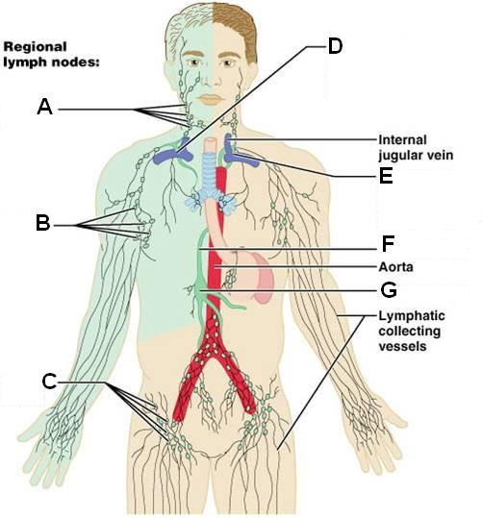

____ 7. Cervical nodes

____ 8. Entrance of right lymphatic duct into right subclavian vein

____ 9. Axillary nodes

____ 10. Cisterna Chyli

____ 11. Thoracic duct

Matching. Match the letters on the diagram with the corresponding questions below:
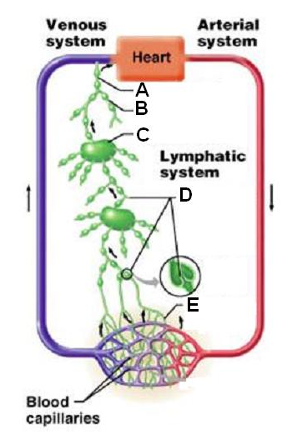

____ 12. Lymph duct

____ 13. Lymphatic collecting vessels, with valves

____ 14. Lymph trunk

Matching. Match the letters on the diagram with the corresponding questions below:
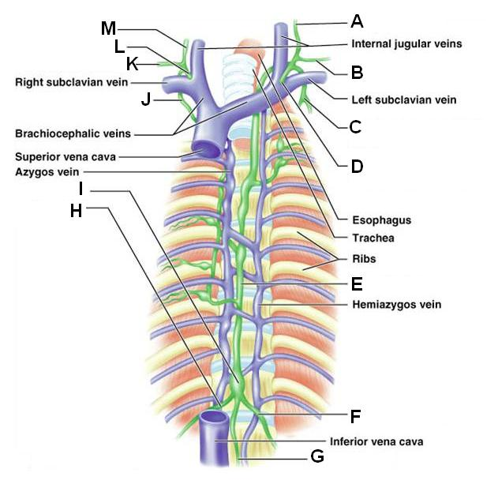

____ 15. Left bronchomediastinal trunk

____ 16. Right lymphatic duct

____ 17. Left subclavian trunk

____ 18. Left jugular trunk

____ 19. Entrance of thoracic duct into left subclavian vein

____ 20. Right bronchomediastinal trunk

____ 21. Thoracic duct

____ 22. Cisterna chyli

____ 23. Right lumbar trunk

____ 24. Intestinal trunk

Label:
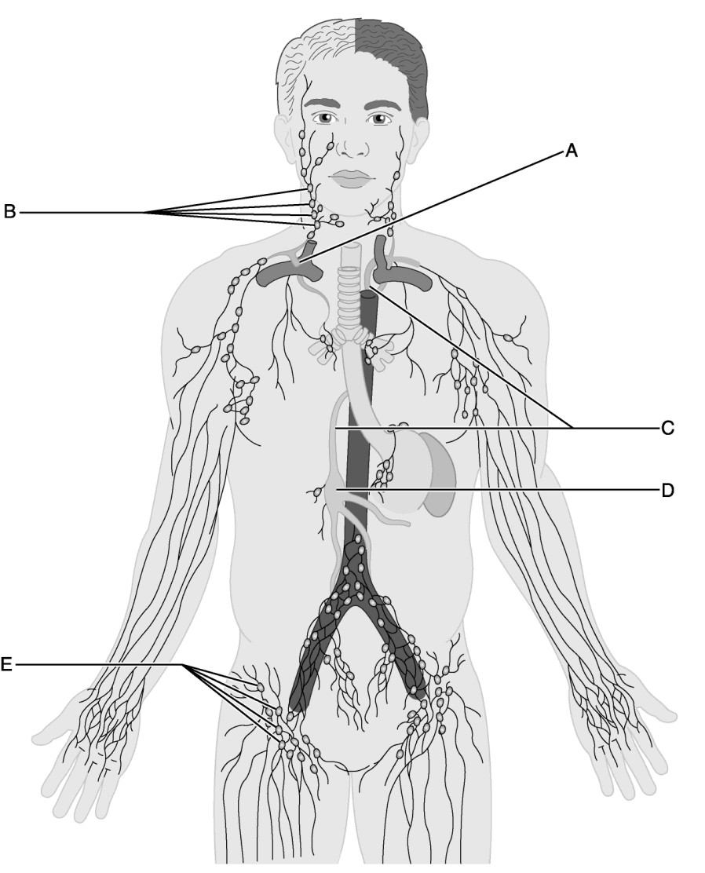

____ 25. Identify the letter that indicates lymph nodes that direct lymph fluid to the jugular trunks.

____ 26. Identify the letter that indicates the large lymph vessel that drains three-quarters of the body.

____ 27. Identify the letter that indicates the union of the right jugular, subclavian, and bronchomediastinal trunks.

____ 28. Identify the letter that indicates inguinal lymph nodes that filter lymph from the lower limbs.

____ 29. Identify the letter that indicates the first structure to receive lymph from both the lumbar and intestinal trunks and is located on the surface of L1 and L2 vertebrae.

Matching. Match the letters on the diagram with the corresponding questions below:
a. | Lumbar trunk | d. | Subclavian trunk
b. | Intestinal trunk | e. | Jugular trunk
c. | Bronchomediastinal trunk

____ 30. Receives chyle

____ 31. Drains lymph from the head and neck

____ 32. Receives lymph from lower limbs

Lymphatics Label MC
Answer Section

MULTIPLE CHOICE

1. ANS: E PTS: 1

2. ANS: D PTS: 1

3. ANS: E PTS: 1

4. ANS: B PTS: 1

5. ANS: A PTS: 1

6. ANS: C PTS: 1

MATCHING

7. ANS: A PTS: 1

8. ANS: D PTS: 1

9. ANS: B PTS: 1

10. ANS: G PTS: 1

11. ANS: F PTS: 1

12. ANS: A PTS: 1

13. ANS: D PTS: 1

14. ANS: B PTS: 1

15. ANS: C PTS: 1

16. ANS: L PTS: 1

17. ANS: B PTS: 1

18. ANS: A PTS: 1

19. ANS: D PTS: 1

20. ANS: J PTS: 1

21. ANS: E PTS: 1

22. ANS: I PTS: 1

23. ANS: H PTS: 1

24. ANS: G PTS: 1

25. ANS: B PTS: 1

26. ANS: C PTS: 1

27. ANS: A PTS: 1

28. ANS: E PTS: 1

29. ANS: D PTS: 1

30. ANS: B PTS: 1

31. ANS: E PTS: 1

32. ANS: A PTS: 1

