Lab Exercise 4 Integumentary System

Multiple Choice
Identify the letter of the choice that best completes the statement or answers the question.

____ 1. Which of the following is not a characteristic of thick skin?
a. | Located over the palms and the soles of the feet | d. | Contains stratum lucidum
b. | Contains hair and arrector pili muscles | e. | Contains sweat glands
c. | Very thick statum corneum

____ 2. Fingerprints are the result of
a. | epidermal ridges | c. | epidermal papillae that create dermal ridges
b. | projections from the hypodermis | d. | dermal paillae that house sebaceous glands

Matching

BASIC STRUCTURE OF THE SKIN
Complete the following statements by matching the appropriate wor or phrase on the correspondingly numbered bank.

The to basic tissues of which the skin is composed are dense irregular connective tissue, which makes up the dermis, and ___(1)___, which forms the epidermis. The tough protective protein found in the epidermal cells is called ___(2)___. The pigments melanin and ___(3)___ contribute to the natural skin color. A localized concentration of melanin is referred to as a ___(4)___.
a. | Keratin | f. | Stratified cuboidal epithelium
b. | Freckle | g. | Transitional epithelium
c. | Stratified squamous epithelium | h. | Collagen
d. | Carotene | i. | Jaundice
e. | Elastin

____ 3. Number 1

____ 4. Number 2

____ 5. Number 3

____ 6. Number 4

Matching. Using the key choices, choose all responses that apply to the following descriptions.
a. | stratum basale | f. | papillary layer
b. | stratum corneum | g. | reticular layer
c. | stratum granulosum | h. | epidermis as a whole
d. | stratum lucidum | i. | dermis as a whole
e. | stratum spinosum

____ 7. translucent cells containing keratin fibrils in thick skin

____ 8. dermal layer responsible for fingerprints

____ 9. major skin areas that produces derivatives (nails and hair)

____ 10. epidermal region exhibiting the most rapid cell division

____ 11. scalelike dead cells, full of keratin, that constantly slough off

____ 12. mitotic cells filled with intermediate filaments

____ 13. location of melanocytes and Merkel cells

____ 14. area where web-like pre-keratin filaments first appear

____ 15. region of areolar connective tissue

Label the skin structures and areas indicated in the accompanying diagram of thin skin.
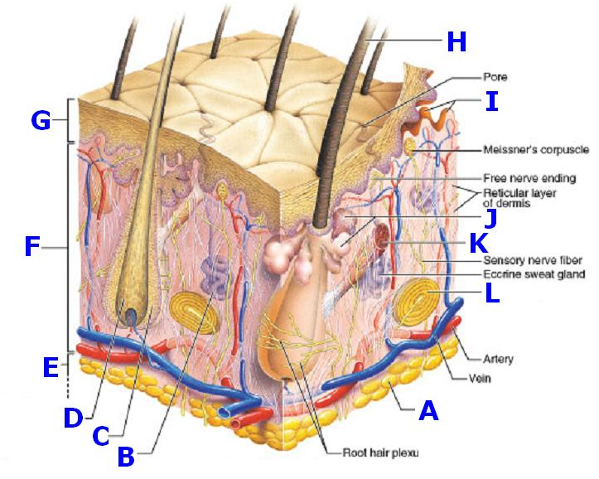

____ 16. Hair follicle

____ 17. Hair shaft

____ 18. Adipocyte

____ 19. Hair root

____ 20. Dermis

____ 21. Sweat gland

____ 22. Arrector pili muscle

____ 23. Sebaceous gland

____ 24. Dermal papillae

____ 25. Epidermis

____ 26. Hypodermis (Subcutaneous tissue)

____ 27. Paccinian corpuscle

Matching. Match the letter choices from the corresponding questions below.
a. | Lamellated | h. | Stratum corneum
b. | Desmosomes | i. | Melanocytes
c. | Keratinocytes | j. | Plasma cells
d. | Merkel disc | k. | Langerhans’ cells
e. | Paccinian corpuscle | l. | Fibroblast
f. | Stratum lucidum | m. | Ceruminous gland
g. | Stratum spinosum | n. | Sebaceous gland

____ 28. ______granules are extruded from the keratinocytes which prevent water loss by diffusion through the epidermis.

____ 29. Fibers in the dermis are produced by_______

____ 30. Glands that respond to rising androgen levels are the _______ glands.

____ 31. Phagocytic cells that occupy the epidermis are called_______

____ 32. A unique touch receptor formed from a stratum basale cell and a nerve fiber is a _______

____ 33. What layer is present in thick skin but not in thin skin?

____ 34. What cell-to-cell structures hold the cells of the stratum spinosum tightly together?

Label. Identify and label the respective layers of the epidermis of THIN Skin:
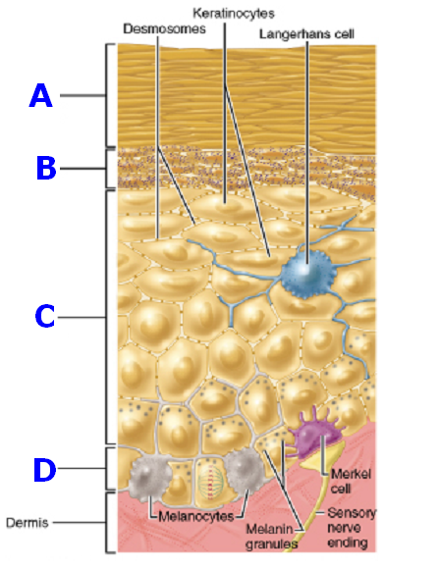

____ 35. Stratum spinosum

____ 36. Stratum granulosum

____ 37. Stratum corneum

____ 38. Stratum basale

Matching. Match the key choices with the appropriate descriptions. You can use the same letter more than once.
a. | arrector pili | e. | nail
b. | cutaneous receptors | f. | sebaceous gland
c. | hair | g. | sweat gland - apocrine
d. | hair follicle | h. | sweat gland - eccrine

____ 39. produces an accumulation of oily material that is known as a blackhead.

____ 40. tiny muscles, attached to hair follicles, that pull the hair upright during fright or cold

____ 41. perspiration gland with a role in temperature control

____ 42. sheath formed of both epithelial and connective tissues

____ 43. less numerous type of perspiration-producing gland; found mainly in the pubic and axillary regions

____ 44. specialized nerve endings that respond to temperature, touch, etc.; lamellated corpuscle located at the dermis.

____ 45. its secretion is a lubricant for hair and skin

____ 46. “sports” a lunula and a cuticle

