QA_Lab Exercise 20 Lymphatic System

Multiple Choice
Identify the choice that best completes the statement or answers the question.

____ 1. Recycles red blood cells and initiates immune responses.
a. | MALT | c. | thymus | e. | spleen
b. | lymph nodes | d. | tonsils

____ 2. Lymphoid organs located in the mucosal lining of the pharynx.
a. | pharygotympanic tube | d. | tonsils
b. | salivary glands | e. | uvula
c. | aggregated lymphoid nodules

____ 3. Small, bean-shaped organs abundant in the cervical, axillary, and inguinal regions.
a. | lymphatic capillaries | d. | lymphatic ducts
b. | lacteals | e. | lymph nodes
c. | afferent lymphatic vessels

____ 4. Duct of the lymphatic system that drains the body's entire lower half.
a. | intestinal trunk | d. | right lymphatic duct
b. | thoracic duct | e. | lumbar trunk
c. | bronchomediastinal trunk

____ 5. The largest kind of lymphatic vessel is a lymphatic
a. | duct. | c. | trunk.
b. | capillary. | d. | sinus.

____ 6. Clusters of lymph nodes occur in all of the following sites except
a. | in the inguinal region. | c. | in bones and bone marrow.
b. | in the mediastinum. | d. | along the aorta.

Matching

Label:
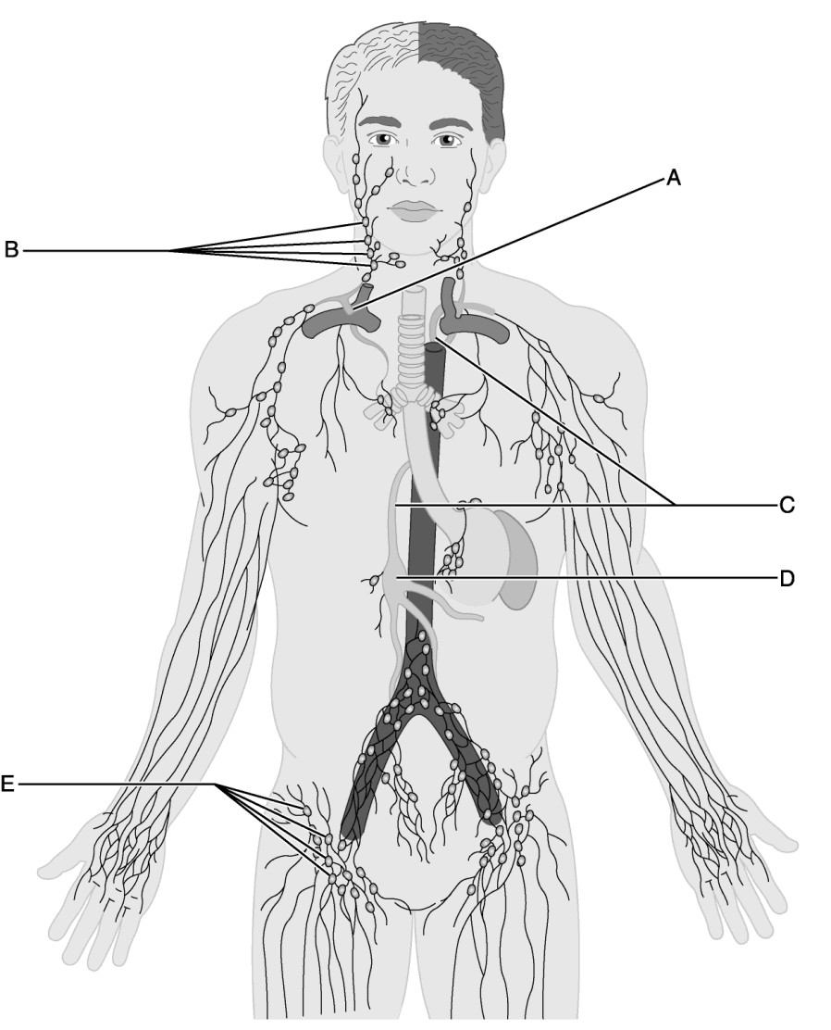

____ 7. Identify the letter that indicates lymph nodes that direct lymph fluid to the jugular trunks.

____ 8. Identify the letter that indicates the large lymph vessel that drains three-quarters of the body.

____ 9. Identify the letter that indicates the union of the right jugular, subclavian, and bronchomediastinal trunks.

____ 10. Identify the letter that indicates inguinal lymph nodes that filter lymph from the lower limbs.

____ 11. Identify the letter that indicates the first structure to receive lymph from both the lumbar and intestinal trunks and is located on the surface of L1 and L2 vertebrae.

Label:
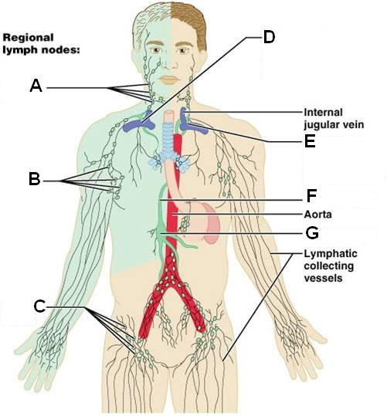

____ 12. Inguinal nodes

____ 13. Cervical nodes

____ 14. Cysterna Chyli

____ 15. Axillary nodes

Label:
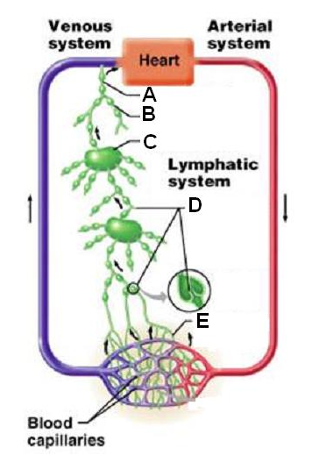

____ 16. Lymph duct

____ 17. Lymph node

____ 18. Lymph trunk

Label:
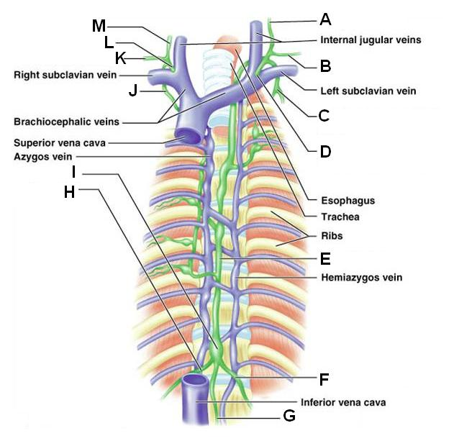

____ 19. Entrance of thoracic duct into left subclavian vein

____ 20. Thoracic duct

____ 21. Intestinal trunk

____ 22. Right jugular trunk

____ 23. Right lymphatic duct

Matching. Match the letters on the diagram with the corresponding questions below:
a. | Lumbar trunk | d. | Subclavian trunk
b. | Intestinal trunk | e. | Jugular trunk
c. | Bronchomediastinal trunk

____ 24. Receives chyle

____ 25. Drains lymph from the head and neck

____ 26. Receives lymph from lower limbs

Lab Exercise 20 Lymphatic System
Answer Section

MULTIPLE CHOICE

1. ANS: E PTS: 1

2. ANS: D PTS: 1

3. ANS: E PTS: 1

4. ANS: B PTS: 1

5. ANS: A PTS: 1

6. ANS: C PTS: 1

MATCHING

7. ANS: B PTS: 1

8. ANS: C PTS: 1

9. ANS: A PTS: 1

10. ANS: E PTS: 1

11. ANS: D PTS: 1

12. ANS: C PTS: 1

13. ANS: A PTS: 1

14. ANS: G PTS: 1

15. ANS: B PTS: 1

16. ANS: A PTS: 1

17. ANS: C PTS: 1

18. ANS: B PTS: 1

19. ANS: D PTS: 1

20. ANS: E PTS: 1

21. ANS: G PTS: 1

22. ANS: M PTS: 1

23. ANS: L PTS: 1

24. ANS: B PTS: 1

25. ANS: E PTS: 1

26. ANS: A PTS: 1

