QA_Lab Exercise 21 Respiratory System

True/False
Indicate whether the sentence or statement is true or false.

____ 1. The epiglottis closes off the laryngopharynx to prevent food from entering the trachea and the lungs.

____ 2. Hemoptysis is also known as a nosebleed.

____ 3. A sinus is an air-filled cavity within a bone that is lined with mucous membrane.

____ 4. Type I alveolar cells secrete pulmonary surfactant.

Multiple Choice
Identify the letter of the choice that best completes the statement or answers the question.

____ 5. Which term describes the exchange of gases within the cells of all the body organs and tissues?
a. | alveolar exchange
b. | external respiration
c. | internal respiration

____ 6. What structure, commonly known as the Adam's apple, protects the larynx?
a. | epiglottis
b. | thyroid cartilage
c. | trachea

____ 7. Which term means any voice impairment including hoarseness, weakness, or loss of voice?
a. | aphonia
b. | dysphonia
c. | laryngitis

____ 8. Which structure carries both food and air?
a. | esophagus | b. | pharynx | c. | trachea | d. | Brinchus | e. | bronchioles

____ 9. Which lung has only two lobes?
a. | left lung | c. | right lung | d. | None of the above
b. | left and right lungs

____ 10. External respiration refers to
a. | pulmonary ventilation
b. | ventilation and gas exchange the air and blood
c. | ventilation, gas exchange, and gas transport by the blood
d. | everything except cellular respiration

____ 11. The conducting zone contains all of the following EXCEPT
a. | the primary bronchi. | c. | the terminal bronchioles.
b. | the larynx. | d. | the respiratory bronchioles.

____ 12. What phospholipid decreases the surface tension of the alveoli?
a. | saliva | b. | mucus | c. | lymph | d. | surfactant

____ 13. How does surfactant reduce the surface tension of water in the lungs?
a. | decomposes water | c. | covers the alveoli
b. | reduces hydrogen bonding between water molecules | d. | All of the choices are correct.

____ 14. Trace the sequence of flow of air from outside to inside:
a. | Nasal cavity, pharynx, esophagus, larynx, trachea, bronchi, bronchioles, and alveoli | c. | Nasal cavity, pharynx, epiglottis, larynx, trachea, bronchioles, bronchi, and alveoli
b. | Nasal cavity, epiglottis, pharynx, larynx, bronchi, bronchioles, and alveoli | d. | Nasal cavity, pharynx, epiglottis, larynx, trachea, bronchi, bronchioles, and alveoli

Matching

Multiple Choice. Choose from the labelled diagram.

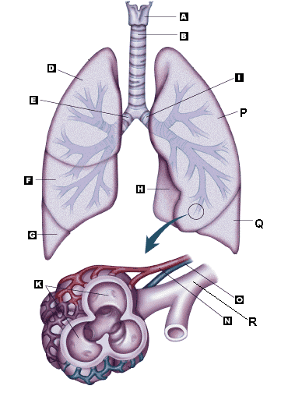

____ 15. Left Bronchi

____ 16. Bronchioles

____ 17. Right Bronchi

____ 18. Larynx

____ 19. Trachea

____ 20. Alveoli

____ 21. Right Upper Lobe

____ 22. Left Upper Lobe

____ 23. Right Middle Lobe

____ 24. Right Lower Lobe

Matching. Match the letters on the diagram with the corresponding questions below:
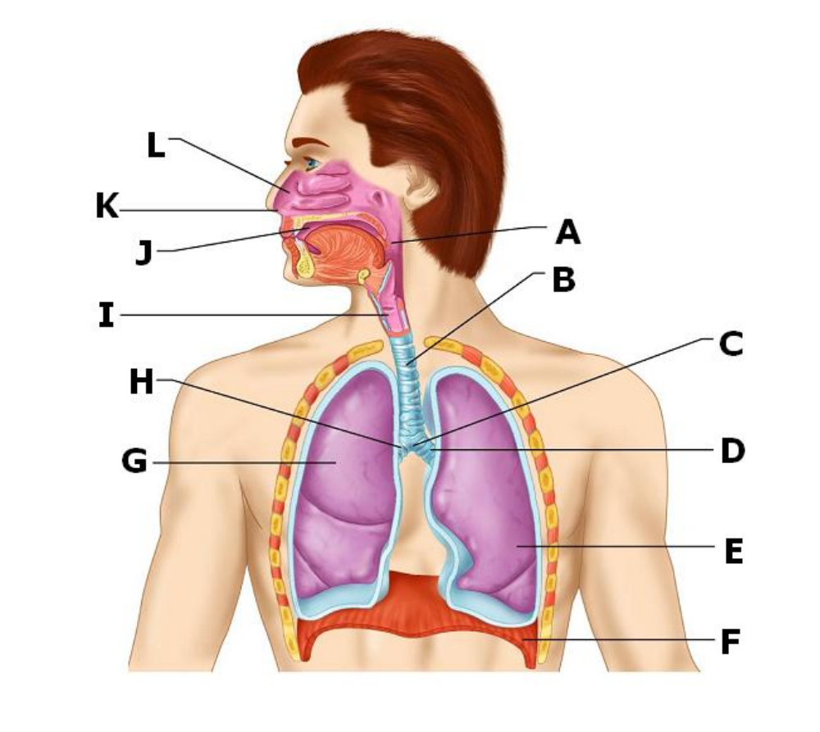

____ 25. Trachea

____ 26. Nasal cavity

____ 27. Pharynx

____ 28. Carina

____ 29. Left Primary bronchus

____ 30. Larynx

____ 31. Oral cavity

____ 32. Right primary bronchus

Matching. Match the letters on the diagram with the corresponding questions below:
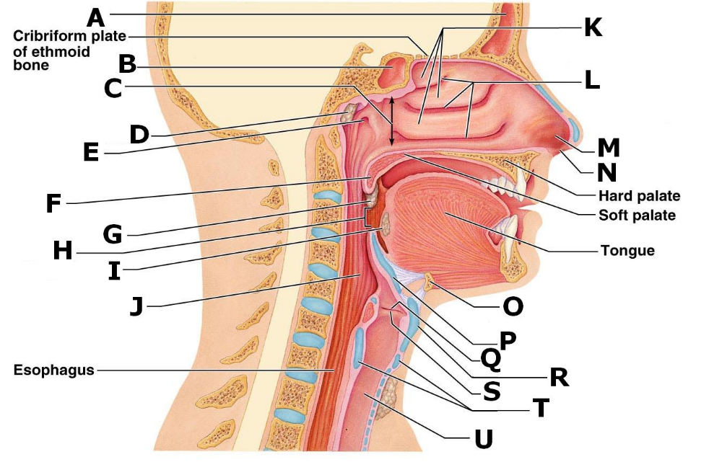

____ 33. Nasal Conchae

____ 34. Nasal Meatuses

____ 35. Pharyngeal tonsil

____ 36. Opening of the Pharyngotympanic tube

____ 37. Palatine tonsil

____ 38. Lingual tonsil

____ 39. Uvula

____ 40. Posterior nasal aperture

____ 41. Hyoid bone

____ 42. Epiglottis

____ 43. Vestibular fold

____ 44. Vocal fold

____ 45. Thyroid cartilage

____ 46. Trachea

____ 47. Cricoid cartilage

Matching. Match the letters on the diagram with the corresponding questions below:
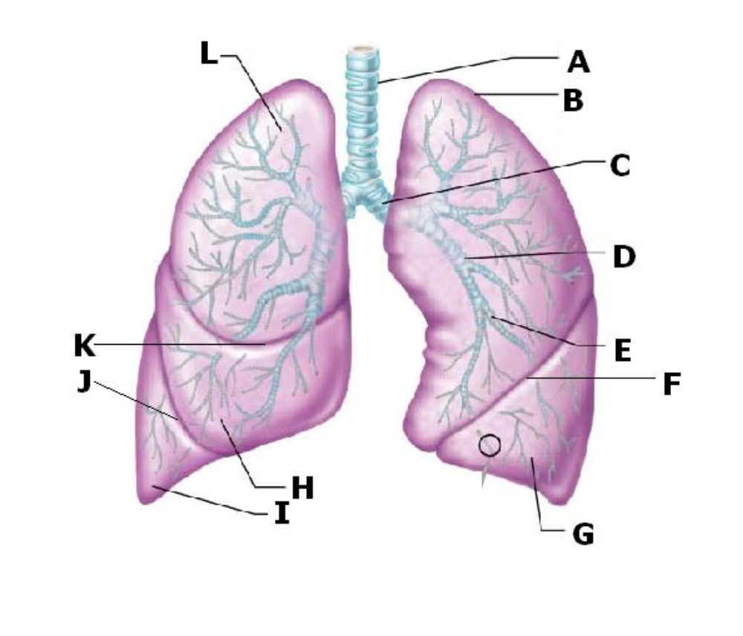

____ 48. Segmental bronchus

____ 49. Lobar bronchus

____ 50. Primary bronchus

____ 51. Left Oblique fissure

____ 52. Right horizontal fissure

____ 53. Middle lobe

____ 54. Superior lobe of the left lung

Matching. Match the letters on the diagram with the corresponding questions below:
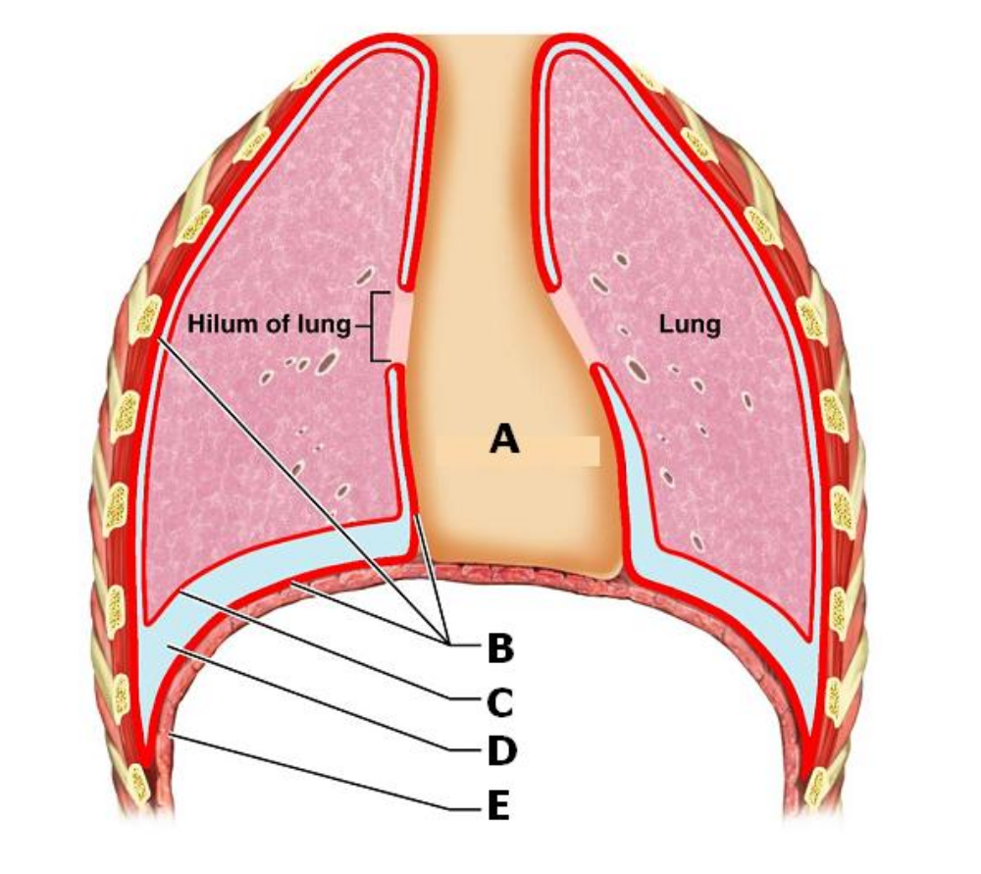

____ 55. Mediastinum

____ 56. Parietal pleura

____ 57. Visceral pleura

____ 58. Pleural cavity

Matching. Match the letters on the diagram with the corresponding questions below.
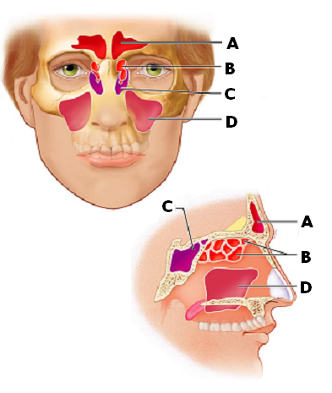

____ 59. Sphenoid sinus

____ 60. Frontal sinus

____ 61. Maxillary sinus

____ 62. Ethmoidal air cells

Matching. Match the letters on the diagram with the corresponding questions below.
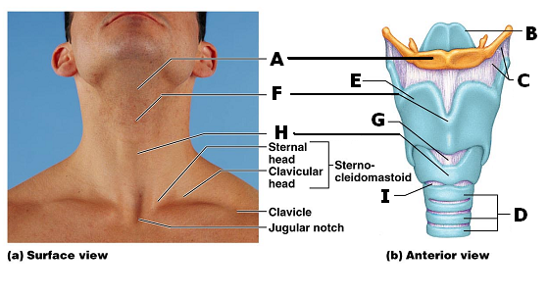

____ 63. Tracheal rings

____ 64. Cricotracheal ligament

____ 65. Body of hyoid bone

____ 66. Thyroid cartilage

____ 67. Laryngeal prominence

____ 68. Cricothyroid ligament

____ 69. Cricoid cartilage

Matching. Match the letters on the diagram with the corresponding questions below.
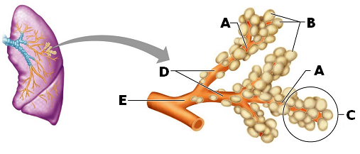

____ 70. Respiratory bronchioles

____ 71. Terminal bronchiole

____ 72. Alveolar sac

____ 73. Alveolar duct

____ 74. Alveoli

Matching. Match the letters with the corresponding questions below.
a. | Nasopharynx | c. | Oropharynx
b. | Laryngopharynx

____ 75. Palatine tonsils

____ 76. Pharyngeal tonsils (Adenoids)

____ 77. Lingual tonsils

Lab Exercise 21 Respiratory System
Answer Section

TRUE/FALSE

1. ANS: T PTS: 1

2. ANS: F PTS: 1

3. ANS: T PTS: 1

4. ANS: F PTS: 1

MULTIPLE CHOICE

5. ANS: C PTS: 1

6. ANS: B PTS: 1

7. ANS: B PTS: 1

8. ANS: B PTS: 1

9. ANS: A PTS: 1

10. ANS: B
Pulmonary ventilation is the movement of air into and out of the lungs. (p. 482)

PTS: 1

11. ANS: D PTS: 1

12. ANS: D PTS: 1

13. ANS: B PTS: 1

14. ANS: D PTS: 1

MATCHING

15. ANS: I PTS: 1

16. ANS: R PTS: 1

17. ANS: E PTS: 1

18. ANS: A PTS: 1

19. ANS: B PTS: 1

20. ANS: K PTS: 1

21. ANS: D PTS: 1

22. ANS: P PTS: 1

23. ANS: F PTS: 1

24. ANS: G PTS: 1

25. ANS: B PTS: 1

26. ANS: L PTS: 1

27. ANS: A PTS: 1

28. ANS: C PTS: 1

29. ANS: D PTS: 1

30. ANS: I PTS: 1

31. ANS: J PTS: 1

32. ANS: H PTS: 1

33. ANS: K PTS: 1

34. ANS: L PTS: 1

35. ANS: D PTS: 1

36. ANS: E PTS: 1

37. ANS: G PTS: 1

38. ANS: I PTS: 1

39. ANS: F PTS: 1

40. ANS: C PTS: 1

41. ANS: O PTS: 1

42. ANS: P PTS: 1

43. ANS: Q PTS: 1

44. ANS: S PTS: 1

45. ANS: R PTS: 1

46. ANS: U PTS: 1

47. ANS: T PTS: 1

48. ANS: E PTS: 1

49. ANS: D PTS: 1

50. ANS: C PTS: 1

51. ANS: F PTS: 1

52. ANS: K PTS: 1

53. ANS: H PTS: 1

54. ANS: B PTS: 1

55. ANS: A PTS: 1

56. ANS: B PTS: 1

57. ANS: C PTS: 1

58. ANS: D PTS: 1

59. ANS: C PTS: 1

60. ANS: A PTS: 1

61. ANS: D PTS: 1

62. ANS: B PTS: 1

63. ANS: D PTS: 1

64. ANS: I PTS: 1

65. ANS: A PTS: 1

66. ANS: E PTS: 1

67. ANS: F PTS: 1

68. ANS: G PTS: 1

69. ANS: H PTS: 1

70. ANS: D PTS: 1

71. ANS: E PTS: 1

72. ANS: C PTS: 1

73. ANS: A PTS: 1

74. ANS: B PTS: 1

75. ANS: C PTS: 1

76. ANS: A PTS: 1

77. ANS: C PTS: 1

