QA_Lab Exercise 23 Reproductive System

True/False
Indicate whether the sentence or statement is true or false.

____ 1. The urethra in the penis is inside the corpus carvernosum

____ 2. Testes are male gonads.

____ 3. Spermatozoa are gametes.

Multiple Choice
Identify the letter of the choice that best completes the statement or answers the question.

____ 4. Which of the following is correct about the female vestibule?
a. | The vaginal orifice is the most anterior of the two orifices in the vestibule. | d. | The urethra is between the vaginal orifice and the anus
b. | The urethral orifice is anterior to the vaginal orifice | e. | The urethral orifice is posterior to the vaginal orifice
c. | The anus is between the vaginal orifice and the urethra

____ 5. Trace the path of the sperm from the inside to the outside of the body
a. | testis, epididymis, seminal vesicle, vas deferens, ejaculatory duct, urethra, meatus (orifice) | c. | testis, seminal vesicle, epididymis, vas deferens, ejaculatory duct, urethra, meatus (orifice)
b. | testis, epididymis, vas deferens, seminal vesicle, ejaculatory duct, urethra, meatus (orifice) | d. | Epididymis, testis, vas deferens, seminal vesicle, ejaculatory duct, meatus, urethra

____ 6. Trace the path of the egg from the inside to the outside of the body:
a. | ovary, fallopian tube, cervix, uterus, vaginal canal, vaginal orifice | c. | ovary, fallopian tube, uterus, cervix, vaginal orifice, vaginal canal
b. | ovary, uterus, fallopian tube, cervix, vaginal canal, vaginal orifice | d. | ovary, fallopian tube, uterus, cervix, vaginal canal, vaginal orifice

____ 7. The three layers of the uterus from the inside to the outside are:
a. | endometrium, myometrium, and epimetrium | c. | interiomuscularis, mediomuscularis, and exteriomuscularis.
b. | intrametrium, mediometrium, and exometrium | d. | endomuscularis, myomuscularis, and epimuscularis.

____ 8. A comma-shaped structure on the posterior testis; maturation of sperm cells occurs here:
a. | prostatic urethra | d. | ejaculatory duct
b. | epididymis | e. | sperm bank
c. | ductus deferens

____ 9. The broad ligament of the uterus in the female pelvis
a. | is really a mesentery | d. | is the same as the lateral cervical ligament
b. | consists of the mesovarium and mesosalphinx but not the mesometrium | e. | B and C
c. | is the same as the round ligament

____ 10. If the uterine tube is a trumpet (“salpinx”), what part of it represents the wide open end of the trumpet?
a. | isthmus | c. | infundibulum
b. | ampulla | d. | flagellum

____ 11. The myometrium is the muscular layer of the uterus, and the endometrium is the
a. | serosa | c. | submucosa
b. | adventitia | d. | mucosa

____ 12. The sheath that encloses the vas deferens along with the arteries, veins, and nerves is:
a. | tunica vaginalis testis. | c. | scrotum.
b. | epididymis. | d. | spermatic cord.

____ 13. Which of the following does NOT provide fluid for semen?
a. | urinary bladder | c. | bulbourethral glands
b. | prostate | d. | seminal vesicles

____ 14. The structure located where the vas deferens joins the urethra is the:
a. | ejaculatory duct. | c. | Cowper’s gland.
b. | prostate gland. | d. | prepuce.

____ 15. The corpora cavernosa and the corpus spongiosum are anatomic structures of the:
a. | testicle. | c. | prostate.
b. | perineum. | d. | penis.

____ 16. The prostate surrounds the:
a. | vas deferens. | c. | ureter.
b. | urethra. | d. | penis.

____ 17. The female gamete is the:
a. | clitoris. | c. | ovum.
b. | ovary. | d. | uterus.

____ 18. The narrowed lower part of the uterus is the:
a. | fundus. | c. | fimbria.
b. | body. | d. | cervix.

____ 19. The fertilized egg is termed the:
a. | ovum. | c. | zygote.
b. | fetus. | d. | embryo.

____ 20. The top of the uterus is the:
a. | body. | c. | fundus.
b. | cervix. | d. | myometrium.

____ 21. Where does fertilization take place?
a. | Uterus | c. | Vagina
b. | Ovaries | d. | Fallopian tubes

Matching

Matching. Match the following accessory gland secretions with the structure involved. You may use the same letter more than once
a. | Prostate gland | c. | Seminal Vesicle
b. | Bulbourethral gland

____ 22. Enzymes that clot and liquify semen

____ 23. Neutralizes traces of acidic urine in the urethra

____ 24. Fructose

____ 25. Prostaglandin, substances that suppress immune response to semen

Matching. Match the letters with the corresponding questions below. You may use the same letter more than once
a. | Mesosalphinx | c. | Mesometrium
b. | Mesovarium

____ 26. part of the Broad ligament for the fallopian tube

____ 27. part of the Broad ligament for the ovary

____ 28. part of the Broad ligament for the uterus

Label.
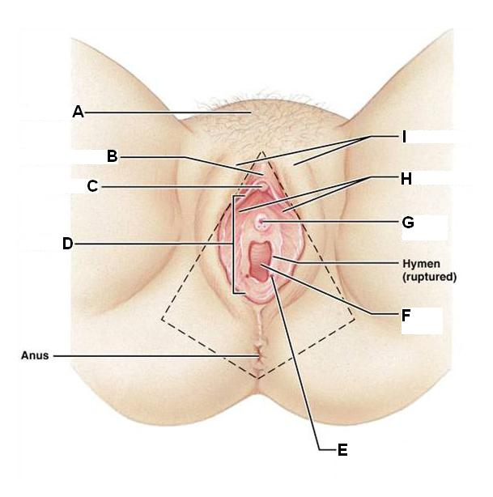

____ 29. Vaginal orifice

____ 30. Vestibular gland duct opening

____ 31. Clitoris

____ 32. Mons pubis

____ 33. Prepuce of clitoris

____ 34. Vestibule

____ 35. Urethral orifice

____ 36. Labia majora

____ 37. Labia minora

Label.
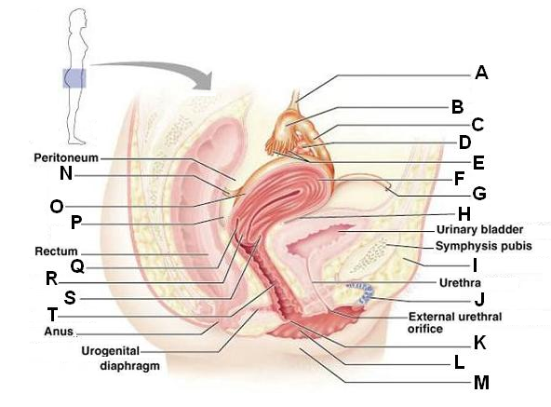

____ 38. Anterior fornix

____ 39. Vagina

____ 40. Hymen

____ 41. Labia majus

____ 42. Labia minus

____ 43. Rectouterine pouch

____ 44. Perimetrium

____ 45. Posterior fornix

____ 46. Cervix

____ 47. Uterus

____ 48. Round ligament

____ 49. Clitoris

____ 50. Vesicouterine pouch

____ 51. Mons pubis

____ 52. Uterosacral ligament

____ 53. Fimbrae of uterine tube

____ 54. Uterine tube

____ 55. Ovary

____ 56. Infundibulum of uterine tube

____ 57. Ovarian suspensory ligament

Label.
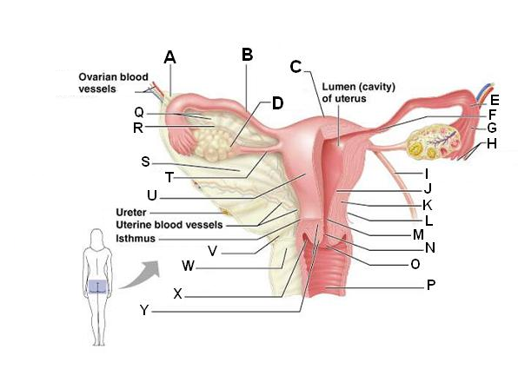

____ 58. Mesometrium

____ 59. Body of Uterus

____ 60. Ovarian ligament

____ 61. Mesovarium

____ 62. Mesosalphinx

____ 63. Ovarian suspensory ligament

____ 64. Fundus of uterus

____ 65. Fallopian tube

____ 66. Ovary

____ 67. Uterosacral ligament

____ 68. Cardinal ligament

____ 69. Cervix

____ 70. Lateral fornix

____ 71. Round ligament of uterus

____ 72. Uterine endometrium

____ 73. Fallopian (Uterine) tube Infundibulum

____ 74. Fallopian (Uterine) tube Fimbriae

____ 75. Fallopian (Uterine) tube Isthmus

____ 76. Fallopian (Uterine) tube Ampulla

____ 77. External os

____ 78. Uterine myometrium

____ 79. Uterine perimetrium

____ 80. Vagina

____ 81. Internal os

____ 82. Cervical canal

Label.
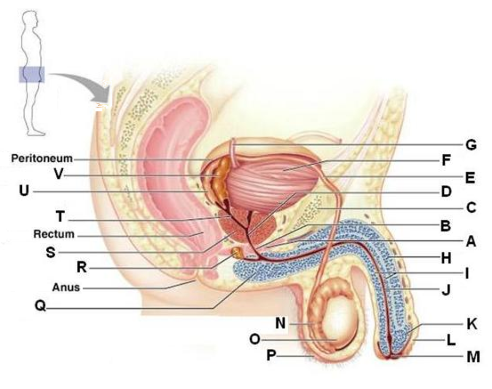

____ 83. Bulb of penis

____ 84. Seminal vesicle

____ 85. Ejaculatory duct

____ 86. Ampulla of ductus deferens

____ 87. Bulbourethral gland

____ 88. Prostate gland

____ 89. Ureter

____ 90. Prostatic urethra

____ 91. Ductus deferens

____ 92. Urinary bladder

____ 93. Epididymis

____ 94. Testis

____ 95. Spongy (penile) urethra

____ 96. Glans penis

____ 97. Prepuce

____ 98. External urethral orifice

____ 99. Corpus spongiosum

____ 100. Corpus cavernosum

____ 101. Spongy (penile) urethra

____ 102. Scrotum

Label.
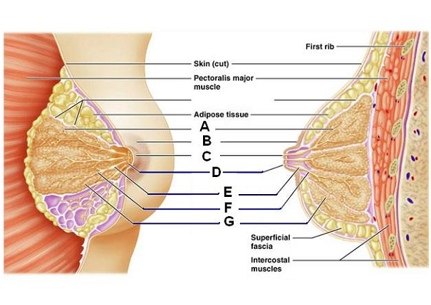

____ 103. Lactiferous sinus

____ 104. Mammary lobe

____ 105. Nipple

____ 106. Lactiferous duct opening

____ 107. Areola

____ 108. Lactiferous duct

Label.
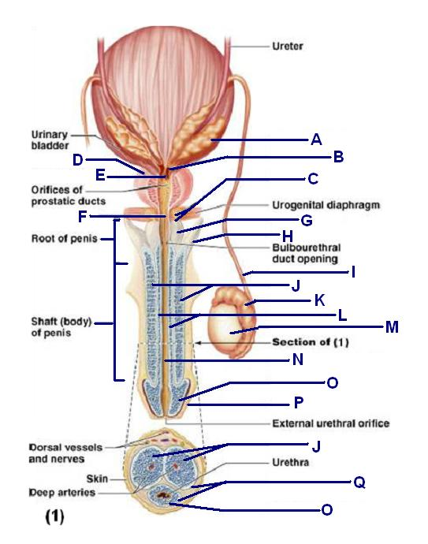

____ 109. Membranous urethra

____ 110. Prostatic urethra

____ 111. Seminal vesicle

____ 112. Ejaculatory duct

____ 113. Prostate gland

____ 114. Bulbourethral gland and duct

____ 115. Corpora spongiosum

____ 116. Bulb of penis

____ 117. Crus of penis

____ 118. Ductus deferens

____ 119. Corpora cavernosa

____ 120. Glans penis

____ 121. Tunica albuginea of erectile bodies

____ 122. Prepuce

____ 123. Spongy (penile) urethra

Label.
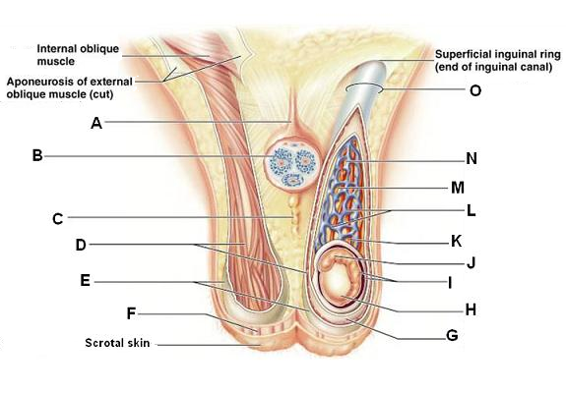

____ 124. Scrotal superficial fascia with dartos muscle

____ 125. Tunica albuginea of testis

____ 126. External spermatic fascia

____ 127. Cremaster muscle

____ 128. Epididymis

____ 129. Tunica vaginalis

____ 130. Testicular artery

____ 131. Middle scrotal septum

____ 132. Pampiniform plexus of testicular veins

____ 133. Ductus deferens

____ 134. Spermatic cord

____ 135. Internal spermatic fascia

____ 136. Tunica albuginea of testis

____ 137. Suspensory ligament of testis

Label.
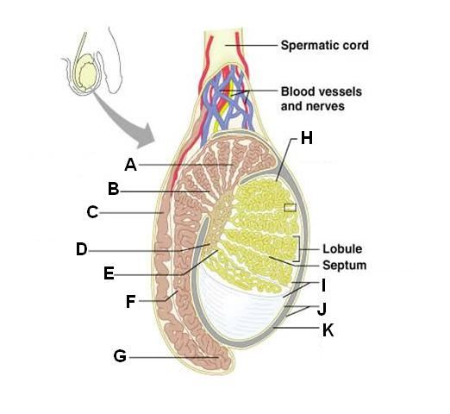

____ 138. Rete testis

____ 139. Efferent ductule

____ 140. Seminiferous tubules

____ 141. Head of epididymis

____ 142. Body of epididymis

____ 143. Tubulus rectus

____ 144. Ductus deferens

____ 145. Tunica albuginea

____ 146. Cavity of tunica vaginalis

____ 147. Tunica vaginalis

____ 148. Tail epididymis

Match each structure with the letter that matches it!

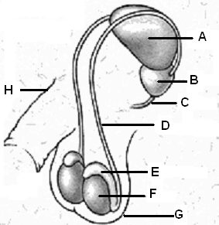

____ 149. Scrotum.

____ 150. Penis.

____ 151. Prostate gland.

____ 152. Vas deferens.

____ 153. Testis.

____ 154. Urinary bladder.

____ 155. Epididymis.

____ 156. Urethra.

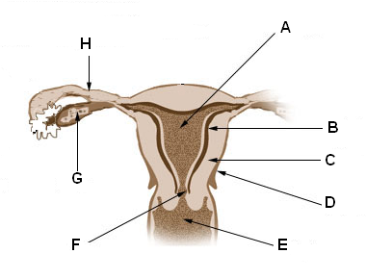

____ 157. Uterus.

____ 158. Fallopian tube.

____ 159. Myometrium.

____ 160. Cervix.

____ 161. Ovary.

____ 162. Endometrium.

____ 163. Vagina.

____ 164. Perimetrium.

Match each structure to its corresponding letter!
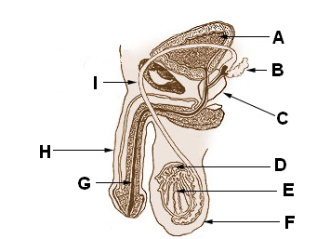

____ 165. Penis

____ 166. Epididymis

____ 167. Scrotum

____ 168. Seminal vesicle

____ 169. Prostate gland

____ 170. Testis

____ 171. Urethra

____ 172. Urinary bladder

____ 173. Vas deferens

Lab Exercise 23 Reproductive System
Answer Section

TRUE/FALSE

1. ANS: F PTS: 1

2. ANS: T PTS: 1 OBJ: A+P TOP: Nondecodable Terms

3. ANS: T PTS: 1 OBJ: A+P TOP: Nondecodable Terms

MULTIPLE CHOICE

4. ANS: B PTS: 1

5. ANS: B PTS: 1

6. ANS: D PTS: 1

7. ANS: A PTS: 1

8. ANS: B PTS: 1

9. ANS: A PTS: 1

10. ANS: C PTS: 1

11. ANS: D PTS: 1

12. ANS: D PTS: 1 OBJ: A+P TOP: Word Parts & Decodable Terms

13. ANS: A PTS: 1 OBJ: A+P TOP: Word Parts & Decodable Terms

14. ANS: A PTS: 1 OBJ: A+P TOP: Nondecodable Terms

15. ANS: D PTS: 1 OBJ: A+P TOP: Nondecodable Terms

16. ANS: B PTS: 1 OBJ: Pathology TOP: Word Parts & Decodable Terms

17. ANS: C PTS: 1 OBJ: A+P TOP: Word Parts & Decodable Terms

18. ANS: D PTS: 1 OBJ: A+P TOP: Word Parts & Decodable Terms

19. ANS: C PTS: 1 OBJ: A+P TOP: Nondecodable Terms

20. ANS: C PTS: 1 OBJ: A+P TOP: Word Parts & Decodable Terms

21. ANS: D PTS: 1

MATCHING

22. ANS: A PTS: 1

23. ANS: B PTS: 1

24. ANS: C PTS: 1

25. ANS: C PTS: 1

26. ANS: A PTS: 1

27. ANS: B PTS: 1

28. ANS: C PTS: 1

29. ANS: F PTS: 1

30. ANS: E PTS: 1

31. ANS: C PTS: 1

32. ANS: A PTS: 1

33. ANS: B PTS: 1

34. ANS: D PTS: 1

35. ANS: G PTS: 1

36. ANS: I PTS: 1

37. ANS: H PTS: 1

38. ANS: S PTS: 1

39. ANS: T PTS: 1

40. ANS: K PTS: 1

41. ANS: M PTS: 1

42. ANS: L PTS: 1

43. ANS: P PTS: 1

44. ANS: O PTS: 1

45. ANS: Q PTS: 1

46. ANS: R PTS: 1

47. ANS: F PTS: 1

48. ANS: G PTS: 1

49. ANS: J PTS: 1

50. ANS: H PTS: 1

51. ANS: I PTS: 1

52. ANS: N PTS: 1

53. ANS: E PTS: 1

54. ANS: C PTS: 1

55. ANS: D PTS: 1

56. ANS: B PTS: 1

57. ANS: A PTS: 1

58. ANS: S PTS: 1

59. ANS: U PTS: 1

60. ANS: T PTS: 1

61. ANS: R PTS: 1

62. ANS: Q PTS: 1

63. ANS: A PTS: 1

64. ANS: C PTS: 1

65. ANS: B PTS: 1

66. ANS: D PTS: 1

67. ANS: V PTS: 1

68. ANS: W PTS: 1

69. ANS: Y PTS: 1

70. ANS: X PTS: 1

71. ANS: I PTS: 1

72. ANS: J PTS: 1

73. ANS: G PTS: 1

74. ANS: H PTS: 1

75. ANS: F PTS: 1

76. ANS: E PTS: 1

77. ANS: O PTS: 1

78. ANS: K PTS: 1

79. ANS: L PTS: 1

80. ANS: P PTS: 1

81. ANS: M PTS: 1

82. ANS: N PTS: 1

83. ANS: Q PTS: 1

84. ANS: V PTS: 1

85. ANS: T PTS: 1

86. ANS: U PTS: 1

87. ANS: R PTS: 1

88. ANS: S PTS: 1

89. ANS: G PTS: 1

90. ANS: D PTS: 1

91. ANS: E PTS: 1

92. ANS: F PTS: 1

93. ANS: N PTS: 1

94. ANS: O PTS: 1

95. ANS: J PTS: 1

96. ANS: K PTS: 1

97. ANS: L PTS: 1

98. ANS: M PTS: 1

99. ANS: I PTS: 1

100. ANS: H PTS: 1

101. ANS: J PTS: 1

102. ANS: P PTS: 1

103. ANS: E PTS: 1

104. ANS: A PTS: 1

105. ANS: C PTS: 1

106. ANS: D PTS: 1

107. ANS: B PTS: 1

108. ANS: F PTS: 1

109. ANS: F PTS: 1

110. ANS: E PTS: 1

111. ANS: A PTS: 1

112. ANS: B PTS: 1

113. ANS: D PTS: 1

114. ANS: C PTS: 1

115. ANS: L PTS: 1

116. ANS: G PTS: 1

117. ANS: H PTS: 1

118. ANS: I PTS: 1

119. ANS: J PTS: 1

120. ANS: O PTS: 1

121. ANS: Q PTS: 1

122. ANS: P PTS: 1

123. ANS: N PTS: 1

124. ANS: F PTS: 1

125. ANS: H PTS: 1

126. ANS: E PTS: 1

127. ANS: D PTS: 1

128. ANS: J PTS: 1

129. ANS: I PTS: 1

130. ANS: K PTS: 1

131. ANS: C PTS: 1

132. ANS: L PTS: 1

133. ANS: N PTS: 1

134. ANS: O PTS: 1

135. ANS: G PTS: 1

136. ANS: G PTS: 1

137. ANS: A PTS: 1

138. ANS: D PTS: 1

139. ANS: B PTS: 1

140. ANS: H PTS: 1

141. ANS: A PTS: 1

142. ANS: F PTS: 1

143. ANS: E PTS: 1

144. ANS: C PTS: 1

145. ANS: I PTS: 1

146. ANS: K PTS: 1

147. ANS: J PTS: 1

148. ANS: G PTS: 1

149. ANS: G PTS: 1

150. ANS: H PTS: 1

151. ANS: B PTS: 1

152. ANS: D PTS: 1

153. ANS: F PTS: 1

154. ANS: A PTS: 1

155. ANS: E PTS: 1

156. ANS: C PTS: 1

157. ANS: A PTS: 1

158. ANS: H PTS: 1

159. ANS: C PTS: 1

160. ANS: F PTS: 1

161. ANS: G PTS: 1

162. ANS: B PTS: 1

163. ANS: E PTS: 1

164. ANS: D PTS: 1

165. ANS: H PTS: 1

166. ANS: D PTS: 1

167. ANS: F PTS: 1

168. ANS: B PTS: 1

169. ANS: C PTS: 1

170. ANS: E PTS: 1

171. ANS: G PTS: 1

172. ANS: A PTS: 1

173. ANS: I PTS: 1

