Q_Lab Exercise 5: Skeletal Tissue Overview

Matching

OVERVIEW OF THE SKELETON
Matching. Match the letters with the corresponding question below.
a. | condyle | i. | process
b. | crest | j. | ramus
c. | epicondyle | k. | sinus
d. | fissure | l. | spine
e. | foramen | m. | trochanter
f. | fossa | n. | tubercle
g. | head | o. | tuberosity
h. | meatus

____ 1. sharp, slender process ( a site of muscle attachment)

____ 2. small rounded projection (a site of muscle attachment)

____ 3. narrow ridge of bone (a site of muscle attachment)

____ 4. large rounded projection (a site of muscle attachment)

____ 5. structure supported on neck (takes part in joint formation)

____ 6. armlike projection (takes part in joint formation)

____ 7. rounded, convex projection (takes part in joint formation)

____ 8. narrow opening ( a passageway for nerves or blood vessels)

____ 9. canal like structure ( a passageway for nerves or blood vessels)

____ 10. round or oval opening through a bone ( a passageway for nerves or blood vessels)

____ 11. shallow depression ( takes part in joint formation)

____ 12. air-filled cavity

____ 13. large, irregularly shaped projection (a site of muscle attachment)

____ 14. raised area on or above a condyle ( a site of muscle attachment)

____ 15. projection or prominence

Matching. Match the letters with the corresponding questions below.
a. | Long bone | c. | Flat bone
b. | Short bone (Specialized short bone) | d. | Irregular bone

____ 16. skull or cranium

____ 17. carpals and tarsals

____ 18. Humerus, radius, or ulna

____ 19. Vertebra

____ 20. Patella

____ 21. scapula or rib

____ 22. Metacarpals or metatarsals

____ 23. Femur, tibia, or fibula

LABEL. Match the letters on the diagram with the corresponding questions below.
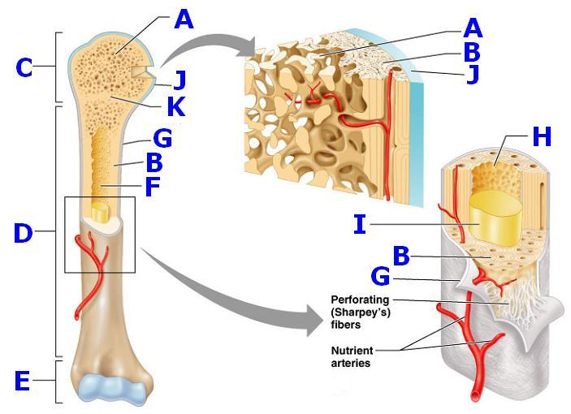

____ 24. Trabeculae of spongy bone

____ 25. Proximal epiphysis

____ 26. Distal epiphysis

____ 27. Diaphysis

____ 28. Periosteum

____ 29. Endosteum

____ 30. Articular cartilage

____ 31. Compact bone

____ 32. Yellow marrow

____ 33. Medullary (marrow) cavity

____ 34. Epiphyseal line

MATCHING. Match the letters on the diagram with the corresponding questions below. Answers can be repeated
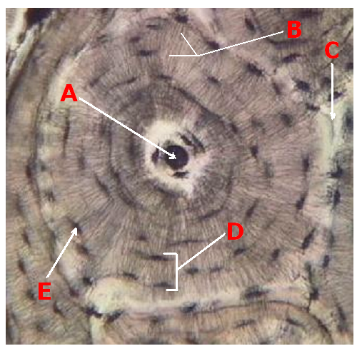

____ 35. Canaliculi

____ 36. Central canal

____ 37. Concentric lamellae

____ 38. Lacunae

____ 39. inorganic salts deposited in organic ground substance

____ 40. Layers of bony matrix around a central canal

____ 41. Site of osteocytes

____ 42. Longitudinal canal carrying blood vessels, lymphatics, and nerves

____ 43. minute canals connecting osteocytes of an osteon

CARTILAGES OF THE SKELETON
Matching. Match the letters with the corresponding questions below.
a. | elastic | c. | fibrocartilage
b. | hyaline

____ 44. supports the external ear

____ 45. between the vertebrae

____ 46. forms the walls of the voice box (larynx)

____ 47. the epiglottis

____ 48. articular cartilage

____ 49. menicus in a knee joint

____ 50. connects the ribs to the sternum

____ 51. most effective at resisting compression

____ 52. most springy and flexible

____ 53. most abundant

