Q_Lab Exercise 7 Joint, Muscle Tissue and Skeletal Muscle Naming

Matching

Matching. Use key responses to identify the joint types described below. You can use the same letter more than once.
Key:
a. | cartilaginous
b. | fibrous
c. | synovial

____ 1. includes joints between the vertebral bodies and the pubic symphysis

____ 2. essentially immovable joints

____ 3. sutures are the most remembered examples

____ 4. characterized by cartilage connecting the bony portions

____ 5. all characterized by a fibrous articular capsule lined with a synovial membrane surrounding a joint cavity

____ 6. all are freely movable or diarthrotic

____ 7. bone regions are united by fibrous connective tissue

____ 8. include the hip, knee, and elbow joints

____ 9. typically allows a slight degree of movement

CLASSIFICATION OF SKELETAL MUSCLES (Muscle Naming)
Several criteria were given relative to the naming of muscles. For each muscle name, choose from the key all criteria on which the name is based. CHOOSE THE BEST ANSWER.
a. | action of the muscle
b. | shape of the muscle
c. | location of the origin and/or insertion of the muscle
d. | number of origins
e. | location of the muscle relative to a bone or body region
f. | direction in which the muscle fibers run relative to some imaginary line
g. | relative size of the muscle
h. | BOTH action of the muscle and relative size of the muscle
i. | BOTH location of the muscle relative to a bone or body region and relative size of the muscle
j. | BOTH number of origins and location of the muscle relative to a bone or body region
k. | BOTH location of the muscle relative to a bone or body region and direction in which the muscle fibers run relative to some imaginary line
l. | Action of the muscle, location of the origin and/or insertion of the muscle, and location of the muscle relative to a bone or body region are correct

____ 10. Gluteus maximus

____ 11. Adductor magnus

____ 12. Biceps femoris

____ 13. Transversus abdominis

____ 14. Extensor carpi ulnaris

____ 15. Trapezius

____ 16. Rectus femoris

____ 17. External oblique

Label.
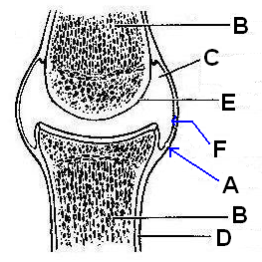

____ 18. Synovial membrane

____ 19. Bone

____ 20. Periosteum

____ 21. Articular cartilage

____ 22. Synovial cavity

____ 23. Articular capsule

Matching. Match the joint categories with their corresponding descriptions below.
a. | ball and socket | f. | saddle
b. | condyloid | g. | suture
c. | gliding | h. | symphysis
d. | hinge | i. | synchondrosis
e. | pivot | j. | syndesmosis

____ 24. joint between skull bones

____ 25. joint between the axis and atlas

____ 26. hip joint

____ 27. intervertebral joints (between articular processes)

____ 28. joint between forearm bones and wrist

____ 29. elbow

____ 30. interphalangeal joints

____ 31. intercarpal joints

____ 32. joint between tarsus and tibia/fibula

____ 33. joint between skull and vertebral column

____ 34. joint between jaw and skull

____ 35. joints between proximal phalanges and metacarpal bones

____ 36. epiphyseal plate of a child’s long bone

____ 37. a multiaxial joint

Matching.
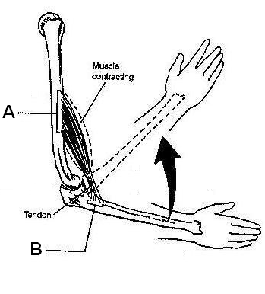

____ 38. Origin

____ 39. Insertion

Matching.
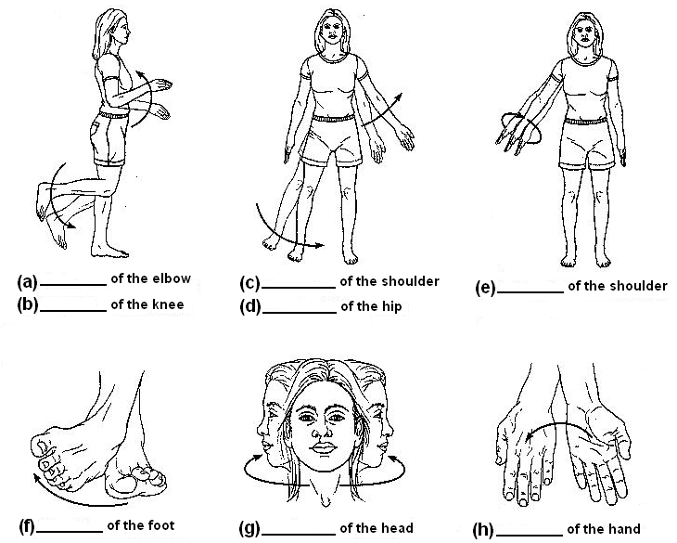

____ 40. Flexion

____ 41. Circumduction

____ 42. Inversion

____ 43. Adduction

____ 44. Rotation

____ 45. Extension

____ 46. Abduction

____ 47. Pronation

Matching. Use the items in the key to correctly identify the structures described below.
a. | endomysium | g. | perimysium
b. | epimysium | h. | sarcolemma
c. | fascicle | i. | sarcomere
d. | fiber | j. | sarcoplasm
e. | myofibril | k. | tendon
f. | myofilament

____ 48. bundle of muscle cells

____ 49. contractile unit of muscle

____ 50. a muscle cell

____ 51. thin reticular connective tisue investing each muscle cell

____ 52. plasma membrane of the muscle fiber

____ 53. a long filamentous organelle with a banded appearance found within muscle cells

____ 54. actin- or myosin-containing structure

____ 55. cord of collaen fibers that attaches a muscle to a bone

____ 56. connective tissue ensheating a bundle of muscle cells

Matching. The diagram illustrates a small portion of a muscle myofibril. Match the letters in the diagram with the corresponding questions below.

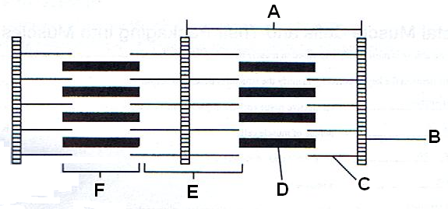

____ 57. actin filament

____ 58. I band

____ 59. myosin filament

____ 60. sarcomere

____ 61. Z disc

____ 62. A-band

Matching. Match the letters on the diagram with the corresponding questions below.
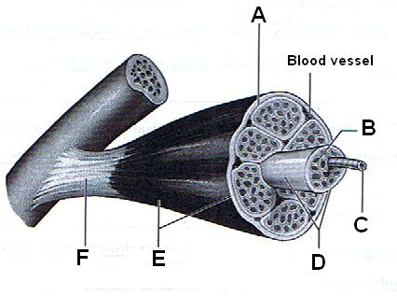

____ 63. Muscle cell

____ 64. Perimysium

____ 65. Fascicle

____ 66. Tendon

____ 67. Epimysium

____ 68. Endomysium

