Q_Lab Exercise 8 Skeletal Muscle

Matching

CLASSIFICATION OF SKELETAL MUSCLES
Match the key terms to the muscles and movements described below.
a. | Prime mover (agonist) | c. | Synergist
b. | Antagonist | d. | Fixator

____ 1. term for the Biceps brachii during elbow flexion

____ 2. term that describes the relation of the Brachialis to the Biceps brachii during elbow flexion

____ 3. term for the Triceps brachii during elbow flexion

____ 4. term for the Gluteus maximus during hip extension when walking up stairs

MUSCLES OF THE HEAD AND NECK
Using choices from the key, correctly identify muscle provided with leader lines on the diagram.
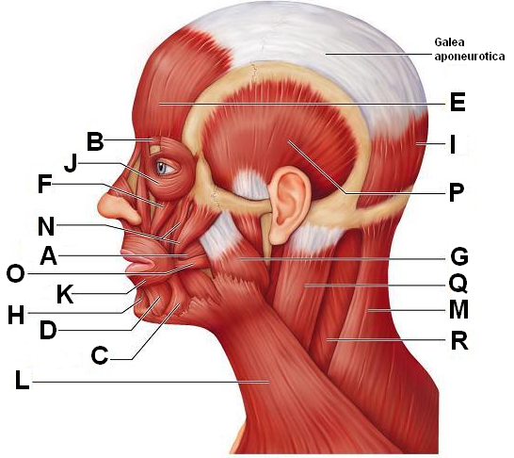

____ 5. Frontal belly of epicranius

____ 6. Corrugator supercilii

____ 7. Masseter

____ 8. Depressor labii inferioris

____ 9. Buccinator

____ 10. Depressor anguli oris

____ 11. Mentalis

____ 12. Occipital belly of epicranius

____ 13. Orbicularis oculi

____ 14. Orbicularis oris

____ 15. Platysma

____ 16. Zygomaticus major and minor

____ 17. Trapezius

MUSCLES OF THE HEAD AND NECK
Identify the muscles described next.

____ 18. used in smiling

____ 19. used to suck on your cheeks

____ 20. used in blinking and squinting

____ 21. used to pout (pulls the corners of the mouth downward)

____ 22. Raises your eyebrows for a questioning expression

____ 23. used to form the vertical frown crease on the forehead

____ 24. your “kisser”

____ 25. prime mover to raise the mandible

____ 26. tenses skin of the neck during shaving

MUSCLES OF THE TRUNK
Identify the muscles by matching the letters on the diagram with the questions below.

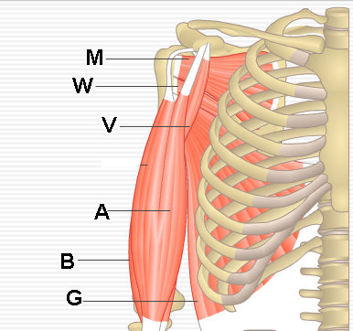

____ 27. Subscapularis

____ 28. Latissimus dorsi

____ 29. Biceps brachii

____ 30. Teres major

____ 31. Coracobrachialis

MUSCLES OF THE TRUNK
Identify muscles on the diagram using the corresponding choices below.
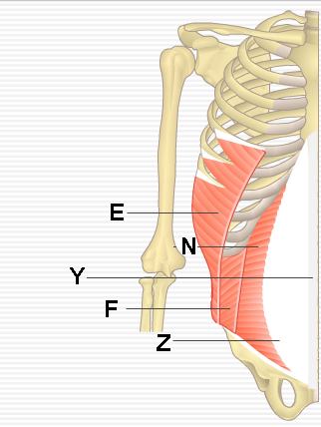

____ 32. External oblique muscle

____ 33. Transversus abdominis

____ 34. Internal oblique muscle

MUSCLES OF THE TRUNK
Matching. Match the letters on the diagram with the corresponding questions below. You can use the same letter more than once.
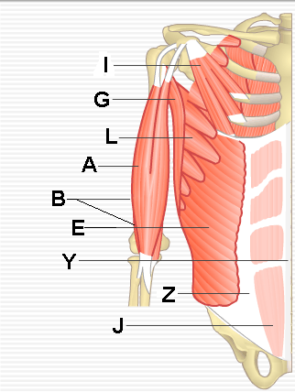

____ 35. Pectoralis minor

____ 36. Serratus anterior

____ 37. Biceps brachii

____ 38. Moves the scapula forward and downward

____ 39. Brachialis

____ 40. Rectus abdominis

____ 41. A major spine flexor

MUSCLES OF THE TRUNK
Matching. Match the letters on the diagram with the corresponding questions below. You can use the same letter more than once.
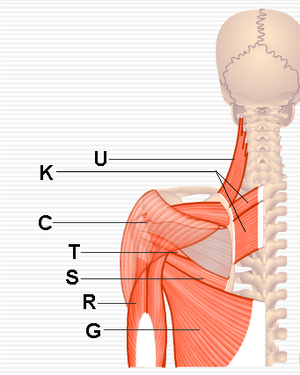

____ 42. Rhomboids

____ 43. Deltoid

____ 44. Latissimus dorsi

____ 45. Prime mover for pulling the arm posteriorly

____ 46. Prime mover of shoulder abduction

____ 47. Pull the scapulae medially

MUSCLES OF THE UPPER LIMB (FOREARM FLEXOR GROUP)
Matching. Match the letters on the diagram with the corresponding questions below.
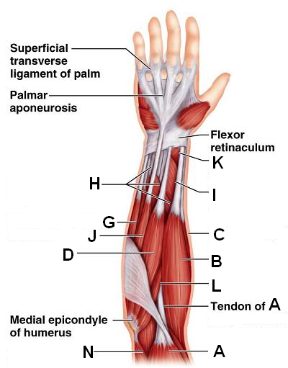

____ 48. Triceps brachii

____ 49. Palmaris longus

____ 50. Flexor carpi radialis

____ 51. Flexor carpi ulnaris

____ 52. Flexor pollicis longus

____ 53. Biceps brachii

____ 54. Extensor carpi radialis longus

____ 55. Brachioradialis

MUSCLES OF THE UPPER LIMB (FOREARM EXTENSOR GROUP)
Matching. Match the letters on the diagram with the corresponding questions below. You may use the same letter more than once.
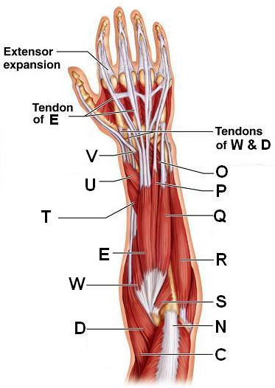

____ 56. Extends the wrist and digits

____ 57. Extensor carpi radialis longus

____ 58. Extensor carpi radialis brevis

____ 59. Triceps brachi (insertion)

____ 60. Brachioradialis

____ 61. Extensor digitorum

____ 62. Extensor carpi ulnaris

____ 63. Flexor carpi ulnaris

MUSCLES OF THE LOWER LIMB
Matching. Match the letters on the diagram with the corresponding questions below. You can use the letters more than once.
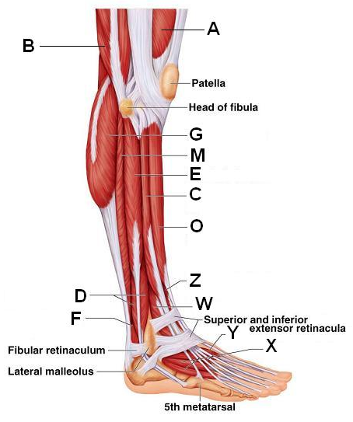

____ 64. Tibialis anterior

____ 65. Soleus

____ 66. Gastrocnemius

____ 67. Biceps femoris

____ 68. Extensor digitorum longus

____ 69. Fibularis longus

____ 70. Fibularis brevis

____ 71. Flexor hallucis longus

____ 72. Prime mover of dorsiflexion of the foot

____ 73. Extends the toe

GENERAL MUSCLE REVIEW: MUSCLE RECOGNITION
Identify the lettered muscle in the diagram of the human anterior superficial musculature by matching with the corresponding questions below:
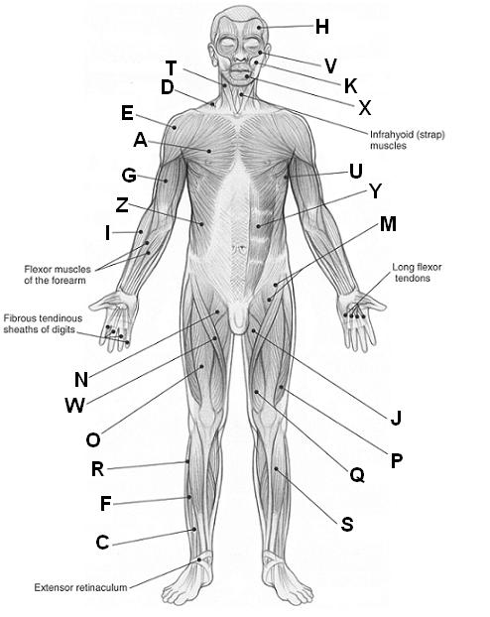

____ 74. Adductor longus

____ 75. Biceps brachii

____ 76. Brachioradialis

____ 77. Deltoid

____ 78. External oblique

____ 79. Fibularis longus

____ 80. Epicranius (frontal belly)

____ 81. Iliopsoas

____ 82. Orbicularis oculi

____ 83. Orbicularis oris

____ 84. Zygomaticus major

____ 85. Pectineus

____ 86. Pectoralis major

____ 87. Rectus abdominis

____ 88. Rectus femoris

____ 89. Sartorius

____ 90. Serratus anterior

____ 91. Sternocleidomastoid

____ 92. Tibialis anterior

____ 93. Trapezius

____ 94. Vastus lateralis

____ 95. Vastus medialis

____ 96. Extensor hallucis longus

____ 97. Extensor digitorum longus

GENERAL MUSCLE REVIEW: MUSCLE RECOGNITION
Identify the lettered muscle in the diagram of the human anterior superficial musculature by matching with the corresponding questions below:
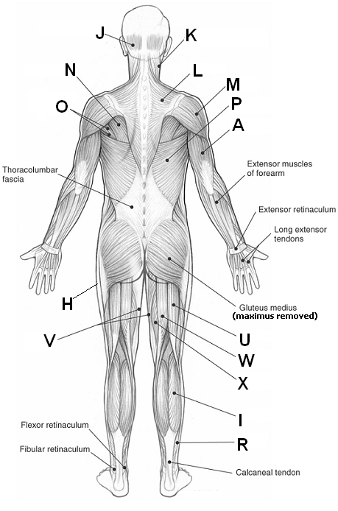

____ 98. Biceps femoris

____ 99. Deltoid

____ 100. Gastrocnemius

____ 101. Gracilis

____ 102. Infraspinatus

____ 103. Latissimus dorsi

____ 104. Occipitalis

____ 105. Semimembranosus

____ 106. Semitendinosus

____ 107. Sternocleidomastoid

____ 108. Teres major and minor

____ 109. Trapezius

____ 110. Triceps brachii

____ 111. Soleus

Label:
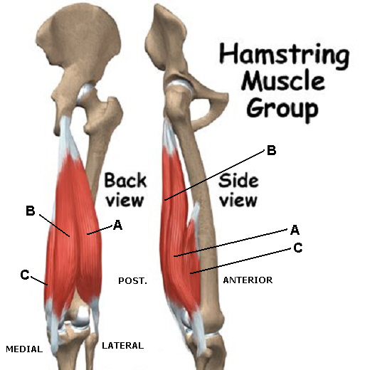

____ 112. Semitendinosus

____ 113. Semimembranosus

____ 114. Biceps femoris

