Professor Ula

English 101

Fall 2020

The Rhetorical Triangle
Aristotle taught that a speaker's ability to persuade is based on how well the speaker appeals to his or her audience in three different areas: ethos (ethical appeals), pathos (emotional appeals), and logos (logical appeals). These areas form something that later rhetoricians have called the Rhetorical Triangle.
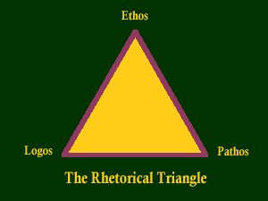
We could also illustrate the concept this way:
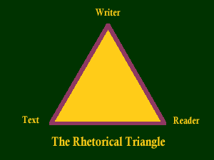

Ethos (Credibility), or ethical appeal, means convincing by the character of the author. We tend to believe people whom we respect. One of the central problems of argumentation is to project an impression to the reader that you are someone worth listening to, in other words making yourself as author into an authority on the subject of the paper, as well as someone who is likable and worthy of respect. "Ethos" refers to the writer's "ethical appeal," that is, how well the writer presents herself. Does she seem knowledgeable and reasonable? Does she seem trustworthy? Does she treat her opponents, people who might disagree, with fairness and respect, or does she take cheap shots at them? Does she try to establish common ground with the reader? Why do you think essays that lack this kind of appeal are likely to be unconvincing? What effect do you think it would have if a writer included nothing but ethical appeals?
Pathos (Emotional) means persuading by appealing to the reader's emotions. We can look at texts ranging from classic essays to contemporary advertisements to see how pathos, emotional appeals, are used to persuade. Language choice affects the audience's emotional response, and emotional appeal can effectively be used to enhance an argument. "Pathos" refers to the argument's "emotional appeals," that is, how well the writer taps into the reader's emotions Many times, this appeal is how a writer will make an argument "matter" to readers. Advertisements do it all the time. Perhaps a writer will offer an anecdote to illustrate suffering or appeal to readers as parents concerned for their children. Does the writer appeal to your emotions—feelings of sadness, pride, fear, being young, anger, patriotism, love, justice? On the other hand, is the essay loaded with facts, figures, and nothing else? Is the emotional appeal effective or overwhelming?
Logos (Logical) means persuading by the use of reasoning. This will be the most important technique we will study, and Aristotle's favorite. We'll look at deductive and inductive reasoning, and discuss what makes an effective, persuasive reason to back up your claims. Giving reasons is the heart of argumentation and cannot be emphasized enough. We'll study the types of support you can use to substantiate your thesis, and look at some of the common logical fallacies, in order to avoid them in your writing. "Logos" corresponds with the argument's "logical appeals," that is, how well the reader uses the "text" of his own argument and evidence. Effective arguments will probably include facts and other supporting details to back up the author's claims. They may contain testimony from authorities and will demonstrate the writer's carefulness in choosing and considering evidence. They are likely to be well organized, skillfully written, and well edited/proofread. Questions to consider: What is being argued here, or what is the author's thesis? What points does he offer to support this idea? Has he presented arguments that seem logical, or does he seem to be jumping to conclusions? Can you think of kinds of writing that rely exclusively on logical appeals? Do they bore you?
Note that this triangle is essentially equilateral. Why? Again, the equal sides and angles illustrate the concept that each appeal is as important as the others. It also suggests that a BALANCE of the three is important. Too much of one is likely to produce an argument that readers will either find unconvincing or that will cause them to stop reading.
Finally, note how each of the areas potentially affects the others. An illogical argument may move us emotionally, but only in the sense that it makes us angry at the author for wasting our time. An overwhelming emotional argument may make us feel that the author is relying exclusively on emotions rather than offering solid reasoning. Finally, if an argument contains only facts and figures and no emotional appeals, we may simply get bored. All these defects may, in turn, affect the author's ethical appeal: how can we trust a writer who appeals only to our emotions? What common ground do we have with a writer who doesn't appeal to our emotions at all?

