East Los Angeles College

CD 4: Creative Experiences for Children II

Instructor: Rokeya Rahman

Topic: Numbers and Operations

Agenda:

- Welcome
- Math in Early Childhood Classroom
- Areas of Math
- Numbers and Operations
- Math Talk
- Upcoming Assignment
- Questions & Answers

Objectives: Early Mathematics

- The student will be able to:
✓Define key terms related to math
✓High Five Mathematize
✓Familiar with concept of number and operation
✓The concepts of Math Talk and Example
✓Math Activity ideas in promoting math experiences in the
classroom.

Review ECE Domains: According to Preschool Learning Foundation, Vol # 1,2,3

  - There are several standards/domain in ECE field in California:
- Social-Emotional Development
- Language and Literacy
- English Language Development (for English Learner)
- Mathematics
- Visual and Performing Arts
- Physical Development
- Health
- History and Social Science
- Science

What is Early Mathematics?

•Early Math Knowledge

•includes skills and concepts related to number, geometry, and spatial sense,
measurement, and patterns.
- is rooted in children’s everyday experiences, and interactions beginning in
infancy.
- is interconnected with all areas of early learning and development.
- (Frye et al., 2013; Ginsburg et al., 2008; NAEYC & NCTM, 2002; National Research Council, 2009; Sarama & Clements, 2009)

Early Math in the ECE

Math is everywhere
Daily living provides a math-rich environment
Math must be hands-on and DAP
Teach math in a context that has a purpose to the child
Focus on conceptual math, not pencil-and-paper
Not limited to a specific period or time of day
Relationships and repetition are key to math learning (Beaver, Wyatt, and Jackman, 2017, p. 261)

Developmental Stages of Math
❑Early Math Knowledge includes skills and concepts related to

Number and Operations
- Geometry & Spatial Sense
- Measurement
- Patterns, Functions, and Algebra
- Data Analysis and Probability
- Problem Solving (Beaver, Wyatt, and Jackman, 2017, p. 263-269)

Mathematize

  - Mathematize means to bring out, or highlight, math concepts during an interaction with a child or group of children.
  - Adults mathematize in a variety of ways, but the first step in mathematizing is to
recognize math concepts embedded in what children are exploring or experiencing
  - Adults can mathematize children’s experiences by-
✓Emphasizing math concepts and relationships
✓Using mathematical language
✓Making comments, asking questions, and posing problems
✓Proving a variety of materials and tools with which to explore math ideas.

Mathematize

- Number and Operation
- Pattern
- Geometry and Spatial Sense
- Measurement and Comparison
- Learning Environment

Number and Operations

  - Early number knowledge includes a wide range of developing skills and concepts,
including:
    - Counting
    - Comparing quantities
    - Adding to and taking away
    - Representing number
    - Solving problems with numbers
  - Number knowledge is critical to all areas of math learning in preschool and
beyond.

Exploring and Learning About Number and

Operations

- Knowing How Many
- Relationships: Comparing
- Representing Number
- Operations: Adding and Subtracting

Defined Number and Operations

- Number Sense: A concept that develops over time as children think about, explore, and discuss mathematical ideas.
- One-to-one Correspondence: The pairing of one object to another object or one
group of objects to another group of equal number.
- Cardinality: The number of elements in a given mathematical set. In other words the total number or quality of objects counted.
- Rote Counting: The ability to recite names of numerals in order.
- Rational Counting: Requires matching each numeral name, in order, to an object in a group. (Beaver, Wyatt, and Jackman, 2017, p. 278)

Learning Path for Number and Operations

General Learning Path for Number and Operations are described

within five areas:

1. | Subitizing
2. | Counting
3. | Comparing and Ordering
4. | Early Addition and Subtraction
5. | Composing Number and Place Value | (Copley,2001, p. 54)

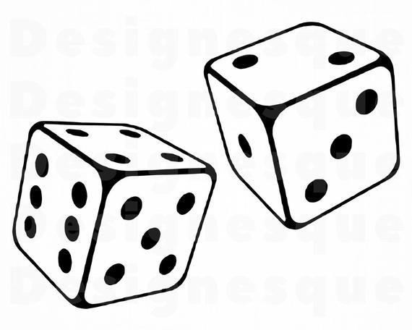

Subitizing

❑Subitizing:

Subitizing is a skill that young children should develop.
- It defined as recognizing the numerosity of a group quickly.
- Looking at a quantity for a short time and then being able to tell how many in the groups without counting.
- This development begins between ages 2 and 6. (Copley,2001, p. 54)

Counting

- Counting is a skill requiring several abilities.
- Reciting the sequence of number names- one, two, three…
- Toddlers recite some counting words
- By 3 1/2 to 4 1/2 years of age, children typically count to 10 and begin to count to 20 or higher.
- The first 20 numbers must be memorized or learned by rote.
- Counting beyond 20 is easier once the pattern is learned.
• (Copley,2001, p. 54)

Counting Example
- Counting
Example: In the morning group time, children count how many students in the class today.

- One-to-one correspondence
Example:

1
One
2 Two 3 Three 4 Four
17

Development of Number and Counting Skills

  - Age 2 and 3: Can count orally the number 1 to 10; can count one to six
items accurately.
  - Age 4 (Prekindergarten): Can count orally from 1 to 39; can count one to fifteen items in a row accurately.
  - Age 5 (Kindergarten): Can count orally to 100 by 10s or by 1s; can count

twenty-five things in a row.
✓Age 6 (Grade I): Can arrange objects in groups of 10; can count by 10s
using the decade numbers and then count the leftover by 1s. (Copley,2001, p. 54)

Counting Discussion

- What are the children in your program counting?
- How can you share information about counting and how children learn with families?
- How can you and their families support children’s developing counting
knowledge?

Number Operations:

Adding and Subtracting

Children as young as 2 and 3 put objects together (add) to make larger groups.
- take objects away (subtract) to make smaller groups.
- find out “how many”
- Beginning at age 4, they can find the results of joining, separating, and part-part –whole relationships.
- As children develop, they begin to count on, find the missing addend, and develop specific counting strategies. (Copley,2001, p. 54)

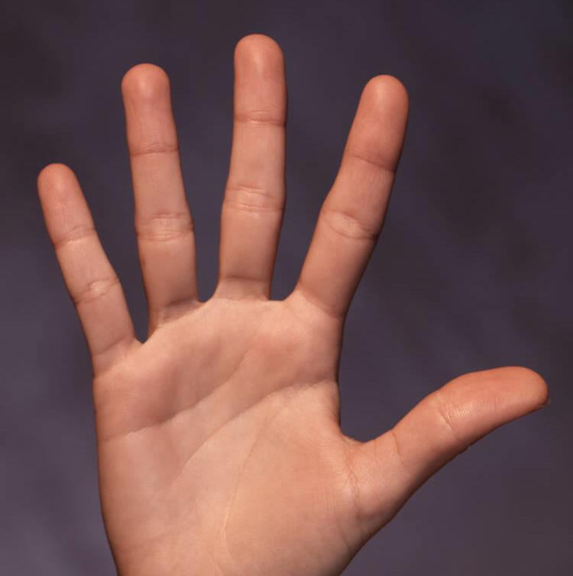

Part-Part-Whole:
Show Me Five fingers
21

Comparing and Ordering

✓Comparison terms mean such as more than, bigger than, greater than, less than
etc.
✓Children begins comparing by matching objects one-to-one with other objects.
✓By age 4 they can compare two small sets of one to five objects, non-verbally and by counting.
✓By age 5 and 6, children count to compare sets of 10, use the ordinal terms first
to tenth.
✓At the age 7 and 8, children compare and order to the number thousands.
✓ (Copley,2001, p. 54)

Composing Number and Place Value

Children at age 3 inaccurately recognize part-part-whole relationships
  - At age 4, they know the number combinations for 4 and 5, then 6 and 7
etc.
  - At age 7, they compose with 10s and 1s and solve problems by composing
and decomposing multidigit numbers. (Copley,2001, p. 54)

What is Math Talk?

•Math Talk is using words about number (or quantity), shapes, space, and
dimensions
Some examples:
    - number words (one, two, three, etc.), many, few, more than, same number
    - circle, square, flat, round, pointy, wide
    - in, on, under, up, down, forward, backward
    - big, little, taller, heavier, shortest, fastest

Math Talk and Math Learning

- More “math talk” by teachers related to greater growth in preschoolers’ math
knowledge (Klibanoff et al., 2006)
- More “number talk” during parent-toddler interactions related to better performance on a number task at 46 months (Levine et al., 2010)
- More “spatial talk” during parent-child interactions from 14 to 46 months predicted
  - the child’s spatial language production and
  - performance on non-verbal spatial reasoning tasks at 54 months (Pruden, Levine,
& Huttenlocher, 2011)

•

Math Talk: Asking Questions

➢How is this shape like that one? How is it different?
➢What if you turned this shape? What if you flipped it? What would it look
like? Would it still be a triangle?
➢Could you take a picture out of these shapes?
➢Where are you going to put that block?
➢Who is sitting next to Jose?
➢How many blocks do you think we can fit on his shelf?
➢How can we make room for one more friend to sit at our table?

Providing a Mathematics-Rich Environment

What materials can we provide?
▪ Different types of blocks, photographs, or books of buildings, large wooden,
plastic, or cardboard blocks or similar materials in the outdoor play area
▪Easy access of materials, such as- geometric puzzles, geoboards with rubber
bands, puzzles with irregular shapes, and board games such as candy Land.
▪Provides trays or mats to help children define and organize their workplace when
they are working with small materials.
▪Outline floor tiles with painter’s tape to create squares, rectangles, hexagons, and
triangles of various sizes and colors.

  - Number Necklaces

Math Activity Ideas on Number and Operation
  - Cookie jar and counting
cookies
  - Counting bears or buttons
  - How many windows
  - How many people live in your house?
  - Number dance
- Pompom Jacks
- Ice-Cream Shop
- Block Towers
- How many legs
- Matching game
- Comparing beans
- Build the Numbers
- Scavenger Hunt

Review: Lesson Plan (Preschool age: 3-5)

  - Curriculum Areas:
  - Language & Literacy
  - Dramatic Play
  - Visual Art
  - Music and Movement
- Math
- Social Science
- Social Studies
- Nutrition
- Science

Domains:
- Social-Emotional Development
- Language and Literacy
- English-Language Development
- Mathematics
- Visual and Performing Arts
- Physical Development
- Health
- History-Social Science
- Science

Objectives: SMART Goal
- S- Specific
- M- Measurable
- A- Achievable
- R- Realistic
- T- Time bound

- Objectives consist of three major part:
✓Identifying the input (or activity) you will provide
✓Specific observable behavior (what the child is to do during the activity
✓level of performance (state the child’s minimum acceptable level of

performance)

Math Activity: Counting Buttons

Curriculum Area: Math
- Domain: Mathematics (Number and Operations)
- Age group: 4-5 Years
- Story Behind the Activity:
Children love using buttons in my class. During free choice time, I saw a group of children were dumping all the buttons on the table and grouping them. They were having fun finding different colored and shaped buttons and discussing who has the most buttons. Their involvements with buttons gave me an idea to provide an activity where children can count buttons and improve their number and cardinality skills.

Objectives: (SMART objectives)

- While counting and exploring different kind of buttons, children will be able to count the number 1-10 correctly.

- Children will improve cardinality skills (identify how buttons in each group after exploring buttons with other children.

Upcoming Assignments:

• Read the PowerPoint Slides
- Visit Modules for Updates and Announcements
- Complete weekly Assignment/activity/discussion

